DAILY ONLINE ACTIVITIES SUMMARY
Date: | 31-05-2020 |  |  |  |  | Name: | LANSON PEREIRA
Sem & Sec | 4th& A |  |  |  |  | USN: | 4AL18CS040
Online Test Summary
Subject |  | N/A
Max. Marks |  | N/A |  | Score |  |  | N/A
Certification Course Summary
Course | Elementary Data Structures
Certificate Provider |  |  | Saylor |  | Duration |  |  | 38 HOURS
Coding Challenges
Problem Statement
1.write a java program to calculate npr
Status: executed
Uploaded the report in Github |  |  |  |  | YES
If yes Repository name |  |  |  |  | - https://github.com/lansonlp/Lockdown-Coding  - https://github.com/lansonlp/Lockdown-Certification-Course
Uploaded the report in slack |  |  |  |  | YES

Online Test Details : N/A

Online Certification Course Summary: I have opted my Online Certification Course In saylor the course which i have opted is Elementary Data Structures

Course Description

Introductory survey of the specification and implementation of basic abstract data types and their associated algorithms. Structures discussed include: stacks, queues, lists, sorting and selection, searching, graphs, and hashing; performance tradeoffs of different implementations and asymptotic analysis of running time and memory usage.

This course is comprised of the following units:

Unit 1: Abstract Data Types and Arrays in C++

Unit 2: Introduction to Stacks and Queues

Unit 3: Pointers and References in C++

Unit 4: Dynamic Memory Allocation

Unit 5: Linked Stacks, Queues, and Lists

Unit 6: Algorithm Efficiency

Unit 7: Searching and Sorting Algorithms

Unit 8: Hash Tables, Graphs, and Trees

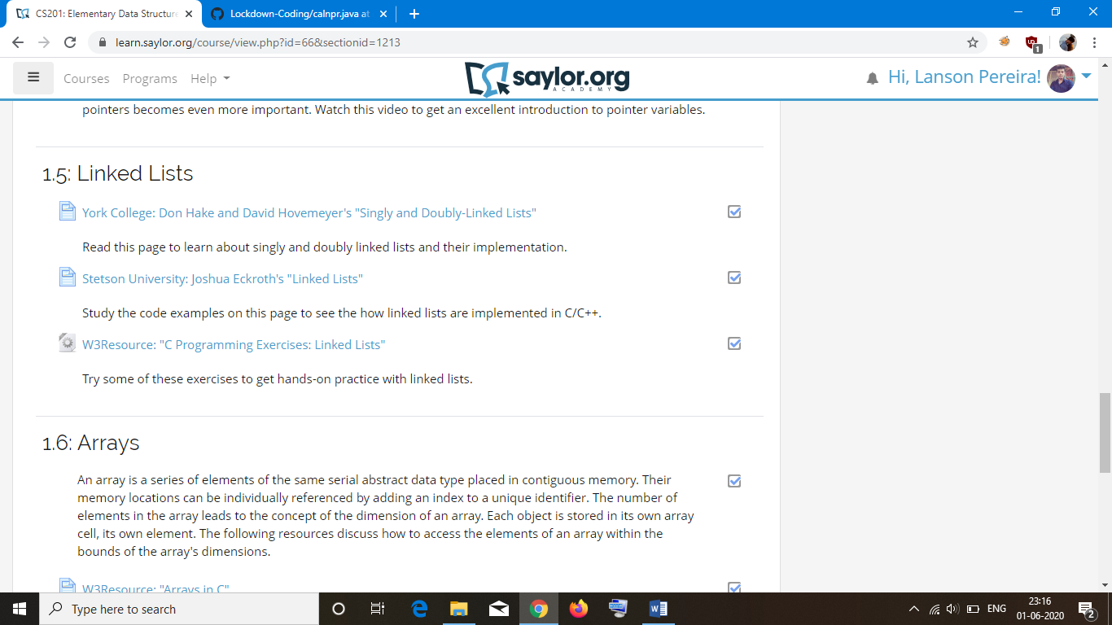

write a java program to calculate npr

