COMPX518-21A Assignment 3
  - Lee So 1364878
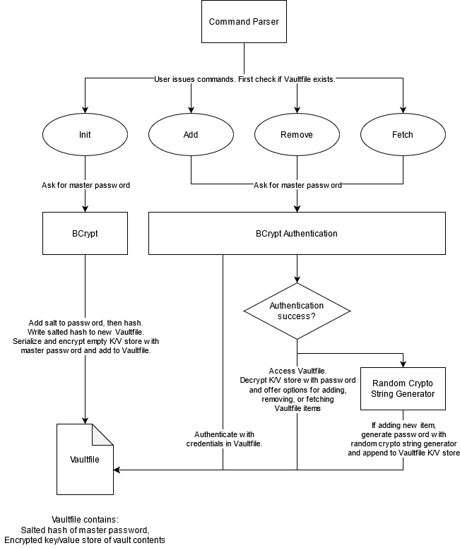
Figure 1: Diagram of the password manager program
This is a simple password manager program. The user interacts with it through the command line. Everything is stored within a Vaultfile in the same directory as the program executable. The Vaultfile contains 2 units of information: the salted hash of the vault’s master password and an AES-256 (GCM mode) encrypted serialized key-value structure containing the vault’s identifier-password pairs.
The user can issue 1 of 4 possible commands: init, add, remove, and fetch. Init only works if there is no Vaultfile in the same directory as the executable. The other commands only work if a Vaultfile is found.
When initializing a new Vaultfile, the user is prompted for a master password which will be randomly salted, hashed, and stored in a new Vaultfile.
When adding, removing, or viewing (fetching) the vault contents, the user will be asked for their master password. The input will be checked against the Vaultfile’s salted hash. If authentication succeeds, the input password is used as the decryption key to load in the vault contents. The user can then interact with the vault’s contents by supplying the identifier (name) of the desired password entry.
I used the PRNG in the Golang standard library’s crypto package for random string generation. Using the standard library is good practice, and crypto/rand implements a cryptographic PRNG like so:
On Linux and FreeBSD, Reader uses getrandom(2) if available, /dev/urandom otherwise. On OpenBSD, Reader uses getentropy(2). On other Unix-like systems, Reader reads from /dev/urandom. On Windows systems, Reader uses the RtlGenRandom API. On Wasm, Reader uses the Web Crypto API.
Sounds pretty good.
Master password storage and authentication follows standard good practice knowledge:
- Password hashing is done with bcrypt. This hash function is designed for use with passwords. Bruteforcing is slow and cpu-expensive. Golang’s crypto bcrypt implementation does random salting for us.
- The only master password information stored is the salted hash of the password. Resistant to rainbow tables.
- To authenticate, the input password has the salt appended before being hashed and compared to the salted hash.
The serialized key-value store is encrypted with AES-256, using the master password put through a key derivation function (PBKDF2) as the key.
This is a simple program that stores everything within a Vaultfile on the local disk. There are no controls for integrity in the sense that there’s not much stopping a person from simply deleting the Vaultfile, or writing nonsense to its contents. However, recovering the master password from the hash or the decrypted vault storage will be a significant challenge. This also makes password vaults highly portable.

