1. Add **Storage & Distribution** as separate tab on left

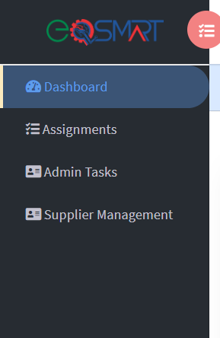

1. Clicking on **Storage & Distribution** should list all service providers under two categories- Carriers & Storage (Name & contact info is attached in this email). Just like supplier tab, admin should be able to upload/view all their documentation.
2. Like supplier, they will also receive email to upload documentation with a different content listed in next steps.
3. On receiving email to upload documents- On page 1, they should be asked to edit & verify contact information. A separate column should ask for Food Safety Emergency contact name, number, and email for them to fill out.
4. Page 2 should ask for signature on letter of conformance (FSMA TRANSPORTATION template is attached in this email)

N**ext, they will be asked to select one option out of these three- Carrier, Storage, or both**

1. On selecting carrier, they will be asked to select yes/no for below questions & upload mandatory/optional attachments.

|  |  |  |
| --- | --- | --- |
| Food Safety & Security Program is established by the service provider | Yes  No | Upload (mandatory) |
| Does the carrier vehicle/ storage facility transport store non-food items in same or previous loads? | Yes  No |  |
| If yes to above, please list/ attach Food Protection & Contamination prevention measures | Yes  No | Upload (optional)  Also provide comment box |
| Has training of carrier personnel in sanitary transportation practices been conducted? If yes, list name & attach certificates of all personnel trained  Refer: <https://www.fda.gov/food/food-safety-modernization-act-fsma/training-carriers-covered-sanitary-transportation-human-and-animal-food-rule> | Yes  No | Upload (mandatory)  Provide comment box & reference link |
| Do you have effective Allergen management strategy? List/ attach a copy | Yes  No | Upload (optional)  Also provide comment box |

1. On selecting Storage or both, they will be asked all the above stated in I. and in addition upload the following documents:
2. THIRD PARTY AUDIT REPORT & CERTIFICATE
3. LETTER OF CONTINUING GUARANTEE
4. FDA FOOD FACILITY REGISTRATION
5. FDA BIOTERRORISM ACT COMPLIANCE
6. CALIFORNIA TRANSPARENCY IN SUPPLY CHAIN ACTS
7. CALIFORNIA PROPOSITION 65 WARRANTY