

User Guide of

Supplier Module

# Introduction

The Supplier Management Module is to manage the suppliers and the ingredients they supply .The supplier Module consist of supplier, ingredients and supplier scorecard details. You can add new and manage existing suppliers, Add new and manage existing ingredients , assign ingredients to suppliers , collect required documents of suppliers and ingredients , create scorecard , fill the scorecard and view history of scorecards.

You can easily access this module from the Panel provided. You can find the option easily in the left panel and it is named as “Supplier Management” after logging in to the system. In this document we will discuss each option provided by this module.

There are four groups specified for this module, Regulatory, Purchasing, QA Manager and Working committee. Here the group working committee will work as admin, as it has all the rights over this module and the other groups have limited access to the system.

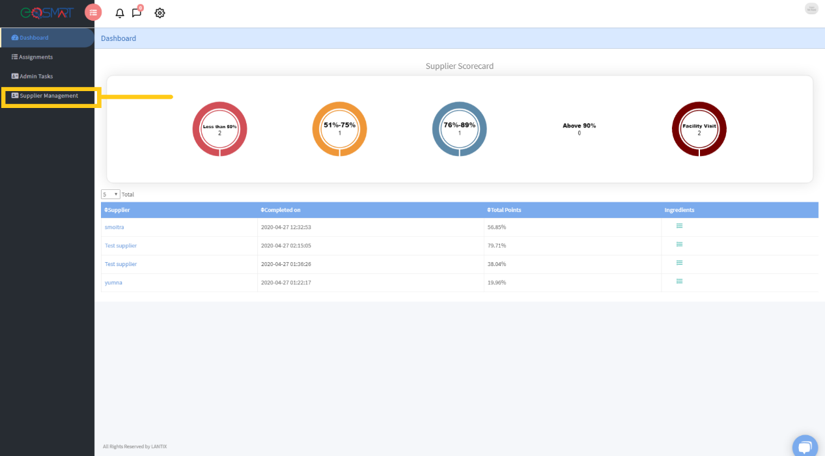

# Suppliers

In the supplier option, you can add new suppliers and you can find this option on the top right side of the screen also you can import a csv file of suppliers (Note: the csv file should have the same format as the file provided as sample). If you click on add new supplier, you can see two sections, one will contain the basic information of supplier and the other consist of the documents that are required from the supplier. Fill the Supplier information with the correct email and leave the documents section as it is without uploading any document. The supplier will automatically receive an email on the email provided by you when you were adding a new supplier. The email consist of username and password to the supplier profile and the link where he can login to the system. The supplier can login and see his/her basic information and can upload the documents along with their expiration dates and the system will automatically trigger a reminder email when your document will expire (Note: the document name that you are trying to upload should have the same name as the label of the document that is required).There is also an ingredient section that will require the Ingredients documents (The ingredients that are being supplied by the supplier). See the ingredient section to find out how you can assign an ingredient to the supplier. The supplier can login to the profile whenever he wants and how many times he want if he couldn’t upload all the documents at once.

On the admin side, you can see the documents and their expiration date that are uploaded by the supplier. The admin can also edit and active/Inactivate a supplier.

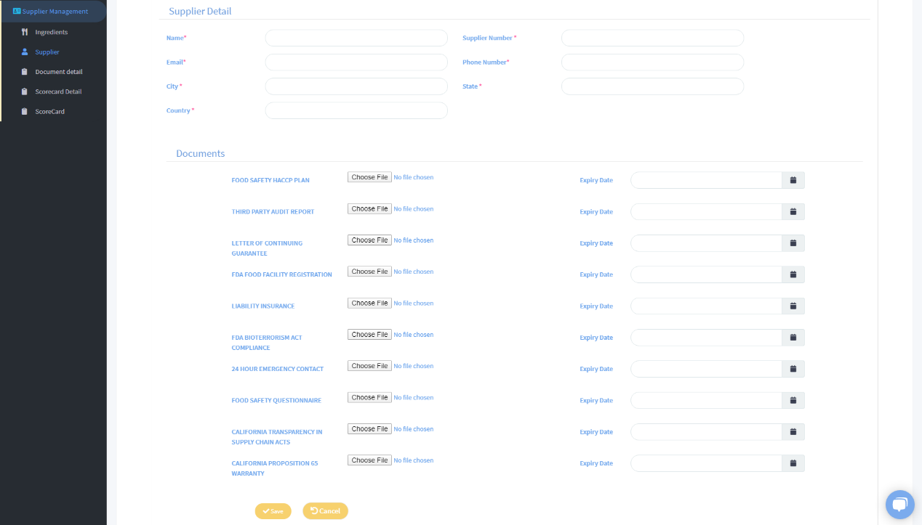

# Ingredients

The ingredient Section allows you to add new ingredients and assign each ingredient his primary and secondary supplier.You can add new ingredient or import a csv file of ingredients with their suppliers (Note: the csv file format should be the same as the format of sample file provided).Click on add new supplier and you can see 2 sections, Ingredients basic information and Supplier section. Add the basic information required and assign type of the ingredient as you have currently 4 types of ingredients. You can also assign multiple types to one ingredient. Moving on to supplier assignment section, here you can select supplier name from the list , his role (Primary/Secondary) ,the number and Name given by supplier to the ingredient.You can add multiple suppliers to one ingredient.

There are some documents specified against each type that you will assign to the ingredient and that document will be asked to submit by the supplier on the supplier profile. You can add/edit and see detail of ingredients

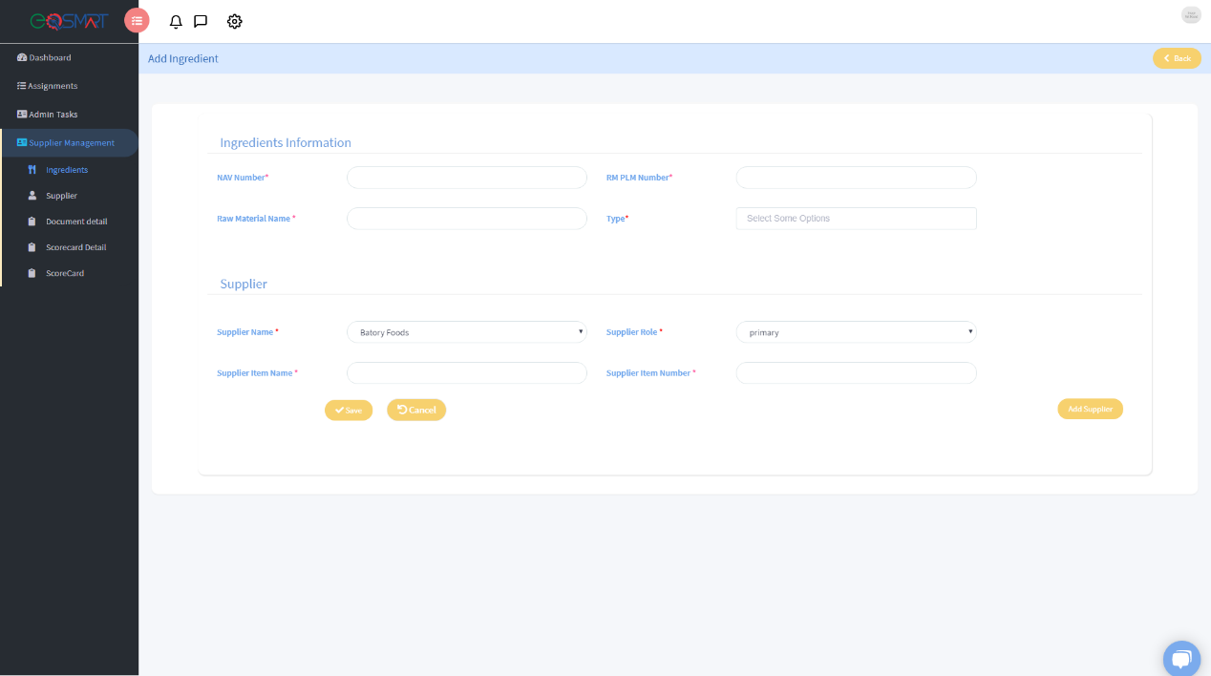

# Document Detail

This section is to specify the documents that needs to be asked to be submitted by the suppliers. Click on add new button, Specify the document name and assign it to supplier or ingredient, it means you can specify if it’s a document that needs to be asked for ingredients or it’s a supplier basic document. If you click on Ingredient than it will ask you to specify that this document will be asked against which type of ingredient. Here you can just manage the documents that needs to be collected from the supplier.

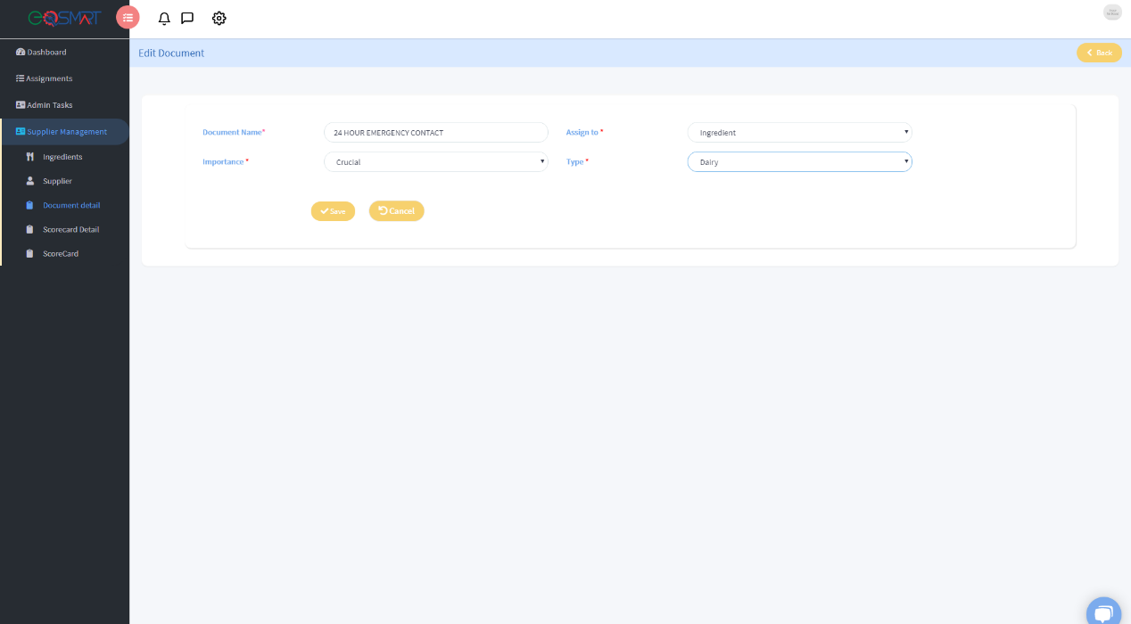

# Scorecard Detail

The suppliers are scored on the basis of different questions filled by different teams. You can create your own customized scorecard here. Click on add new and you will be adding a team that will score the suppliers. Name the Questioner and assign a team that will be responsible for scoring the supplier. After submitting the form, under the actions heading in the table you can see an icon that represents the manage questions. Click on that icon and you will see a new page with the button add new, from here you can add questions that we be asked to by the team against the supplier. Add multiple questions and there descriptions.

Initially we have three Questioners and they are assigned to three separate teams, and they will be responsible for scoring the suppliers but you can add new or edit the questions that are added against the teams of add another questioner.

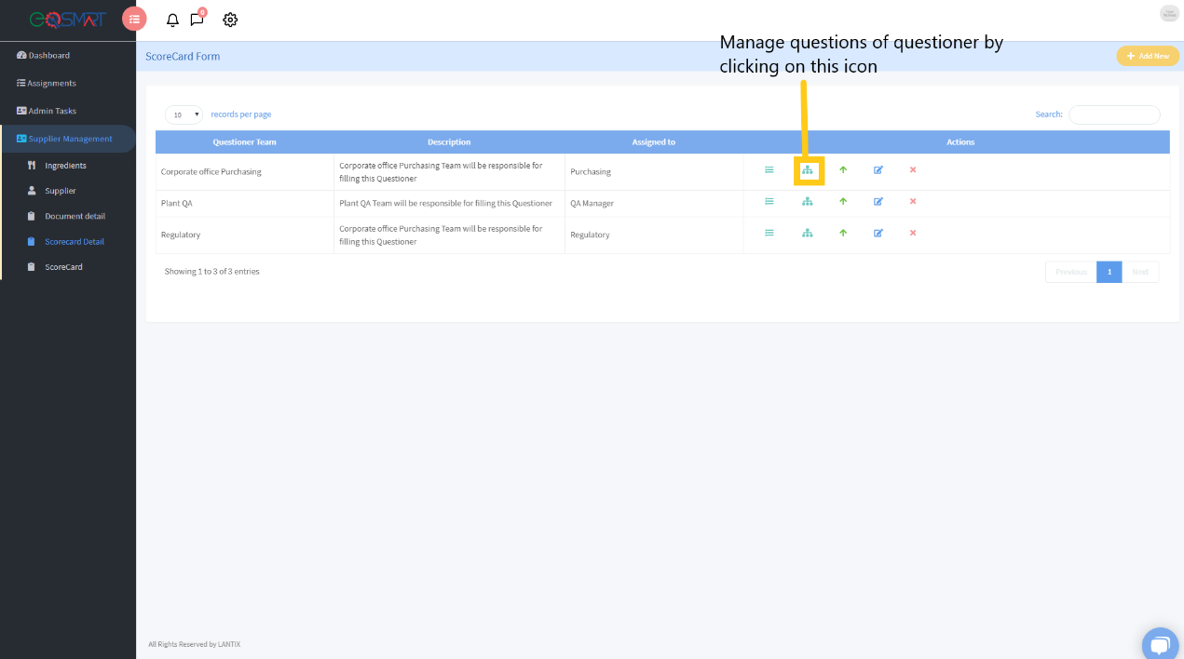

# Scorecard

This scorecard section further contains multiple option, the first option is to create a new scorecard. The System is designed in a way that you will have to firstly create a scorecard against a supplier and then after every 3 months the system will automatically generate a new scorecard for that supplier. In the header you can see a setting icon, if you will click on that option, you can see a tab named as scorecard approval team, here you select the name of the team that will be the final review team, initially it is the working committee.

After the scorecard is generated, it goes in the “In Progress Scorecards” tab that consist of the 3 questioners assigned to three different teams. The corresponding team member will login to the system and will be assigned the limited access to the system that he can only see the scorecards that are created for that particular team.

The scorecard contains three sections (General questions section, documents and ingredients section).Note: the ingredient and document section is only available for the Regulatory team. The scorecard Regulatory Questioner consist of the questions specified for that team along with the documents scoring of the supplier and that supplier ingredient scoring. If you open a scorecard you can see three colors against each question that hold different scores (green= 100%, Yellow 50% and red 0%). Select any one option for each question and submit the scorecard. If the documents are not uploaded by the supplier than automatically the red option is selected but if the supplier has uploaded the document, you can download the document by clicking on the name and review the document and then select the score. Five questions are asked against each ingredient and that makes another ingredient section in the scorecard.

Regulatory Questioner

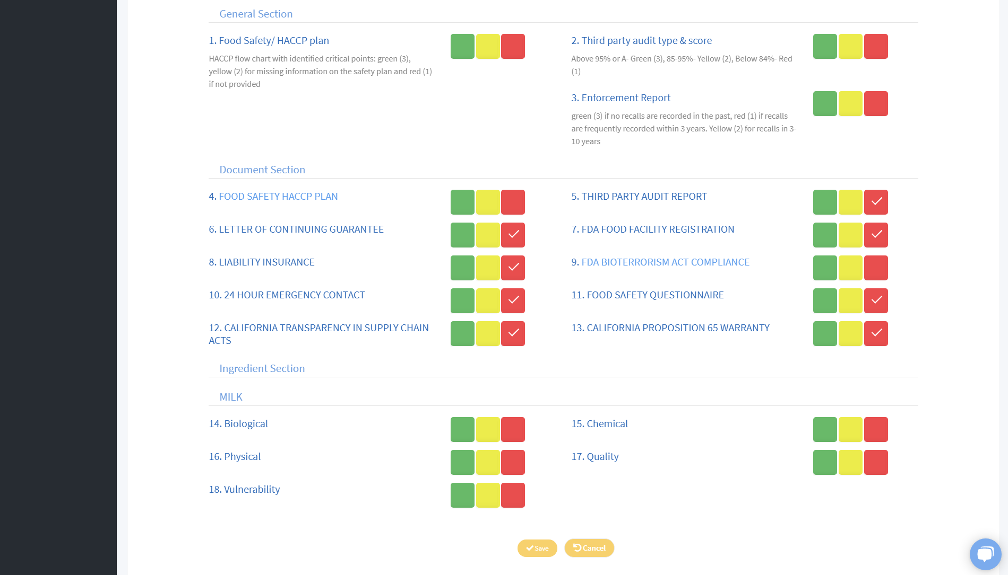

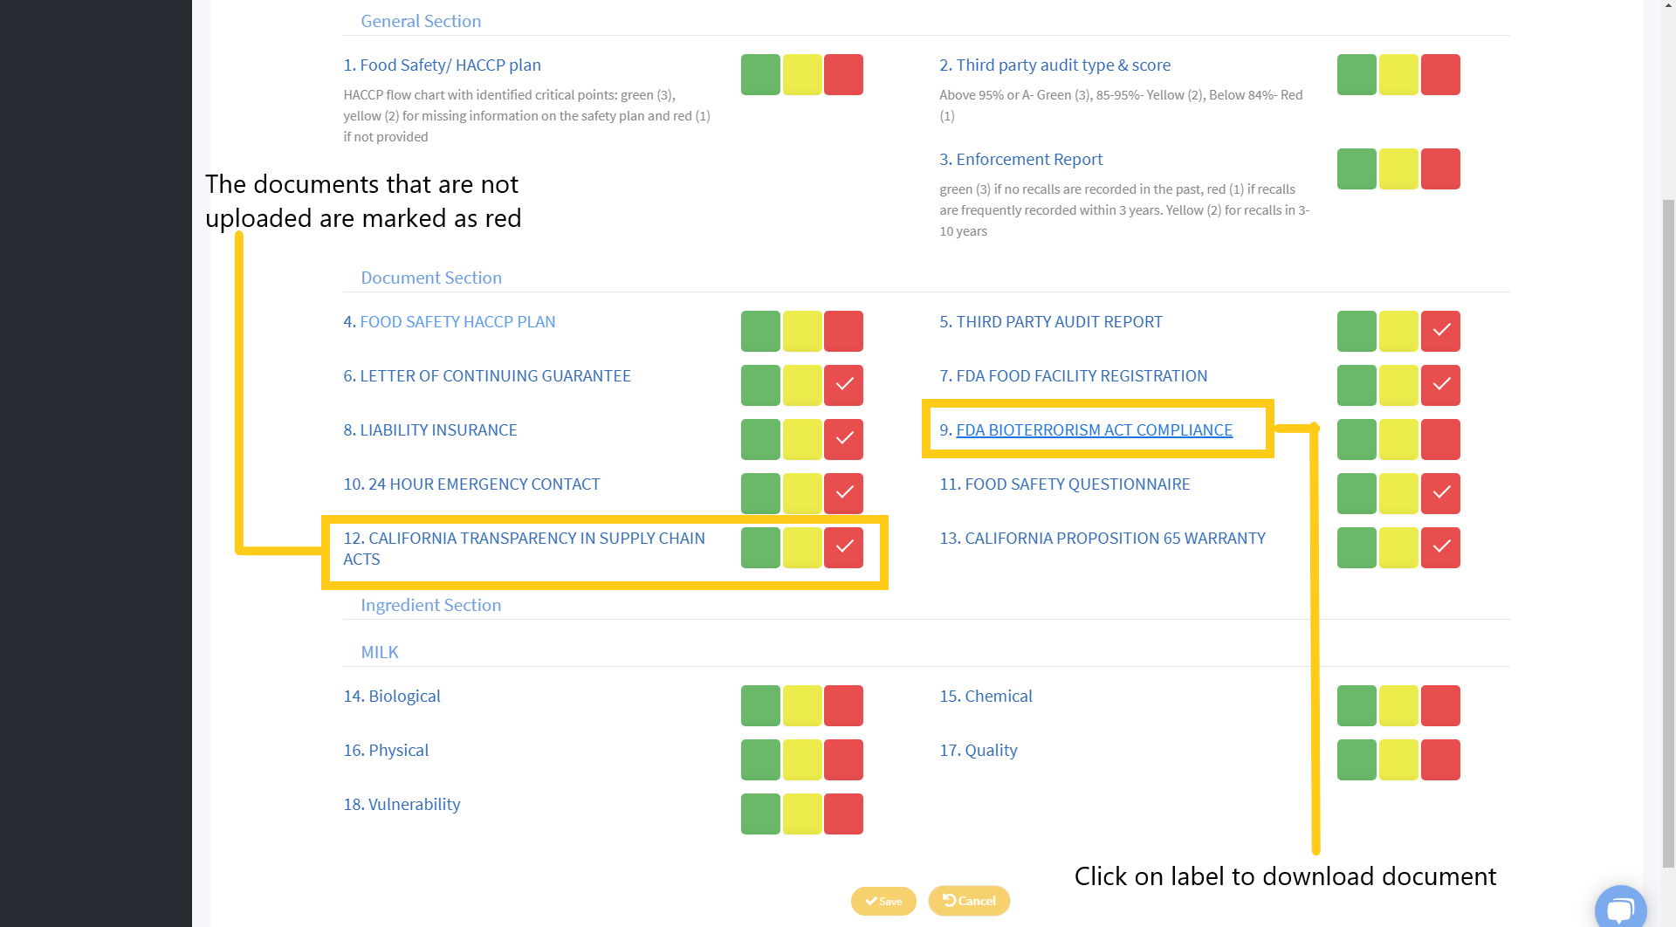

Each scorecard contains the weightage of 33.33% and if any of the questioner after being scored gets the weightage less than 20% than it goes in the section “In Progress Pending Reviews” otherwise it gets completed. if the scorecard goes for further review than it needs to be reviewed by the working committee, this team can see the previous scores given against each question and will be asked 4 new questions whose answers will be whether Yes or No and will be required to give some comments against the scorecard. If any of the questions answer is yes than it means the Facility Visit is needed.

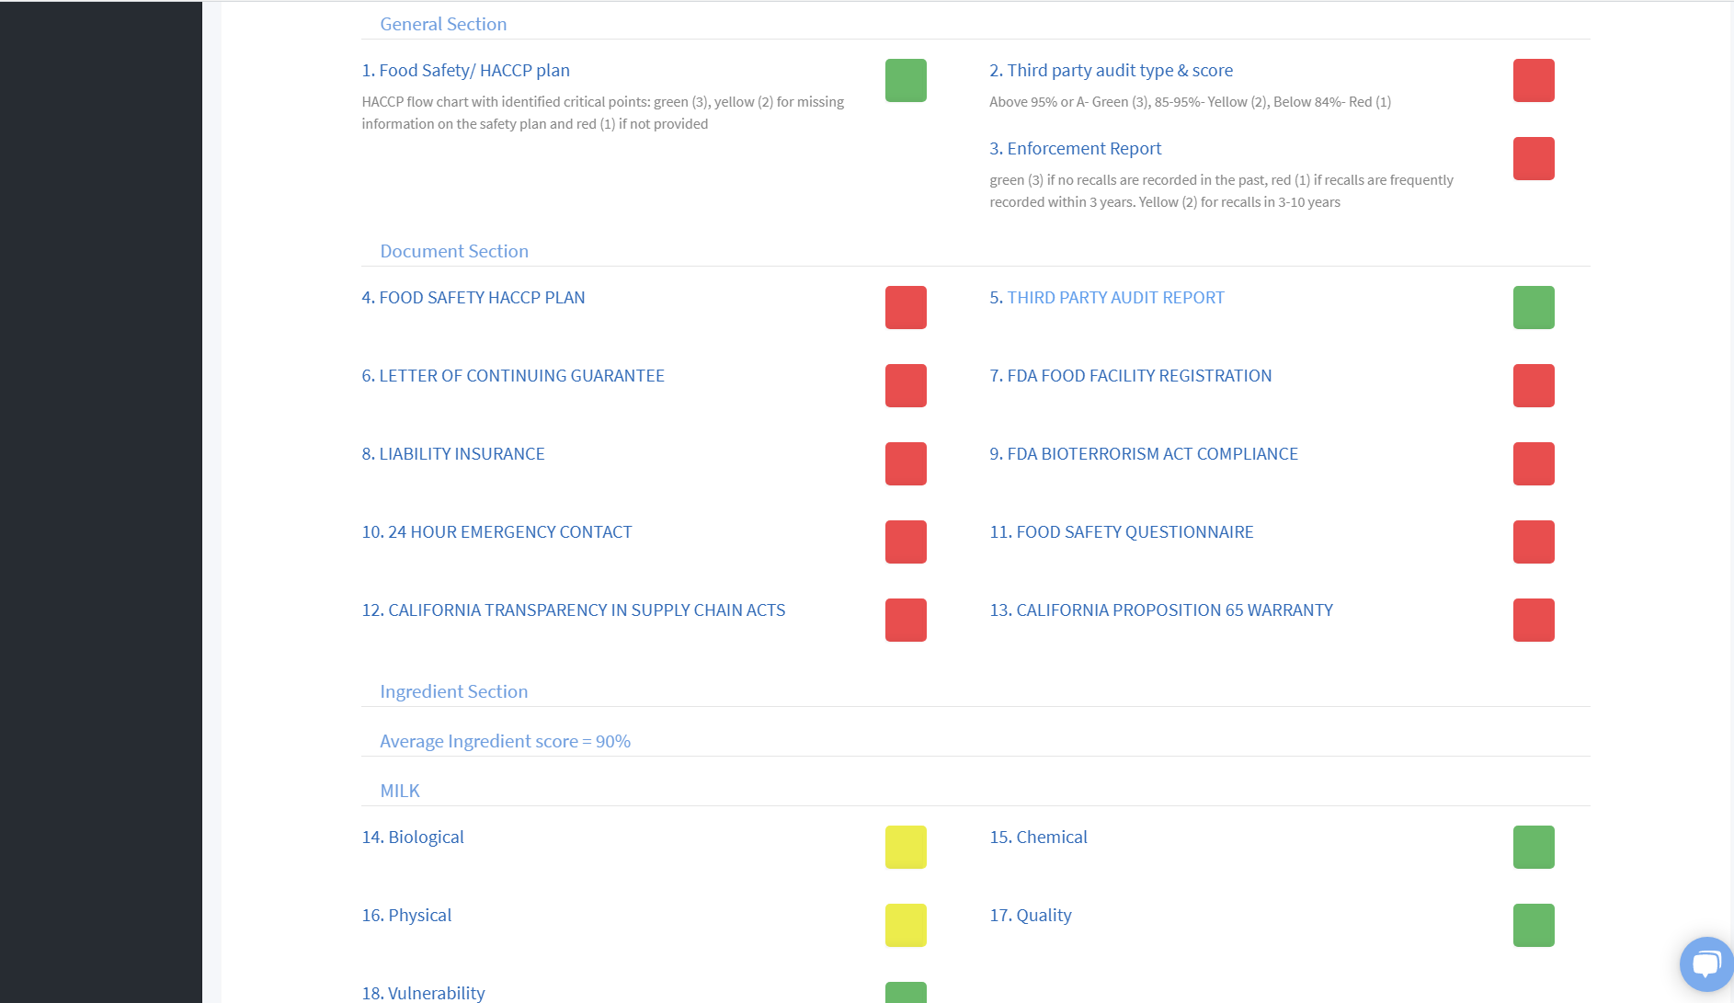

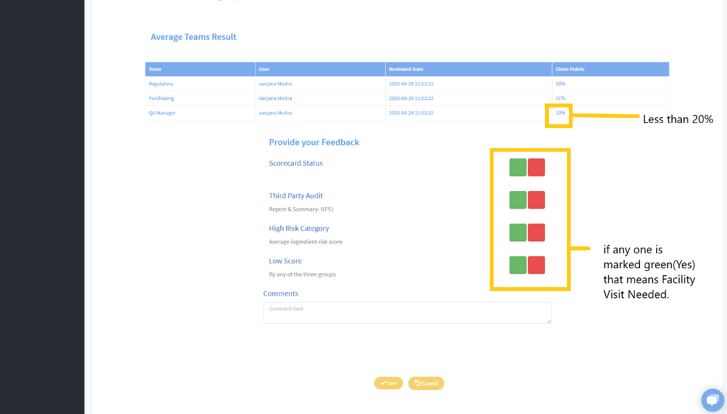

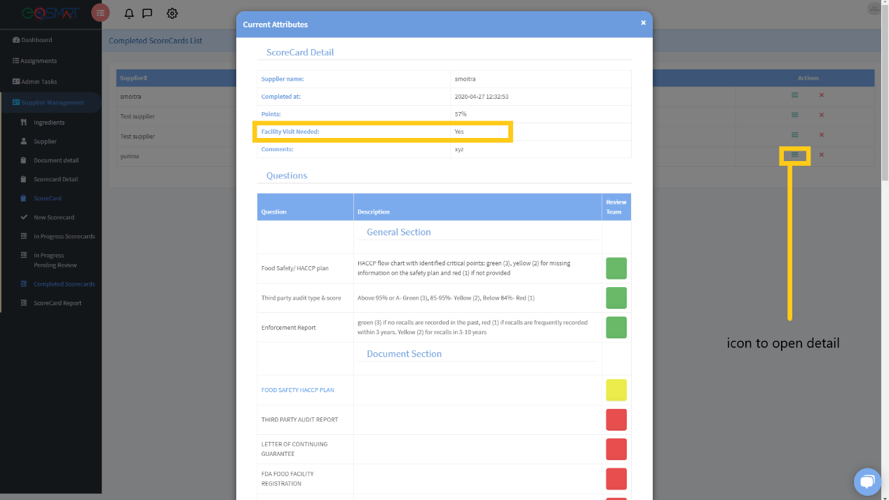

You can also see the scorecards filtered by date and supplier on the Scorecard History tab. It also represents the scorecard graphical representation by the scoring.

On the dashboard you can see 4 pie charts that represents that the scorecards are separated on different weightage criteria and the last one represents the scorecards that needs the Facility Visit