**Revision needed from test 3**

1. If a supplier documentation isn’t uploaded, the score should automatically select Red

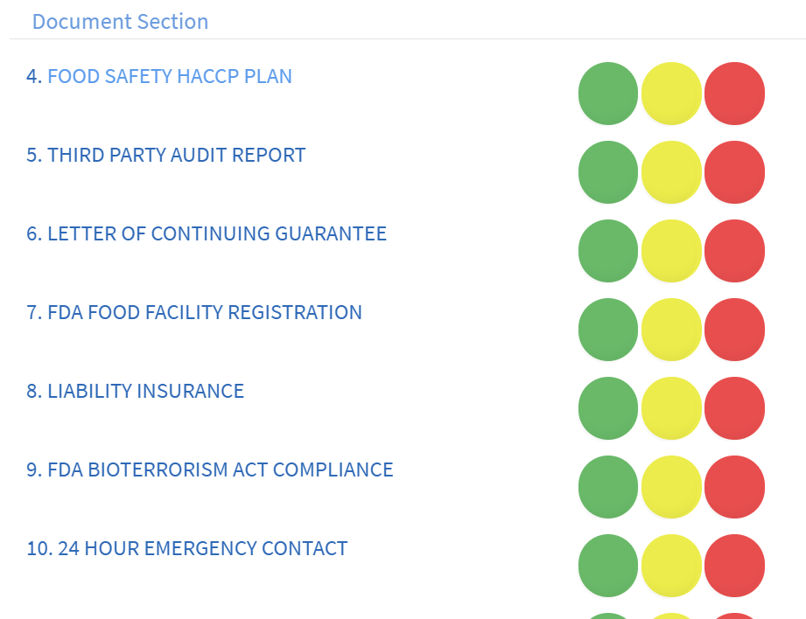

1. Scoring criteria should be reflected below each parameter for ingredient score.

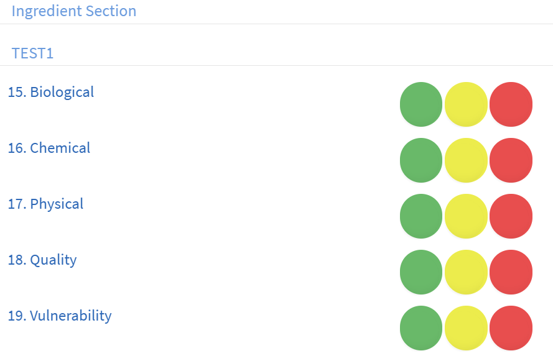

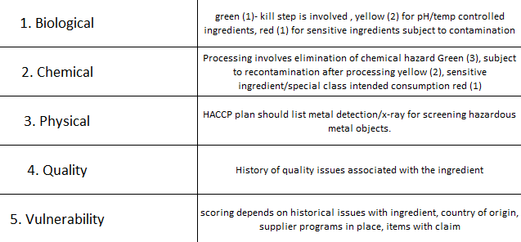

1. Supplier should be able to access both ingredient & supplier section where they can upload supplier documentation & each ingredient information. See below

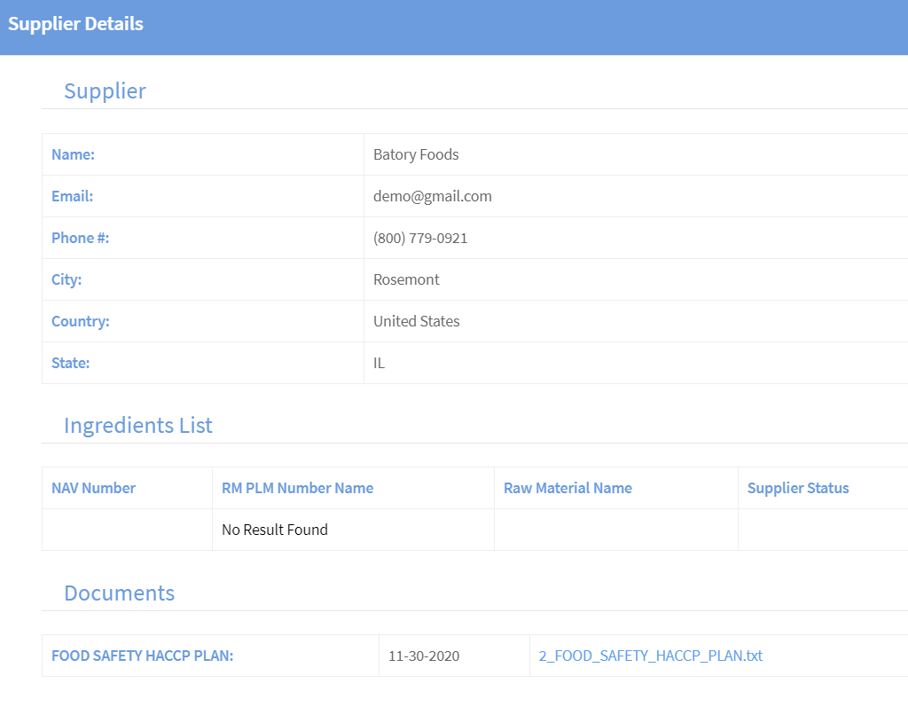

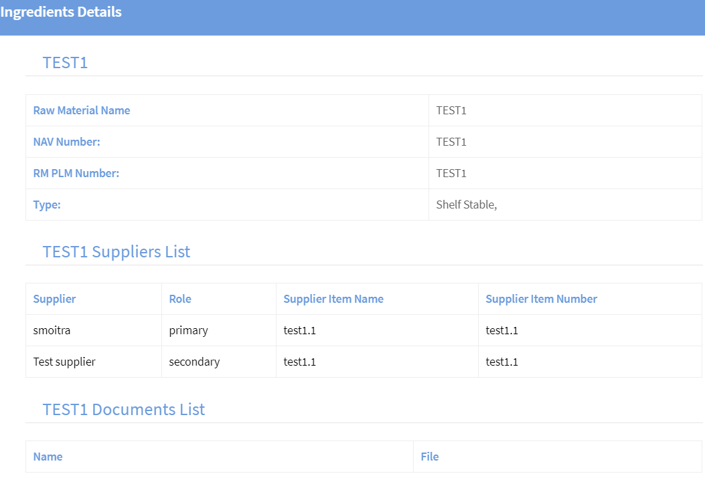

Supplier should be able to categorize each ingredient out of these 4 categories- shelf stable, produce, dairy, meat category and upload COUNTRY OF ORIGIN, SAMPLE COA, PRODUCT SPECIFICATION to each assigned ingredient- Documents are created under document detail for each category.

1. Average ingredient score should be reflected for each supplier under in-progress pending review for working committee. They shouldn’t be able to score/give feedback for each parameter again rather just view scores provided by 3 groups

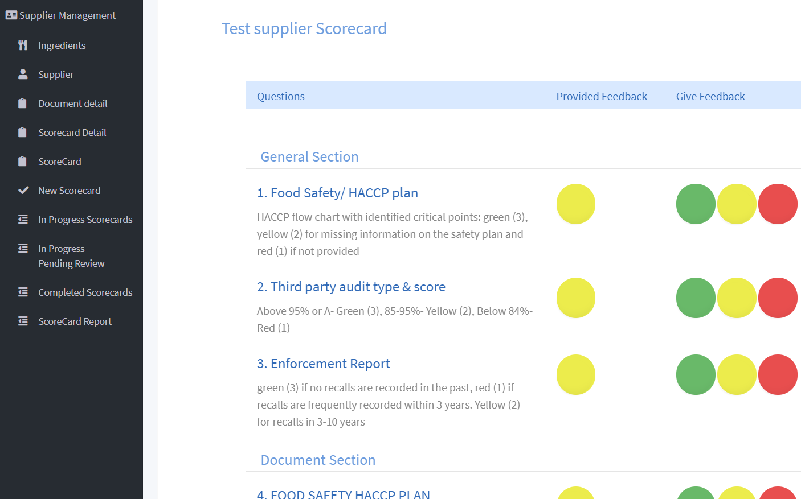

**Test 4**

1. **Change in workflow**

Below changes are needed in the workflow. The scoring will be done by 3 groups- Regulatory (33.33%), Purchasing (33.33%) & QA (33.33%) collectively holding 100% weight. If the score of any of the 3 teams lie below 20%, only that supplier will be sent for working committee approval.

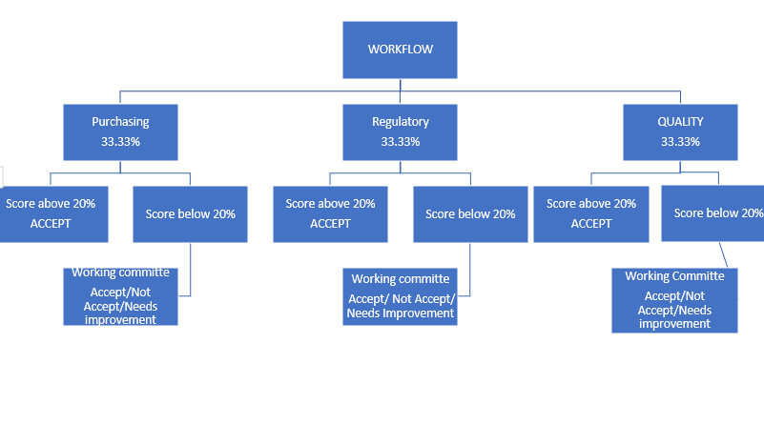

Ex. ***Approved: Score provided by all 3 teams is more than 20%*** (will not go for working committee approval)

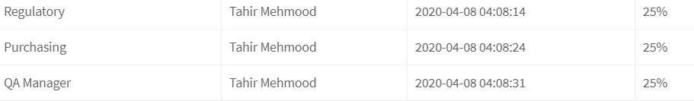

***Not Approved: Score provided is less than 20% for any of the teams*** (whole scorecard summary will go for working committee approval)

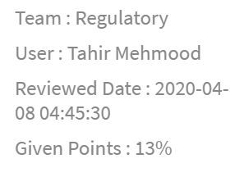

1. **New working committee scoring criteria**
   1. Working committee should receive only those scorecards for approval, whose *score is less than 20% for any of the team*. They should be able to see all results provided by regulatory (including average ingredient score), purchasing & quality and provide either *ACCEPT/NEEDS IMPROVEMENT/NOT ACCEPT (green/yellow/red)* along with a place to provide comments.
   2. Create trigger to escalate to Working committee when food safety audit is missing from QA section. Some other critical triggers might be provided by other groups during UAT.
   3. An added parameter to be completed by working committee is-

*FACILITY VISIT NEEDED- YES OR NO*

This will be based on answers to the below 3 parameters by working committee: If any of these parameters reflect yes, FACILITY VISIT NEEDED should be YES and reflected on a separate criterion on dashboard.

|  |  |  |  |
| --- | --- | --- | --- |
| **No.** | **PARAMETER** | **DETAILS** | **YES/NO** |
| 1. | THIRD PARTY AUDIT | REPORT & SUMMARY-GFSI |  |
| 2. | HIGH RISK CATEGORY | AVERAGE INGREDIENT RISK SCORE |  |
| 3. | LOW SCORES | BY ANY OF THE 3 GROUPS |  |

1. The completed scorecard section will only show all approved supplier’s scores by 3 groups- Regulatory, Purchasing & QA and the ones approved by working committee.

*This will include a scorecard summary capturing all scoring by 3 groups, comments (by working committee, if any) & facility visit is needed or not.*

However, only 3 groups will reflect final scores out of 100%

