**Edge Specification Review**

**Main Details:**

* Countries where sold should be USA, Region should be All Stores, unless this is a specialty itemcompleted

**Recipe and Raw Materials:**

**Recipe Tab:**

* Each of the individual stabilizer ingredients should be listed on their own as 1a, 1a, 1acompleted
* Does Unsalted Butter have subcomponents? No
* Chicken in row 13 may be listed as Chicken Sausage Crumbles since it has subcomponents and does not need to be selected from the drop down list Not moving forward with this item
* Is the Chicken used in the Poultry Sausage ABF/Raised w/o antibiotics? Not moving forward with this item
* Are the eggs from free range chickens, cage free, humanely raised, grass fed? No

**Allergy and Dietary Advice:**

**Additional Information Tab:** I see that you selected No for disclosure for Bioengineered ingredients. Do you confirm that your sugar is cane sugar and not beet sugar? If so, we require a statement on your company letterhead stating that the ingredients used have not been bioengineered and the Wegmans brand items do not require disclosure. USDA items with egg as the first ingredient is exempt from disclosure

**Suitable For Tab**: Complete all fields for label claims.

All Wegmans Brand products must be Suitable For and Declared Food You Feel Good About. The criteria for this has been sent to your team for review. Do you not support? If you do, please revise to Yes for Suitable for and Declared. FYFGA okay to use for all 4 items per Wegmans specs.

**Nutrition:** *(If any changes are made, always remember to* ***Re-Calculate Nutrients and Declarations****)*

* Complete the section using 100 gram data for best accuracy completed
* Confirm the packaging requires linear format and won’t fit a full table yes
* Select the Facts Upfront Key; our design team will determine if this should be utilized Please explain
* Can we make a protein claim on these items? Are they a complete protein? (PDCAAS = 1)
  + If yes, %DV Calculated based on: Select 2,000 Calorie Diet + Protein […] and enter the protein digestibility (we don’t make any claims, only protein & total sugars call-out in front)
* Added Sugar is noted as 0 grams per 100 grams as this was entered per serving, but the recipe contains sugar. Enter the 100 gram value to confirm no added sugars in product

Please note:  Edge is not a nutritional database, but a data collection program.  We do find that our %DV can often differ from those of our suppliers as it is Wegmans best practice to take a conservative approach with rounding rules.  It is imperative for you to understand that our QA, regulatory, and design teams only reference the information in Edge and do not reference attachments.  Should your data vary slightly from EDGE, please support the design of the Nutrition Facts Panel based on Edge values. If you do not, you may consider adjusting the 100 gram values ever so slightly to see if you can get Edge in agreement with the values you will support.

**Finished Product Standards:** updated

**Product Attributes Tab**: This section should be completed with the utmost level of detail to fully describe the product and its attributes without even seeing the product. Since I have not actually seen the product myself I question the following:

Appearance: Include the color and shape of the muffin, are there any spices or cheese visibly present, is the chicken sausage a topping on the muffin or throughout, what color is the sausage?

Aroma: is egg the only aroma?

Texture: will the sausage be soft and fluffy?

Color: are any spices visible?

Size/Shape: What shape is muffin shaped/what are the dimensions/diameter/thickness

**Chemical Standards Tab:**

* Units, Method of testing (ie. include AOAC method), and the Frequency of testing (ie. every hour, every lot, every day) are all required fields. Not performed
* These items contain Salt. Is that something you test for? no
* Do you test for Fat, Protein, or Moisture? no

**Microbiological Standards Tab**:

* Method of testing (ie. include AOAC method), and the Frequency of testing (ie. every hour, every lot, every day) are all required fields. Not performed

**Storage:** Indicate the format of the Best By code (Shelf Life field) MM/DD/YY HH:MM

* Complete the minimum shelf life into Wegmans if applicable 30
* Use the Free Text Box to complete details on the method of implementing lot code and location on package (ie. Jet code on back panel) as well as any other Batch details included completed

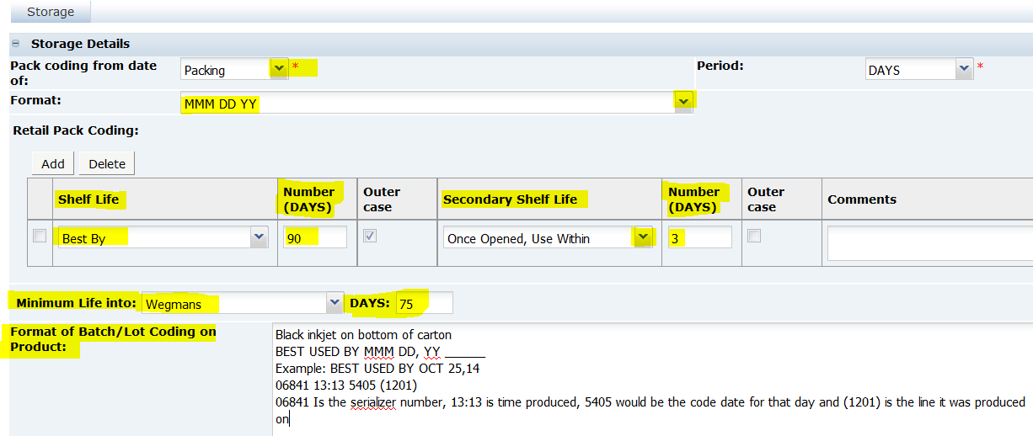

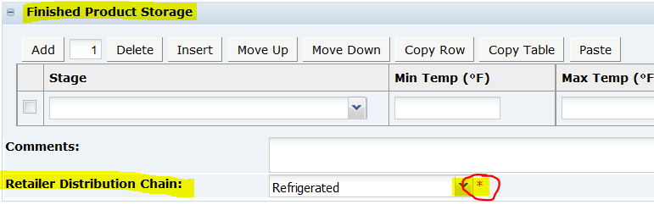

**Packaging:**

**Packaging Components Tab**:

* Specification Sections: Provide thickness & dimensions for each component. Note any opening instructions, tear notches, cut here, etc as applicable; Note color of tray Done.
* Is all of the packaging recyclable? Which component utilizes Triangle 7? No, only the label is recyclable as 7 ‘other’.

**Other Labeling Copy:**

**Front Panel Statements Tab:** *Logo:* Wegmans Logo, since no set standard of identity, need description as noted in Edge “Fluffy mini muffin...”,

*Icon/Flashes:* must include FYFGA Banner, Facts Upfront Key:

1. USDA Red Meat icon with EST.22102 inside (couldn’t find under options),
2. include Gluten Free logo with url
3. Recommend Marketing claim: Cooks in 90 seconds

Cook Thoroughly, etc. please include: “Perishable. Cook Thoroughly.”

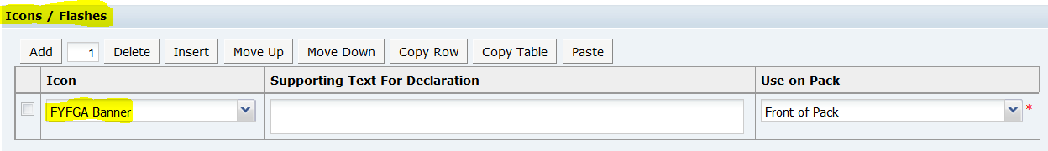

*Nutrition Claims:* Enter as appropriate: Excellent source of protein; Low Sugar; No Fat, etc. (none used) recommend calling out XXg Protein per Tray, Xg Sugar per Tray,

*Safety & Warning Phrases and Environmental/Recycling Phrases*: Complete as necessary,

Is this item considered Ready to Eat or Ready to Cook? Not ready to eat. Cooks in 90 sec, need a statement on variability of microwaves and cooking time.

Does this require a cook to 165° statement? Yes

*Other Icons:* This should be “Wegmans Family Statement” for Use on: Back of Pack changed

**Cooking & Prep and Sub Copy Options Tab:** Wegmans Internal Use Only

**Usage/Storage Tab:** Please enter Statements accordingly completed

**Other Labeling Copy:**

Our design team requires a copy of the appropriate format for the Nutrition Fact Panel to be used, it can be marked “For Placement Only” if the data does not exactly match that in Edge. Would this be the linear format? Yes, Linear Display for small format. I’ve added the diagram per CFR to Edge, also included Country Style Sausage as example of label design and location on back of pack. but will be applicable for Sausage item.