**Revision needed- Test 5**

1. Clicking on each circle should list only those suppliers below (instead all are listed together)

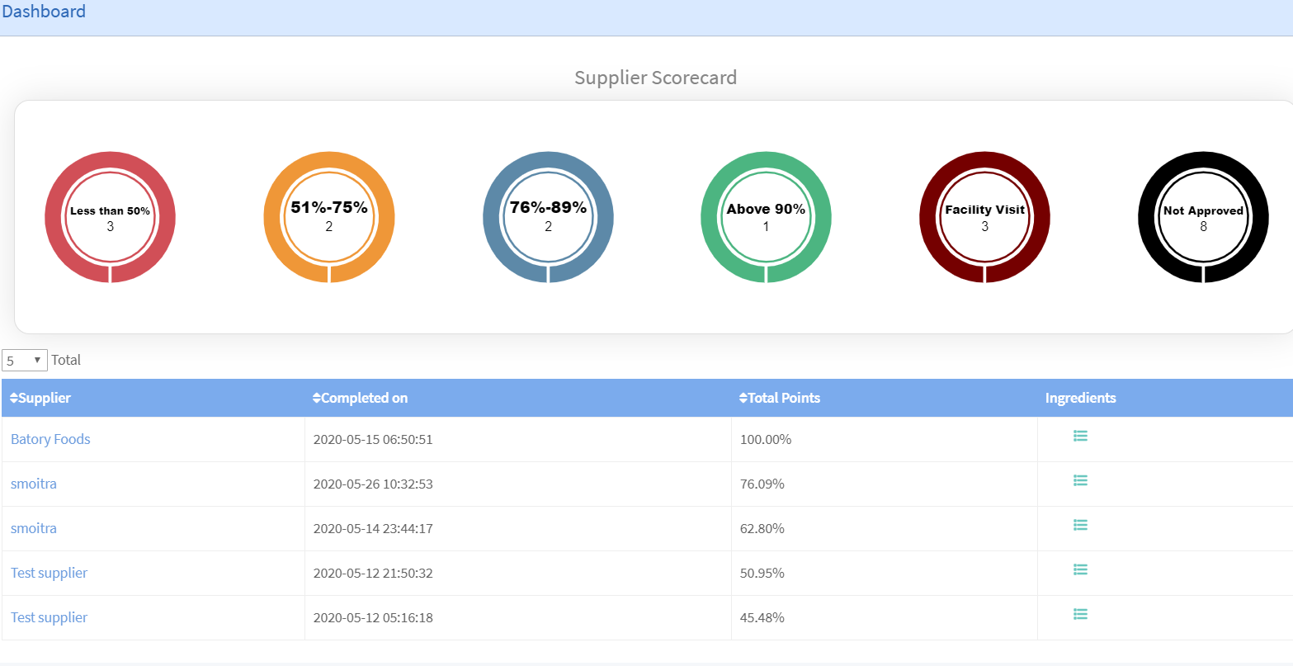

1. Email which supplier receives should list “You have been Registered at EQ smart as a Supplier **by Valley Fine Foods”**

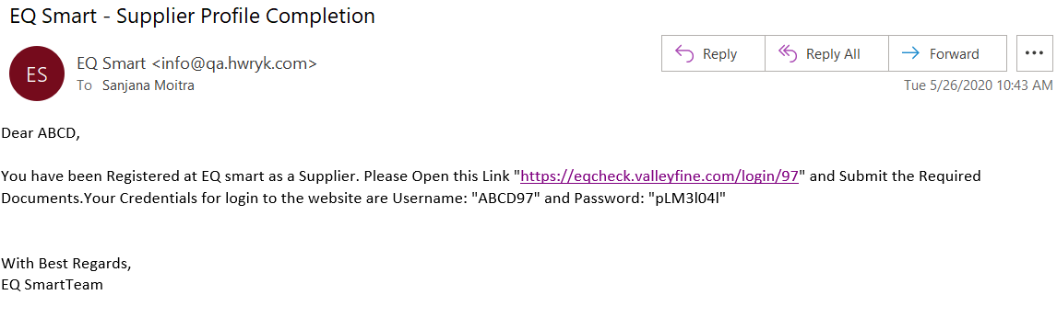

1. Option to select supplier type should given to only Supplier & not Admin

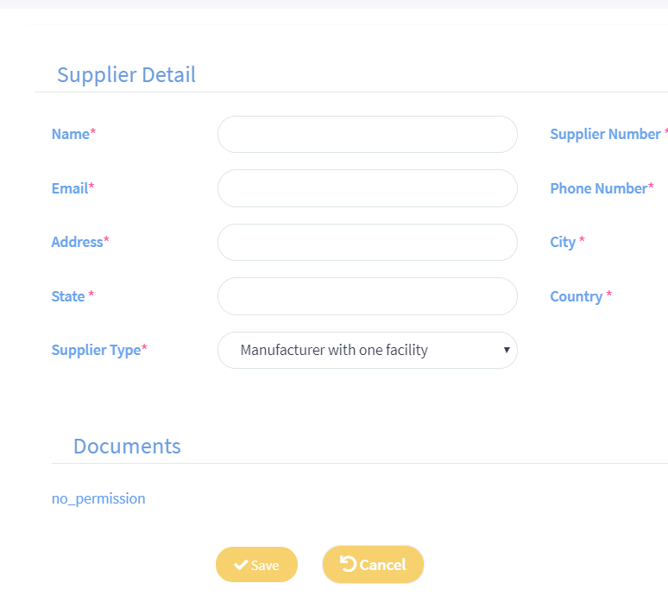

1. Supplier should be able to select type and then the documents will be requested in manner described in Test 5. Since all are mandatory documents, do not categorize them separately. Please utilize the document test 5 points 3 & 4

