DSI_lecture_28_visualization_3

Overview of reproducibility
- Explore why reproducibility in data visualization matters
- Understand why reproducible data visualization practices are both ethical and practical
- Discuss practices we can implement to make our data visualizations reproducible
Case study: image manipulation
- In 2016 a research article showing the effectiveness of a particular molecular compound as a potential cancer treatment was published will cell staining images used to support the authors conclusions
- A microbiologist noticed that certain features of the published images contained problematic duplications at minor points in the background
  - Areas enclosed in same coloured boxes show signs of deliberate duplications and if the images were manipulated can we still trust the authors conclusions?
  - 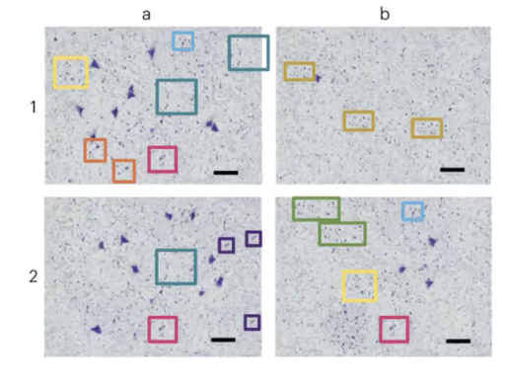
- Dr. Biks work spotting manipulated figures and images in scientific publications has led to 172 retractions and more than 300 corrections
  - She and her colleagues have examined over 20k biomedical publications and found over 3.8% contain problematic figures and that numbers of these figures are rising
Why is this important?
- Images and visualizations are often the best way to communicate our data and insights
  - But if we can’t trust that visualizations are representing the real data we can’t trust what their creators are trying to communicate
- So how can we ensure the visualizations we create are representing our data with integrity
Reproducibility
- Reproducible work is capable of being checked because the data code and methods of analysis are available to other researchers
  - E.g. someone could repeat the steps we took to generate a particular result or image from our data
- The figures in the case study are not reproducible because they were made by an unknown third party using unclear methods
- Reproducibility of data is a hot topic across many contexts as increasingly a requirement for publications in academic research contexts
Reproducibility is ethical
- The American statistical associations ethical guidelines for statistical practice state that good statistical practice is fundamentally based on transparent assumptions, reproducible results and valid interpretations
  - Recall from last class that visualizing data means making decisions
  - Reproducibility helps to hold us accountable for those decisions
Reproducibility is practical
- Making data visualization reproducibly is practical as well as ethical:
  - It makes it easier to make changes if we have to edit a plot or images weeks/months after its creation
  - Helps us to draw on previous work to make new graphics more easily
  - Useful for version control because we can see where we made changes
NOTE:
- The ability to reproduce a results does not necessarily indicate correctness, nor does the inability to do so mean a result is incorrect
  - But science is incremental: its only through transparency and by enabling reproducibility that scientific knowledge evolves
How can we make our data visualization reproducible?
- We need to do as much work on our figures as possible programmatically
  - E.g. make our images in code as much as possible so its easy to trace changes and data sources
- Code should be written in a simple plain-text format, not in a word processor
  - Ideally our pretty final products can be procedurally and reproducible generated just by running our code
Comment your code
- When others want to look back at the code we used to make our data visualizations, comments can help us make sense of what choices were made and why
- Comments make code easier to understand, maintain, and update
Overview
- Make modifications to plots using matplotlib including:
  - Legends
  - Annotations (text, shapes and labels)
  - Axis labels
  - styles
Code
- import packages and setup random data first
- adding a legend
  - we have to add a label argument to each plot object
      - e.g. ax.plot(x, ya, label = “Person 1”
    - we also need to call “legend” and specify our legend location
      - e.g. ax.legend(loc = “lower right”)
        - location can be best or any combination of center, left and right
  - we can also customize other parts of the legend like:
    - add a frame
      - e.g. ax.legend(loc = “lower right”, frameon = True)
    - specifiy font fize
      - e.g. ax.legend(loc = “lower right”, fontsize = 12)
    - specify number of columns
      - e.g. ax.legend(loc = “lower right”, ncol = 2)
    - add shadow
      - ax.legend(loc = “lower right”, shadow = True)
- moving the legend outside of the plot area
  - we can position the legend outside of our plot by specifying legend location as before
  - and specifying where we want to anchor that location on our figure using bbox_to_anchor
    - e.g. ax.legend (bbox_to_anchor = (1, 1))
      - in this case the number point to coordinates in the axis coordinate system of the plot area or axis (it goes from 0 to 1, 0, 0 = bottom left, 1-1 = top right)
- text and annotations with the text() function
  - to add text use:
    - ax.text(x, y, “string”)
      - x and y indicate the coordinates of the text
- modifying text annotations using arguments
  - ha = “string”
    - indicates text horizontal alignment
      - can be center, left or right
  - color = “string”
    - indicate color
  - size = x
    - indicates size of text
- there are other ways to position text annotation
  - just now we used the coordinates of data points
  - if we want our annotation linked to a fixed spot we can locate it at a specific location on our axes or the figure itself using axis or figure cooridnates
    - start by making a simple set of empty axes
      - ax.axis([0, 10, 0, 10])
        - this is just an empty set of axes with values on x and y ranging from 0-10
    - then we can position our annotation with reference to the data (like before), the axes that we just specified or the figure
- annotating with errors
  - we can uyse the annotate() function to annotate with arrows and text (e.g. to focus at a specific point)
    - we have to specify the location to point at and the location where we want our text
  - we do this using
    - ax.annotate(“string”, xy = (10, 95), xytext=(20, 94), arrowprops=dict(facecolor=’black’)
      - xytext = position of text
      - xy = datapoint arrow points too
- modifying arrows
  - we use the arrowprops arugment to adjust our arrow style and color
    - matplotlib documentation described possible arrow styles https://matplotlib.org/3.1.1/api/_as_gen/matplotlib.pyplot.annotate.html
      - e.g. arrowprops = dict(arrowstyle = “string”, color = “string”)
- customized axis labels
  - we can remove tick marks or labels from our axis like so:
    - use a locator to remove ticks and labels
      - e.g. ax.x/yaxis.set.major_location(plt.NullLocator())
    - use a formatter to remove only labels
      - e.g. ax.x/yaxis.set.major_formatter(plt.NullFormatter())
- limiting tick marks
  - we can also define a maximum number of ticks we want on our axis
    - ax.x/yaxis.set_major_locator(plt.MaxNLocator(x))
      - in this case x in MaxNLocator refers to the maximum number of ticks we want
- tick mark intervals
  - we can set tick marks at a particular interval (e.g. every 5 numbers on an axis) using MultipleLocator
    - e.g. ax.x/yaxis.set_major_locator(ply.MultipleLocator(x))
      - in this case x in multiplelocator is how frequent we want our tickes to be (for example x=5 means a tick every 5 units of the xaxis)
- rotating axis tick mark labels
  - to rotate axis labels and horizontal alignment use xticks()
    - e.g. (full new line) plt.xticks(rotation=x, ha=’right/left/center’)
      - x = degrees of rotation
      - ha = which side of the label is attached to the tick mark?
- Modifying axis title fonts
  - Remember we specify fonts as a dictionary
    - E.g. font1 = { ‘family’: serif, ‘color’: ‘indigo’}
  - Then we apply this to our labels
    - E.g. plt.xlabel(“string”, fontsize = x, fontdict = font_dict_name)
Styles coding
- Styles are a convient way to change many aesthetic dimensions of our plots at the same time
  - To view available pre-made style use:
    - Plt.style.available
  - To use a style type this before you make a figure
    - Plt.style.use(‘style_name’)
Reproductibility in research FAIR principles
- The FAIR (finability, accessibility, interoperability, reusability) principles were first produced to improve the stewardship and management of research datasets
  - They have since been adopted into numerous disciplines
    - Findability = your data is easily found
    - Accessibility = the data can be accessed in a clear and controlled way with clear access conditions and staple repositories (e.g. github)
    - Interoperability = we use standard formats or common vocabularies so its easy for others to use with other softwares
    - Reusageability = data can be reused for future studies (clear license with sufficient documentation)
- There are various checklists that can help you assess whether your dataset is ‘FAIR’;
  - The original can be found here
  - 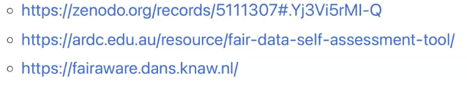
Reproducibility vs replicability vs reusability
- These terms are often used inconsistently or as synonyms which they are not
- Reproducibility and reusability are complementary
  - For someone to be able to reproduce your work it needs to be fair (i.e. they have to be able to find it, access it, ‘read’ it, and reuse it)
- Reproducibility vs replicability
  - Reproducibility is obtaining consistent results using the same input data; computational steps, methods, and code and conditions of analysis
  - Replicability is obtaining consistent results across studies aimed at answering the same scientific question each of which has obtained its own data
Data practices and context documents
- Data practices are “what and how data are collected managed, used, interpreted, reused, deposited, curated and so on”
- Context documents are interventions deisnged to accompany a dataset or ML model allowing builders to communicate with users
  - Our data design and visualization design decisions can be captured in context documents
    - They are essentially templates for documenting data design and visualizing design decisions
Datasheets for datasets
- Datasheets are a type of context document
  - They allow us to document all the processes we went through when developing a dataset. Its motivation, composition, collection processes, recommended uses, etc
    - These same processes can be used for documenting visualizations
  - Datasheets can facilitate connections between underlying data and final analytical products (in this case, images and figures)
- Example
- 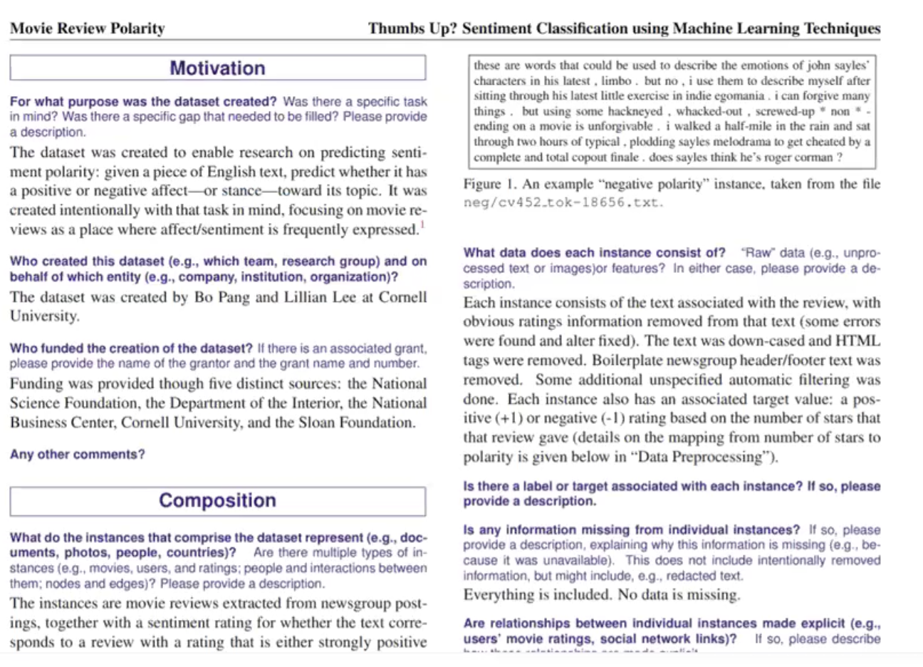
  - Motivation section
    - This section describes for what purpose was the dataset created, was there a specific task in mind, was there a specific gap to be filled?
    - Who created this dataset and on the behalf of which entity
    - Who funded the creation of the dataset
  - Composition
    - This section describes what each data instance represents, what datatypes are included, whether anything is missing from the dataset and whether instances are related
- Basically this lets us demonstrate the processes we went through to create a dataset, and we can do the same thing when creating our visualizations
activity recall
- using what we learned in lesson 1 can we make a plot with both variables on the same axis?

