DSI lecture 26 visualization 1

Learning objectives
- Why should we care about data visualization?
- What makes a good data visualization?
- Introduce a range of visualization software and tools that are used for data visualization and how to choose them
Case study: why care about data visualization
- We often think of visualization as a final presentation step, but the quality of visualization has a strong impact on how well we can communicate the results
  - Often the best way to communicate insights from data is in visual format
- Regardless of AI generating code we still need to know how to evaluate whether a visualization is clear, accurate and appropriate for the message we are trying to communication, and how to guide the AI to make the best plots for our purpose
- 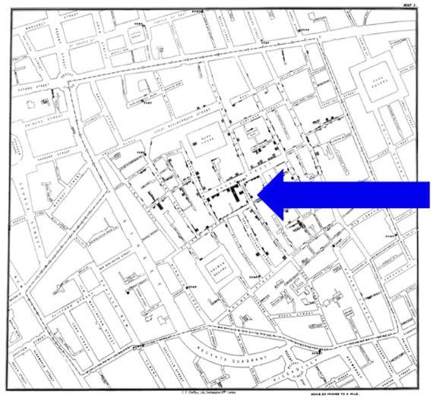
  - This is a map showing cholera deaths during a pandemic in 1854
  - The black bars mark locations where death occur with height representing the number of deaths at a specific location
    - By plotting the deaths the physician noticed the deaths were concentrated around a water pump suggesting the disease was spreading through that pump
      - By removing it he slowed the outbreak (this is one of the earliest epidemiological application)
- 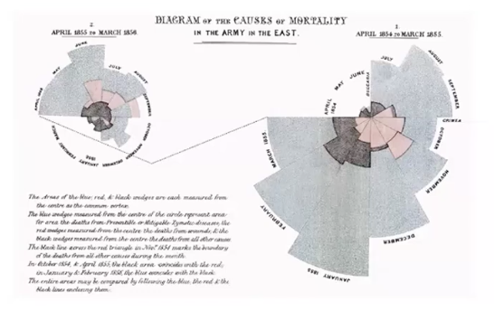
  - This visualization shows soldiers deaths due to wounds in battle (pink), other causes (black) and disease (blue)
    - It was used to advocate for prioritizing nutrition and other factors
    - Area of the block shows deaths per month which a breakdown for causes
  - The second diagram on the left shows deaths in the second year after hospital reforms
- Things we care about for visualization:
  - Good to look at
  - Message we are trying to convey is accurate
  - Whether there are any confusing parts
So why visualization information?
- The cholera outbreak diagram lets us see data in context getting insight into the underlying cause of the disease
- Nightingales rose diagram presents an argument and advocated for hospital reforms
- Napoleons Russian campaign diagram tells a really good story via data visualization
But sometimes its not that simple to design a good visualization: challenger disaster
- In 1986 the space shuttle challenger exploded 73s after launching chilling everyone
- The explosion occurred because hot propellant gases burned through rubber seals on the shuttles riht solid rocket booster
  - For months before up until the launch there were concerns about the rubber rings (o-rings) but the launch proceeded anyways
- In 1997 edward tuft published a visualization showing the relationship between temperature during launches of test shuttle flights and incidents of damage to O-rings
- 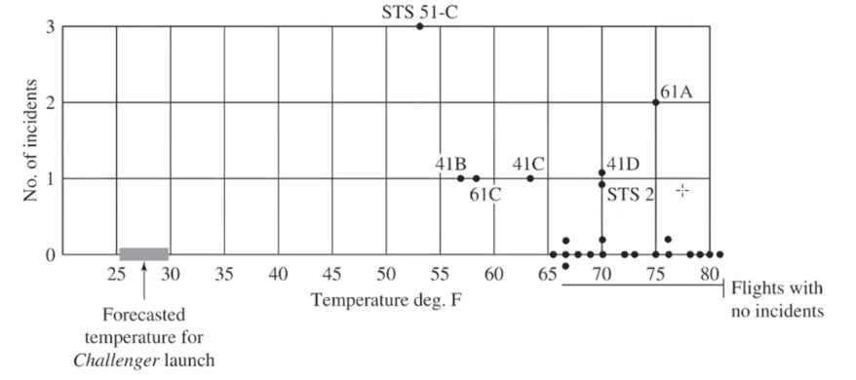
  - Each dot is 1 shuttle flight and were launched mostly at 65-80 degree and had a few incidents
    - Look at where the forecasted temperature for the challenger launch, its super low which suggests the launch temperature was unusual and notice O-ring incidents increase as temperature increase
      - By launching at lower temp than the tested flights nasa caused the disaster
  - Tufte argued engineers responsible for data visualization failed to represent data that might have saved the crew and this is a common test factor
    - The accuracy of his data has been contested
      - According to tuft the challenger disaster is case where good data visualization could’ve saved lies
      - According to robson variables were correlated in a misleading way leading the audience to unjustly place blame
Activity
- Look at the following examples of data visualizations and consider:
  - Is it pleasing to look at
  - Does it accurately represent data
  - Can we understand the message the visualizations maker is truing to convey
  - Consider factors like colour, size, use of images, is this good or not?
- 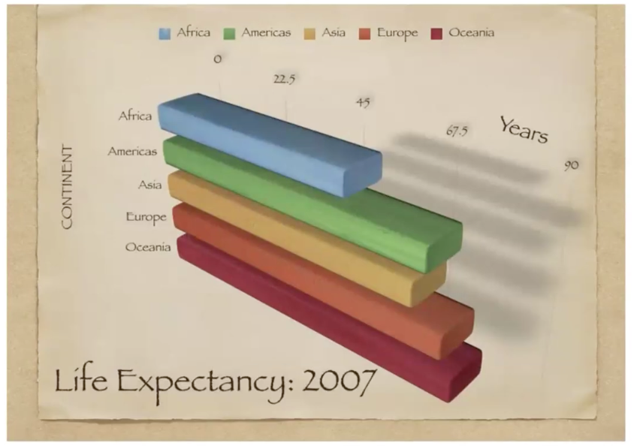
  - Not pleasing to look at, the angling is weird
  - It does represent the data “accurately” but more numbers on the x-axis are needed to full convey the data and the angling makes it harder to interpret than necessary
  - Yes I can understand the message its showing which continents have the greatest life expectancy and explicitly pointing out the massive difference between Africa and all others
  - The colors contribute nothing, the use of images is weird (shitty angle) and size is fine… I really hate the angling and shadows though
- 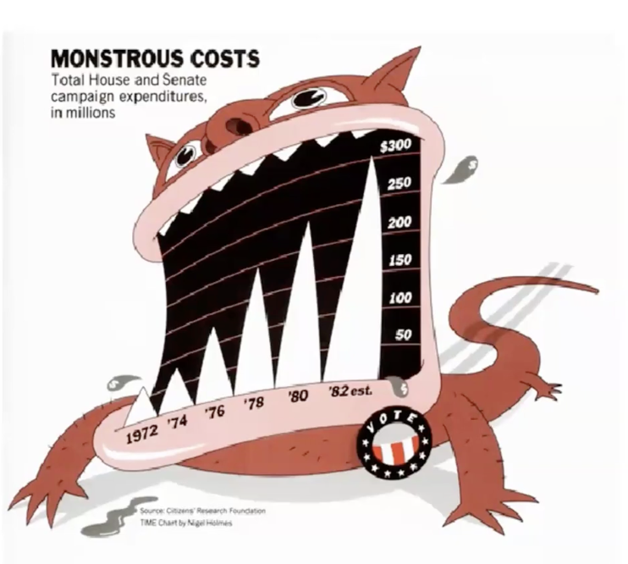
  - Terrible to look at (3d format and distracting monster)
  - Data is hard to interpret due to 3D and the peaked nature of the bars
  - The message is conveyed (massive increase in campaign expenditures over 10 years), but I’m not sure who its criticizing
  - No axis labels
  - Scale is not clearly indicated
- 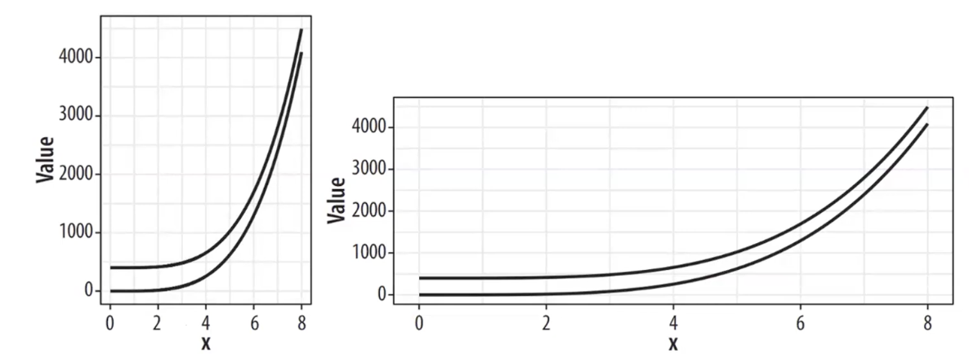
  - Both are fine to look at (right is better)
  - Message changes based on aspect ratio (sharp vs flow decrease)
  - What is the x axis??? I have no clue
  - There is no source so I don’t know about accuracy
  - It needs a title
  - What is it comparing?? Maybe it should have a legend
- 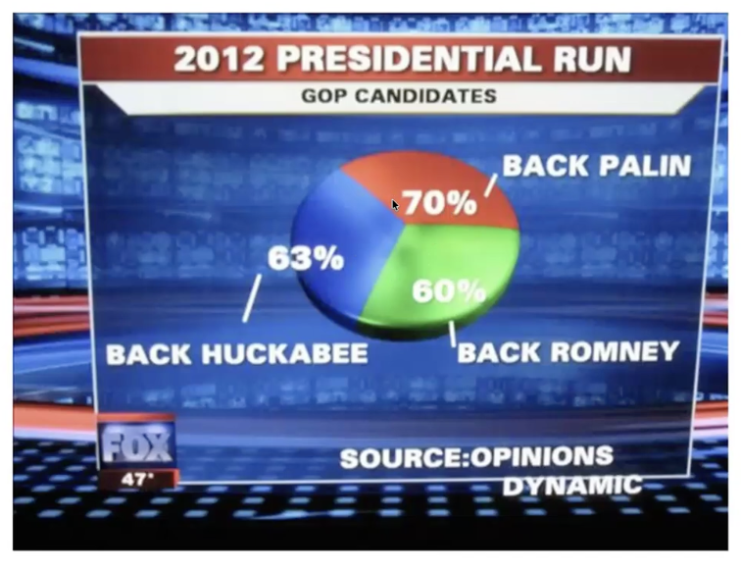
  - Sum is greater than 100% so accuracy is bad
  - Not pleasing to look at (the effect and 3D is ugly), pies are the same size…
  - Overall very confusing and the source is opinions????
- Each of the questions correspond to an important quality of data visualizations
  - It is pleasing to look at (aesthetic)
  - Does visualization accurately and honestly present data (substantive)
  - Can we understand what message the maker of the visualization is attempting to convey (perceptual)
- We need to consider all of these qualities when evaluating and designing “good” data visualizations
What data visualization is
- Data visualization is dependent on:
  - Context where and how our visualization will be used
  - Audience who is intended to use our visualization
  - Data structure what information does our data capture
What data visualization is not
- Its not hard and fast rules for every situations its about making thoughtful decisions related to our situation
What tools are used for data visualization?
- Excel
- 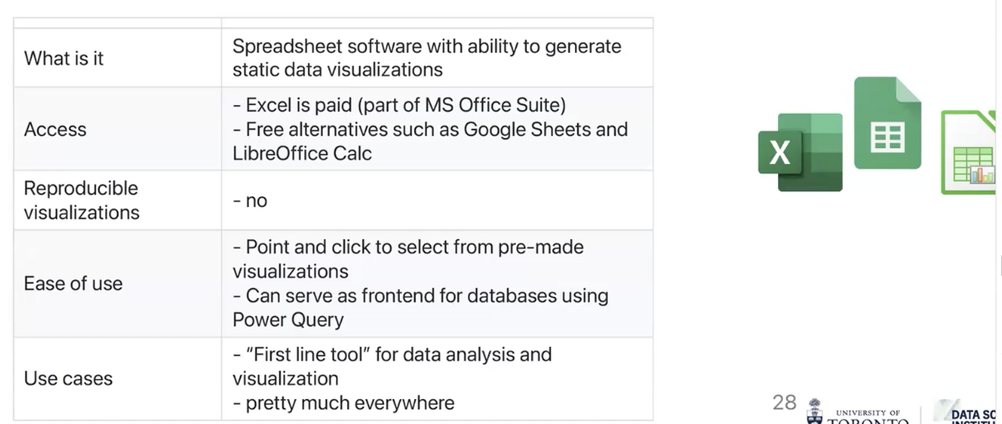
  - Easy to use, connects well with databases through power query but not reproducible
- Power BI
- 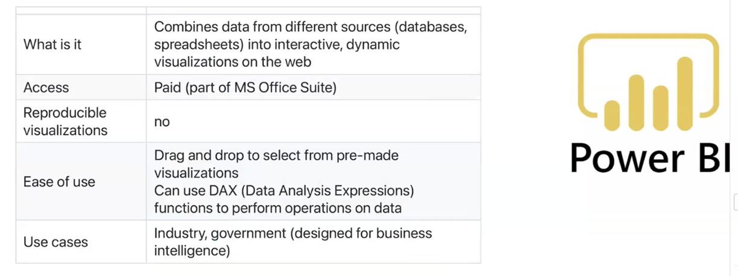
  - Used for interactive dynamic visualizations on the web, with drag and drop
  - Isn’t reproducible due to the interface
  - Has DAX functions allowing for more advanced data analytics
- Rstudio
- 
  - Is reproducible because it’s a programing language and is widely use, but requires some coding knowledge
  - Free and open source
- Python
- 
  - Reproducible because it’s a programming language, is widely used but requires some coding knowledge
  - Free and open source
- Tablue
- 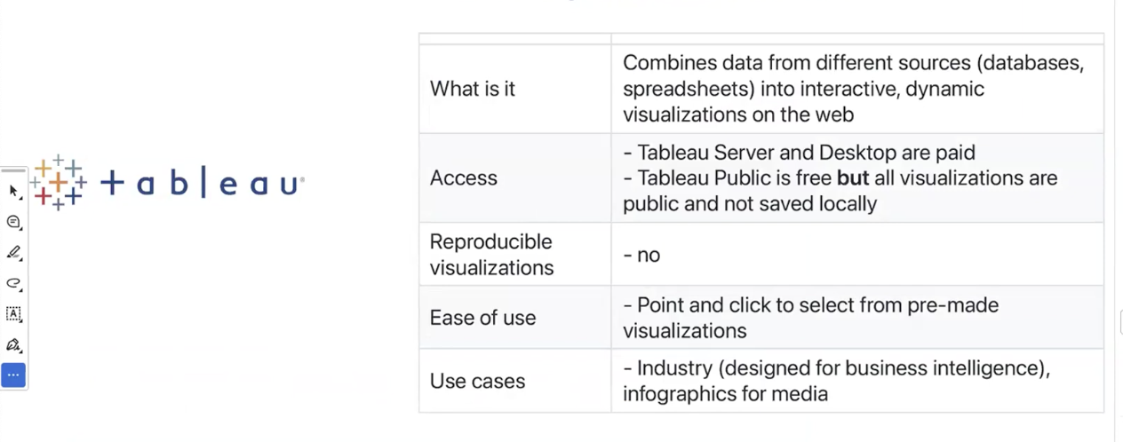
  - Also easy to use with a point and click interface and is very popular in industry for creating interactive/dynamic visualizations
- Some tools are better suited for some situations
For our purposes
- We will do step by step walkthroughs focused on python (matplotlib package) which we chose because:
  - Its free
  - Its commonly used
  - Its reproducible
  - There are lots of available resources online
- Remember
  - General design principles will apply to creating data visualizations regardless of which software we decide to use
Learning outcomes:
- Create and customize data visualizations start to finish in python
- Use general design principles for reating accessible and equitable data visualization in python and other software
- Use data visualization to purposely tell a story
Slidedeck 2 overview
- Learn about matplotlib
- Produce our first data viz in python
- Begin to modify elements of our data viz including
  - Colour
  - Line type
  - Marker size
What is matplotlib
- Its an open source package for data visualization in python
- It was developed in 2003 and has lots of features for visualization
How does matplotlib work?
- In matplotlib a figure is like a container holding a set of axes
  - The axes is our actual plot or graph
- A figure can hold multiple axes (like subplots)
- Every visual elements of our plots (colour, legends, axis titles, scales and text) is called an artist and belongss to an axes not a figure
- 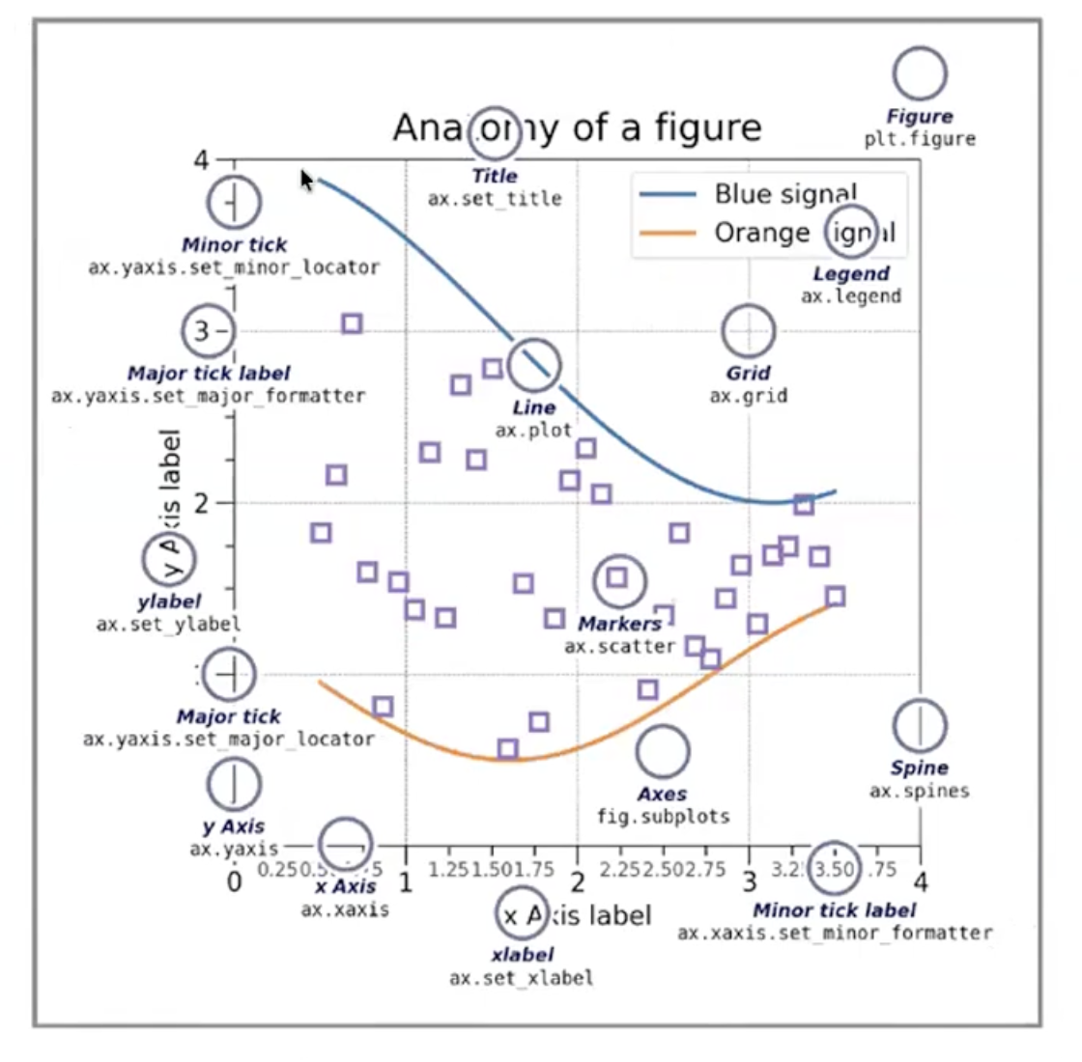
  - So heres our general canvas containing a figure (everything is a figure)
    - Then we have one subplot that’s the actual plotting area with different color legends and so on and so forth
  - The actual plot inside the figure is out axes (not the same as x and y axes)
- So matplotlib automatically creates 1 figure and the axes object
Making a figure with matplotliv
- First import libraries
- import numpy as np
- import matplotlib.pyplot as plt
- import pandas as pd
- import scipy
- import PIL
- import requests
making a basic figure with matplotlib
- lets make some sample data so we have something to plot
  - first set our random seed using:
    - np.random.seed(x)
  - then use the numpy arrange functions here to generate integers from 0-49
    - x = np.arrange(50)
      - remember it starts from 0 to 50 is actually 0-49
  - then randomly generate integers from 0-99
    - y = np.random.randint(0, 100, 50)
      - numbers 1-2 specify range
      - number 3 specifies number of random integers
- then we make our basic scatterplot
  - fig, ax = plt.subplots(figsize=(5, 3))
    - subplot creates the plots
      - this function creates 2 objects at the same time (comma lets us unpack them separately)
        - object fig
          - refers to the figure object (whole canvas)
            - so if we have 2 subplots both are within the figure
        - object ax
          - refers to the axes object (actual plotting area)
    - figsize=(x, y)
      - specifies the size of the plot with
        - x = width (in inches)
        - y = height (in inches)
  - ax.scatter(x, y)
    - .scatter() makes a scatter plot
    - X and y are just our input data
- Now lets try modifying our graph
  - We can keep our figure and axis definition the same but edit the type of graph by changing
    - Ax.scatter(x,y) ax.bar(x, y)
      - This if for a bar graph
    - Ax.scatter(x,y) ax.plot(x, y)
      - This is for a line plot
    - Ax.scatter(x,y) ax.hist(y)
      - This is for a histogram
        - We only input 1 variable because a histogram only graphs 1 bariable
  - *we need to recreate the figure and axis object to not overlay the 2 axes
Plot labels
- To add tables we can add labels to the axes or figure
  - To labels the axes use
    - Ax.set_title("string”)
    - Ax.set_ylabel("string”)
    - Ax.set_xlabel("string”)
- Fig.tight_layout()
  - This function automatically adjusts spacing in the figure if you have multiple plots, and margins to axes labels and titles fit
Modifying labels and titles
- We can modify label and titles appearance by using font dictionaries
  - First make a dictionary with the properties we want for our labels
    - Font1 = {‘family’: ‘sans-serif’, ‘color’: ‘blue’, ‘size’: ‘20’}
    - Font2 = {‘family’: ‘monospace’, ‘color’: ‘green’, ‘size’: ‘40’}
      - Family is the key that specifies font
      - Color is the key that specifies color
      - Size is the key that specifies size
  - Then we specify these dictionaries when setting text
    - Ax.set_title("string”, fontdict = font1)
    - Ax.set_ylabel("string”, fontdict = font2)
    - Ax.set_xlabel("string”, fontdict = font2)
- We can also specify the location of the labels using the loc function
    - Ax.set_title("string”, fontdict = font1, loc=’left’)
      - Loc specifies how the label aligns with the margins of the axes
Customizing plot appearance
- We can remake our basic scatterplot but add color and marker arguments
- fig, ax = plt.subplots(figsize=(5, 3))
- ax.scatter(x,y,
    - marker = ‘*’,
    - color = ‘indigo’,
    - )
  - color specifies colors
  - marker specifies shape of datapoint
- we can add specific functions for lineplots
  - fig, ax = plt.subplots(figsize=(5,3))
  - ax.plot(x ,y, linestyle = '--', linewidth = '2')
  - linestyle lets us format lines
  - linewidth lets us specify the width of the lines we add
- fig.show()
  - this function shows the figure (this happens automatically in juptyr but not in pure python scripts)
modifying data ponts: color
- we can modify colour using named colors (matplotlib website)
- or we can use numeric hex codes
  - fig, ax = plt.subplots(figssize=(5,3))
  - ax.plot(x,y,marker=’*’, color=’#xxxxxx’, linestyle = ‘--’, linewidth = x)
- we can also modify the color of marker:
  - edges
    - markeredgecolor = ‘code/color’
  - facecolor
    - markerfacecolor = ‘code/color’
- we can also modify the size of the marker
  - markersize=x
grid lines
- we can add grid lines to our axis object using .grid()
  - ax.grid(axis = ‘y’)
- then we can modify features of the grid including
  - color
    - color = ‘string’
  - linewidth
    - linewidth = x
  - linestyle
    - linestyle = ‘line’
