DSI_lecture_27_visualization2

Learning objects
- Explore how to choose the right data visualization for a given situation
- Explore ch3 (on rational, scientific, objective viewpoints from mythical, imaginary, impossible standpoints)
- Discuss how ideas of neutrality and objectivity apply to data visualization
- Understand how different elements and types of data visualization and generally perceived and use this understanding to decide what kind of visualization we should use for a particular situation
Review how does matplotlib work
- A figure is like a container that holds a set of axes
- The axes is our actual plot/graph
- A figure can hold multiple axes (like subplots)
- Every visual element of our plots, colour, legends, axis titles and scales, text is called an artist and belongs to an axes
Review making a figure with matplotlib
- Create a figure container and one axes (subplot) inside it; store them in fig and ax
  - Fig, ax = plt.subplots(figsize=(5, 3))
- If we color the fig object red and the ax object green, we get the following result:
  - 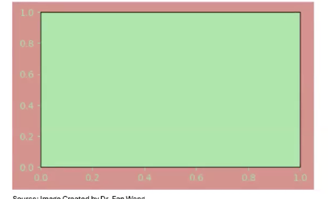
  - 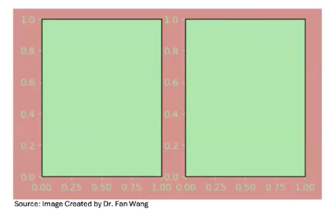
    - This is another example, rembmer
      - The figure = the entire canvas (red) that contains everything
      - The axes = each individual green thing
- So far we have learned how to make and modify different types of data visualization
- How do we decide which of these types of data visualization to use and when?
- If we are accurately and honestly displaying our data does the type of visualization even matter?
How do we choose the right visualization activity?
- We will explore 2 data visualization each showing similar datasets with different techniques
- For each visualization discuss the following questions:
  - What information can we learn from this visualization?
  - Is this an example of objective, neutral data visualization? Why or why not?
- 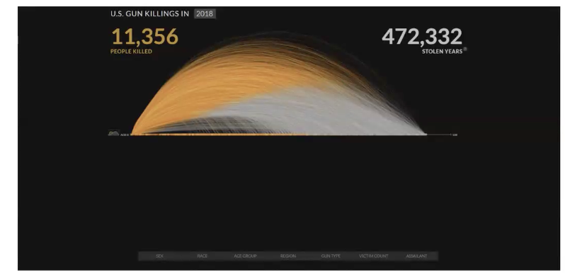
  - We can learn
    - The number of gun killings
    - Age of victims
    - Estimated difference in total lifespan due to gun violence
  - Objectivity and neutrality
    - Its not fully objective because its voluntarily reported gun homicide, doesn’t include suicides and is inconsistent with coroner reports
    - Its also trying to project lifespan
    - Its definitely made for a specific reason so its not truly neutral
      - It emphasizes a sense of loss and the visualization has been criticized as actively shaping data to support a cause
- 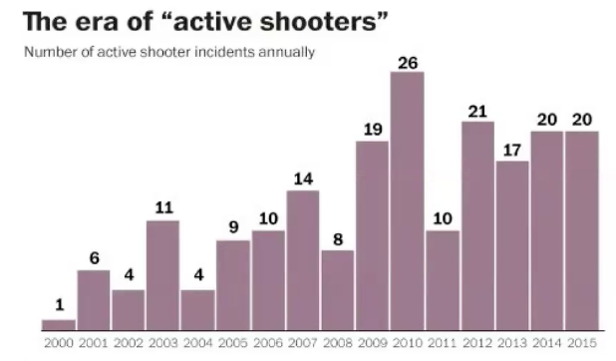
  - We can learn number of active shooter incidents annually
  - A change in the distribution of active shooters over time (seems to be increasing)
  - I think it is pretty neutral, it aims to convey information clearly and concisely and also actively promotes its source
    - This plot is intended to present a deliberately neutral emotional field letting viewers choose their own response to the info
  - Some terms need to be clearly defined (e.g. active shooter)
What qualities of visual 2 help it be neutral
- No emotional words
- Neutral color palate
Can data visualization be neutral?
- Short answer is NO!
  - “the constraints of truth leave a very wide space for interpretation”
Data visualization as rhetorical objects
- Rhetoric is the act of communicating effectively and persuasively
  - that is, we make choices about how to visualize our data so these visualizations are not neutral
    - but, data visualizations can be factual without being neutral
- data visualization is an interpretative, rhetorical act and that’s not necessarily a bad thing but is it one we should be aware of
recall
- three important qualities of data visualization
  - aesthetic does it look nice
  - substantive is that data accurately and honestly presented
  - perceptual can we understand what message the maker of the visualization is attempting to convey?
- Two data visualizations can share the same substantive qualities while, intentionally or not, being perceived completely differently
- When we are aware of the choices we make while creating data visualizations we can design data visualizations that are suited to the situation at hand (perceptual qualities) without sacrificing honesty and accuracy (substantive qualities)
What do we want our data visualization to do
- When visualizing data we need to think about the intended purpose of the visualization, consider:
  - Persuading
    - This means we try to use the visualization to convince the audience of a claim or viewpoint
  - Comparison
    - This means we try to use the visualization to compare 2 things such as values or groups
  - Evaluation
    - This means we try to use the visualization to judge performance against a target/benchmark/criteria (e.g. which model performs best)
  - Exploration
    - This means we try to use the visualization to explore questions
- We also need to consider our intended audience
  - Age
  - Education
  - Expertise
  - Accessibility
- We need to consider the intended medium
  - Print
    - For paper visualization should have thicker line and no tiny visuals as well as legible for grayscale if possible
  - Web
    - For a website we consider screen size, pixels and resolution
  - Poster
    - For a poster we should consider how visible is that graph? Can you read labels from far away?
  - Presentation
    - For a presentation we should consider whether the presentation is virtual, in-person, image resolution, will it be okay if blow up on a projector?
Dataset types and visualization
- Before choosing a visualization its key to identify the datatype because different data types naturally map to different chart families. There are 4 basic types:
  - Tables
    - In this case there are different items across different rows with columns as different attributes
      - E.g. a spreadsheet of students with columns for “age”, “major”, “department”
    - Typicially this is done with a:
      - Bar chart
      - Line plot
      - Scatter plot
  - Networks
    - In network dataset there are different items denoted as nodes and the dataset is trying to describe the relationship between different nodes and relationships are the main point of these datasets
  - Fields
    - Fields have a value defined over a continuous space and are often sampled on a grid (e.g. 1 value per grid coordinate)
      - A example dataset could be temperature over a region
    - Typical visualization =
      - Heat map
      - Surface plot
      - rasterplot
  - geometry
    - in geometry there are objects with coordinates and different shapes described in the dataset
      - e.g. country boundaries, cities, roads etc
    - typical visualization include:
      - maps
      - cartograms
        - spatial position is part of the meaning and matters a lot here
  - multidimensional tables

  - trees
    - e.g. a family tree, a decision tree or a file system
- identifying the attribute types for our data also helps us make choices about how to visualization it
  - datatypes can include:
    - items (individual values)
    - attributes (column names)
    - links (in a network)
    - positions (hierarchical or spatial)
    - grid coordinates
  - attributes also have their own types:
    - categorical (e.g. categories)
    - ordinal (e.g. ordered)
    - quantitative (measureable/numerical)
  - attributes also have ordering directions
    - sequential (low to high)
      - e.g. age
        - we can visualize this with one way gradients like increasing bar lengths, light color to dar color
    - diverging (e.g. profit or loss, temp above/below average)
      - we can use 2 different colors schemes centered at a midpoint to represent this
    - cyclic (e.g. time of day, month of year)
      - we can use a circular layout or color map to describe the cyclic attributes
effective visualization
- so effective visualizations depends on the purpose, audience and medium
- a good goal is to satisfy: “to find one of the many possible good solutions rather than one of the even larger number of bad ones”
  - 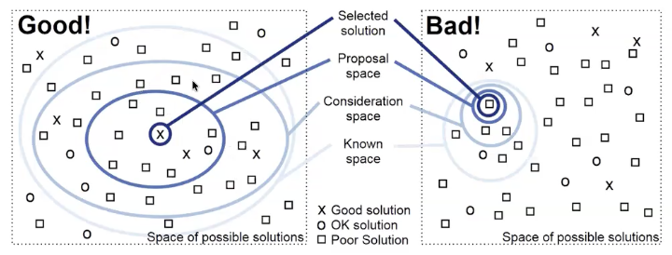
How is our data visualization perceieved
- We try to take advantage of cognitive psychology by learning how people tend to process information we can communicate more effectively with our graphs
  - For example there are a set of gestalt principles a thory of how people organize visual info and are commonly used in UX design and data visualization
- Gestalt principles:
  - Proximity
    - Objects that are close together are perceived as belonging to one group
  - Similarity
    - Similar objects are groups regardless of proximity
  - Contintuity
    - Aligned objects or objects that appear to continue are perceived as one group
  - Closure
    - Open structures are perceived as closed/complete (our brains fill in the gaps)
  - Enclosure
    - Objects with a boundary around them are perceived as a group
  - Connection
    - Connected objects are perceived as related/as a group
Cognitive load
- It can be helpful to consider cognitive load, the mental effort required to take in new info and can be devided into 3 types:
  - Intrinsic (intrinsic complexity of new information)
  - Germane (the audiences familiarity with the information)
    - E.g. sales chart is easy to interpret for financial professionals
  - Extraneous (complexity from how the information is presented)
- In a data visualization context, extraneous cognitive load is mostly within our control
- Elements of visualization that can affect cognitive load include:
  - Familiar vs rare chart types rare types increase cognitive load
  - Accurate vs approximate interpretation visualization like bar and scatterplots are easier and more accurate to interpret but charts relying on areas and angles require more effort
  - Concise vs detailed composition more visual elements increase cognitive load
  - Explanatory vs exploratory composition a chart that the audience navigates alone increases cognitive load compared to a chart we guide them through step by step (we can design charts to do this)
    - Exploratory = audience finds info themselves
Cognitive over memory
- Working memory is limited
- It better to show side-by-side views than using our memory
  - Do this when comparing different graphs because when having to remember stuff from another load cognitive load increases decreasing comprehensive ability
No 3D without cause
- Using 3D increases cognitive load so don’t use it unless absolutely necessary
  - It also reduces perceptual accuracy
Perceived factual basis
- Sociologists kennedy et al find that adherence to four conventions of data visualization reinforces the perceived objectivity and factual basis of a visualization:
  - 2D images
  - Clean layouts
  - Geometric shapes and lines
  - Inclusion of data sources at the bottom of the image
Provenance rhetoric
- Citing the sources of our data isn’t only the best practice but also helps people trust our data visualizations more
- Provenance rhetoric is the idea that the inclusion of a data source with our graphic signals transparency and trustworthiness to the audience
- This increases the persuasiveness of the visualization since viewers are more likely to believe what they see
Resources for choosing data visualization types
- Decision making tools
  - There are resources online that incorporate visualization purpose and cognitive principles into reference guides to help us decide the most suitable data visualization in a given situation
    - The data visualization catalogue is one
Assignment-2
- Assignment 2 is about judging whether visualizations are good or bad
  - Pick 2 online visualization, 1 good, 1 bad (they provide links to help you find them but you can use anywhere)
- For each visualization you explain why they are good or bad referencing materials we have covered so far
  - Just submit the markdown file named assignment_2.md
Activity: exploring matplotlib
- *add this into your coding files and save it (participation)
- visit the python graph gallery at https://python-graph-gallery.com/all-charts/
- Select one of the visualization types you find most interesting
- For your visualization choice
  - Copy the provided code and attempt to replicate the output in python (you may have to install packages
  - Recall the aesthetic substantive and perceptual qualtities of data visualizations. Does you visualizaiton of choice succeed in each area

