Github link: https://github.com/lantoallen/inventory-and-stock-management-system.git

1. Introduction
Our client is The Twelve Cafe. The cafe keeps track of its stock on two paper sheets: a raw ingredient inventory (Delivery, Beginning and Ending columns) and a production inventory for food prepared in the kitchen (Prod, Beginning, Out and Ending columns, with an assigned staff). Staff fill in the sheets by hand every day.
Because everything is done on paper, the cafe has these problems:
- The ending stock is computed by hand, so mistakes are common.
- There is no warning when an item is running low, so the cafe finds out only when a dish cannot be made.
- Expiry dates are not tracked, so perishable items such as salmon, shrimp and lettuce can spoil unnoticed.
- Waste and missing stock are not recorded separately, so the owner cannot see where stock went.
- Old sheets are filed away, so there is no easy way to look back at past days.
Our program, the Twelve Cafe Inventory and Stock Management System, is a Java desktop application that replaces the two paper sheets. It starts with the cafe's own item list (88 raw ingredients and 48 production items). Staff record what comes in and what goes out, and the program computes the stock, warns about low and expiring items, keeps a full history, and rebuilds the daily inventory sheet automatically.
After analyzing the problem, we included these transactions:
Transaction | What it does | Replaces on the paper sheet
Stock In | Records a supplier delivery (raw) or kitchen production (prepared) as a new batch, with an optional expiry date | Delivery / Prod column
Stock Out | Records stock used or served; the oldest batch is used first | Used / Out column
Waste | Records spoiled, dropped, burnt or expired stock with a reason | (not on the sheet)
Ending Count | Staff enter the physical count; differences are saved as adjustments | Ending column
Undo | Reverses the most recent transaction | Crossing out a wrong entry
Reports | Restock list, expiring stock, and the daily inventory sheet for any date | The whole sheet
Manage Items | Adds new items and changes an item's unit and reorder level | Rewriting the item list

To meet the requirements of the project, the program uses a queue (FIFO stock batches), a stack (undo), Merge Sort (all sorting), and Binary Search and Linear Search (finding items). All five were written by our group; the program does not use Java's built-in sorting, searching, stack or queue.

2. Program Design
The program is written in Java 17 and uses Swing for its window. The code is split into packages so that each part has one job. The screens (gui) only collect input and show results. All the inventory logic is in one class, InventoryManager, which uses our own data structures and algorithms. Data is saved to plain text files after every change.
Package | Classes | Role
twelvecafe | Main | Starts the program: loads the data and opens the window
model | InventoryItem, RawIngredient, ProductionItem, StockBatch, Transaction, TransactionType, StockStatus | The things the cafe keeps track of
ds | LinkedQueue, LinkedStack | Our data structures
algo | MergeSort, Search | Our sorting and searching algorithms
service | InventoryManager, FileStorage, SeedData, UndoRecord, ReportRow, ExpiringBatch | Business logic, saving and loading
gui | MainFrame, DashboardPanel, InventoryPanel, StockEntryPanel, EndingCountPanel, ReportsPanel, HistoryPanel, ItemsPanel, ItemPicker, UiKit, Refreshable | The window and its pages

2.1 Program Flowchart
Figure 1 shows the general flow. When the program starts, it loads the saved data (or the cafe's item list on the first run) and shows the Dashboard. The user then picks a page. Recording a transaction validates the input, updates the item's queue, logs the transaction, pushes an undo record and saves. Viewing a page searches and sorts the items. Undo pops the last record from the stack and restores the stock. This repeats until the program is closed.
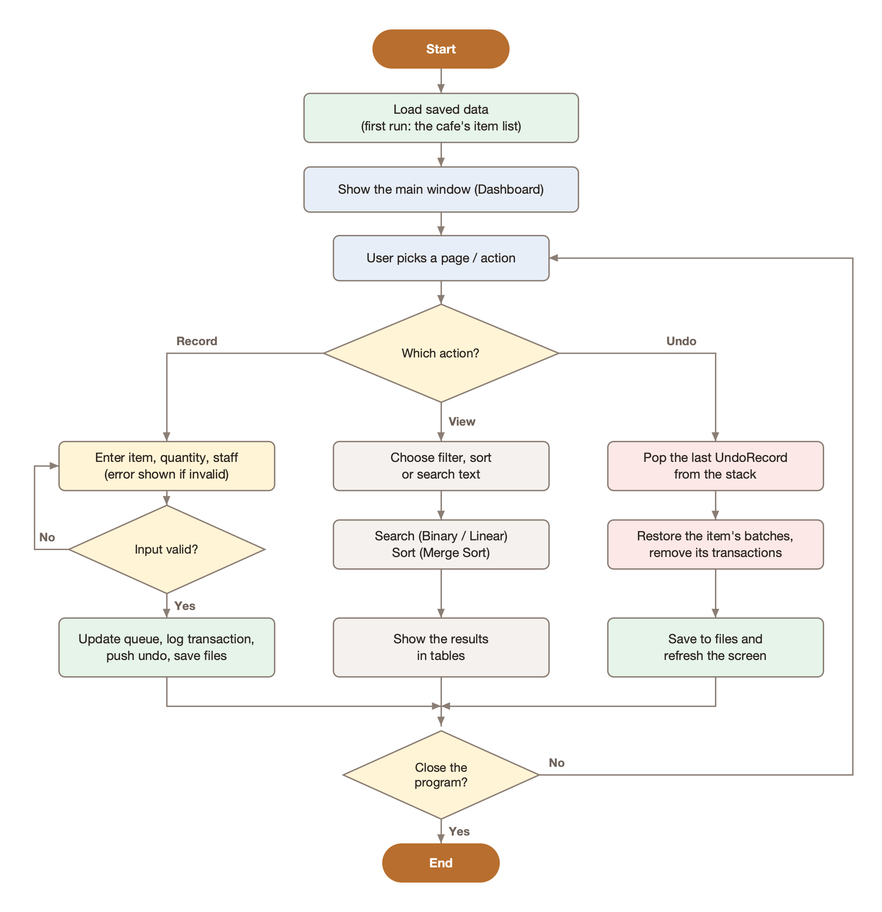
Figure 1. Program flowchart

2.2 UML Class Diagram
Figure 2 shows the main classes and how they are related. InventoryManager manages all InventoryItem objects and records Transaction objects. Each item keeps its stock in a LinkedQueue of StockBatch objects. RawIngredient and ProductionItem inherit from the abstract InventoryItem. The undo history is a LinkedStack of UndoRecord objects. MergeSort, Search and FileStorage are used by the manager. The GUI classes are left out of the diagram to keep it readable; each page simply calls the manager's methods.

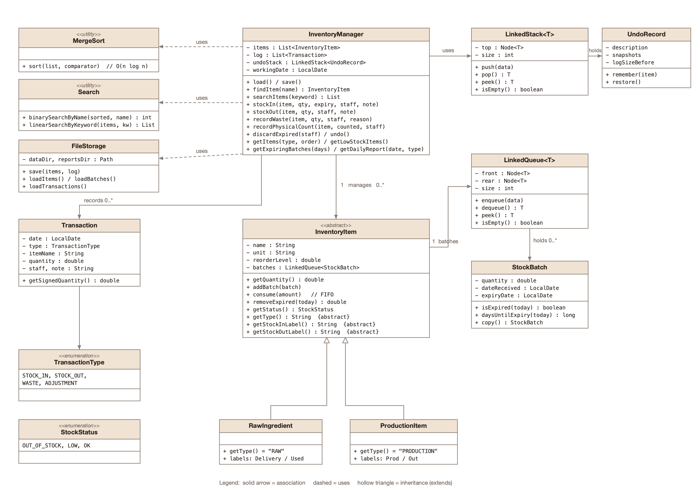
Figure 2. UML class diagram of the core classes

2.3 Saved Files
File | Contents (one line per record, fields separated by |)
data/items.txt | TYPE | NAME | UNIT | REORDER_LEVEL
data/batches.txt | NAME | QUANTITY | DATE_RECEIVED | EXPIRY (written front to rear, so the queue order is kept)
data/transactions.txt | DATE | TYPE | NAME | QUANTITY | STAFF | NOTE
reports/*.txt | Reports exported for printing

3. Code Inventory
The program has 29 Java files (about 4,200 lines). This section lists the control structures, libraries, classes, variables and functions we used.

3.1 Control Structures
Control structure | Where it is used and for what part of the problem
if / else if / else | Validating input in StockEntryPanel.record() (an item must be chosen, quantity must be a number above 0, staff name is required); InventoryItem.getStatus() decides OK, LOW or OUT; InventoryItem.consume() stops if there is not enough stock; Binary Search decides to go left or right
switch | Transaction.getSignedQuantity() (stock in is +, stock out and waste are -); InventoryManager.getDailyReport() adds each transaction to the right column; InventoryPanel picks the sort order; StockEntryPanel sets labels for Stock In, Stock Out or Waste
for (counter) | MergeSort copies and merges array positions; EndingCountPanel goes through each row of counts; ReportsPanel computes column widths when exporting
for-each | InventoryItem.getQuantity() adds up every batch in the queue; Linear Search checks every item; getLowStockItems() and getExpiringBatches() scan all items; FileStorage writes every item, batch and transaction
while | Binary Search loop (while low <= high); FIFO loop in consume() (while stock is still needed); the merge step of Merge Sort; removeExpired() empties and rebuilds the queue; FileStorage reads files line by line; undo() removes transactions
Recursion | MergeSort.mergeSort() calls itself on the left and right halves
try / catch | Reading the quantity typed by the user (NumberFormatException); showing errors such as "Not enough stock" (IllegalArgumentException); saving and loading files (IOException)
throw | consume() throws an error when there is not enough stock; LinkedQueue.dequeue() and LinkedStack.pop() throw an error when empty; quantities of 0 or less are rejected
Ternary operator (?:) | Short choices such as showing "Raw" or "Prod.", picking the badge color, or choosing the quantity label

3.2 Libraries
Library | Classes used | Purpose
java.util | List, ArrayList, Comparator, HashMap, HashSet, Iterator | Storing the item and transaction lists, defining sort orders, adding up report totals
java.time | LocalDate, ChronoUnit, DateTimeFormatter | Delivery dates, expiry dates, days until expiry, the working date
java.io, java.nio.file | BufferedReader, BufferedWriter, Files, Path | Saving and loading the data files and exporting reports
javax.swing | JFrame, JPanel, JTable, JList, JButton, JTextField, JComboBox, JSpinner, JOptionPane | The window, pages, tables, forms and dialogs
java.awt | BorderLayout, GridBagLayout, CardLayout, Color, Font, Graphics2D | Page layout, colors, fonts and drawing the buttons

Note: the ArrayList and HashMap from java.util are only used to store data. The queue, stack, sorting and searching required by the project are our own classes (LinkedQueue, LinkedStack, MergeSort, Search).

3.3 Classes
Class | Description
Main | Entry point. Loads the inventory and opens the main window.
InventoryItem | Abstract class for any item in stock: name, unit, reorder level and its queue of batches. Computes quantity and status, and removes stock FIFO.
RawIngredient | An ingredient from a supplier (e.g. Chicken Breast). Its stock-in label is "Delivery" and stock-out label is "Used".
ProductionItem | Food prepared in the kitchen (e.g. Tapa). Its labels are "Prod" and "Out".
StockBatch | One delivery or production batch: quantity, date received and expiry date.
Transaction | One recorded stock movement: date, type, item, quantity, staff and note.
TransactionType | Enum: STOCK_IN, STOCK_OUT, WASTE, ADJUSTMENT.
StockStatus | Enum: OUT_OF_STOCK, LOW, OK.
LinkedQueue<T> | Our generic FIFO queue made of linked nodes.
LinkedStack<T> | Our generic LIFO stack made of linked nodes.
MergeSort | Our Merge Sort that sorts any list using a Comparator.
Search | Our Binary Search (exact name) and Linear Search (keyword).
InventoryManager | The core of the program: records every transaction, runs undo, and produces all reports.
FileStorage | Saves and loads the items, batches and transactions as text files.
SeedData | The cafe's item list from its paper sheets, loaded on the first run.
UndoRecord | What the undo stack stores: a copy of the item's batches before a change.
ReportRow | One row of the daily inventory sheet (Beginning, In, Out, Waste, Adjust, Ending).
ExpiringBatch | A batch together with its item, for the expiry report.
MainFrame | The main window: sidebar, header with working date and Undo, and the page area.
DashboardPanel | Home page with totals, the restock list and expiring stock.
InventoryPanel | All items with search, filter and sort; shows an item's batches and history.
StockEntryPanel | One form used for Stock In, Stock Out and Waste.
EndingCountPanel | The physical count sheet; saves differences as adjustments.
ReportsPanel | Restock List, Expiring Stock and Daily Inventory Sheet tabs.
HistoryPanel | Every transaction, newest first, with filters.
ItemsPanel | Adds items and edits units and reorder levels.
ItemPicker | Search box with a live list for choosing an item.
UiKit | Shared colors, fonts, buttons and table styles.
Refreshable | Interface with refresh(), implemented by every page.

3.4 Objects
- One InventoryManager object is created in Main and shared by every page.
- One InventoryItem object per cafe item (136 at the start), each either a RawIngredient or a ProductionItem.
- A StockBatch object is created for every delivery or production entry and placed in the item's queue.
- A Transaction object is created for every stock movement and added to the history log.
- An UndoRecord object is pushed onto the undo stack after every transaction.
- GUI objects: one MainFrame window and one panel object for each page.

3.5 Important Variables
Variable | Class | Description
items | InventoryManager | List of all items, always kept sorted by name so Binary Search works
log | InventoryManager | List of every Transaction (the history)
undoStack | InventoryManager | LinkedStack<UndoRecord> used by Undo
workingDate | InventoryManager | The date new entries are recorded under (normally today)
EXPIRY_ALERT_DAYS | InventoryManager | 3; a batch is "expiring soon" within this many days
batches | InventoryItem | LinkedQueue<StockBatch>; the item's stock, oldest first
name, unit, reorderLevel | InventoryItem | The item's name, unit (kg, pack...) and the level where it becomes LOW
EPSILON | InventoryItem | 0.0001; tolerance when comparing decimal quantities
front, rear, size | LinkedQueue | First node, last node and number of elements
top, size | LinkedStack | Top node and number of elements
quantity, dateReceived, expiryDate | StockBatch | How much the batch has, when it arrived and when it expires
low, high, mid | Search | The part of the list still being searched in Binary Search

3.6 Functions (Methods)
Method | Class | Description
enqueue(), dequeue(), peek() | LinkedQueue | Add at the rear, remove from the front, look at the front
push(), pop(), peek() | LinkedStack | Add to the top, remove from the top, look at the top
sort(list, comparator) | MergeSort | Sorts a list in the order given by the comparator
binarySearchByName(list, name) | Search | Finds an exact item name in the sorted list
linearSearchByKeyword(list, kw) | Search | Finds every item whose name contains the keyword
getQuantity() | InventoryItem | Adds up the quantities of all batches
consume(amount) | InventoryItem | Removes stock from the oldest batch first (FIFO)
removeExpired(today) | InventoryItem | Removes all expired batches
getStatus() | InventoryItem | Returns OK, LOW or OUT_OF_STOCK
stockIn(), stockOut(), recordWaste() | InventoryManager | Record the three stock transactions
recordPhysicalCount() | InventoryManager | Compares the count with the system and saves the difference
discardExpired() | InventoryManager | Removes expired stock and records it as waste
undo() | InventoryManager | Pops the last UndoRecord and restores the stock
findItem(), searchItems() | InventoryManager | Call Binary Search and Linear Search
getLowStockItems() | InventoryManager | Items at or below their reorder level, sorted by urgency
getExpiringBatches(days) | InventoryManager | Batches expiring soon, sorted by expiry date
getDailyReport(date, type) | InventoryManager | Rebuilds the daily inventory sheet for any date
save(), load() | FileStorage / InventoryManager | Save and load all data

3.7 Principles of OOP Used
Principle | How it is used in our code
Classes and Objects | Each real thing in the cafe is a class (item, batch, transaction). Every cafe item becomes an object when the program starts.
Encapsulation | Fields are private and are changed only through methods. For example, an item's batches can only change through addBatch() and consume(), and the Node class inside LinkedQueue and LinkedStack is hidden from other classes.
Inheritance | RawIngredient and ProductionItem extend InventoryItem and reuse all of its stock code. The pages extend JPanel and MainFrame extends JFrame.
Abstraction | InventoryItem is abstract with abstract methods getType(), getStockInLabel() and getStockOutLabel(). The GUI only calls simple methods like stockOut() without knowing how the queue works.
Polymorphism | getStockInLabel() returns "Delivery" for a RawIngredient and "Prod" for a ProductionItem, so the same form shows the cafe's own words. MergeSort receives different Comparator objects to sort by name, quantity, status or expiry. MainFrame calls refresh() on any page through the Refreshable interface.
Interfaces | Refreshable (our own), Iterable (implemented by LinkedQueue so it can be used in a for-each loop) and Comparator.
Generics | LinkedQueue<T>, LinkedStack<T> and MergeSort.sort() work with any type.
Enumerations | TransactionType and StockStatus list the only allowed values.
Composition | An InventoryItem has a LinkedQueue of StockBatch objects; InventoryManager has a list of items, a transaction log, an undo stack and a FileStorage.

4. Concepts of Data Structures and Algorithms
This section explains each data structure and algorithm we used, how we implemented it, and how it solves part of the cafe's problem.

4.1 Queue (FIFO) - stock batches
A queue is a First-In, First-Out (FIFO) structure: elements are added at the rear and removed from the front, like a line at a counter. We wrote LinkedQueue<T> using linked nodes and two references, front and rear. Because both ends are known, enqueue(), dequeue() and peek() all take O(1) time.
How it solves the problem: every item keeps its stock as a queue of batches. A new delivery is enqueued at the rear. When stock is used or wasted, consume() takes from the front, the oldest batch, and only moves to the next batch when the oldest one is empty. This is the FIFO rule used in food service, so older stock is used before it spoils. Figure 3 shows the steps.
Example: Chicken Breast has batch #1 = 6 kg (received Oct 14) and batch #2 = 2 kg (received Oct 15). Using 7 kg dequeues batch #1 completely (6 kg) and takes the remaining 1 kg from batch #2, which now has 1 kg left.
public void consume(double amount) {
if (amount > getQuantity() + EPSILON)
throw new IllegalArgumentException("Not enough stock ...");
double remaining = amount;
while (remaining > EPSILON && !batches.isEmpty()) {
StockBatch oldest = batches.peek(); // front of the queue
if (oldest.getQuantity() <= remaining + EPSILON) {
remaining -= oldest.getQuantity();
batches.dequeue(); // batch fully used
} else {
oldest.setQuantity(oldest.getQuantity() - remaining);
remaining = 0;
}
}
}
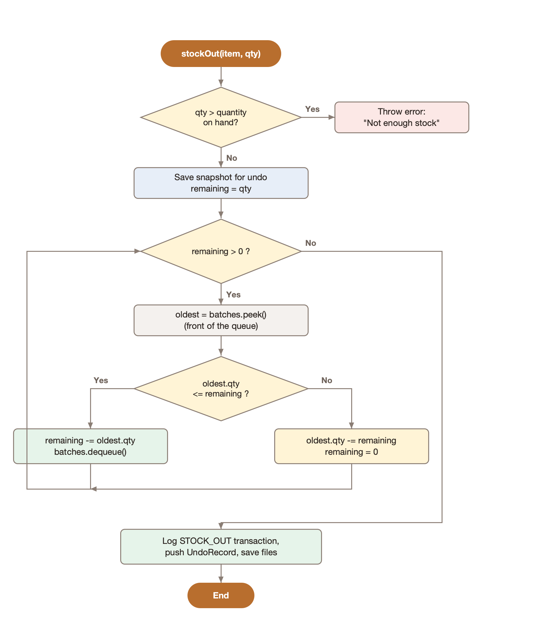
Figure 3. Flowchart of Stock Out using the queue (FIFO)

4.2 Stack (LIFO) - undo
A stack is a Last-In, First-Out (LIFO) structure: the last element added is the first one removed, like a pile of plates. We wrote LinkedStack<T> using linked nodes with a top reference. push(), pop() and peek() all take O(1) time.
How it solves the problem: staff make typing mistakes. Before every transaction, InventoryManager saves a copy of the item's batches in an UndoRecord and pushes it onto the stack. The Undo button pops the top record, puts the old batches back, and removes the transaction from the history. Because it is a stack, the most recent mistake is always fixed first.
Example: after recording a delivery of 5 kg Chicken Breast, then using 9 kg, then a waste of 2 portions of Tapa, the top of the stack is the waste. Pressing Undo reverses the waste first; pressing it again reverses the 9 kg usage.

4.3 Merge Sort - sorting
Merge Sort is a divide-and-conquer algorithm: (1) divide the list into two halves, (2) sort each half by calling Merge Sort again (recursion), and (3) merge the two sorted halves into one sorted list. It always takes O(n log n) time and uses O(n) extra space. It is also stable: items that are equal keep their original order.
How it solves the problem: our MergeSort.sort(list, comparator) receives a Comparator, so the same algorithm produces every order the cafe needs: items by name (A-Z), by quantity (lowest or highest first), by status (most urgent first), the restock list by urgency, and expiring batches by expiry date. It also keeps the item list sorted by name, which Binary Search needs.
Example: sorting six items by quantity on hand (lowest first):
Step | List
Start | OIL 12, EGGS 1.5, TAPA 4, GARLIC 1.5, POTATO 10, BUTTER 5
Divide | [OIL 12, EGGS 1.5, TAPA 4] [GARLIC 1.5, POTATO 10, BUTTER 5]
Divide | [OIL 12, EGGS 1.5] [TAPA 4] [GARLIC 1.5, POTATO 10] [BUTTER 5]
Merge | [EGGS 1.5, OIL 12] [TAPA 4] [GARLIC 1.5, POTATO 10] [BUTTER 5]
Merge | [EGGS 1.5, TAPA 4, OIL 12] [GARLIC 1.5, BUTTER 5, POTATO 10]
Merge (done) | EGGS 1.5, GARLIC 1.5, TAPA 4, BUTTER 5, POTATO 10, OIL 12

EGGS and GARLIC both have 1.5 and stay in their original order, which shows that Merge Sort is stable.

4.4 Binary Search - exact item lookup
Binary Search finds a value in a sorted list. It checks the middle element; if that is not the target, it throws away the half where the target cannot be and repeats. It takes O(log n) time, so the 136 items need at most 8 comparisons, compared with up to 136 for checking one by one.
How it solves the problem: when staff type an exact item name, Search.binarySearchByName() finds it immediately. It is also used to block duplicate names when adding an item and to match saved batches to their items when loading. The item list is kept sorted by name with Merge Sort so that Binary Search always works.
Example: searching for SALMON FILLET in the real list of 136 items:
Step | low | high | mid | Item at mid | Result
1 | 0 | 135 | 67 | KATSU SAUCE | target is after, go right
2 | 68 | 135 | 101 | SALT | target is before, go left
3 | 68 | 100 | 84 | PEANUT BUTTER | go right
4 | 85 | 100 | 92 | PORK STEAK | go right
5 | 93 | 100 | 96 | RIB EYE STEAK | go right
6 | 97 | 100 | 98 | SALMON BIG | go right
7 | 99 | 100 | 99 | SALMON FILLET | found

while (low <= high) {
int mid = (low + high) / 2;
int result = sortedItems.get(mid).getName().compareToIgnoreCase(key);
if (result == 0) return mid; // found
else if (result < 0) low = mid + 1; // key is in the right half
else high = mid - 1; // key is in the left half
}
return -1; // not found

4.5 Linear Search - keyword lookup
Linear Search checks every element one by one. It takes O(n) time but works on any list and can find partial matches, which Binary Search cannot do.
How it solves the problem: staff often type only part of a name. Search.linearSearchByKeyword() returns every item whose name contains the keyword. For example, typing "chicken" finds 7 items: Chicken Breast, Chicken Cubes, Chicken Powder, Chicken Thigh, Chicken for Salad, Chicken Katsu and Chicken Katsu Sauce. The search boxes use Binary Search for an exact name and Linear Search for everything else.

4.6 Summary
Concept | Our class | Used for | Time complexity
Queue (FIFO) | LinkedQueue<T> | Stock batches; oldest stock used first | O(1) per operation
Stack (LIFO) | LinkedStack<T> | Undo; latest entry reversed first | O(1) per operation
Merge Sort | MergeSort | All sorting: items, restock list, expiry list | O(n log n)
Binary Search | Search | Exact item name, duplicate check, loading data | O(log n)
Linear Search | Search | Partial / keyword search | O(n)

