3. METHODOLOGY

3.1 Problem Formulation
UAV position prediction is formulated as a time-series regression problem. Given a sequence of historical UAV trajectory observations, the objective is to predict the future position in terms of latitude and longitude.
Let the UAV position at time step t be denoted as:
p_t = (lat_t, lon_t)
To capture temporal dependencies, input sequences are constructed using a sliding window of length n:
X_t = { p_{t−n+1}, …, p_t }
The prediction model estimates the next-step position:
ŷ_{t+1} = (lat_{t+1}, lon_{t+1})
Depending on the model configuration, the output may represent either the absolute next position or an incremental displacement, which is then converted back to absolute coordinates for evaluation. This formulation ensures consistent temporal input across all models and enables fair comparative evaluation.

3.2 Overall Experimental Framework
The overall pipeline is illustrated in Fig. 1, which consists of raw trajectory acquisition, data preprocessing, sequence generation (sliding window), representation learning (for selected models), prediction modeling, and performance evaluation.
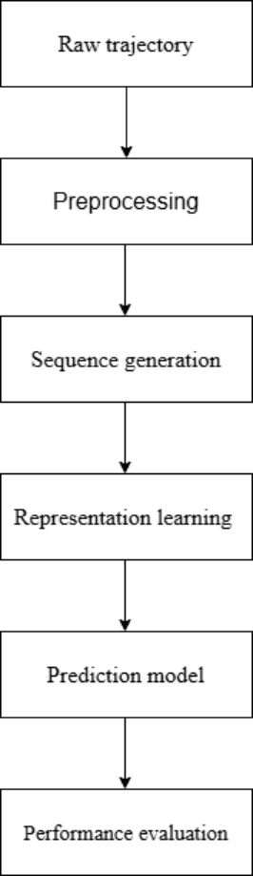
Fig. 1. Overview of the experimental pipeline.
Raw trajectory data are normalized to stabilize model training. Sequential samples are generated using a sliding window mechanism (Fig. 2). For models incorporating a representation learning stage—specifically the LSTM autoencoder introduced in Section 3.4.3—an additional pretraining phase is conducted on the training data before the supervised prediction module is optimized. All other models proceed directly from the windowed data to supervised training. After training, all models are evaluated on the held-out test set, and the results are reported using the metrics defined in Section 3.5.

3.3 Sequence Generation
Before applying prediction models, the raw trajectory data are first processed to generate sequential training samples. To capture temporal dependencies, a sliding window mechanism is applied as shown in Fig. 2.
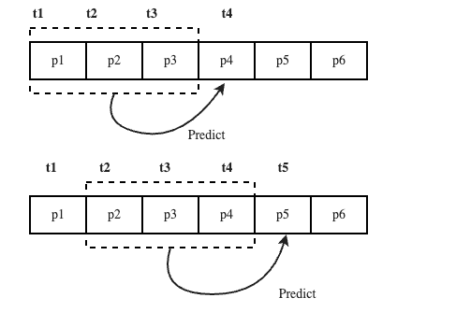
Fig. 2. Illustration of the sliding window mechanism for generating supervised training samples from continuous UAV trajectory data.
The sliding window operates as follows. Given a window length n and a trajectory consisting of T position observations, the mechanism scans from the beginning of the sequence to its end, extracting at each position a contiguous subsequence of n observations as the input, paired with the observation at time t+1 as the output target. Formally, each training sample is defined as:
( p_{t−n+1}, …, p_t ) → ( lat_{t+1}, lon_{t+1} )
The window then shifts forward by one time step:
( p_{t−n+2}, …, p_{t+1} ) → ( lat_{t+2}, lon_{t+2} )
This one-step shift produces a high degree of overlap between consecutive windows: adjacent samples share (n − 1) position observations, differing only in that one observation is dropped from the beginning and one new observation is appended at the end. This overlap is beneficial because it greatly increases the number of training samples that can be generated from a trajectory of length T—yielding up to (T − n) samples in total—while ensuring that the temporal continuity of the trajectory is preserved across samples.

3.4 Prediction Models
This study evaluates five prediction models spanning a spectrum of methodological complexity: three classical machine learning baselines, a standard LSTM, an LSTM autoencoder with unsupervised pretraining, and a Transformer-based model. The classical models provide interpretable baseline references; the LSTM isolates the contribution of explicit temporal modeling; the LSTM autoencoder examines whether unsupervised representation learning further improves prediction quality; and the Transformer investigates whether a non-recurrent, attention-based architecture offers advantages over recurrent approaches.

3.4.1 Classical Machine Learning Models
Three classical supervised regression models are implemented as performance baselines: Linear Regression (LR), Support Vector Regression (SVR), and Random Forest Regression (RF) [3][10]. For all three, the input window X_t is flattened into a one-dimensional feature vector of length 2n before being passed to the model. LR fits a linear mapping from this vector to the output coordinates and serves as the simplest reference, though it cannot capture nonlinear trajectory dynamics. SVR extends this by applying an RBF kernel to model smooth nonlinear relationships between historical observations and predicted position. RF constructs an ensemble of decision trees and averages their outputs, enabling it to approximate more complex, discontinuous input-output mappings. Importantly, none of these models explicitly encode the temporal ordering of observations; the window is treated as a flat feature vector rather than an ordered sequence, which is a fundamental limitation when trajectory prediction depends on fine-grained temporal dynamics.

3.4.2 LSTM-Based Model
To model nonlinear temporal dynamics, a Long Short-Term Memory (LSTM) network is adopted [36]. Unlike classical regressors, the LSTM processes the input sequence X_t step-by-step, maintaining a hidden state h and cell state c that are updated at each time step through a gating mechanism comprising input, forget, and output gates. This design allows the network to selectively retain or discard information across time steps, overcoming the vanishing gradient problem that limits standard RNNs and making it well-suited to capturing the nonlinear temporal dynamics of UAV flight.
After processing all n time steps, the final hidden state h_t summarizes the observed trajectory and is passed through a fully connected output layer to produce the predicted next position:
ŷ_{t+1} = W · h_t + b
where W and b are the weight matrix and bias of the output layer. The model is trained end-to-end using the Adam optimizer with mean squared error as the loss function. The architecture is illustrated in Fig. 3.
Fig. 3. Architecture of the LSTM-based prediction model.

3.4.3 LSTM Autoencoder-Based Representation Learning
To investigate the effect of unsupervised representation learning on prediction performance, an LSTM-based autoencoder is incorporated into the pipeline [20]. The model follows an encoder–decoder design: the encoder compresses the input window X_t into a compact latent vector z that captures the essential temporal structure of the trajectory:
z = Encoder(X_t)
A decoder LSTM is then trained to reconstruct the original input sequence from z, with the full autoencoder optimized by minimizing the mean squared reconstruction error. This unsupervised pretraining encourages the encoder to learn a general-purpose temporal representation rather than one tuned narrowly to the prediction objective. Once pretraining is complete, the decoder is discarded and the frozen encoder is paired with a fully connected prediction head g(·), trained in a supervised manner to map z to the next position:
ŷ_{t+1} = g(z)
This two-stage design separates representation learning from prediction, allowing analysis of how the quality of the latent temporal features influences forecasting performance. The architecture is illustrated in Fig. 4.
Fig. 4. Overview of the LSTM-based autoencoder model.

3.4.4 Transformer-Based Model
As a non-recurrent alternative to the LSTM, a Transformer encoder is included to assess whether attention-based sequence modeling offers advantages for UAV trajectory prediction [REF]. Unlike the LSTM, which processes the sequence step-by-step, the Transformer attends to all time steps simultaneously via a self-attention mechanism, allowing it to capture global temporal dependencies without the sequential bottleneck of recurrent processing.
Each position vector in the input window X_t is first projected into a higher-dimensional embedding space of size d_model. Since the Transformer has no built-in notion of temporal order, sinusoidal positional encodings are added to the embeddings to inject sequence position information:
PE(pos, 2i) = sin( pos / 10000^{2i/d_model} ), PE(pos, 2i+1) = cos( pos / 10000^{2i/d_model} )
The encoded sequence is then passed through a stack of Transformer encoder layers, each consisting of a multi-head self-attention module followed by a position-wise feed-forward network, with residual connections and layer normalization applied around each sub-layer. The self-attention operation is defined as:
Attention(Q, K, V) = softmax( Q · Kᵀ / √d_k ) · V
where Q, K, and V are the query, key, and value projections of the input, and d_k is the key dimensionality. After all encoder layers have been applied, the output at the final time step h_n is extracted and passed through a fully connected prediction head to produce the next position:
ŷ_{t+1} = W_out · h_n + b_out
This design is structurally consistent with the LSTM model, enabling a direct comparison between recurrent and attention-based temporal modeling. The model is trained end-to-end with the Adam optimizer. The architecture is illustrated in Fig. 5.

3.5 Evaluation Metrics
Model performance is evaluated using Mean Squared Error (MSE). MSE is a standard and widely adopted criterion for regression tasks, computed as the average of the squared differences between predicted and ground-truth values over the test set. Its quadratic nature makes it particularly sensitive to large prediction errors, which is desirable in the context of UAV trajectory prediction. Evaluation is performed under two settings: joint position error and dimension-wise error. The joint metric offers a single summary measure of overall spatial accuracy, while the dimension-wise metrics enable a more granular diagnostic analysis of where errors arise within the prediction space.

3.5.1 Joint Position Error (Latitude–Longitude)
To evaluate overall spatial accuracy, latitude and longitude are assessed jointly:
MSE_pos = (1/N) · Σᵢ₌₁ᴺ [ (lat̂ᵢ − latᵢ)² + (lôn ᵢ − lonᵢ)² ]
where lat̂ᵢ and lôn ᵢ denote the predicted latitude and longitude for the i-th test sample, and latᵢ and lonᵢ denote the corresponding ground-truth values. This metric aggregates spatial error along both coordinate axes into a single scalar, reflecting total horizontal positional error, and serves as the primary criterion for ranking models.

3.5.2 Dimension-Wise Error
While the joint MSE provides a useful summary statistic, it can obscure important differences in how a model performs along each spatial axis independently. To address this, the latitude and longitude prediction errors are also evaluated separately:
MSE_lat = (1/N) · Σᵢ₌₁ᴺ (lat̂ᵢ − latᵢ)²
MSE_lon = (1/N) · Σᵢ₌₁ᴺ (lôn ᵢ − lonᵢ)²
Joint evaluation reflects overall spatial accuracy, while dimension-wise evaluation provides insight into directional prediction characteristics, revealing whether errors are systematically higher along one coordinate axis.

3.6 Exclusion of Altitude from Primary Comparison
Although altitude information is available in the dataset, the primary comparative analysis focuses on horizontal positioning (latitude and longitude). Altitude measurements exhibit significantly higher variability and noise due to sensor limitations and dynamic vertical fluctuations, and preliminary experiments showed that altitude errors were considerably larger in magnitude and tended to dominate overall MSE values, potentially obscuring the comparative evaluation of trajectory modeling performance.
Furthermore, horizontal position accuracy is of greater practical relevance for most UAV applications, including airspace conflict detection and path planning, which are primarily governed by horizontal proximity. Therefore, to ensure a stable, consistent, and fair comparison across models, this study focuses solely on horizontal position prediction.

