Neurology

- Intraventricular hemorrhage (IVH)
- Hydrocephalus
- Neonatal Seizure
- Hypoxic Ischemic Encephalopathy(HIE)
- 振幅整合腦電圖Amplitude EEG (aEEG)
- NAS, neonatal abstinence syndrome
- Neonatal stroke
- Vein of Galen aneurysmal malformation

- Intraventricular hemorrhage (IVH)
- Definition
IVH is an intracranial hemorrhage that originates in the periventricular subependymal germinal matrix with subsequent entrance of blood into the ventricular system.
- Timing
  - Early IVH: diagnosed at < 72h after birth
  - Late IVH: diagnosed after 72h of life
  - 50% of IVH occurs in the 1st 6-12h of life, 75% by the 2nd day, 90% by the 3rd day
  - In 20% to 40%, the hemorrhage may extend during the first week of life.
- Risk factors
  - Extreme prematurity /Presence of labor /Birth asphyxia /Need for vigorous resuscitation at birth/ Pneumothorax/Ventilated preterm infants, especially those who breathe out of synchrony with the ventilator/Seizures
  - Sudden elevation in arterial blood pressure as in rapid volume expansion and administration of hypertonic sodium bicarbonate
  - Hypothermia, hypotension, hypercarbia, acidosis, exchange transfusion, etc
  - Coagulation disturbances.
- Incidence：Around 25% in infants weighing < 1500g; 60% in infants weighing <1000 g.
- Grading：(Ref : Avery's diseases of the Newborn10th, p. 881)
1978 Papile Grading System |  | 2008 Volpe Grading System
I | Subependymal hemorrhage | I | Germinal matrix hemorrhage, IVH<10%
II | IVH without ventricle dilatation | II | IVH 10-50%
III | IVH with ventricle dilatation | III | IVH >50%, usually ventricle distension
IV | Hemorrhage extend to parenchyma along with IVH | separate notation: periventricular echogenicity signifying parenchymal lesion

- Symptoms and signs
  - Asymptomatic (25-50%)
  - Subtle symptoms: eg. a bulging fontanelle, abrupt clinical deterioration with hypotension, apnea, bradycardia, metabolic acidosis, anemia, seizures, and change in muscle tone or level of consciousness

- Diagnosis and follow-up
  - Brain sonography
- Routine brain echo for VLBW: DOL 3 & 7-10 d, or deterioration of clinical condition
- If IVH is noted, repeat sonogram 1-2 weeks to assess the extent of hemorrhage
- PVHI, periventricular hemorrhagic infarction: IVH後會造成腦室周圍白質 venous infarction
- Gr. IV IVH 會在 1-8 wks內因為 tissue destruction 形成 porencephalic cyst
  - Brain CT and MRI are acceptable alternatives (more expansive and require transport)
- Treatment
- Supportive care : volume expanders and pharmacologic agents to support BP,
assisted ventilation to correct hypoxemia and hypercarbia, and RBC transfusion to correct anemia
- Anticonvulsant therapy for seizure.
- Repeated spinal tap or shunt operation for posthemorrhagic hydrocephalus (PHH)
- Prevention of IVH with early indomethacin (缺藥, 不常規使用) (Ref: Pediatrics Apr 1994)
- 0.1mg/kg qd x3days (1st dose at 6-12 postnatal hours, then every 24 hours for 2nd 3rd doses)
- In D5W 2cc iv drip > 30 mins扣IV if U.O. >0.5ml/kg/hr and no contraindication
- Prognosis: (Ref : Avery's diseases of the Newborn10th, p. 933, 883)
- 30-50% of neonates with Gr. 3-4 IVH develop PHVD (posthemorrhagic ventricular dilatation) and 20-40% of them will need VP shunt
- Neurologic sequelae occur in 35% of Gr. 3 IVH and 55% Gr. 4 IVH
- Hydrocephalus
- Classification
- Noncommunicating hydrocephalus: aqueductal stenosis, Dandy-Walker cyst, tumors, ventricular inflammation and scars
- Communicating hydrocephalus : Arnold-Chiari malformation, encephalocele, leptomeningeal inflammations (infection, hemorrhage), lissencephaly, congenitalabsence of arachnoid granulations, tumors, overproduction of CSF (choroidplexus papilloma)
- Signs
- If increased intracranial pressure is present, the infant may show signs of apnea, bradycardia, irritability, lethargy, vomiting, tense fontanelle, widely split sutures, dilated scalp veins, rapid head growth, and setting-sun sign
- Papilledema is rarely observed in neonates
- Diagnosis
- Intrauterine ultrasonographic screening
- Neonatal ultrasonographic screening for premature infants
- VLBW / Larger, sick premature infants
- Rapidly enlarging head circumference / Signs of increased intracranial pressure
- CT scan or MRI of the head
- Management
- Congenital aqueductal stenosis or neural tube defects
- Decompression by prompt placement of a ventricular bypass shunt into anintracranial or extracranial compartment
- Ventriculoperitoneal shunts are considered the method of choice
- Posthemorrhagic hydrocephalus, PHH
- Mild hydrocephalus usually arrests within 4 weeks of progressive ventricular dilatation or returns to normal size within the first few months of life
- Severe, rapidly progressive hydrocephalus :, external ventricular drain (EVD), ventriculosubgaleal shunt (VSGS), ventricular access device(VAD) and VP shunt
- Posthemorrhagic hydrocephalus of prematurity management protocol
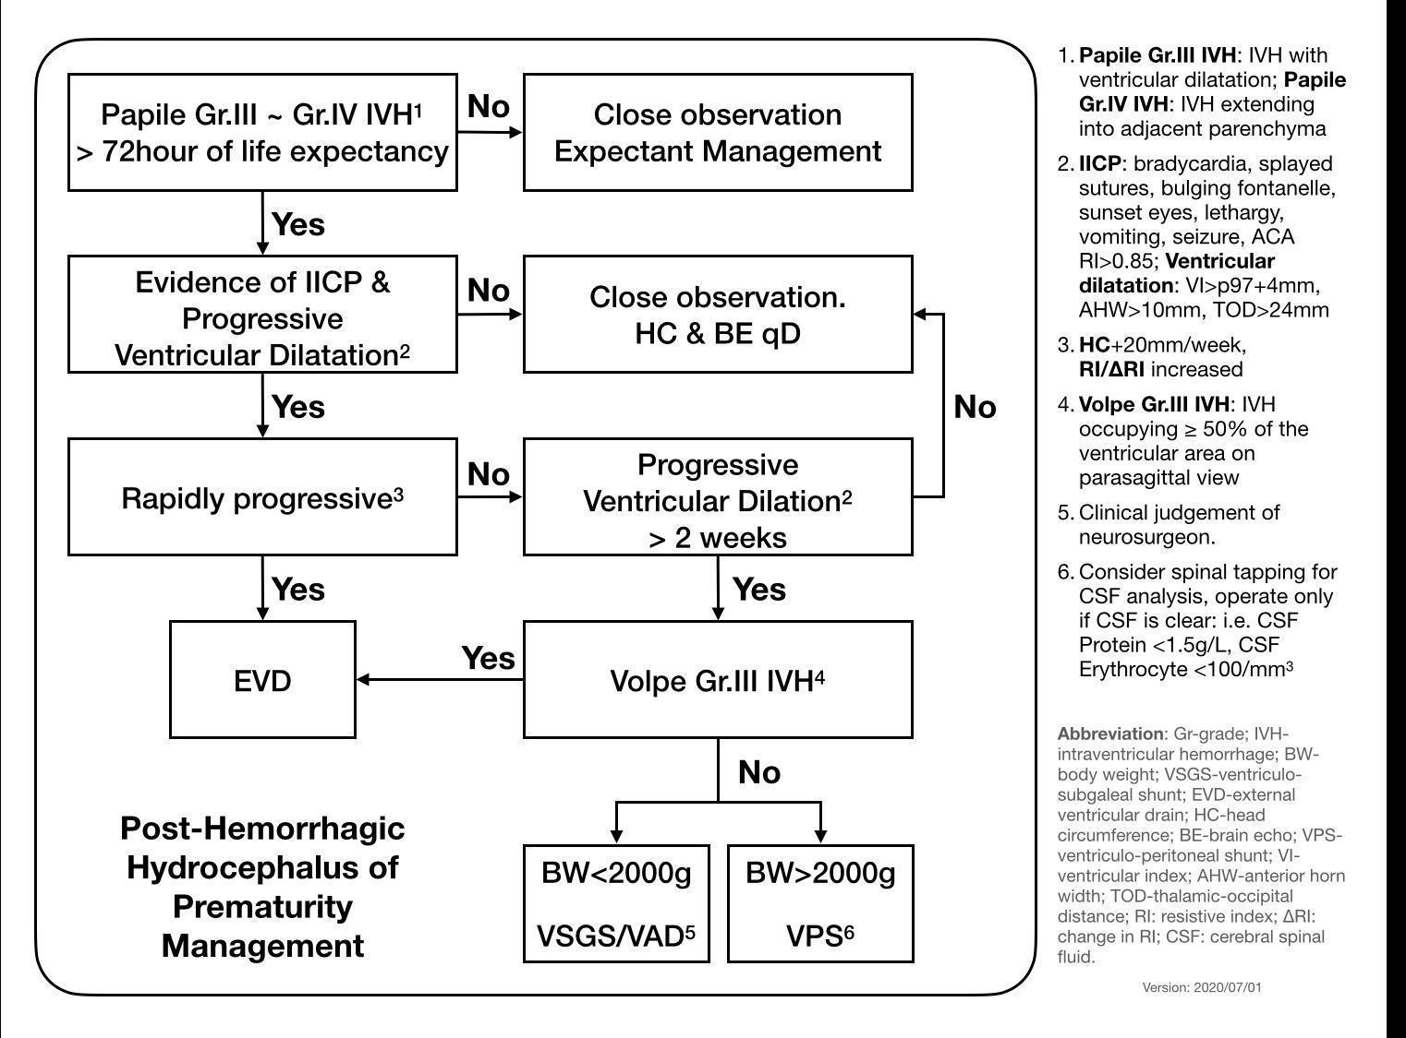
- Neonatal Seizure
- Differentiation between jitteriness and seizure
- Jitteriness is often precipitated by stimuli such as moving the infant, suctioning, or noise
- If the abnormal movement can be stopped by manipulating the infant, particularly by flexing the involved limbs, it is probably jitteriness
- The jitteriness is of equal amplitude in both moving direction, however, the seizure consists of a rapid movement in one direction, with a slower recovery phase in the other
- Jitteriness is not accompanied by abnormal eye movements or other subtle signs
- Classification：Subtle, clonic (focal, multifocal), tonic (focal, generalized), myoclonic (focal, multifocal, generalized)
- Etiology
- Perinatal asphyxia, hypoxic-ischemic encephalopathy
- Intracranial hemorrhage / trauma
- Subarachnoid hemorrhage / periventricular or intraventricular hemorrhage
- Subdural hemorrhage
- Central nervous system infections / congenital malformations
- Cerebrovascular syndromes
- Metabolic diseases (hypoglycemia, hypocalcemia, electrolyte disturbances: hypo- and hypernatremia)
- Drug-related disorders (ex: heroin, methadone, alcohol)
- Benign neonatal seizures
- Manifestations
- Ocular: staring, pupillary dilation or constriction, tonic deviation of eyes, nystagmus, blinking, eyelid fluttering
- Oral: sucking, smacking, drooling, chewing, tongue twitching, tongue protrusion, crying, grunting
- Changes in vital signs: bradycardia, tachycardia, hypotension, hypertension, arrhythmia, apnea, shallow respiration, hyperpnea, irregular respiration
- Color: flushing, cyanosis, pallor, mottling
- Abnormal movements and tone: multifocal twitching, focal twitching, generalized myoclonus, focal myoclonus, swimming movements, bicycling movements, hypotonia, hypertonia, and opisthotonus, etc.
- Laboratory evaluation
- Dextrostix, glucose, Ca²⁺, Mg²⁺, Na⁺, K⁺, BUN/Cr, GOT/GPT, ABG, NH₃, PT/PTT, CBC/DC, amino acid in urine and plasma, etc.
- Ultrasonography, CT or MRI of the head
- Blood culture if infection is suspected
- CSF for culture, routine , glucose and protein if meningitis is suspected
- EEG

- Management

- Keep airway patent, adequate ventilation and circulation
- Glucose IV
- Anticonvulsants
- Anticonvulsants
ILAE + 小兒神經科最新建議, 請掃右方 QR code
- Phenobarbital (Luminal) First choice!
- Loading dose : 建議從 loading 10 mg/kg/dose, IM or IV(ELBW or bleeding tendency).
If necessary-additional dose : 5 mg/kg/dose IM/IV to a maximum of 20 mg/kg
- Maintenance dose : GA ≧ 30wks 3-8 mg/kg/day
GA＜30wks 1-3mg/kg/day IM or IV Q12H
- Adverse effects : sedation, lethargy, paradoxical excitement, GI upset, ataxia, rash, Steven-Johnson syndrome
- Luminal drug level monitoring：(Ref: Micromedex)
  - Newborn Luminal T^{1/2} = 60h-180h
  - Therapeutic level : 15-40 mcg/ml (Ref : Avery’s Diseases of the Newborn 9th edition)
  - 驗藥物濃度的時間：
  - For suspect intoxication→ 隨時都可以驗藥化濃度!
  - For susepct 劑量不足→ 至少3-4個半衰期後再驗；急的話，至少５天後再驗
  - 藥物濃度報告出來 → 與主治醫師、小兒神經科、NI/NBC藥師討論→調劑量
- Levetiracetem (Keppra) (500mg/5ml vial, 100mg/ml oral solution)
- Loading dose : 20 mg/kg/dose, IVD 30min, 可以 loading 2 times
- Maintenance dose : 30-60 mg/kg/day q12h
- IV diluted in D5W or NS, max concentration: 15mg/ml, drip 15-30 mins
- Adverse effects : somnolence, irritability

- Phenytoin (Dilantin) (50mg/ml)
- Dosage: 建議從 loading 10mg/kg/dose, maintenance 2.5mg/kg/dose q12h開始
  - Loading dose: 20 mg/kg/dose IVD (1 mg/kg/min) NI常用IV slowly push
  - Maintenance dose: 3~8 mg/kg /day IV q12h
  - Diluted in an electrolyte solution (in dextrose water→precipitation)
- Therapeutic level: 10-20 mcg/mL
- Adverse effects : extravasation causes inflammation and necrosis, other rare in neonates, nystagmus, ataxia, lethargy, slurred speech, diplopia, headache, hirsutism, behavior changes, gum hyperplasia
- Midazolam (Dormicum) :
- Dosage：(5mg/ml amp)
Give 0.15 mg/kg iv bolus and l μg/kg/min IV continuous infusion, with increment of 1 μg/kg/min every 15 min until seizures stop or up to the upper limit of 10μg/kg/min.
- Adverse effects : miosis, respiratory depression, drowsiness, bradycardia, hypotension, constipation, sedation, GI upset, urine retention, histamine release, sweating, physiologic dependent
- 泡法：6×BW mg in D10W 10 ml，1ml/hr=10 ug/kg/min，Max:10ug/kg/min
- Lorazepam (Ativan) (Reference: NEOFAX, 2011)
- Usual dosage : 0.05-0.1 mg/kg/dose IV slowly push
- Repeat doses based on clinical response
- Adverse effects : Respiratory depression, rhythmic myoclonic jerking has occurred in premature neonates receiving lorazepam for sedation
- Valproic acid (Depakine) : 小於兩歲不建議使用，因肝毒性明顯

- Hypoxic Ischemic Encephalopathy(HIE)
- Etiology
- Antepartum : maternal hypotension, infertility treatment, thyroid disease
- Intrapartum : maternal fever, difficult forceps delivery, breech extraction, cord prolapse, abruptio placentae etc.
- Postnatal : severe respiratory distress, congenital heart disease, sepsis, and shock etc.
- Clinical presentations
- Symptoms usually evolve over a period of 72 hours
- First 12 hours : not easily arousable, periodic breathing with apnea or bradycardia, intact pupillary responses, hypotonia, Moro/grasp/suck/swallow reflex may be absent or depressed, seizure (+/-)
- 12-24 hours : increase in the level of alertness, seizure, apnea, jitteriness, weakness in the proximal limbs, exaggerated Moro reflex and DTR
- 24-72 hours : level of consciousness deteriorates, followed by respiratory arrest and signs of brainstem dysfunction such as loss of responsiveness to the doll’s eyes maneuver, fixed and dilated pupils
- Diagnosis (Ref : Avery’s Diseases of the Newborn 9th edition) 2021 revised
- Metabolic abnormalities, cerebral dysgenesis, and infection can mimic HIE
- History of intrauterine distress, eg. abnormalities on the fetal heart tracing, passage of meconium, or a history of difficult labor or delivery with decrease in placental or fetal blood flow; history of a difficult resuscitation
- Laboratory studies may show metabolic complications, such as hypoglycemia, hypocalcemia, hyponatremia, and acidosis
- EEG, brain echo, brain MRI (Ref: Arch Pediatr Adolesc Med. 2012;166(7):634-640)
  - MRI 建議事件發生後第5-7或第10-14天做，因為第7-10天有pseudonormalization，但實際檢查時間須配合臨床情形，如呼吸器使用與否來決定
- Brain CT often is not useful
- Treatment
- Supportive care
- Oxygen to prevent further hypoxia during a seizure or secondary to prolonged apnea, in severe cases, mechanical ventilation may be necessary
- Plasma expanders for hypotension
- Correct acidosis
- Maintain blood sugar at least 45 mg/dl
- Fluid to maintain urine output, D10W at 65 ml/kg/day is recommended at day 1 (but fluid requirement will depend on the presence of asphyxia-induced renal failure)
- Medications :
- Anticonvulsants for seizure: phenobarbital, phenytoin, midazolam
- Erythropoietin (EPO) alfa (4000 IU/amp, NT811/amp) 自費使用
    - Dosage for HIE: 1000IU/kg/day at DOL 1, 2, 3, 5, 7 (Ref: NEATO trial, Wu el al., 2012&2016)
    - Dosage for PVL: 2500 IU/kg/day qd x 3 days
    - Slowly iv push (over 1-5 mins) or SC, 不可IV drip or IM
Modified Sarnat Staging
 | Stage 1 (Mild) | Stage 2 (Moderate) | Stage 3 (Severe)
1. Level of Consciousness | Hyperalert | Lethargic/obtunded | Stupor/coma
2. Activity | Normal | Decreased | Absent
3. Neuromuscular Control
Muscle Tone | Normal | Mild hypotonia | Flaccid
Posture | Mild distal flexion | Strong distal flexion | Intermittent decerebration (extension)
Stretch Reflexes | Overactive | Overactive | Decreased or absent
4. Complex/primitive Reflexes
Suck | Weak | Weak or absent | Absent
Moro | Strong;  low threshold | Weak; incomplete;  High threshold | Absent
Tonic reflex | Slight | Strong | Absent
5. Autonomic Function
Pupil | Mydriasis | Miosis | Variable, often unequal; poor light reflex, fixed, dilated
Heart rate | Tachycardia | Bradycardia | Variable
6. Seizures | None | Common;  Focal or mutifocal | Uncommon (excluding decrebration)

- Therapeutic hypothermia (NRP 6th Ed., Nelson 19th Ed.) 快速鍵"cooling"

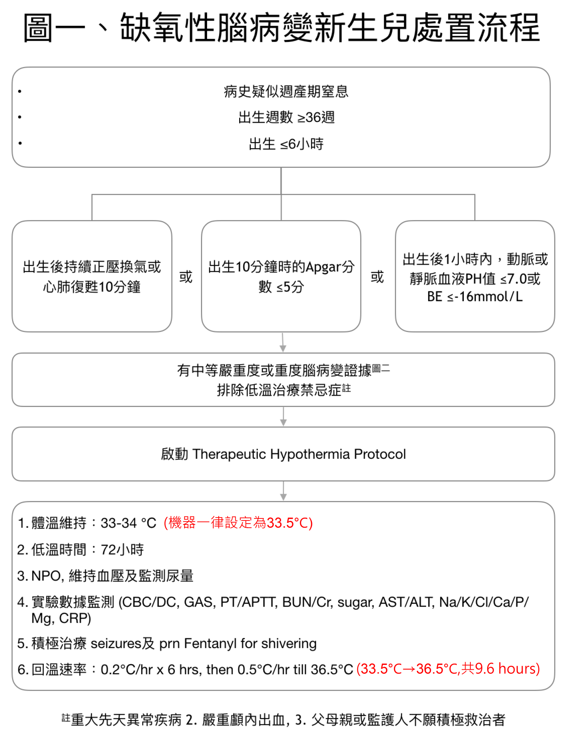

- 健保給付規定：
- 須符合以下3項：1)出生週數≧36週, 2)事件發生後6小時內實施, 3)出生後有「中等嚴重度(stage 2)」至「重度(stage 3)」腦病變之證據
- 「且」有下列「任一」項之情形：1)出生後一小時內嚴重酸血症，血液PH值≦7或base deficit ≧16mmol/L(動脈血或靜脈血均可)。 2) 出生10分鐘時的APGAR分數≦5分。3) 出生後持續急救至少10分鐘。
註：不完全符合健保給付標準者，如出生週數介於34-36週間、出生體重>1800gm克等，是否仍實施自費低溫治療，可依個別案例與主治醫師討論後決定。
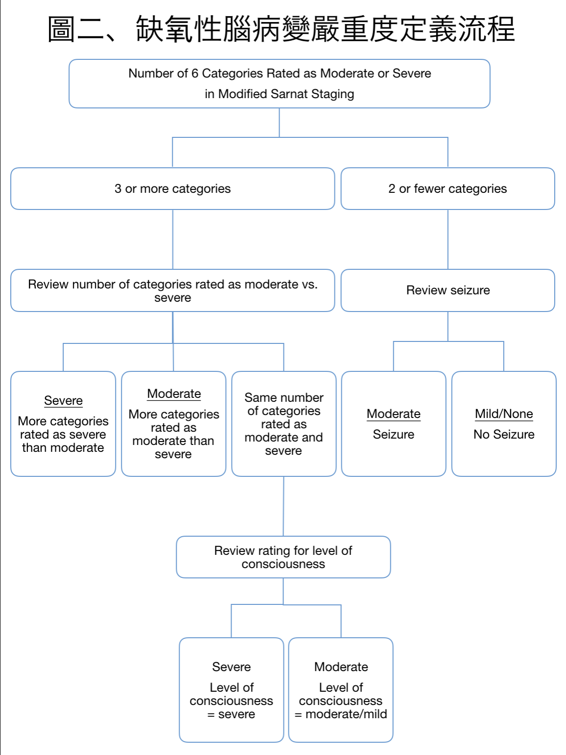
- 振幅整合腦電圖Amplitude EEG (aEEG)
(Reference: Shah NA, Wusthoff CJ. Arch Dis Child Educ Pract Ed 2015;100: 75–81)
- 使用目的：提供即時、持續、簡便監測腦部背景活動的工具
- 適用對象：疑腦傷或腦病變需監測大腦功能者
- 醫囑開立：
- Combine or consult pediatric neurologist (Call CR)
- 開awake & sleep EEG單，聯絡腦波室安排完整的EEG檢查才會有正式報告
- aEEG 使用
- 去小兒神經生理檢查室借aEEG 機器並記得填寫借閱本
(2025增) 值班或假日時間須急借用的話，請聯絡Neuro CR借鑰匙
- 導線黏貼及軟體操作可詢問NB or Neuro CR
- 請事先將頭皮清潔乾淨(建議使用磨砂膏)，若導極與頭皮黏貼不夠密合，易有干擾波影響判讀
- 簡易的aEEG需貼C3,P3, C4,P4及reference 和ground電極，監測左右各一通道
- 基本判讀
- 畫面分上下兩半(如下圖)，上半部是左右大腦即時的原始腦波(raw EEG)，下半部是以15秒為單位形成的振幅整合腦電圖 (aEEG)，把每15秒內最高及最低的振幅以一直線表現
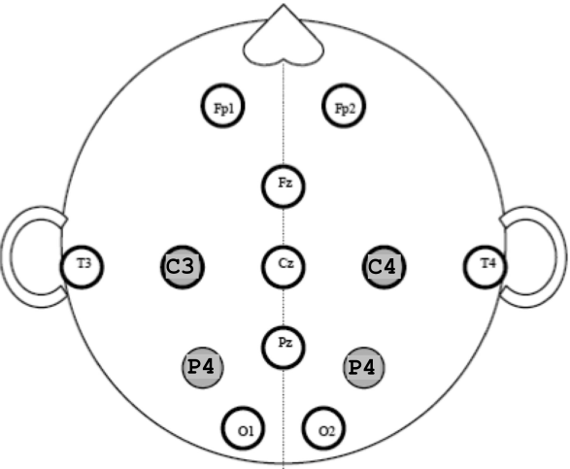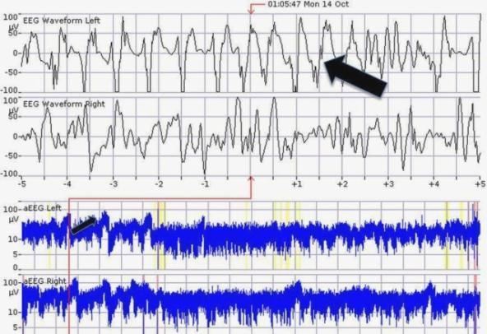

- aEEG可分三大面向判讀：背景形態(Background pattern)、痙攣訊號
(Seizure activity)、以及睡眠喚醒週期(Sleep-wake cycle)

- 背景形態：
    - 根據振幅的活動頻帶可分為下列五種形態：Continuous, discontinuous, burst suppression, low voltage, flat trace

Z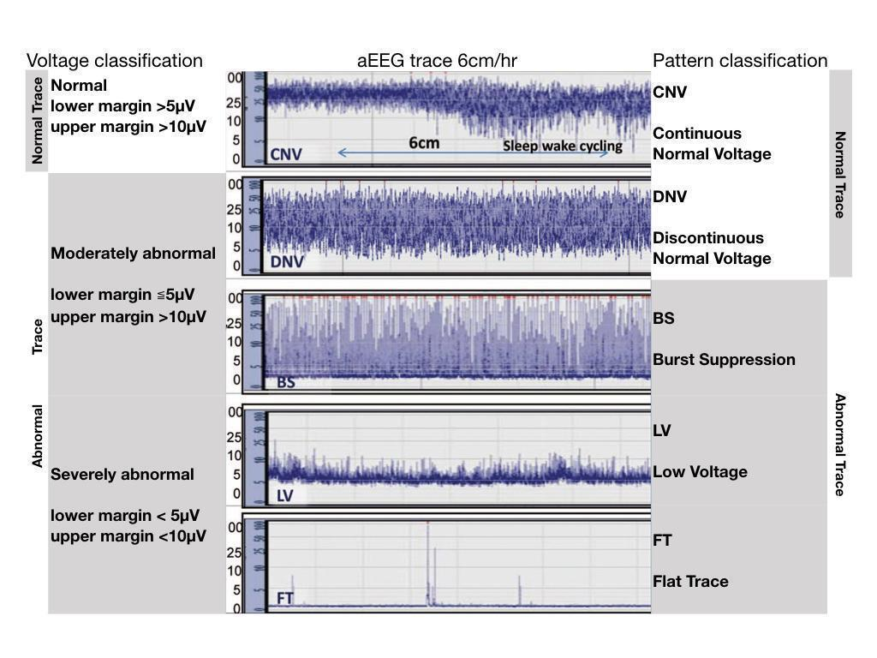

    - 背景腦部功能異常嚴重度可依照振幅或是形態去定義
  - 正常：aEEG 的活動頻帶的下側邊緣在>5μV。睡眠喚醒週期存在。
  - 輕微異常：aEEG的活動頻帶的下側邊緣在>5μV。睡眠喚醒週期不存在。
  - 中度異常：aEEG的活動頻帶上側邊緣在>10μV，下側邊緣在<5μV。
  - 嚴重異常： aEEG 的活動頻帶上側邊緣在<10μV，下側邊緣在<5μV。
  - 中度的腦病變：非連續性的形態Discontinuous pattern
  - 重度的腦病變：猝發壓抑 Burst suppression，連續性低電壓Continuous low voltage，平坦波Flat trace

- 痙攣訊號：與aEEG有關的痙攣發作特點是電壓突然增加，伴隨著縮小的aEEG活動頻帶，並隨後會有一段短暫的發作後抑制期間，在原始腦波raw EEG可見異常。可分為Single, Repetitive, Status epilepticus。
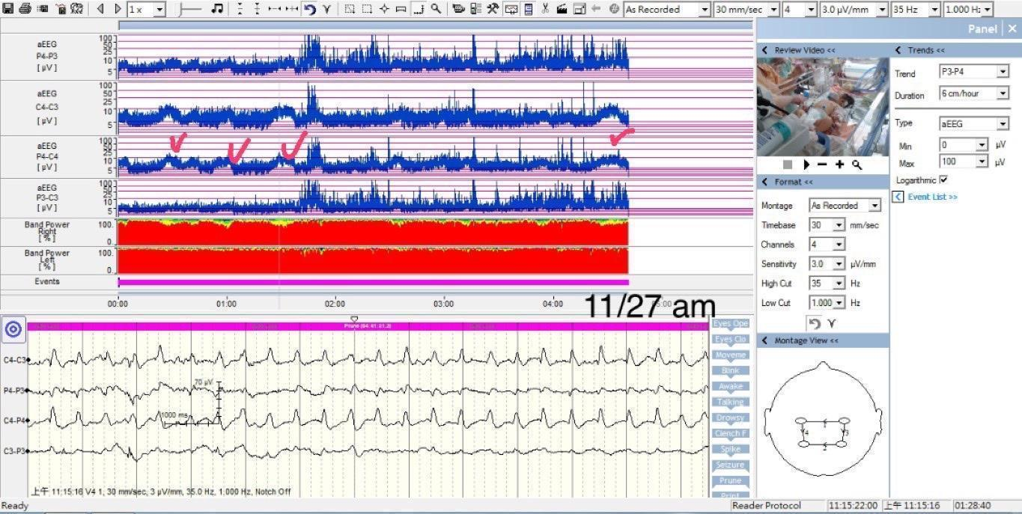
注意：若aEEG看到疑似seizure訊號，應調閱當時的raw EEG，若無異常波型就不是seizure。如下左圖。
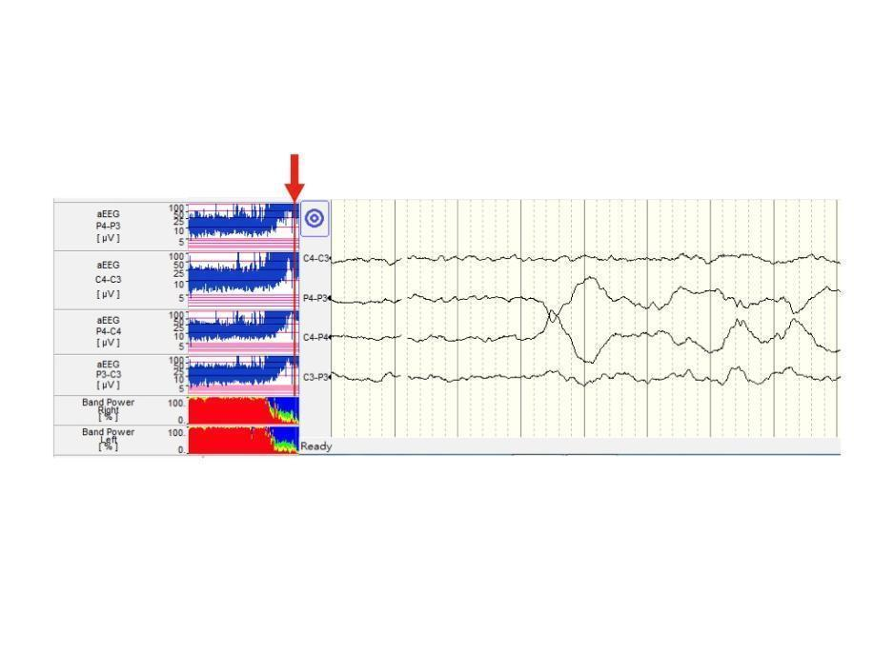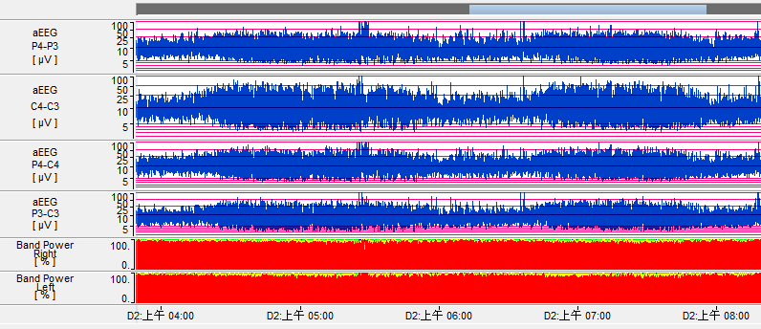

- 睡眠喚醒週期：睡眠時期的振幅較寬，清醒時則較窄。可分類為Developed, Immature, Absent。如上右圖。

- aEEG 的臨床應用
  - aEEG 形態符合 mod HIE 定義者，於 severe HIE 相比，對低溫療法的反應較好。
  - 在腦傷後的3-6小時的aEEG可預測18個月後的無嚴重殘疾的存活率：
若aEEG正常，18個月時的無嚴重殘疾的存活率為100%，
若aEEG有重度異常，18個月時的中重度殘疾或死亡率為59%。
  - 若接受低溫療法的病嬰在出生48小時後aEEG轉為正常（EEG形態，以及正常的睡眠清醒週期）、預後較好。
  - 以aEEG來偵測發作正確率只有40-76%，只能用於篩檢，也可能會有偽陰性的可能。不能用於確診發作。
  - 偵測Subclinical seizure。接受低溫療法的病嬰約有34%會有seizure，而其中43%屬於subclinical seizure是臨床上看不到症狀的。(Ref: Nash et al. 2011)
- Treatment for Neonatal abstinence syndrome(NAS) (2024年修)
- Check NAS score q 4 h, 但若NAS score > 8, 則q 2 h check
請掃下列 QR code 參考 NAS 評分項目

- Medication
- Neonatal opium solution (NOS): 將opium tincture 以Distilled water稀釋25倍(=0.4mg/ml of morphine) (MMH目前沒有)
- Morphine Sulfate (15mg): 0.5# in D/W 7.5ml=1mg/ml of morphine 冰箱保存一週
NAS Score | NOS (0.4mg/ml) | Morphine Sulfate(1mg/ml)
8-10 | 0.8 ml/kg/day Q4H | 0.32ml/kg/day Q4H
11-13 | 1.2 ml/kg/day Q4H | 0.48ml/kg/day Q4H
14-16 | 1.6 ml/kg/day Q4H | 0.64ml/kg/day Q4H
≥ 17 | 2.0 ml/kg/day Q4H;  每次加＋0.4ml/kg直到症狀控制住 | 0.80ml/kg/day Q4H  每次加＋0.16ml/kg直到症狀控制住
  - Side effect: sleepiness, constipation, poor suck, and ultimately profound narcosis with obtundation, hypothermia, respiratory depression, apnea and bradycardia
  - If this occurs, stop the medication until the abstinence scores >8.
  - Add Phenobarbital to control irritability when the NOS is > 2 ml/kg/day
- Phenobarbital (5-8 mg/kg/day)
  - IM or PO TID, and taper by 10% each day after improvement of symptoms.
  - Drug of choice if the infant is thought to be withdrawing from a nonnarcotic drug or from multiple drug use.
  - Does not control the diarrhea that occurs with withdrawal.
  - Using Phenobarbital with NOS allows a lower dose of NOS and lessens the side effects.
- Weaning:
- If NAS score <8 for 1-2 days→wean by 10% of total dose q 1-2 days
- If NAS score >8 after weaning→restart the last effective dose
- DC when the daily dose of NOS < 0.3 ml/kg/day or Morphine Sulfate<0.12ml/kg/day
- Observe the infant for 2-3 days under no medication control prior to discharge.
- If the scores are too low, make sure that the infant is not overdosed.

- Neonatal stroke 2025新增
- Classification (clinical-anatomic subtypes)
- Arterial ischemic stroke
- Hemorrhagic stroke
- Cerebral sinovenous thrombosis (CSVT)
- Periventricular venous infarction (PVI)
- Clinical presentations: Encephalopathy, seizure, abnormal tone, focal neurologic deficits, respiratory impairments(apnea), and feeding problems
- Diagnosis
Define lesion
- Cranial doppler sonogram, brain CT
- MRI (greater sensitivity and specificity)
- DWI may underestimate full extent of infarction: first 24 h and after day 5
- T2 & T2 FLAIR more reliable than DWI at day 7 and later in term newborns
- Neurovascular imaging: MRA, MRV
Investigate underlying cause
- CBC/DC, PLT, CRP, B/C, ABG, blood group, BUN/Cr, GOT/GPT, CK/CKMB, dextrose, PT/APTT, D-dimmer, Fibrinogen, FDP
- Collage /EPI closure time
- Factor XIII Activity (自費)
- Von Willebrand factor (vWF Activity)
- Anti-Thrombin III (AT-III), Protein-C/S test
- Echocardiogram: detect structural heart disease with right- to-left shunt
- Management
Supportive care
- Adequate oxygenation and ventilation
- Correct dehydration and anemia
- Monitor and correct metabolic disturbances(acidosis, hypoglycemia, hypocalcemia, and electrolyte disorders)
- Antiseizure medications
Prevent further injury
- In acute CSVT: consider anticoagulation with unfractionated heparin or LMWH
- For intracerebral hemorrhage:
- Correction of markedly low platelet counts
- Replacement of deficient coagulation factors for neonates with coagulation factor deficiency
- Ventricular drainage or shunting for hydrocephalus

- Vein of Galen aneurysmal malformation (VGAM) 2025新增
- Classification
- Primary
  - choroidal type:Multiple feeders, including: thalamoperforating, choroidal and pericallosal arteries are located in the subarachnoid space in the choroidal fissure
  - mural type:Fistulae in the subarachnoid space in the wall of the median prosencephalic vein
- Secondary:Parenchymal Arteriovenous Malformations
- Clinical presentations: The greater the size, the larger the degree of shunting through the lesion, and the earlier the presentation.
- CV : high-output cardiac failure, pulmonary hypertension, and multiorgan system failure
- Neuro: Cyanosis, hemorrhagic lesions, hydrocephalus, cerebral atrophy,impaired cortical development
- Diagnosis
- Prenatal screening ultrasound or with the fetal MRI
- Cranial doppler sonogram
- Brain CT with
- MRI
Investigate for severity of heart failure
- Echocardiogram
- Renal and liver function test
- EEG
- Management: The main therapy goal is to minimize congestive heart failure
Bicêtre score
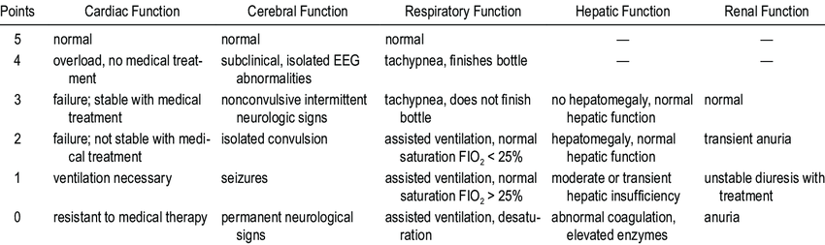
- < 8 points：No treatment (recent studies showed this group receiving embolization may still have good outcome)
- 8-12 points：Emergent embolization
- >12 points：Embolization at 5 months of age with continue management
- Embolization：the main approach to treatment and can be performed by an arterial transarterial approach using liquid adhesive agents or micro coils or by a transvenous approach typically using the umbilical or femoral veins.
- Microsurgery： not a primary treatment, but may still be performed for persistent hydrocephalus, intracranial bleeds, hematomas, or when embolization fails

