Nephrology

- Acute Renal Failure
- Hematuria
- Urinary Tract Infection
- Newborn CCr formula, Creatine ref
- Peritoneal Dialysis
- 新生兒 CVVH Protocol
- Nephrolithiasis

- Acute Renal Failure
- Definition
- Anuria or oliguria with an associated increase in serum creatinine.
- It is recognized now that acute renal failure in the neonate can present with anuria (<0.5 ml/kg/hr), oliguria (<1 ml/kg/hr), normal urine output (1-5 ml/kg/hr) or polyuria (>5 ml/kg/hr)
- Etiology
- Prerenal Causes
  - Decreased plasma volume: hemorrhage, dehydration, sepsis
  - Other causes of renal hypoperfusion: hypoxia, RDS, CHF, shock
- Intrinsic (renal) Causes
  - Congenital renal anomalies: Bil.agenesis, bilateral multicystic (dysplastic) kidneys (MCDK), infantile polycystic kidney disease (ARPKD, ADPKD)
  - Vascular lesions: renal artery thrombosis, renal vein thrombosis
  - Ischemic: shock, hemorrhage, dehydration, sepsis, hypoxia, RDS
  - Nephrotoxic: aminoglycoside antibiotics
  - Uric Acid: hyperuricemia in the newborn
- Postrenal Causes
  - Bilateral obstruction: posterior urethral valves, trauma to urethra, imperforate prepuce, urethral diverticulum, neurogenic bladder, megacystis, megaureter syndrome
  - Obstruction of only functioning kidney ureteropelvic junction obstruction
- Incidence: 1%-8% (some studies, up to 23%), prerenal factor as the cause in 73%
- Clinical presentation
- Decreased or absent urine output
- Family history: urinary tract disease (congenital anomalies), oligohydramnios
- Physical examination
- Abdominal mass: distended bladder, hydronephrosis, polycystic kidney
- Potter's facies
- Meningomyelocele
- Pulmonary hypoplasia
- Urinary ascites
- Prune belly: 先天性腹肌缺失
- Diagnosis
- Bladder catheterization: to check the existence of urine in the bladder
- Lab. study:
- serum BUN and creatinine
- Urinary index:
- CBC/DC + platelet: thrombocytopenia
- Electrolyte: K↑
- Urinalysis: hematuria (renal vein thrombosis, tumors, DIC), pyuria (UTI)
(2021 修) | Prerenal | Intrinsic
Urine flow rate (mL/kg per hour) | Variable | Variable
Urine osmolality (mOsm/L) | >400 | ≦400
U/P osmolar ratio | >1.3 | ≦1.0
U/P creatinine | 29.2±1.6 | 9.7±3.6
Urine sodium (mEq/L) | 10-50 | 30-90
Fractional excretion of sodium (FENa) % | <0.3 (0.9±0.6) | >3.0 (4.3±2.2)
Renal failure index (RFI)# | <3.0 (1.3±0.8) | >3.0 (11.6±9.5)
Response to fluid challenge | Improved tachycardia; Increased UOP | No effect on tachycardia or UOP
* FENa = (UNa/UCr) × (PCr/PNa)×100 | UNa = Urine sodium in mEq/l  UCr = Urine creatinine in mg/l  PCr = Plasma creatinine in mg/l  PNa = Plasma sodium in mEq/l
# RFI = (UNa /UCr) × PCr
Reference: Avery’s diseases of the newborn 10th ed p 1287
- Diagnostic fluid challenge (see treatment)
- Radiologic studies
- Abdominal ultrasonography
- Intravenous urography: limited usefulness
- Abdominal X-ray study
- Radionuclide scanning: DMSA, DTPA
Definition of neonatal acute kidney injury (2021 修)
Stage | Serum creatitine | Urine output/24 Hours
0 | No change in SCr or rise < 0.3 mg/dL | > 1 mL/kg/h
1 | SCr rise ≧ 0.3 mg/dL within 48 h OR | > 0.5 and ≦ 1 mL/kg/h
 | SCr rise ≧1.5–1.9 x Reference SCr within 7 d
2 | SCr rise ≧ 2.0–2.9 x Reference SCr | > 0.3 and ≦ 0.5 mL/kg/h
3 | SCr rise ≧ 3 x Reference SCr OR | ≦ 0.3 mL/kg/h
 | SCr ≧ 2.5 mg/dL OR
 | Receipt of dialysis
* Reference SCr will be defined as the lowest previous SCr value
** SCr value of 2.5 mg/dL represents < 10 mL/min/1.73m2
Reference: Avery’s diseases of the newborn 10th ed p 1281
- Treatment
- Fluid
- The “Fluid challenge” is perhaps the most useful diagnostic test (重建kidney perfusion 很重要)
“Appropriate” volume expander: 10-20 ml/kg。ex: N/S, blood products, 5% albumin
Contraindication of fluid challenge and mannitol: fluid overload, CHF, or severe hypertension
- Dopamine, low dose (2-5 mcg/kg/min) (less therapeutic value currently)
If no response is obtained (>2 mL/kg of urine per hour)-> diuretic
if furosemide ineffective, should be discontinued to avoid the associated risk of ototoxicity
- Furosemide
Single dose: 1 mg/kg/dose, (range: 0.5~2 mg/kg/dose Q6-12H)
Continuous: 0.1 - 0.2 mg/kg/hr, 以12~24hrs U/O調整,每次0.1 mg/kg/hr, Max 0.4~0.5 mg/kg/hr
- Burinex：單次最大劑量或許可以高至0.1 mg/kg/dose
Preterm：0.01- 0.06 mg/kg/dose Q12-48H ; Term：0.01-0.05 mg/kg/dose Q12-48H
- Prostaglandin E1 may at as a diuretic in neonates and is useful in increasing renal perfusion and naturesis. Prostaglandin is not used extensively for this purpose.
If no response is obtained -> Obstruction should be ruled out
      - Place a lubricated 5-8 Fr feeding tube in the urethra
      - Renal eho
      - Fluid restriction
      - weighting the patient twice a day
      - 計算 I/O, total output = insensible water loss + urine and GI losses
Insensible water loss ( a normal newborn ) = 50 ml/kg/day
      - The goal of fluid restriction may be impossible → Peritoneal dialysis or CAVH (Continuous arteriovenous hemofiltration) or CAVHD (Continuous arteriovenous hemofiltration and dialysis)

Transdermal Water Loss (g/100 cm2/day)
GA\ d/o | 1 | 3 | 5 | 7 | 14 | 21 | 28
26 | 14.40 | 11.09 | 5.54 | 4.44 | 3.02 | 2.93 | 2.81
28 | 9.60 | 9.07 | 4.63 | 3.43 | 2.52 | 2.33 | 2.21
30 | 6.96 | 6.46 | 4.13 | 3.53 | 2.90 | 2.28 | 2.02
32 | 5.95 | 5.74 | 3.82 | 3.02 | 2.52 | 2.11 | 1.80
34 | 4.94 | 4.44 | 2.83 | 2.52 | 2.21 | 1.80 | 1.51
36 | 3.53 | 3.22 | 2.62 | 2.33 | 1.70 | 1.42 | 1.32
38 | 3.34 | 3.02 | 2.52 | 2.02 | 1.61 | 1.37 | 1.32
40 | 3.22 | 3.02 | 2.33 | 1.82 | 1.42 | 1.32 | 1.30
reference: Avery’s diseases of the newborn 9th ed p 371

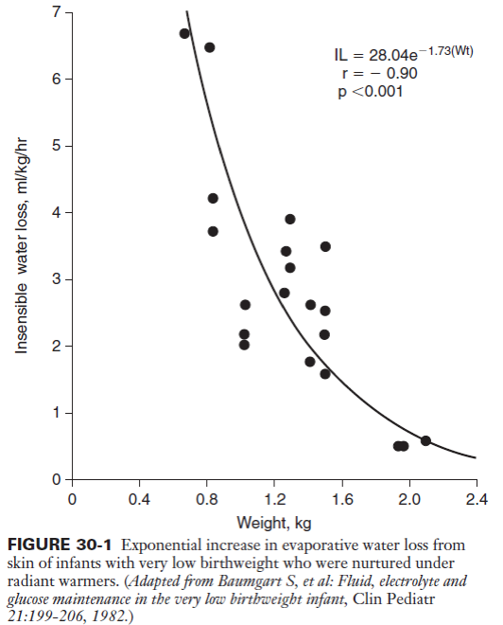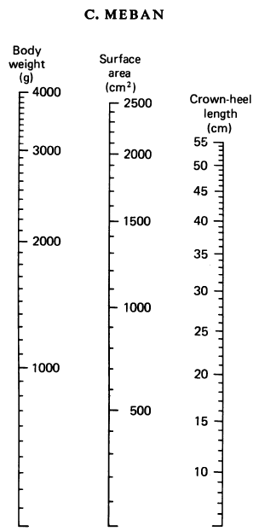
C. MEBAN, J. Anat. (1983), 137, 2, pp. 271-278

- Correct electrolyte imbalance and metabolic acidosis
- Follow serum Na and K levels
- IV bicarbonate therapy if the pH < 7.25 or serum HCO3- < 12 mEq
- Restrict protein < 2g/kg/day and ensure adequate nonprotein caloric intake
- Follow BP serially: always at risk for developing chronic H/T
- Although BP initially may be low in neonatal acute renal failure, mild hypertension is common later.
- Secondary to the specific diagnoses of polycystic kidney disease and renal artery thrombosis, the H/T may be more acute and more severe.
- For practical purposes, significant H/T in the term infant: BP >100/70; Premature infant: >90/60
- UAC lines are perhaps the most frequent cause of renal arterial occlusion in the neonate. The infusion solutions usually contain heparin at 0.2-1 unit/mL
- Initial management consists of fluid and electrolyte control.
- Antihypertensive agents:
- Diuretic therapy is inappropriate in patients with ARF.
- ACE inhibitors, used with caution, are a good first approach; they have excellent efficacy in the H/T associated with renal artery thrombosis.
- Life threatening H/T in the neonate can be treated with diazoxide or nitroprusside.

- Dialysis
Persistent hyperkalemia with K> 7 mEq/L and ECG changes
Congestive heart failure with fluid overload | Hyperuricemia
Refractory acidosis with HCO₃<12mEq/L | Hyperphosphatemia
Uncontrolled hypertension | Refractory hypocalcemia
Uremic encephalopathy | Uremic coagulopathy
Rapidly progressive azotemia with BUN > 100 mg/dL | Pericarditis
Supportive dialysis (facilitate administration of nutritional fluids, blood products, drugs)

- Hematuria
- Definition
- Presence of gross or microscopic blood in the urine
- A red-stained diaper: may due to bile pigmented, porphyrins or urates
- Incidence not a common problem in newborns
- Etiology
- perinatal asphyxia  - cortical or medullary necrosis  - infection  - trauma (bladder aspiration or catheterization)  - renal vein or artery thrombosis | - hyperosmolar infusion into umbilical catheters  - neoplasms  - urinary tract obstruction (urolithiasis following lasix)  - coagulopathy  - neonatal glomerulonephritis (most caused by syphilis)
- Diagnosis
- Lab. Study : urinalysis/urine culture/ serum BUN, Cr/ coagulation study : PT, PTT, Thrombin time
- Ultrasonography/IVP/nuclear scans
- Management：directed at the underlying cause
- Urinary Tract Infection
- Incidence
- 0.5-1.0 % in term infants ; 3-5 % in preterm infants or BW < 2500g
- Note: male>female incidence in neonatal period
- Pathophysiology
- UTI presents in an infant 1 y/o with associated urinary tract abnormality found in about 50 % of neonates
- The most common organisms are gram-negative rods, E. coli.
- In neonates, UTI are frequently acquired by hematogenous spread
- Risk Factors
indwelling urinary catheters, systemic sepsis, urinary tract obstruction, neurogenic bladder, male newborns
- Clinical presentation
- Signs of sepsis
- Nonspecific findings：poor feeding, vomiting, jaundice, failure to thrive
- Diagnosis
- urinalysis
- urine culture: bladder aspiration/catheterization
- blood culture, CBC/DC, serum bilirubin
- Management
- Initial antibiotics treatment：IV Ampicillin + gentamicin until definitive U/C and B/C
- Further investigations: renal /bladder ultrasound, VCUG, renal scan/IVP (for complex problems)
- Prognosis
- One-fourth of infants can have recurrent UTI within the first year of life
- Effective use of long-term suppressive antibiotics (in VUR ) + indicated corrective surgery reduce incidence of renal scarring and renal insufficiency
- Newborn CCr
- Newborn CCr算法: GFR = K * height (cm)/ Cr (plasma)
Age Group | Proportionality Constants (K)
Low birth weight infants, age < 1 yr | 0.33
Term infants, age < 1 yr | 0.45
Children, ages 2-12 years | 0.55
Girls, ages 13-21 years | 0.55
Boys, ages 13-21 years | 0.70

- Lab data (Ref: 1. Nelson 17 th edition, 2. Pediatric dosage handbook 16 th edition 3. Manual of neonatal care 6 th edition)
 | NB | Child | Ref
P | 4.2-9.0 mg/dL | 6w-19m/o: 3.8-6.7; 19m-3y/o:2.9-5.9; 3-15y/o:3.6-5.6 ; >15y/o:2.5-5 | 2
Uric acid | <7 mg/dL | Male:3-7；Female:2-6 | 2,3
Cr | <0.7 mg/dL | ≦1y/o: ≦0.6；1y/o-15y/o:0.5-1.5 | 1,2
LDH | 290-501 units/L | 110-144 units/L | 3

- Creatinine level (mg/dL) Ref: Journal of Perinatology (2008) 28, 226–229
GA  (wk) | At birth | 12h | 24h | 36h | 48h | D3 | D4 | D7 | 2W | 3W | 4W | 5W | 6W | 7W | 8W
22-24  (n=33) | 0.90 | 1.08 | 1.20 | 1.30 | 1.34 | 1.32 | 1.33 | 1.23 | 1.24 | 1.04 | 0.80 | 0.79 | 0.62 | 0.60 | 0.58
25-26  (n=55) | 0.87 | 1.03 | 1.18 | 1.25 | 1.27 | 1.28 | 1.26 | 1.17 | 0.95 | 0.84 | 0.76 | 0.64 | 0.59 | 0.54 | 0.52
27-28  (n=73) | 0.91 | 1.05 | 1.17 | 1.20 | 1.18 | 1.17 | 1.14 | 1.04 | 0.88 | 0.75 | 0.66 | 0.62 | 0.57 | 0.53 | 0.52

GA (wk) | 出生後天數
 | 2 | 7 | 14 | 21 | 28
<28 | 1.31 | 0.95 | 0.81 | 0.68 | 0.66
29-32 | 1.18 | 0.94 | 0.78 | 0.67 | 0.59
33-36 | 1.05 | 0.77 | 0.62 | 0.57 | 0.40
37-42 | 0.85 | 0.56 | 0.43 | 0.40 | 0.34
- 腹膜透析
- 適應症(Indications)
- 急性腎衰竭(Acute renal failure)
  - 嚴重或有症狀的電解質不平衡(Electrolyte imbalance)：高血鉀症(Hyperkalemia)
  - 酸血症(Severe acidosis)
  - 水分儲積太多(Fluid overload)：高血壓、鬱血性心衰竭或肺水腫
  - 嚴重的腎功能不全(Renal insufficiency)：BUN>100 mg/dL或Creatinine上升太快
  - 有尿毒的症狀：如腦病變(Uremic encephalopathy)
- 毒物的移除（如先天代謝異常導致的高氨血症等）
- 禁忌症(Contraindications) ：臍膨出(omphalocele)、腹裂(gastroschisis)、橫膈疝氣、膀胱外翻、腹膜沾黏、NEC、VP shunt、剛動過腹膜手術仍有引流管時
- 外科beside放PD管時參考用藥
  - Fentanyl 0.04 cc/kg/dose
  - Atracurium 0.3 mg/kg/dose
  - Ketamine 0.02 cc/kg/dose
- 操作步驟
  - 於superior anterior iliac crest與肚臍連線外1/3處定位。
  - 消毒，鋪洞巾。以22號IC自肚臍與symphysis pubis連線上1/3處插入，拔出硬管，將軟管推入，注入warm normal saline (10ml/Kg)。
  - 以Xylocaine局部麻醉，於定位點劃0.5 cm 的平行傷口，先縫一針以利後續固定，並將下方的脂肪組織盡量撐開。以外包PD tube的 trocar 垂直插入，直到出現裂痕聲，表示已穿破腹膜進入腹腔。將trocar稍往外拉，以免傷及內臟，再將trocar與PD tube一起朝Douglas pouch向下插入至底，此時先前打入的 normal saline 應由PD tube流出。將多餘的tube 剪掉，留下約1cm的PD tube以利固定位置，接上Y型管並縫合傷口
  - 照一張Plain abdomen film 看 PD tube位置是否正確。
  - 每隔三天應重換PD導管，以防感染。
  - 若PD tube流出不順，可打入normal saline沖洗，絕不可回抽，否則易吸住mesentery，造成 bleeding。若流出的PD solution 呈鮮紅色，則每CC加1～2單位的Heparin 沖洗，直到流出液變clear為止
  - PD solution可分為1.5％/2.5％/4.25％ glucose三種濃度,濃度越高者,脫水效果越好。
  - PD order: 通常以10cc/kg/cycle 開始, 然後漸加至15cc/kg/cycle, 最高不要超過20cc/kg/cycle
  - PD solution 放置於腹腔時間愈久,脫水效果愈差。如欲脫水者,可縮短透析時間(如每個小時換液一次)。
  - Drain 時間：若位置正確，功能良好時，10～15分鐘即可。
  - 若要Hold Peritoneal dialysis時, 要先將PD管路密閉不可打開。

- 新生兒 CVVH Protocol
- 適應症
- 急性腎臟衰竭：無尿期超過48小時、高血鉀且伴有心電圖之變化、嚴重高尿酸血症、尿毒性腦病變
- 敗血症：移除發炎物質
- 猛爆性肝炎: bridge to liver transplantation
- 身體體液過多、充血性心臟衰竭
- 代謝急症：楓糖尿症，脂肪酸代謝異常，尿素循環代謝異常，丙酸血症
- 誤食毒性物質
- 處理流程
- 與兒童腎臟科醫師共照
- 聯絡心臟血管外科置放血液透析導管/腹膜透析管
- 聯絡 CVVH 廠商 (機器及管路安裝)
- 醫囑開立：快速鍵-CVVH/CVVH A 液加KCl: CVVHKCL
Sign CVVHD Permit
備+ 輸全血 45ml (for priming) | 體外管路約 43ml
Filter: D150
Tubing Set: TS-400-05
Check ACT stat & q2H, keep 150-200 | ACT與baseline 差不多即可
Check Hct, ABG, Na/K/Cl/Ca/P, Dex q6H | K ≥2.5mEq/L
Check CBC/DC、BUN/Cr qD
Check I/O q8H & BP q1H
CVVH Solution A: 3000ml | K 低從這裡補
CVVH Solution B: 2760ml + 7% NaHCO3 240ml | 不變
AK priming: N/S 2000ml with heparin 10000U
Priming with whole blood 45ml
Blood Flow Rate: 5-10 mL/kg/min | 要≥25ml/min， 血壓不好可降到 20ml/min
UF: 35ml/kg/hr, high volume 50-75ml/kg/hr | 維持 (UF/BFR)x60 ≤ 30%
Pre-dilution 50% | 管路血液容易栓塞時，可考慮加到 60%
Weight loss: 0 mL/hour | 依照病人狀況可隨時調整
No Heparin/Heparin Infusion Rate: 5-20U/kg/hr | 若有凝血功能異常/敗血症不用Heparin Pump
Warm Dialysate to 38C | 宜設在 37-38C間; ≥38.5C 透析液會產生結晶
- 常見問題處理及參數調整
- 血壓低:
    - 降低 blood flow rate (過低容易形成血栓)
    - 降低脫水量
- 跨膜壓增加
    - 降低 ultrafiltration rate
    - 更換管路並考慮加上或是增加heparin劑量
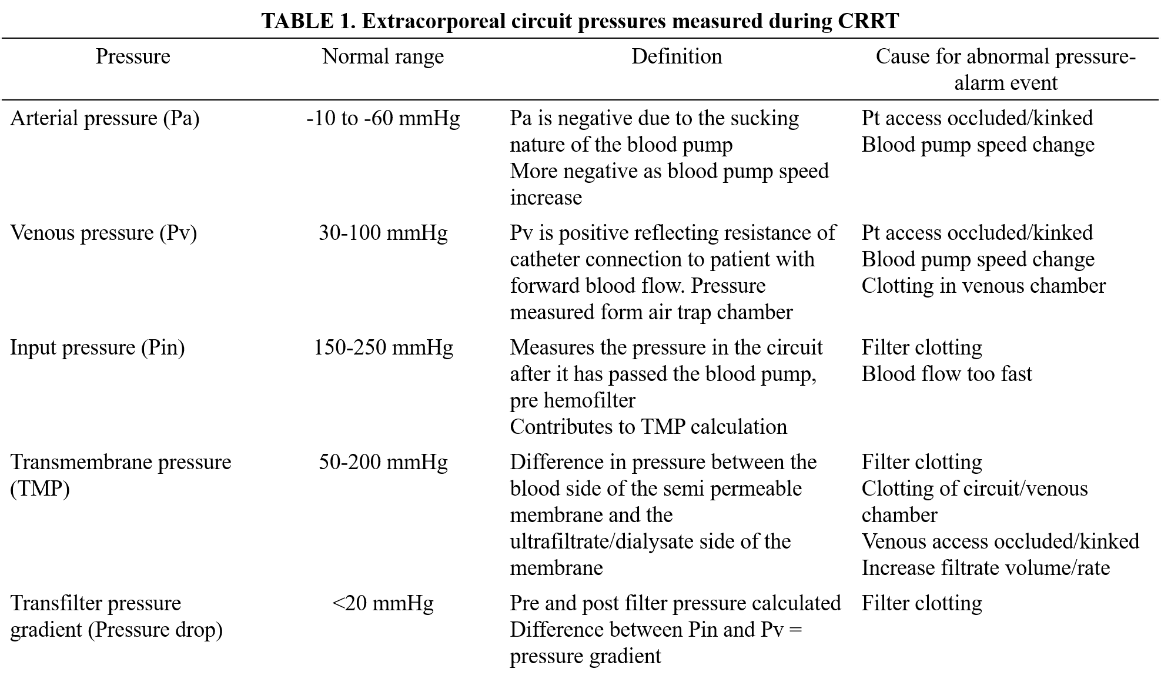
- 附錄 (一)、血液透析導管
- 管路選擇
    - MedComp 8Fr Double Lumen - NICU 常備一組，其他常備單位: PICU
    - Arrow 16Ga One Way CVC - NICU 常備兩組，其他常備單位: 麻醉科
    - Arrow 4Fr Two Way CVC - NICU 常備
    - MedComp 7Fr CVC **罕病基金會 **
- 施打部位
    - Double Lumen: 右內頸/右外頸/左內外頸/左右股靜脈
    - Single Lumen: trans-diaphragmatic
- 管路維護
    - 透析靜脈導管
    - 預防導管內血栓形成-On heparin lock ： 以1ml 5000U 之 Heparin不稀釋，推入管路上標示priming量，on lock
    - 預防 Staphyloccus/ Streptococcus 感染：Heparin- Vancomycin lock （25mcg/mL Vancomycin & Heparin 100U/L）

    - 中央導管
    - 以普通點滴持續輸注使用
    - 若管路已阻塞：Urokinase 1amp (60,000) dilute with N/S to 12ml, prime the lumen with 0.6ml, and on lock immediately. Hold the solution in the lumen for 15 minutes. Repeat up to 3 times.
附錄 (二): CVVHA液鉀離子含量對應血鉀濃度
KCl | CVVHA液 | 對應血中鉀離子濃度
7.5ml | 3L | 2.5mEq/L
9ml | 3L | 3.0mEq/L
10.5ml | 3L | 3.5mEq/L
12ml | 3L | 4.0mEq/L

附錄 (三): ACT 數值矯正
ACT 數值 | Heparin Pump 滴數調整
>240 | Hold heparin pump
221-240 | -0.4
181-220 | 0
161-180 | 0.4
140-160 | 0.8
120-139 | 1.2
  - Heparin pump 泡法: BW (kg) * 1ml (5000U) Heparin in 500ml N/S, run 1ml/hr (10U/kg/hr)
附錄 (四): 相關聯絡人
廠商/產品 | 聯絡人 | 電話
CVVH 機器廠商 | John | 0985-397-588
前茂/美德康&亞諾 導管廠商 | 戴’R | 0933-025-505

- Nephrolithiasis
- Incidence: 7~41% in prematurity
- Pathogenesis: 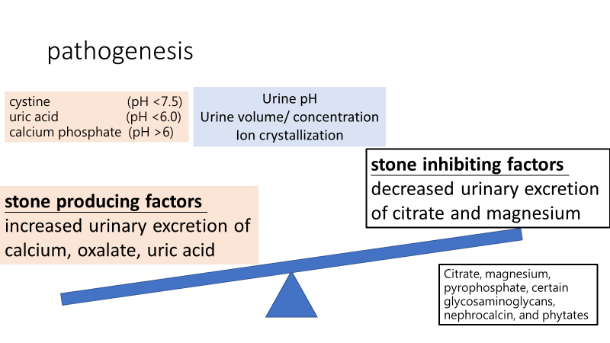
- Risk factor:
  - Prematurity (especially male, GA<32wks, VLBW)
目前本院常規針對 ELBW (BW < 1000gm) infants 在出院前會安排 Kidney echo
    - Renal tubule immaturity
    - Increased likelihood of hypercalciuria, hypocitraturia
    - Nephrogenesis：Calcium oxalate crystal adherence to hyaluronan, osteopontin, and CD44 expressing injured/regenerating tubular epithelial cells
    - Lower GFR
    - Lower fluid flow rate within the tubular lumen
    - VLBW : decreased bicarbonate reabsorptive capacity
    - Drug exposure: Furosemide (especially > 410 mg/kg/day , the strongest risk factor of nephrocalcinosis), Dexamethasone, xanthine(theophylline, caffeine), aminoglycoside
    - Length of assisted ventilation and Oxygen therapy
    - Length of hospital stay
    - Formula and parenteral feeding
  - Genitourinary anomalies
    - 30% of children with urolithiasis
    - 50% with metabolic abnormality：Hypercalciuria, 34~50%、Hyperoxaluria, 10~20%、Hypocitraturia, 10%、Cystinuria, 5~20%、Hyperuricosuria, 2~20%
- Symptoms and signs
    - acute, severe flank pain, radiation to groin are uncommon, particularly in children < 5 years
    - Macroscopic or microscopic hematuria, nonspecific pain localized to the abdomen, flank, or pelvis
    - may be confused with colic pain
    - Renal stones may be found incidentally
    - UTI

- Lab evaluation
    - Urine
- Specific gravity  - pH  - Hematuria or pyuria  - Culture | - Glucosuria/proteinuria for tubular dysfunction  - Cystine(目前無法驗)  - Microscopic exam for Crystal  - Calcium , oxalate, uric acid, citrate(目前無法驗) ratio to Cre
    - Blood：Ca, Mg, P, Cre, uric acid；If hypercalcemia→parathyroid hormone, 25(OH)-D
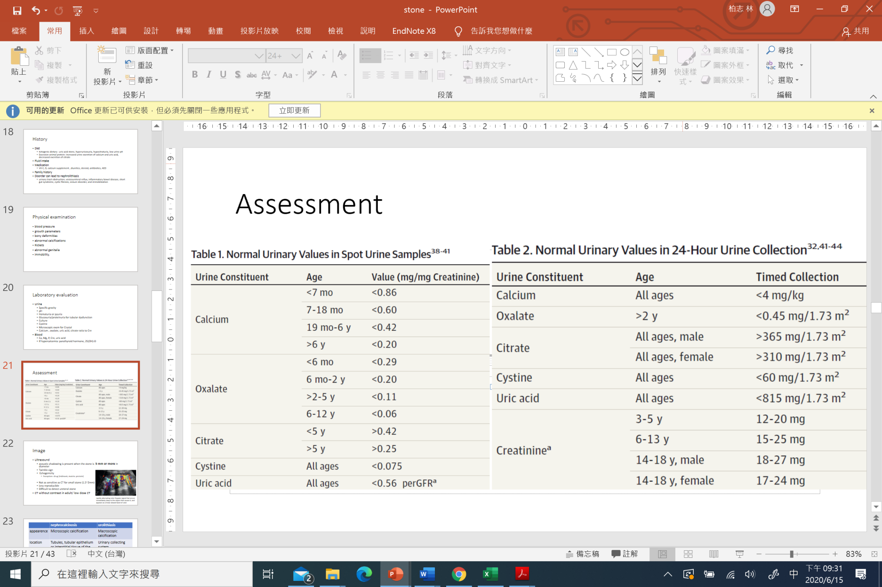
- Treatment
    - Increase fluid intake, at least 1.5 to 2 L/m²/d
    - Keep U/O> 750ml/day in infant
    - Decrease sodium intake
    - Lower Ca/P intake；Dietary calcium restriction is not recommended since it can increase intestinal oxalate absorption
    - No restriction of protein
    - Change loop diuretics to Thiazide
    - Magnesium supplement
    - Correction of low Vit D
    - 額外藥物見下表 (Dr. 蔡: potassium citrate 0.5~1 meq/kg/day)
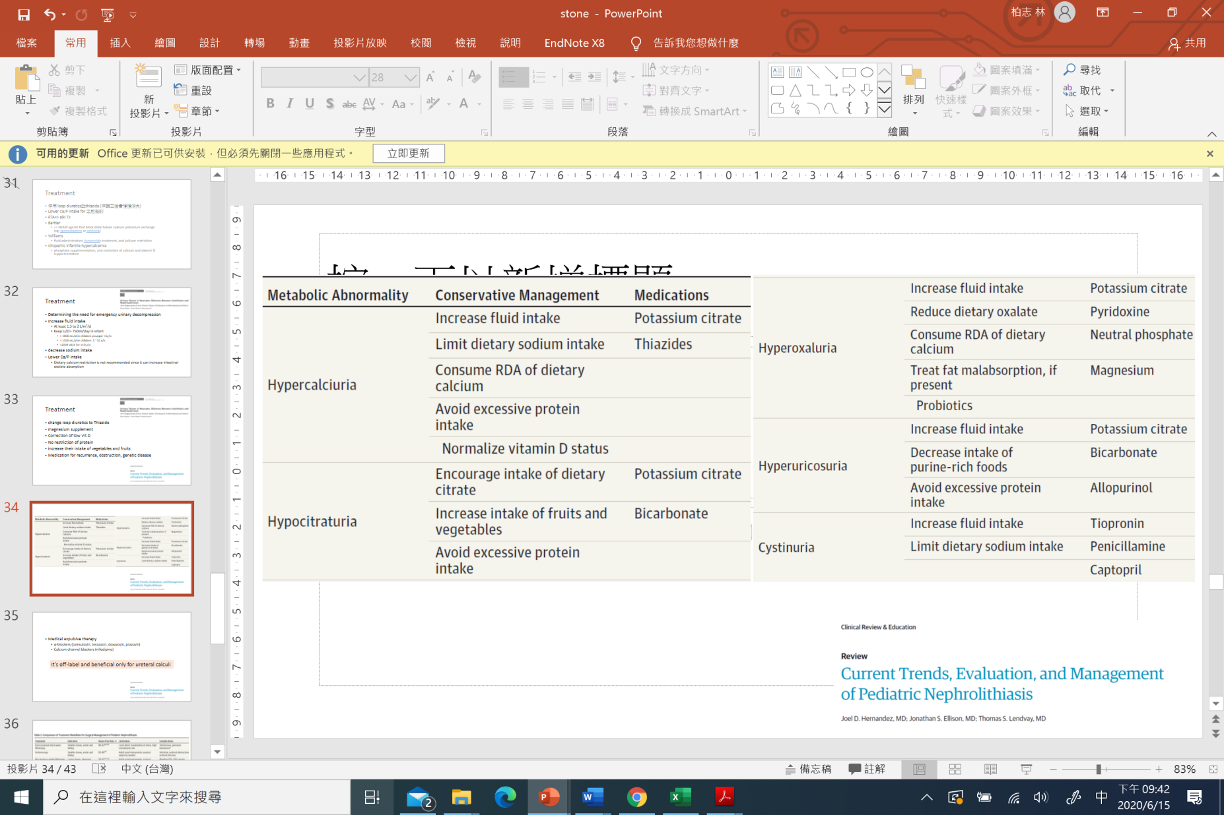
Ref: Urolithiasis in Children, Pediatr Clin N Am 59 (2012) 881–896
Current Trends, Evaluation, and Management of Pediatric Nephrolithiasis, JAMA Pediatr. 2015;169(10):964-970

