Gastroenterology

- Hyperbilirubinemia of neonates
      - Unconjugated hyperbilirubinemia
      - Exchange Transfusion
      - Conjugated hyperbilirubinemia + cholestasis 藥物
      - Prolonged jaundice
- Contrast enema
- Stoma care
Trust Guideline for the Management of Stoma Output in Neonates and Infant
- IHPS management algorithm
- GI drugs

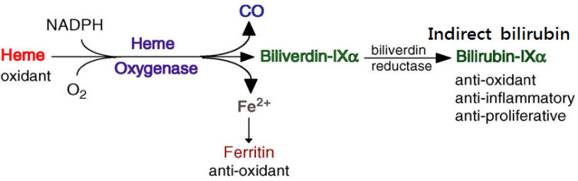
- Hyperbilirubinemia of neonates
- Bilirubin
- Sources: heme-containing protein
  - Major 75% from hemoglobin,
1 gm Hb → 34 mg bilirubin
  - Other 25%- “early-label hemoglobin”
    - from ineffective erythropoiesis in the bone marrow
    - from other heme containing protein in tissues, eg: myoglobin, peroxidase...
    - from free heme
  - Normal bilirubin production rate in normal newborn 6-10 mg/kg/day, higher than in adult (3-4 mg/kg/day) because
    - Greater RBC mass
    - Shorter RBC life span by nearly 25%
- Metabolism
  - Transport in blood
    - Unconjugated bilirubin (bilirubin IX alpha) is a weak acid and lipophilic
    - Unconjugated bilirubin is bound to albumin in blood (1g albumin binds 8g bilirubin in term infants, less in preterm infants)
    - Albumin binding sites may be occupied by other agents (eg. valium) and the binding may be reduced by decreased pH
  - Metabolism by hepatocytes
    - Unconjugated bilirubin is taken up by hepatocytes, bound by carrier proteins (including Ligandin) and conjugated by uridine diphosphate glucuronyl transferase (UDPG–T)
    - Conjugated bilirubin is water soluble
    - Phenobarbital can increase the concentration of hepatic Ligandin and UDPG–T
  - Excretion and re-uptake
    - Conjugated bilirubin is excreted into the biliary tract and enters the intestinal lumen
    - Although bacteria may convert conjugated bilirubin into water soluble stercobilin, this does not appreciably occur in the sterile gut of the neonate
    - Beta–glucuronidase in the newborn gut degrades conjugated bilirubin producing unconjugated form allowing reabsorption and binding to serum albumin (enterohepatic recirculation)
    - Persistent enterohepatic recirculation of bilirubin can significantly contribute to hyperbilirubinemia in infants without stool output

- Physiologic vs non–physiologic (pathologic) hyperbilirubinemia
- Physiologic (non–pathologic or “normal jaundice”)
  - Unconjugated bilirubin levels (Ref: Nelson^{21th} Table 123.4)
    - Full term infants: peak <12 mg/dl
    - Preterm infants: peak < 15 mg/dl
  - Etiology
    - Increased unconjugated bilirubin formation
    - Difficulty of hepatocytes removing unconjugated bilirubin
    - Continued enterohepatic cycling despite lack of maternal clearance
- Pathologic (黃疸處置建議手冊1st p. 22)
  - 早發性：在第一天大就出現的黃疸
  - 上升太快：膽紅素上升速率一天超過 5 mg/dL，或是一小時超過 0.2 mg/dL
  - 數值過高：總膽紅素值超過同年齡群 (以出生後小時或天數計) 正常分佈的
第 95 百分位以上
  - 膽汁滯留：直接型膽紅素超過 1.5-2 mg/dL (有文獻建議 1mg/dl)，或是超過
總膽紅素的 20% (15%-Avery’s diseases of Newborn 10th ed, p.1099)
  - 延遲性黃疸：足月兒超過二星期或是早產兒超過三星期仍有黃疸
- Unconjugated hyperbilirubinemia (indirect hyperbilirubinemia)
- Introduction: the most common form in the newborn
  - Elevations of indirect serum bilirubin are related to bilirubin load more than bilirubin excretion and are therefore dependent on the GA and chronological age of the infant.
- Complication:
  - Fat-soluble bilirubin stains basal ganglion → cerebral palsy
  - Staining of the basal ganglion is kernicterus
- Lab studies:
  - Blood smear, CBC, ABO & HDNB (= direct and indirect Coomb’s test),
reticulocyte count, G-6-PD
  - Sepsis work-up: only when the patient show other signs of sepsis
  - Anti-A and anti-B antibodies (IgG): for suspected ABO incompatibility
  - Rh antigens (mother’s and newborn’s) for positive Coombs’ test
- Treatment
  - Stop agents that displace bilirubin from albumin (ex: NSAIDs, ceftriaxone)
  - Ensure metabolic stability
  - Feeding if possible
  - Evaluate and treat sepsis if indicated
  - Phototherapy 可參考routine章節
    - Rationale
      - Reduce serum bilirubin by photoisomerization and photo-oxidation
      - Bilirubin 4Z,15z -> 4z,15E which binds to albumin and is excreted by liver without conjugation
      - Photo-oxidation produces some polar bil. byproducts that are excreted in the urine
    - Goal is to prevent kernicterus
      - Difficult to predict, many guidelines for starting P/T have been suggested
      - Prophylactic
      - When rate of increase suggests bilirubin level will enter hazardous range
      - These curves were developed for infants with erythroblastosis and may be overly conservative curves
      - When clinical circumstances would suggest that newborn will have rapidly increasing bilirubin (eg. severely bruised premature infant)
    - Fluid management during phototherapy (黃疸處置建議手冊1st p.32 )
照光身體須暴露，加上光照射會改變環境溫度、影響末梢循環，因此須注意嬰兒體溫和insensible water loss，如每日BW體重變化、尿量等，避免脫水現象。在沒脫水的情況給予額外的體液補充並無證據顯示有好處。
    - General observations
      - Light sources include blue light fluorescent lamps 45 cm above infants and phototherapy blankets
      - Infants should have minimal clothing
      - Eye patches should be worn by infants at all times
      - Since insensible water losses may be increased (FT 40%; preterm 80 - 200%) fluid intake should be encouraged or increased and infant weights followed
  - Exchange Transfusion (科共同快速鍵 BET)
    - Indications
      - Correct anemia in infants severely affected by hemolytic process
      - Cord bilirubin > 4.5 mg/dl and cord Hb < 11 gm/dl
      - Bilirubin increasing over 1 mg/dl/hr despite phototherapy and hydration
      - Hb 11-13 mg/dl and bilirubin increasing >0.5 mg/dl/hr despite phototherapy and hydration
      - Bilirubin > 25 mg/dl or appears will exceed this level
      - Prevent or correct hyperbilirubinemia that has been associated with neurologic sequelae
    - Expected effects of exchange transfusion
      - Beneficial
        - Lowers bilirubin by nearly 50%
        - Rebound bilirubin level reaches 60% of pre-exchange values within 0.5 hr
        - Greater rebound may reflect
          - RBC sequestered in spleen and bone marrow
          - Hemolysis of transfused RBC
      - Detrimental
        - Citrate in CPD blood may cause hypocalcemia and hypomagnesemia
          - Observe EKG and treat if indicated
        - Citrate may cause acid - base abnormalities
          - May be metabolized to alkali by liver of healthy infants
          - May not be metabolized by livers of critically ill infants and thus contribute to acidosis
          - Follow blood pH and treat as indicated
        - Dextrose may cause rebound hypoglycemia
          - May occur 1 – 2 hours following exchange transfusion
          - Monitor serum glucose and treat if hypoglycemia develops
        - Blood banked blood > 24 hours may have increased potassium
          - Fresh blood is used for exchange transfusions
    - Additional potential problems
      - Hemodynamic instability
        - Use appropriate volumes for exchange
        - Monitor patient closely during exchange transfusion
        - Consider other metabolic causes for instability noted above
      - Hypothermia: use warmed blood; treat patient under radiant warming unit
      - Sepsis: use sterile technique; remove catheters when indicated
      - Graft vs. host reaction
        - Reduced by irradiating blood before use
        - Manifests by maculopapular rash with eosinophilia, leukopenia and thrombocytopenia
        - If occurs is usually transient and not associated with other signs of immunodeficiency
      - Bleeding: rare; deficient clotting factors and thrombocytopenia

    - Procedure
      - Type of blood used for exchange transfusion
    - In ABO hemolytic disease:
    - “O” packed RBC 2 U + AB FFP 2 U( or baby same type plasma), to achieve the desired Hct level (45% for full term, 50% for premature)
    - If whole blood will be used, fresh ”O” type whole blood (less than 3 days old) with the low anti-A and anti-B titer
    - ABO compatible Rh-negative cells are used, cross-matched with the mother’s serum is required
    - If no ABO or Rh incompatibility problem, e.g.: Mother and baby have same blood type, use baby same blood type whole blood
      - Double-volume exchange transfusion
    - The amount of blood needed: 2 x BW (kg) x (80~95)ml/kg
    - Normal blood volume in full-term infant: 80 ml/kg
    - Normal blood volume in preterm infant: 95 ml/kg
      - Aliquots usually used in neonatal exchange transfusion
    - Total duration for double – volume ET: 90-120 mins

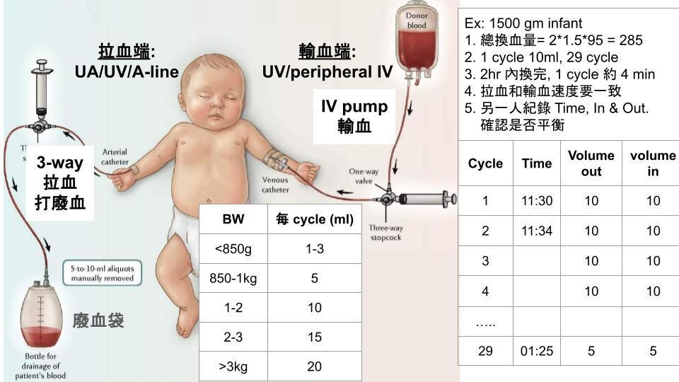

- Conjugated hyperbilirubinemia (direct hyperbilirubinemia)
- Definition: direct bilirubin level > 1-2 mg/dl and is > 20% of the total serum bilirubin
- Etiology:
  - Extrahepato-biliary (obstruction): biliary atresia, choledochal cyst ….
  - Mixed - Hepatocellular: TORCH infection, TPN-related cholestasis, hepatitis, sepsis
  - Intrahepato-biliar: alagille syndrome, inspissated bile syndrome
  - Other: endocrine (hypothyroidism), GALD
- Workup (開立前請和主治醫師討論:
- CBC/DC, TBI/DBI, GOT/GPT, rGT, ALKP, liver function (Alb, PT/aPTT, glu..), B/C, U/A, U/C, urine virus culture, CMV IgG/IgM, NBS, thyroid function,
genetic test, Abdominal sonography
- Tc99 DISIDA: 在檢查前三天要服用 luminal 5mg/kg/day * 3days
- MRCP
- Management – Operative cholangiography, resolution of primary problems
- Medication of cholestasis: Seminars in Pediatrics Surgery 9(2):96-102. 2000 (May)
可使用於膽汁滯留症藥物如下，可視狀況單獨或合併使用
    - Phenobarbital: 5 mg/kg/day, PO BID×6 weeks
    - Actigall: 5 mg/kg/dose, PO TID indefinitely
    - Kanamycin: 7.5 mg/kg/dose, PO BID×2 weeks
    - Cefoperazone: 50 mg/kg/dose, IV Q12H×6-8 weeks
    - Polymyxin B: 100,000-200,000 units/kg/d (10-20 mg/kg/d) divided into 3 or 4 doses, Use IV form PO. Never give this dose IV.
    - Consider cycling steroids: 10 mg PO bid x 4 weeks, then taper over 2 weeks and discontinue or 10 mg PO bid for 3 days every 2 weeks for 2-4 months
    - Ursodeoxycholic acid (100mg/tab): 15-20 mg/kg/day, BID or TID
    - Silymarin(150mg/tab): 1/2# QD or 1# QOD

- Prolonged jaundice (快速鍵 prolong)
- 延遲性黃疸：足月兒超過二星期、或是早產兒超過三星期仍有黃疸。
- Tests for liver disease, congenital infections, sepsis, metabolic defects, or hypothyroidism are indicate
- Initial workup: CBC/DC, B/C, TBI/DBI, GOT/GPT, rGT, ALKP, U/A, U/C, urine virus culture, (CMV IgG/IgM), Abdominal sonography
- If direct bilirubin is elevated, obtain urinalysis and urine culture, check state newborn screen for hypothyroidism and galactosemia, and check urine for reducing substances
- 開立醫囑前請與fellow 或主治醫師討論
Ref: Manual of Neonatal Care 8th ed, p. 343
- Contrast enema
- 簡介：原為放射科顯影劑由Noblett於1969年首先使用，主要利用其高滲透壓所造成鄰近器官釋放大量液體流入腸道後將堅硬胎便溶解攜出
- Indication
- Uncomplicated meconium ileus
- Meconium plug syndrome
- Complicated meconium ileus, meconium peritonitis post–operation, for removal of meconium
- 材料：顯影劑，可向CT室索取
目前CT室常備顯影劑為Omnipaque (Osmolarity 465mOsm/L), Ultravist (428mOsm/L),已不再常備Gastrografin (2150mOsm/L) or Urograffin ; 或者是用太陽牌人生浣腸 (15% glycerol + 15% NaCl, Osm約6000 mOsm/L)
- 方法
- Dose: 將contrast與 N/S 以1: 1-4的比例稀釋後，取10-20ml/kg進行enema
- Frequency: q12-24hours
- Duration: <2 weeks
- Intravenous fluids: before enema –L.R 20ml/kg over 30mins, after enema -1.5times maintenance
- Meconium pellets followed by loose stool meconium pass over 4-8 hours in 4-14 days
- 若大於兩週仍無法將胎便沖出，則考慮手術治療。
- 若初始灌出的大便沒有膽汁染色，則需考慮可能為需要開刀之腸阻塞
(許醫師寶貴經驗)
- Complications: fluid depletion causes perforation, NEC, shock
- Consider orally administered contrast: 3~7cc/dose (與N/S 1:1 dilute)
- PO Gastrografin : water 1:2 稀釋， osmolarity 2150→717mOsm/L; 因Ultravist的Osmlarity(428)已經低了許多，所以不用多倍稀釋
Ref: Haiden et al. 2012 Pediatrics

- Stoma care (2021增)
- Background information:
A stoma is formed surgically by opening part of the bowel to the outside of the abdomen for the output of feces

- Indication examples:
- Necrotizing enterocolitis
- Hirschsprung’s disease
- High type imperforate anus
- Complex intestinal malformation or volvulus
- Intestinal atresia

- Monitoring
      - 每日體重變化
      - Total intake/output
      - Stoma losses, 顏色性狀也很重要
      - Serum electrolytes: hypokalemia and hyponatremia are common at initial stage
      - Urine sodium and potassium: urine electrolytes could serve as indicators of adequate electrolytes intake
        - Adequate sodium intake will give a urinary sodium concentration of ≥ 20 mmol/L
- Nutritional considerations during stoma care
- 注意feeding intolerance
  - Vomiting, abdominal distension, bile in NG aspirates, large NG losses
  - Low stoma losses – obstruction or dysmotility
  - High stoma losses – malabsorption
  - Reducing substances or fat globules in the stoma effluent
- 理論上，stoma位置越遠，腸胃道耐受性越好
- If breast milk is not available, consider using hydrolyzed formula

- High stoma output:
  - Daily output ≥ 20ml/kg/day in premature or LBW babies and ≥30ml/kg/day in term babies
  - Replace excessive losses分班補量：實際操作上可以設每班loss超過某個標準，即開始補半量或全量
  - Replacement fluid: 依流失體液種類及量做考量。
    - 舉例來說，若為ileostomy，流失液體鈉含量約45-135mEq/L，可以先以0.45% glucose saline補量，並監測電解質來決定後續補量點滴種類，欲減少鈉含量可改成0.33% glucose saline，欲增加可改成lactated ringer’s等等
    - 若長期high output stome合併體重增加不足，可與主治醫師討論是否將部分補量點滴改成PN，但必須嚴格監測血糖、electrolytes等，避免過度波動，且需避免快速大量輸液
Ref: Morris et al. 2019 revised Wales Neonatal Network Guideline

Trust Guideline for the Management of Stoma Output in Neonates and Infants, 2020
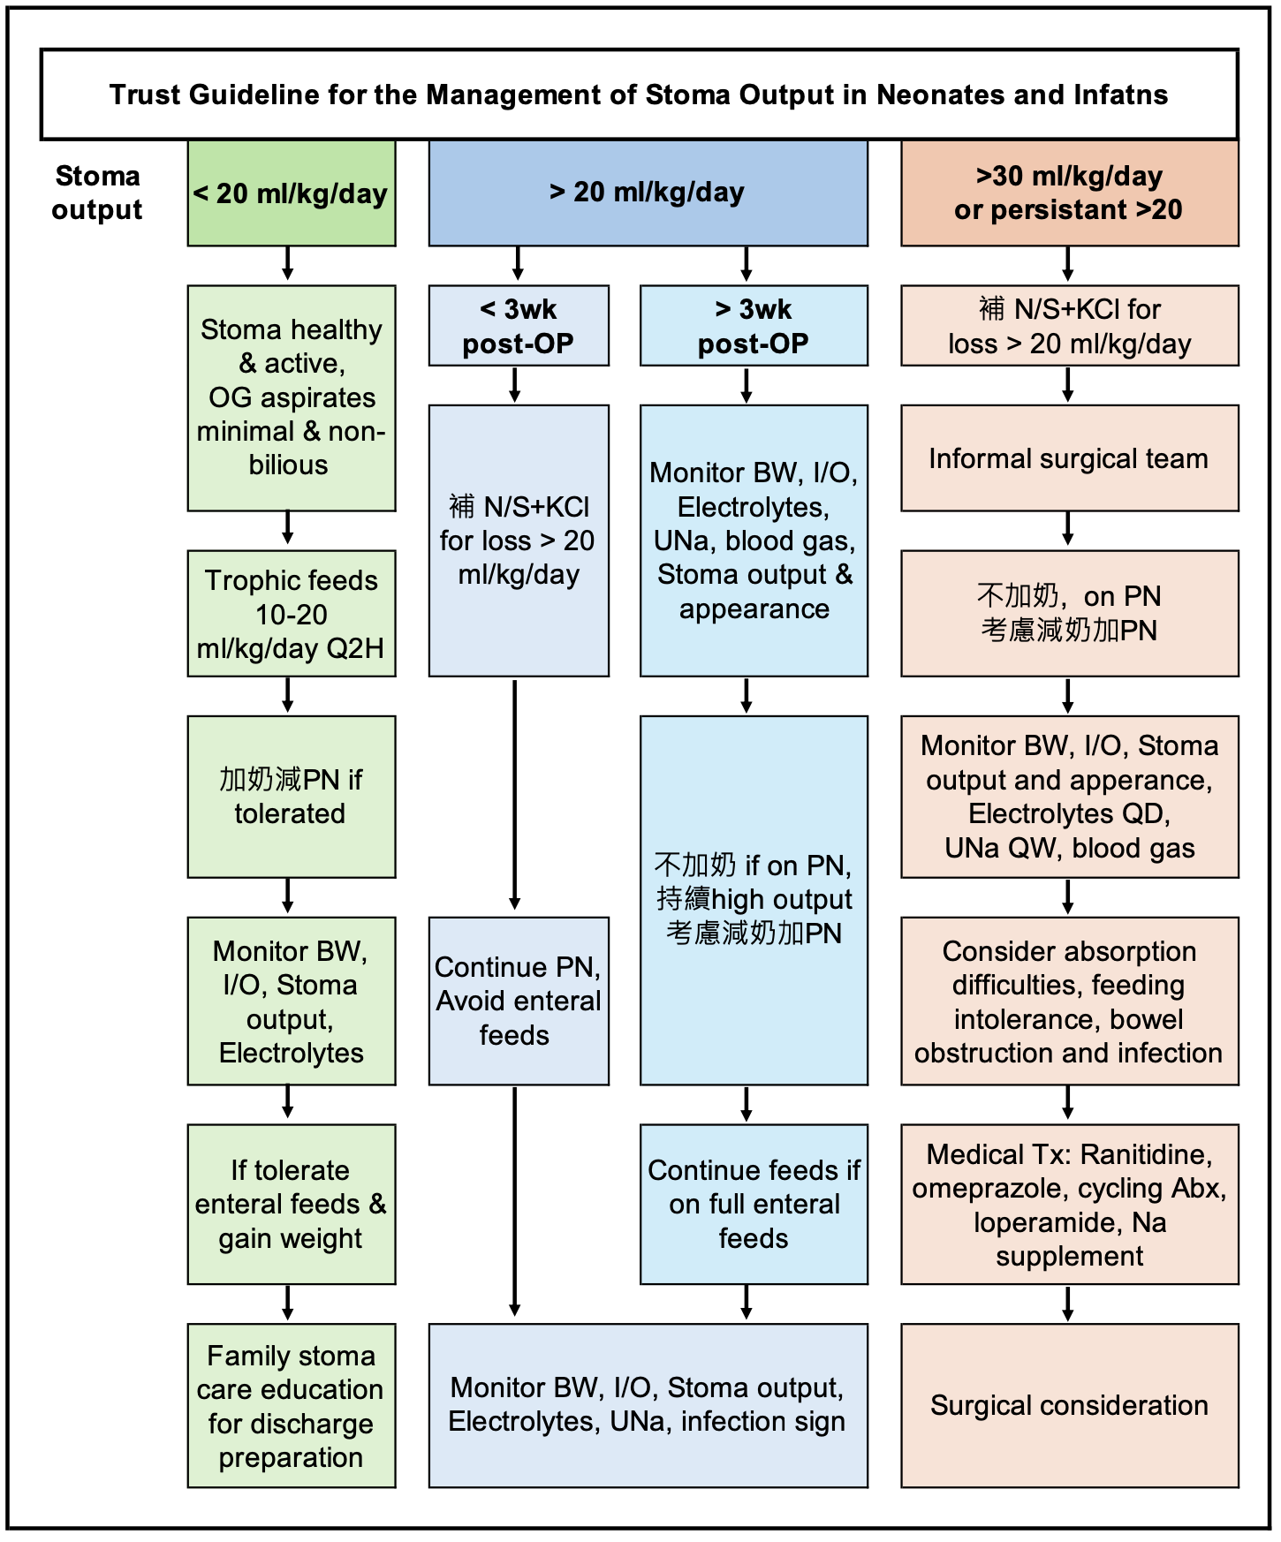
- IHPS management algorithm 
- GI Drugs
- GER drugs :
  - Metoclopramide (Primperan), 0.1ml/kg/dose
  - Domperidone (Motilium), 0.1ml/kg/dose
    - Action : Both central and peripheral DA-antagonist effects, blockade of DA-receptors and modulation of Ach release, ↑ lower esophageal pressure enhances gastric emptying.
    - Adverse effects : Irritability, somnolence, EPS (dystonias, akathisia, drug-induced Parkinsonism) — dose related, early in the initiation of therapy, reversible, GI symptoms (nausea, vomiting, diarrhea), urticaria, increased lactation, gynecomastia, fluid retention secondary to aldosterone release, methemoglobinemia
  - Bethanechol (25mg/tab) 1# in diswater 25mL=1mg/ml, 冰箱保存3-5天，0.1ml/kg/dose
    - 多AC吃, UpToDate: max 4次/day,日本有paper 0.25mg/kg/dose Q3H AC
    - Action (for GER) : Acetylcholine receptor agonist, Increase lower esophageal pressure, increase the amplitude and duration of esophageal peristaltic contractions
    - Adverse effects: abdominal cramping, blurred vision, increased urinary frequency, dystonic reactions, wheezing, increased salivary and bronchial secretions, bronchospasm
  - Mosapride (5mg/tab)(off-label use in neonate,使用前須向家屬說明可能side effect)
[GI用法0.3mg/kg/day，科內用法0.6mg/kg/day，range 0.5-1mg/kg/day TIDAC]
    - Action: Diffuse effects along the entire GI tract, Enhances Ach release from postganglionic nerve endings of the myenteric plexus (increase antral motility and duodenal contractility) In premature infants: decrease gastric residuals, increase feeding volume, decrease vomiting, increase weight gain
    - Adverse effects : QT prolongation, torsades de pointes, diarrhea
    - Contraindicated in patients receiving macrolide antibiotics (erythromycin, clarithromycin), azole antifungals (fluconazole, ketoconazole, itraconazole), protease inhibitors (sequinavir , indinavir, ritonavir), class IA and III antiarrhythmics (quinidine, procanamide), astemizole
  - Erythromycin (目前無solution 。250mg/tab，不可磨粉-遇胃酸會失效)
    - 類似Motilium 的效果，不可與cisapride 併用
    - Dose：低/中/高劑量分別為2.5/5/10~12.5 mg/kg/dose Q6H
  - H2-receptor antagonists :
    - Famotidine (Gaster)： (PO 20mg/tab，IV 20mg/2ml)
0.5 mg/kg/day QD，Max. dose for infant/children:1mg/kg/dose Q12H
PO: 1# in distilled water 10cc=2mg/ml，放冰箱存放24hr，膜衣錠可磨粉
    - Adverse effects : rash, dizziness, impaired liver function, agranulocytosis, leukopenia, thrombocytopenia
  - PPI
    - Nexium (Esomeprazole): PO/IVD 0.5mg/kg/day QD
IVD: in N/S, 濃度 0.4-0.8mg/ml, drip for 30 min，與PN不相容
    - Takepron(Lansoprazole): PO/IVD 0.5-1mg/kg/day QD, Max: 1.5mg/kg/day
IVD: in D5W or N/S, 濃度 0.6mg/ml, drip for 30 min，與PN不相容
- Zinc sulfate for Zn deficiency (Zn sulfate 5.94 mg/1ml，內含Zinc 1.35 mg/ml)
    - 泡在D5W or D10W (不可以有e-) run 10~12 hr/day
    - 以element Zn計算Preterm:0.4mg/kg/day Term<3m/o:0.3mg/kg/day

