Hematology

- Anemia
- Polycythemia
- Disorders of White Blood Cell + G-CSF
- The Bleeding Newborn
Hemorrhagic disease of newborn: Vit K deficiency
Thrombocytopenia
Coagulopathy
NovoSeven – Recombinant factor VIIa use in neonates
- 四肢末稍黑掉時處理流程 (Management of limb ischemia)
- Hemophilia
- Treatment of Thrombosis in the perinatal period
- Hemangioma
- Neonatal hemogram normal range

- Anemia
- Definition:
Hb (central venous blood)＜13 g/dl or
Hb (capillary venous blood)＜14.5 g/dl in neonates (＞GA 34 weeks)
- Clinical presentations: Pallor, tachypnea, tachycardia, hypotension (hypovolemia with weak pulse), congestive heart failure, heart murmur, feeding problem
- If anemia is chronic, patient may be asymptomatic other than pallor
- If blood loss is acute, patient may be usually symptomatic
- Diagnosis:
- Obligatory initial studies
  - Hb
  - Red blood cell indices
  - Microcytic (MCV＜90fl) or hypochromic
  - Fetomaternal transfusion/hemorrhage
  - Twin-twin hemorrhage
  - α-thalassemia
  - Normocytic or normochromic
  - Acute hemorrhage
  - Systemic disease
  - Intrinsic red cell defect
  - Hypoplastic anemia
  - Reticulocyte count (corrected)
Corrected reticulocyte count＝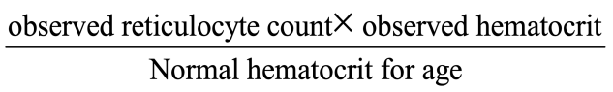
  - Blood smear
  - Spherocyte: ABO isoimmune hemolysis or hereditary spherocytosis
  - Elliptocyte: hereditary elliptocytosis
  - Schistocyte or helmet cell: consumptive coagulopathy
  - Direct Coombs’ test: isoimmune or autoimmune hemolysis
- Other selected laboratory studies
  - Isoimmune hemolysis
  - Fetomaternal hemorrhage：Kleihauer-Betke test (Acid elution test) (抽媽媽的血)
2×2400×Ratio of fetal to maternal cells＝__ml of fetal blood lost into maternal circulation
Ex: 一位1kg的NB, 媽媽的Acid elution test為5/2000
代表baby有12 c.c.的血跑到媽媽身上 (2×2400×5/2000 = 12c.c.)
NB的全身血量為 : kg × 85 (Term)/ 95 (preterm)
這位NB的全身血量為95c.c.
NB blood loss量為 12/95 = 12.6%

- In ABO incompatibility, which will result in increased clearance rate of fetal cells from the maternal circulation, giving a falsely low result
- D.D. with maternal hemoglobinopathies with increased hemoglobin F levels, such as maternal thalassemia minor, sickle cell anemia, hereditary persistence of HbF and in some normal women, a pregnancy induced rise in HbF production
  - GI hemorrhage: Apt test （僅剛出生時GJ有血適合做）
- Apt test (+) : HbF(+) → infant GI bleeding
- Apt test (−) : HbF(−) → 可能吞到媽媽的血
  - Congenital hypoplastic or aplastic anemia: bone marrow aspiration
  - TORCH infection
  - Skull and long bone films
  - IgM
  - Serological study
  - Urine culture for CMV (and/or urine CMV PCR, blood CMV viral load)
  - Consumption coagulopathy
- PT and PTT
- platelet count
- TT or fibrinogen assay
- FDP
- fibrin
  - Occult hemorrhage: arrange brain and abdominal sonography
  - Intrinsic red blood cell defect
- Management:
- If patient is asymptomatic, observe and iron replacement (2-4 mg/kg) if necessary
- Symptomatic patients require transfusion, draw initial blood samples (一定要用抽的，不可以採腳根血) before transfusion
- Calculation for amount of blood to be transfused
- 3 mL of packed RBC/kg will increase Hb by 1gm
- 6 mL of whole blood/kg will increase Hb by 1gm
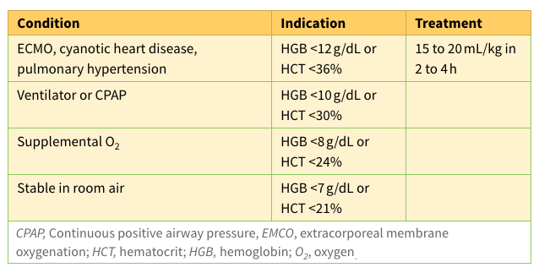
- Infuse 15-20ml/kg pRBC，早產兒大部分都輸 20ml/kg，可間隔約24小時分兩次輸注，避免fluid overload，早產兒輸血標準參考Routine章節，一般新生兒輸血標準可參考下表 (Ref: Avery’s Diseases of the Newborn, 10th Ed, Table 81.7)
- Choosing blood product
- PRBC to avoid volume overload
- Whole blood if acute blood loss of a large amount of blood
- In newborn, use “O” P-RBC if there is possibility of ABO incompatibility
(eg. mother “O” type, baby “A” or “B”)
- Erythropoietin administration as prophylactic regimen
- Partial Exchange transfusion for correction of severe anemia:
Volume(ml)= infant’s blood volume x (Hb desired- Hb initial)/(Hb of pRBC- Hb initial)
    - Packed RBC 的Hb大約18-26g/dL(Ht 55-80%，換算為Hb可除以3)，換血前請提前聯絡血庫幫忙驗
Infant’s blood volume in preterm infant: 90-95 ml/kg; in term infant: 80-85ml/kg
- Polycythemia
- Definition
- Polycythemia：venous Hct＞65%；warm heel stick Hct＞70%
- Hyperviscosity
  - The relationship of Hct and viscosity is nearly linear below a Hct of 60%, but viscosity increases exponentially at a Hct of 70% or greater
- Incidence and Risk factor
- Incidence: 0.4～5%, mostly occurs within the first 4 to 6 hours of life
- Risk factor:
  - SGA
  - Pre-eclampsia, eclampsia or chronic hypertension
  - Infant of diabetic mother
  - Delayed clamping of umbilical cord
  - Neonatal hypothyroidism
  - Down syndrome
  - Untreated maternal cyanotic heart disease
  - Nesidiodysplasia
  - Recipient of twin-twin transfusion
  - Maternal smoking
  - Other: potential causes: hypoxemia, placental dysfunction, hyperinsulinism or high maternal sugar level
- Clinical presentations：3C=Cyanosis, CNS symptoms, Cardiovascular symptoms
- Congestive heart failure
- Respiratory distress
- Seizure
- Plethora (多血症)
- Renal vein thrombosis
- Cyanosis due to stasis
- Associated findings－hyperbilirubinemia, hypoglycemia, hypocalcemia
- Diagnosis and laboratory studies
- Central Hct level
- Serum glucose level: hypoglycemia
- Serum bilirubin level: hyperbilirubinemia
- Serum Na and BUN: higher if dehydration is present
- Urine specific gravity:＞1.015, indicating dehydration
- ABG: evaluate oxygenation status
- Serum platelet count: thrombocytopenia
- Serum calcium level: hypocalcemia
- Management
- Guidelines
  - Venous Hct＞70% & arterial Hct＞68%
With or without s/s→partial exchange transfusion (PET)
  - Venous Hct 65～70% & arterial Hct 62～68%
    - With s/s→PET
    - Without s/s→ observation and avoid dehydration
- Replacement agent in PET：N/S, FFP, 5% albumin, lactate Ringer’s solution
- Replacement volume calculation：
Volume to exchanged＝BW (kg) ×BV×[Hct (o)-55%]/Hct (o)
Hct (o) : observed Hct
BV: blood volume for each kg of body weight
BV: 85ml/kg for term babies ,95ml/kg for every premature babies
55%: aim Hct for PET
eg. 3 kg infant, Hct 75%, BV＝80ML×3＝240 ml, aim Hct: 55%
Volume of exchange (ml)＝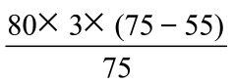＝64ml exchange
- Disorders of White Blood Cell (2021 revised)
- Neutropenic disorders
- Definition of neutropenia:
Neutropenia is defined as an absolute granulocyte count less than 1500 cells per ul.
This may occur as a transient phenomenon associated with infection or as a chronic process.
- Clinical presentation
- Infection or sepsis
- Alloimmune neutropenia
- Neutropenia associated with maternal disease
- Severe congenital neutropenia (Kostmann syndrome)
- Benign congenital neutropenia
- Cyclic neutropenia
- Neutropenia secondary to drugs
- Diagnosis
- In association with other hematologic and/or physical examination abnormalities:
Bone marrow examination to rule out leukemia, neoplasm, or aplastic anemia
- In the absence of other hematologic abnormalities:
- Maternal neutrophil counts to rule out maternal disease or drugs
- Neutrophil counts on family members to rule out hereditary neutropenia
- Antineutrophil antibody determination to rule out immune neutropenia
- Repeat neutrophil counts on baby (two times per week for 6 weeks) to rule out cyclic neutropenia
- Bone marrow examination if associated with frequent bacterial infections to rule out agranulocytosis (Kostmann syndrome)
- Management
- Treat underlying disease
- G-CSF (Granulocyte-Colony Stimulating Factor) subcutaneous injection
      - Indications: neonatal sepsis with neutropenia, immune-mediated neutropenia, idiopathic neutropenia with ANC <500/μL
      - 健保給付規定：先天性或循環性中性白血球低下症者(當白血球數量少於1000/μL，或中性白血球 (ANC) 少於500/μL)
      - Dose: 5-10 mcg/kg/day if necessary
Ref: Avery’s Diseases of the Newborn, 10th Ed, p.1189-1190
- Disorders of leukocyte function
- Congenital neutrophil membrane glycoprotein deficiency
- Chronic granulomatous disease
- Chediak-Higashi syndrome
- Eosinophilia in premature infants
- Myeloproliferative disorders in the newborn
- Neonatal leukemia
- Transient myeloproliferative syndrome
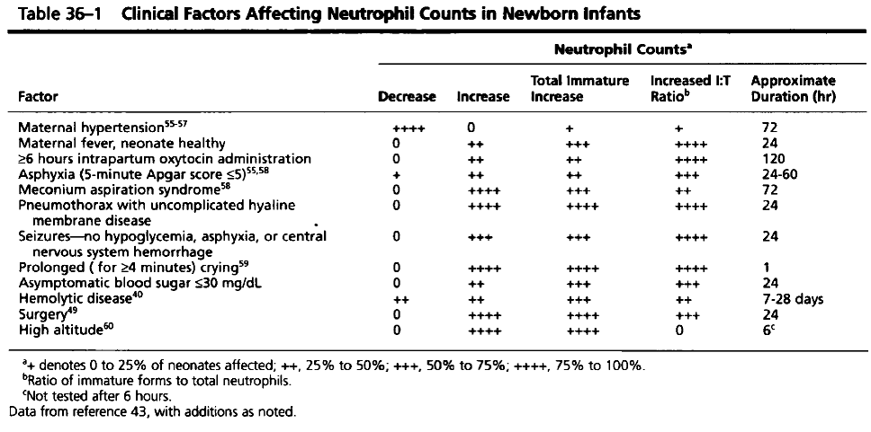

- The Bleeding Newborn
- Etiology
- Hemorrhagic disease of the newborn: Vit K deficiency
- Thrombocytopenia
- Coagulopathy
- Clinical evaluation：
Sick infant, petechiae, small superficial ecchymosis, mucosa bleeding, large bruises, enlarged spleen, jaundice, abnormal retinal findings, hematuria, intraventricular hemorrhage, hemoarthrosis, bleeding or oozing from the sites of injection or blood sampling
- Laboratory studies < Blood sampling before transfusion>
- Apt test
- CBC/DC, platelet count and blood smear
- PT, PTT, bleeding time
- Fibrinogen, FDP, D-dimer
- Factor assay
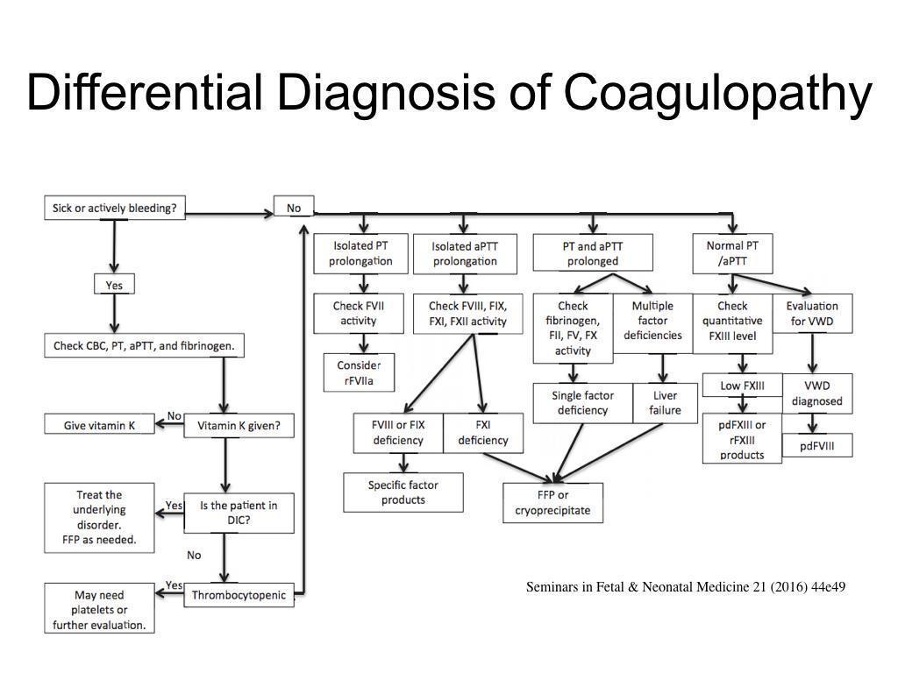

- Hemorrhagic disease of newborn: Vit K deficiency
- The “healthy” infant is not given Vit K:
- The infant may have been born in a busy delivery room, at home or transferred from elsewhere
- ＞48h/o: bleeding and bruising
- Lab data: platelet normal; PT, PTT prolonged
- As active bleeding: 10ml/kg FFP and 1mg Vit K IV
- Maternal drug effect
- Phenytoin (Dilantin), primidone (Mysoline), methsuximide (Celontin), or phenobarbital
- During the first 24 hours
- Management
    - The mother should be given Vit K 24 hours prior to delivery (10mg Vit K IM)
    - Vit K 1mg IM given as usual postpartum and repeated in 24 hours
    - If any bleeding occurs, FFP infusion
- Delayed hemorrhagic disease of newborn
- Malabsorption such as prolonged broad spectrum antibiotics or cystic fibrosis
- 4w/o～12w/o
- Thrombocytopenia
- Definition
- Platelet count＜150,000/ml of blood in both term and premature infants
- Platelet count nadir: 4 d/o , usually resolved: 10 d/o
- General approach to diagnosis of thrombocytopenia
- Maternal history：There may be a history of thrombocytopenia, bleeding before or during pregnancy, having undergone a splenectomy, drug use, or infection.
- Infant：Healthy or sick, petechiae or large bruises, hepatosplenomegaly, jaundice, and congenital anomalies
- Laboratory work-up
- Mother: platelet count
- Baby: CBC, platelet count, PT, PTT
- Management
- Platelet transfusion in the newborn, if necessary
- indication: platelet＜20,000/ml
- source: random donor, except in the infant with alloimmune thrombocytopenia
- 1U pl/3kg→↑50,000～100,000/ul
- frequency: normal half life 4～5 days
- route: never give platelet through an arterial line or into the liver, because thrombosis may occur
- all platelet transfusion should be irradiated
- Steroid therapy: prednisolone 2mg/kg/day
- Emergency situation, fresh whole blood for exchange transfusion
- IVIG: 1g/kg/day for 2 days for immune thrombocytopenia
- Coagulopathy
- Congenital factor deficiency－Factor replacement
- Acquired coagulopathy: DIC (Disseminated Intravascular Coagulopathy)
- Management
  - Treat underlying cause: e.g. sepsis, NEC
  - Vit K₁ 1mg IV
  - PLT and FFP transfusion to keep PLTt＞50,000/ul and to stop the bleeding
- Treatment
  - In general, clinically ill infants or infant weighing less than 1500g are given the benefit of transfusion with FFP (10ml/kg) if the PT or PTT or both are greater than two times normal or with platelet if the platelet count is under 20,000/ul
- NovoSeven – Recombinant factor VIIa use in neonates (2021年新增)
- 除了血友病以外，其他使用皆為off-label use
- 臨床應用：(皆為自費 NTD 28268/vial)
  - Life threatening bleeding which shows limited response to conventional therapy
  - Intolerability to conventional therapy
  - Acute, massive bleeding
- Dose: 90-400mcg/kg/dose in case reports; repeat in 3-12 hours if needed
- Complication: thrombotic events, especially in the presence of indwelling IV catheters
Ref: Journal of Perinatology (2006) 26, 706–713, J Perinatol. 2011 March ; 31(3): 188–192.
- 四肢末稍黑掉時處理流程(Management of limb ischemia)
- 發現時立即熱敷對側手
- 安排週邊血管超音波(檢查碼61132) (打3073聯絡安排，並非每天都能做)
- Medication:
  - Low molecular heparin:
    - 給前檢測PT,PTT, fibrinogen, anti-thrombin III, protein C,S (PTT管x 2)
    - 劑量：< 2 months : 1.5 mg /kg /dose subcutaneously(皮下注射) q12h x 7天
    - 使用中應注意bleeding，若bleeding立即停藥
  - Sildenafil (Viagra®)(100mg/1#)
    - 100mg in distilled water 40ml (2.5mg/ml) 可放冰箱10天
    - 取1-3ml滴在紗布上濕敷(視患部大小而定)
    - 每敷30分鐘休息15分鐘，交替一直到患部改善
  - Sildenafil Jelly (Jeligra®)
- 口服Jelly，一包100mg，找fellow領取
- 取適量塗在患部(視患部大小而定)，再包上濕紗布濕敷 ( 濕紗布儘量擰乾)。然後整個以塑膠手套包裹
- 每敷30分鐘休息15分鐘，交替一直到患部改善
- 注意可能導致低血壓
  - NTG：off label use (2023增)
- 2% NTG Ointment 2.4mg/kg Q8H (但本島目前無)
- Nitroglycerin inj 5mg /10mL (0.5%) amp：
經驗上可取1-2 ml/kg Q8H濕敷，使用時須小心低血壓

- Hemophilia
- Hemophilia: X-linked recessive disorders, new mutations in 30% of cases
- Algorithm for suspected hemophilia
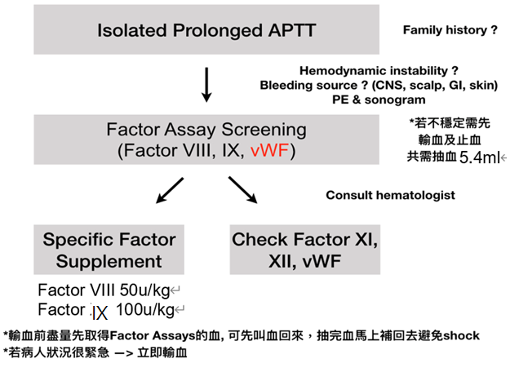
- Treatment of Thrombosis in the perinatal period
- Low-Molecular-Weight Heparin (LMWH) 1 mg=0.01ml
  - Advantages : minimal nonspecific binding to proteins, longer half-life, administered subcutaneously, less side-effect
  - Dosage
    - < 2 months of age : 1.5mg/kg/dose SQ Q12H
    - older children : 1.0mg/kg/dose SQ Q12H
  - Duration of therapy: varies from initial therapy alone to treatment for the entire 3-6 months
- Hemangioma
- Natural course
- Rapid growth within the first 3 months, 80% of final size in 5 months¹
- Slow proliferation during 6 to 12 months of age
- Possible proliferation after the 1 year but uncommon
- Presentation
- Superficial: most common, bright red papule, nodule or plaque
- Deep (subcutaneous): raised skin-colored nodule often with bluish hue, uncommon to present isolatedly
- Combined: commonly presenting with superficial and deep contains

- Evaluation
- History: age of development, site, characteristics, numbers, previous treatment or response, symptoms of high-output heart failure (prolonged feeding or interrupted feeding, diaphoresis, irritability, failure to thrive)
- PE: skin and mucous, morphology, location, size, ulceration or secondary infection, hepatosplenomegaly, signs of high-out heart failure (tachycardia, bounding pulse, mid-systolic murmur)
- Special Consideration:
- Beard distribution --> airway hemangioma, *PHACE syndrome
  - PHACE: Posterior fossa brain malformation, most commonly Dandy-Walker variant, Hemangioma (large or segmental), Arterial anomalies, Cardiac anomalies or CoA, Eye and Endocrine abnormalities
- Multiple (≧5) cutaneous or large? hemangiomas with high-output heart failure→ hepatic hemangiomas
- Lumbosacral distribution: spinal dysraphism or genitourinary anomalies
- Differential diagnosis：Rapid growth with tenseness, purpuric appearance and thrombocytopenia: Kasabach-Merritt syndrome (important!!)
- Work-up：Ultrasonography (especially abdomen), CT, MRI, Fiberoscopy (airway)
- Management
  - Indications for treatment
  - Large, rapid progressing
  - Site: periorbital, airway, liver or GI tract, face?
  - Marked raise and sharp border or pedunculated lesions
  - Goal
  - Prevention or reversal of life-threatening complications
  - Minimizing the psychosocial distress for the patient and family
  - Adequate treatment of ulceration to avoid scarring, bleeding, infection and pain
- Treatment
  - Local therapy: topical beta-blockers, intralesional corticosteroid
    - Topical timolol
    - Indication:proliferating superficial infantile hemangioma
    - 比較有公信力的paper引用的topical treatment多是用0.5% gel-forming solution，但是因為我們醫院只有眼藥水，因此以下都是用眼藥水的做法
    - Dose：3-15 drops 敷 15-30 min , BID~TID
  - Systemic therapy:
    - Oral propranolol (Inderal)
    - Mechanism (possible): vasoconstriction, decreased expression or vascular endothelial growth and basic fibroblast growth factor or triggering apoptosis
    - For infantile hemangiomas: Not approved in infants younger than 5 weeks
    - Dosing: 1-4 mg/kg/day, initially 0.5-1 mg/kg/day in 2-3 doses, increments of 0.5mg/kg/day in 1-2 weeks) with meals
    - Optimal maintenance dose, timing, and duration have not been established
  - Week 1: 0.6 mg/kg/dose orally twice daily, at least 9 hours apart
    - Week 2: 1.1 mg/kg/dose orally twice daily
    - Week 3: 1.7 mg/kg/dose orally twice daily for 6 months
    - Adjust the dose periodically as the child's weight increases. May re-initiate if hemangiomas recur. 2 to 3 mg/kg/day was recommended (guideline dosing)
    - Tapering periods have ranged from 2 weeks to 1 month
    - Dose adjustment: In infants with PHACE syndrome (posterior fossa defects, hemangiomas, cerebrovascular arterial anomalies, cardiovascular anomalies, and eye anomalies), especially in the presence of neurovascular anomalies, slowly titrate dose, use the lowest effective dose, and administer in 3 divided doses
    - Admission should be considered in the following situations:
    - ≤8 weeks of corrected age
    - Infants of any age with inadequate social support
    - Infants of any age with comorbid conditions affecting the cardiovascular or respiratory system, including symptomatic airway hemangiomas
    - Infants of any age with conditions affecting blood glucose maintenance
    - Adverse effects: hypotension, bradycardia, bronchospasm (wheezing), hypoglycemia, hyperkalemia, anorexia
Ref. 1. NeoFax: Propranolol 2. (2019 AAP) Clinical Practice Guideline for the Management of Infantile Hemangiomas
    - Interferon-α, angiogenesis inhibitor: alternative therapy for aggressive hemangiomas not responsive to systemic corticosteroids
    - Dosing: 3 million units/m2/day
    - Duration: weeks to months
    - Adverse effects: fever, irritability, neutropenia, abnormal AST/ALT, neurotoxicity (spastic diplegia)
    - Vincristine
    - Indication: more aggressive hemangiomas as an alternative therapy for life-threatening or refractory to propranolol or corticosteroids
    - Adverse effects: peripheral neuropathy, constipation, jaw pain, leukopenia or anemia
  - Surgical therapies：Pulsed-dye laser, excisonal surgery, Embolization
- 註
- 皮膚科的染料雷射(要自費)通常是長大後，入學前如果還消不掉，才選擇的治療，通常是對小孩外觀跟心裡上考量。對於一開始就complicated血管瘤比較沒角色。
Reference:
1. Pediatrics. 2008;122(2):360.
2. J Am Acad Dermatol. 1997;37(4):631.
3. J Pediatr. 1997;131(4):643.
4. Pediatrics. 2009;124(5):1447.
5. PediatrRadiol. 2012;42(3):315.
6. J Pediatr. 1997;130(4):631.
7. Pediatrics. 2015;136(4):e1060.
8. Pediatrics. 2013;131(1):128. Epub 2012 Dec 24.
9. Dermatol Surg. 2001;27(5):475
10. Br J Oral Maxillofac Surg
. 2015 Nov;53(9):836-40
11. Eur J Pediatr 184, 151 (2025)

- Neonatal hemogram
(Reference: Nathen’s Hematology, 7th edition)
