Genetics & Endocrinology

- Hypoglycemia
- Hyperglycemia
- Hypocalcemia
- Hypomagnesemia
- Hyperkalemia
- Hyponatremia
- Late Metabolic Acidosis
- Metabolic Acidosis
- Infant of Diabetic mother
- Metabolic Bone Disease of Prematurity
- Thyroid disorder
- CAH
- Carnitine deficiency interpretation and supplement dose
- 急性新生兒高血氨處理

如果遇到一出生後急救無效的Newborn，極度懷疑有Genetic的問題時，如果來不及consult，可先留以下檢體 (各3-5ml)
大綠頭管 (含Sodium的heparin管，無Agar)：1管，3-5ml，for 染色體，不冰。
EDTA管 (紫頭大管)：2管, 可以依病人需求作不同的基因檢查，可冰可不冰。
從NI-15櫃拿採檢刷(組)，往咽喉部或口腔內側臉頰各上下來回刷取數次採檢
以上檢查皆為自費項目，染色體是＄3500，基因檢查則依項目種類不同而不同。

- Hypoglycemia
- Definition: blood sugar < 40 mg/dL in a term or premature infant.
  - Newborn < 48 h/o: 50 mg/dL ; ≧ 48 h/o: 60 mg/dL
  - For permanent hypoglycemia: 70 mg/dL (Turk Pediatri Ars. 2018)
- Clinical presentations:
- Lethargy, apathy and limpness  - Tremor or jitteriness  - Apnea  - Cyanosis | - Seizure, coma  - Weak or high-pitched cry  - Poor feeding  - Asymptomatic
- 小嬰孩和慢性病童其肝醣貯藏能力有限，且損失快速, High risk infants include: preterm,
SGA, twins, IDM, infants of eclampsia and preeclampsia mother and critically ill infants
- Differential diagnosis:
- Adrenal insufficiency  - Maternal drug use  - Heart disease | - Renal failure  - Liver failure  - CNS disorder | - Metabolic abnormalities：hypocalcemia, hyponatremia or hypernatremia, hypomagnesemia, pyridoxine deficiency
- Screening and Management:
  - Well neonates (term or late premature, e.g. 33-36 wks) who are at risk for hypoglycemia
- Monitor blood glucose level at birth + Q6H for 24h
  - 原則：Newborn hypoglycemia 應先調整SIR，必要時應先set central line!
- 吃的跟打的SIR請分開算！
- 高濃度之glucose (eg.D25W or D50W)為高張力、高滲透壓，可使週遭靜脈硬化。中央靜脈所能承受之最高濃度為25%，周邊勿超過12.5%
  - “Asymptomatic” hypoglycemia
- 可餵食者：Early oral or gavage feeding with D10W or milk q 2 - 4 hours
- NPO者：give IVF supplement, keep SIR: 4-6 mg/kg/min
- Recheck 30mins later and adjust SIR until Dex > 60 mg/dL
- Check Dex q6h until stable
  - Infants with "symptomatic" hypoglycemia
- Monitor blood glucose level q 1 hr to q 4hr
- D10W 2ml/kg (0.2 g/kg) over 20 min, followed by an infusion of 8 mg/kg/min
- Glucose infusion for maintenance provide adequate glucose infusion rate
  - Asphyxiated infants
- Parenteral glucose administration may be through the umbilical vein (avoid a rapid bolus of conc. glucose solution and to ensure proper placement of the catheter)

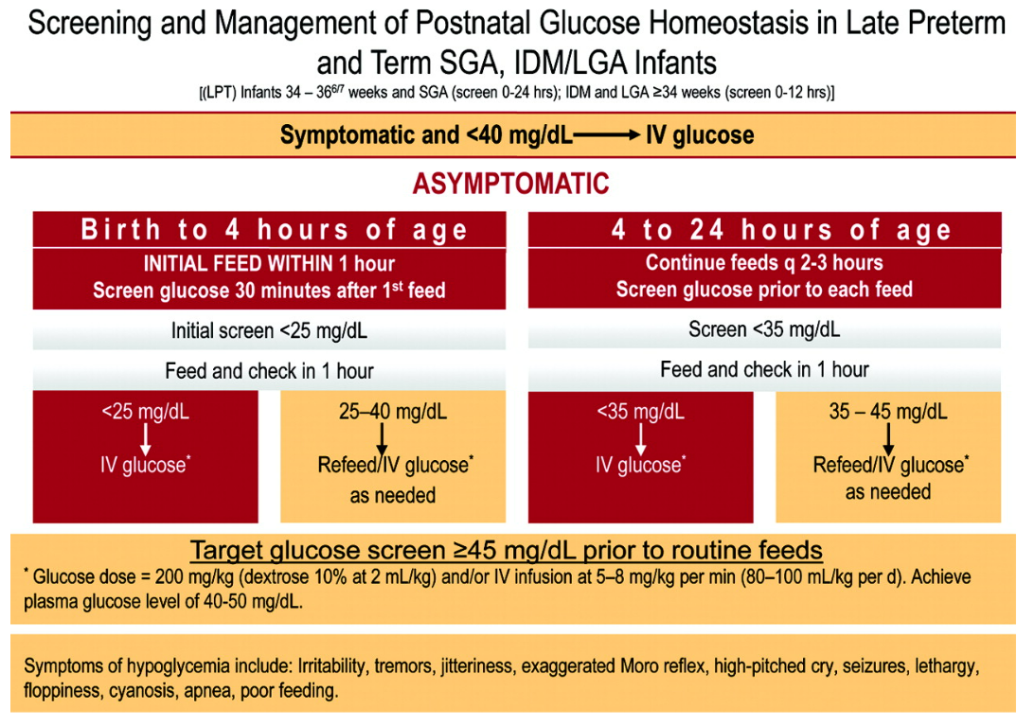

When refractory to continuous SIR > 12-15 mg/kg/min, can try
  - Glucagon
- 0.05mg/kg IM / IV (0.025-0.3 mg/kg/dose, Max 1 mg), can repeat in 20 min PRN
  - Hydrocortisone (Solucortef, 100mg/via)
- 5mg/kg/day q8h~q12h or 1~2 mg/kg/dose q6h
(Reference: Pediatric dosage handbook with international trade names index, 16th edition, p.628)

新生兒低血糖懷疑Hyperinsulinemia處理流程
科內快速鍵#GLUCATI 2019/07 修訂by endocrine李翊誠醫師
- If Dex ≦50 mg/dL x2 次 (Ex: 發現≦50 mg/dL時立即測另一隻腳若也≦50 mg/dL)請做critical sample
- STAT check serum glucose, insulin, C-peptide, blood ketone, Free T4, TSH,
growth hormone(HGH), ACTH, cortisol, blood gas, NH3(Ammonia), lactate, pyruvate, urine and blood amino acid analysis, and urine organic acid
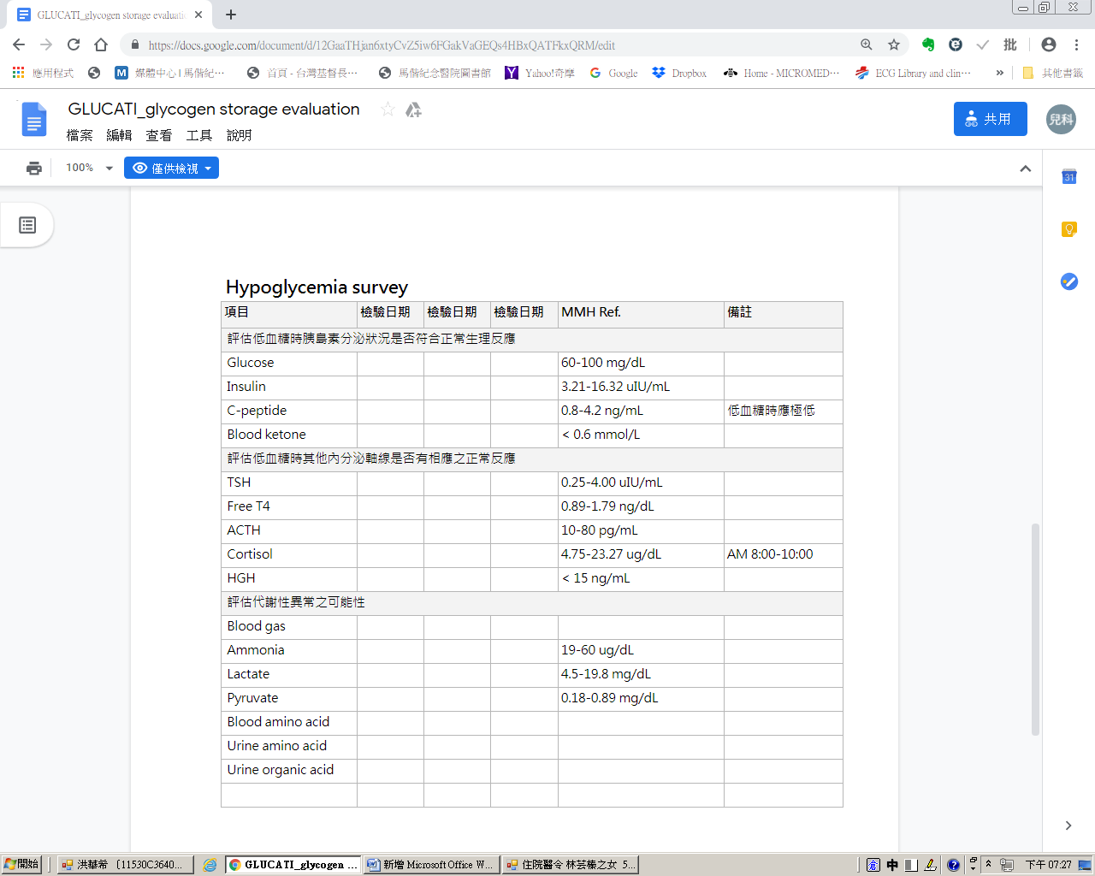
- 必要時請on A line並同時執行 << Glucagon stimulation test >>
  - Administer _ mg glucagon IV push (Glucagon 0.05mg/kg)
給予後請再 push N/S，以確保glucagon 確實進入患者體內
  - On A line for glucagon test
  - Glucagon IV and monitor glucose every 10 min for 40 min.
 | 0min | 10min | 20min | 30min | 40min
Insulin | v
Dex | v | v | v | v | v
Glucose | v | v | v | v | v
  - Check Dex Q3H (檢查結束後)
  - If Dex> 90 mg/dL, decrease IVF A mL/hr;
請依患者體重，計算SIR增減0.5之滴數作為A
  - If Dex between 60-90 mg/dL, keep current IV
  - If Dex < 60 mg/dL, increase IVF B mL/hr;
請依患者體重，計算SIR增減1之滴數作為B
  - If Dex < 50 mg/dL, gave D10W ____(2cc/kg) iv push, recheck dex 30min latter,
if still hypoglycemia may consider add SIR 2 or more
- Hypoglycemia時正常人體生理調控機轉如下：
  - 第一步：血糖 <70 mg/dL時insulin分泌要降低
  - 第二步：血糖 <50 mg/dL時counter-regulation hormone (cortisol/GH/glucagon) 開始分解肝醣。Glucagon首先分解肝臟肝醣，cortisol與GH逐步分解肌肉肝醣達到血糖上升之效果
  - 第三步：體內所有醣類耗盡將轉而使用脂肪產生酮體
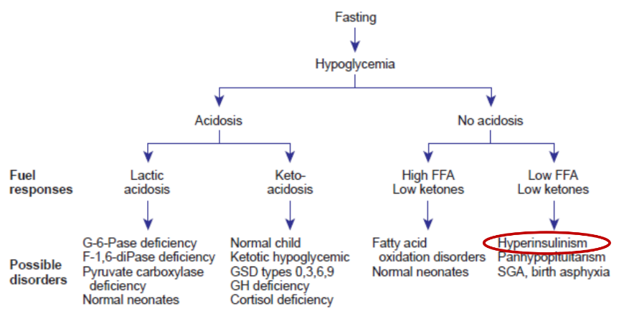
- Hyperinsulinemia病患因為insulin過多，無法開啟低血糖調控三步曲，因此無法產生ketone。脂肪酸代謝異常之病患無法產生ketone，因此也會低血糖
- Glucagon要昇糖的前提是肝臟要有足夠的肝醣。所有低血糖的疾病中也只有hyperinsulinemia 打glucagon會有效，因為insulin大量把糖份儲存在肝臟而不用。其他像肝醣儲積症(糖份亂儲存在器官無法使用)、GHD/adrenal insufficiency(無法使用肌肉肝醣)等等疾病使用glucagon不會有明顯效果，反而應該考慮使用solucortef
- Criteria for diagnosis of hyperinsulinemia base on critical sample (when dex <50mg/dl):
  - Hyperinsulinemia (plasm insulin> 2μu/ml)
  - Hypofatty academia (plasma free fatty acid<1.5mmol/L)
  - Hypoketonemia (plasma β hydroxybutyrate<2mmol/L)
  - Inappropriate response to glucagon test (change in glucose >40mg/dl)
- 確診Hyperinsulinemia後應嘗試使用diazoxide做血糖控制
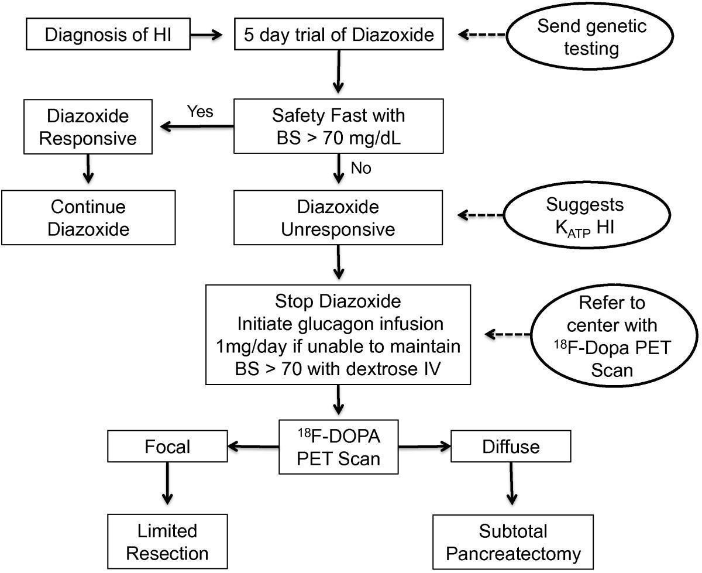
- Nutritional treatment of hyperinsulinemia:
  - Hypertonic glucose infusion(PICC最高可承受22-25%糖水)
  - 每25cc milk可加1g糖飴
  - Special formula for glycogen storage disorder
  - Enteral feeding (via NG of gastrostomy)
- Medical treatment for hyperinsulinemia:
  - Diazoxide(專案藥物申請)
    - Initial: 10 mg/kg/day orally divided every 8 hours
    - Usual Maintenance:
      - (Neonates) 5 - 15 mg/kg/day, div. Q8H
      - (Infants) 5 – 20 mg/kg/day, div. Q8H
      - Adjust doses to achieve desired clinical and laboratory effects. If not effective within 2 to 3 weeks, then discontinue. Ref. NeoFax: Diazoxide
    - 副作用fluid retention, hypertrichosis, GI upset
    - ABCC8, KCNJ11 mutation no response to diazoxide
  - Glucagon 1-20μg/kg/hr IVD 副作用GI upset, crystallization in infusion set
  - Octreotide 5-25μg/kg/day SC 副作用NEC, Cholelithiasis
- Surgical treatment:
  - Pancreatectomy (total, subtotal, partial) if F-DOPA scan had specific finding
  - 97% of focal hyperinsulinemia are cured by pancreatectomy. However, as for the diffuse hyperinsulinemia, 31% were euglycemia, 20% were hyperglycemia and 49% were hypoglycemia even performed total pancreatectomy. 47% of patients who were 10-20 years of age at follow-up had diabetes or DKA.
- Hyperglycemia
- Definition:
  - Glucose level > 150 mg/dL on Dextrostix
  - Clinically important hyperglycemia as Dex >180 to 200 mg/dL
  - Dex > 300~400 mg/dL may result in brain damage
- Clinical presentations:
  - Subtle signs of sepsis (e.g. temperature instability, changes in peripheral perfusion or any changes in gastric aspirates if the infants are feeding)
  - Poor skin turgor, dehydration
  - D.D.
    - Excessive glucose administration
    - Inability to metabolize glucose: occur with prematurity or secondary to sepsis or stress
    - Transient neonatal diabetes mellitus
    - Medications: e.g. maternal use of diazoxide and theophylline
- Laboratory studies:
  - Serum glucose level
  - Urine dipstick testing for glucose level
  - CBC/DC
  - Blood and urine culture
  - Serum electrolytes
- Because hyperglycemia may cause osmotic diuresis, which may lead to electrolyte loss and dehydration
- Treatment:
  - Treat underlying disease (如sepsis)
  - Decrease glucose infusion rate
    - Do not use a solution that has a dextrose conc. of less than 4.7%. Such a solution is hypoosmotic and could cause hemolysis, with resulting hyperkalemia. If a glucose conc. of less than 4.7% is used, electrolytes should be added.
  - Insulin: 上述治療反應不佳的話才用，一般從低劑量 0.03 IU/kg/hr 開始
- Hypocalcemia
- Definition:
  - Total Ca < 7mg/dL(preterm) or < 8mg/dL(term)
校正 : Ca (mg/dL) = 0.8 x (正常albumin level – 病人albumin level) + serum Ca (mg/dL)
  - ionized Ca < 3 ~ 4.4 mg/dl or < 0.75~1.1 mmol/L
  - A decrease of 1mg/dl of albumin, a decrease of 0.8mg/dl of calcium
  - Hypocalcemia associated with the age
    - Early neonatal hypocalcemia (during the first 3 days): asymptomatic
    - Late neonatal hypocalcemia (after the first 3 days): symptomatic
- Risk factors:
  - Increase incidence in premature or sick neonates
  - infants with poor enteral intake
  - infants of diabetic mothers
  - infants stressed during the perinatal period
  - infants receiving blood transfusion
  - infants with alkalosis
  - infants receiving furosemide
  - infants receiving excessive phosphate intake
  - infants with insufficient magnesium intake
  - infants with congenital hypoparathyroidism (e.g. DiGeorge's syndrome)
- Clinical presentations:
  - Acute hypocalcemia: apnea, irritability, slight tremors of the extremities, profound tetany, or seizures, cardiac dysfunction characterized by prolonged QT intervals and arrhythmias.
  - Chronic hypocalcemia: rickets characterized by apnea, bone demineralization, elevated alkaline phosphatase levels, and rib, long bone fracture.
- Diagnosis:
  - Ca level (total and ionized form)
    - iCa < 3mg/dl
    - tCa < 6mg/dl or tCa < 7mg/dl with clinical symptoms
  - Serum Mg level: less than 1.5mg/dL indicate hypomagnesemia
  - Alkaline phosphatase level: > 225IU/L
  - Serum phosphate level: > 8mg/dl
  - EKG monitor: prolonged QT interval or arrhythmias

- Treatment:
  - Replacement therapy
由於肌肉的電刺激，鈣離子由細胞外進入肌漿中。鈣離子包含在內質網，被快速地運用至肌節的肌蛋白纖維，來啟動肌纖維之縮短。因此鈣可增加心臟收縮功能。鈣的增加心縮功能，可藉由其對全身性血管阻力之作用而調節。在正常心臟，鈣加強心收縮力和血管收縮效果，而產生全身性動脈壓之上升。但若於心肌缺氧狀態造成能量不足下，無法將細胞質內之鈣移出，反而會造成毒性影響，另外血中游離鈣之濃度會受血中酸鹼值與血中白蛋白總量所影響。
- Calcium carbonate (p.o.) or calcium gluconate (IV)
- Calcium gluconate (10%, 100mg/ml, Sincal / Calglon)
    - 適應症：hypocalcemia, hyperkalemia, hypermagnesemia, CCB劑量過高
    - Elemental Ca 9.3 mg/ml=0.465mEq/ml
    - Dosage: 1-2ml/kg/dose (速記：BW+BW distilled water)
    - Slowly infuse, rate < 0.5mg/min
- Calcium Chloride (2%，20mg/ml, Vitacal, 目前限麻醉科急用)
    - Slowly infuse, not exceeding 50-100mg/min
    - Dosage: 1 ml/kg (速記:BW+BW)
  - 注意事項
- 重覆給藥前需確定血中游離鈣濃度，否則可能會增加致病率
- 給藥時需監測 HR, 注射過速會引發 bradycardia ，尤其是服用 digoxin 時
- 不可併用 Sodium bicarbonate，會引起沉澱，易使週遭靜脈血管硬化
- 給藥前要確認 IV line function 是否順, 否則可能會 extravasation of calcium, and cause skin sloughs, tissue necrosis, and subcutaneous calcium deposition endangering joint contracture
- Calcinosis cutis: 形成原因不明。有時候在非輸注處也會形成。治療方式為局部塗抹 Uburn (Silver sulfadiazine)。
- Hypomagnesemia
- MgSO4 (10%, Mg²⁺: 16mEq/20ml, 100mg/ml)
1,000 mg of magnesium sulfate = 98.6 mg elemental magnesium = 8.12 mEq magnesium
= 4.06 mmol magnesium
- Mg <1.6 mg/dl, or seizure attack with hypomagnesemia
- MgSO4 50-100mg/kg/dose over 1-2 hours, maybe repeat in 12 hours if necessary
- Dilute with D5W, D10W, or N/S to a concentration of 0.5mEq/ml (建議至少1:1稀釋)
(速記：BW/2+BW/2) (2021 增修)
- Bolus infusion over 1-4 hours: not exceed 1mEq/kg/hr
- Prevention of metabolic bone disease in prematurities especially in the index cases of long term malnutrition or exclusively breastfeeding without fortifier
    - For "healthy" VLBW infants：Ca 100 mg/kg/day, P 50 mg/kg/day, Vit D 400 IU/day
    - For "ill” VLBW infants:
    - Parenteral nutrition for extended period: Ca 30 - 40 mg/kg/day, P 40mg/kg/day
    - Oral intake: Ca 130 mg/kg/day, P 65 mg/kg/day, Vit D 1000 IU/day

- Hyperkalemia
- Definition: Serum K > 5.5mEq/dl (normal potassium levels are 3.5 - 5.5mEq/dl); symptomatic hyperkalemia may begin at a serum K level >6 mEq/L.
(Reference: Manual of Neonatal Care, 7 th edition, p279)
- Clinical presentations:
- EKG changes:
    - Early sign : tall, "tented" T waves
    - Late sign : wide QRS complex; wide, flat P waves, ventricular tachycardia, ventricular fibrillation or cardiac arrest
- Diagnosis:
- Serum K level: microelectrode method as follow-up, central blood sampling via arterial line or UAC to confirm the accurate level of serum potassium
- Serum ionized and total Ca levels
- Serum pH
- BUN and Cr
- Urine specific gravity to assess renal status
- EKG monitor
- Treatment:
  - 換點滴：Shift to potassium-free IVF (D5W or D10 W)
  - 降血鉀：Ventolin inhaler 1-2 puff q6h
  - 保護心臟：Give Sincal for cardiac protection (VT)
Ca. gluconate (10%): 0.5mEq/kg=1ml/kg IV over 2-4min. Be careful about bradycardia
  - Ventolin + Sincal可以於以下情形開始使用
    - BW ≤ 1000g, K ≥ 5.5 mEq/dL
    - BW > 1000g, K ≥ 6.5 mEq/dL
  - Correct acidosis: NaHCO3-2.5mg/kg (approx 3mg/kg) by slow push or rapid drip.
  - RI+Glucose
    - Indication
- Any K level with EKG change due to hyperkalemia
- 須先確認此檢體為 central serum potassium without hemolysis
如果有以下情形，必須立刻使用glucose plus insulin !
      - BW ≤ 1000g, K ≥ 6.0 mEq/dL
      - BW > 1000g, K ≥ 7.0 mEq/dL

    - RI continuous infusion
BW*100U in D10W 500 c.c., 1ml/hr=0.2 U/kg/hr
可從0.1U/kg/hr開始run, 最高可⽤到0.6 U/kg/hour以達到降低K效果(2020修)
    - 須配合當時的體重、fluid status、glucose level、IVF、SIR及病人狀況綜合評估。
例如：BW太小or必須限水(PDA)，則可以泡得更濃一些!
    - 若持續高血鉀→↑U/kg/hr→增加RI滴數或泡更濃之RI
    - 每單位RI 至少與3-5g 的glucose 同時輸注，以避免低血糖。

- $\frac{glucose(g)}{RI(U)}=3\sim 5=\frac{SIR(g/kg/hr)}{RI(U/kg/hr)}=\frac{SIR(mg/kg/min)×0.06(換單位係數)}{RI流量((U/kg)/hr)}$

    - 若低血糖<60 mg/dL→↑SIR→泡更濃之糖水(主line, RI or others)或增加滴數(if tolerated)
    - Monitor glucose level Q1H *2 times then q6h if Dex>60 mg/dL
Ref.: The management of acute hyperkalaemia in neonates and children. Arch Dis Child. 2012;97(4):376-380

【舉例】以BW 500g之ELBW premature baby為例: if K=8.0 mEq/L。
Order開立：RI 50U in D10W 500c.c, 1ml/hr=0.2 U/kg/hr; run 0.5 ml/hr= 0.1 U/kg /hour
然後請再依其Dex、fluid status(是否須限水?)、BW之變化，靈活調整RI滴數or泡法
(RI unit數 or glucose water之concentration)!
Medication | Doses (i.v. unless otherwise specified) | Mechanism | Onset | Duration
Calcium gluconate | 0.5-1 mEq/kg  over 5-10 min | Modifies myocardial excitability | 立刻 | 30mins
Sodium bicarbonate | 1 mEq/kg  over 10-30 min | Intracellular uptake of K | 立刻 | variable
Glucose and insulin | 見上方說明 | Intracellular uptake of K | 30 min | 4-6 h
Furosemide | 1mg/kg Q6H | Increase renal K excretion | 0.25~1h | 4h
Salbutamol  (albuterol) | 150μg/kg INH Q20min x3, then 150~300 μg/kg | Intracellular uptake of K | 40 min | > 120 min
Kayexalate | 1 g/kg intrarectally q6h | Exchange of K for Na or Ca | 1-2 h | 4-6 h
Exchange transfusion |  | Uptake of K by erythrocytes | Minutes | > 12 h
Peritoneal dialysis | Use a dialysate with low K Concentration | Dialysis | Minutes | No limit
Hemofiltration & HD |  | Filtration, dialysis | Minutes | Days
- Hyponatremia
- Definition: serum Na level < 135mEq/l
- Approach and D.D. of hyponatremia:
  - Laboratory studies
  - Evaluation of bedside chart
    - Check body weight and I/O (input/output)
    - Weight gain or input greater than output : dilutional hyponatremia
    - Urine output and specific gravity
    - Serum Na and osmolarity
    - Spot urine Na, osmolarity and specific gravity
  - Diagnosis of SIADH:
    - Low urine output
    - Urine osmol > serum osmol
    - Low serum Na and low serum osmol
    - High urine Na and high specific gravity
- Physical examination
  - Note the signs of seizure activity
  - Volume overload: edema
- Management:
  - Emergent measures: if seizure occur - 3% NaCl 4~6ml/kg immediately
  - Volume overload (dilutional hyponatremia)
    - Fluid restriction
    - Diuretic e.g. Lasix 1mg/kg
  - Inadequate Na intake
    - The maintenance Na requirement for term infants is 2 ~ 4mEq/kg/day, it is higher in premature infants.
    - Calculate the total Na deficit
  - Na≦125時必須處理，否則可能會抽筋！
    - （Na value desired (130~135) － Infant's Na value） X weight (kg) X 0. 6
=____ meq，再除以(0.513) = ____ ml (if補全量)
    - 如果（Na value desired (130~135)－ Infant's Na value）數值大於10 則用10算
    - 通常說半量是為了避免鈉濃度上升太快，所以如果目標Na 130 一般補全量，而目標135會補半量(上升5) (請與主治醫師或學長姐確認目標濃度及補法)
    - 建議IVD 3 hrs, then 扣IV or 打Lasix

  - SIADH (Syndrome of inappropriate secretion of antidiuretic hormone)
    - Fluid restriction 40 - 60ml/kg/day
    - Further investigation of underlying entities
- Late Metabolic Acidosis
- Definition:
In the slowly growing premies, acidosis may occur as a result of formula feeding with a high amount of protein (esp. high casein content) or with a usual protein load.
- Cause:
  - Disproportion between the rate of endogenous acid production and renal excretion - net positive acid balance with a decreased growth rate, rule out inborn error of metabolism and urea cycle defects and organic acid disorders
  - Rare seen at present after feeding whey protein dominant premature formula
- Clinical presentations:
Poor feeding, weight loss, lethargy, vomiting and seizure
- Treatment:
  - Sodium bicarbonate (2 - 4mEq/kg/day) for 1 or 2 days
  - Decrease protein feeding
  - Growth begins and acidosis resolves: Discontinue alkali supplementation

- Metabolic Acidosis
- Respiratory acidosis者，應優先correct CO2 retention之情形，而非補NaHCO3
- 低體溫者應先保暖；newborn剛生下來體溫尚未回升、稍微acidosis時，
勿輕易補sodium bicarbonate
- Correct severe metabolic acidosis, NaHCO3 0.835mEq/ml
- Stat補Sodium bicarbonate (BW+BW) c.c. iv slowly push
- NaHCO3(ml) = 0.6 * BW * (BE值) 再除以 (0.835)，then除以2 = _____ml
(通常我們只補半量)，以distilled water dilute一倍，IVD for 2~4 hrs，
扣IV or 打lasix

- Infant of Diabetic mother
Good control of maternal diabetes is the key factor in determining fetal outcome
- Definition
Defined by maternal history, including an abnormal glucose tolerance test.
- Clinical manifestation
  - Metabolic disorders
    - hypoglycemia
    - hypocalcemia
    - hypomagnesemia
  - Cardiorespiratory disorders
    - perinatal asphyxia
    - hyaline membrane disease or respiratory distress syndrome
    - transient tachypnea of the newborn
    - cardiomyopathy
  - Hematologic disorders
    - hyperbilirubinemia
    - polycythemia and hyperviscosity
    - renal vein thrombosis
  - Morphologic and functional problems
    - macrosomia
    - birth injury
    - congenital malformation
- Diagnosis:
    - monitor Dex frequent as needed
    - serum calcium level at 6, 24 and 48 hours of age
    - Hct at birth and at 4 and 24 hours of age
    - serum bilirubin level
    - other test: ABG, complete blood counts, cultures
    - EKG and echocardiography:hypertrophic cardiomyopathy or cardiac malformation
- Management:
  - recognition of RDS and treat
  - monitor blood glucose level treat asymptomatic hypoglycemia
  - early oral feeding to prevent hypoglycemia if no RDS
  - polycythemia and hypocalcemia should be diagnosed or excluded
- Metabolic Bone Disease of Prematurity
- Definition
- Decreased bone mineral content occurs mainly as a result of lack of adequate Ca and P intake in extrauterine life.
- Osteopenia: evidence of decreased bone mineralization without radiological signs
- Rickets: radiological evidence of bone demineralization and elevated serum ALP levels
- Incidence: <1500 gm: 30%; <1000 gm: 50%; < 800 gm: 70%
- Onset: postnatal age 6-7 w/o
- High risk patient: GA<34 wks esp. GA<28 wks
- Clinical Manifestations
- A spectrum extending from overt bone disease (rickets and fracture) to mild biochemical disturbances
- Fracture site: extremities – pain, loss of movement, deformity, ribs – exacerbating respiratory distress
- Skeletal deformity: rib cage softening and altered head shape
- Radiological grading of MBDP
  - Grade 0: Normal bone
  - Grade 1: Bone rarefaction only
  - Grade 2: Metaphyseal changes with subperiosteal new bone formation
  - Grade 3: The above changes with fractures
- Late onset respiratory disease
- Diagnosis
- Early detection
  - Biweekly to bimonthly: serum Ca, P, Mg, ALP, gas
  - Monthly: serum Vit D levels, wrist or knee radiographs
- Moderate elevations in ALP (400-800 IU/L)
  - Common in rapidly growing prematurity
- ALP > 800 IU/L, P < 3.5mg/dl, Ca: usually remaining normal
- Supplementary test: 25-OH-Vit D, 1,25-(OH)2-Vit D, PTH, urine Ca and P
- Serum P concentrations showed high specificity in diagnosing MBDP.
- B-ALP gave no additional information in detecting MBDP.
- Combination of ALP > 900 IU/L and P < 1.8 mmol/L (5.5mg/dl)
  - Sensitivity 100% and specificity 70% (Acta paediatr 2000, Finland)

- Radiology
- X-ray: standard radiographs of the long bone or ribs
  - 20-40% bone mineral depletion
  - Craniotabes
  - Splaying of the metaphyseal ends of the long bones
  - Epiphyseal cupping
  - Thickening wrist and/or knee
  - Non-traumatic palpable swelling of the costochondral junctions of the rib cage
  - Non-traumatic fracture of ribs and extremities
  - Kyphoscoliosis, bowing of the legs
- Bone mineral densitometry
  - Single-photon absorptiomerty
  - Dual-energy X-ray absorptiomerty
- Correlation between radiologic changes and ALP activity is poor.
- Prevention
- Initiate enteral feedings as early as possible.
- Early nutritional care is fundamental in reducing the incidence of MBDP.
- Provide Ca and P in the recommended ratio of 1.3-1.7:1.
- Long term PN usage: receiving maximal amounts of Ca and P (keep at 重量比 1.3-1.7:1)
- Parenteral Nutrition with sodium glycerophosphate: 使用有機磷不受鈣磷沉澱的限制，可補足新生兒骨骼發育所需之磷，以下情況可考慮使用有機磷，使用PN兩週以上且腸道營養< 30cc/kg/day或腸道手術後預期長期使用PN者 (2021 修)
- Vit D: 400 IU/day
- Use preterm formula or fortified human milk instead of standard formula.
- Fortifier: powder fortifier is better than liquid fortifier.
- Add P and/or Ca in the human milk: oral intake 2ml/hr
  - Add P (2mmol/kg/day)
  - Relative Ca deficiency
  - Add Ca ( after adding P for 5 min)
- Minimize the use of diuretics (esp. loop diuretics).
  - Switch from lasix to an anticalciuric diuretic.
- Limit the use of aminophylline and dexamethasone therapy by switching to albuterol and weaning steroids as soon as medically possible.
- Use of passive range of motion to the extremities.

- Treatment
- The mainstay of therapy is the provision of adequate Ca and P to permit mineralization of bone.
- Fractures secondary to MBDP: conservative orthopedic approach, positioning and use of simple splints with good outcome
- Management of MBDP complicated by other medical conditions:
  - Lasix use: switch to chlorothiazide
  - Aminophylline and dexamethasone
  - Phenobarbital and hydantoin
  - PN associated cholestatic liver disease
  - Chronic renal failure
  - Malabsorption and fed with pregestimil
  - Chronic PN with MBDP
- Formula feeding after discharge
- Three months of an enriched formula may be adequate in maximizing bone mineral acquisition.(Arch of Disease in childhood 1996)
- The most important period of skeletal mineralization occurs immediately after hospital discharge, when the infant may be developing increased Vit D sensitivity.
- A persistent need for human milk fortifier in a former ELBW infant during the first 6 months of life while he was fed with expressed own mother’s milk exclusively.
- Outcome
- Biochemical and radiologic evidence of MBDP: little associated morbidity, seems to be self-limited
- Decreased bone mineral content at 4-16 y/o
- High incidence of myopia: head flattening caused by osteopenia
- Affect growth and long-term skeletal structure?
- Infants exhibiting osteopenia with elevated ALP have the potential for a deficit in body length by 18 months of age.
- Childhood height in preterm infants is strongly influenced by genetic factors. However, biochemical evidence of metabolic bone disease during the neonatal period may have a long-term stunting effect persisting up to 12 years later, providing support for current practices that aim to prevent this condition. (J Pediatr 2000, UK)
- In preterm-born children, spontaneous resolution of lumbar spinal osteopenia occurs during early childhood. (Biol Neonate 1995, Japan)

- Thyroid disorder
- 新生兒甲狀腺疾病與NB出生情況、母親病史以及用藥情況息息相關。
常見疾病包含Congenital hypothyroidism、Transient hypothyroxinemia of prematurity (THOP)、sick euthyroid syndrome、neonatal Graves
- 新生兒生理：正常新生兒受出生的stress、hypothermia，會出現TSH surge (2~4hrs)，然後5日後逐漸回到初始值，1個月大時TSH降到約6 mU/L，2m/o前到成人的0.5~4mU/L，但早產兒因為hypothalamic-pituitary-thyroid axis較不成熟所以TSH surge, T3, T4 level都較低
- 新生兒篩檢：現行newborn screen 檢測TSH(滿48~72小時後做)，如果不到24小時就做不管結果如何都得重驗 (避免TSH surge干擾)。第一次檢驗異常者需再抽TSH及 free T4做二次確認。此外，出生週數未滿34週的早產兒，如果滿28天大時還沒出院就會再增加一次新生兒篩檢採血 (開立新生兒篩檢複檢醫令661485，於備註註明TSH) ，以便及早診斷先天性甲狀腺低能症 (Congenital hypothyroidism, CH)
- 懷孕生理：正常懷孕過程，母親E2增加連帶造成TBG製造增加
🡪 total T4, FT4增加(relative hyperthyroidism)
🡪 使胎兒能藉由transplacenta gradient得到足夠之FT4幫助腦部發育。任何甲狀腺疾病之母親，需將FT4控制在upper normal range，胎兒才可得到足夠供應
- (2021 增)BR及NBC新生兒甲狀腺機能亢進篩檢流程圖 (2020.10 馬偕兒童內分泌科 製表)
新生兒篩檢可以把關甲狀腺低下的新生兒，此流程圖的目的為找出有甲狀腺亢進的新生兒，若懷孕母親有符合下列四項任一的定義，新生兒才需要進一步檢查，如此可以減少不必要的抽血檢驗。
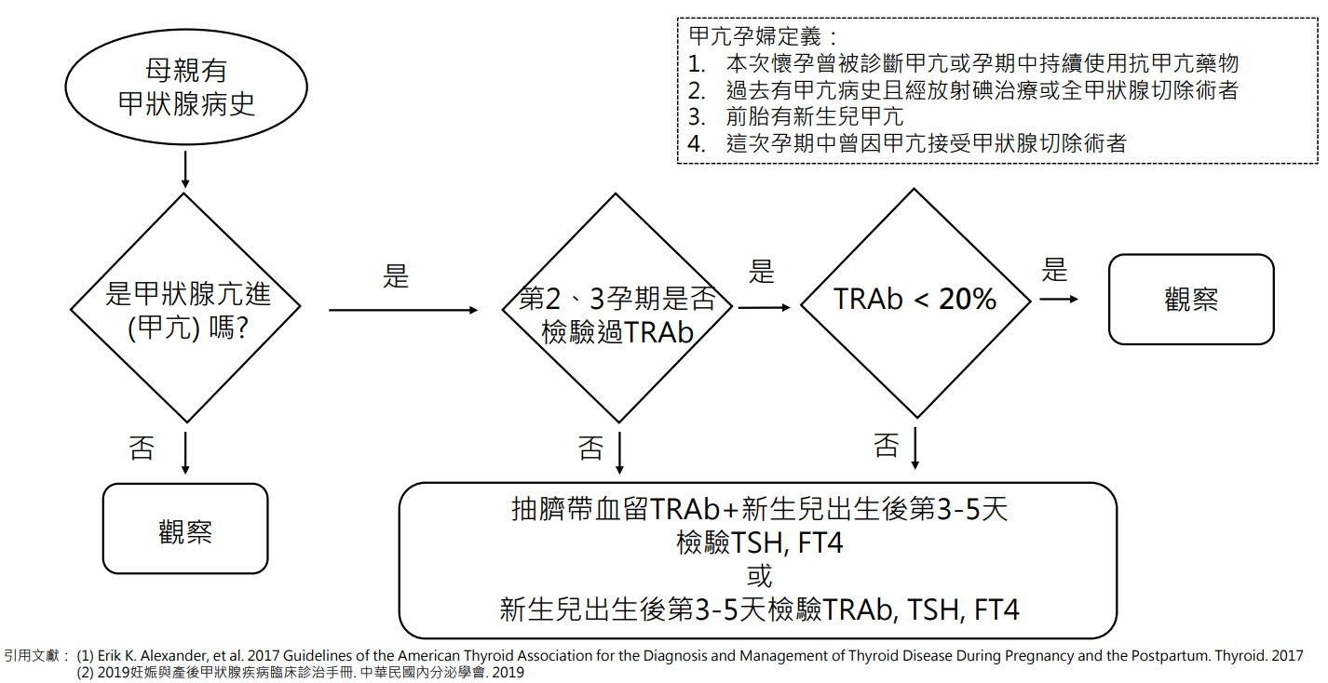
- 重點病史詢問可以排除許多問題： (灰底者為易遺漏資訊請會診時一定要提供)
母親病史 | 甲狀腺疾病 | Hypothyroidism(Autoimmune or Iodine deficiency or iatrogenic or CH) or hyperthyroidism(Graves' disease or (toxic adenoma, toxic multinodular goiter)?  是否曾經接受過thyroid surgery or radioactive iodine(RAI) therapy?
 | 懷孕中  甲狀腺症狀 | 有無hyper or hypothyroidism之症狀?  懷孕中TSH/FT4/TSH-R Ab data? 是否有將FT4維持在upper normal range ?
 | 懷孕  藥物使用 | 藥物使用多久?停用多久?懷孕中曾使用藥物(PTU/Methimazole/Propranolol/Thyroxine)
NB病史 | 出生史 | GA ? Perinatal asphyxia? Congenital disease? Down syndrome?  近期有無使用優碘消毒造成Wolff Chaikoff effect?
 | Vital sign | T/P/R/BP and 是否使用昇壓藥物? 有無使用Amiodarone?
 | 其他  重點症狀 | Hypothyroidism: Poor feeding、prolonged jaundice、umbilical hernia、macroglossia、hypothermia、constipation、abdominal fullness  Graves disease: Irritability、fever、tachycardia、poor BW gain、hyperreflexia、increase bowel movement
- Treatment for Thyroid Disorder
- Congenital hypothyroidism
  - A low FT4 level and TSH > 40 µU/ml are indicative of congenital hypothyroidism.
  - Borderline TSH levels (20-40 µU/ml) should be repeated.
  - Levothyroxine: initial starting dose (oral )
  - Premature infants 8-12 µg/kg/day；Term infants 10-15 µg/kg/day
  - Maintain FT4 in upper half of the normal range and TSH < 10 µU/ml
  - Usually given about 1/2 hour prior to feedings because it is less well absorbed with food intake
  - Further follow-up：F/U FT4 and TSH 2-4 weeks later after initiation of therapy to rule out the possibility of transient hypothyroidism.
    - Then every 1-2 months during the 1st year of life.
    - Two weeks after changing dosage
    - Every 2-3 months during the 2nd and 3rd years
    - In children > 3 y/o. should not exceed 4-6 months

Thyroid hormone reference range (Mean ±SD) for Full term and Preterm Neonates
Gestational age (wks) | Birth | 7 days old | 14 days old | 28 days old
Free T4 (ng/dL)
23-27 | 1.3±0.4 | 1.5±0.6 | 1.4±0.5 | 1.8±0.5
28-30 | 1.4±0.4 | 1.8±0.7 | 1.6±0.4 | 1.7±0.5
31-34 | 1.5±0.3 | 2.1±0.6 | 2.0±0.4 | 1.8±0.6
≧37 | 1.4±0.4 | 2.7±0.6 | 2.0±0.3 | 2.1±2.5
TSH (mU/L)
23-27 | 6.8±2.9 | 3.5±2.6 | 3.9±2.7 | 3.8±4.7
28-30 | 7.0±3.7 | 3.6±2.5 | 4.9±11.2 | 3.6±2.5
31-34 | 7.9±5.2 | 3.6±4.8 | 3.8±9.3 | 3.5±3.4
≧37 | 6.7±4.8 | 2.6±1.8 | 2.5±2.0 | 1.8±0.9

- Neonatal thyrotoxicosis
  - Therapy depends on the severity of the symptoms.
  - Mild: close observation is required. Therapy is not necessary.
  - Moderate:
- Lugol’s solution (iodine), 1 drop q 8 h
- Propylthiouracil, 10 mg/kg/day tid
- Methimazole, 0.5-1 mg/kg/day tid
- Severe: In addition to antithyroid medication, propranolol, 1-2 mg/kg/day bid-qid
- Transient hypothyroxinemia of prematurity (THOP)
  - 對象：小於32週早產兒(但不建議例行替32週以前小孩驗free T4/TSH)
  - 定義：TSH < 10 μU/mL 及 free thyroxine (FT4) < 0.8 ng/dL
  - 治療時間：6~8週時間
  - 建議起始劑量：5 μg/kg/day
  - 用藥後兩星期後追蹤
  - 安排甲狀腺超音波檢查

- CAH
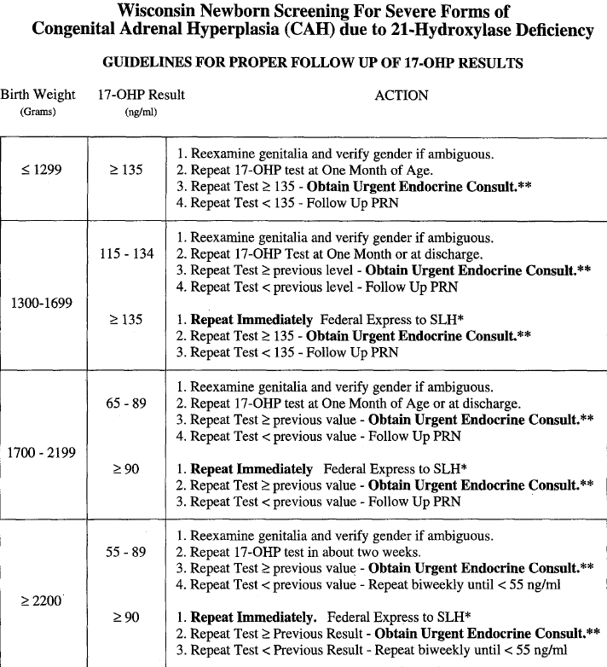
Reference: J Pediatr 1997; 130:128-33
- Carnitine deficiency interpretation and supplement dose
- Lab data interpretation:
 | 正常範圍 | 判讀 | 臨床意義
FC | ≥20 micromole/L | 須參考AC/FC ratio | Plasma free carnitine
TC | 30-60 micromole/L | 須參考FC/TC ratio | Plasma total carnitine
AC/FC | <0.4 | >0.4🡪carnitine deficiency | 代謝異常
FC/TC | >0.7 | <0.7🡪carnitine insufficiency | 給得不夠
TC (plasma total carnitine) = AC (Acylcarnitine carnitine) + FC (plasma free carnitine)

- Carnitine Supplement Dose:
- For primary carnitine deficiency: 10-20mg/kg/day in parenteral nutrition solution
- May be administered by a continuous infusion dilute to 0.5~8 mg/ml in Lactated ringer solution or normal saline..
例: Carnitine10~20 mg/kg/dose QOD IV slowly push
- PO (UpToDate, 2023修)
For deficiency: 50 mg/kg/day Q3-4H; titrate slowly as needed to 50-100 mg/kg/day; (up to 400 mg/kg/day) (Longo 2006; Magoulas 2012)
口服 1#(1000mg) in distilled water 10cc冰冰箱(可放3天)，再依所需劑量頻率開出
Reference: Pediatric dosage handbook with international trade names index, 16th edition, p.231

- IV (Uptodate):
Initial: 2 -5 mg/kg/day in PN solution; higher doses up to 10 -20 mg/kg/day may be necessary in patients with elevated triglyceride levels or receiving parenteral nutrition longer than 7 days; free and total plasma carnitine concentrations should be monitored and doses adjusted accordingly (ASPEN [Corkins 2015])

- 急性新生兒高血氨處理 (快速鍵 HiNH3)
- 對象:
- 出生 ≤ 30天
- 血氨 ≥ 150μg/dL (1μg/dL=1.7μmol/L)
- 無法排除先天性代謝異常病嬰

- 醫囑/ STAT 檢驗檢查
- ABG
- CBC/DC, CRP
- PT/aPTT
- Na/K/Cl/Ca/Mg/P, Bun/Cr
- AST/ALT, Alkaline Phosphatase, Bilirubin total/direct, Albumin
- Glucose
- Plasma uric acid
- Plasma ammonia ** 冰浴 ** 20分鐘內有結果 **
- Plasma amino acid
- Plasma lactic acid
- Plasma acylcarnitines
- Total & free carnitines
- Blood culture
- EDTA 管留 2-3ml ** 輸血 & CVVH 前 **
- Urinalysis
- Urine organic acids (20-30ml, 收集部分檢體後可先冰存, 待集滿後再送檢)
- Urine culture
- CSF studies & culture (optional) 預留一管CSF 冷藏保存
- Brain Ech

- Management - 急性期病患處理
血氨 (μg/dL) | 未確診先天性代謝異常 | 已確診先天性代謝異常
150-200 | 與小兒遺傳科醫師共照  停止進食以及蛋白質攝取  給予含糖點滴 | Same as undiagnosed case  換成無蛋白配方  開始藥物治療
200-300 | 給予藥物: Carbaglu, Buphenyl, Carnitine, Vitamin B12  開始靜脈注射 SMOF 2-3g/kg/day | 開始腹膜透析/血液透析  停止進食
300-500 | 與蔡政道醫師共照  照會心臟血管外科建立血液透析及腹膜透析管路  開始腹膜透析  若於8小時內無顯著改善開始CRRT | Same as undiagnosed case  開始CRRT
≥ 500 | 開始CRRT | Same as undiagnosed case

- CVVH 醫囑快速鍵: CVVH
  - 詳見新生兒加護病房工作指引手冊
- PD 醫囑快速鍵: PD
  - 詳見新生兒加護病房工作指引

- Management - 急性期藥物劑量
  - Carbamyl glutamate (Carbaglu) Loading: 100mg/kg stat, 250mg/kg/day q4~6H (每dose盡量以半顆或一顆為單位以利分藥。 藥物泡製後無法保存)
院內無此藥，聯絡中國醫藥大學附設醫院「罕見疾病特殊營養食品暨緊急需用藥物物流中心」申請調藥，須符合特定條件及遺傳科醫師開立才能健保給付。
  - Sodium Phenobutyrate (Phenbuty) 250mg/kg/day q6H (小心保存, 易潮解)，須符合特定條件及遺傳科醫師開立才能健保給付。
  - Vitamin B12 stat im 1pc
  - Carnitine 50mg/kg/day iv qD
- Management - Patient Monitoring
Item | Interval | Item | Interval
Ammonia | q3-q12H | Brain Echo | q1W
Dextrose | q4H-qD | Plasma AA | q1-2W
ACT | q2H | Urinalysis | q1-2W
Na/K/Cl/Ca/P/Mg | q6H | Urine Organic Acid | q1-2W
CBC | qD | PT/aPTT | q1-2W
- Management - Supportive Care in the acute hyperammonemia phase
Nutrition
1. 前24-48小時：暫停使用含蛋白質或氨基酸之奶品及輸液
    - 若無意識不清噁心嘔吐，可喝美強生PFD (無氨基酸配方，0.8kcal/ml)
    - 若需靜脈營養，可特調 D (10%-20%) AA 0% PN配方 (非常規，請先電聯拜託幫忙)
    - 可加上SMOF 2g/kg/day
2. 48小時後：可加入少量氨基酸，若無意識不清噁心嘔吐應即早餵食
    - TPN (0.5-1%AA); 急性期 total protein intake 1.0-1.2g/kg/day
    - Essential amino acid supplement 亞培 Cyclinex (0.67kcal/ml, 0.01g protein/ml)
    - 奶量達 20ml/meal 可逐量加入母乳 (MOM) 或一般配方奶 (母乳優先)
3. Hydration: 1.2-1.5倍的維持液需求量, 輸液流速 ≥ 4ml/kg/hr
4. 每日熱量攝取目標：120-130kcal/kg/day
5. 理想血糖範圍：100-150mg/dL
- 維持 SIR ≥ 4 mg/kg/min, DO NOT DECREASE SIR unless Lactate ≥ 27mg/dL
- 高血糖：若 > 150mg/dL，可調降SIR最低到4mg/kg/min。若高血糖持續，加上RI
- 低血糖：增加輸液Dextrose濃度，提高 SIR
6. SMOF: 2-3g/kg/day
7. 微量元素及維他命補充:
    - Folinate qW
    - Biotin, Vitamin B6, Vitamin B12, Vitamin K1 in Lyo-Povigen qW1,3,5 (in TPN)
Neuroprotection
  - BT 36C-36.5C
  - Hypertonic saline or mannitol, and hyperventilation if cerebral edema is present
  - Avoid Valproic acid & Steroids
  - If seizure: Luminal, Keppra, Dormicum
Symptomatic Relief:
  - Nausea/vomiting: Primperan/Domperidon/Ondansetron
  - Probiotics
Others
1. Antibiotics - 依病患臨床狀況決定; 若有接受腹膜透析或血液透析劑量需調整
2. 血液製品輸注:
    - 血品 (PRBC, Platelet) 需洗滌
    - 避免使用血漿製品 (Albumin, FFP)，若要使用需注意整體蛋白質攝取量需 < 1 g/kg
    - 各血品蛋白質含量：
Albumin 25% (1ml=0.25g), FFP 7~8% (1ml=0.07g), Washed PRBC <0.5g/unit
3. 避免其他加據高血氨因子:
    - 增加血氨生成:
      - Infection with urea-producing bacteria (Proteus mirabilis, E.coli, Klebsiella, Providencia rettgeri, Morganella morganii, diphtheroids, systemic mycobacterium or mycoplasma infections, herpes simplex virus infections)
      - Increased muscle catabolism: seizures, starvation, trauma
      - Iatrogenic: TPN with high protein load
      - GI hemorrhage
    - 減少血氨排出: Portosystemic shunt, Ureterosigmoidostomy
    - 藥物引起: Valproic acid, Carbamazepine, Sulfadiazine, Ribavirin, Salicylates, Glycine
Reference
- Nakamura, K., Kido, J., Mitsubuchi, H., and Endo, F. Pediatrics International (2014) 56, 506-509.
- Häberle, J., Boddaert, N., Burlina A. et al. Orphanet Journal of Rare Diseases 2012, 7:32
- Häberle, J. Eur J Pediatr (2011) 170:21-34.
- Upadhyay R., Bleck TP, Busl KM. Case Rep Med. 2016;2016:8512721

附錄 (一): 相關聯絡人
廠商/產品 | 聯絡人 | 電話
CVVH 機器廠商 | John | 0985-397-588
前茂/美德康&亞諾 導管廠商 | 戴’R | 0933-025-505
藥物: Carbaglu, Buphenyl  特殊配方奶: Cyclinex, PDF | 24hr 中國附醫罕病基金會物流中心 | 04-22086971

