- Vein of Galen aneurysmal malformation (VGAM) 2025新增
- Classification
- Primary
  - choroidal type:Multiple feeders, including: thalamoperforating, choroidal and pericallosal arteries are located in the subarachnoid space in the choroidal fissure
  - mural type:Fistulae in the subarachnoid space in the wall of the median prosencephalic vein
- Secondary:Parenchymal Arteriovenous Malformations
- Clinical presentations:
The greater the size, the larger the degree of shunting through the lesion, and the earlier the presentation.
- CV : high-output cardiac failure, pulmonary hypertension, and multiorgan system failure
- Neuro: Cyanosis, hemorrhagic lesions, hydrocephalus, cerebral atrophy,impaired cortical development
- Diagnosis
- Prenatal screening ultrasound or with the fetal MRI
- Cranial doppler sonogram
- Brain CT with
- MRI
Investigate for severity of heart failure
- Echocardiogram
- Renal and liver function test
- EEG
- Management
The main therapy goal is to minimize congestive heart failure
Bicêtre score
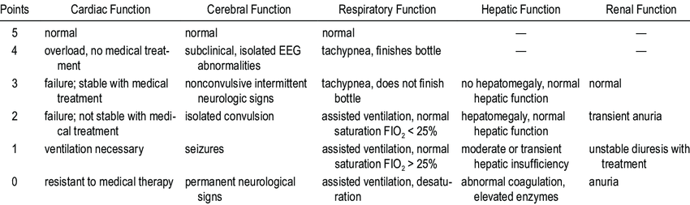
- < 8 points：No treatment (recent studies showed this group receiving embolization may still have good outcome)
- 8-12 points：Emergent embolization
- >12 points：Embolization at 5 months of age with continue management

- Embolization：the main approach to treatment and can be performed by an arterial transarterial approach using liquid adhesive agents or micro coils or by a transvenous approach typically using the umbilical or femoral veins.
- Microsurgery： not a primary treatment, but may still be performed for persistent hydrocephalus, intracranial bleeds, hematomas, or when embolization fails

