Stub application structure description

Overview
Stub application represents a skeleton that can be used to build a more sophisticated web site. It contains necessary infrastructure for building an application itself, its unit and web tests.

Technologies used
Build scripts: Maven
Database integration: MyBatis
Application Core: Spring Framework, Spring Security, Jackson JSON and others
View engine: JSP
Javascript libraries: jQuery, jqGrid
Unit tests: jUnit, dbUnit, EasyMock
Web Tests: Selenium Web Driver

Application Structure

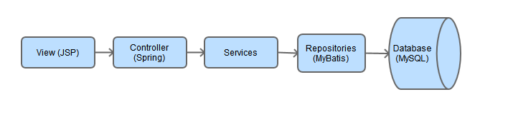
View
JSP and JSTL should be used. Direct access to the application core is not allowed here. View should access only data that is available in model sent by controller.

Controller
Should be used only for filling view model and parsing request parameters. Complicated logic should not be implemented here.

Services
Responsible for managing transactions, securing data access layer and implementing complicated functionality. These classes should be tested with fast mock-based tests.

Repositories
Responsible for mapping POJOs to mysql database contents. Minimum (or no) logic should be here. Should be tested with dbUnit tests.

Web Tests Structure
All tests should operate with HTML elements through Page Objects ( https://code.google.com/p/selenium/wiki/PageObjects ). HTML element names, ids or other properties should be mentioned in Pages only and only once each. Each tests consists of three phases:
- Filling database with tests data before running test. All methods related to this phase should be named starting with GIVEN
- Running tests and performing interaction with a page. All methods related to this phase should be named starting with WHEN
- Comparing tests results to the expected values. All jUnit asserts should be here (and only here). Methods related to this phase should be named starting with THEN

