**1.Home page**

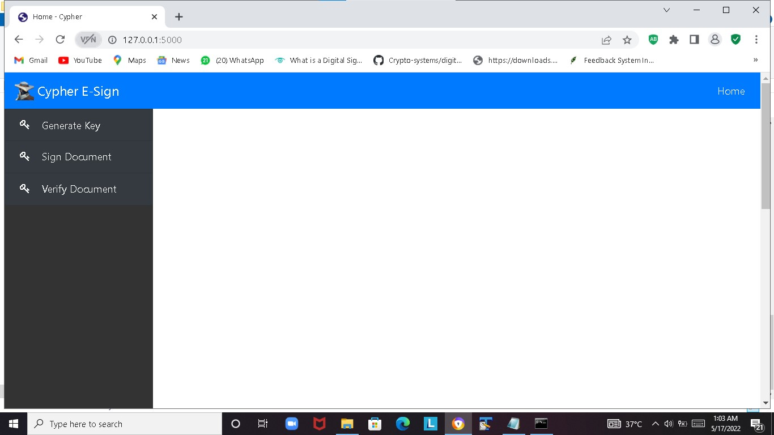

**2. Generate Keys Page**

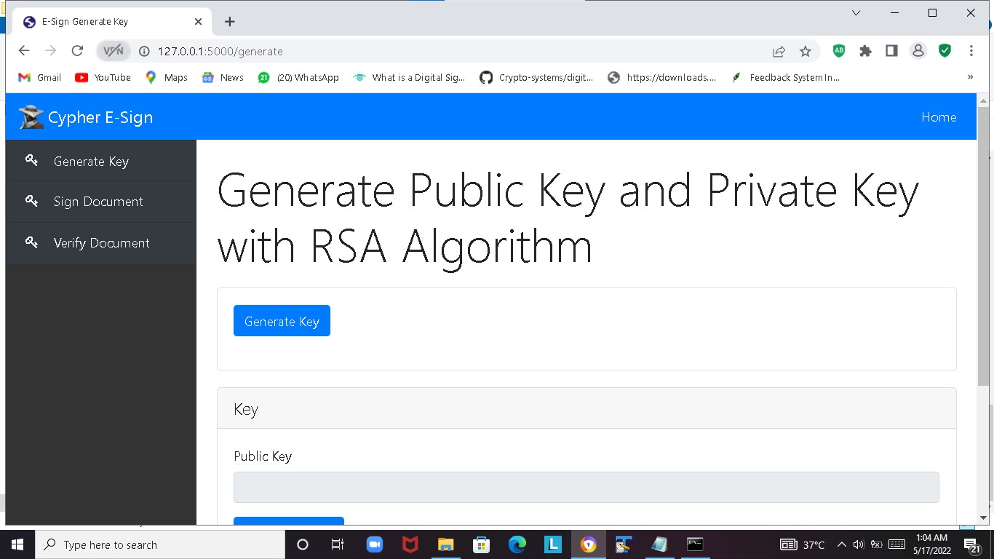

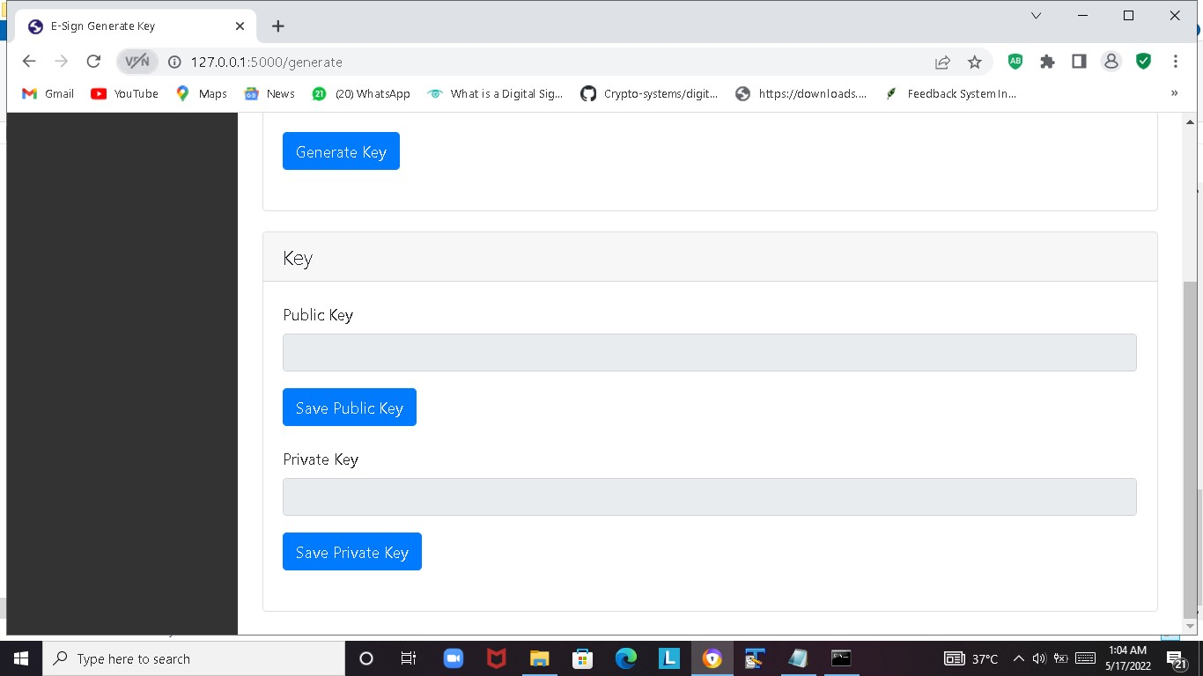

a. Generate Key Page- Public and Private keys generated

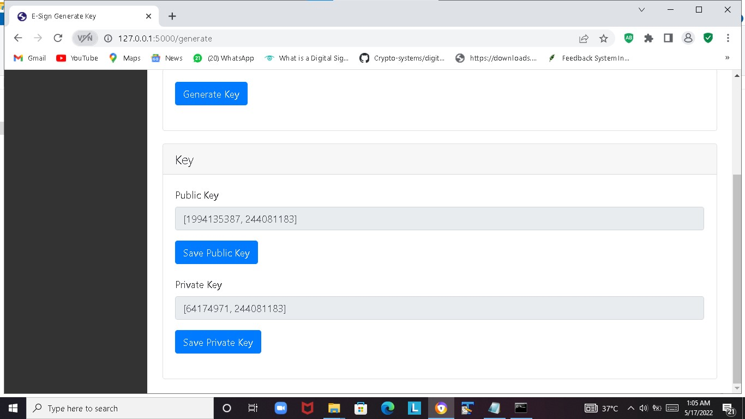

b. Generate Key Page-Save Public and Private keys

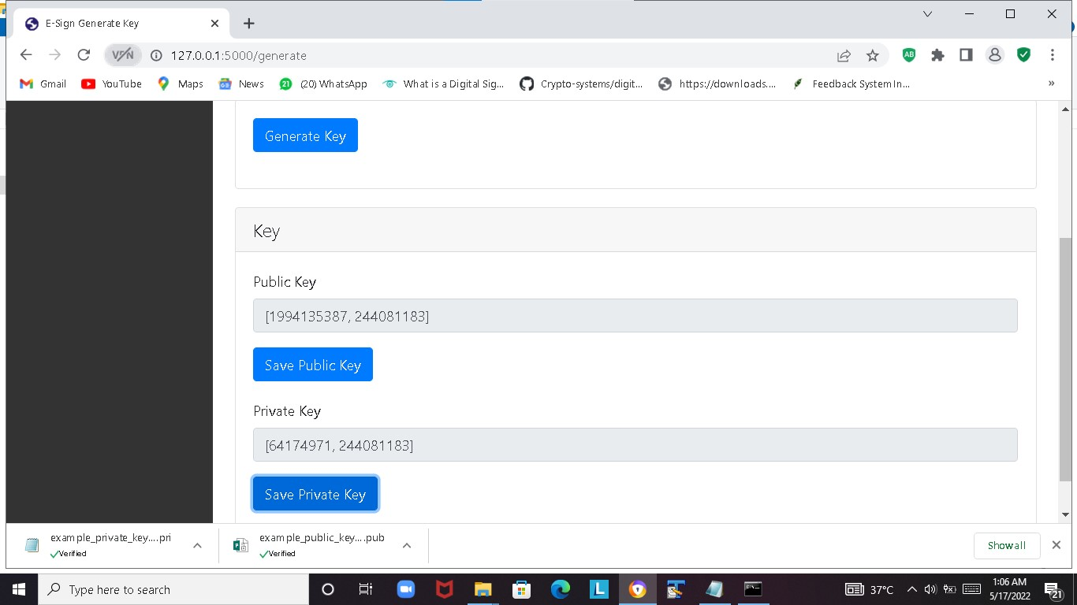

**3. Sign Document Page –**

**3.1 Sign Document Page – Sign and document combined**

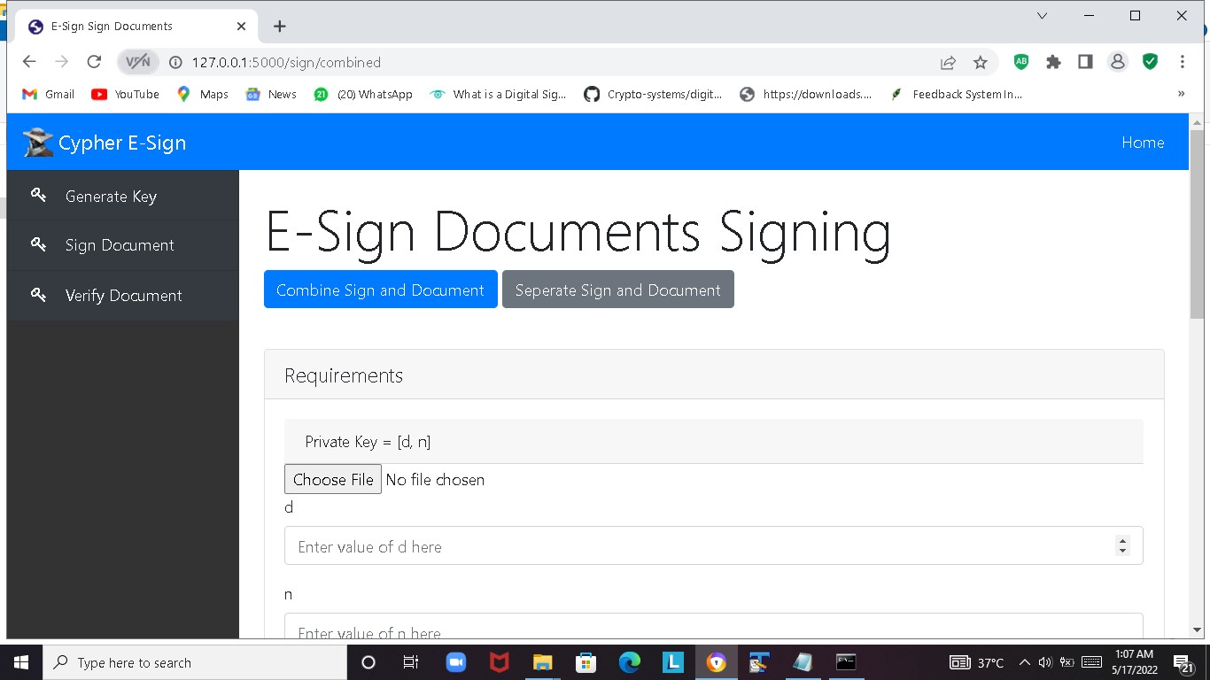

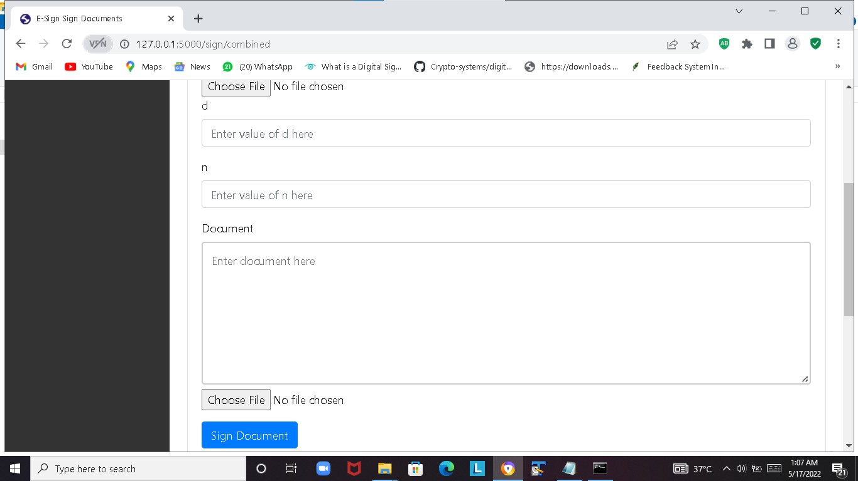

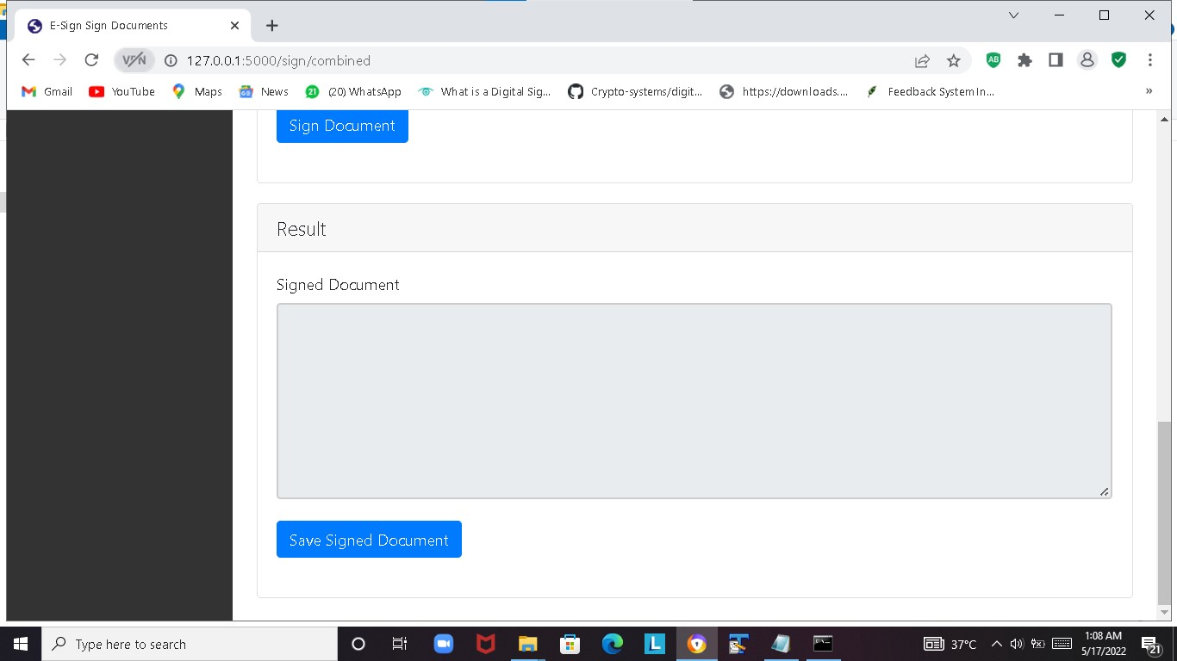

3.1.1a Sign and document combined - Upload Private key and Type Text to Sign

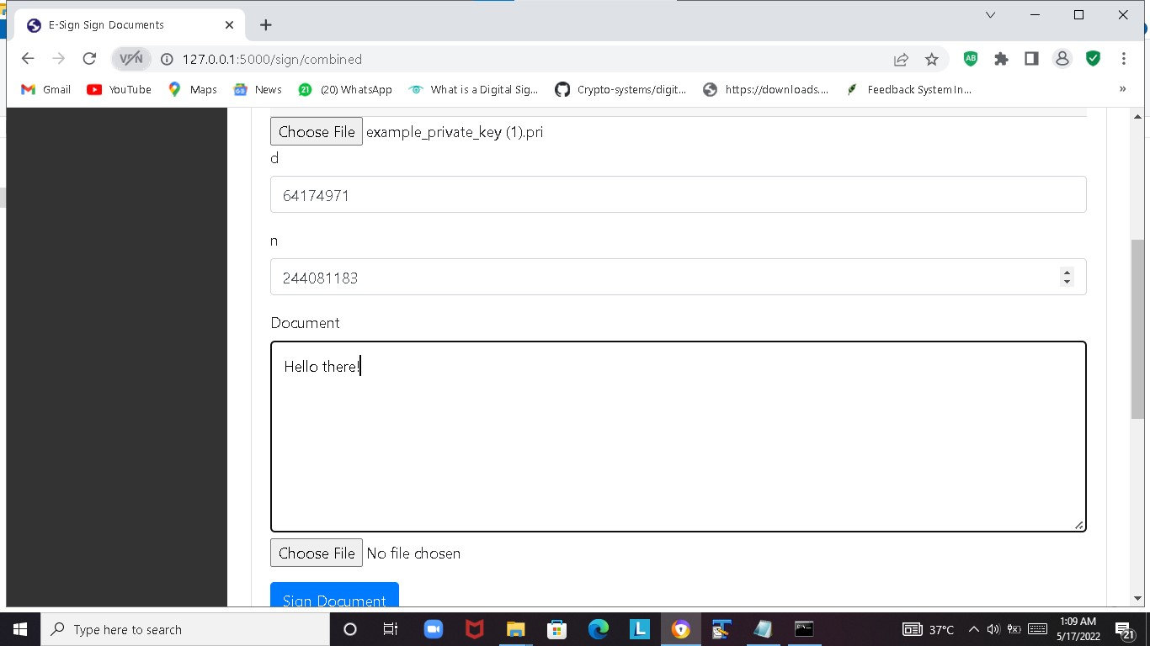

3.1.1bSign and document combined - Upload Private key and Type Text to Sign

3.1.2. Sign and document combined - Document with signature is displayed

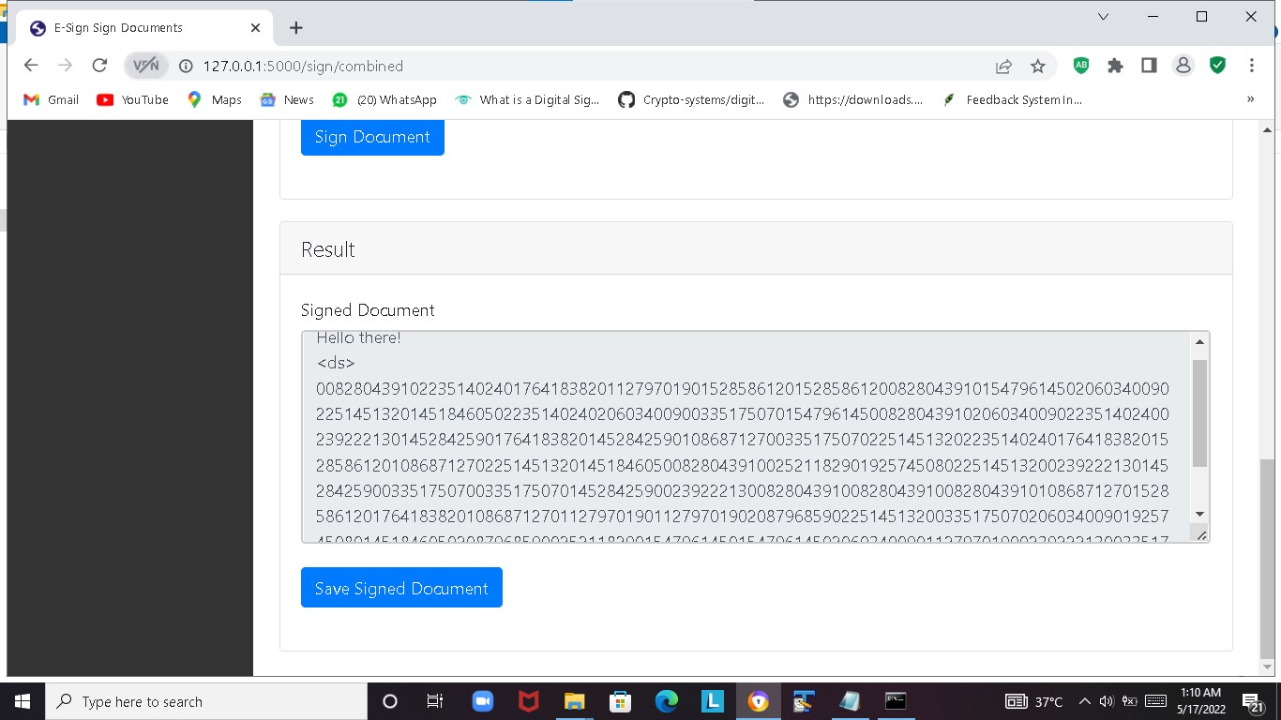

3.1.3 Sign and document combined - Save Signed Document

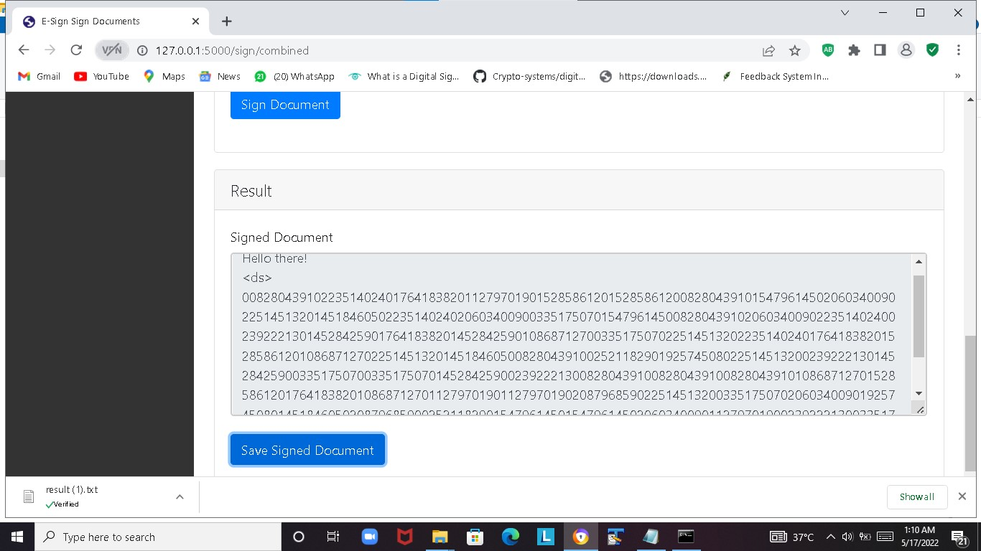

3.2 **Sign Document Page -Separate Sign and Document**

3.2.1a **Separate Sign and Document**- Upload Private key and Type Text to Sign

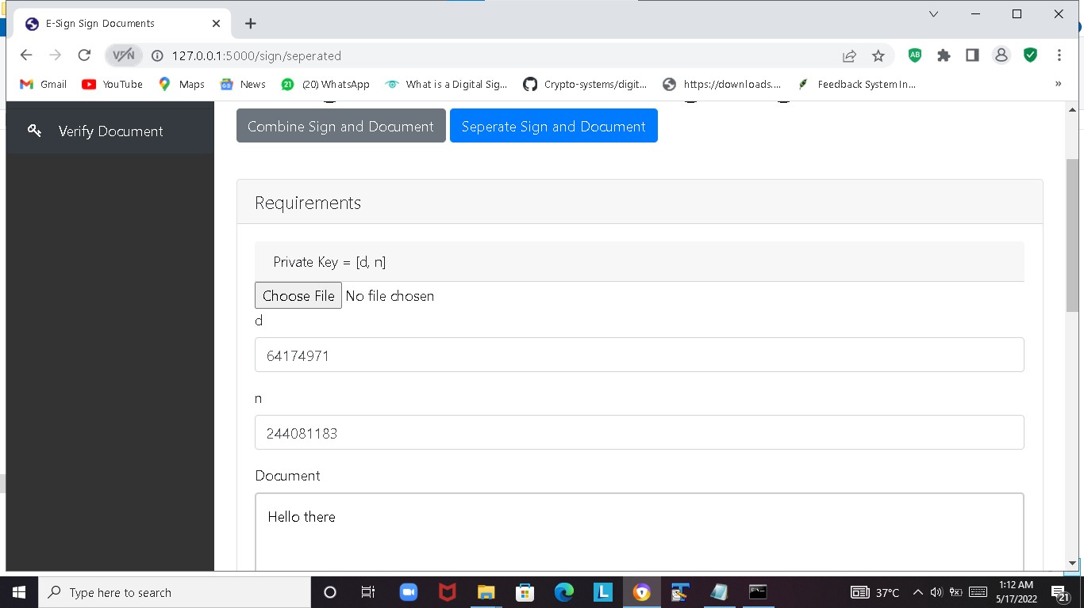

3.2.1b **Separate Sign and Document**- Upload Private key and Document to Sign

3.2.2. **Separate Sign and Document-** Document and signature is displayed and Saved

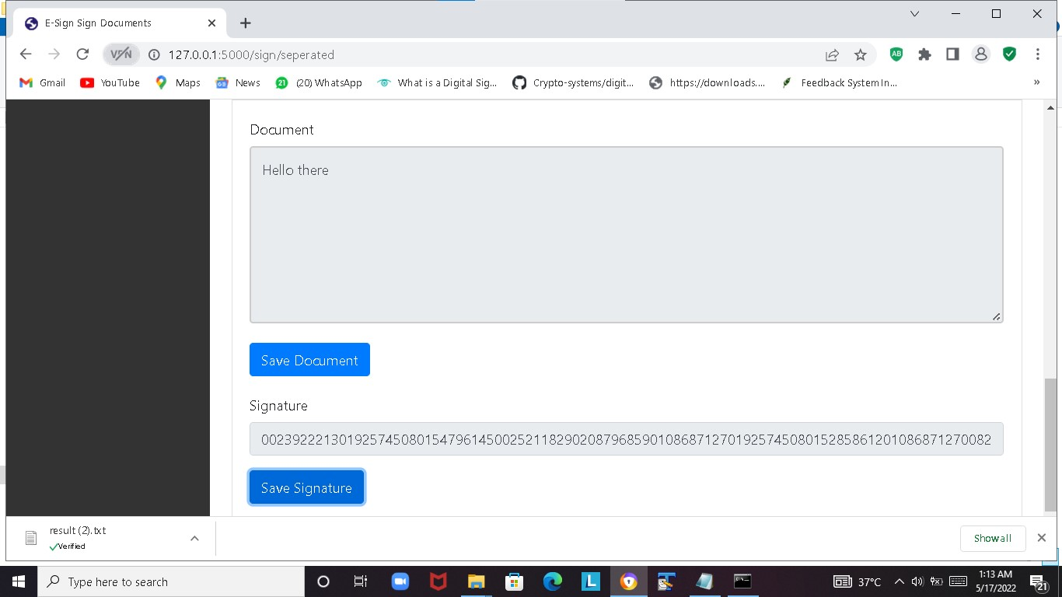

1. **Verify Document Page-**

**4.1 Verify Document Page- Sign and Document Combined**

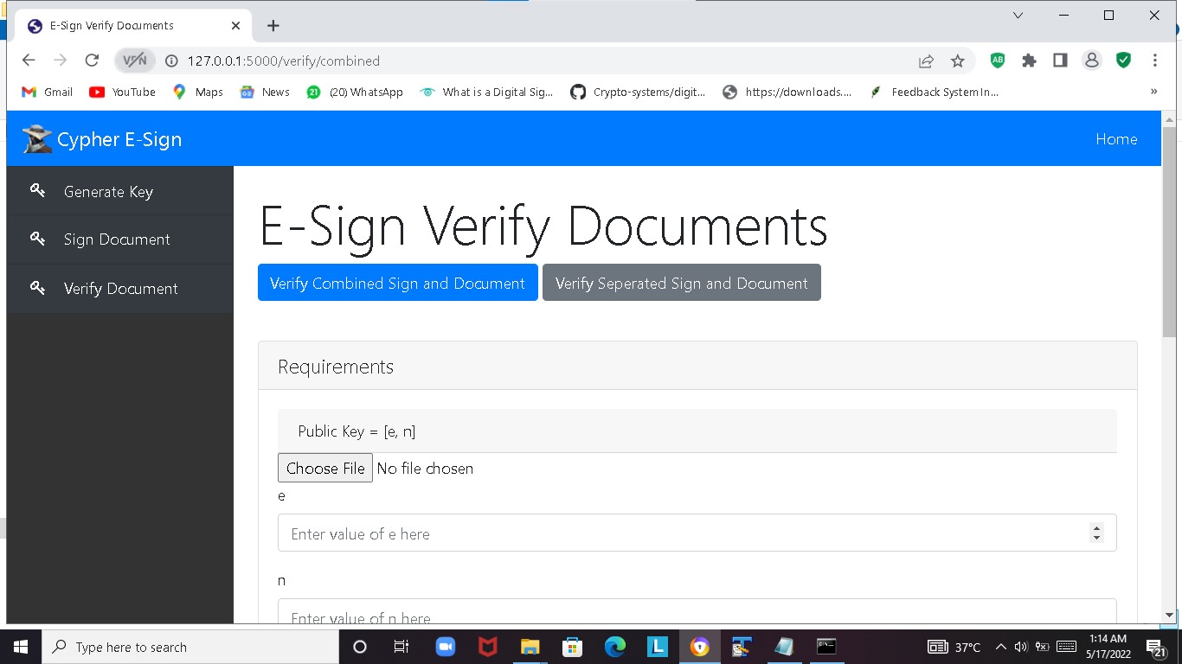

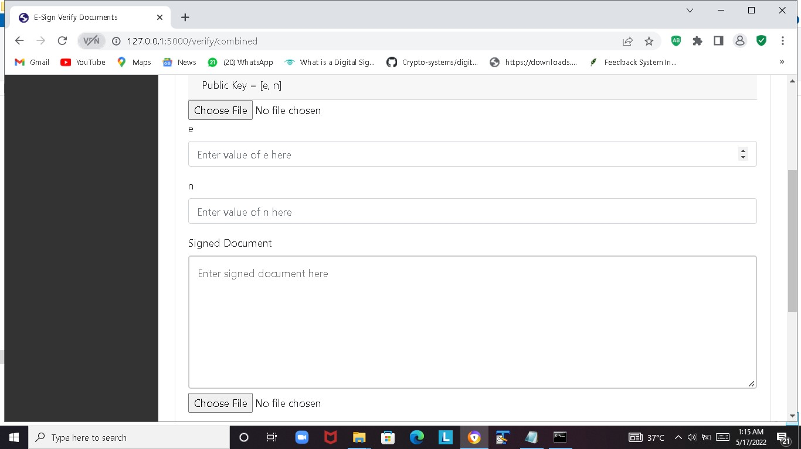

* + 1. **Sign and Document Combined**- Upload Public Key and Signed Document to Verify

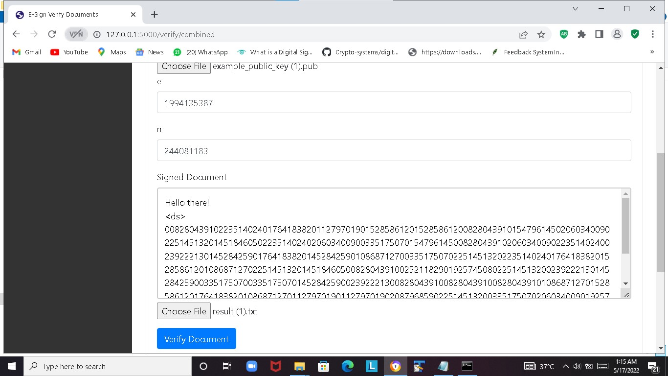

**4.1.2 Sign and Document Combined-** Verified Status is displayed

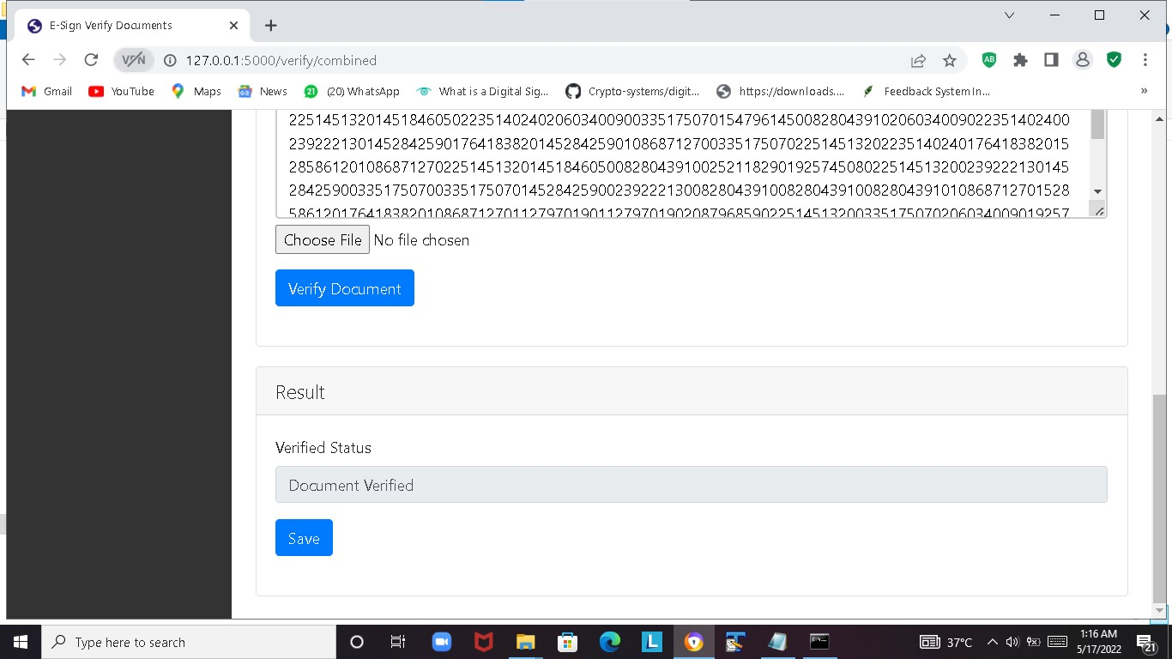

**4.1.3 Sign and Document Combined**- Signature is tampered with highlighted letters

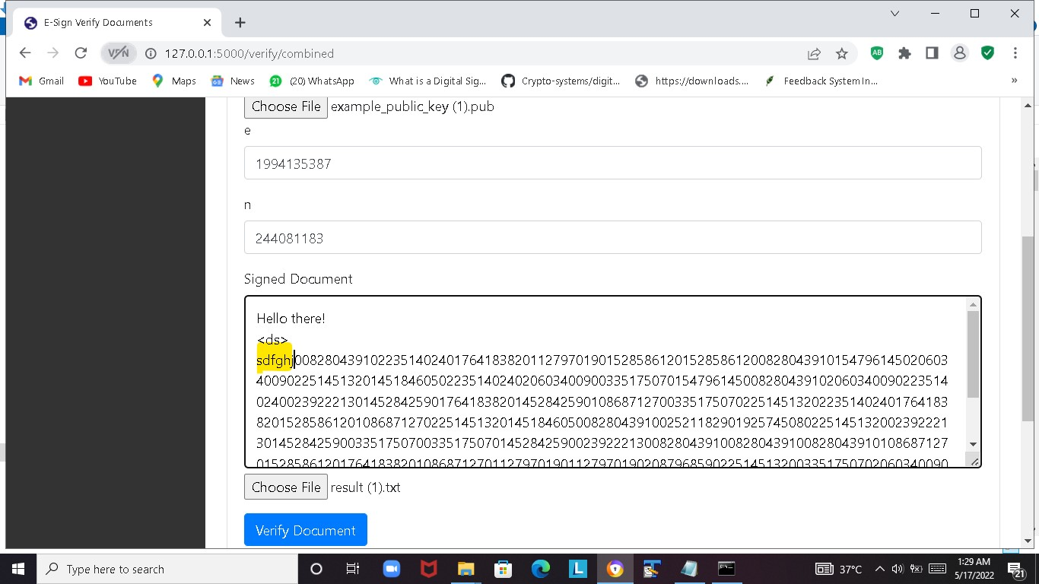

4.1.4 **Sign and Document Combined-** Verified Status is displayed: Document Not Verified

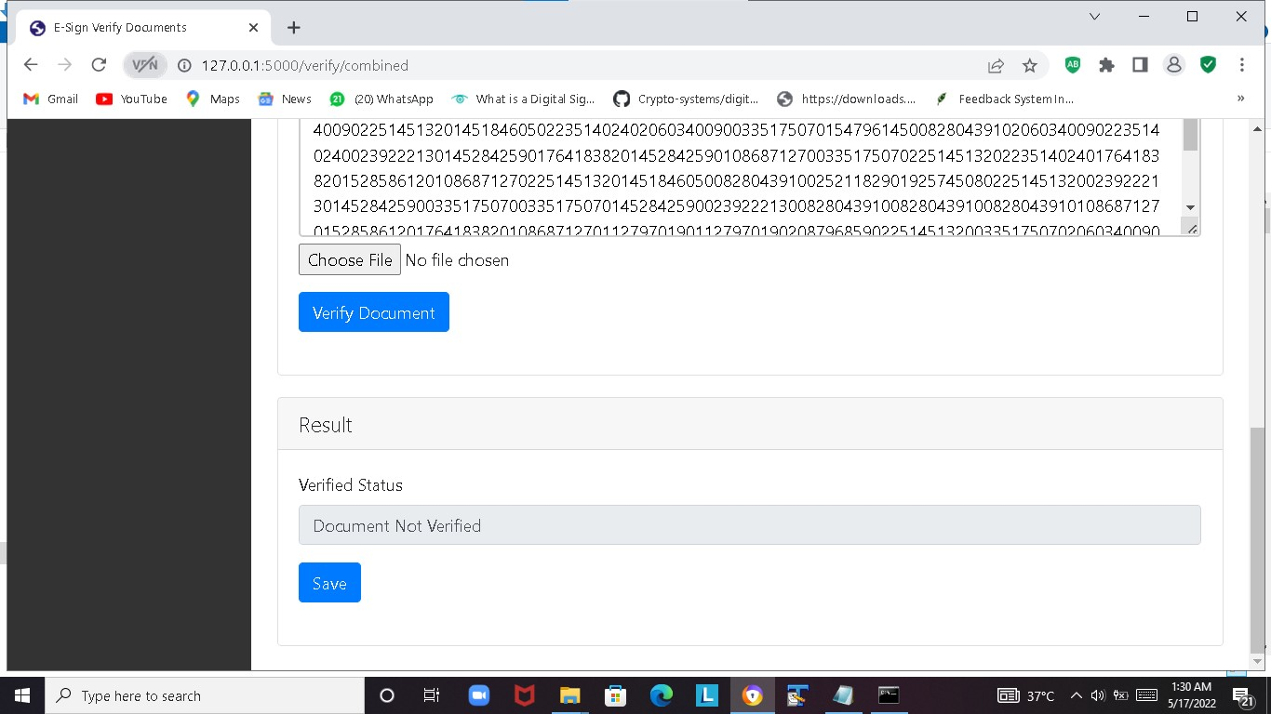

**4.2 Verify Document Page- Sign and Document Separated**

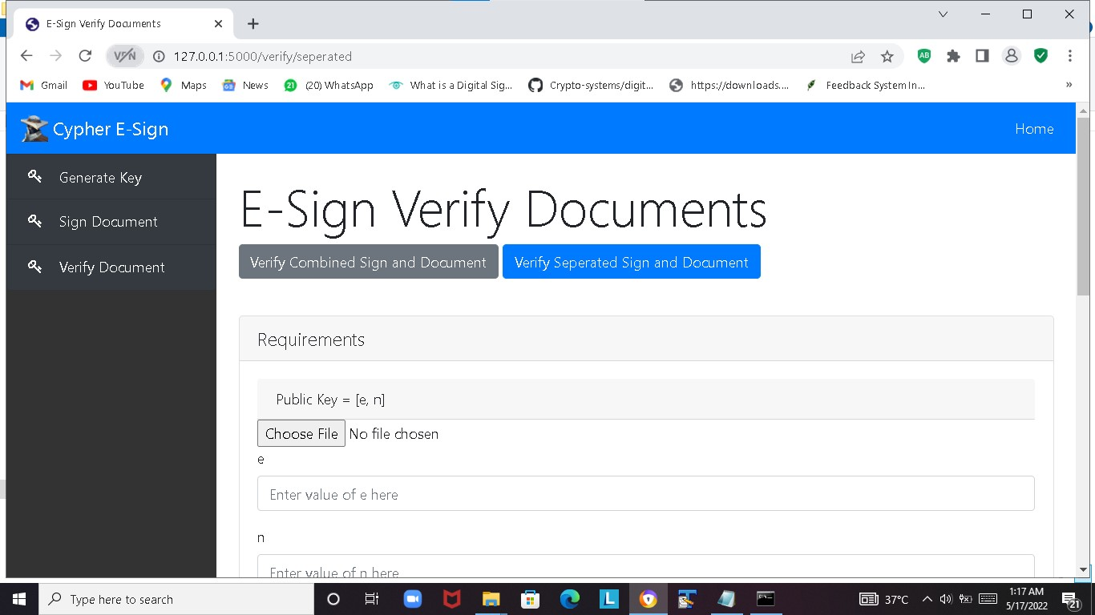

**4.2 Sign and Document Separated-** Upload Public Key ,Document and Signature

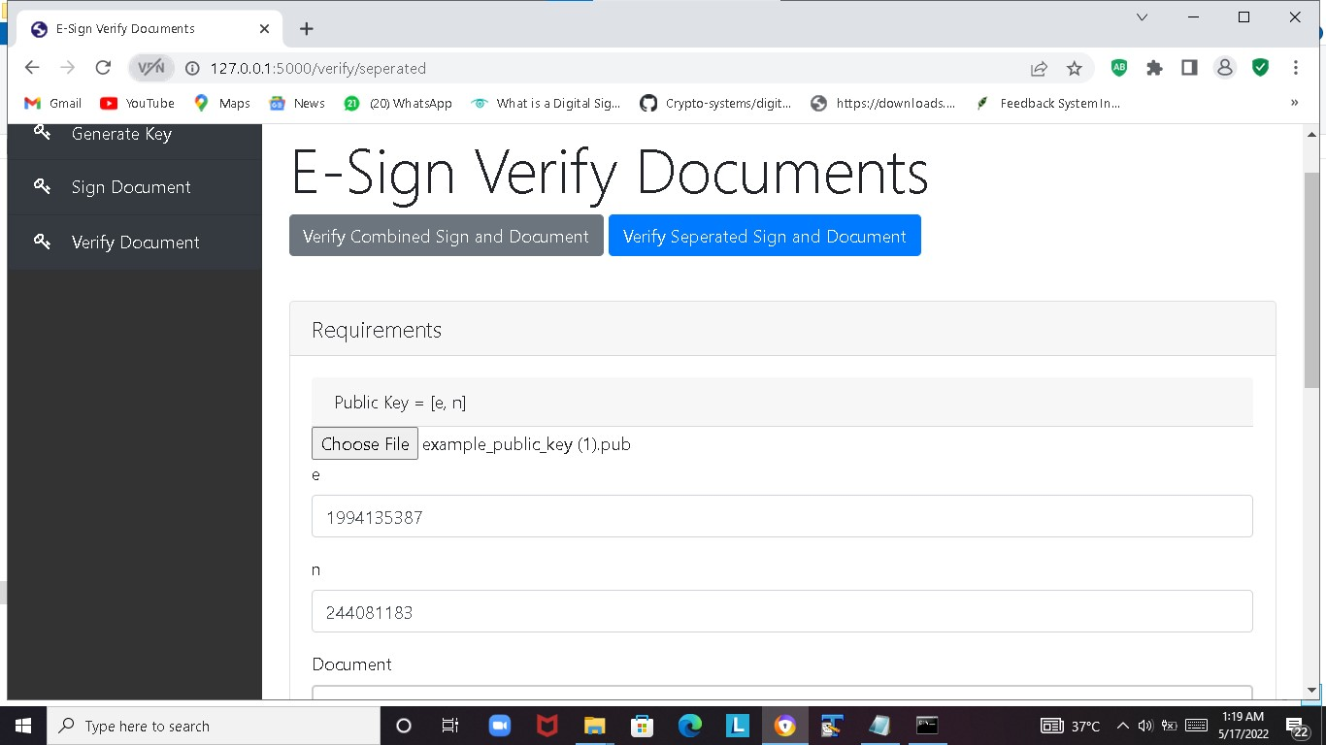

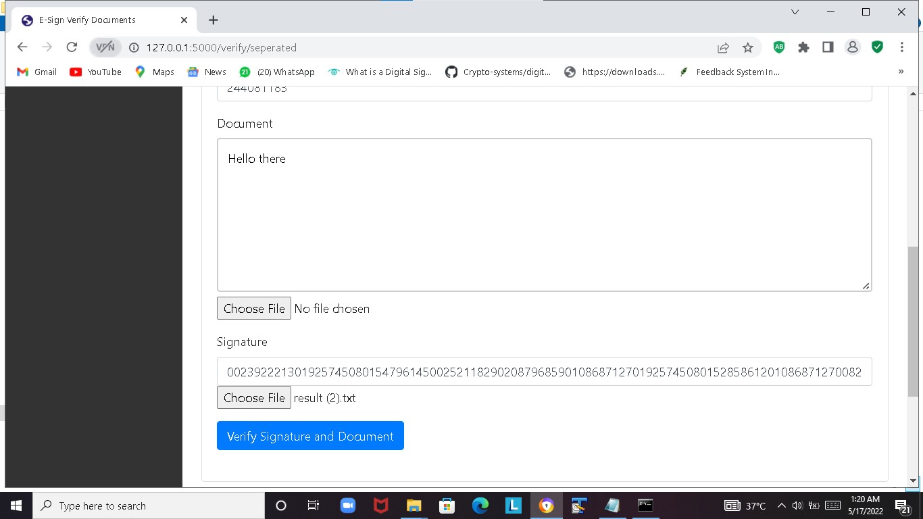

**4.2 Sign and Document Separated-** Verified status is displayed :Document Verified

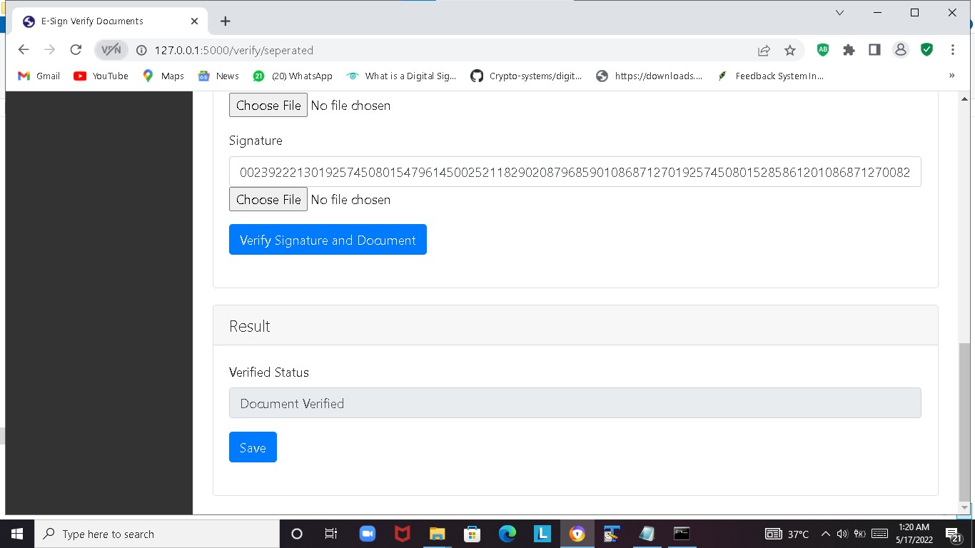

**4.2 Sign and Document Separated-** Signature is tampered with highlighted letters

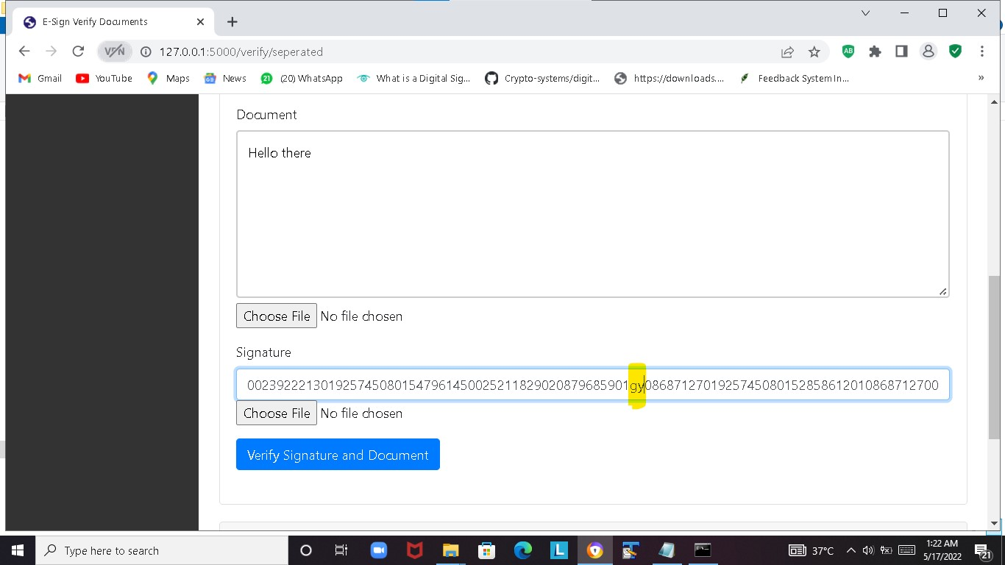

**4.2 Sign and Document Separated**- Verified Status is displayed: Document Not Verified

