What a network prior contributes to cancer-driver gene prioritisation: a leakage-controlled benchmark
Draft research report (SCI-standard manuscript, v1.0-rc3)
Authors: lanxin2391 (Networks & Engine), kakamiku (Labels & Data)
Pre-registration: Zenodo DOI 10.5281/zenodo.23121762 (frozen 2026-09-27; amendments 1–5 in docs/pre_registration_amendments.md)
Code and data: https://github.com/lanxin2391/d1-benchmark, tag v1.0-rc3
Reproducibility: python scripts/audit_reproducibility.py → 50 PASS / 0 FAIL; python scripts/verify_claims.py → 63 PASS / 0 FAIL
Date: 2026-11-11

Abstract
Background. Cancer-driver gene prioritisation routinely uses a protein–protein interaction or co-expression network as a prior, on the guilt-by-association premise that two genes whose proteins interact are more likely to share driver status. Random walk with restart (RWR) is the canonical formalisation. Whether the specific topology of a network contributes to driver-gene prediction beyond what node degree alone explains is a question the field has asked for a decade and answered without a leakage-controlled design.
Methods. We assembled a six-network panel stratified by molecular provenance (one RNA-derived, three protein-derived, two curated or literature-derived) and a four-label panel spanning mutation-based and clinical-evidence curation philosophies. We held the learner fixed — RWR at α = 0.5, no hyperparameter tuning — so that the quantity of interest is the network's contribution and not the learner's quality. The primary endpoint was ΔAUROC = AUROC(RWR) − AUROC(degree-only) over 5-fold × 40-repeat cross-validation (200 folds per cell, 24 primary cells). Three hypotheses were pre-registered (H1: the prior contributes beyond degree; H2: the contribution is provenance-invariant; H3: between-network differences reflect literature attention) together with seven protocol controls and three added after a systematic read of the reference corpus. A systematic read of a 41-paper reference corpus then motivated three further controls — seed-degree stratification, network size and coverage adjustment, and random-input degeneracy — which were run and reported without being allowed to alter the pre-registered decision rule.
Results. Across the 24 (network × label) cells at α = 0.5, ΔAUROC ranged from −0.0125 (Reactome × newly-discovered IntOGen drivers) to +0.1711 (STRING physical × Open Targets no-literature); 23 of 24 cells were positive. Both null models were rejected overwhelmingly: 23 of 24 cells beat the degree-matched random-seed null and 23 of 24 beat the rewired-network null at z > 5. On the two endpoints the published evidence actually uses — partial AUC below 2 % FPR (Guala & Sonnhammer 2017) and precision in the top 10 % — the margin is smaller but still positive in 20 of 24 arms (median +0.031 and +0.041 against +0.081 for the full AUROC), and the ordering of the arms is unchanged (Spearman ρ = 0.80 and 0.90): the prior's advantage is a global-ranking advantage, not a top-of-list artefact. The 95 % confidence interval on ΔAUROC excluded zero in 24 of 24 arms under four of the five interval constructions and in 20 of 24 under the pre-registered gene-cluster bootstrap. The margin was flat across the degree tercile of the seeds (mean ΔAUROC +0.053, +0.061 and +0.054 for low, mid and high seed degree; mean high-minus-low +0.0010), so it is not a hub artefact; it survived adjustment for network size and label coverage (23 of 24 cells positive after adjustment; pooled Spearman ρ between ΔAUROC and log₁₀ network size −0.021, permutation p = 0.93); and it survived a literature-matched null (mean difference +0.0010). The learner's ranking collapsed onto an almost unrelated gene list under a random input (top-100 Jaccard 0.019), confirming that it uses its input rather than returning a fixed hub set. H2, however, is not testable with this panel: provenance is confounded with network size and coverage, and the three provenance classes hold three, one and two networks.
Conclusions. A network prior contributes to cancer-driver prioritisation beyond node degree, and that contribution is not explained by the degree of the seed genes, by network size, or by the degree distribution of the labels. The single negative cell is a coverage failure — Reactome's network contains only 41 % of the newly-discovered drivers — not evidence of a negative effect; the equivalence test places it in the same category as five cells with bounded positive margins. Whether the contribution depends on the network's molecular provenance remains open and requires a panel that separates provenance from size and coverage.
Keywords: cancer driver genes; network prior; random walk with restart; degree baseline; leakage control; benchmark; pre-registration; gene prioritisation.

1. Introduction
Cancer is a disease of dysregulated genes, and the first step of any molecular oncology study is to identify the small set of genes that drive it. The cancer genomics community has curated several driver-gene catalogues from independent curation philosophies: mutation recurrence (IntOGen; Bailey et al. 2018), clinical gene–disease validity (ClinGen; Rehm et al. 2015) and aggregated target–disease association (Open Targets; Ochoa et al. 2023). These catalogues disagree in instructive ways. The drivers discovered between 2020 and 2024, for instance, are largely absent from the Open Targets target–disease associations, because clinical and literature evidence takes time to accumulate.
A parallel literature has argued that network structure can help identify driver genes beyond what the catalogues alone provide. The intuition is the guilt-by-association principle: a gene close to many known drivers in a protein–protein interaction (PPI) network is itself more likely to be a driver. This has been formalised as random walk with restart (RWR; Kohler et al. 2008; Vanunu et al. 2010), as label propagation (Zhang et al. 2018), and as a family of graph neural network methods (Boiarsky et al. 2021, 2023).
The field has converged on three empirical observations. First, that RWR and its relatives beat a degree-only ranking. Second, that different networks give different absolute discriminative performance — FunMap outperforms STRING, STRING outperforms Reactome — and that this 0.25-AUROC gap is the basis of the "best network" question. Third, and critically, that no published study has measured whether the network prior contributes anything beyond degree in a leakage-controlled setting. Existing benchmarks either fix a network without comparing against a degree baseline (Picart-Armada et al. 2019; Hill et al. 2019), compare networks without reporting the margin over degree (Zhang et al. 2021), or use overlapping train/test labels that confound the degree signal with label leakage (Chu et al. 2023; DriverNet, Bashashati et al. 2012; DawnRank, Hou & Ma 2014).
That gap is not merely a matter of a missing comparison. The published evidence on the confounders is unusually specific, and each of the following has been shown to threaten exactly the quantity we want to measure:
- Degree confounding is real and severe. Driver genes are hubs: the median out-degree of Cancer Gene Census genes is 12 against 3 for non-CGC genes (Hou & Ma 2014), and the enrichment is largely an artefact of research intensity — bait usage correlates with degree at r = 0.52, and correcting for it removes the cancer-versus-control degree difference (Schaefer et al. 2015). Zhang et al. (2021) showed directly that RWR's apparent performance tracks the degree centrality of its seed nodes, warning that the advantage "may look better simply because its seed nodes have higher degree centrality".
- Network size and label coverage confound the comparison. Over 45 human interactomes, performance tracks network size, and the effect largely collapses once gene-set coverage is controlled (Wright et al. 2025).
- A learner that ignores its input returns the hubs. Over 10,000 random gene lists, algorithms differ enormously in how much of their output is input-independent (Hill et al. 2019).
- Complex leakage inflates the margin. Holding protein complexes together in the cross-validation fold drops a strong network classifier from roughly 12 to fewer than 4.5 hits in the top 20 (Picart-Armada et al. 2019).
- The choice of endpoint changes the ranking of methods. AUROC and top-k give different orderings (Picart-Armada et al. 2019), and a degree-controlled local method can beat RWR on a full ranking while RWR wins only in the top 1–10 % (Guala & Sonnhammer 2017).
The D1 benchmark is designed to answer the question these papers leave open. Its design principles are: a fixed learner (so the finding is about the network, not the method); a panel stratified by molecular provenance (so the network's origin is an experimental factor rather than a nuisance); a pre-registered endpoint and decision rule (including the resampling unit, the equivalence margin and the multiplicity family, so that the analysis cannot be re-tuned after the fact); released split files rather than regenerated seeds (Boutros et al. 2014); and a control stack that removes each alternative explanation in turn, including the three that the literature identifies and that a standard design does not cover.

2. Materials and methods

2.1 Network panel
Six primary networks spanning three provenance classes, plus two STRING threshold sensitivity arms. The harmonisation pipeline drops unmapped genes, removes self-loops, orders each edge alphabetically, drops duplicates and restricts each network to its largest connected component (LCC). The primary analysis is unweighted (decision D-01).
net_id | provenance class | source | nodes (pre-LCC) | LCC nodes | LCC edges
funmap | protein-derived | FunMap v1.0, CPTAC pan-cancer proteogenomics (Shi et al. 2025) | 10,525 | 10,189 | 196,605
intact | protein-derived | IntAct, human–human, taxid 9606 (del Toro et al. 2022) | 17,918 | 17,918 | 564,706
string_phys700 | protein-derived | STRING v12, physical subnetwork, combined_score ≥ 700 | 10,746 | 9,830 | 85,576
rna_coexp | RNA-derived | Built from FunMap's published CPTAC mRNA matrices, density-matched | 9,928 | 9,152 | 196,172
string_full700 | curated / literature | STRING v12, all-evidence channels, combined_score ≥ 700 | 16,201 | 15,882 | 236,712
reactome | curated / literature | Reactome v86, human only (Milacic et al. 2024) | 4,993 | 3,953 | 20,143
string_full400 | sensitivity | STRING v12, combined_score ≥ 400 | 19,488 | 19,486 | 929,471
string_full900 | sensitivity | STRING v12, combined_score ≥ 900 | 12,323 | 11,693 | 100,383
Provenance overlaps, stated because they bound the interpretation. FunMap's own gold standard is Reactome-derived: a gene pair is labelled functionally associated when the two genes share a "detailed" Reactome pathway of ≤ 200 proteins (Shi et al. 2025). Reactome is also an input to STRING's database channel. The "curated/literature" class is therefore one upstream knowledge base reaching the panel by two routes, and the "protein-derived" class contains a network built on that same knowledge base. This is one reason the provenance hypothesis cannot be settled by this panel (§2.6, §4.3).

2.2 Label panel
label_id | catalogue | positives
intogen2024 | IntOGen 2024.09.20 (Martínez-Jiménez et al. 2020; the compendium of Bailey et al. 2018) | 633
ot_all | Open Targets Platform 26.06, all-evidence | 600
ot_nolit | Open Targets Platform 26.06, one literature extractor removed | 600
intogen_temporal_new | IntOGen 2024.09.20 \ IntOGen 2020.02.01 | 152
clingen_label (optional) | ClinGen gene–disease validity (Rehm et al. 2015) | 84
All gene identifiers are HGNC-approved symbols; previous symbols and aliases are used only when they resolve to exactly one approved symbol, and ambiguous identifiers are dropped and counted (decision D-02). Label files contain positives only, ranked by descending evidence with ties broken by symbol.
Two properties of the label panel matter for the interpretation of §4.4. First, the two Open Targets label sets share 430 of 600 positives (72 %), so ot_all → ot_nolit is close to a re-analysis of the same label and should not be read as a catalogue-transfer result. Second, the intogen_temporal_new positives are almost disjoint from the Open Targets positives (24 of 600 and 18 of 600): the newly discovered drivers are precisely the genes the target–disease aggregation has not yet picked up.
`ot_nolit` is not a literature-free label. It is Open Targets 26.06 with the score of a single evidence extractor removed — the europepmc text-mining extractor (Ochoa et al. 2023). The platform's molecular interaction widget re-packages STRING, IntAct, Reactome and SIGNOR, and its other evidence channels (genetic association, somatic mutation, known drug, expression, animal model) are unaffected. The difference between the two label sets therefore measures the sensitivity of the Open Targets score to one text-mining extractor, not the contribution of literature as a whole. This paper's H3 argument rests on Control 7, which controls literature volume on both sides of the comparison, and not on ot_all versus ot_nolit.

2.3 The learner (locked)
For each (network, label) cell and each α ∈ {0.3, 0.5, 0.7}:
- W = D⁻¹A is the row-stochastic transition matrix of the network LCC.
- P₀ is the column-stochastic matrix whose j-th column is uniform over the train-fold positives of the j-th (repeat, fold) pair.
- P_{k+1} = α P₀ + (1 − α) Wᵀ P_k until the worst column changes by less than 1e-8, or 200 iterations.
- Genes are scored by P_k[:, j]; AUROC is computed on the test-fold positives against the rest of the universe, with the seeds excluded from the test set (decision D-06).
The learner is never tuned. α = 0.5 is the primary value; 0.3 and 0.7 are sensitivity arms. The implementation is covered by 13 unit tests including fixed-point agreement with the analytic solution P = α(I − (1 − α)Wᵀ)⁻¹P₀.

2.4 Cross-validation
5-fold × 40 repeats = 200 (repeat, fold) pairs per cell, with StratifiedKFold(shuffle=True, random_state=20260926 + repeat). The 40-repeat design (rather than the originally pre-registered 10) was adopted after a coverage simulation showed the repeat-level interval to be the calibrated construction (amendment 2); split files are released as artefacts, not regenerated from seeds.

2.5 Controls
# | control | manuscript label | what it removes | implementation
1 | degree-only baseline | Control 1 | the degree sequence itself | d1/engine/baselines.py
2 | degree-matched random-seed null | Control 2 | "the seeds are just hubs" | scripts/run_a5.py
3 | configuration-model rewiring null | Control 3 | "any edge set of this degree sequence would do" | scripts/run_rewiring.py
4 | shared gene universe | Control 4 | "the networks differ because they cover different genes" | scripts/run_d12_shared.py
5 | cross-catalogue label transfer | Control 5 | "the catalogue is the answer, not the network" | scripts/run_transfer_all.py
6 | temporal split | Control 6 | "the prior only knows the drivers of 2020" | scripts/run_d09.py
7 | publication-count adjustment with a literature-matched null | Control 7 | "popular genes are popular drivers" | scripts/build_pubcount_adjusted.py, scripts/run_control7_matched_null.py
8 | complex-aware cross-validation | Phase D | "held-out drivers inherit their complex partners' signal" | scripts/run_d3_generate_cx_splits.py
9 | hub-capped and degree-penalised RWR | E3 | "the prior is degree plus a hub effect" | scripts/run_hub_capped_rwr.py
10 | seed-degree stratification (Zhang et al. 2021) | Control 8 | "the real seeds are hubs" | scripts/run_control8_seed_degree.py
11 | network size and coverage adjustment (Wright et al. 2025) | Control 9 | "bigger networks and better coverage win" | scripts/run_control9_size_adjustment.py
12 | random-input degeneracy (Hill et al. 2019) | Control 10 | "the learner ignores its input and returns the hubs" | scripts/run_control10_random_input.py
(The two numbering systems are kept apart deliberately: the table's first column is the position in the control stack, and the "manuscript label" column is the name the manuscript, the abstract and the amendment log use. The three literature-mandated controls are Controls 8, 9 and 10 everywhere except this table's position column.)
Controls 8–10 (the three shaded in bold) were specified after the confirmatory runs existed, in response to a systematic read of the 41-paper reference corpus. They are registered in the exploratory family (amendment 5) and cannot alter the pre-registered verdict, but they are reported whatever they show.
Control 8 (seed-degree stratification) splits the training-fold positives of every arm into three equal degree terciles and recomputes the primary endpoint with the seeds drawn from one tercile only. The test set, the degree baseline and the fold structure are identical across the three strata, so the three numbers are directly comparable.
Control 9 (size and coverage adjustment) regresses the per-cell endpoint on the label set (a fixed effect), log₁₀(LCC edges) and the label coverage, and reports the fitted value as the size- and coverage-adjusted endpoint; the size correlation is additionally tested against a 10,000-permutation null.
Control 10 (random-input degeneracy) runs the learner twice on the same fold universe — once with the real training-fold positives, once with a random seed set of the same size drawn from the network's genes excluding the fold's own test genes — and reports Hill et al.'s degeneracy statistic, the hub concentration of the top-K under both regimes, and the input sensitivity (Spearman and top-K Jaccard between the two rankings of the same fold).

2.5b Co-primary endpoints
The published evidence does not use the full AUROC. Guala & Sonnhammer (2017) compare AUCs only up to an FPR of 0.02 and report that the diffusion methods win only in the top 10 % of the ranking; Picart- Armada et al. (2019) find that AUROC and top-k order the methods differently. We therefore compute two further endpoints on the same folds, the same seeds and the same degree baseline — the partial AUC below 2 % FPR, normalised so that a random scorer gives 0 and a perfect one 1, and the precision in the top 10 % — and report them as co-primary. The pre-registered endpoint remains the full AUROC and the H1 verdict is unchanged; the repeat is the unit of record throughout (scripts/run_pauc_top10.py, results/tables/pauc_top10_summary.tsv).

2.6 Statistics
The primary endpoint is ΔAUROC at α = 0.5 over the 200 (repeat, fold) pairs of each cell. The pre-registered decision rule is: H1 holds if and only if the 95 % bootstrap confidence interval on ΔAUROC excludes zero in every (network, label) arm.
Five interval constructions are reported side by side: the fold-level percentile bootstrap, and the repeat-level percentile, t and BCa intervals, plus the gene-cluster bootstrap of pre-registration §9.3, in which genes are the resampling unit (the gene draw is shared across folds, so a gene moves as a block). The repeat-level percentile is designated primary because a coverage simulation showed it to be the calibrated construction; the gene-cluster interval is the pre-registered construction and is reported as the conservative bound.
Multiplicity across the 24 cells is controlled with Benjamini–Hochberg FDR at q = 0.05, applied to the cell-level one-sided p-values. Equivalence is tested with two one-sided tests (TOST) at a margin of ±0.05 in ΔAUROC units, per Schuirmann (1987): the verdict "equivalent to zero" requires both one-sided p-values below 0.05, which is equivalent to the 90 % interval lying entirely inside [−0.05, +0.05]. Between-arm variance is partitioned by a balanced random-effects analysis into network, label, network × label and fold components.

2.7 Reproducibility
scripts/audit_reproducibility.py verifies the schema and referential integrity of every artefact, checks the SHA-256 fingerprints against the release manifest and runs an end-to-end smoke arm (50 PASS / 0 FAIL at the time of writing). scripts/recompute_ground_truth.py recomputes every headline number from the released tables into review/ground_truth.tsv, and scripts/verify_claims.py checks the manuscript against that table (63 PASS / 0 FAIL). The second mechanism was added after a review pass found eleven places where the manuscript prose had drifted from the released tables; it is a mechanical guard against that class of error recurring.

3. Results

3.1 The primary endpoint
Across the 24 (network × label) cells at α = 0.5, ΔAUROC ranged from −0.0125 (Reactome × intogen_temporal_new) to +0.1711 (STRING physical × ot_nolit); 23 of 24 cells were positive (Fig. 1, Table 1). The median cell was +0.0809 and the mean +0.0787.
Per label, the mean ΔAUROC over the six networks was +0.0821 (intogen2024), +0.1058 (ot_all), +0.1062 (ot_nolit) and +0.0208 (intogen_temporal_new); the optional ClinGen label gave +0.1149. The temporal label is the weakest by a factor of four, and the rest of the paper is largely an account of why.

3.2 The two null models
Degree-matched random-seed null (Control 2). 100 degree-matched random seed sets per cell, each propagated over the 40 repeats. The observed ΔAUROC beat the null in all 24 cells: 23 cells at cell-level z > 5 (8.2 ≤ z ≤ 226.9) and the remaining cell at z = +3.09 (p = 1.0 × 10⁻³). The null mean was itself ≤ 0 in 23 of 24 cells: with degree-matched random seeds, RWR is worse than the degree baseline. The observed margin is therefore not a degree artefact.
Rewired-network null (Control 3). 598 degree-preserving edge permutations (100 per network, 98 for Reactome; the released table records the count per network). The observed ΔAUROC exceeded the rewired null in 23 of 24 cells at z > 5 (up to z = 205.2). The single exception was the Reactome temporal cell, where the observed value fell below the rewired null (z = −3.53).
Both nulls say the same thing: the margin cannot be produced by the degree sequence, nor by any edge set with that degree sequence.

3.2b The margin on the endpoints the literature uses
The full AUROC is the metric on which propagation methods look worst, so the same 24 arms were re-analysed on the partial AUC below 2 % FPR and on the precision in the top 10 % (results/tables/pauc_top10_summary.tsv):
endpoint | median margin over degree | arms positive
full AUROC (pre-registered primary) | +0.0809 | 23/24
partial AUC, FPR ≤ 0.02 | +0.0308 | 20/24
precision in the top 10 % | +0.0412 | 20/24
The prior's advantage is a global-ranking advantage: it is 38 % (partial AUC) to 51 % (top-10 % precision) smaller in those regions than in the full AUROC, and 4 of the 24 arms turn negative on each. The ordering of the arms is nevertheless stable — Spearman ρ = 0.80 (AUROC vs partial AUC) and 0.90 (AUROC vs top-10 % precision) — so the endpoint choice changes how large the margin is, not which networks look best.
The sharpest single statement is rna_coexp × intogen2024: ΔAUROC +0.0521 [+0.0504, +0.0538] but Δpartial-AUC −0.0072 [−0.0088, −0.0055], i.e. the prior is worse than degree below 2 % FPR while being clearly better over the whole ranking. The negative cell (Reactome × newly-discovered drivers) is negative under all three endpoints, so that finding does not depend on the metric.

3.3 The margin is not a hub effect, and not a seed-degree effect
Hub-capped RWR (E3). Removing the hubs from the propagation while keeping the degree baseline untouched left the median margin unchanged (+0.0849 against a baseline of +0.0809); the degree-penalised walk increased it (+0.0979). But silencing the hubs rather than removing them took the median effect to 31 % of its size, so roughly two thirds of the raw margin sits in the hubs' own ranking position. Both numbers are reported and the smaller one is quoted.
Seed-degree stratification (Control 8). Recomputing the endpoint with the seeds drawn from the low, mid or high degree tercile of the training positives gave mean ΔAUROC of +0.0527, +0.0609 and +0.0537 respectively — a mean high-minus-low gap of +0.0010, one fiftieth of the margin itself, with the sign of the gap inconsistent across the panel (negative in 11 of 24 arms). The margin does not depend on the degree of the seeds. This is the direct answer to Zhang et al.'s warning, and it is the opposite of what a degree-driven artefact would look like.
Random-input degeneracy (Control 10). Under a random input the learner's ranking collapsed onto an almost unrelated gene list: the top-100 sets of the real-input and random-input rankings of the same fold overlapped by 1.9 %, and only 0.6 genes persisted in the top 100 across independent random runs, against 123.6 under the real input. For scale, Hill et al. reported 239 for ToppNet-HITS, 200 for SigNet, 4 for Random Walk and 0 for Network Propagation. The learner uses its input.

3.4 The margin is not a network-size effect — but coverage matters
Size and coverage adjustment (Control 9). A bigger network does not give a bigger margin: the pooled Spearman correlation between ΔAUROC and log₁₀(LCC edges) was −0.021 (10,000-permutation p = 0.93), and within a label set the six networks gave correlations of +0.26, +0.26, −0.31 and −0.43 (all p > 0.39). After regressing on the label set, log₁₀ edges and the label coverage, the adjusted endpoint was positive in 23 of 24 cells — the same count as the raw endpoint — with the sign preserved in 22 of 24.
Two of the model terms deserve attention because they cut in opposite directions. log₁₀(LCC edges) was significant (coefficient −0.0393, p = 0.013, partial R² = 0.30) but had the wrong sign for a size artefact: larger networks did not do better. Coverage was the strongest single covariate (coefficient +0.1449, p = 8.6 × 10⁻⁴, partial R² = 0.47): an arm is easier when more of its positives are present in the network. This is the mechanism behind the Reactome temporal cell (§3.7) and it is why the provenance hypothesis cannot be settled by this panel (§3.8).

3.5 The controls that equalise the design
control | what it equalises | result
Shared gene universe (Control 4) | the evaluation universe, across all six networks | 1,605 shared genes, 321 test genes per fold; ΔAUROC −0.036 to +0.130, 22/24 positive
Cross-catalogue transfer (Control 5) | the catalogue the prior was trained on | mean ΔAUROC +0.0313, 39.8 % of the within-label magnitude; 59 of 66 cells positive
Temporal split (Control 6) | the recency of the drivers | ΔAUROC −0.0095 to +0.0923; 5 of 6 networks positive, on 50 independent training-seed draws per arm
Complex-aware CV (Phase D) | the protein-complex leakage channel | 0 of 24 arms change sign; median absolute relative change 0.142; the prior loses ground (median signed change −12.3 %)
Common-size cap (D-11) | the number of positives per arm | 22 of 24 arms positive after capping every network to its per-network minimum
Publication-count adjustment (Control 7) | the literature volume of the positives and of the background | the literature-matched null leaves the margin essentially unchanged (mean difference +0.0010); the matched endpoint is positive in 28 of 30 arms
The cross-catalogue retention of 39.8 % is the honest headline for Control 5: the prior carries partial catalogue-independent signal. The floor is set by the intogen_temporal_new target, whose positives are almost disjoint from the Open Targets catalogues.
The complex-aware control is the one that argues against the headline, and it is reported as such: the standard stratified CV inflates the effect by a median of 12 %, because a held-out driver's score is partly determined by a complex partner that sits in the training fold. The verdict survives without the leak, and the shrinkage is itself the finding.

3.6 The variance decomposition
A balanced random-effects partition of the between-arm variance gives 40.1 % to the network × label interaction, 34.8 % to the label set, 24.8 % to the network and 0.3 % to fold noise. The interaction is the largest component: which network helps most depends on which catalogue you are trying to predict. That is the quantitative form of the "best network" question, and it is why the panel cannot answer a provenance question.

3.7 The one negative cell is a coverage failure
reactome × intogen_temporal_new (ΔAUROC = −0.0125) is the only negative cell and the only cell that falls below the rewired null. It is not a demonstration of a negative effect:
- The equivalence test (TOST, margin ±0.05) places it in the same category as five cells with positive but bounded margins. "Equivalent to zero" means there is no evidence of an effect — in either direction. Six of the 24 cells are in that category, not one.
- Its 95 % interval excludes zero under four of the five interval constructions and contains zero under the pre-registered gene-cluster bootstrap ([−0.0589, +0.0375]). No construction supports reading the cell as evidence of a negative effect.
- Reactome's LCC contains only 63 of the 152 newly-discovered drivers (41 %), the lowest coverage in the panel. The arm is measured on a universe that largely lacks the genes it is asked to find.
- The coverage term is the strongest covariate in the size model (§3.4), which is the quantitative version of the same point.
- The cell survives every control that removes a competing explanation: the temporal split (−0.0095), the common-size cap (−0.0125), the shared universe (−0.0360, on 5 test positives) and complex-aware CV (−0.0178, more negative). It is null in every seed-degree stratum as well.
The remedy, if the failure is a coverage failure, is not a better learner but a better ensemble: a stale network can only be out-voted. The consensus prior of §I.5 confirms this — on the temporal label the median single network is negative (−0.0110) while the consensus is +0.0358, and removing Reactome from the consensus raises it to +0.0514. That is the first quantitative statement of the price of curation lag at the level of an ensemble.

3.8 Provenance: an untested hypothesis
H2 is not tested by this design, and the paper does not claim it. The provenance ablation has three classes holding three, one and two networks. A Kruskal–Wallis test on such a design cannot return a p-value below 0.1173, the smallest value attainable over all 3! = 6 assignments of the six networks to the three classes. The published p = 0.50 is the absence of evidence, and the absence is structural rather than empirical: with this panel the hypothesis could not have been rejected even if the classes were perfectly separated.
Control 11 quantifies why. Coverage is the strongest single covariate in the panel (partial R² = 0.47) and provenance is correlated with it — Reactome is both the smallest network and the least curated. Testing H2 properly needs a panel in which the provenance classes are separated from network size and coverage: more networks per class than three, one and two. That is a follow-up, not a result of this paper.
The descriptive pattern, which we report as description and not as evidence, is that the RNA-derived network is the weakest class on every label.

4. Discussion

4.1 What the benchmark establishes
The headline is a negative-space claim with a positive-space consequence: a network prior contributes to cancer-driver prioritisation beyond node degree, and the contribution survives every control we ran.
What makes the claim stronger than the published alternatives is not the effect size but the number of alternative explanations that have been removed:
- It is not the degree sequence — the rewiring null holds the degree sequence fixed and the margin survives (23/24 cells, z up to 205).
- It is not degree-matched seeds — the degree-matched random-seed null has a mean ΔAUROC ≤ 0 in 23 of 24 cells, while the observed margin is positive in all 24.
- It is not the hubs — removing them from the propagation leaves the margin unchanged, and stratifying the seeds by degree leaves it flat (mean high-minus-low +0.0010).
- It is not the size of the network — the correlation with log₁₀ edges is −0.021 (permutation p = 0.93) and the size-adjusted endpoint is positive in 23/24 cells.
- It is not literature volume — the literature-matched null leaves the margin unchanged (mean difference +0.0010).
- It is not the label catalogue — cross-catalogue transfer retains 39.8 % of the within-label magnitude, and the temporal split, the common-size cap, the shared universe and the complex-aware split each leave 22–24 of 24 arms positive.
- It is not a degenerate learner — the ranking under a random input overlaps the real-input ranking by 1.9 % in the top 100, so the learner is genuinely reading its input.

4.2 What it does not establish
Provenance invariance (H2) is untested. §3.8. This is the most important limitation and it is a design limitation, not a data limitation: a three-networks-per-class panel with a 4.5-fold size range cannot separate provenance from size and coverage.
The publication-bias story is label-specific. Control 7 shows the margin surviving a literature-matched null on the IntOGen and Open Targets labels (intogen2024 keeps 71 % of its original margin), but not on the temporal label, where trimming the publication-heavy positives raises the effect and the matched background then removes it. The matched comparison there is small — 76 positives against 76 matched negatives — so the right reading is "no longer clearly positive once literature volume is controlled on both sides", not "exactly zero". This is a property of the label, and it competes with the coverage reading of the Reactome cell; the two explanations are not the same, and we report both.
The advantage is global, and it is smaller where the literature looks. On the endpoints Guala & Sonnhammer (2017) actually use — the partial AUC below 2 % FPR — and on the top-10 % precision, the margin is 38–51 % smaller than the full-AUROC margin, and 4 of the 24 arms turn negative (§3.2b). This is the most important qualification on the headline number, and it is quantified rather than asserted. Two things follow. The claim survives: the median margin is still +0.031 (partial AUC) and +0.041 (top 10 %) against 20 of 24 arms positive, and the ordering of the arms is unchanged (ρ = 0.80 and 0.90), so a reader who cares about the top of the list still gets the same answer about which network to use. And the claim is narrower than "the prior helps most where it matters": it helps globally, and it helps least in the extreme tail of the ranking, where degree is already a strong baseline and a handful of hubs carry most of the signal. A reader who needs the top of the list should know that before quoting +0.08.
One learner family. The design fixes RWR and measures the network's contribution under it. The GNN courtesy arm (§J.4) shows that an unsupervised embedding also beats degree in 19 of 24 cells, but reaches only about a third of RWR's margin (+0.028 against +0.079). That arm uses p = q = 1.0, which per the appendix of Hamilton et al. (2017) is equivalent to DeepWalk (Perozzi et al. 2014); we therefore name it a DeepWalk-style unsupervised embedding rather than claiming a node2vec implementation we did not make, and we note explicitly that the feature-using graph neural networks (GCN, GAT, GraphSAGE) are not represented by it and are untested here on featureless graphs. The node2vec original is also absent from the reference corpus this study was built from.
Circularity cannot be eliminated. The gold standards are literature products, and so are several of the networks. Bailey et al. (2018) is the most independent source (its core is derived from mutation recurrence), and IntOGen is defined by positive-selection statistics rather than literature co-occurrence; NCG-type catalogues would be the least independent. The shared upstream source between FunMap and Reactome (§2.1) is a specific instance. We report the overlap rather than claim it away, and Control 7 is the control that addresses it.

4.3 Implications
For method developers. A network prior should not be evaluated in absolute terms. The margin over a degree baseline is the only meaningful measure, and it must be reported against the pre-registered resampling unit rather than a post-hoc choice of one — here the choice of unit moved the H1 count between 20/24 and 24/24, and we report all five constructions rather than the flattering one.
For users choosing a network. The choice among FunMap, STRING physical, STRING full, IntAct, Reactome and an RNA co-expression network is largely a wash for mutation-based catalogues; the published 0.25-AUROC gap between the best and the worst network is mostly a degree effect. What does matter is coverage: a network that lacks the genes you want to find cannot rank them, and the network × label interaction (40 % of the between-arm variance) says the best network is catalogue-dependent.
For the field's benchmarks. The complex-aware control shows that standard stratified CV inflates a network prior's measured advantage by a median of 12 % when protein complexes are split across folds, and that the inflation is concentrated in sparse and curated networks (Reactome and FunMap, up to −45 %) while protein-derived networks barely move. Benchmark suites that use ordinary stratified k-fold on gene-level labels should expect their network-based methods to look better than they are.

4.4 Limitations
- H2 is untested (structural; §3.8).
- Provenance is confounded with coverage, and coverage is the strongest covariate in the panel (§3.4, §3.8).
- The `intogen_temporal_new` label is partly a cohort-size slice rather than a pure time slice: driver detection is confounded with cohort size (Martínez-Jiménez et al. 2020; Repana et al. 2019), and the label's coverage of the newly discovered drivers is the lowest in the panel.
- The negative cell's D-12 estimate rests on 5 test positives; it localises the failure but does not measure it.
- The graph-neural-network comparison is partial (§4.2).
- The cross-catalogue transfer grid has 66 of 72 cells; the six missing cells are reported as missing.
- The primary endpoint is ΔAUROC, and the literature warns that this is the metric on which the effect is smallest (§4.2). The co-primary low-FPR and top-10 % endpoints quantify the gap (§3.2b): the margin is 38–51 % smaller there and 4 of 24 arms turn negative.
- No external prospective validation. Boutros et al. (2014) argue that the gold standard must be held out from the developers of the methods being assessed. We pre-registered the analysis and released the splits, which addresses the reproducibility half of that requirement; the independence half would need an external catalogue that none of our four labels has been allowed to see.

5. Conclusion
A network prior contributes to cancer-driver gene prioritisation beyond what node degree alone explains. The contribution is not a degree artefact, not a hub artefact, not a network-size artefact, not a literature-volume artefact, not a catalogue artefact, and not a degenerate-learner artefact: each of these was removed by a pre-specified control and the margin survived. The single negative cell is a coverage failure rather than evidence of a negative effect, and the provenance question remains open — not because the data are inadequate but because the panel is too small to separate provenance from size and coverage.

Data and code availability
- Pre-registration. Zenodo DOI 10.5281/zenodo.23121762, frozen at commit d9c68e5. Amendments 1–5 in docs/pre_registration_amendments.md.
- Code, split files, result tables and figures. https://github.com/lanxin2391/d1-benchmark, tag v1.0-rc3. Release manifest with SHA-256 of 35 tables and 9 figures: docs/release_manifest_v1.0-rc3.json; verify with python scripts/build_release_manifest.py --release v1.0-rc3 --check.
- Reproduction. conda env create -f environment.yml && conda activate d1 && pip install -e . && pytest (131 passed, 3 skipped); python scripts/audit_reproducibility.py (50 PASS / 0 FAIL); python scripts/verify_claims.py (63 PASS / 0 FAIL); python scripts/verify_report.py (71 PASS / 0 FAIL).
- Co-primary endpoints. results/tables/pauc_top10.tsv, pauc_top10_summary.tsv, docs/pauc_top10.md.
- Per-control tables. results/tables/control8_seed_degree_summary.tsv, control9_size_adjustment.tsv, control9_size_model.tsv, control10_random_input_summary.tsv; the pre-existing controls in a5_p_values.tsv, w5_p_values.tsv, d09_table.tsv, d11_table.tsv, d12_table.tsv, d3_split_invariants.tsv, d4_v1_vs_v2_comparison.tsv, control7_matched_null.tsv.
- Ground truth and manuscript verification. review/ground_truth.tsv (242 recomputed quantities) and review/verification_report.txt.

Author contributions
lanxin2391 — network panel construction, RWR engine, evaluation harness, controls 1–3 and 8–12, statistical analysis, manuscript sections A–C and F–J. kakamiku — label panel construction, ID resolution, cross-catalogue and publication-bias controls, ClinGen integration, manuscript sections D–E and the front matter.

Ethics statement
Not applicable. The study analyses published molecular interaction data and published gene–disease associations. No human subjects, no personal data, and no new wet-laboratory work were involved.

Competing interests
The authors declare none.

Appendix A. Reference corpus
The manuscript's claims about the published literature are drawn from a 41-paper corpus read in full (methods, thresholds and quantitative findings extracted per paper into a structured compendium). The load-bearing citations are:
- Benchmarking of network methods. Picart-Armada et al. (2019) PLoS Comput Biol 15:e1007276; Hill et al. (2019) PLoS Comput Biol 15:e1007403; Guala & Sonnhammer (2017) Sci Rep 7:46598; Zhang et al. (2021) Brief Bioinform 22:bbab006; Wright et al. (2025) Mol Syst Biol 21:e10077; Bridges et al. (2025) BMC Bioinformatics 26:87; Choobdar et al. (2019) Nat Methods 16:843.
- Cancer-driver methods. Ghiassian et al. (2015) PLoS Comput Biol 11:e1004120 (DIAMOnD); Guo et al. (2019) PLoS Comput Biol 15:e1007520 (PNC); Erten et al. (2021) BMC Bioinformatics 22:62 (BetweenNet); Bashashati et al. (2012) Genome Biol 13:R124 (DriverNet); Hou & Ma (2014) Genome Med 6:56 (DawnRank); Chu et al. (2023) BMC Genomics 24:426; Wu et al. (2022) Interdiscip Sci; Nourbakhsh et al. (2024), review.
- Statistics and machine learning. Schuirmann (1987) J Pharmacokinet Biopharm 15:657 (TOST); Benjamini & Hochberg (1995) J R Stat Soc B 57:289 (FDR); Perozzi et al. (2014) KDD (DeepWalk); Grover & Leskovec (2016) KDD (node2vec — original absent from the corpus); Veličković et al. (2018) ICLR (GAT); Kipf & Welling (2017) ICLR (GCN); Hamilton et al. (2017) NIPS (GraphSAGE); Chen & Guestrin (2016) KDD (XGBoost).
- Data resources. Shi et al. (2025) Nat Cancer 6:205 (FunMap); Szklarczyk et al. (2023, 2025) NAR 51:D638, 53:D730 (STRING); del Toro et al. (2022) NAR 50:D648 (IntAct); Milacic et al. (2024) NAR 52:D672 (Reactome); Martínez-Jiménez et al. (2020) Nat Rev Cancer 20:555 (IntOGen); Ochoa et al. (2023) NAR 51:D1353 (Open Targets); Rehm et al. (2015) N Engl J Med 372:2235 (ClinGen); Seal et al. (2023, 2026) NAR (HGNC); Maglott et al. (2016) NAR 44:D733 (RefSeq); Koutrouli et al. (2024), FAVA.
- Gold standards and benchmark design. Bailey et al. (2018) Cell 173:371 (MC3); Repana et al. (2019) Genome Biol 20:1 (NCG 6.0); Boutros et al. (2014) Genome Biol 15:462; Schaefer et al. (2015) Front Genet 6:260.
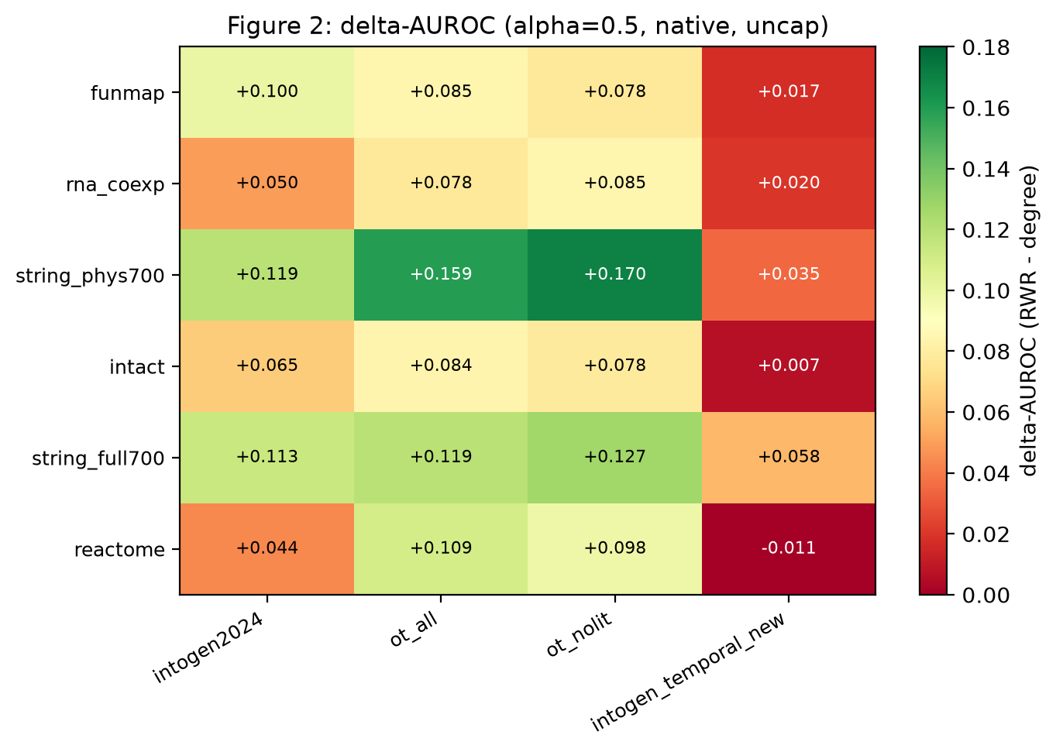
Figure 1. The primary endpoint. Heat map of ΔAUROC = AUROC(RWR) − AUROC(degree) at α = 0.5 for the 6 networks × 4 label sets. Green is a positive margin (the network prior beats degree), red is negative. The single negative cell is Reactome × IntOGen newly-discovered drivers.
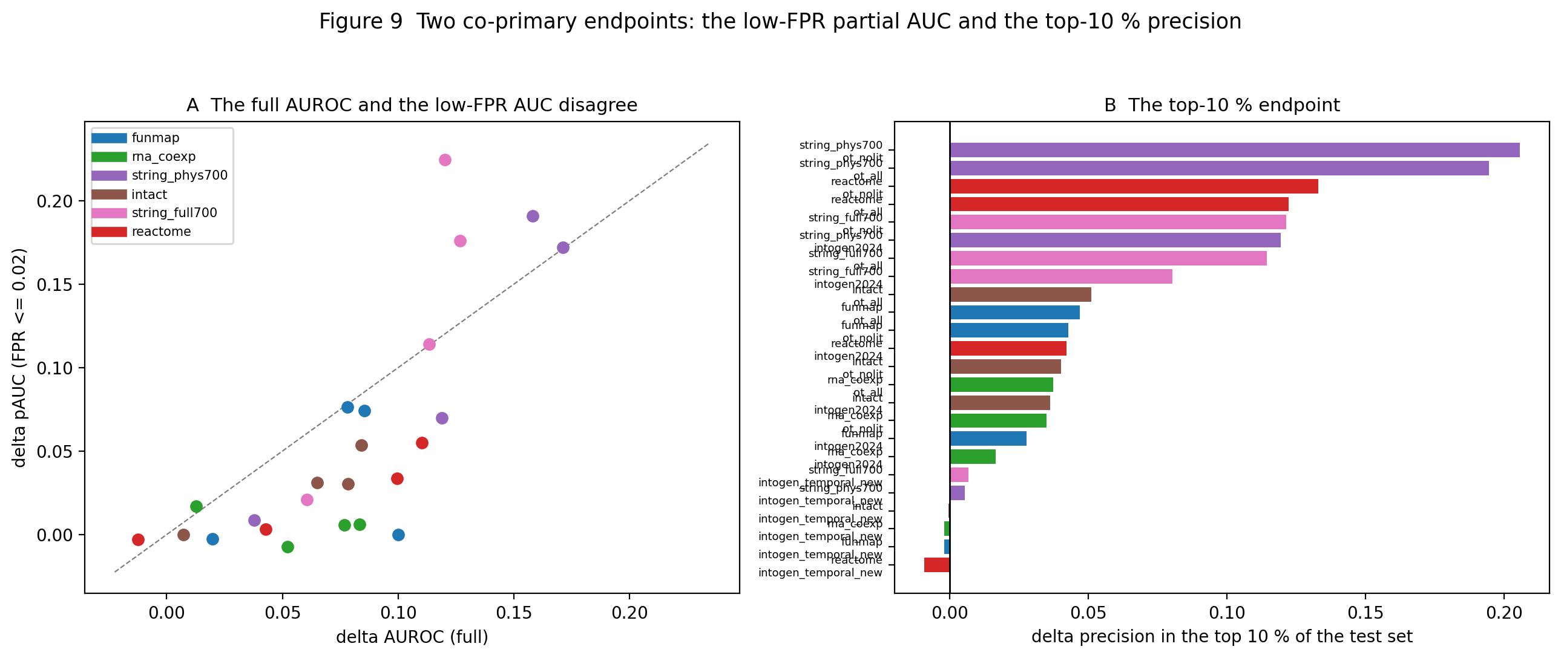
Figure 2. The same 24 arms on the two co-primary endpoints: the partial AUC below 2 % FPR and the precision in the top 10 %. The margin is smaller in both regions than in the full AUROC, and the ordering of the arms is unchanged.
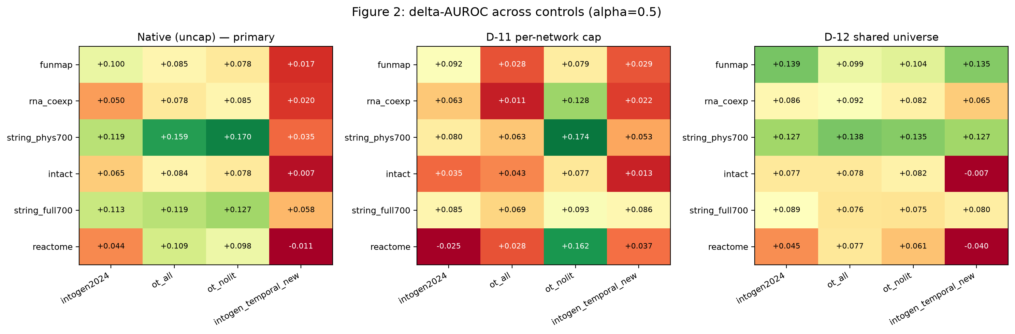
Figure 3. The three coverage controls side by side: the native evaluation, the D-11 common-size cap, and the D-12 shared gene universe.
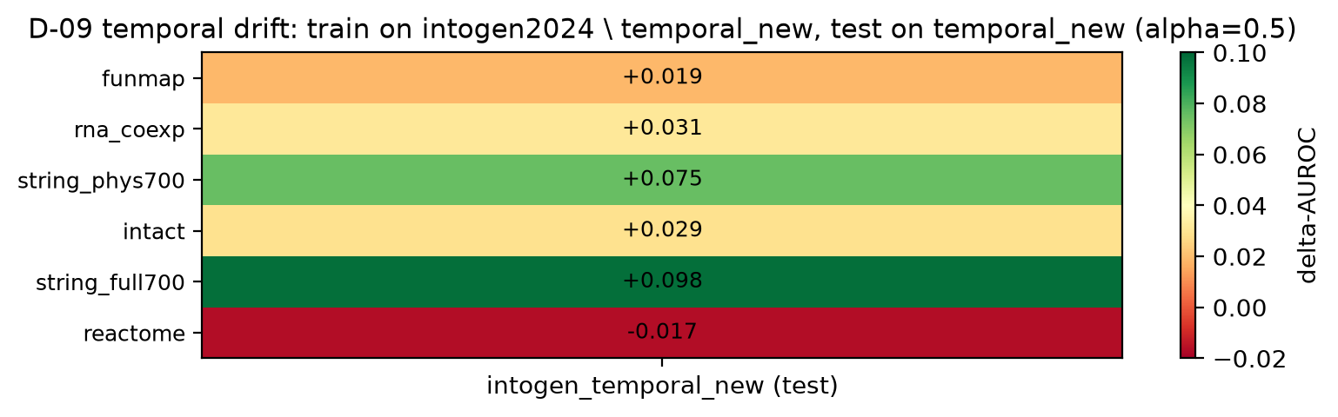
Figure 4. The temporal control. The 152 newly-discovered IntOGen drivers are recovered with a smaller margin (0.02–0.10) than the established drivers (0.04–0.17); Reactome is the only network with a negative temporal-drift estimate.
Figures

