Public data sources, releases and identifiers
What this file is for. The course requires a "reference and public dataset source list" with dataset identifiers (GEO / SRA / PRIDE / MetaboLights). This project re-analyses already published, already public data — it produces no new sequencing data — so the honest identifier for most of our inputs is the release identifier and the exact download URL, which is what scripts/download_D1_data.py actually fetched. Where a DOI-style accession exists we give it. Anything we could not verify offline is marked TO CONFIRM and must be checked in a browser before submission.
Rule followed. Every URL below was read out of our own download script or our own data directory; none is written from memory.

1. The network panel
# | Dataset | Release / version | Source URL (as downloaded) | Local file
1.1 | FunMap functional network (protein-derived; CPTAC pan-cancer proteogenomics) | FunMap v1.0 | https://funmap.linkedomics.org/data/download/funmap.tsv | data/raw/networks/funmap.tsv
1.2 | FunMap published CPTAC mRNA matrices (the RNA-derived network) | Zenodo record 7948944 | https://zenodo.org/records/7948944/files/funmap_input_expression_data.tgz?download=1 | data/raw/networks/funmap_expression.tgz
1.3 | IntAct human-human interactions (taxid 9606) | 2024-09 (the intact.zip in the current release) | https://ftp.ebi.ac.uk/pub/databases/intact/current/psimitab/intact.zip | data/raw/networks/intact.zip
1.4 | STRING v12 all-evidence links (combined_score ≥ 700) | 12.0 | https://stringdb-downloads.org/download/protein.links.detailed.v12.0/9606.protein.links.detailed.v12.0.txt.gz | data/raw/networks/9606.protein.links.detailed.v12.0.txt.gz
1.5 | STRING v12 physical subnetwork (≥ 700) | 12.0 | https://stringdb-downloads.org/download/protein.physical.links.v12.0/9606.protein.physical.links.v12.0.txt.gz | data/raw/networks/9606.protein.physical.links.v12.0.txt.gz
1.6 | STRING v12 protein info / aliases (the symbol crosswalk) | 12.0 | https://stringdb-downloads.org/download/protein.info.v12.0/9606.protein.info.v12.0.txt.gz and .../protein.aliases.v12.0/9606.protein.aliases.v12.0.txt.gz | data/raw/networks/
1.7 | Reactome human interactions | v86 (content version 86, September 2023) | https://reactome.org/download/current/interactors/reactome.homo_sapiens.interactions.tab-delimited.txt | data/raw/networks/reactome.tsv

2. The label panel
# | Dataset | Release | Source URL (as downloaded) | Local file
2.1 | IntOGen driver catalogues (MC3 / recurrence) | 2024-09-20, 2023-05-31, 2020-02-01 | https://www.intogen.org/download?file=IntOGen-Drivers-20240920.zip (and the 20230531 / 20200201 zips) | data/raw/labels/intogen/*.zip
2.2 | Open Targets Platform 26.06 | 26.06 | https://ftp.ebi.ac.uk/pub/databases/opentargets/platform/26.06/output (association_overall_direct, association_by_datasource_direct, association_by_datatype_direct, target, disease) | data/raw/labels/opentargets_26.06/
2.3 | ClinGen gene-disease validity | the file created 2026-09-26 | https://search.clinicalgenome.org/kb/gene-validity/download | data/raw/labels/clingen/clingen_gene_validity.csv
2.4 | NCG driver catalogue (the arbitration set) | the 2019 supplementary files of the Genome Biology paper (see §5) | the article's Additional file 2 / 3 | data/raw/labels/ncg/13059_2018_1612_MOESM{2,3}_ESM.xlsx
2.5 | HGNC complete set (the symbol authority, decision D-02) | the file fetched with the release | https://storage.googleapis.com/public-download-files/hgnc/tsv/tsv/hgnc_complete_set.txt | data/raw/reference/hgnc_complete_set.txt
2.6 | PubMed gene→publication counts (the publication-count adjustment and the bait-matched null) | the gene2pubmed dump fetched with the release | https://ftp.ncbi.nlm.nih.gov/gene/DATA/gene2pubmed.gz | data/raw/reference/gene2pubmed.gz

3. The external validations
# | Dataset | Release | Source | Local file
3.1 | DepMap CRISPR gene effect (the primary, 1,361 cell lines) | the release whose file we hold | DepMap portal (download needs a free account) | data/raw/depmap/CRISPRGeneEffect (1).csv
3.2 | DepMap CRISPR gene effect (the earlier release, 1,150 cell lines) | earlier | DepMap portal | data/raw/depmap/CRISPRGeneEffect.csv
3.3 | DepMap expression (log2(TPM+1), protein-coding) | as above | DepMap portal | data/raw/depmap/OmicsExpressionProteinCodingGenesTPMLogp1.csv
3.4 | DepMap expression (log2(TPM+1), human protein-coding) | as above | DepMap portal | data/raw/depmap/OmicsExpressionTPMLogp1HumanProteinCodingGenes.csv
3.5 | UniProtKB / ComplexPortal (the protein-complex map used for the complex-aware splits) | the REST snapshot fetched on 2026-11-05 | https://rest.uniprot.org/uniprotkb/search (cross-references to ComplexPortal) | data/raw/complexportal/ → data/processed/complexes/complex_map.tsv

4. Our own artefacts (the identifiers a reader needs)
Artefact | Identifier
The pre-registration (frozen 2026-09-27) | Zenodo DOI 10.5281/zenodo.23121762 (https://doi.org/10.5281/zenodo.23121762)
The amendments to it | docs/pre_registration_amendments.md in the repository (A2.3a–A2.3k + the analysis-family register)
The code, tables, figures and split manifests | GitHub `github.com/lanxin2391/d1-benchmark`, tag v1.0-rc3
The release bundles | three zips (source / splits / results) + docs/release_manifest_v1.0-rc2.json
The v1.0 Zenodo DOI | TO CONFIRM — the v1.0 record is minted in a browser (the placeholder 10.5281/zenodo.d1-benchmark-v1.0 is not yet live)
The bio.tools entry | TO CONFIRM — registered in a browser
The leaderboard placeholder | docs/leaderboard.md (TO CONFIRM — not created yet)

5. A correction we must carry into the reference list
The NCG catalogue has two associated papers, and the supplementary files we actually downloaded come from the Genome Biology one:
- Repana D, Nulsen J, Dressler L, Bortolomeazzi M, Kuppili Venkata SK, Tourna A, Yakovleva A, Palmieri T, Ciccarelli FD. The Network of Cancer Genes (NCG): a comprehensive catalogue of known and candidate cancer genes from cancer sequencing screens. Genome Biology 2019;20:1. doi:10.1186/s13059-018-1612-0 — this is the source of Additional file 2 and 3, i.e. of our 2,372-gene catalogue.
- Repana D, D'Antonio M, Pendino V, Ratti E, Gentilini M, Ciccarelli FD. The network of cancer genes. Nucleic Acids Res. 2019;47(D1):D671-D675 — the NCG 6.0 methods paper.
The raw-data note in data/raw/labels/ncg/README.md cited only the NAR paper; it has been corrected to name the Genome Biology paper as the source of the files we used.

6. TO CONFIRM before the submission (needs a browser)
- CPTAC proteogenomics accessions (PRIDE). The FunMap network is built from the CPTAC pan-cancer proteogenomics; the upstream raw mass-spectrometry files have PRIDE / ProteomeXchange accessions. We did not re-download them (we used FunMap's published matrices and edge list), so we do not record a PXD id we cannot verify. Action: copy the PXD accession(s) from the FunMap paper's data availability section (Shi Z et al., Nat Cancer 2025;6:205-222) into this list.
- DepMap release version. Our two CRISPRGeneEffect files come from two DepMap public releases (1,150 and 1,361 cell lines); the release tag (e.g. 24Q2 / 25Q2) is in the download portal's file listing. Action: write the exact release tag next to each file.
- IntOGen release identifiers. The three driver zips are named by release date (2020-02-01, 2023-05-31, 2024-09-20); the compendium inside the 2024-09-20 archive still carries a "RELEASE 20230531" header. Action: confirm with the IntOGen portal which release each archive corresponds to.
- Reactome v86 vs "current". We downloaded the file from the current interactor export but cite content version 86 (September 2023). Action: re-download the archived v86 export (or state the version we actually used) so the file and the citation agree.
- The clean-machine reproduction. Not an identifier, but the release protocol's hard gate: clone → install → pytest → re-run the two audit scripts on a clean machine, and record the result in docs/reproducibility_audit.md.

7. Why there are no GEO / SRA / MetaboLights identifiers here
The course asks for "public dataset identifiers (GEO, SRA, PRIDE, MetaboLights)" for the data you actually used. Our project uses aggregated releases and curated portals — a network edge list, a driver catalogue, a gene-disease validity table, a CRISPR screen matrix and a publication-count table. None of these is a sequencing run produced by us or deposited by us, and none of them has a GEO/SRA accession; the ones that do have a repository accession (the CPTAC raw proteomics behind FunMap, Zenodo 7948944) are listed above with the identifier we can verify, and the one we cannot verify offline is explicitly flagged for the browser check. Inventing an accession that was never in our download record would be the exact failure the course's academic-integrity clause forbids.
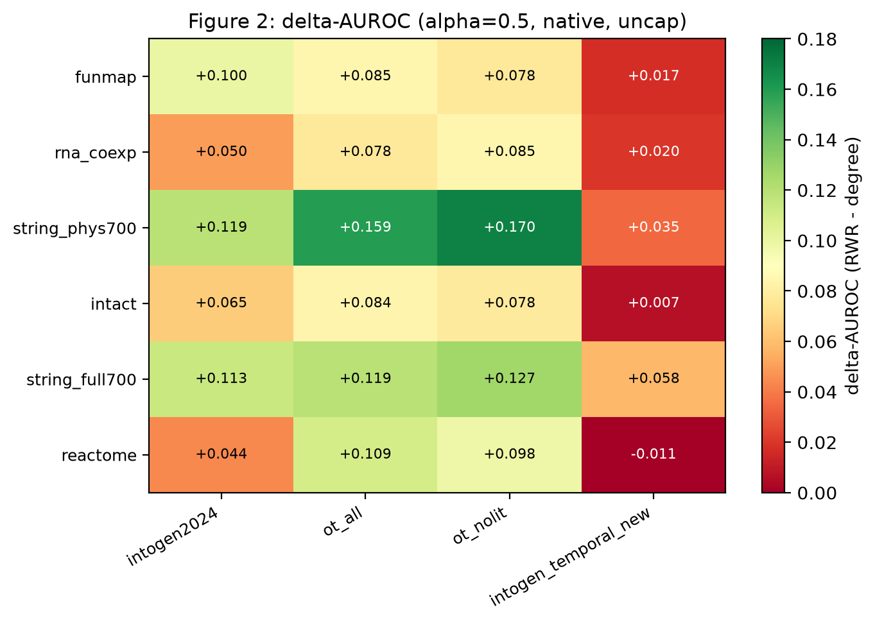
Figure 1. The primary endpoint. Heat map of ΔAUROC = AUROC(RWR) − AUROC(degree) at α = 0.5 for the 6 networks × 4 label sets. Green is a positive margin (the network prior beats degree), red is negative. The single negative cell is Reactome × IntOGen newly-discovered drivers.
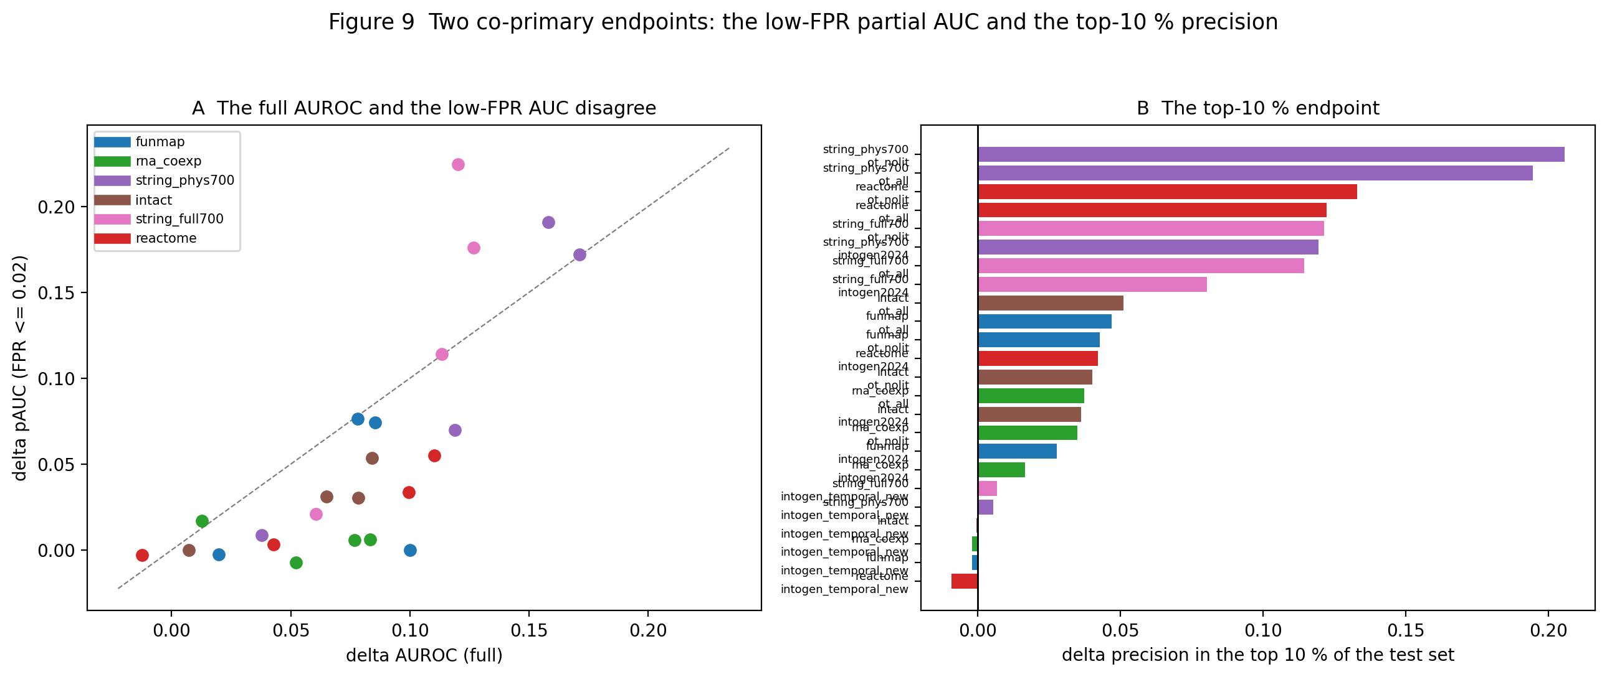
Figure 2. The same 24 arms on the two co-primary endpoints: the partial AUC below 2 % FPR and the precision in the top 10 %. The margin is smaller in both regions than in the full AUROC, and the ordering of the arms is unchanged.
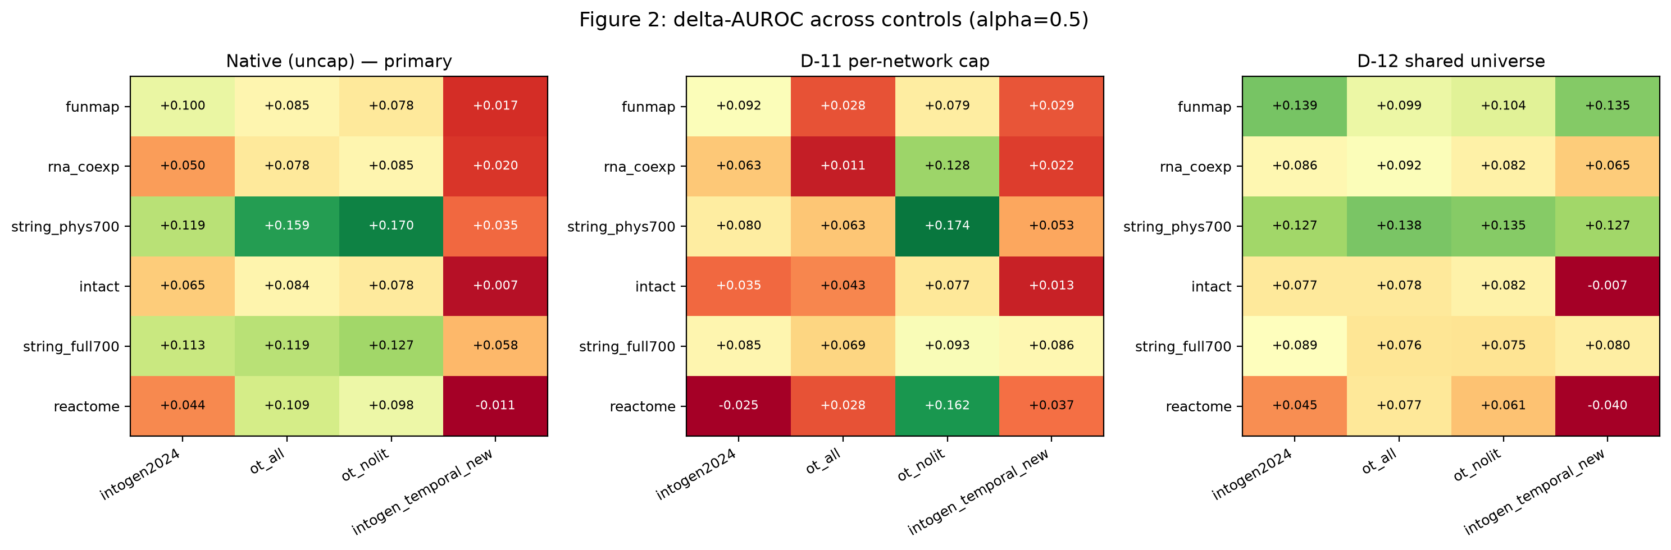
Figure 3. The three coverage controls side by side: the native evaluation, the D-11 common-size cap, and the D-12 shared gene universe.
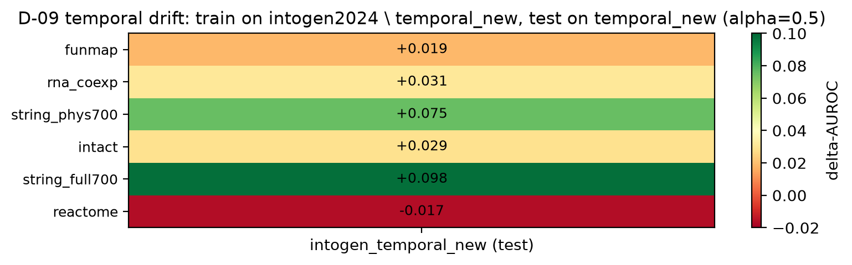
Figure 4. The temporal control. The 152 newly-discovered IntOGen drivers are recovered with a smaller margin (0.02–0.10) than the established drivers (0.04–0.17); Reactome is the only network with a negative temporal-drift estimate.
Figures

