The numbers the 1118 deck quotes
Generated: scripts/dump_report_facts.py (do not edit by hand). Every figure on a slide comes from here, so the deck, the Q&A bank and the manuscript cannot drift apart.

1. The primary endpoint (24 arms, alpha = 0.5)
- the margin over the degree baseline is positive in 23/24 arms; median +0.0809, range -0.0125 .. +0.1711
- the best arm: string_phys700 x ot_nolit (+0.1711); the worst: reactome x intogen_temporal_new (-0.0125)
- the single negative cell: [{'network': 'reactome', 'label_set': 'intogen_temporal_new', 'm': -0.0125}]
network | label | dAUROC | SD
string_phys700 | ot_nolit | +0.1711 | 0.0191
string_phys700 | ot_all | +0.1582 | 0.0150
string_full700 | ot_nolit | +0.1267 | 0.0125
string_full700 | ot_all | +0.1201 | 0.0126
string_phys700 | intogen2024 | +0.1189 | 0.0170
string_full700 | intogen2024 | +0.1133 | 0.0128
reactome | ot_all | +0.1103 | 0.0208
funmap | intogen2024 | +0.1001 | 0.0175
reactome | ot_nolit | +0.0996 | 0.0250
funmap | ot_all | +0.0853 | 0.0210
intact | ot_all | +0.0842 | 0.0109
rna_coexp | ot_nolit | +0.0834 | 0.0209
intact | ot_nolit | +0.0784 | 0.0121
funmap | ot_nolit | +0.0780 | 0.0188
rna_coexp | ot_all | +0.0767 | 0.0205
intact | intogen2024 | +0.0651 | 0.0086
string_full700 | intogen_temporal_new | +0.0604 | 0.0273
rna_coexp | intogen2024 | +0.0521 | 0.0163
reactome | intogen2024 | +0.0429 | 0.0207
string_phys700 | intogen_temporal_new | +0.0378 | 0.0352
funmap | intogen_temporal_new | +0.0196 | 0.0292
rna_coexp | intogen_temporal_new | +0.0127 | 0.0372
intact | intogen_temporal_new | +0.0071 | 0.0195
reactome | intogen_temporal_new | -0.0125 | 0.0501
The H1 decision table (stats_h1_verdict_v40.tsv):
interval n_arms n_excl0 rule_met rule failing_arms
fold_pct 24 24 True pre-registered H1: the 95% CI excludes 0 in EVERY arm NaN
repeat_pct 24 24 True pre-registered H1: the 95% CI excludes 0 in EVERY arm NaN
repeat_t 24 24 True pre-registered H1: the 95% CI excludes 0 in EVERY arm NaN
repeat_bca 24 24 True pre-registered H1: the 95% CI excludes 0 in EVERY arm NaN
gene 24 20 False pre-registered H1: the 95% CI excludes 0 in EVERY arm funmap x intogen_temporal_new; intact x intogen_temporal_new; reactome x intogen_temporal_new; rna_coexp x intogen_temporal_new

2. The control stack (the leakage controls)
- control 2, degree-matched random seeds (results/runs/a5/a5/ + results/tables/stats_fine_z_summary.tsv): 23/24 arms beat the null at z > 5; cell-level z = 3.09-226.9; the null mean is -0.052 .. +0.005, i.e. degree-matched random seeds are WORSE than the real seeds
- control 3, rewired network (results/tables/stats_fine_z_summary.tsv): 23/24 arms beat the rewired null at z > 5
- D-09, temporal drift (50 seed resamples) (results/tables/d09_table.tsv): -0.0095 +/- 0.0116
- D-11, common-size cap per network (results/tables/d11_table.tsv): -0.0125; reactome x intogen2024 flips from +0.0429 to negative
- D-12, shared gene universe (1,605 genes) (results/tables/d12_table.tsv): -0.0360
- complex-aware cross-validation (Phase D) (results/tables/d4_v1_v2_comparison.tsv): the leakage drops from 0.87-0.96 to 0.02-0.18; the median |relative change| of the margin is 0.142; H1 still holds in 24/24 and no sign flips
- hub-capped RWR (E3) (results/tables/hub_capped_rwr.tsv): the margin barely moves (+0.0849 -> +0.0809 clean; +0.0252 in the harshest cap, 8/24 arms flip) -> the degree-orthogonalised model of the second paper is NOT needed
- Control 7, publication-count adjusted label (results/tables/control7_matched_null.tsv): IntOGen +0.0826 -> +0.0804 -> +0.0587 (survives); temporal +0.0162 -> +0.0308 -> +0.0022 (collapses)

3. The results added since the manuscript draft (v1.0-rc3)

G3 -- the bait-matched null (study visibility)
network label n_positives_tested frac_matched_null_above median_p_matched frac_unmatched_null_above median_p_unmatched frac_positives_beating_matched_null frac_positives_beating_unmatched_null
funmap intogen2024 18440 0.085412 0.450 0.108460 0.30 0.085412 0.108460
funmap ot_all 15760 0.140990 0.400 0.173858 0.25 0.140990 0.173858
funmap ot_nolit 14960 0.141110 0.400 0.167246 0.30 0.141110 0.167246
funmap intogen_temporal_new 4160 0.038942 0.500 0.057452 0.40 0.038942 0.057452
rna_coexp intogen2024 15400 0.133182 0.350 0.150325 0.30 0.133182 0.150325
rna_coexp ot_all 14480 0.091713 0.375 0.119061 0.30 0.091713 0.119061
rna_coexp ot_nolit 13960 0.084885 0.400 0.112966 0.30 0.084885 0.112966
rna_coexp intogen_temporal_new 3560 0.059270 0.500 0.062640 0.45 0.059270 0.062640
string_phys700 intogen2024 21760 0.122840 0.250 0.248667 0.15 0.122840 0.248667
string_phys700 ot_all 21520 0.298978 0.100 0.402835 0.05 0.298978 0.402835
string_phys700 ot_nolit 20760 0.320665 0.100 0.402360 0.05 0.320665 0.402360
string_phys700 intogen_temporal_new 4640 0.040517 0.450 0.074138 0.35 0.040517 0.074138
intact intogen2024 24920 0.083587 0.300 0.235995 0.15 0.083587 0.235995
intact ot_all 23560 0.125042 0.250 0.282725 0.10 0.125042 0.282725
intact ot_nolit 23400 0.108974 0.300 0.247607 0.15 0.108974 0.247607
intact intogen_temporal_new 6000 0.049667 0.450 0.092167 0.30 0.049667 0.092167
string_full700 intogen2024 24520 0.161582 0.200 0.354078 0.05 0.161582 0.354078
string_full700 ot_all 23760 0.330598 0.100 0.492172 0.05 0.330598 0.492172
string_full700 ot_nolit 23480 0.326661 0.100 0.447061 0.05 0.326661 0.447061
string_full700 intogen_temporal_new 5800 0.059483 0.450 0.118276 0.25 0.059483 0.118276
reactome intogen2024 14920 0.094839 0.300 0.178820 0.20 0.094839 0.178820
reactome ot_all 14840 0.262871 0.150 0.336456 0.10 0.262871 0.336456
reactome ot_nolit 14040 0.236182 0.150 0.294872 0.10 0.236182 0.294872
reactome intogen_temporal_new 2520 0.044444 0.400 0.059524 0.40 0.044444 0.059524

G7 -- the NCG arbitration test
- dAUROC positive in 24/24 arms, median +0.0413, range +0.0064 .. +0.1269
- dpAUC (FPR <= 0.02) positive in 13/24 arms, median +0.0036; the split is systematic: the four protein networks are positive in every label, funmap and RNA co-expression negative in all four

G8 -- the negative set is not clean
- 9.6% to 22.1% of the held-out negatives are curated NCG drivers; 1.3% to 9.5% are NCG-known
- the effect of cleaning the background (delta_AUROC, standard -> cleaned):
network | label | standard | NCG-cleaned
funmap | intogen2024 | +0.1001 | +0.0247
funmap | intogen_temporal_new | +0.0196 | +0.0402
funmap | ot_all | +0.0853 | +0.1030
funmap | ot_nolit | +0.0780 | +0.0979
intact | intogen2024 | +0.0651 | +0.0304
intact | intogen_temporal_new | +0.0071 | +0.0025
intact | ot_all | +0.0842 | +0.0968
intact | ot_nolit | +0.0784 | +0.0866
reactome | intogen2024 | +0.0429 | +0.0140
reactome | intogen_temporal_new | -0.0125 | +0.0073
reactome | ot_all | +0.1103 | +0.1575
reactome | ot_nolit | +0.0996 | +0.1378
rna_coexp | intogen2024 | +0.0521 | +0.0299
rna_coexp | intogen_temporal_new | +0.0127 | +0.0134
rna_coexp | ot_all | +0.0767 | +0.1063
rna_coexp | ot_nolit | +0.0834 | +0.1110
string_full700 | intogen2024 | +0.1133 | +0.0780
string_full700 | intogen_temporal_new | +0.0604 | +0.0327
string_full700 | ot_all | +0.1201 | +0.1411
string_full700 | ot_nolit | +0.1267 | +0.1388
string_phys700 | intogen2024 | +0.1189 | +0.0768
string_phys700 | intogen_temporal_new | +0.0378 | +0.0384
string_phys700 | ot_all | +0.1582 | +0.1806
string_phys700 | ot_nolit | +0.1711 | +0.1979

GR-9 -- the cancer-type stratification
- 26/26 cancer types have a positive median margin (median over the types +0.0271)

4. The fifth label (NCG)
- the six NCG arms (alpha = 0.5): funmap +0.0771, rna_coexp +0.0426, string_phys700 +0.1352, intact +0.0673, string_full700 +0.1387, reactome +0.0647
- on the D-11 capped panel (equal positive-set size):
network | intogen2024 | intogen_temporal_new | ncg_known | ot_all | ot_nolit
funmap | +0.1268 | +0.0196 | +0.1127 | +0.0191 | +0.0885
intact | +0.0681 | +0.0071 | +0.0858 | +0.0664 | +0.0973
reactome | -0.0110 | -0.0125 | +0.0893 | +0.0627 | +0.1649
rna_coexp | +0.0829 | +0.0127 | +0.0720 | +0.0403 | +0.0956
string_full700 | +0.1020 | +0.0604 | +0.1177 | +0.0785 | +0.1388
string_phys700 | +0.0955 | +0.0378 | +0.1222 | +0.0938 | +0.1819
Reactome is positive on NCG (+0.0893) and negative on the two newest catalogues -> the Reactome failure is label-specific (curator lag), not network-specific.

The variance decomposition, 24 arms vs 30 arms
variance source | % between-arm (24) | % between-arm (30)
network (between) | 24.82 % | 26.95 %
label (between) | 34.78 % | 30.75 %
network x label (interaction) | 40.07 % | 41.95 %
fold (within cell) | 0.34 % | 0.35 %

4b. C9: the factorial re-run with a cleaned background
- the positive arms: 23/24 standard, 23/24 with the curated drivers removed from the background; sign flips: 0
- the median margin: +0.0809 standard, +0.0822 cleaned
- the gene-cluster interval passes in 21/24 arms after the cleaning (20/24 before)
- the earlier post-hoc reading (G8) removed 87 % of the IntOGen positives from the evaluation set along with the background, which is why it appeared to halve the margin
network | label | standard | cleaned | change
string_phys700 | ot_nolit | +0.1711 | +0.1741 | +0.0030
string_phys700 | ot_all | +0.1582 | +0.1624 | +0.0042
string_full700 | ot_nolit | +0.1267 | +0.1269 | +0.0002
string_full700 | ot_all | +0.1201 | +0.1214 | +0.0013
string_phys700 | intogen2024 | +0.1189 | +0.1289 | +0.0100
string_full700 | intogen2024 | +0.1133 | +0.1183 | +0.0050
reactome | ot_all | +0.1103 | +0.1119 | +0.0016
funmap | intogen2024 | +0.1001 | +0.1046 | +0.0045
reactome | ot_nolit | +0.0996 | +0.1028 | +0.0032
funmap | ot_all | +0.0853 | +0.0889 | +0.0036
intact | ot_all | +0.0842 | +0.0853 | +0.0011
rna_coexp | ot_nolit | +0.0834 | +0.0832 | -0.0002
intact | ot_nolit | +0.0784 | +0.0793 | +0.0009
funmap | ot_nolit | +0.0780 | +0.0813 | +0.0033
rna_coexp | ot_all | +0.0767 | +0.0768 | +0.0001
intact | intogen2024 | +0.0651 | +0.0671 | +0.0020
string_full700 | intogen_temporal_new | +0.0604 | +0.0681 | +0.0077
rna_coexp | intogen2024 | +0.0521 | +0.0533 | +0.0012
reactome | intogen2024 | +0.0429 | +0.0466 | +0.0037
string_phys700 | intogen_temporal_new | +0.0378 | +0.0490 | +0.0112
funmap | intogen_temporal_new | +0.0196 | +0.0239 | +0.0043
rna_coexp | intogen_temporal_new | +0.0127 | +0.0152 | +0.0025
intact | intogen_temporal_new | +0.0071 | +0.0089 | +0.0018
reactome | intogen_temporal_new | -0.0125 | -0.0099 | +0.0026

5. Label quality (C7)
label | high | mid | low
clingen_label | 80 | 4 | 0
intogen2024 | 252 | 203 | 177
intogen_temporal_new | 11 | 74 | 66
ncg_known | 115 | 313 | 280
ot_all | 245 | 355 | 0
ot_nolit | 236 | 364 | 0
The tier-restricted margin (median over the six networks):
label | high | mid | low
clingen_label | +0.1042 | +0.1207 | -
intogen2024 | +0.0892 | +0.0633 | +0.0653
intogen_temporal_new | +0.0743 | +0.0123 | +0.0232
ncg_known | +0.0666 | +0.0874 | +0.0650
ot_all | +0.1120 | +0.0908 | -
ot_nolit | +0.1097 | +0.0775 | -
The ClinGen 17 % noise anchor: the margin moves by -0.0018 .. +0.0026 when a random 17 % of the positives is demoted to background in every fold (a perfect scorer would lose 8.5 AUROC points).

6. The stability analysis (Phase S)

stability_per_gene.tsv (267696 rows, columns: network, label, gene, y, degree, score_mean, score_sd, score_cv)
network label gene y degree score_mean score_sd score_cv rank_mean rank_sd rank_range top10_hits top50_hits top1pct_hits top5pct_hits crowding_scott local_score_density provenance
funmap intogen2024 A1BG 0 107.0 2.540538e-05 5.268542e-06 0.207379 0.362868 0.042644 0.156851 0 0 0 0 861 351 protein-derived
funmap intogen2024 A2M 0 93.0 2.992524e-05 6.479200e-06 0.216513 0.336096 0.041186 0.136533 0 0 0 0 697 326 protein-derived
funmap intogen2024 A2ML1 0 22.0 2.560937e-05 4.068137e-06 0.158853 0.359150 0.026784 0.092069 0 0 0 0 858 357 protein-derived
funmap intogen2024 AAAS 0 22.0 1.892030e-05 3.098196e-06 0.163750 0.409121 0.029210 0.102572 0 0 0 0 1214 335 protein-derived
funmap intogen2024 AACS 0 2.0 9.614867e-07 2.176916e-07 0.226411 0.835687 0.023119 0.079309 0 0 0 0 4283 183 protein-derived
funmap intogen2024 AAGAB 0 7.0 1.955915e-05 7.763371e-06 0.396918 0.422809 0.096826 0.256871 0 0 0 0 1178 339 protein-derived
funmap intogen2024 AAK1 0 3.0 2.310961e-06 4.333659e-07 0.187526 0.740118 0.025660 0.115037 0 0 0 0 4577 264 protein-derived
funmap intogen2024 AAMDC 0 1.0 1.326497e-06 3.474608e-07 0.261939 0.805629 0.034051 0.134766 0 0 0 0 4366 214 protein-derived
funmap intogen2024 AAMP 0 6.0 3.520186e-06 6.658168e-07 0.189142 0.681562 0.031911 0.101394 0 0 0 0 4787 318 protein-derived
funmap intogen2024 AAR2 0 13.0 1.567730e-05 2.470446e-06 0.157581 0.440931 0.029330 0.119651 0 0 0 0 1457 366 protein-derived
funmap intogen2024 AARS1 0 18.0 1.431643e-05 4.540743e-06 0.317170 0.463442 0.064246 0.185807 0 0 0 0 1609 372 protein-derived
funmap intogen2024 AARS2 0 16.0 3.052971e-06 5.523966e-07 0.180937 0.702488 0.028456 0.116215 0 0 0 0 4718 284 protein-derived

network_stability.tsv (8 rows, columns: network, net_delta_mean, net_stability_sd, net_stability_sd_max, net_cross_label_spread, net_icc, n_nodes, n_edges)
network net_delta_mean net_stability_sd net_stability_sd_max net_cross_label_spread net_icc n_nodes n_edges density mean_degree mean_clustering modularity degree_assortativity approx_mean_path_length max_k_core frac_in_2core frac_in_10core mean_label_coverage min_label_coverage provenance is_sensitivity_arm s2_transfer_r2_scorecv
funmap 0.070759 0.006478 0.010128 0.035296 -0.141277 10189 196605 0.003788 38.591618 0.288042 0.756950 0.435776 4.742462 115 0.856512 0.431348 0.68374 0.6233 protein-derived False 0.212947
intact 0.058695 0.003464 0.006512 0.035292 -0.165044 17918 564706 0.003518 63.032258 0.095770 0.370036 -0.059700 2.924198 82 0.952450 0.761860 0.98316 0.9750 protein-derived False 0.128862
reactome 0.060056 0.005366 0.009861 0.056686 -0.205926 3953 20143 0.002579 10.191247 0.511802 0.759887 0.058277 5.016409 24 0.847458 0.230458 0.58666 0.4145 curated-literature False -1.177396
rna_coexp 0.056213 0.007679 0.012894 0.031980 -0.121940 9152 196172 0.004685 42.869755 0.384850 0.707356 0.392310 4.690739 166 0.835555 0.472465 0.59240 0.5817 rna-derived False 0.171597
string_full400 0.073187 0.002065 0.005113 0.012890 -0.216605 19486 929471 0.004896 95.398850 0.260567 0.496093 0.129033 2.967229 169 0.995741 0.906446 0.99570 0.9917 curated-literature True NaN
string_full700 0.105138 0.003442 0.006744 0.030298 -0.198267 15882 236712 0.001877 29.808840 0.383762 0.681319 0.279801 4.090385 112 0.904357 0.538534 0.97812 0.9539 curated-literature False 0.270122
string_full900 0.130704 0.004317 0.007761 0.039849 -0.193247 11693 100383 0.001469 17.169760 0.436939 0.772446 0.393367 4.714104 85 0.860515 0.353117 0.91462 0.8289 curated-literature True NaN
string_phys700 0.121509 0.004394 0.007229 0.060035 -0.196359 9830 85576 0.001771 17.411190 0.478059 0.783354 0.336463 4.669437 87 0.847813 0.317091 0.86734 0.7632 protein-derived False 0.036164

stability_attribution.tsv (22 rows, columns: outcome, feature, beta, se, ci_low, ci_high, p, q_bh)
outcome feature beta se ci_low ci_high p q_bh sign_stability marginal_spearman_median marginal_spearman_min marginal_spearman_max arms_positive
score CV log_degree 0.065954 0.015577 0.035424 0.096484 2.294617e-05 6.310195e-05 1.0 -0.151816 -0.377281 0.027418 2
score CV k_core -0.036520 0.009464 -0.055070 -0.017970 1.139905e-04 2.507792e-04 1.0 -0.156576 -0.399760 0.031041 2
score CV clustering -0.002319 0.001916 -0.006074 0.001436 2.260755e-01 2.486831e-01 1.0 -0.029662 -0.289652 0.088833 7
score CV log_betweenness -0.000010 0.001835 -0.003608 0.003587 9.954555e-01 9.954555e-01 0.6 -0.098029 -0.182252 0.021994 1
score CV log_pagerank -0.011949 0.007614 -0.026872 0.002974 1.165759e-01 1.602918e-01 1.0 -0.092900 -0.232741 0.030640 5
score CV log_community_size 0.005324 0.003628 -0.001787 0.012434 1.422875e-01 1.739069e-01 0.9 -0.060015 -0.449434 0.094802 7
score CV dist_to_seed -0.015812 0.004495 -0.024622 -0.007002 4.350844e-04 6.837040e-04 1.0 -0.094773 -0.356007 0.187713 7
score CV log_local_score_density 0.081345 0.018355 0.045370 0.117320 9.344896e-06 5.139693e-05 1.0 0.097001 -0.078795 0.245356 20
score CV log_score_mean -0.125563 0.029055 -0.182509 -0.068617 1.548952e-05 5.679489e-05 1.0 0.144720 -0.043893 0.422651 18
score CV log_score_cv 0.616390 0.024602 0.568171 0.664610 1.573834e-138 1.731217e-137 1.0 1.000000 1.000000 1.000000 24
score CV log_crowding_scott -0.086891 0.023498 -0.132946 -0.040836 2.174751e-04 3.987043e-04 1.0 -0.125963 -0.353694 0.092102 7
rank SD log_degree -0.083405 0.020700 -0.123976 -0.042833 5.597382e-05 1.231424e-04 1.0 0.038001 -0.098519 0.238072 16

7. DepMap external validation (figure 4)
- K = 0.01: median over the 24 arms of the fraction of cell lines with p < 0.05 = 2.8% (chance = 5 %); median p = 0.602
- K = 30.0: median over the 24 arms of the fraction of cell lines with p < 0.05 = 5.8% (chance = 5 %); median p = 0.523
- K = 100.0: median over the 24 arms of the fraction of cell lines with p < 0.05 = 47.6% (chance = 5 %); median p = 0.058

8. The design (panel and labels)
network | provenance | LCC genes | LCC edges
funmap | protein (CPTAC proteogenomics) | 10,189 | 196,605
rna_coexp | RNA-derived | 9,152 | 196,172
string_phys700 | protein (STRING physical >= 700) | 9,830 | 85,576
intact | protein (IntAct) | 17,918 | 564,706
string_full700 | curated (STRING all >= 700) | 15,882 | 236,712
reactome | curated (Reactome v86) | 3,953 | 20,143
label | source | positives
intogen2024 | mutation recurrence (MC3/IntOGen) | 633
ot_all / ot_nolit | Open Targets 26.06, with / without the literature channel | 600 / 600
intogen_temporal_new | the 152 newest IntOGen drivers | 152
clingen_label | ClinGen cancer gene-disease validity | 84
ncg_known | NCG known tier (Repana 2019) | 708 (capped per arm)
- design: 6 networks x 4 labels x 3 alphas x 5 folds x 40 repeats = 1,200 evaluations per arm; the learner (RWR, alpha = 0.5) is frozen and pre-registered; the pre-registration is frozen at Zenodo DOI 10.5281/zenodo.23121762 and every departure is an amendment.
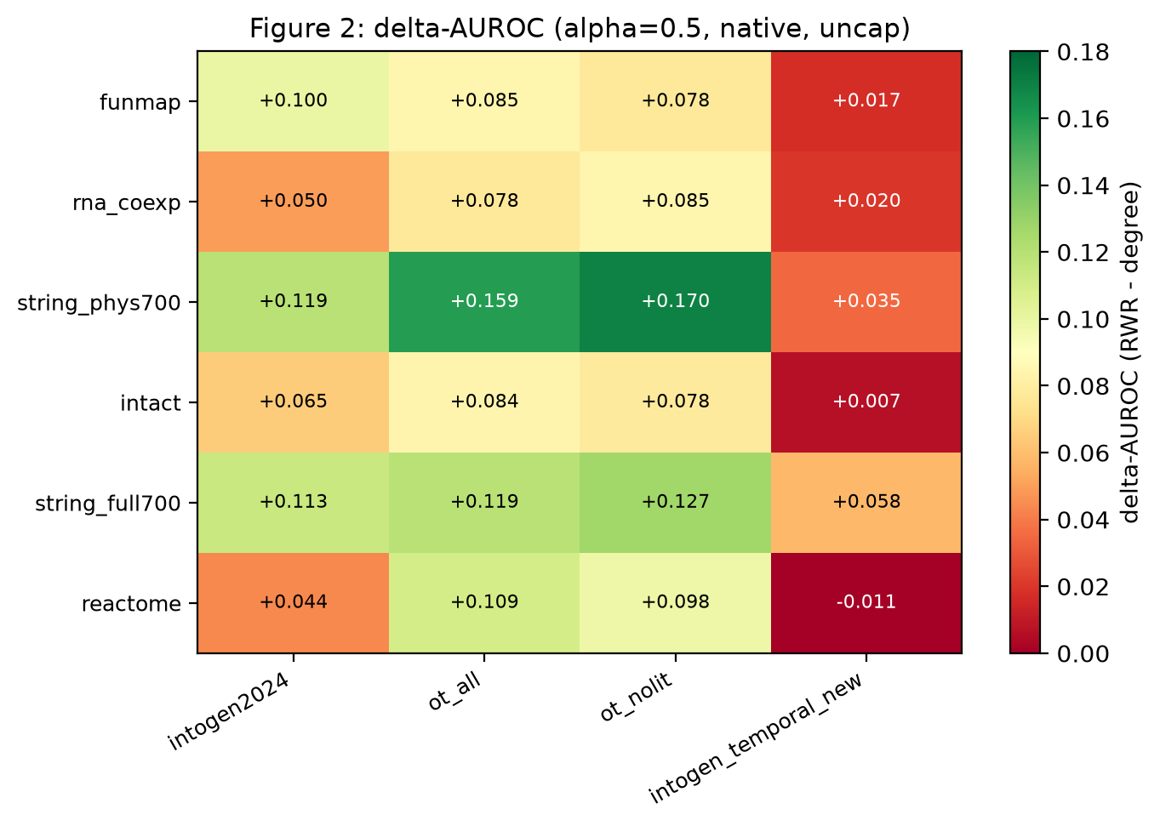
Figure 1. The primary endpoint. Heat map of ΔAUROC = AUROC(RWR) − AUROC(degree) at α = 0.5 for the 6 networks × 4 label sets. Green is a positive margin (the network prior beats degree), red is negative. The single negative cell is Reactome × IntOGen newly-discovered drivers.
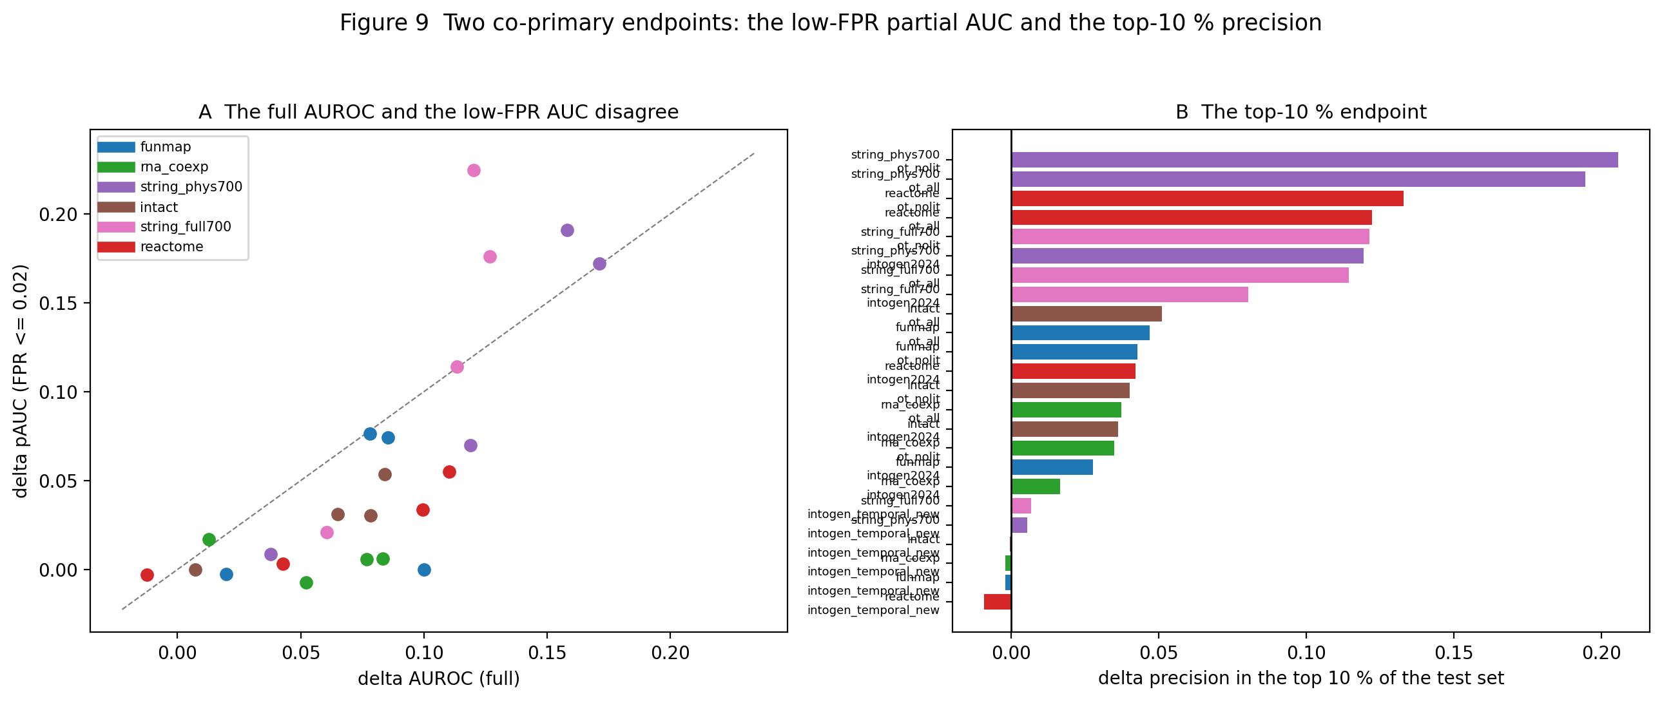
Figure 2. The same 24 arms on the two co-primary endpoints: the partial AUC below 2 % FPR and the precision in the top 10 %. The margin is smaller in both regions than in the full AUROC, and the ordering of the arms is unchanged.
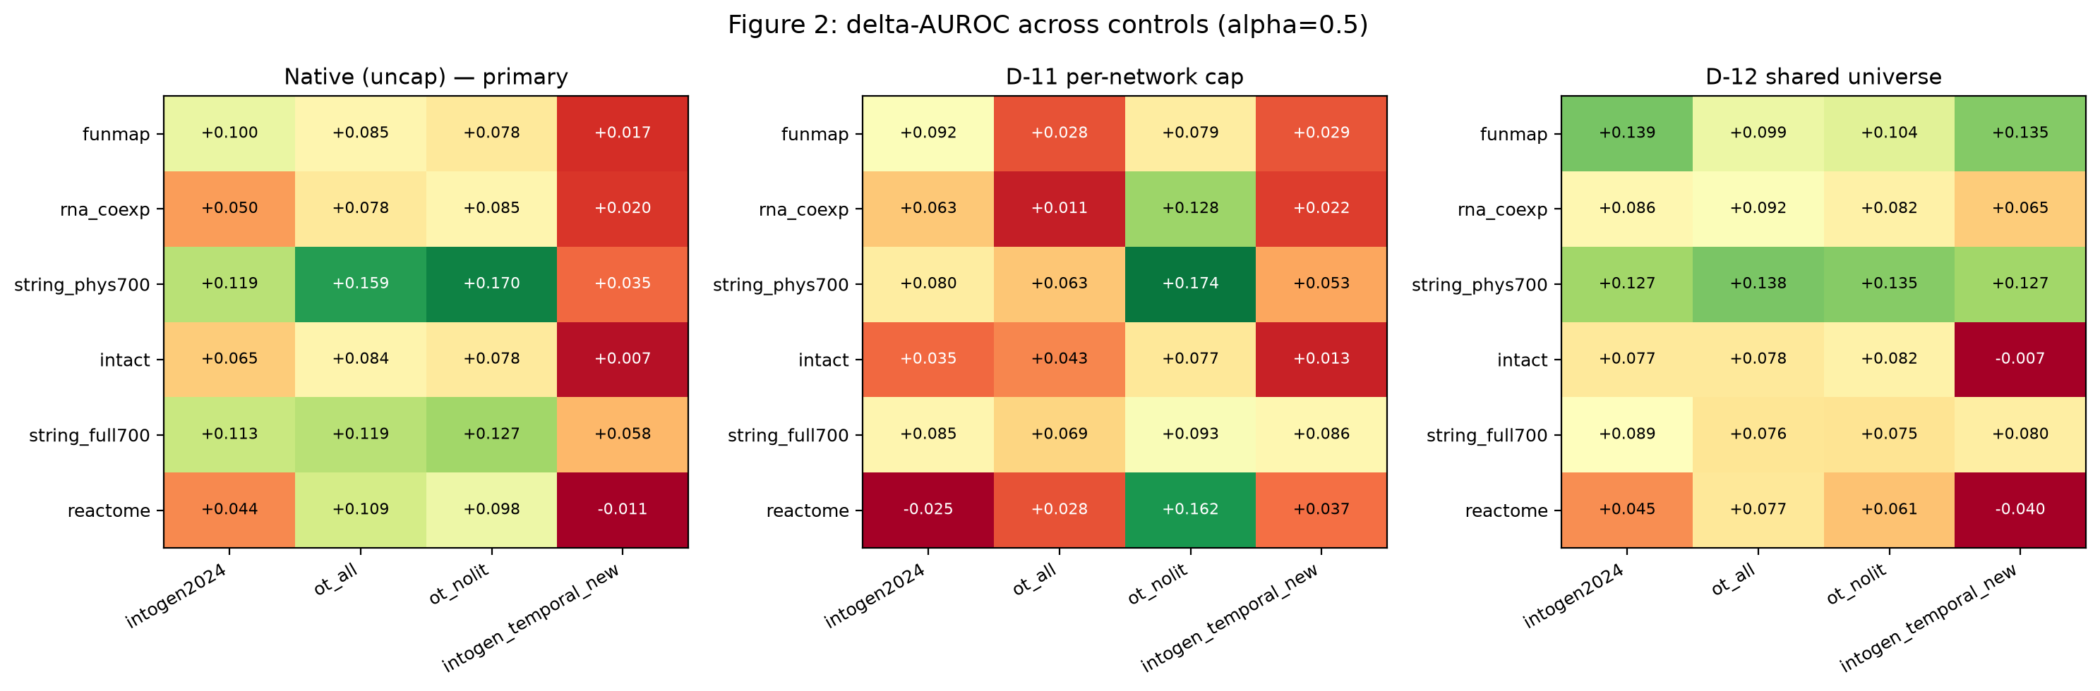
Figure 3. The three coverage controls side by side: the native evaluation, the D-11 common-size cap, and the D-12 shared gene universe.
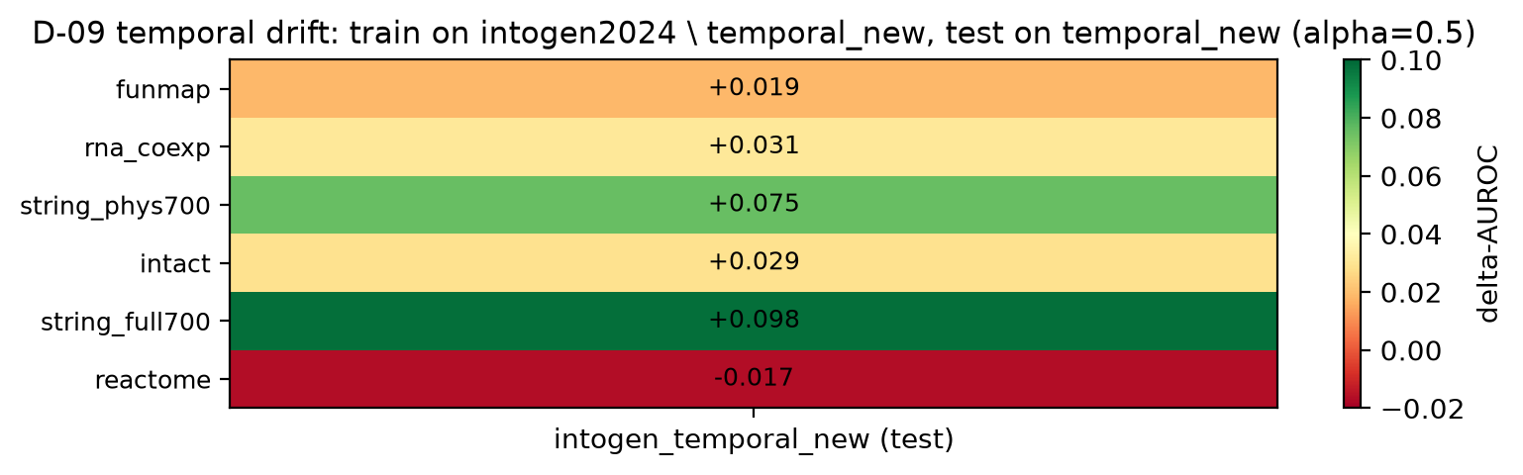
Figure 4. The temporal control. The 152 newly-discovered IntOGen drivers are recovered with a smaller margin (0.02–0.10) than the established drivers (0.04–0.17); Reactome is the only network with a negative temporal-drift estimate.
Figures

