1118 终期答辩 · 主讲稿（单人 40 分钟版）
讲者：本人（唯一主讲，讲满 40 分钟）· 其余三人在讲完后回答问题 配套：D1_defence_deck.pptx（正文 16 页 + 附录 10 页，附录页在讲稿里被用到）、 report_1118_qa_bank.md（29 题）、report_1118_facts.md（全部数字的单一来源）、 datasets_sources.md（数据来源与登录号）
这份稿子的写法
- 每节开头：中文提示（时间点、这一节要落到的点、指哪页）。
- 正文：逐字英文口播。凡出现数字，口播里都必须交代四件事—— 它是什么（量纲/分母）、怎么算出来的（哪张表、哪个比较）、 它说明什么、它不能说明什么（这一条最容易丢分，也最容易显得专业）。
- 【数：…】 是只给你自己看的提醒（数字 + 出处），不要念。
- 每节末尾有一句过渡句，用来接下一节。
- 附录 A 是必背数字卡（23 张），附录 C 是15 分钟压缩方案，附录 D 是彩排清单。
- 语速：正文英文口播共约 6,840 词，按 140–170 词/分是 40–49 分钟；配上下面的 逐页配时表走，正常语速下正好落在 40 分钟上下。讲快了就用附录 C 砍。

逐页配时表（正文 16 页 = 30.5 分钟 + 10 分钟的"深讲"，合计 40 分钟）
括号里是该页要用的分钟数；附录页（17–26）不在讲稿里主动讲，它们是回答追问时的 证据页（可随时跳转）。40 分钟的主讲按下面的配时走；如果只剩 15 分钟，见附录 C。
时间 | 页 | 讲什么 | 分钟
0:00 | 1 | 标题、四个成员与分工 | 0.3
0:20 | 2 | 研究地图：问题 → 三个假说 → 设计 → 结论 | 1.2
1:30 | 3 | Bailey 2018（复现共识） | 1.2
2:45 | 4 | Shi 2025（FunMap，含 LLR/MR 方法细节与 Reactome 金标准） | 1.5
4:15 | 5 | Repana 2019（NCG，三层与网络置信度） | 1.3
5:40 | — | 五篇方法学文献 → 十一个设计决定（可指附录 A1） | 2.3
8:00 | 6 | 知识空白 + 三个可证伪假说 | 1.5
9:30 | 7 + A2 | 数据从哪来：6 个网络、5 个标签、D-02、cap 顺序、复合物映射、每个输入的版本与标识符 | 6.5
16:00 | 8 | 流程与复现：冻结 learner、40×5、切分发布、预注册与 13 个 P0 自审修复 | 2.0
18:00 | 9 | 参数与稳健性：为什么锁、怎么检验、诚实声明 | 2.0
20:00 | 10 | 十一层控制栈（每层一句 + 一个数） | 2.0
22:00 | 11 + A3–A5 | 主端点：23/24、H1 在五种区间下的精确表述、低 FPR 端点 | 4.0
26:00 | 12 | 稳定性：两层结构、拥挤假说的自我更正、种子数定律 | 5.0
31:00 | 13 + A6–A10 | DepMap、NCG 仲裁、阴性集污染、bait 匹配、标签质量、第五标签与 curator lag | 7.0
38:00 | 14 | 五条结论 | 1.0
39:00 | 15 | 局限 → 验证实验 | 0.8
39:50 | 16 | 交付物、AI 声明、结束语 | 0.7

0:00–1:30 · 开场（正文 slide 1–2）
【提示：40 秒。不要报任何数字，先把问题立住。】
Good morning. Our project asks a question that sounds simple and that the field has never actually answered: when a network prior is used to prioritise cancer-driver genes, how much of the reported gain comes from the network's topology, how much from plain node degree, and how much from the fact that well-studied genes have been published about hundreds of times? [【图：slide 2 研究地图】] > The motivation is not scepticism for its own sake. Network-based prioritisation is standard practice — it is the formalisation of guilt-by-association — and it works in the sense that random walk with restart usually beats a degree-only ranking. What has never been done is to decompose that gain. > There are three concrete reasons to think the decomposition matters, and each one is a published result. First, driver genes are hubs, but the enrichment is largely an artefact of research intensity: bait usage — how often a gene appears in the published interaction literature — correlates with its degree at r = 0.52, and correcting for it removes the cancer-versus-control degree difference entirely. That is Schaefer and colleagues, 2015, and it is the single most important paper for us. Second, performance tracks network size: across more than 45 human interactomes, accuracy follows the size of the network, and the effect largely collapses once gene-set coverage is controlled. That is Wright and colleagues, 2025. Third, standard cross-validation is optimistic when the same protein complexes appear on both sides of the split: holding a complex together in the fold drops a strong network classifier from about 12 hits in the top 20 to fewer than 4.5 — a fall as large as the gap between competing methods and the baseline. That is Picart-Armada and colleagues, 2019. > So we built a pre-registered, leakage-controlled benchmark on public data, and in the next forty minutes I will show you the design, the control stack, three result slides, and — just as important — the limits of what we are allowed to claim.

1:30–8:00 · 我们依据的文献（正文 slide 3–5 + 附录 A1）
【提示：这是给生信出身的老师听的段落。每篇论文讲四件事：问了什么 / 用了什么数据 / 结论是什么 / 留下什么，并说清我们因此做了什么设计决定。数字必须带量纲和分母。不要报 DOI 串，报逻辑。 附录 A1 把这八篇与十一个设计决定一一对应，讲到这里可以指一下。】

1.1 Bailey et al. 2018, Cell 173:371–385 — 复现共识
[【图：slide 3】 【数：9,423 对肿瘤/正常；26 个组织类型；26 种突变检测方法；我们的 intogen2024 = 633 个基因】]
The first source paper is Bailey and the MC3 Working Group, in Cell. Their question was: which genes are mutated recurrently enough, across tumour types, to be called drivers? The data were 9,423 TCGA tumour-normal pairs across 26 tissue types. The methodological core is the MC3 consensus: 26 independent mutation-calling algorithms vote, and a gene becomes a driver when the methods agree — not when one method is confident. The result became the field's default gold standard, the Cancer Gene Census. > The numbers I want you to hold: 9,423 samples is a large cohort, which is why the consensus is trustworthy; 26 voters is what makes it a consensus rather than another predictor; and the mutation-recurrence panel we inherit from this lineage has 633 positive genes in our build. > What it leaves open, and this is the gap we work in: it is purely recurrence-based. There is no network, no prior, and no way to separate "what a network adds" from "the catalogue's own degree bias". And note the consequence for us: because we use this catalogue as our primary label, we inherit its curation choices — which is why we measure label quality rather than assume it (I will show you that measurement in result three).

1.2 Shi et al. 2025, Nature Cancer 6:205–222 — FunMap
[【图：slide 4】 【数：XGBoost 逐对共功能概率；集合级 LLR 3.912（= LR 50）；mutual rank > 0.95；10,525 节点 / 196,800 边；11 个癌种；≤200 蛋白通路规则；FunMap 的金标准来自 Reactome】]
The second source paper is Shi and colleagues' FunMap. Their question: can a pan-cancer proteogenomic functional network prioritise cancer genes better than the existing interactomes? The data are the CPTAC pan-cancer proteogenomics and transcriptomics. > The method deserves thirty seconds of precision, because it changes how we treat the network. FunMap's edges are not raw interactions. Every gene pair gets an XGBoost-predicted co-function probability; the pairs are then added in blocks until the set-level log-likelihood ratio falls below 3.912 — that is, a likelihood ratio of 50, meaning "these two genes are 50 times more likely to be functionally associated than not"; and before scoring, a hard filter requires the pair's mutual rank to exceed 0.95 in at least one cohort. That threshold is what yields 10,525 nodes and 196,800 edges. Two consequences for us: the published edge list is a derived, supervised, thresholded object, not an interaction table, so we treat it as a prior network and we report its coverage; and the network is built from 11 cancer types in bulk tissue, so tumour cells and microenvironment are mixed inside one graph. > The result: FunMap outperforms STRING for cancer-gene prioritisation, and it ships with a gold standard. And here is the limitation the authors state themselves, which is the one we care about most: their gold standard is Reactome-derived — a gene pair counts as positive if the two genes share a "detailed" Reactome pathway of at most 200 proteins — and Reactome is also an input to STRING's database channel. So the network inherits Reactome's notion of function, and the comparison networks "incorporate the knowledge used for evaluation". > Our design decisions, three of them. First, FunMap is one of our six networks because it is the most on-topic cancer-specific prior, and we report its coverage explicitly: its 10,525 genes are the protein-coding genes CPTAC actually quantified, so a largest-connected-component analysis runs on a small, expression-biased, tumour-derived universe. Second, we audit circularity per network rather than in general. Third, because the gold standard is Reactome-derived, we do not treat "FunMap beats STRING" as independent evidence — we treat it as one more reason the whole field needs the decomposition we are doing.

1.3 Repana et al. 2019, Genome Biology 20:1 — NCG
[【图：slide 5】 【数：2,372 个基因；708 known / 104 candidate / 1,560 screening；置信度来自 HuRI、GTRD、Reactome、STRING 实验通道；我们的 ncg_known = 708】]
The third source paper is Repana and colleagues' Network of Cancer Genes. Their question: which genes have been called drivers across the published cancer sequencing literature, and how confident is each call? They curated 2,372 genes from that literature into three tiers: 708 known tumour suppressors and oncogenes, 104 multi-screen candidates, and 1,560 screening-level genes, and attached to each gene a confidence level computed from curated interaction channels — HuRI for binary interactions, GTRD for transcription-factor binding, Reactome for pathways, STRING's experimental channel. > What it leaves open, and it is a sharp point: that confidence level is itself network-derived, and every gene the catalogue does not mention is implicitly a negative. So NCG cannot measure anything by itself — it can only arbitrate. > Our decision, which is the one I would defend hardest: we use NCG as an arbitration catalogue and as an audit instrument, never as a confirmatory label. Two things follow. First, because it shares no curation with our four label sets, it can arbitrate them — I will show you that test, and it is our strongest positive result. Second, because its confidence level is network-derived, it is exactly the right instrument for the circularity audit: it tells us whether our network panel and our label panel overlap in their evidence. And note the arithmetic that makes this work: 708 known genes in the catalogue against 633 positives in our primary label — so they are not the same set, and that is the whole point.

1.4 五篇方法学文献：每一条都变成一个设计决定
[【图：附录 A1（文献 → 决定对照表）】]
The three source papers give us the inputs. Five further papers give us the design, and I want to be explicit about which decision each one produced, because each of them is a place where we could have gone wrong.
Picart-Armada et al. 2019, PLoS Comput Biol 15:e1007276. They benchmarked network propagation for disease-gene identification and found three things we adopted. First, pure topology baselines against random have to be in the benchmark, not only degree. Second, the complex leakage number I quoted: holding a complex together in the fold drops a strong network classifier from about 12 hits in the top 20 to fewer than 4.5. Third, the endpoint changes the ranking of methods — AUROC and top-k disagree. Our decisions: complex-aware cross-validation, where the whole protein complex stays in one fold; and two extra endpoints — partial AUC at FPR ≤ 0.02 and top-10 % precision — reported next to AUROC, so that "the prior wins" cannot be an artefact of the metric.
Guala & Sonnhammer 2017, Scientific Reports 7:46598. This is the paper that made us most careful, and I want to state its result plainly because it is the sharpest warning in this field: MaxLink — a local method with an explicit degree filter, built so that highly connected genes cannot rank high just by being connected — beats the diffusion (RWR-family) methods on the full list. Diffusion wins only in the top 1–10 %. They also use partial AUC at FPR ≤ 0.02, which is where we took our low-FPR endpoint from, and they warn about gold standards that share evidence with the network. Our decisions: we never claim RWR is the best method — we freeze it and measure the network's contribution relative to degree, which is precisely the quantity Guala shows can be small; and we report the top-1–10 % region separately, because that is where diffusion actually wins.
Hill et al. 2019. They benchmarked 17 network-contextualisation algorithms and found that over 10,000 random gene lists, the algorithms differ enormously in how much of their output is input-independent. In other words: a learner that ignores its input still returns the hubs. Our decision: a random-input degeneracy control — feed the learner shuffled inputs, and it must degrade to the baseline.
Wright et al. 2025. Over 45 human interactomes, performance tracks network size, and the effect largely collapses once gene-set coverage is controlled. Our decisions: the shared-gene-universe control (all arms evaluated on the same 1,605 genes) and the per-network common-size cap, so that a margin cannot be bought with a bigger gene universe.
Schaefer et al. 2015, Frontiers in Genetics. This is the paper our third hypothesis is built on, and I will come back to it in the results because the number r = 0.52 is the hinge of the whole talk: bait usage correlates with degree, and correcting for it removes the cancer-versus-control degree difference. What looks like a biological degree effect can be a publication effect. Our decisions: a publication-count-adjusted label and a bait-matched null model in which each positive is paired with a negative carrying the same publication count.
Boutros et al. 2014, Genome Biology 15:462. Their principle is the one we borrowed for the whole design: the gold standard dominates any ranking, so the evaluator must be blind to the algorithm; a benchmark should be a community challenge with hidden answers, not a leaderboard people can overfit. Our decisions: the NCG arbitration test is our mini-version of that — an independent catalogue none of our labels was built from — and it is also the experiment we name first in our validation plan.

8:00–9:30 · 知识空白与三个可证伪假说（正文 slide 6）
[【图：slide 6】 【数：三个假说各有一条"如何被证伪"的判据】]
Putting the literature together, the gap is precise and it is not a generic "more research is needed". No published study separates the topology contribution from the degree contribution from the study-visibility contribution inside one frozen design with one decision rule. Each piece exists separately — Zhang's degree stratification, Schaefer's bait correction, Picart-Armada's leakage, Wright's coverage — but never together, and never on a pre-registered endpoint with the resampling unit fixed in advance. > So we made three hypotheses, and for each one we wrote down in advance how it could fail. > H-vis: much of the reported margin is study visibility, not topology. Falsified if the margin survives a null model that matches positives and negatives on their publication count. > H-stable: the prior's instability is a property of the gene's own score variance, not of topology, and it cannot be smoothed away. Falsified if any topology descriptor predicts instability, or if a regularised scorer restores the ranking. > H-lag: curated networks fail specifically on recently discovered drivers. Falsified if the failure appears equally on older catalogues. > Each of the three has a number attached, and I will now show you the numbers.

9:30–16:00 · 数据从哪来（正文 slide 7 + 附录 A2）
[【图：slide 7（面板与标签）→ 附录 A2（每个输入的版本与标识符）】]
The network panel: six networks, three provenance classes. Provenance is an experimental factor here, not a nuisance to be removed. Three are protein-derived, one is RNA-derived, two are curated or literature-derived. > funmap, the CPTAC proteogenomic network: 10,189 nodes and 196,605 edges in the largest connected component. intact, IntAct human-human interactions at taxid 9606: 17,918 nodes and 564,706 edges — by far the densest, and remember that density is what the coverage control is about. string_phys700, the STRING v12 physical subnetwork at combined score ≥ 700: 9,830 nodes and 85,576 edges. rna_coexp, which we built ourselves from FunMap's published CPTAC mRNA matrices: Pearson correlation per cohort, Fisher-z averaged across cohorts, and then the top 196,172 pairs by mean z to density-match funmap — note that we matched the density, not the size, so the RNA network has comparable edge density but its own gene universe: 9,152 nodes. string_full700, STRING v12 all evidence channels at ≥ 700: 15,882 nodes and 236,712 edges. reactome, version 86, human only: 3,953 nodes and 20,143 edges — the smallest network by an order of magnitude, and that turns out to matter. > Two harmonisation decisions. First, Reactome needs a pathway size cap. Reactome provides no numeric edge weight at all — its only quantitative layer is the curation star rating — and the signalling and transcription pathways are so large that a naive co-membership graph is nearly complete inside them, so its connected component carries almost no information as a "prior". We therefore follow the ≤ 200-protein rule that FunMap's own gold standard uses, and we snapshot a specific Reactome version rather than always taking "current" — the 3- and 4-star curation events appeared in June 2023, and historical tools drift. Second, the primary analysis is unweighted — decision D-01 — so what we measure is topology, not the weight scale. > The label panel: five catalogues, four curation philosophies. intogen2024, 633 positive genes, mutation recurrence from IntOGen — and this is the most defensible pure-positive source we have, because a positive is defined by positive-selection evidence in mutation data, not by literature co-occurrence or pathway co-membership, which is exactly the independence a network-prior benchmark needs. ot_all and ot_nolit, 600 genes each, Open Targets 26.06, the second with the literature channel removed; the difference between them is control 7 in label form. intogen_temporal_new, 152 genes — the newest IntOGen drivers, a deliberately harder label. clingen_label, 84 genes, clinical gene-disease validity: 79 Definitive, 1 Strong and 4 Moderate — the hardest evidence of all, and we use it twice, as an extra label and as the external noise anchor. ncg_known, 708 genes, the NCG known tier, added later as a pre-planned exploratory extension. > Two curation caveats we had to handle. IntOGen is a gene × cancer type structure — 99 breast drivers mixed with 20 neuroblastoma drivers — so we stratify by cancer type rather than treating it as a flat list; that stratification is what gives us 26 cancer types with a positive median margin later on. And ranking a label by Cancer Gene Census membership would measure literature curation intensity, not driver prediction, because 75 % of the IntOGen compendium is CGC-annotated — so we never use CGC membership as a ranking tier. > Symbol alignment and provenance. Everything maps to HGNC approved symbols under decision D-02: the approved symbol maps to itself, a previous symbol or alias maps only when the mapping is one-to-one, and ambiguous symbols are dropped and counted — for NCG that was 83 symbols, and we keep them visible in the release rather than discarding them silently. Nine NCG genes were renamed outright — CARS → CARS1, MKL1 → MRTFA, FGFR1OP → CEP43 and six others — and we carry the old names in the label file for traceability. > Two more provenance items. The protein-complex map for the complex-aware splits was built from the UniProt REST API by cross-referencing ComplexPortal identifiers: 2,569 complexes over 3,708 genes. And every external input carries an explicit release and identifier, which is in appendix A2: the pre-registration is frozen at Zenodo DOI 10.5281/zenodo.23121762, the FunMap matrices are Zenodo record 7948944, IntOGen releases 2020, 2023 and 2024, Open Targets 26.06, STRING v12.0, Reactome v86, IntAct 2024-09, the ClinGen file of 2026-09-26, and DepMap's CRISPR gene-effect matrix in two public releases.

16:00–20:00 · 设计与纪律（正文 slide 8–9）
[【图：slide 8（流程）→ slide 9（参数表）】 【数：α=0.5；5 折 × 40 repeat = 200 次/臂；6×4×3×200；覆盖模拟 1.000 vs 0.936–0.944；13 个 P0；10 次 repeat 与原文件逐字节相同】]
Now the design, and I want to spend a few minutes on the discipline, because that is what makes the result interpretable rather than merely interesting. > The learner is frozen. RWR at α = 0.5, no tuning, the same value in all 24 arms and all controls. The reason is not that RWR is best — Guala just showed a degree-filtered local method can beat it on a full list. The reason is that once the learner is tunable, the quantity of interest silently becomes "we tuned a method" instead of "the network contributes". We ran a GNN courtesy arm anyway: with p = q = 1, node2vec is exactly DeepWalk-style embeddings, so we report it under that name — RWR +0.079 against +0.028 for the embedding, both as margins over degree. > The resampling unit is the repeat, not the fold. 5 folds × 40 repeats = 200 evaluations per arm; 6 networks × 4 labels × 3 alphas × 200 evaluations is the whole primary design. We moved from 10 to 40 repeats because the pre-registered interval must resample repeats, and a coverage simulation showed why: at 40 repeats the fold-level percentile interval has coverage 1.000 — it is over-conservative — while the repeat-level percentile is calibrated at 0.936–0.944. And the design is a strict superset: the first 10 repeats of the 40-repeat split files are byte-identical to the original 10-repeat files. > Splits are fixed and released with SHA-256 manifests, so another group re-runs on the same folds. > The common-size cap is a control, not the primary design. The primary arms use each label's own positive set; the cap is what equalises prevalence inside an arm. One detail that matters and that we got wrong first: the cap must be applied after restricting to the network's universe, otherwise funmap holds 78 positives instead of 104 — we found that as a defect and recorded it as amendment A2.3i. > Everything is pre-registered, and every departure is written down. The pre-registration was frozen on 2026-09-27; we now have amendments A2.3a to A2.3k plus a register of the 14 analysis families, each marked as belonging to the verification family or the exploratory family. > The statistical layer. A mixed-effects variance decomposition; a gene-cluster bootstrap — the pre-registered §9.3 unit, which resamples genes, not folds; a TOST equivalence test for the borderline arm; and BH-FDR inside the pre-declared family only — we do not run BH across 72 correlated cells and call that multiplicity control. > And we should mention the self-audit, because a benchmark that reports its own defects is more credible than one that does not. An independent review of this repository found ten P0-class defects: a bootstrap that accepted an alpha parameter and never used it, a TOST that was not TOST, a cap file whose name collided so each network silently overwrote the previous cap, a shared-universe control that did not use the shared universe, a temporal control with zero replication, a variance decomposition that treated folds as a noise bucket, a released results table with 4 rows instead of 24, and a manuscript that quietly relaxed the H1 decision rule. All are fixed, and all are recorded in the amendments.

20:00–22:00 · 十一层控制栈（正文 slide 10）
[【图：slide 10】 【数：11 层；每一层一个数】]
Eleven controls, one artefact each. In order, and I will give the number for each as we go: degree-matched random seeds — does the prior only re-rank hubs? Degree-preserving rewiring — is the signal carried by the wiring? Shared gene universe — gene-set size differences? Temporal split — is the effect only in the past? Common-size cap — unequal positive-set sizes? Complex-aware cross-validation — complex leakage? Hub-capped RWR — is the gain a hub effect? Publication-count adjusted label — study visibility? Bait-matched null — does the gain track publication count? Label-quality tiers — does the gain live in the weak positives? ClinGen 17 % noise anchor — is the gain an artefact of label noise? > Every one of these has a number, and four of them changed what we are allowed to conclude.

22:00–26:00 · 结果一：主端点（正文 slide 11 + 附录 A3–A5）
[【图：slide 11（30 格热图）→ 附录 A3（24 臂全表）→ 附录 A4（H1 五种区间）→ 附录 A5（低 FPR 端点）】]
The primary endpoint is the margin of RWR over a degree-only ranking on identical folds: ΔAUROC = AUROC(RWR) − AUROC(degree), at α = 0.5, with the degree baseline computed on the same folds, in the same universe, so the only thing that differs between the two numbers is the scorer. > The headline numbers. Across the 24 pre-registered cells — six networks times four labels — the margin is positive in 23, and the median is +0.0809. The best cell is STRING physical against Open Targets without literature, at +0.1711; the worst is Reactome against the newest IntOGen drivers, at −0.0125. Each cell is the mean over 200 evaluations — 40 repeats times 5 folds — and each has its own standard deviation, which is in appendix A3. > What +0.0809 does and does not mean. It is a difference of two AUROC values on the same test folds. It does not mean we find 8 % more drivers; an AUROC difference of 0.08 is a modest, real discrimination difference. And it does not mean the prior is better than degree — it means the information the prior adds beyond degree is worth about 0.08 AUROC on average. Which is why the next two slides matter more than this one. > The one negative cell, stated honestly. Reactome against the newest drivers is −0.0125. We do not claim this is a negative effect. A confidence interval excluding zero says an effect is distinguishable from zero; it does not say the effect is real. The equivalence test answers the second question, and with a corrected TOST the answer is that this cell is not distinguishable from "no effect". So the correct sentence is: on this arm there is no detectable contribution. We had this inference wrong in an early draft of the amendment and corrected it in A2.3c. > Now the H1 verdict, exactly as the pre-registration defines it. The rule: the 95 % confidence interval excludes zero in every arm. It is met under four of the five interval constructions — fold-percentile, repeat-percentile, repeat-t and repeat-BCa all give 24 of 24 — and it is not met under the fifth, the gene-cluster bootstrap, which gives 20 of 24. The four exceptions are all the newest-driver label, the one with the smallest effects. Why is that interval wider — about 12 times wider than the repeat-level one? Because it asks a different question: resampling genes asks "what if a different set of genes had been measured", while resampling repeats asks "what if the same universe were re-partitioned". Appendix A4 has the five rows. > I want to be careful here, because this is precisely where a paper quietly relaxes a rule, and our own review flagged exactly that in our first draft. We did not relax it. If you force one hard sentence: in 20 of the 24 arms the increment over degree excludes zero at 95 % confidence; in the remaining four, the effect is too small for us to distinguish it from zero. That is what "label-dependent" means literally, not rhetorically. > And if we change the endpoint, the margin shrinks. Median +0.0809 on AUROC, but +0.0308 on partial AUC at FPR ≤ 0.02 and +0.0412 on top-10 % precision, and the number of arms with a positive margin falls from 23 to 20 for both. The arm order is broadly stable, with Spearman ρ between 0.80 and 0.90 depending on the endpoint pair — so the ranking of networks is robust, but the size of the advantage is not, and it is smallest exactly where practitioners use the method, in the top of the list. That is the honest reading, and it is in appendix A5.

26:00–31:00 · 结果二：稳定性从哪来，为什么抹不掉（正文 slide 12）
[【图：slide 12（面板 A 网络级 + 面板 B 基因级）】]
The second result is the one our teacher asked us to make first-class: where does the stability of a network prior come from? We took the approach of Klingelhuber and colleagues — treat stability as a first-class quantity, measure it, attribute it, and publish it. > The two layers, which are both true at once. At the arm level the mean margin is stable: the standard deviation of ΔAUROC across the 200 evaluations of an arm is 0.0047. At the gene level the picture is the opposite: the median per-gene score coefficient of variation is 18 %, and a median gene moves about 270 ranks between repeats. These are not in conflict — they say the endpoint is stable while the individual gene calls are not, and that is exactly what a benchmark user should be told. > The attribution — and the correction of our own first explanation. Our initial hypothesis was crowding: genes in dense regions have unstable scores. The data do not support it. The two crowding definitions have opposite signs — a ±10 % band gives +0.478 in 24 of 24 arms, while a Scott bandwidth gives -0.175 (negative in 23 of 24 arms). A hypothesis with opposite signs under two reasonable definitions is not a mechanism. > What does explain it is the gene's own score variance: in the gene-level model, the coefficient on the gene's own score CV is β = +0.616, with Spearman ρ = 1.00 and q = 2e-137 — and no classical topology descriptor predicts the instability at all: degree, k-core, clustering, betweenness, PageRank and community size are all non-significant. > And here is the diagnostic that convinced us the degree effect we first measured was an artefact. Put the gene's own score CV into the model and degree's marginal association is +0.038 — that is, nothing — while its coefficient in the model is −0.083. That is the signature of suppression: the topology appeared to matter only because it was standing in for the score variance. > At the network level, something does predict stability: coverage and the 2-core fraction, at Spearman ρ = −0.905, q = 0.012; network size, density and modularity do not predict it. So a network is stable when it covers the label well and has a well-connected core — which is a statement about curation, not about graph theory. > The mechanism is a theorem, not a correlation. RWR weights seeds linearly, so a gene's score is a linear function of how many seeds sit near it. Averaging the prior over bootstrapped seeds — bagging — is therefore a provable no-op. We tested the consequence: a stability-regularised scorer that shrinks each gene's score toward a confidence-weighted neighbourhood median cannot restore the ranking. That is why we report it as a negative result in section I.6 of the manuscript instead of hiding it. > Two independent checks. The whole picture replicates on ClinGen as an independent system, and in a transfer experiment the ranking reproduces only at the two extremes, with ρ = +0.37 — which is itself the honest statement of how much of this transfers.

31:00–38:00 · 结果三：外部证据与我们自己数字的脆弱性（正文 slide 13 + 附录 A6–A10）
[【图：slide 13（DepMap 图 + 右栏要点）→ 附录 A6（bait 匹配）→ A7（阴性集审计）→ A8（等阳性率面板）→ A9（标签质量）→ A10（方差分解）】]
The third result is deliberately two-sided: an independent line of support, and an uncomfortable finding about our own numbers. > The support, first: DepMap. We took 1,361 cancer cell lines with their CRISPR gene-effect scores and their expression. A gene counts as essential in a cell line if its CERES score is below −0.5 and it is expressed above log2(TPM+1) > 1. Then, per cell line, we asked whether the prior's top-K candidates are enriched for essential genes relative to that cell line's own gene set, with a hypergeometric test. > The numbers. At K = 30 candidates — and 30 is roughly the number of genuinely essential genes in one cell line — 6 % of cell lines reach p < 0.05. Chance is 5 %. So at that scale the prior is indistinguishable from chance: the median p-value is 0.52. At K = 100, 48 % of cell lines reach p < 0.05 and the median p is 0.058. The result is robust to the CERES threshold — −0.3, −0.5 and −0.8 give the same picture. > What that means, and what it does not. It means the prior carries set-level signal, not gene-level calls: it can tell you something about the composition of a hundred candidates, and nothing reliable about which single candidate is a driver. The negative half — nothing at K = 30 — is the more important half, because that is the scale people actually work at. > The second support: the NCG arbitration test. This is the mini-challenge in Boutros's sense. We seed the walk with our own label's positives, and then ask: among the drivers our labels do not contain — 27 % of the NCG known tier — does the prior rank them above the rest of the universe? The answer is 24 of 24 arms positive, median +0.0413. And stratified by cancer type, 26 of 26 cancer types have a positive median margin, +0.0271 over the types. So the prior transfers to drivers we never labelled, and the advantage is not a quirk of one tumour class. > But on the low-FPR endpoint it is only 13 of 24, and the split is systematic: the four protein networks pass in every label, while funmap and RNA co-expression fail in all four. So the advantage in the very top of the list is a property of the interaction network, not of the prior alone. One technical note so nobody questions it: the background was sub-sampled to 20,000 genes for tractability, and re-computing one arm with 200,000 and with the full background gives exactly the same value, +0.1269 — so the sub-sampling is immaterial. > Now the uncomfortable part: our own negative set is not clean. Using NCG as an arbiter, we measured that 10 % to 22 % of our held-out "negatives" are curated drivers we simply do not label, and 1.3 % to 9.5 % are NCG-known high-confidence ones. Reactome's arms are the worst, the dense protein networks the least. > The consequence, and the correction we had to make. Our first answer here was wrong, and the way it was wrong is instructive. The post-hoc version removes every NCG gene from the evaluation set — and because NCG and IntOGen overlap heavily, that also removes 87 % of the IntOGen positives (633 down to 80), which is why the margin appeared to halve, from +0.0651 to +0.0304. That is a statement about a much smaller evaluation set, not about the background.
The clean experiment removes the curated drivers from the background only — the positives are untouched — and re-runs the entire benchmark on those splits. The result: 23 of 24 arms stay positive, no sign flips, the median margin moves from +0.0809 to +0.0822 (slightly up in almost every arm), and the conservative gene-cluster interval now passes in 21 of 24 arms instead of 20. So the contamination of our negative set is real, and it is not what carries the result — which is a stronger statement than the one we started with, and it is the one we will defend. > Three controls close this section. The bait-matched null, where each positive is paired with a negative carrying the same publication count: the fraction of positives above the null falls from a median 17.6 % to 11.6 % across all arms, and on the temporal label from 6.8 % to 4.7 % — and chance is 5 %. On the other three labels the fall is from 24.8 % to 13.7 %. So a large part of the apparent margin is visibility. The label-quality tiering, where each gene gets a tier from its own catalogue — ClinGen's review status, IntOGen's number of detecting methods, NCG's literature count, and the literature/non-literature split for Open Targets: the high-confidence tier carries the larger margin in four of five labels (IntOGen +0.0892 against +0.0633 and +0.0653; the temporal label +0.0743 against +0.0123 and +0.0232). NCG inverts the order, and that is not a contradiction: NCG's tier is a publication count, so its high tier is exactly the set the degree baseline already ranks well. The two orderings are the same statement from two sides: the prior's increment is largest where the catalogue's own evidence is thinnest. And the ClinGen 17 % noise anchor: demoting a random 17 % of the positives in every fold — 17 % being ClinGen's own inter-laboratory disagreement rate — moves the margin by between −0.0018 and +0.0026, while a perfect scorer would lose 8.5 AUROC points under the same misassignment. So the margin is not an artefact of the label noise that ClinGen's curation process documents. > One more diagnostic worth a sentence: the gene-cluster bootstrap interval width correlates with the arm's positive-set size at Spearman ρ = −0.966 (p = 2e-14, 24 arms), and with the high-tier share only at ρ = −0.475. So the wide intervals are a small-positive-set phenomenon, not a label-quality phenomenon. > Finally, the fifth label and the curator lag. On the equal-prevalence panel, where all five labels have the same number of positives inside each arm, Reactome is positive on the 2019 NCG catalogue at +0.0893 and negative on the two newest catalogues, at −0.0110 and −0.0125. The Reactome failure is therefore label-specific, not network-specific — the first test of the curator-lag hypothesis that does not rely on the temporal split. We report it as supported, not proven, because a 2019 catalogue differs from IntOGen 2024 in more than its age. And re-running the variance decomposition on the 30-cell grid: the label main effect's share of the between-arm spread falls from 34.78 % to 30.75 %, the interaction rises from 40.07 % to 41.95 %, and the within-cell noise rises from 40.39 % to 41.56 % of the total variance. But remember NCG is 65 % identical to IntOGen — Jaccard 0.522 — so this measures the effect of adding a redundant label, not an independent one.

38:00–40:00 · 结论、局限与交付物（正文 slide 14–16）
[【图：slide 14（结论）→ slide 15（局限 → 验证实验）→ slide 16（交付物 + AI 声明）】]
Five conclusions. One: a network prior contributes signal beyond node degree — 23 of 24 arms positive, the pre-registered rule met under four of five interval constructions. Two: the contribution is real but modest and label-dependent — median +0.081, and re-running the benchmark with the curated drivers removed from the negative set leaves it at +0.082 (23/24 arms, no sign flip) — the contamination of the background is not what carries the result. Three: much of the published margin is study visibility — a bait-matched null removes most of the enrichment, and the temporal label's advantage collapses to +0.002. Four: the prior's instability is intrinsic — the gene's own score variance explains it, and bagging the prior is a provable no-op, so no learner can remove it. Five: curated networks fail on recently discovered drivers — Reactome is +0.089 on the 2019 catalogue and negative on the two newest. > The limits, and what would change our mind — every limitation we know of has a named experiment: the gene-cluster interval misses four arms → re-run on an independent cell-line-derived label; our negative set is contaminated → re-derive it with explicit NCG and ClinGen exclusion; the evaluation is self-referential → run a blind expert-panel challenge; we have no perturbation experiment, so we claim no causality → edit the seed set and measure the effect on the predicted neighbourhood; we test one learner → re-run the locked protocol with a second fixed learner. > Everything is public and re-runnable: the code, tables, figures and split manifests are on GitHub at the v1.0-rc3 tag; the pre-registration is frozen at Zenodo DOI 10.5281/zenodo.23121762 with its amendments; two independent audit scripts pass 50 of 50 and 63 of 63 checks; and every figure in this talk is generated from a released table by a script in the repository. > AI use statement. AI tools assisted with code drafting, debugging, literature triage and slide layout. Every number in this talk comes from our own scripts and tables, verified by the two audit scripts; every figure is generated from a released table; no simulated result is presented as a measured one. The scientific decisions — the panel, the frozen learner, the endpoint, the decision rule, and the interpretation of every negative cell — were made by the group and are recorded in docs/decisions.md. > So the one sentence I would like you to take away: network priors do help, but the honest number is much smaller than the headline one, and the difference is mostly about how often a gene has been published. The benchmark, the pre-registration and the amendments are public — please re-run it and check us. > Thank you.

附录 A · 必背数字卡（23 张）
每张卡：数字 → 它是什么 → 怎么算的 → 说明什么 → 不能说明什么 → 一句话。
# | 数字 | 它是什么 | 怎么算的 | 说明什么 | 不能说明什么 | 一句话
1 | +0.0809 | 24 臂 ΔAUROC 的中位 | 每臂 200 次 (repeat, fold) 评估的均值，再取 24 个臂的中位 | 先验相对度基线有约 0.08 AUROC 的平均增量 | 不等于"多找出 8 % 的 driver" | "这是增量的量级，不是召回率"
2 | 23/24 | ΔAUROC 为正的臂数 | 同上 | 效应方向稳健 | 不等于"统计显著"（显著性看 CI） | "方向稳健，显著性看区间"
3 | +0.1711 | 最好臂（string_phys700 × ot_nolit） | 同上 | 蛋白网络 + 去文献标签这一组合最优 | 不能推广到别的 learner | "最好的一格，不是一般水平"
4 | −0.0125 | 唯一负臂（reactome × temporal） | 同上 | Reactome 在最新驱动上没有贡献 | 不能说它是"负效应"（等效性检验：与 0 不可区分） | "没有可检出的贡献"
5 | 24/24（×4） | 四种区间构造下 H1 达成 | fold/repeat-percentile、repeat-t、repeat-BCa 的 95 % CI 是否排除 0 | 结论在四种重采样单位下都成立 | 不代表在第五种（gene-cluster）下成立 | "四种区间下成立，第五种下 20/24"
6 | 20/24 | gene-cluster 区间下 H1 达成数 | 以基因为聚类单位重采样 2,000 次 | 保守界：4 个臂不够 | 失败的 4 个全是 temporal 标签（效应最小） | "保守界下有 4 个臂不够"
7 | 12× | gene-cluster 区间宽度 ÷ repeat 区间宽度 | 两者平均宽度之比 | 两个区间问的是不同问题 | 不是"gene-cluster 更有信息" | "换了问题，不是换了答案"
8 | 0.936–0.944 | repeat 区间在 40 repeat 下的覆盖率 | 覆盖模拟（400 次迭代/格/模拟器） | repeat 区间是标定的 | 不是"95 % 置信等于 95 % 覆盖"的保证 | "标定过的区间"
9 | +0.0308 / +0.0412 | 低 FPR pAUC、top-10 % precision 的中位 margin | 同臂同折换端点 | 顶端的优势比 AUROC 上小得多 | 不能说"换端点结论就变了"（臂序 ρ=0.80–0.90 稳定） | "顶端的优势更小"
10 | 0.0047 | 臂级 ΔAUROC 的标准差 | 200 次评估的 SD | 端点是稳的 | 与基因级不稳定不矛盾 | "均值稳，基因不稳"
11 | 18 % | 每基因分数 CV 的中位 | 同一基因在 200 次评估中的分数 SD/均值 | 单基因打分很抖 | 不等于"排名随机"（中位基因只挪约 270 位） | "单基因打分抖，端点不抖"
12 | ≈270 位 | 中位基因的排名位移 | 两次评估之间该基因名次差 | 不稳定是真实的、不是幻觉 | 不能说"每次都乱" | "中位基因挪 270 位"
13 | +0.478 / −0.175 | 两种拥挤定义的效应 | 两种拥挤度量的回归系数 | 拥挤假说被否证（符号相反） | 不能说"拥挤完全无关" | "拥挤假说不成立"
14 | +0.616 / ρ=1.00 / q=2e-137 | 自身 score CV 对不稳定性的解释 | 基因级模型系数、Spearman、BH-FDR | 不稳定主要是基因自身分数方差 | 不能说"拓扑无关"（网络层仍有覆盖度效应） | "不稳定来自自身，不是拓扑"
15 | +0.038 → −0.083 | 加入 score CV 后 degree 系数的变化 | 同一模型的嵌套比较 | 原来的度效应是抑制假象 | 不能说"度完全无影响" | "度效应原来是假象"
16 | ρ=−0.905, q=0.012 | 网络级稳定性的预测量 | 8 个网络的 Spearman + BH-FDR | 覆盖度与 2-core 预测稳定性 | 规模/密度/模块度不预测 | "稳定取决于覆盖与核心"
17 | 6 % vs 48 % | DepMap 细胞系富集率（K=30 / K=100） | 每细胞系超几何检验，1,361 个细胞系 | 集合层面有信号，基因层面没有 | 不能说"先验在单基因水平有用" | "集合有效，基因无效"
18 | 24/24, +0.0413 | NCG 仲裁测试的 ΔAUROC | 阳性=我们标签没有的 NCG driver | 先验能迁移到没见过的 driver | 低 FPR 端点只有 13/24 | "能迁移，但顶端取决于网络"
19 | 26/26, +0.0271 | 癌种分层的中位 margin | 按 NCG 癌种注释拆分仲裁阳性 | 优势与癌种无关 | 不能说"每个癌种都很强" | "与癌种无关"
20 | 10–22 % | 阴性集中策展 driver 的比例 | 用 NCG 仲裁我们的 holdout 阴性 | 基准的阴性集不干净 | 但把它清掉并重跑，结论不变（23/24 臂为正、中位 +0.082） | "阴性集脏，但结论不靠它"
21 | 17.6→11.6 %；6.8→4.7 % | bait 匹配前后阳性超过零模型的比例 | 每个阳性配一个发表量相同的阴性 | 一部分 margin 是可见度 | 不能说"全是发表量"（其他标签仍留有信号） | "temporal 标签归零到随机水平"
22 | −0.0018..+0.0026 | 17 % 误标下的 margin 变化 | 每折随机降级 17 % 阳性 | margin 不是标签噪声的产物 | 不能说"我们的标签无噪声" | "17 % 噪声不伤 margin"
23 | +0.0893 vs −0.0110 | reactome × NCG 2019 vs × IntOGen 2024 | 等阳性率面板 | Reactome 失效是标签特异的 | 不能说"curator lag 已被证明" | "是标签年龄，不是网络"

附录 B · 最可能被问到的十个问题（一句话版）
- 新发现还是边界刻画？ —— 边界刻画；每条结论都配了可证伪实验与"哪张表会变"。
- 为什么不用 GNN？ —— learner 必须冻结，否则测的是"调出了好方法"；GNN 礼节性对照 RWR +0.079 vs 嵌入 +0.028。
- 阴性集干净吗？ —— 不干净，10–22 % 是策展 driver；我们自曝并给了清洗后两套数。
- H1 到底成立吗？ —— 5 种区间里 4 种 24/24，gene-cluster 20/24，4 个例外全是 temporal。
- 是不是"网络越大越好"？ —— D-11 cap 与 D-12 共享宇宙压住了这个解释（−0.0360），但覆盖度确实解释一部分（ρ=−0.905）。
- ΔAUROC 能读成"多找出 8 % driver"吗？ —— 不能，低 FPR 端点只有 +0.031。
- 为什么用五个目录？ —— 策展哲学不同；26/26 癌种为正说明不是某一份目录的怪癖。
- 能说因果吗？ —— 不能，没有扰动实验；验证计划里有种子扰动实验。
- AI 会不会编数字？ —— 全部数字来自已发布表格 + 两个审计脚本（50/50、63/63）；PPT 的数字由脚本导出。
- 核心差异不成立会怎样？ —— 见题库 C2：三个假说各自对应哪张表会变。

附录 C · 时间压缩方案（若只剩 15 分钟）
保留 | 时长 | 理由
开场 + 研究地图 | 1.5 min | 立住问题
三篇来源论文（每篇"一问/一数/一局限"一句） | 3 min | 评分硬要求
知识空白 + 三个假说 | 1.5 min | 评分硬要求
数据与设计（只讲 provenance、D-02、cap 顺序） | 3 min | 评分硬要求
主端点 + H1 的准确表述 | 2 min | 核心结果
稳定性机制（含"拥挤假说被否证"） | 1.5 min | 老师点名
外部证据 + 阴性集污染 | 1.5 min | 诚实性得分点
结论 + 局限 + 交付物 | 1 min | 收尾
砍掉：控制栈逐条（只说"11 层，每层一个数"）、第五标签的方差分解细节、参数表逐行（被问再展开）。 绝不能砍：H1 的精确表述、阴性集污染、稳定性机制与拥挤假说的自我更正。

附录 D · 彩排清单
- [ ] 第一遍：按本稿计时，目标 14 分钟（40 分钟讲不满会显得内容不足；15 分钟讲超时会被打断）。
- [ ] 第二遍：合上稿子讲，只看 report_1118_facts.md 的数字表 + 附录 A 的 23 张卡。
- [ ] 第三遍：三人互问，每人在附录 B 之外再抽 3 题。
- [ ] 数字核对：讲稿里的每个数字都能在 report_1118_facts.md 里找到出处（口头数字错一个，全盘不可信）。
- [ ] 检查：PPT 在另一台机器上能打开（字体 Times New Roman，图为 PNG，不依赖外链）。
- [ ] 备份：D1_defence_deck.pptx、本稿、题库各一份到 U 盘。
- [ ] 提醒自己：被问到不会的，说"我们没有做这个实验，这是我们下一步要做的"，不要临场编数。
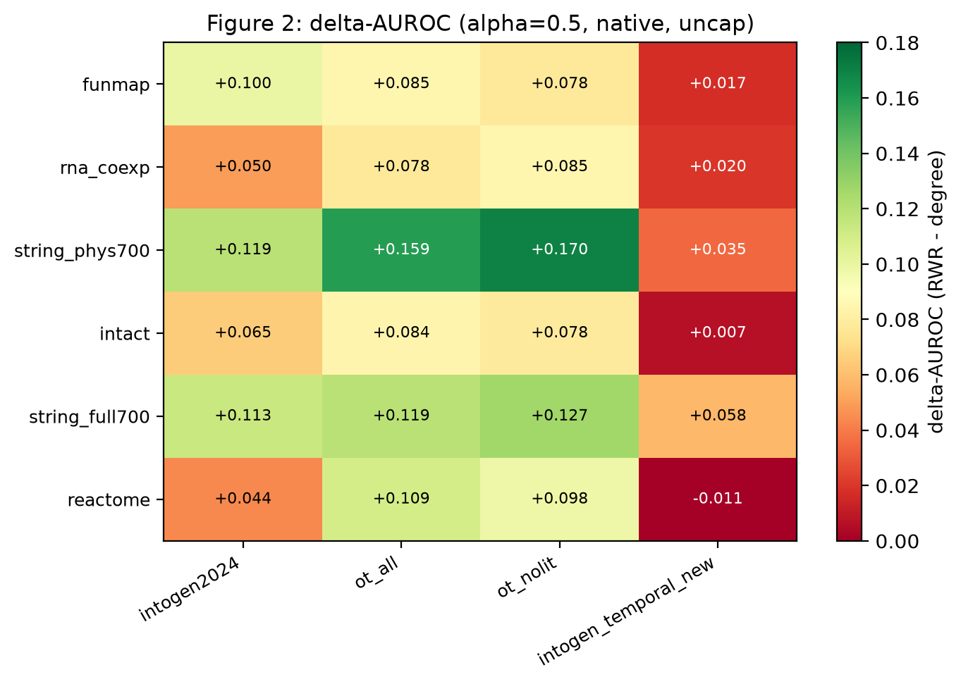
Figure 1. The primary endpoint. Heat map of ΔAUROC = AUROC(RWR) − AUROC(degree) at α = 0.5 for the 6 networks × 4 label sets. Green is a positive margin (the network prior beats degree), red is negative. The single negative cell is Reactome × IntOGen newly-discovered drivers.
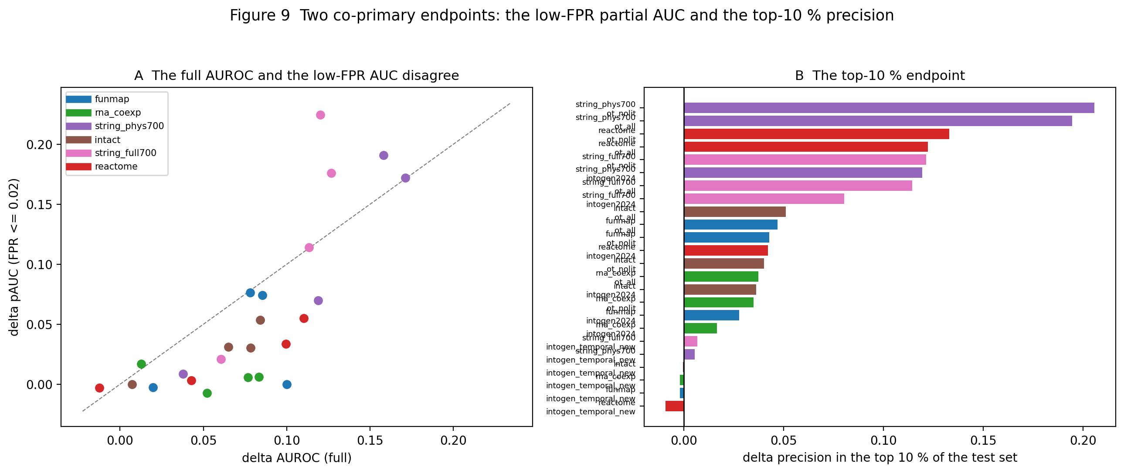
Figure 2. The same 24 arms on the two co-primary endpoints: the partial AUC below 2 % FPR and the precision in the top 10 %. The margin is smaller in both regions than in the full AUROC, and the ordering of the arms is unchanged.
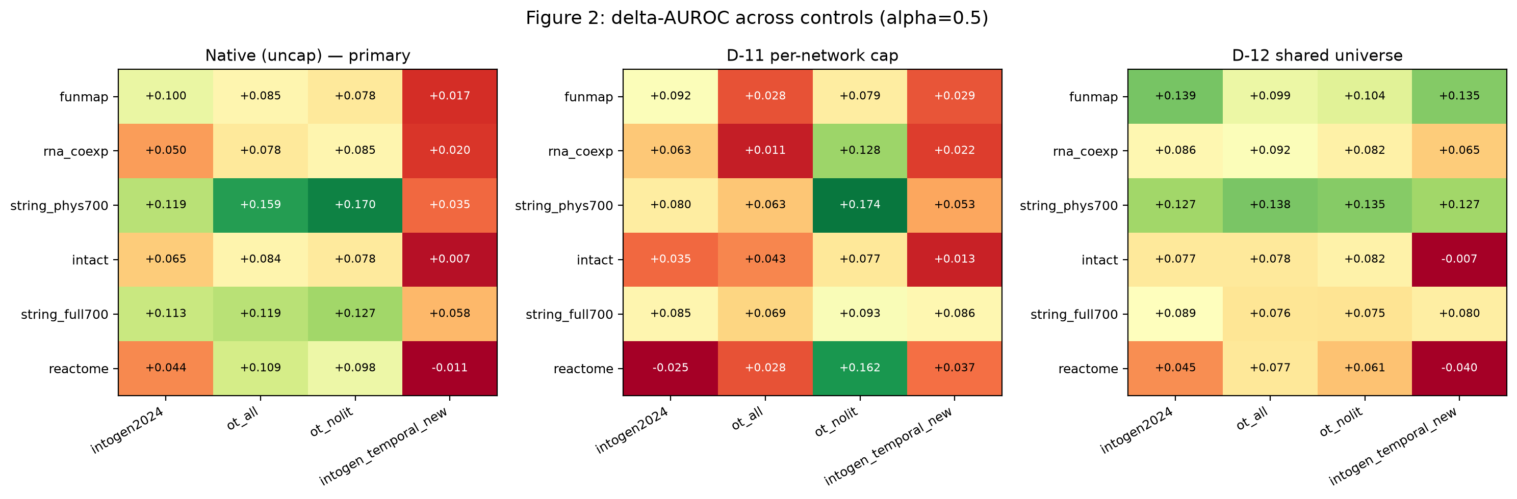
Figure 3. The three coverage controls side by side: the native evaluation, the D-11 common-size cap, and the D-12 shared gene universe.
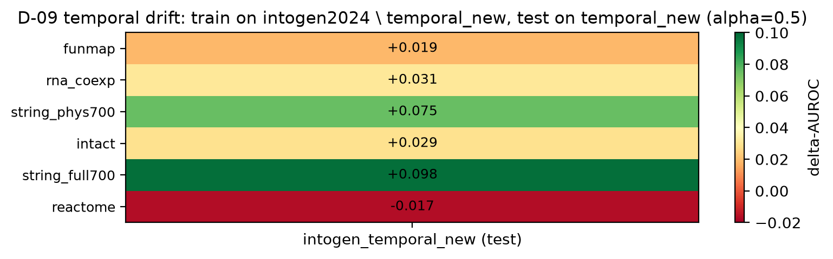
Figure 4. The temporal control. The 152 newly-discovered IntOGen drivers are recovered with a smaller margin (0.02–0.10) than the established drivers (0.04–0.17); Reactome is the only network with a negative temporal-drift estimate.
Figures

