Introduction to Machine Learning

Problem Set 3: SVM and PCA

Xinyue Chen NetID: xc1305

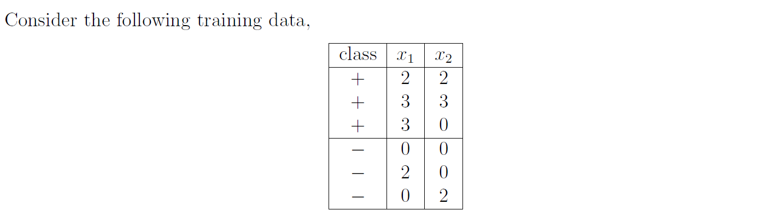**Problem 1**

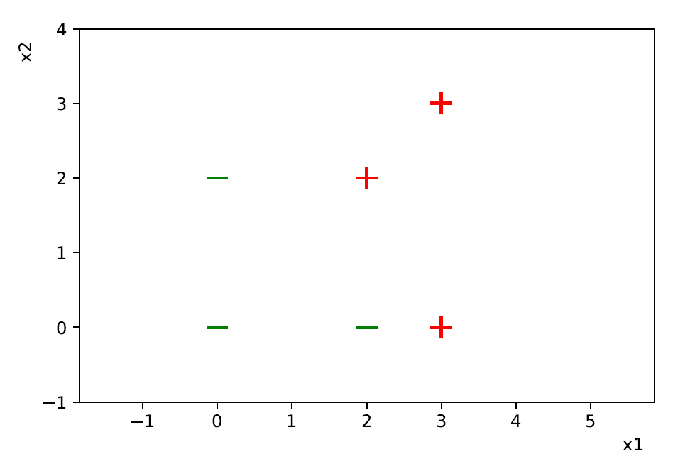(a) Plot these six training points. Are the class {+, −} linearly separable?

Yes, the class {+, −} are linearly separable.

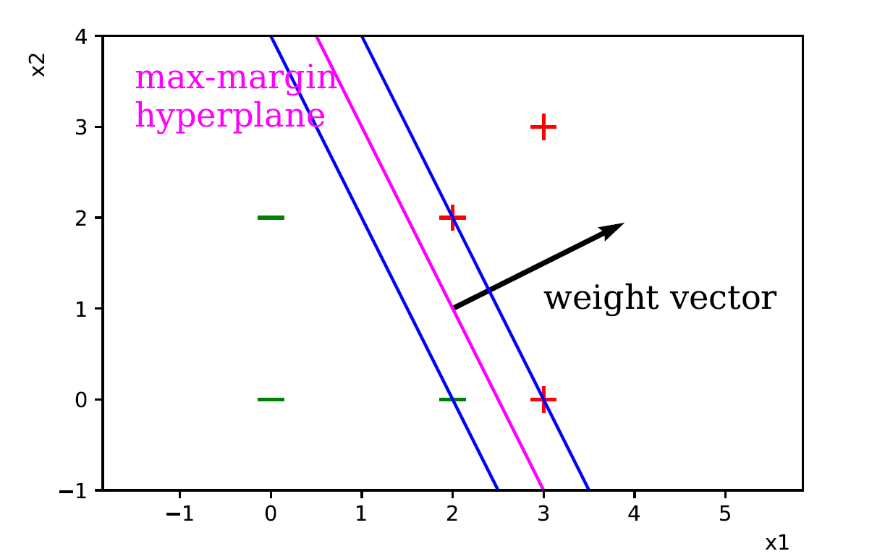(b) Construct the weight vector of the maximum margin hyperplane by inspection and identify the support vectors.

The weight is any scalar vector of (2,1).

The support vectors are (2,2), (3,0) of + class and (2,0) of – class.

(c) If you remove one of the support vectors, does the size of the optimal margin decrease, stay the same, or increase?

Increase.

Since support vectors are imposing restrictions on the optimal margin.

**Problem 4**

Code in ‘xc1305_PCA_student_completed.py’

1. Display a face image chosen randomly from the 400 images.

Output is random.

2. Compute and display the mean of the faces. Subtract the mean from each faces to get the “centered faces”.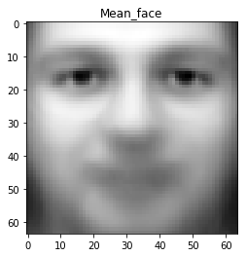

3. For each centered face, compute its covariance matrix. Then, compute the average covariance matrix V by averaging the 400 covariance matrices. Note that V is a 64 x 64 matrix.

4. Calculate the eigenvalues and eigenvectors of the covariance matrix V using the method stated in the eigenface tutorial.

Please refer to the code.

5. Display the first 16 principal components.

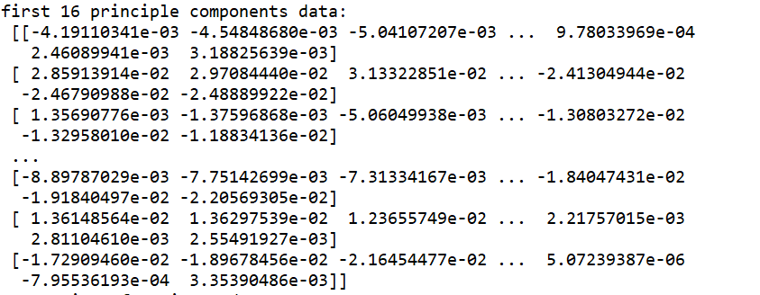

If you want to see pictures displaying those PCs, please run the code.

6. Reconstruct the first face using the first two principal components.

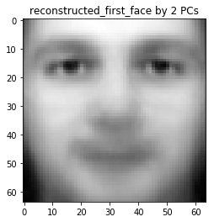

7. ~~Randomly choose a face, reconstruct it~~ reconstruct image No.100 (index 99) using 5, 10, 25, 50, 100, 200, 300, 399 principle components, and show the reconstructed images.

