Tetris

# Group member:

陳南宏，李培寗，黃喬苡，藍翊庭

# Description:

Tetriminos are game pieces shaped like tetrominoes, geometric shapes composed of four square blocks each. A random sequence of Tetriminos fall down the playing field (a rectangular vertical shaft, called the "well" or "matrix"). The objective of the game is to manipulate these Tetriminos, by moving each one sideways and rotating it by 90 degree units, with the aim of creating a horizontal line of ten blocks without gaps. When such a line is created, it disappears, and any block above the deleted line will fall.

# Specification:

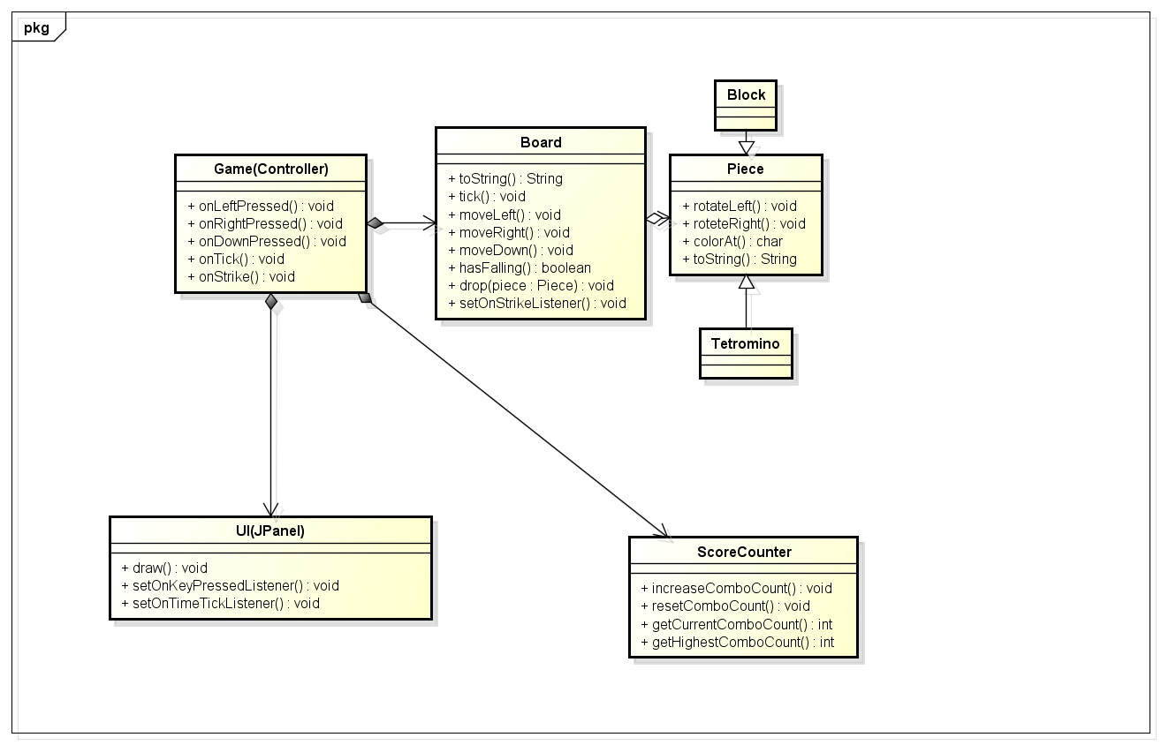

# Work distribution:

李培寗，藍翊庭: UI and ScoreCounter

黃喬苡，陳南宏: GameController, Board, and Piece