**优化方法算法实现报告**

学 院（系）： 数学科学学院

专 业： 数学1601

学 生 姓 名： 兰宇恒

学 号： 201686043

大连理工大学

Dalian University of Technology

1. First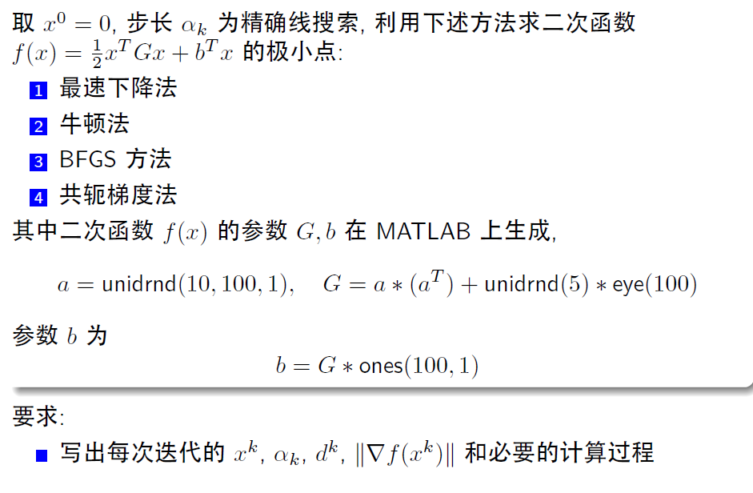
2. 程序概述（部分代码展示）
3. 生成矩阵

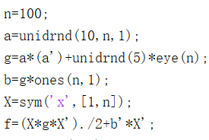

1. 步长



1. 参数选择

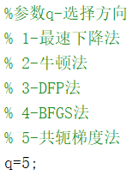

1. 各部分实现

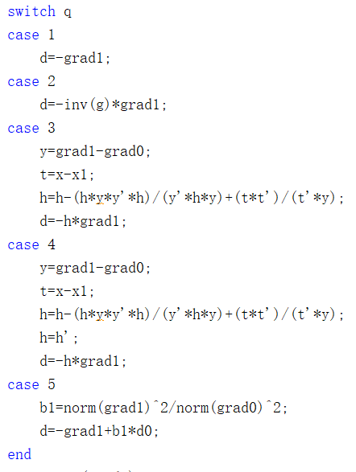

1. 图像生成

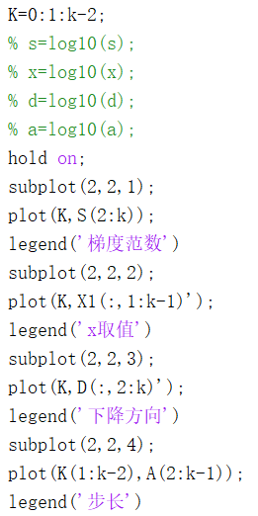

1. 结果
2. 最速下降法

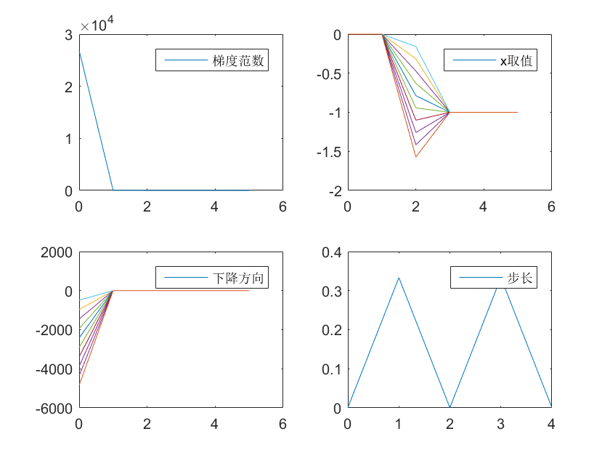

最终结果x如下，其余结果均保留在first文件下的first-steep-all.mat文件中

-0.999999999998702 -0.999999999999738 -1.00000000000009 -0.999999999999738 -1.00000000000027 -1.00000000000007 -1.00000000000067 -1.00000000000150 -0.999999999999738 -0.999999999999738 -1.00000000000009 -0.999999999999738 -0.999999999999738 -0.999999999999558 -0.999999999998702 -1.00000000000009 -0.999999999999557 -0.999999999999738 -1.00000000000039 -0.999999999999738 -1.00000000000027 -1.00000000000007 -0.999999999998702 -0.999999999999738 -1.00000000000027 -1.00000000000039 -1.00000000000039 -1.00000000000034 -1.00000000000027 -1.00000000000009 -1.00000000000039 -1.00000000000007 -1.00000000000067 -1.00000000000007 -1.00000000000007 -0.999999999998702 -1.00000000000027 -1.00000000000034 -0.999999999999738 -1.00000000000007 -0.999999999999103 -0.999999999999885 -1.00000000000039 -1.00000000000039 -1.00000000000009 -0.999999999999103 -0.999999999999103 -1.00000000000027 -1.00000000000039 -1.00000000000039 -1.00000000000067 -1.00000000000118 -1.00000000000118 -1.00000000000009 -1.00000000000009 -0.999999999999103 -0.999999999999738 -0.999999999999885 -1.00000000000150 -1.00000000000067 -1.00000000000039 -1.00000000000067 -1.00000000000105 -1.00000000000027 -0.999999999998703 -0.999999999999738 -1.00000000000105 -1.00000000000009 -1.00000000000009 -1.00000000000067 -0.999999999997793 -1.00000000000067 -0.999999999998702 -1.00000000000067 -0.999999999998829 -0.999999999999885 -1.00000000000009 -1.00000000000067 -1.00000000000072 -0.999999999999558 -1.00000000000034 -0.999999999998702 -1.00000000000150 -1.00000000000150 -0.999999999998829 -1.00000000000067 -1.00000000000039 -1.00000000000039 -0.999999999999885 -1.00000000000150 -0.999999999999959 -0.999999999999959 -1.00000000000150 -0.999999999999484 -0.999999999998829 -0.999999999999859 -1.00000000000150 -0.999999999999103 -1.00000000000007 -0.999999999999885

1. 牛顿法

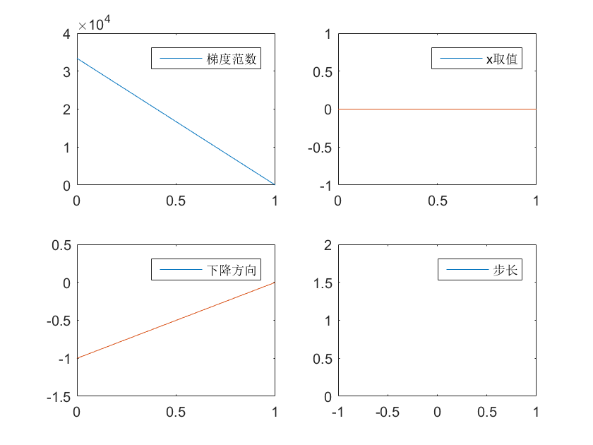

最终结果x如下，其余结果均保留在first文件下的first-Newton-all.mat文件中

-0.999999999999808 -0.999999999999957 -0.999999999999460 -0.999999999999932 -0.999999999999794 -0.999999999999700 -0.999999999999972 -0.999999999999585 -0.999999999999935 -1.00000000000038 -0.999999999999988 -0.999999999999786 -1.00000000000078 -0.999999999999923 -1.00000000000016 -0.999999999999572 -1.00000000000074 -0.999999999999949 -1.00000000000034 -0.999999999999926 -1.00000000000067 -0.999999999999978 -0.999999999999623 -0.999999999999910 -0.999999999999854 -0.999999999999944 -0.999999999999771 -0.999999999999724 -1.00000000000033 -1.00000000000039 -1.00000000000047 -0.999999999999923 -0.999999999999730 -0.999999999999970 -0.999999999999938 -1.00000000000027 -0.999999999999333 -0.999999999999453 -0.999999999999923 -1.00000000000023 -0.999999999999807 -0.999999999999851 -0.999999999999393 -1.00000000000017 -0.999999999999943 -0.999999999999695 -0.999999999999900 -0.999999999999896 -0.999999999999739 -1.00000000000015 -0.999999999999989 -1.00000000000063 -1.00000000000049 -1.00000000000016 -1.00000000000023 -0.999999999999871 -1.00000000000023 -0.999999999999999 -0.999999999999913 -0.999999999999739 -0.999999999999822 -0.999999999999700 -1.00000000000027 -0.999999999999961 -0.999999999999945 -1.00000000000054 -1.00000000000046 -0.999999999999553 -0.999999999999967 -0.999999999999771 -1.00000000000004 -0.999999999999660 -1.00000000000000 -1.00000000000000 -0.999999999999993 -0.999999999999874 -0.999999999999577 -0.999999999999583 -1.00000000000032 -0.999999999999538 -0.999999999999862 -0.999999999999520 -0.999999999999979 -0.999999999999878 -0.999999999999947 -0.999999999999908 -1.00000000000018 -0.999999999999805 -1.00000000000001 -1.00000000000023 -0.999999999999918 -1.00000000000018 -1.00000000000016 -1.00000000000009 -0.999999999999929 -0.999999999999438 -0.999999999999819 -0.999999999999556 -0.999999999999950 -0.999999999999859

1. BFGS方法

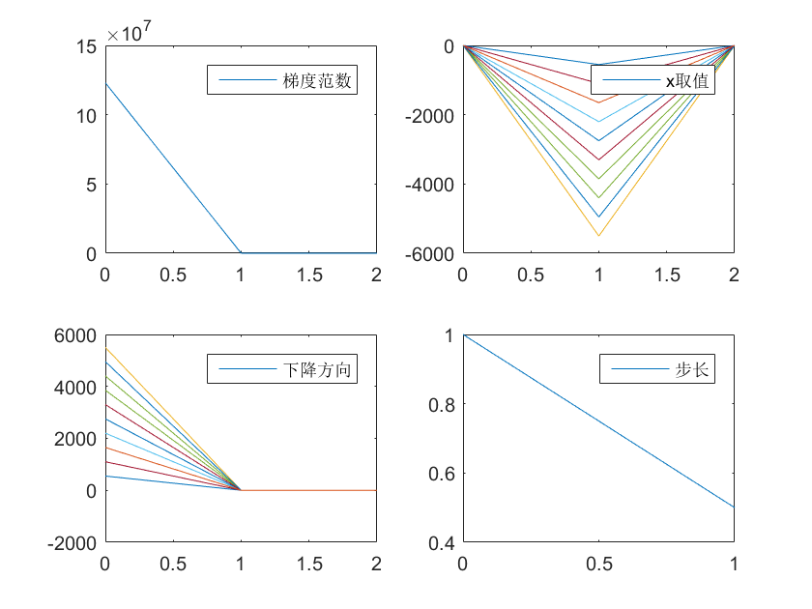

最终结果x如下，其余结果均保留在first文件下的first-BFGS-all.mat文件中

-1.00000000000034 -0.999999999999924 -0.999999999999950 -0.999999999999874 -1.00000000000034 -0.999999999999924 -0.999999999999912 -0.999999999999924 -0.999999999999735 -0.999999999999950 -0.999999999999937 -0.999999999999735 -1.00000000000034 -0.999999999999975 -0.999999999999735 -0.999999999999975 -0.999999999999735 -0.999999999999937 -0.999999999999950 -0.999999999999874 -0.999999999999937 -0.999999999999975 -0.999999999999874 -0.999999999999874 -0.999999999999937 -0.999999999999975 -0.999999999999735 -0.999999999999937 -0.999999999999924 -0.999999999999735 -0.999999999999912 -0.999999999999899 -0.999999999999735 -0.999999999999975 -0.999999999999735 -0.999999999999950 -0.999999999999937 -0.999999999999924 -0.999999999999988 -0.999999999999735 -1.00000000000034 -0.999999999999988 -0.999999999999874 -0.999999999999899 -0.999999999999937 -0.999999999999924 -0.999999999999735 -0.999999999999937 -0.999999999999874 -0.999999999999924 -0.999999999999924 -0.999999999999735 -0.999999999999937 -0.999999999999912 -0.999999999999912 -0.999999999999950 -0.999999999999950 -0.999999999999874 -0.999999999999988 -1.00000000000034 -0.999999999999874 -0.999999999999899 -0.999999999999988 -0.999999999999735 -0.999999999999950 -1.00000000000037 -0.999999999999975 -0.999999999999899 -0.999999999999975 -1.00000000000037 -0.999999999999937 -0.999999999999899 -0.999999999999899 -0.999999999999874 -1.00000000000034 -0.999999999999950 -1.00000000000037 -0.999999999999975 -0.999999999999988 -0.999999999999899 -0.999999999999924 -0.999999999999937 -0.999999999999874 -1.00000000000037 -1.00000000000037 -1.00000000000034 -1.00000000000034 -0.999999999999924 -0.999999999999975 -1.00000000000019 -1.00000000000034 -0.999999999999988 -0.999999999999937 -0.999999999999975 -0.999999999999874 -0.999999999999899 -0.999999999999924 -0.999999999999937 -0.999999999999988 -1.00000000000037

1. 共轭梯度法

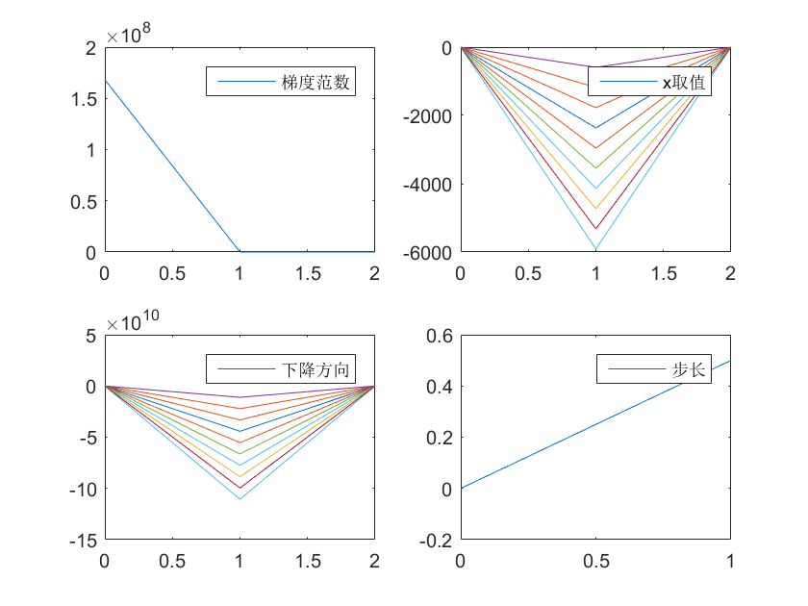

最终结果x如下，其余结果均保留在first文件下的first-CG-all.mat文件中

-1.00000000000005 -1.00000000000014 -0.999999999999794 -1.00000000000008 -0.999999999999794 -1.00000000000007 -0.999999999999794 -1.00000000000007 -0.999999999999970 -1.00000000000007 -1.00000000000014 -1.00000000000005 -1.00000000000005 -1.00000000000005 -1.00000000000004 -1.00000000000008 -1.00000000000008 -1.00000000000009 -1.00000000000015 -0.999999999999794 -0.999999999999970 -1.00000000000014 -1.00000000000014 -1.00000000000005 -1.00000000000005 -0.999999999999885 -1.00000000000004 -1.00000000000007 -1.00000000000007 -1.00000000000024 -1.00000000000008 -1.00000000000009 -0.999999999999794 -0.999999999999970 -1.00000000000007 -0.999999999999995 -1.00000000000005 -1.00000000000007 -1.00000000000005 -1.00000000000004 -0.999999999999970 -1.00000000000005 -1.00000000000008 -0.999999999999794 -0.999999999999995 -0.999999999999970 -0.999999999999995 -0.999999999999794 -1.00000000000015 -1.00000000000008 -1.00000000000004 -1.00000000000009 -1.00000000000008 -1.00000000000009 -1.00000000000001 -1.00000000000024 -1.00000000000008 -1.00000000000024 -0.999999999999995 -0.999999999999970 -0.999999999999995 -1.00000000000024 -0.999999999999970 -1.00000000000009 -1.00000000000005 -1.00000000000015 -1.00000000000014 -1.00000000000009 -0.999999999999794 -1.00000000000008 -1.00000000000024 -0.999999999999970 -1.00000000000005 -1.00000000000024 -1.00000000000014 -1.00000000000007 -1.00000000000024 -1.00000000000007 -1.00000000000001 -1.00000000000005 -0.999999999999989 -0.999999999999970 -1.00000000000024 -0.999999999999970 -0.999999999999995 -1.00000000000007 -1.00000000000001 -1.00000000000005 -1.00000000000005 -0.999999999999885 -1.00000000000008 -1.00000000000001 -0.999999999999989 -1.00000000000001 -1.00000000000001 -1.00000000000005 -1.00000000000016 -1.00000000000014 -0.999999999999885 -1.00000000000007

1. Second

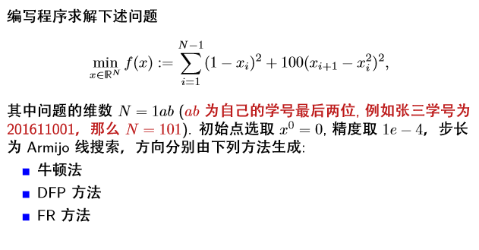

1. 程序概述（部分代码展示）
2. 求解函数值

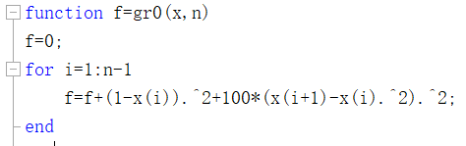

1. 求解一阶导值

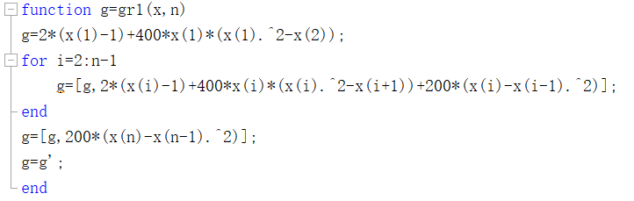

1. 求解二阶导值

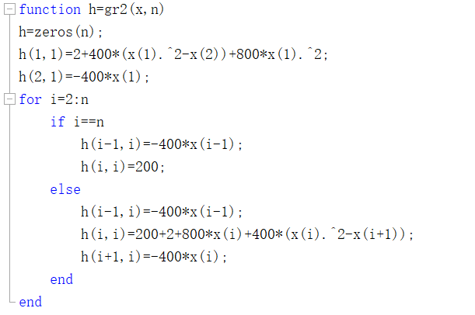

1. 步长

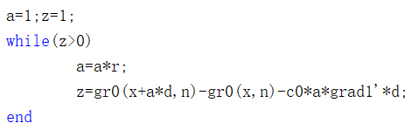

1. 参数选择



1. 各部分实现



1. 图像生成（注明：取了对数让下降趋势更明显）

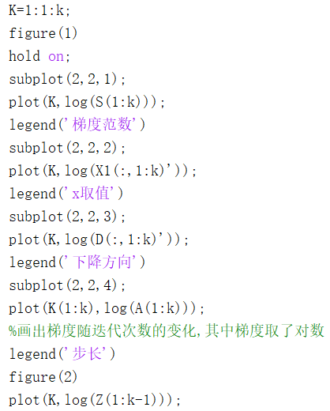

1. 结果
2. 牛顿法

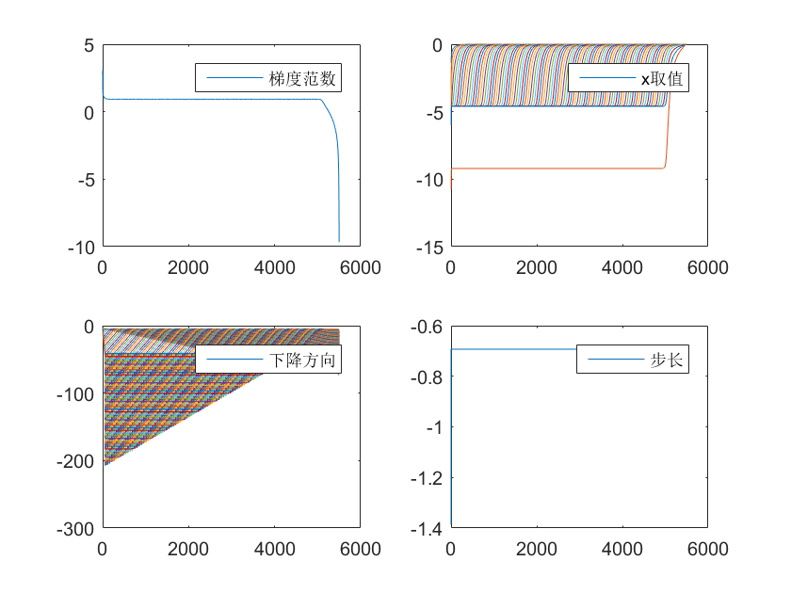

对应armijo方法的z值，详见代码

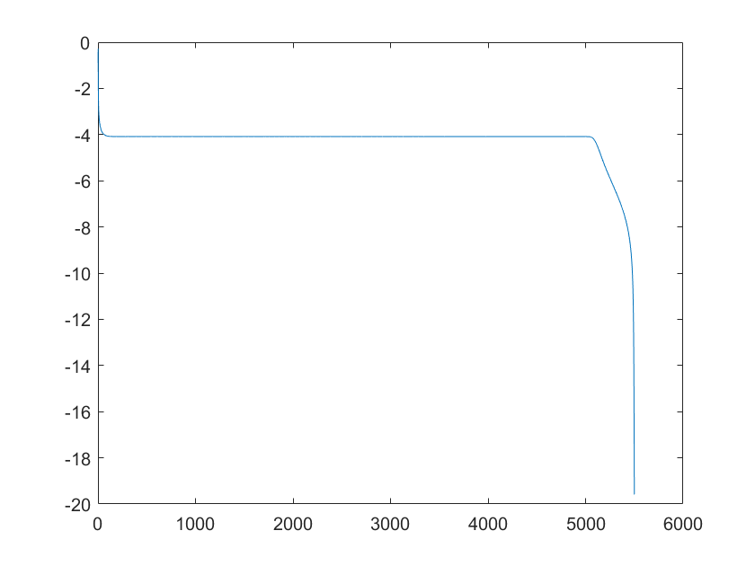

最终结果x如下，其余结果均保留在first文件下的second-Newton-all.mat文件中

1 1 1 1 1 1 1 1 1 1 1 1 1 1 1 1 1 1 1 1 1 1 1 1 1 1 1 1 1 1 1 1 1 1 1 1 1 1 1 1 1 1 1 1 1 1 1 1 1 1 1 1 1 1 1 1 1 1 1 1 1 1 1 0.999999999999999 0.999999999999998 0.999999999999997 0.999999999999994 0.999999999999987 0.999999999999974 0.999999999999948 0.999999999999895 0.999999999999789 0.999999999999577 0.999999999999152 0.999999999998299 0.999999999996586 0.999999999993149 0.999999999986251 0.999999999972411 0.999999999944639 0.999999999888909 0.999999999777077 0.999999999552670 0.999999999102361 0.999999998198745 0.999999996385495 0.999999992746923 0.999999985445554 0.999999970794226 0.999999941394121 0.999999882398608 0.999999764016651 0.999999526472202 0.999999049832847 0.999998093506560 0.999996174994727 0.999992327243873 0.999984614355290 0.999969170274627 0.999938311529341

1. DFP方法

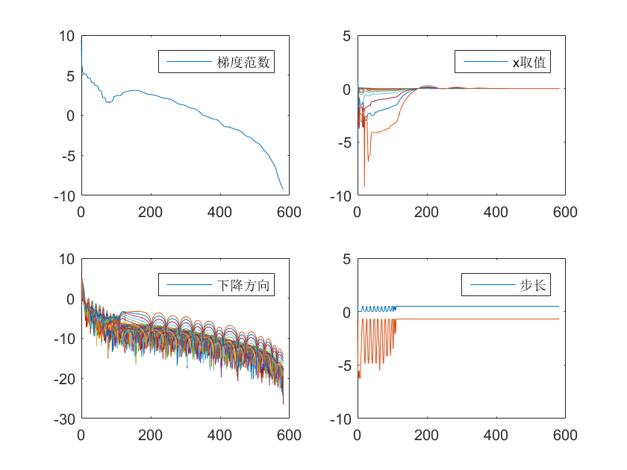

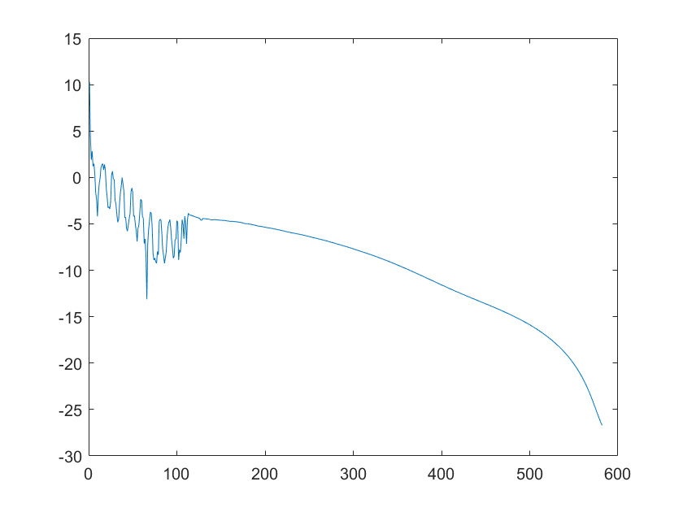

最终结果x如下，其余结果均保留在first文件下的second-DFP-all.mat文件中

1.00000004821481 1.00000005689783 1.00000005629824 1.00000003657071 1.00000003585078 1.00000005342372 1.00000004897578 1.00000003669770 1.00000002734254 1.00000002854090 1.00000003253108 1.00000003961678 1.00000003712053 1.00000002191878 1.00000000576155 1.00000000118743 1.00000001940763 1.00000001729233 1.00000000508704 0.999999992833448 1.00000000713651 1.00000001143228 1.00000003765878 1.00000005405519 1.00000003638501 1.00000002813044 1.00000001441925 0.999999994792587 0.999999994224738 0.999999988752734 0.999999996678438 0.999999988189262 0.999999995047840 0.999999990251910 1.00000000280931 1.00000001191405 1.00000002080057 1.00000002347698 1.00000000725049 0.999999987476727 0.999999987180536 0.999999992684211 1.00000001046205 1.00000003005691 1.00000003256944 1.00000003624037 1.00000003884098 1.00000004442791 1.00000005164009 1.00000005094990 1.00000003749322 1.00000002124527 0.999999996859135 0.999999983494958 0.999999989037937 0.999999981792066 0.999999985313775 0.999999974823782 0.999999984979789 1.00000000897727 1.00000003548896 1.00000004669291 1.00000004556175 1.00000004386683 1.00000002780174 1.00000001134075 0.999999997266849 0.999999994394300 0.999999993108868 1.00000000030373 1.00000000729392 1.00000001402408 0.999999995800564 1.00000000560697 1.00000003558426 1.00000001634945 1.00000001968681 1.00000000671076 1.00000000160299 1.00000001889107 1.00000004973193 1.00000005874424 1.00000003415157 1.00000002470464 1.00000003059142 1.00000004607049 1.00000004467479 1.00000003568022 1.00000001456750 1.00000000070705 1.00000001204668 1.00000003743270 1.00000004612516 1.00000005696637 1.00000011265302 1.00000022929966 1.00000045281825 1.00000089527135 1.00000174357362 1.00000345672741

1. FR方法

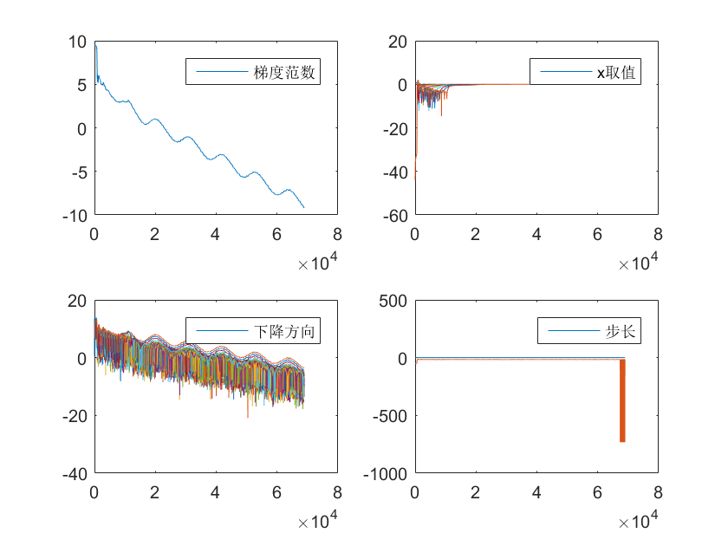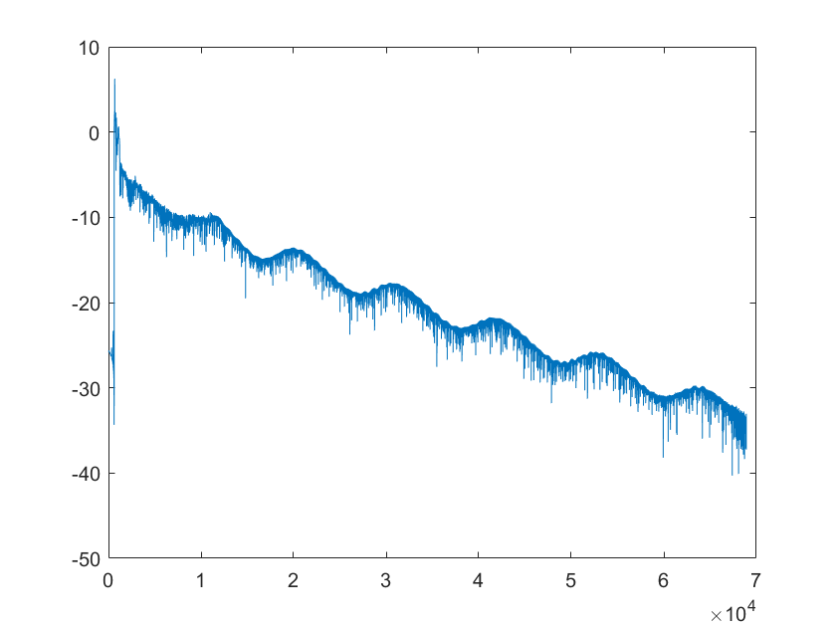

最终结果x如下，其余结果均保留在first文件下的second-FR-all.mat文件中

-0.993286114634101 0.996651084015691 0.998330317654323 0.999167724135691 0.999585184833402 0.999793272241121 0.999896992874934 0.999948693936542 0.999974468487933 0.999987311553355 0.999993695937823 0.999996866221899 0.999998433013985 0.999999197593900 0.999999577622872 0.999999778402199 0.999999882061397 0.999999937868696 0.999999974278805 0.999999985387491 0.999999975171680 0.999999962735733 0.999999966089327 0.999999969788769 0.999999973417192 0.999999981672035 0.999999998096187 0.999999994189624 0.999999977265643 0.999999961047371 0.999999957168860 0.999999956563383 0.999999962570860 0.999999979467448 0.999999988947950 0.999999978948765 0.999999957263511 0.999999958407202 0.999999972062757 0.999999977628413 0.999999958002565 0.999999953522014 0.999999977988773 1.00000000939159 1.00000001380055 0.999999981746920 0.999999954901052 0.999999952100139 0.999999989117032 1.00000002996935 1.00000005095318 1.00000004939621 1.00000004479855 1.00000005152950 1.00000005107582 1.00000005847086 1.00000006469555 1.00000006492704 1.00000005241646 1.00000003527702 1.00000002061592 0.999999999096570 1.00000000147137 1.00000000989955 1.00000000567887 0.999999992140605 0.999999968963953 0.999999947321534 0.999999928823244 0.999999937237167 0.999999954840656 0.999999965551113 0.999999985914515 0.999999992977719 0.999999988702677 0.999999983494170 0.999999975097896 0.999999970898374 0.999999972944494 0.999999983923241 0.999999990308018 0.999999993573815 0.999999998024293 0.999999996038792 1.00000000468355 1.00000001212746 1.00000000665764 1.00000000268213 0.999999984560310 0.999999956937180 0.999999931336998 0.999999887292519 0.999999817075896 0.999999688631778 0.999999421924636 0.999998883486262 0.999997792194948 0.999995592775599 0.999991179284536 0.999982318825393

1. 通用方法

在以上算法例子的基础上，我通过符号变量写出了一个对任意函数均可实现优化算法的程序

1. 程序概述
2. 主程序

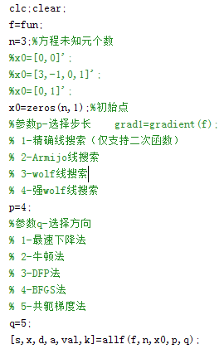

1. allf函数主要部分

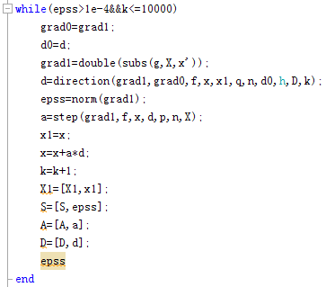

1. 下降方向

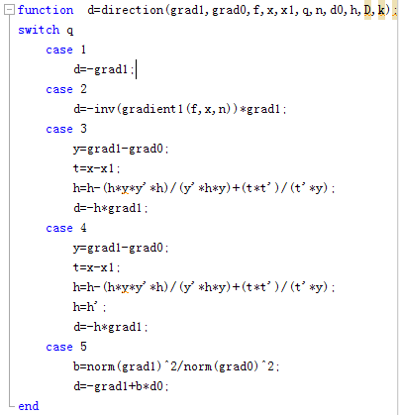

1. 下降步长

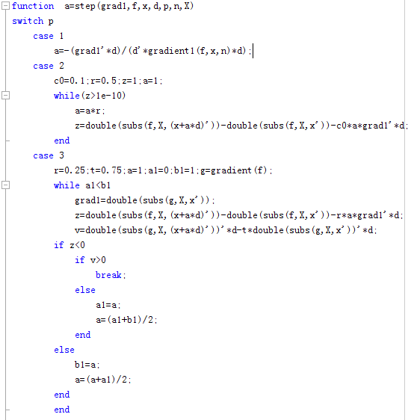

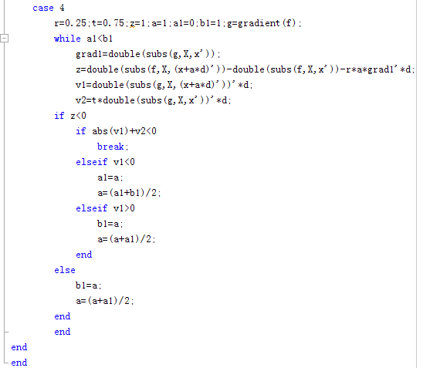

1. 求函数一阶导

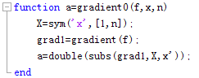

1. 求函数二阶导

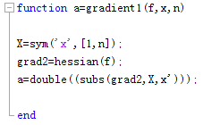

1. 对二维函数画出等高线下的逼近散点图

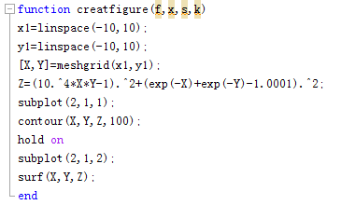

1. 函数测试

由于matlab适用于数值计算导致符号变量的赋值过程成为程序运算速度的瓶颈，但程序可对任意形式的函数进行计算，在对特定函数计算时只需要改变参数p,q选择下降方向和步长。

以二维rosenbrock函数为例结果如图所示

