**品优购电商系统开发**

**第15章**

**SpringBoot框架与短信解决方案**

传智播客.黑马程序员

# 1.Spring Boot入门

## 1.1什么是Spring Boot

Spring 诞生时是 Java 企业版（Java Enterprise Edition，JEE，也称 J2EE）的轻量级代替品。无需开发重量级的 Enterprise JavaBean（EJB），Spring 为企业级Java 开发提供了一种相对简单的方法，通过依赖注入和面向切面编程，用简单的Java 对象（Plain Old Java Object，POJO）实现了 EJB 的功能。

虽然 Spring 的组件代码是轻量级的，但它的配置却是重量级的。一开始，Spring 用 XML 配置，而且是很多 XML 配置。Spring 2.5 引入了基于注解的组件扫描，这消除了大量针对应用程序自身组件的显式 XML 配置。Spring 3.0 引入了基于 Java 的配置，这是一种类型安全的可重构配置方式，可以代替 XML。所有这些配置都代表了开发时的损耗。因为在思考 Spring 特性配置和解决业务问题之间需要进行思维切换，所以写配置挤占了写应用程序逻辑的时间。和所有框架一样，Spring 实用，但与此同时它要求的回报也不少。

除此之外，项目的依赖管理也是件吃力不讨好的事情。决定项目里要用哪些库就已经够让人头痛的了，你还要知道这些库的哪个版本和其他库不会有冲突，这难题实在太棘手。并且，依赖管理也是一种损耗，添加依赖不是写应用程序代码。一旦选错了依赖的版本，随之而来的不兼容问题毫无疑问会是生产力杀手。

Spring Boot 让这一切成为了过去。

Spring Boot 是 Spring 社区较新的一个项目。该项目的目的是帮助开发者更容易的创建基于 Spring 的应用程序和服务，让更多人的人更快的对 Spring 进行入门体验，为 Spring 生态系统提供了一种固定的、约定优于配置风格的框架。

Spring Boot 具有如下特性：

（1）为基于 Spring 的开发提供更快的入门体验

（2）开箱即用，没有代码生成，也无需 XML 配置。同时也可以修改默认值来满足特定的需求。

（3）提供了一些大型项目中常见的非功能性特性，如嵌入式服务器、安全、指标，健康检测、外部配置等。

（4）Spring Boot 并不是不对 Spring 功能上的增强，而是提供了一种快速使用 Spring 的方式。

## 1.2 Spring Boot入门小Demo

### 1.2.1起步依赖

创建Maven工程 springboot_demo（打包方式jar）

在pom.xml中添加如下依赖

|  |
| --- |
| <parent>  <groupId>org.springframework.boot</groupId>  <artifactId>spring-boot-starter-parent</artifactId>  <version>1.4.0.RELEASE</version>  </parent>  <dependencies>  <dependency>  <groupId>org.springframework.boot</groupId>  <artifactId>spring-boot-starter-web</artifactId>  </dependency>  </dependencies> |

我们会惊奇地发现，我们的工程自动添加了好多好多jar包

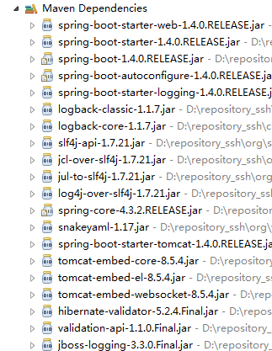

........

而这些jar包正式我们做开发时需要导入的jar包。因为这些jar包被我们刚才引入的spring-boot-starter-web所引用了，所以我们引用spring-boot-starter-web后会自动把依赖传递过来。

### 1.2.2变更JDK版本

我们发现默认情况下工程的JDK版本是1.6 ,而我们通常用使用1.7的版本，所以我们需要在pom.xml中添加以下配置

|  |
| --- |
| <properties>  <java.version>1.7</java.version>  </properties> |

添加后更新工程，会发现版本已经变更为1.7

### 1.2.3引导类

只需要创建一个引导类 .

|  |
| --- |
| **package** cn.itcast.demo;  **import** org.springframework.boot.SpringApplication;  **import** org.springframework.boot.autoconfigure.SpringBootApplication;  @SpringBootApplication  **public** **class** Application {  **public** **static** **void** main(String[] args) {  SpringApplication.*run*(Application.**class**, args);  }  } |

简单解释一下，@SpringBootApplication其实就是以下三个注解的总和

@Configuration： 用于定义一个配置类

@EnableAutoConfiguration ：Spring Boot会自动根据你jar包的依赖来自动配置项目。

@ComponentScan： 告诉Spring 哪个packages 的用注解标识的类 会被spring自动扫描并且装入bean容器。

我们直接执行这个引导类，会发现控制台出现的这个标识

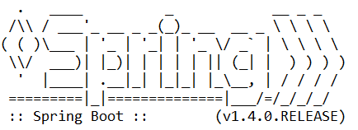

你能不能看出来上边这个图是什么东西？

### 1.2.4 Spring MVC实现Hello World输出

我们现在开始使用spring MVC框架，实现json数据的输出。如果按照我们原来的做法，需要在web.xml中添加一个DispatcherServlet的配置，再添加一个spring的配置文件，配置文件中需要添加如下配置

|  |
| --- |
| <!-- 使用组件扫描，不用将controller在spring中配置 -->  <context:component-scan base-package="cn.itcast.demo.controller" />  <!-- 使用注解驱动不用在下边定义映射器和适配置器 -->  <mvc:annotation-driven>  <mvc:message-converters register-defaults=*"true"*>  <bean class=*"com.alibaba.fastjson.support.spring.FastJsonHttpMessageConverter"*>  <property name=*"supportedMediaTypes"* value=*"application/json"*/>  <property name=*"features"*>  <array>  <value>WriteMapNullValue</value>  <value>WriteDateUseDateFormat</value>  </array>  </property>  </bean>  </mvc:message-converters>  </mvc:annotation-driven> |

但是我们用SpringBoot，这一切都省了。我们直接写Controller类

|  |
| --- |
| **package** cn.itcast.demo.controller;  **import** org.springframework.web.bind.annotation.RequestMapping;  **import** org.springframework.web.bind.annotation.RestController;  @RestController  **public** **class** HelloWorldController {  @RequestMapping("/info")  **public** String info(){  **return** "HelloWorld";  }  } |

我们运行启动类来运行程序

在浏览器地址栏输入 http://localhost:8080/info 即可看到运行结果

### 1.2.5修改tomcat启动端口

在src/main/resources下创建application.properties

|  |
| --- |
| server.port=8088 |

重新运行引导类。地址栏输入

<http://localhost:8088/info>

### 1.2.6读取配置文件信息

在src/main/resources下的application.properties 增加配置

|  |
| --- |
| url=http://www.itcast.cn |

我要在类中读取这个配置信息，修改HelloWorldController

|  |
| --- |
| @Autowired  **private** Environment env;  @RequestMapping("/info")  **public** String info(){  **return** "HelloWorld~~"+env.getProperty("url");  } |

### 1.2.7热部署

我们在开发中反复修改类、页面等资源，每次修改后都是需要重新启动才生效，这样每次启动都很麻烦，浪费了大量的时间，能不能在我修改代码后不重启就能生效呢？可以，在pom.xml中添加如下配置就可以实现这样的功能，我们称之为热部署。

|  |
| --- |
| <dependency>  <groupId>org.springframework.boot</groupId>  <artifactId>spring-boot-devtools</artifactId>  </dependency> |

赶快试试看吧，是不是很爽。

## 1.3 Spring Boot与ActiveMQ整合

### 1.3.1使用内嵌服务

（1）在pom.xml中引入ActiveMQ起步依赖

|  |
| --- |
| <dependency>  <groupId>org.springframework.boot</groupId>  <artifactId>spring-boot-starter-activemq</artifactId>  </dependency> |

（2）创建消息生产者

|  |
| --- |
| /**  * 消息生产者  * **@author** Administrator  */  @RestController  **public** **class** QueueController {  @Autowired  **private** JmsMessagingTemplate jmsMessagingTemplate;  @RequestMapping("/send")  **public** **void** send(String text){  jmsMessagingTemplate.convertAndSend("itcast", text);  }  } |

（3）创建消息消费者

|  |
| --- |
| @Component  **public** **class** Consumer {  @JmsListener(destination="itcast")  **public** **void** readMessage(String text){  System.***out***.println("接收到消息："+text);  }  } |

测试：启动服务后，在浏览器执行

[http://localhost:8088/send](http://localhost:8080/send)?text=aaaaa

即可看到控制台输出消息提示。Spring Boot内置了ActiveMQ的服务，所以我们不用单独启动也可以执行应用程序。

### 1.3.2使用外部服务

在src/main/resources下的application.properties增加配置, 指定ActiveMQ的地址

|  |
| --- |
| spring.activemq.broker-url=tcp://192.168.200.128:61616 |

运行后，会在activeMQ中看到发送的queue

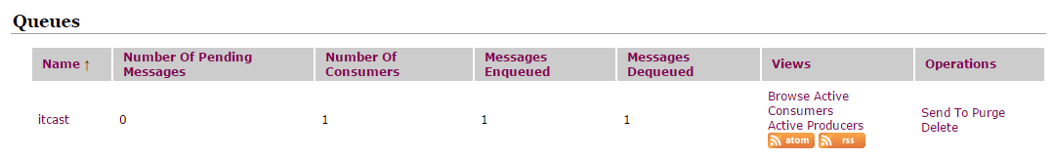

### 1.3.3发送Map信息

（1）修改QueueController.java

|  |
| --- |
| @RequestMapping("/sendmap")  **public** **void** sendMap(){  Map map=**new** HashMap();  map.put("mobile", "13900001111");  map.put("content", "恭喜获得10元代金券");  jmsMessagingTemplate.convertAndSend("itcast_map",map);  } |

（2）修改Consumer.java

|  |
| --- |
| @JmsListener(destination="itcast_map")  **public** **void** readMap(Map map){  System.***out***.println(map);  } |

测试访问: http://localhost:8088/sendmap

# 2.短信发送平台-阿里云通信

## 2.1阿里云通信简介

阿里云通信是**阿里云**旗下产品，融合了三大运营商的通信能力，通过将传统通信业务和能力与互联网相结合，创新融合阿里巴巴生态内容，全力为中小企业和开发者提供优质服务阿里大于提供包括短信、语音、流量直充、私密专线、店铺手机号等个性化服务。通过阿里大于打通三大运营商通信能力，全面融合阿里巴巴生态，以开放API及SDK的方式向开发者提供通信和数据服务，更好地支撑企业业务发展和创新服务。

## 2.2准备工作

### 2.2.1注册账户

首先我们先进入“阿里云通信” [www.alidayu.com](http://www.baidu.com/baidu.php?url=ZzmK000GQJC8hW1POcJEP4KEa9MqOc64Kv9VaSYkPBGRtKKgrM9zjpMjkg0QSyMnQxKRQWKjPMwVPRtuZHdquplwvyTojNksmJ4fXyH6PR2oD2XMXttLlESx3RspZ_3aMmqjEv4UOpBl4_suPNxrqoJgxNO3dD62O8C6tR-EGupmJLpXA6.7D_iuTZ-GYkYApacrSapBsAprFMw6wKL9JuBBHwmEukmr_X5is1gsdeEQx3txQ_erMktJOAEWkl_LT8FB8zzEWgEvNSQQPLuy--rexduYt8FWojG4THZgZG4THZy7MHWuxJB4THAe_tpqOudEmtxZ_L2N9h9mLU2Srqf.U1Yk0ZDq_2Q0eeH1YSn0IjvsC_jEV55H3sKGUHYznWR0u1dBuHms0ZNG5yF9pywd0ZKGujYk0APGujY1rjR0UgfqnH0YP7tknjDLg1DsnH-xn1msnfKopHYs0ZFY5Hm4P0K-pyfqnHfdndtznHDzPdtkP10snNtznW01PNtznWDLPdtznWDdPsKBpHYznjf0UynqnHR4PWRzPWbdP-t1PWn4rHmknj9xn1mYPjbsnHDYg100TgKGujYs0Z7Wpyfqn0KzuLw9u1Ys0AqvUjYzPWm4Qywlg1cvPW-mQywlg1msn1nVn7t3PHbVnsK9mWYsg100ugFM5H00TZ0qn0K8IM0qna3snj0snj0sn0KVIZ0qn0KbuAqs5H00ThCqn0KbugmqTAn0uMfqn0KspjYs0Aq15H00mMTqnH00UMfqn0K1XWY0IZN15HDLPjnzPjnzP1b4rjnzP1RvPWD10ZF-TgfqnHf3rjcYPjDLPjmvP6K1pyfqmyPbryNBmH6snjK9ujRdnsKWTvYqrjuAwjNarDRdnH03rH7aPsK9m1Yk0ZK85H00TydY5H00Tyd15H00XMfqn0KVmdqhThqV5HDsPjuxn7tsg100uA78IyF-gLK_my4GuZnqn7tsg1Kxn0KbIA-b5H00ugwGujYVnfK9TLKWm1Ys0ZNspy4Wm1Ys0Z7VuWYs0AuWIgfqn0KhXh6qn0KlTAkdT1Ys0A7buhk9u1Yk0APzm1YznWnz&us=0.0.0.0.0.0.10&us=0.0.0.0.0.0.30&ck=0.0.0.0.0.0.0.0&shh=www.baidu.com) （https://dayu.aliyun.com/）

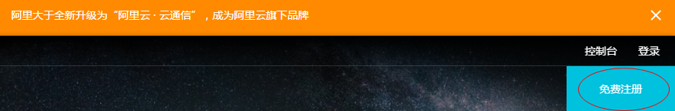

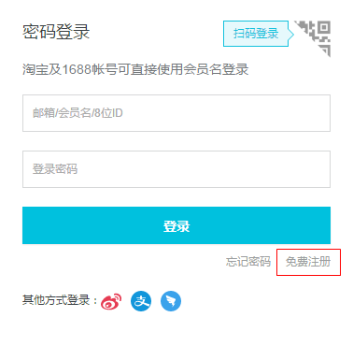

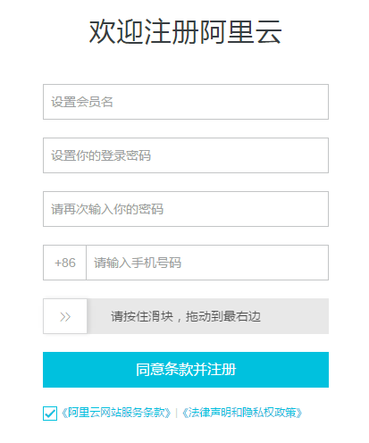

注册账号后，再在手机下载“阿里云”应用，登陆，然后进行在线实名认证。

### 2.2.2登陆系统

使用刚才注册的账号进行登陆。

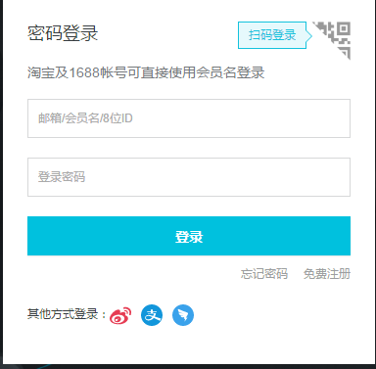

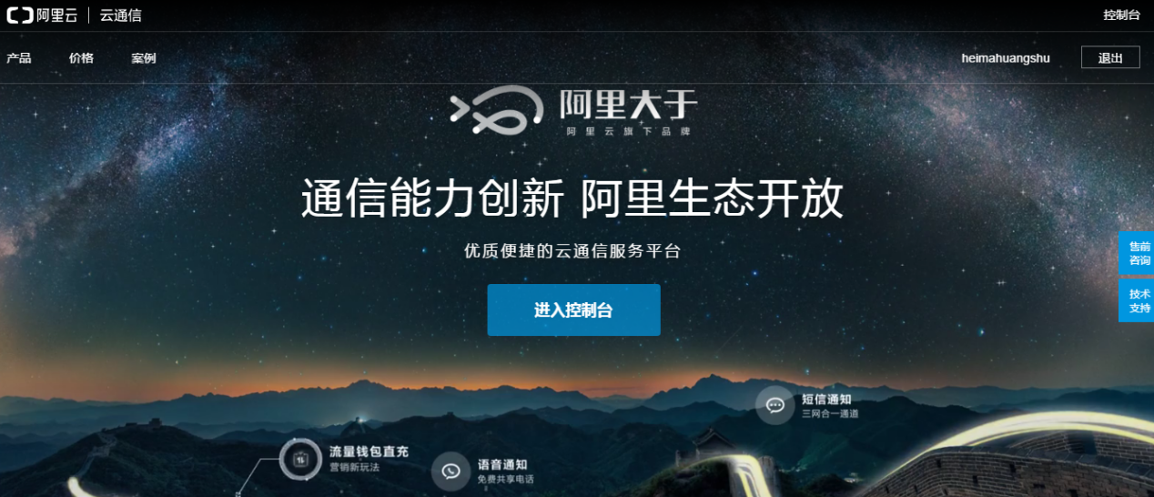

点击进入控制台

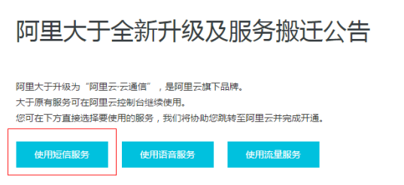

点击使用**短信服务**

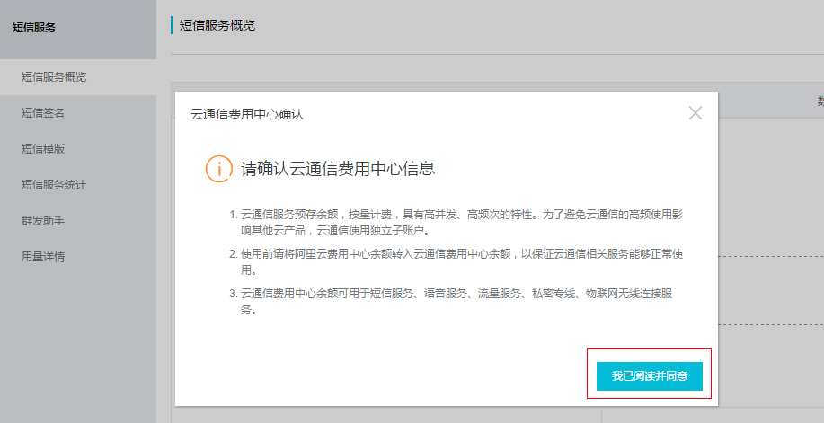

### 3.2.3申请签名

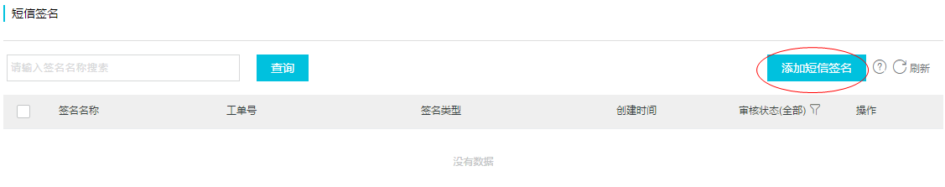

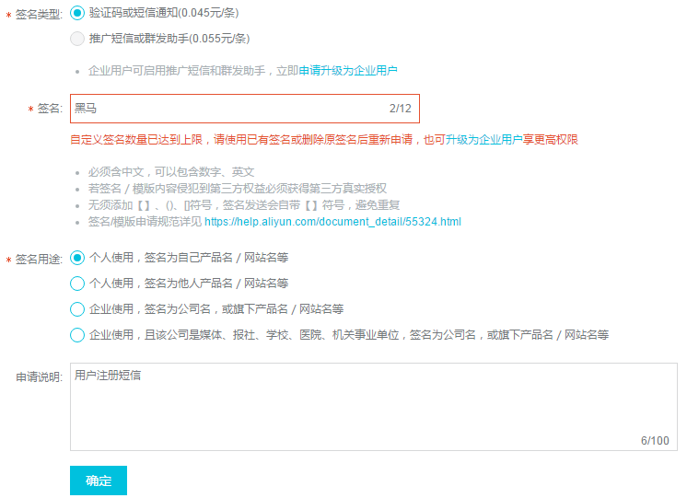

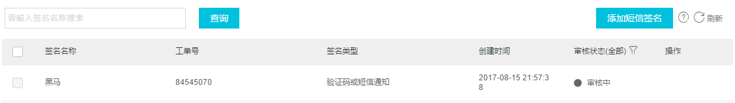

### 3.2.4申请模板

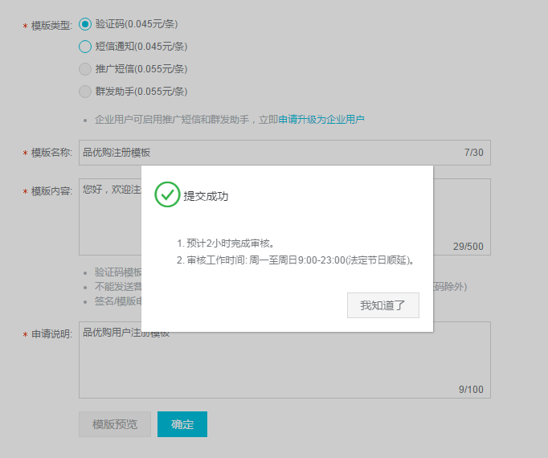

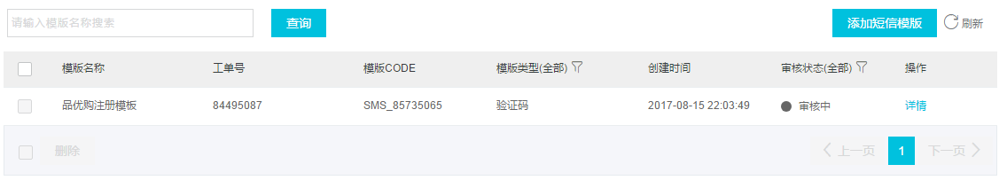

### 3.2.5创建accessKey

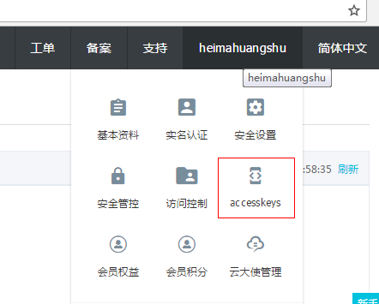

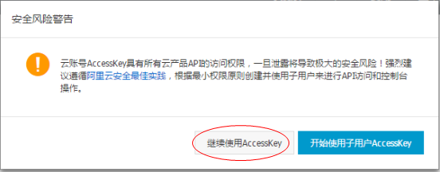

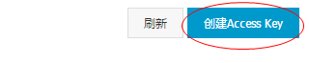

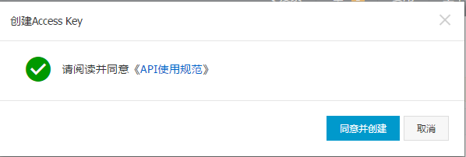

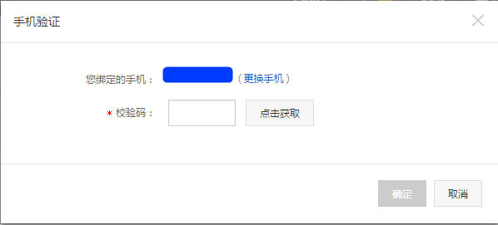

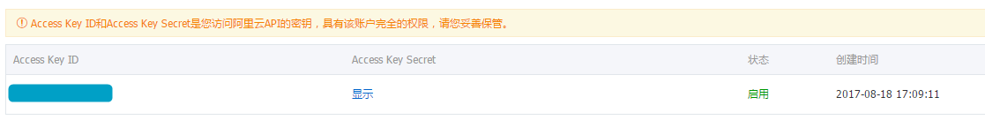

## 3.3 SDK安装

创建 alicom-dysms-api工程引入依赖

|  |
| --- |
| <dependencies>  <dependency>  <groupId>com.aliyun</groupId>  <artifactId>aliyun-java-sdk-dysmsapi</artifactId>  <version>1.0.0-SNAPSHOT</version>  </dependency>  <dependency>  <groupId>com.aliyun</groupId>  <artifactId>aliyun-java-sdk-core</artifactId>  <version>3.2.5</version>  </dependency>  </dependencies> |

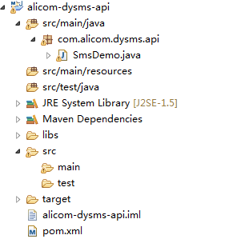

## 3.4发送短信测试

（1）打开SmsDemo

替换下列几处代码

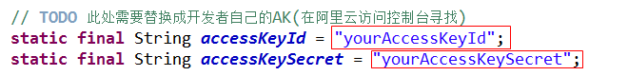

这个accessKeyId和accessSecret到刚才申请过的

手机号，短信签名和模板号

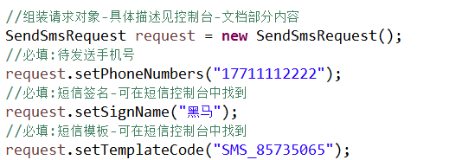

模板参数



number是我们申请模板时写的参数

执行main方法我们就可以在手机收到短信啦

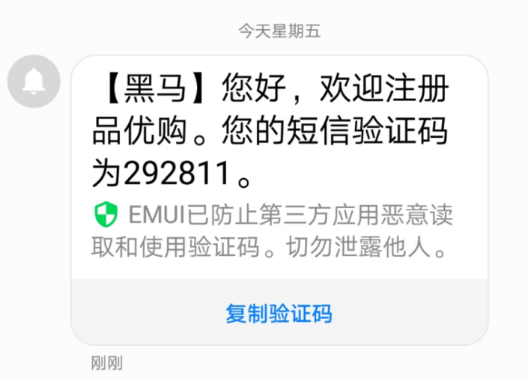

# 3.短信微服务

## 3.1需求分析

构建一个通用的短信发送服务（独立于品优购的单独工程），接收activeMQ的消息（MAP类型） 消息包括手机号（mobile）、短信模板号（template_code）、签名（sign_name）、参数字符串（param ）

## 3.2代码实现

### 3.2.1工程搭建

（1）创建工程itcast_sms （JAR工程），POM文件引入依赖

|  |
| --- |
| <properties>  <java.version>1.7</java.version>  </properties>  <parent>  <groupId>org.springframework.boot</groupId>  <artifactId>spring-boot-starter-parent</artifactId>  <version>1.4.0.RELEASE</version>  </parent>  <dependencies>  <dependency>  <groupId>org.springframework.boot</groupId>  <artifactId>spring-boot-starter-web</artifactId>  </dependency>  <dependency>  <groupId>org.springframework.boot</groupId>  <artifactId>spring-boot-starter-activemq</artifactId>  </dependency>  <dependency>  <groupId>com.aliyun</groupId>  <artifactId>aliyun-java-sdk-dysmsapi</artifactId>  <version>1.0.0-SNAPSHOT</version>  </dependency>  <dependency>  <groupId>com.aliyun</groupId>  <artifactId>aliyun-java-sdk-core</artifactId>  <version>3.2.5</version>  </dependency>  </dependencies> |

（2）创建引导类

|  |
| --- |
| **package** cn.itcast.sms;  **import** org.springframework.boot.SpringApplication;  **import** org.springframework.boot.autoconfigure.SpringBootApplication;  @SpringBootApplication  **public** **class** Application {  **public** **static** **void** main(String[] args) {  SpringApplication.*run*(Application.**class**, args);  }  } |

（3）创建配置文件application.properties

|  |
| --- |
| server.port=8003  spring.activemq.broker-url=tcp://192.168.200.128:61616  accessKeyId=不告诉你  accessKeySecret=不告诉你 |

### 3.2.2短信工具类

参照之前的短信demo创建短信工具类

|  |
| --- |
| **package** cn.itcast.sms;  **import** com.aliyuncs.DefaultAcsClient;  **import** com.aliyuncs.IAcsClient;  **import** com.aliyuncs.dysmsapi.model.v20170525.QuerySendDetailsRequest;  **import** com.aliyuncs.dysmsapi.model.v20170525.QuerySendDetailsResponse;  **import** com.aliyuncs.dysmsapi.model.v20170525.SendSmsRequest;  **import** com.aliyuncs.dysmsapi.model.v20170525.SendSmsResponse;  **import** com.aliyuncs.exceptions.ClientException;  **import** com.aliyuncs.profile.DefaultProfile;  **import** com.aliyuncs.profile.IClientProfile;  **import** java.text.SimpleDateFormat;  **import** java.util.Date;  **import** org.springframework.beans.factory.annotation.Autowired;  **import** org.springframework.core.env.Environment;  **import** org.springframework.stereotype.Component;  /**  * 短信工具类  * **@author** Administrator  *  */  @Component  **public** **class** SmsUtil {  //产品名称:云通信短信API产品,开发者无需替换  **static** **final** String ***product*** = "Dysmsapi";  //产品域名,开发者无需替换  **static** **final** String ***domain*** = "dysmsapi.aliyuncs.com";    @Autowired  **private** Environment env;  // **TODO** 此处需要替换成开发者自己的AK(在阿里云访问控制台寻找)    /**  * 发送短信  * **@param** mobile 手机号  * **@param** template_code 模板号  * **@param** sign_name 签名  * **@param** param 参数  * **@return**  * **@throws** ClientException  */  **public** SendSmsResponse sendSms(String mobile,String template_code,String sign_name,String param) **throws** ClientException {  String accessKeyId =env.getProperty("accessKeyId");  String accessKeySecret = env.getProperty("accessKeySecret");    //可自助调整超时时间  System.*setProperty*("sun.net.client.defaultConnectTimeout", "10000");  System.*setProperty*("sun.net.client.defaultReadTimeout", "10000");  //初始化acsClient,暂不支持region化  IClientProfile profile = DefaultProfile.*getProfile*("cn-hangzhou", accessKeyId, accessKeySecret);  DefaultProfile.*addEndpoint*("cn-hangzhou", "cn-hangzhou", ***product***, ***domain***);  IAcsClient acsClient = **new** DefaultAcsClient(profile);  //组装请求对象-具体描述见控制台-文档部分内容  SendSmsRequest request = **new** SendSmsRequest();  //必填:待发送手机号  request.setPhoneNumbers(mobile);  //必填:短信签名-可在短信控制台中找到  request.setSignName(sign_name);  //必填:短信模板-可在短信控制台中找到  request.setTemplateCode(template_code);  //可选:模板中的变量替换JSON串,如模板内容为"亲爱的${name},您的验证码为${code}"时,此处的值为  request.setTemplateParam(param);  //选填-上行短信扩展码(无特殊需求用户请忽略此字段)  //request.setSmsUpExtendCode("90997");  //可选:outId为提供给业务方扩展字段,最终在短信回执消息中将此值带回给调用者  request.setOutId("yourOutId");  //hint 此处可能会抛出异常，注意catch  SendSmsResponse sendSmsResponse = acsClient.getAcsResponse(request);  **return** sendSmsResponse;  }  **public** QuerySendDetailsResponse querySendDetails(String mobile,String bizId) **throws** ClientException {  String accessKeyId =env.getProperty("accessKeyId");  String accessKeySecret = env.getProperty("accessKeySecret");  //可自助调整超时时间  System.*setProperty*("sun.net.client.defaultConnectTimeout", "10000");  System.*setProperty*("sun.net.client.defaultReadTimeout", "10000");  //初始化acsClient,暂不支持region化  IClientProfile profile = DefaultProfile.*getProfile*("cn-hangzhou", accessKeyId, accessKeySecret);  DefaultProfile.*addEndpoint*("cn-hangzhou", "cn-hangzhou", ***product***, ***domain***);  IAcsClient acsClient = **new** DefaultAcsClient(profile);  //组装请求对象  QuerySendDetailsRequest request = **new** QuerySendDetailsRequest();  //必填-号码  request.setPhoneNumber(mobile);  //可选-流水号  request.setBizId(bizId);  //必填-发送日期 支持30天内记录查询，格式yyyyMMdd  SimpleDateFormat ft = **new** SimpleDateFormat("yyyyMMdd");  request.setSendDate(ft.format(**new** Date()));  //必填-页大小  request.setPageSize(10L);  //必填-当前页码从1开始计数  request.setCurrentPage(1L);  //hint 此处可能会抛出异常，注意catch  QuerySendDetailsResponse querySendDetailsResponse = acsClient.getAcsResponse(request);  **return** querySendDetailsResponse;  }  } |

### 3.2.3消息监听类

创建SmsListener.java

|  |
| --- |
| **package** cn.itcast.sms;  **import** java.util.Map;  **import** org.springframework.beans.factory.annotation.Autowired;  **import** org.springframework.jms.annotation.JmsListener;  **import** org.springframework.stereotype.Component;  **import** com.aliyuncs.dysmsapi.model.v20170525.SendSmsResponse;  **import** com.aliyuncs.exceptions.ClientException;  /**  * 消息监听类  * **@author** Administrator  */  @Component  **public** **class** SmsListener {  @Autowired  **private** SmsUtil smsUtil;    @JmsListener(destination="sms")  **public** **void** sendSms(Map<String,String> map){  **try** {  SendSmsResponse response = smsUtil.sendSms(  map.get("mobile"),  map.get("template_code"),  map.get("sign_name"),  map.get("param") );  System.***out***.println("Code=" + response.getCode());  System.***out***.println("Message=" + response.getMessage());  System.***out***.println("RequestId=" + response.getRequestId());  System.***out***.println("BizId=" + response.getBizId());  } **catch** (ClientException e) {  e.printStackTrace();  }  }  } |

## 3.3代码测试

修改springboot-demo 的QueueController.java

|  |
| --- |
| @Autowired  **private** JmsMessagingTemplate jmsMessagingTemplate;  @RequestMapping("/sendsms")  **public** **void** sendSms(){  Map map=**new** HashMap();  map.put("mobile", "13900001111");  map.put("template_code", "SMS_85735065");  map.put("sign_name", "黑马");  map.put("param", "{\"code\":\"102931\"}");  jmsMessagingTemplate.convertAndSend("sms",map);  } |

启动itcast_sms

启动springboot-demo

地址栏输入：http://localhost:8088/sendsms

观察控制台输出

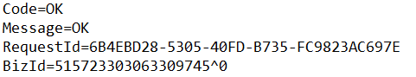

随后短信也成功发送到你的手机上

# 4.用户注册

## 4.1需求分析

完成用户注册功能

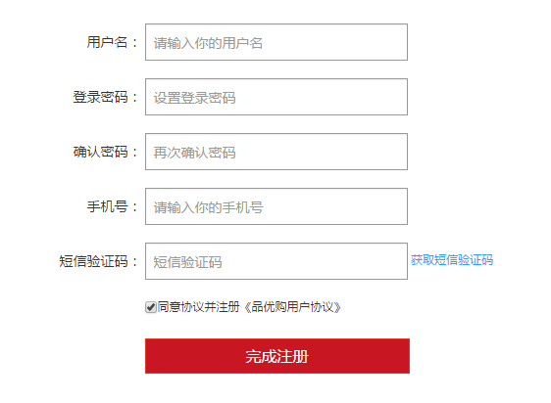

## 4.2工程搭建

### 4.2.1用户服务实现层

（1）创建user-service（war）依赖interface

（2）添加配置文件, 在“02品优购资源-zhaojian\03配置文件\第一天搭建”目录下

### 4.2.2用户中心WEB层

创建war工程 web- 我们将注册功能放入此工程

（1）添加配置文件, 在“02品优购资源-zhaojian\03配置文件\第一天搭建”目录下

（2）拷贝静态原型页面register.html 及相关资源

## 4.3基本注册功能实现

### 4.3.1生成和拷贝代码

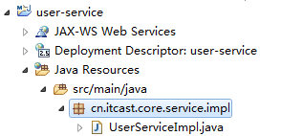

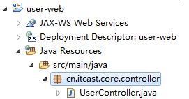

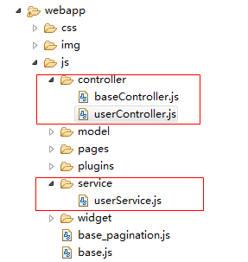

### 4.3.2后端服务实现层

修改user-service的UserServiceImpl.java

|  |
| --- |
| /**  * 增加  */  @Override  **public** **void** add(User user) {  user.setCreated(**new** Date());//创建日期  user.setUpdated(**new** Date());//修改日期  user.setSourceType("1");//注册来源  String password = DigestUtils.*md5Hex*(user.getPassword());//对密码加密  user.setPassword(password);  userDao.insertSelective(user);  } |

### 4.3.3前端控制层

修改userController.js

|  |
| --- |
| //控制层  app.controller('userController' ,**function**($scope,$controller ,userService){  //注册  $scope.reg=**function**(){  **if**($scope.entity.password!=$scope.password) {  alert("两次输入的密码不一致，请重新输入");  **return** ;  }  userService.add( $scope.entity ).success(  **function**(response){  alert(response.message);  }  );  }  }); |

### 4.3.4修改页面

修改页面register.html ，引入js

|  |
| --- |
| <script type=*"text/javascript"* src=*"plugins/angularjs/angular.min.js"*></script>  <script type=*"text/javascript"* src=*"js/base.js"*></script>  <script type=*"text/javascript"* src=*"js/service/userService.js"*></script>  <script type=*"text/javascript"* src=*"js/controller/baseController.js"*></script>  <script type=*"text/javascript"* src=*"js/controller/userController.js"*></script> |

指令

|  |
| --- |
| <body ng-app=*"pinyougou"* ng-controller=*"userController"* > |

绑定表单

|  |
| --- |
| <form class=*"sui-form form-horizontal"*>  <div class=*"control-group"*>  <label class=*"control-label"*>用户名：</label>  <div class=*"controls"*>  <input type=*"text"* placeholder=*"请输入你的用户名"* ng-model=*"entity.username"* class=*"input-xfat input-xlarge"*>  </div>  </div>  <div class=*"control-group"*>  <label for=*"inputPassword"* class=*"control-label"*>登录密码：</label>  <div class=*"controls"*>  <input type=*"password"* placeholder=*"设置登录密码"* ng-model=*"entity.password"* class=*"input-xfat input-xlarge"*>  </div>  </div>  <div class=*"control-group"*>  <label for=*"inputPassword"* class=*"control-label"*>确认密码：</label>  <div class=*"controls"*>  <input type=*"password"* placeholder=*"再次确认密码"* ng-model=*"password"* class=*"input-xfat input-xlarge"*>  </div>  </div>  <div class=*"control-group"*>  <label class=*"control-label"*>手机号：</label>  <div class=*"controls"*>  <input type=*"text"* placeholder=*"请输入你的手机号"* ng-model=*"entity.phone"* class=*"input-xfat input-xlarge"*>  </div>  </div>  <div class=*"control-group"*>  <label for=*"inputPassword"* class=*"control-label"*>短信验证码：</label>  <div class=*"controls"*>  <input type=*"text"* placeholder=*"短信验证码"* class=*"input-xfat input-xlarge"*> <a href=*"#"*>获取短信验证码</a>  </div>  </div>  <div class=*"control-group"*>  <label for=*"inputPassword"* class=*"control-label"*>&nbsp;&nbsp;&nbsp;&nbsp;&nbsp;&nbsp;</label>  <div class=*"controls"*>  <input name=*"m1"* type=*"checkbox"* value=*"2"* checked=*""*><span>同意协议并注册《品优购用户协议》</span>  </div>  </div>  <div class=*"control-group"*>  <label class=*"control-label"*></label>  <div class=*"controls btn-reg"*>  <a class=*"sui-btn btn-block btn-xlarge btn-danger"* ng-click=*"reg()"* target=*"_blank"*>完成注册</a>  </div>  </div>  </form> |

## 4.4 注册判断短信验证码

### 4.4.1实现思路

点击页面上的”获取短信验证码”连接，向后端传递手机号。后端随机生成6位数字作为短信验证码，将其保存在redis中（手机号作为KEY），并发送到短信网关。

用户注册时，后端根据手机号查询redis中的验证码与用户填写的验证码是否相同，如果不同则提示用户不能注册。

### 4.4.2生成验证码

(1)在common的properties目录下创建配置文件sms.properties

|  |
| --- |
| template_code=SMS_85735065  sign_name=\u9ED1\u9A6C |

（2）修改interface工程UserService.java ，增加方法

|  |
| --- |
| /**  * 生成短信验证码  * **@return**  */  **public** **void** createSmsCode(String phone); |

（3）修改user-service工程的UserServiceImpl.java

|  |
| --- |
| @Autowired  **private** RedisTemplate redisTemplate;  @Autowired  **private** JmsTemplate jmsTemplate;  @Autowired  **private** Destination smsDestination;  @Value("${template_code}")  **private** String template_code;  @Value("${sign_name}")  **private** String sign_name;  @Override  **public** **void** createSmsCode(**final** String phone) {  //1.生成一个6位随机数（验证码）  **final** String smscode= (**long**)(Math.*random*()*1000000)+"";  System.***out***.println("验证码："+smscode);    //2.将验证码放入redis  redisTemplate.boundHashOps("smscode").put(phone, smscode);  //3.将短信内容发送给activeMQ    jmsTemplate.send(smsDestination, **new** MessageCreator() {    @Override  **public** Message createMessage(Session session) **throws** JMSException {  MapMessage message = session.createMapMessage();  message.setString("mobile", phone);//手机号  message.setString("template_code", template_code);//验证码  message.setString("sign_name", sign_name);//签名  Map map=**new** HashMap();  map.put("code", smscode);  message.setString("param", JSON.*toJSONString*(map));  **return** (Message) message;  }  });  } |

（4）在 common项目 添加工具类PhoneFormatCheckUtils.java，用于验证手机号

（5）修改user-web的UserController.java

|  |
| --- |
| /**  * 发送短信验证码  * **@param** phone  * **@return**  */  @RequestMapping("/sendCode")  **public** Result sendCode(String phone){  //判断手机号格式  **if**(!PhoneFormatCheckUtils.*isPhoneLegal*(phone)){  **return** **new** Result(**false**, "手机号格式不正确");  }  **try** {  userService.createSmsCode(phone);//生成验证码  **return** **new** Result(**true**, "验证码发送成功");  } **catch** (Exception e) {  e.printStackTrace();  **return** **new** Result(**true**, "验证码发送失败");  }  } |

(6)user-web的userService.js

|  |
| --- |
| //发送验证码  **this**.sendCode=**function**(phone){  **return** $http.get("../user/sendCode.do?phone="+phone);  } |

(7)user-web的userController.js

|  |
| --- |
| //发送验证码  $scope.sendCode=**function**(){  **if**($scope.entity.phone==**null**){  alert("请输入手机号！");  **return** ;  }  userService.sendCode($scope.entity.phone).success(  **function**(response){  alert(response.message);  }  );  } |

(8)修改页面register.html

|  |
| --- |
| <a ng-click=*"sendCode()"* >获取短信验证码</a> |

### 4.4.3用户注册判断验证码

（1）修改interface的UserService.java

|  |
| --- |
| /**  * 判断短信验证码是否存在  * **@param** phone  * **@return**  */  **public** **boolean** checkSmsCode(String phone,String code); |

（2）修改user-service的 UserServiceImpl.java

|  |
| --- |
| /**  * 判断验证码是否正确  */  **public** **boolean** checkSmsCode(String phone,String code){  //得到缓存中存储的验证码  String sysCode = (String) redisTemplate.boundHashOps("smscode").get(phone);  **if**(sysCode==**null**){  **return** **false**;  }  **if**(!sysCode.equals(code)){  **return** **false**;  }  **return** **true**;  } |

（3）修改user-web的UserController.java

|  |
| --- |
| /**  * 增加  * **@param** user  * **@return**  */  @RequestMapping("/add")  **public** Result add(@RequestBody TbUser user,String smscode){  **boolean** checkSmsCode = userService.checkSmsCode(user.getPhone(), smscode);  **if**(checkSmsCode==**false**){  **return** **new** Result(**false**, "验证码输入错误！");  }  **try** {  userService.add(user);  **return** **new** Result(**true**, "增加成功");  } **catch** (Exception e) {  e.printStackTrace();  **return** **new** Result(**false**, "增加失败");  }  } |

1. 修改user-web的userService.js

|  |
| --- |
| //增加  **this**.add=**function**(entity,smscode){  **return** $http.post('../user/add.do?smscode='+smscode ,entity );  } |

1. 修改user-web 的UserController.js

|  |
| --- |
| //保存  $scope.reg=**function**(){  userService.add( $scope.entity, $scope.smscode ).success(  **function**(response){  alert(response.message);  }  );  } |

（6）修改页面，绑定变量

|  |
| --- |
| <input type=*"text"* placeholder=*"短信验证码"* ng-model=*"smscode"* class=*"input-xfat input-xlarge"*> <a href=*"#"* ng-click=*"sendCode()"*>获取短信验证码</a> |

# 附录1. Spring-boot的启动器

(摘自Spring-boot 1.4.4官方文档)

1. **Spring Boot application starters**

spring-boot-starter-thymeleaf

使用Thymeleaf视图构建MVC Web应用程序

spring-boot-starter-ws

使用Spring Web服务。1.4不推荐使用，推荐使用spring-boot-starter-web-services

spring-boot-starter-data-couchbase

Starter for using Couchbase document-oriented database and Spring Data Couchbase

spring-boot-starter-artemis

使用Apache Artemis启动JMS消息传递

spring-boot-starter-web-services

使用Spring Web服务

spring-boot-starter-mail

支持使用Java Mail和Spring Framework发送电子邮件

spring-boot-starter-data-redis

使用Redis键值数据存储与Spring Data Redis和Jedis客户端

spring-boot-starter-web

启动器构建web，包括RESTful，使用Spring MVC的应用程序。使用Tomcat作为默认嵌入式容器

spring-boot-starter-data-gemfire

Starter for using GemFire distributed data store and Spring Data GemFire

spring-boot-starter-activemq

使用Apache ActiveMQ启动JMS消息传递

spring-boot-starter-data-elasticsearch

使用Elasticsearch搜索和分析引擎和Spring Data Elasticsearch

spring-boot-starter-integration

Starter for using Spring Integration

spring-boot-starter-test

Spring Boot应用程序用于测试包括JUnit，Hamcrest和Mockito

spring-boot-starter-hornetq

使用HornetQ启动JMS消息传递。1.4已弃用，推荐使用spring-boot-starter-artemis

spring-boot-starter-jdbc

使用JDBC与Tomcat JDBC连接池

spring-boot-starter-mobile

使用Spring Mobile构建Web应用程序的入门

spring-boot-starter-validation

使用Java Bean校验与Hibernate校验器

spring-boot-starter-hateoas

使用Spring MVC和Spring HATEOAS构建基于超媒体的RESTful Web应用程序的入门

spring-boot-starter-jersey

使用JAX-RS和Jersey构建RESTful Web应用程序的入门。 spring-boot-starter-web的替代品

spring-boot-starter-data-neo4j

使用Neo4j图数据库和Spring Data Neo4j

spring-boot-starter-websocket

使用Spring Framework的WebSocket支持构建WebSocket应用程序

spring-boot-starter-aop

使用Spring AOP和AspectJ进行面向方面编程

spring-boot-starter-amqp

使用Spring AMQP和Rabbit MQ的入门

spring-boot-starter-data-cassandra

使用Cassandra分布式数据库和Spring Data Cassandra

spring-boot-starter-social-facebook

使用Spring Social Facebook

spring-boot-starter-jta-atomikos

使用Atomikos进行JTA事务

spring-boot-starter-security

使用Spring Security

spring-boot-starter-mustache

使用Mustache视图构建MVC Web应用程序

spring-boot-starter-data-jpa

使用Spring Data JPA与Hibernate

spring-boot-starter

核心启动器，包括自动配置支持，日志记录和YAML

spring-boot-starter-velocity

使用Velocity视图构建MVC Web应用程序。1.4已弃用

spring-boot-starter-groovy-templates

使用Groovy模板视图构建MVC Web应用程序

spring-boot-starter-freemarker

使用FreeMarker视图构建MVC Web应用程序

spring-boot-starter-batch

使用Spring Batch

spring-boot-starter-redis

使用Redis键值数据存储与Spring Data Redis和Jedis客户端的入门。1.4已弃用，建议使用spring-boot-starter-data-redis

spring-boot-starter-social-linkedin

Stater for using Spring Social LinkedIn

spring-boot-starter-cache

支持使用Spring Framework的缓存

spring-boot-starter-data-solr

使用带有Spring Data Solr的Apache Solr搜索平台

spring-boot-starter-data-mongodb

使用MongoDB和Spring Data MongoDB

spring-boot-starter-jooq

使用jOOQ访问SQL数据库。 spring-boot-starter-data-jpa或spring-boot-starter-jdbc的替代方法

spring-boot-starter-jta-narayana

Spring Boot启动Narayana JTA

spring-boot-starter-cloud-connectors

启动者使用Spring Cloud连接器，简化了连接到云平台中的服务，如Cloud Foundry和Heroku

spring-boot-starter-jta-bitronix

使用Bitronix进行JTA事务

spring-boot-starter-social-twitter

使用Spring Social Twitter

spring-boot-starter-data-rest

使用Spring Data REST通过REST暴露Spring数据存储库

1. **Spring Boot production starters**

spring-boot-starter-actuator

使用Spring Boot的Actuator，提供生产就绪的功能，以帮助您监视和管理您的应用程序

spring-boot-starter-remote-shell

使用CRaSH远程shell通过SSH监视和管理您的应用程序

1. **Spring Boot technical starters**

spring-boot-starter-undertow

使用Undertow作为嵌入式servlet容器。 spring-boot-starter-tomcat的替代方法

spring-boot-starter-jetty

使用Jetty作为嵌入式servlet容器的。 spring-boot-starter-tomcat的替代方法

spring-boot-starter-logging

使用Logback进行日志记录。 默认日志启动器

spring-boot-starter-tomcat

使用Tomcat作为嵌入式servlet容器。 spring-boot-starter-web使用的默认servlet容器

spring-boot-starter-log4j2

使用Log4j2进行日志记录。 spring-boot-starter-logging的替代方法

# 附录2. Spring-boot的application.properties

(摘自Spring-boot 1.4.4官方文档)

*# ===================================================================*

*# COMMON SPRING BOOT PROPERTIES*

*#*

*# This sample file is provided as a guideline. Do NOT copy it in its*

*# entirety to your own application. ^^^*

*# ===================================================================*

*# ----------------------------------------*

*# CORE PROPERTIES*

*# ----------------------------------------*

*# BANNER*

banner.charset=UTF-8 *# Banner file encoding.*

banner.location=classpath:banner.txt *# Banner file location.*

banner.image.location=classpath:banner.gif *# Banner image file location (jpg/png can also be used).*

banner.image.width= *# Width of the banner image in chars (default 76)*

banner.image.height= *# Height of the banner image in chars (default based on image height)*

banner.image.margin= *# Left hand image margin in chars (default 2)*

banner.image.invert= *# If images should be inverted for dark terminal themes (default false)*

*# LOGGING*

logging.config= *# Location of the logging configuration file. For instance `classpath:logback.xml` for Logback*

logging.exception-conversion-word=%wEx *# Conversion word used when logging exceptions.*

logging.file= *# Log file name. For instance `myapp.log`*

logging.level.*= *# Log levels severity mapping. For instance `logging.level.org.springframework=DEBUG`*

logging.path= *# Location of the log file. For instance `/var/log`*

logging.pattern.console= *# Appender pattern for output to the console. Only supported with the default logback setup.*

logging.pattern.file= *# Appender pattern for output to the file. Only supported with the default logback setup.*

logging.pattern.level= *# Appender pattern for log level (default %5p). Only supported with the default logback setup.*

logging.register-shutdown-hook=false *# Register a shutdown hook for the logging system when it is initialized.*

*# AOP*

spring.aop.auto=true *# Add @EnableAspectJAutoProxy.*

spring.aop.proxy-target-class=false *# Whether subclass-based (CGLIB) proxies are to be created (true) as opposed to standard Java interface-based proxies (false).*

*# IDENTITY (*[ContextIdApplicationContextInitializer](https://github.com/spring-projects/spring-boot/tree/v1.4.4.RELEASE/spring-boot/src/main/java/org/springframework/boot/context/ContextIdApplicationContextInitializer.java))

spring.application.index= *# Application index.*

spring.application.name= *# Application name.*

*# ADMIN (*[SpringApplicationAdminJmxAutoConfiguration](https://github.com/spring-projects/spring-boot/tree/v1.4.4.RELEASE/spring-boot-autoconfigure/src/main/java/org/springframework/boot/autoconfigure/admin/SpringApplicationAdminJmxAutoConfiguration.java))

spring.application.admin.enabled=false *# Enable admin features for the application.*

spring.application.admin.jmx-name=org.springframework.boot:type=Admin,name=SpringApplication *# JMX name of the application admin MBean.*

*# AUTO-CONFIGURATION*

spring.autoconfigure.exclude= *# Auto-configuration classes to exclude.*

*# SPRING CORE*

spring.beaninfo.ignore=true *# Skip search of BeanInfo classes.*

*# SPRING CACHE (*[CacheProperties](https://github.com/spring-projects/spring-boot/tree/v1.4.4.RELEASE/spring-boot-autoconfigure/src/main/java/org/springframework/boot/autoconfigure/cache/CacheProperties.java))

spring.cache.cache-names= *# Comma-separated list of cache names to create if supported by the underlying cache manager.*

spring.cache.caffeine.spec= *# The spec to use to create caches. Check CaffeineSpec for more details on the spec format.*

spring.cache.couchbase.expiration=0 *# Entry expiration in milliseconds. By default the entries never expire.*

spring.cache.ehcache.config= *# The location of the configuration file to use to initialize EhCache.*

spring.cache.guava.spec= *# The spec to use to create caches. Check CacheBuilderSpec for more details on the spec format.*

spring.cache.hazelcast.config= *# The location of the configuration file to use to initialize Hazelcast.*

spring.cache.infinispan.config= *# The location of the configuration file to use to initialize Infinispan.*

spring.cache.jcache.config= *# The location of the configuration file to use to initialize the cache manager.*

spring.cache.jcache.provider= *# Fully qualified name of the CachingProvider implementation to use to retrieve the JSR-107 compliant cache manager. Only needed if more than one JSR-107 implementation is available on the classpath.*

spring.cache.type= *# Cache type, auto-detected according to the environment by default.*

*# SPRING CONFIG - using environment property only (*[ConfigFileApplicationListener](https://github.com/spring-projects/spring-boot/tree/v1.4.4.RELEASE/spring-boot/src/main/java/org/springframework/boot/context/config/ConfigFileApplicationListener.java))

spring.config.location= *# Config file locations.*

spring.config.name=application *# Config file name.*

*# HAZELCAST (*[HazelcastProperties](https://github.com/spring-projects/spring-boot/tree/v1.4.4.RELEASE/spring-boot-autoconfigure/src/main/java/org/springframework/boot/autoconfigure/hazelcast/HazelcastProperties.java))

spring.hazelcast.config= *# The location of the configuration file to use to initialize Hazelcast.*

*# PROJECT INFORMATION (*[ProjectInfoProperties](https://github.com/spring-projects/spring-boot/tree/v1.4.4.RELEASE/spring-boot-autoconfigure/src/main/java/org/springframework/boot/autoconfigure/info/ProjectInfoProperties.java))

spring.info.build.location=classpath:META-INF/build-info.properties *# Location of the generated build-info.properties file.*

spring.info.git.location=classpath:git.properties *# Location of the generated git.properties file.*

*# JMX*

spring.jmx.default-domain= *# JMX domain name.*

spring.jmx.enabled=true *# Expose management beans to the JMX domain.*

spring.jmx.server=mbeanServer *# MBeanServer bean name.*

*# Email (*[MailProperties](https://github.com/spring-projects/spring-boot/tree/v1.4.4.RELEASE/spring-boot-autoconfigure/src/main/java/org/springframework/boot/autoconfigure/mail/MailProperties.java))

spring.mail.default-encoding=UTF-8 *# Default MimeMessage encoding.*

spring.mail.host= *# SMTP server host. For instance `smtp.example.com`*

spring.mail.jndi-name= *# Session JNDI name. When set, takes precedence to others mail settings.*

spring.mail.password= *# Login password of the SMTP server.*

spring.mail.port= *# SMTP server port.*

spring.mail.properties.*= *# Additional JavaMail session properties.*

spring.mail.protocol=smtp *# Protocol used by the SMTP server.*

spring.mail.test-connection=false *# Test that the mail server is available on startup.*

spring.mail.username= *# Login user of the SMTP server.*

*# APPLICATION SETTINGS (*[SpringApplication](https://github.com/spring-projects/spring-boot/tree/v1.4.4.RELEASE/spring-boot/src/main/java/org/springframework/boot/SpringApplication.java))

spring.main.banner-mode=console *# Mode used to display the banner when the application runs.*

spring.main.sources= *# Sources (class name, package name or XML resource location) to include in the ApplicationContext.*

spring.main.web-environment= *# Run the application in a web environment (auto-detected by default).*

*# FILE ENCODING (*[FileEncodingApplicationListener](https://github.com/spring-projects/spring-boot/tree/v1.4.4.RELEASE/spring-boot/src/main/java/org/springframework/boot/context/FileEncodingApplicationListener.java))

spring.mandatory-file-encoding= *# Expected character encoding the application must use.*

*# INTERNATIONALIZATION (*[MessageSourceAutoConfiguration](https://github.com/spring-projects/spring-boot/tree/v1.4.4.RELEASE/spring-boot-autoconfigure/src/main/java/org/springframework/boot/autoconfigure/MessageSourceAutoConfiguration.java))

spring.messages.always-use-message-format=false *# Set whether to always apply the MessageFormat rules, parsing even messages without arguments.*

spring.messages.basename=messages *# Comma-separated list of basenames, each following the ResourceBundle convention.*

spring.messages.cache-seconds=-1 *# Loaded resource bundle files cache expiration, in seconds. When set to -1, bundles are cached forever.*

spring.messages.encoding=UTF-8 *# Message bundles encoding.*

spring.messages.fallback-to-system-locale=true *# Set whether to fall back to the system Locale if no files for a specific Locale have been found.*

*# OUTPUT*

spring.output.ansi.enabled=detect *# Configure the ANSI output.*

*# PID FILE (*[ApplicationPidFileWriter](https://github.com/spring-projects/spring-boot/tree/v1.4.4.RELEASE/spring-boot-actuator/src/main/java/org/springframework/boot/actuate/system/ApplicationPidFileWriter.java))

spring.pid.fail-on-write-error= *# Fail if ApplicationPidFileWriter is used but it cannot write the PID file.*

spring.pid.file= *# Location of the PID file to write (if ApplicationPidFileWriter is used).*

*# PROFILES*

spring.profiles.active= *# Comma-separated list of* [active profiles](http://docs.spring.io/spring-boot/docs/1.4.4.RELEASE/reference/htmlsingle/#howto-set-active-spring-profiles).

spring.profiles.include= *# Unconditionally activate the specified comma separated profiles.*

*# SENDGRID (*[SendGridAutoConfiguration](https://github.com/spring-projects/spring-boot/tree/v1.4.4.RELEASE/spring-boot-autoconfigure/src/main/java/org/springframework/boot/autoconfigure/sendgrid/SendGridAutoConfiguration.java))

spring.sendgrid.api-key= *# SendGrid api key (alternative to username/password)*

spring.sendgrid.username= *# SendGrid account username*

spring.sendgrid.password= *# SendGrid account password*

spring.sendgrid.proxy.host= *# SendGrid proxy host*

spring.sendgrid.proxy.port= *# SendGrid proxy port*

*# ----------------------------------------*

*# WEB PROPERTIES*

*# ----------------------------------------*

*# EMBEDDED SERVER CONFIGURATION (*[ServerProperties](https://github.com/spring-projects/spring-boot/tree/v1.4.4.RELEASE/spring-boot-autoconfigure/src/main/java/org/springframework/boot/autoconfigure/web/ServerProperties.java))

server.address= *# Network address to which the server should bind to.*

server.compression.enabled=false *# If response compression is enabled.*

server.compression.excluded-user-agents= *# List of user-agents to exclude from compression.*

server.compression.mime-types= *# Comma-separated list of MIME types that should be compressed. For instance `text/html,text/css,application/json`*

server.compression.min-response-size= *# Minimum response size that is required for compression to be performed. For instance 2048*

server.connection-timeout= *# Time in milliseconds that connectors will wait for another HTTP request before closing the connection. When not set, the connector's container-specific default will be used. Use a value of -1 to indicate no (i.e. infinite) timeout.*

server.context-parameters.*= *# Servlet context init parameters. For instance `server.context-parameters.a=alpha`*

server.context-path= *# Context path of the application.*

server.display-name=application *# Display name of the application.*

server.max-http-header-size=0 *# Maximum size in bytes of the HTTP message header.*

server.max-http-post-size=0 *# Maximum size in bytes of the HTTP post content.*

server.error.include-stacktrace=never *# When to include a "stacktrace" attribute.*

server.error.path=/error *# Path of the error controller.*

server.error.whitelabel.enabled=true *# Enable the default error page displayed in browsers in case of a server error.*

server.jetty.acceptors= *# Number of acceptor threads to use.*

server.jetty.selectors= *# Number of selector threads to use.*

server.jsp-servlet.class-name=org.apache.jasper.servlet.JspServlet *# The class name of the JSP servlet.*

server.jsp-servlet.init-parameters.*= *# Init parameters used to configure the JSP servlet*

server.jsp-servlet.registered=true *# Whether or not the JSP servlet is registered*

server.port=8080 *# Server HTTP port.*

server.server-header= *# Value to use for the Server response header (no header is sent if empty)*

server.servlet-path=/ *# Path of the main dispatcher servlet.*

server.use-forward-headers= *# If X-Forwarded-* headers should be applied to the HttpRequest.*

server.session.cookie.comment= *# Comment for the session cookie.*

server.session.cookie.domain= *# Domain for the session cookie.*

server.session.cookie.http-only= *# "HttpOnly" flag for the session cookie.*

server.session.cookie.max-age= *# Maximum age of the session cookie in seconds.*

server.session.cookie.name= *# Session cookie name.*

server.session.cookie.path= *# Path of the session cookie.*

server.session.cookie.secure= *# "Secure" flag for the session cookie.*

server.session.persistent=false *# Persist session data between restarts.*

server.session.store-dir= *# Directory used to store session data.*

server.session.timeout= *# Session timeout in seconds.*

server.session.tracking-modes= *# Session tracking modes (one or more of the following: "cookie", "url", "ssl").*

server.ssl.ciphers= *# Supported SSL ciphers.*

server.ssl.client-auth= *# Whether client authentication is wanted ("want") or needed ("need"). Requires a trust store.*

server.ssl.enabled= *# Enable SSL support.*

server.ssl.enabled-protocols= *# Enabled SSL protocols.*

server.ssl.key-alias= *# Alias that identifies the key in the key store.*

server.ssl.key-password= *# Password used to access the key in the key store.*

server.ssl.key-store= *# Path to the key store that holds the SSL certificate (typically a jks file).*

server.ssl.key-store-password= *# Password used to access the key store.*

server.ssl.key-store-provider= *# Provider for the key store.*

server.ssl.key-store-type= *# Type of the key store.*

server.ssl.protocol=TLS *# SSL protocol to use.*

server.ssl.trust-store= *# Trust store that holds SSL certificates.*

server.ssl.trust-store-password= *# Password used to access the trust store.*

server.ssl.trust-store-provider= *# Provider for the trust store.*

server.ssl.trust-store-type= *# Type of the trust store.*

server.tomcat.accesslog.directory=logs *# Directory in which log files are created. Can be relative to the tomcat base dir or absolute.*

server.tomcat.accesslog.enabled=false *# Enable access log.*

server.tomcat.accesslog.pattern=common *# Format pattern for access logs.*

server.tomcat.accesslog.prefix=access_log *# Log file name prefix.*

server.tomcat.accesslog.rename-on-rotate=false *# Defer inclusion of the date stamp in the file name until rotate time.*

server.tomcat.accesslog.request-attributes-enabled=false *# Set request attributes for IP address, Hostname, protocol and port used for the request.*

server.tomcat.accesslog.suffix=.log *# Log file name suffix.*

server.tomcat.background-processor-delay=30 *# Delay in seconds between the invocation of backgroundProcess methods.*

server.tomcat.basedir= *# Tomcat base directory. If not specified a temporary directory will be used.*

server.tomcat.internal-proxies=10\\.\\d{1,3}\\.\\d{1,3}\\.\\d{1,3}|\\

192\\.168\\.\\d{1,3}\\.\\d{1,3}|\\

169\\.254\\.\\d{1,3}\\.\\d{1,3}|\\

127\\.\\d{1,3}\\.\\d{1,3}\\.\\d{1,3}|\\

172\\.1[6-9]{1}\\.\\d{1,3}\\.\\d{1,3}|\\

172\\.2[0-9]{1}\\.\\d{1,3}\\.\\d{1,3}|\\

172\\.3[0-1]{1}\\.\\d{1,3}\\.\\d{1,3} *# regular expression matching trusted IP addresses.*

server.tomcat.max-threads=0 *# Maximum amount of worker threads.*

server.tomcat.min-spare-threads=0 *# Minimum amount of worker threads.*

server.tomcat.port-header=X-Forwarded-Port *# Name of the HTTP header used to override the original port value.*

server.tomcat.protocol-header= *# Header that holds the incoming protocol, usually named "X-Forwarded-Proto".*

server.tomcat.protocol-header-https-value=https *# Value of the protocol header that indicates that the incoming request uses SSL.*

server.tomcat.redirect-context-root= *# Whether requests to the context root should be redirected by appending a / to the path.*

server.tomcat.remote-ip-header= *# Name of the http header from which the remote ip is extracted. For instance `X-FORWARDED-FOR`*

server.tomcat.uri-encoding=UTF-8 *# Character encoding to use to decode the URI.*

server.undertow.accesslog.dir= *# Undertow access log directory.*

server.undertow.accesslog.enabled=false *# Enable access log.*

server.undertow.accesslog.pattern=common *# Format pattern for access logs.*

server.undertow.accesslog.prefix=access_log. *# Log file name prefix.*

server.undertow.accesslog.suffix=log *# Log file name suffix.*

server.undertow.buffer-size= *# Size of each buffer in bytes.*

server.undertow.buffers-per-region= *# Number of buffer per region.*

server.undertow.direct-buffers= *# Allocate buffers outside the Java heap.*

server.undertow.io-threads= *# Number of I/O threads to create for the worker.*

server.undertow.worker-threads= *# Number of worker threads.*

*# FREEMARKER (*[FreeMarkerAutoConfiguration](https://github.com/spring-projects/spring-boot/tree/v1.4.4.RELEASE/spring-boot-autoconfigure/src/main/java/org/springframework/boot/autoconfigure/freemarker/FreeMarkerAutoConfiguration.java))

spring.freemarker.allow-request-override=false *# Set whether HttpServletRequest attributes are allowed to override (hide) controller generated model attributes of the same name.*

spring.freemarker.allow-session-override=false *# Set whether HttpSession attributes are allowed to override (hide) controller generated model attributes of the same name.*

spring.freemarker.cache=false *# Enable template caching.*

spring.freemarker.charset=UTF-8 *# Template encoding.*

spring.freemarker.check-template-location=true *# Check that the templates location exists.*

spring.freemarker.content-type=text/html *# Content-Type value.*

spring.freemarker.enabled=true *# Enable MVC view resolution for this technology.*

spring.freemarker.expose-request-attributes=false *# Set whether all request attributes should be added to the model prior to merging with the template.*

spring.freemarker.expose-session-attributes=false *# Set whether all HttpSession attributes should be added to the model prior to merging with the template.*

spring.freemarker.expose-spring-macro-helpers=true *# Set whether to expose a RequestContext for use by Spring's macro library, under the name "springMacroRequestContext".*

spring.freemarker.prefer-file-system-access=true *# Prefer file system access for template loading. File system access enables hot detection of template changes.*

spring.freemarker.prefix= *# Prefix that gets prepended to view names when building a URL.*

spring.freemarker.request-context-attribute= *# Name of the RequestContext attribute for all views.*

spring.freemarker.settings.*= *# Well-known FreeMarker keys which will be passed to FreeMarker's Configuration.*

spring.freemarker.suffix= *# Suffix that gets appended to view names when building a URL.*

spring.freemarker.template-loader-path=classpath:/templates/ *# Comma-separated list of template paths.*

spring.freemarker.view-names= *# White list of view names that can be resolved.*

*# GROOVY TEMPLATES (*[GroovyTemplateAutoConfiguration](https://github.com/spring-projects/spring-boot/tree/v1.4.4.RELEASE/spring-boot-autoconfigure/src/main/java/org/springframework/boot/autoconfigure/groovy/template/GroovyTemplateAutoConfiguration.java))

spring.groovy.template.allow-request-override=false *# Set whether HttpServletRequest attributes are allowed to override (hide) controller generated model attributes of the same name.*

spring.groovy.template.allow-session-override=false *# Set whether HttpSession attributes are allowed to override (hide) controller generated model attributes of the same name.*

spring.groovy.template.cache= *# Enable template caching.*

spring.groovy.template.charset=UTF-8 *# Template encoding.*

spring.groovy.template.check-template-location=true *# Check that the templates location exists.*

spring.groovy.template.configuration.*= *# See GroovyMarkupConfigurer*

spring.groovy.template.content-type=test/html *# Content-Type value.*

spring.groovy.template.enabled=true *# Enable MVC view resolution for this technology.*

spring.groovy.template.expose-request-attributes=false *# Set whether all request attributes should be added to the model prior to merging with the template.*

spring.groovy.template.expose-session-attributes=false *# Set whether all HttpSession attributes should be added to the model prior to merging with the template.*

spring.groovy.template.expose-spring-macro-helpers=true *# Set whether to expose a RequestContext for use by Spring's macro library, under the name "springMacroRequestContext".*

spring.groovy.template.prefix= *# Prefix that gets prepended to view names when building a URL.*

spring.groovy.template.request-context-attribute= *# Name of the RequestContext attribute for all views.*

spring.groovy.template.resource-loader-path=classpath:/templates/ *# Template path.*

spring.groovy.template.suffix=.tpl *# Suffix that gets appended to view names when building a URL.*

spring.groovy.template.view-names= *# White list of view names that can be resolved.*

*# SPRING HATEOAS (*[HateoasProperties](https://github.com/spring-projects/spring-boot/tree/v1.4.4.RELEASE/spring-boot-autoconfigure/src/main/java/org/springframework/boot/autoconfigure/hateoas/HateoasProperties.java))

spring.hateoas.use-hal-as-default-json-media-type=true *# Specify if application/hal+json responses should be sent to requests that accept application/json.*

*# HTTP message conversion*

spring.http.converters.preferred-json-mapper=jackson *# Preferred JSON mapper to use for HTTP message conversion. Set to "gson" to force the use of Gson when both it and Jackson are on the classpath.*

*# HTTP encoding (*[HttpEncodingProperties](https://github.com/spring-projects/spring-boot/tree/v1.4.4.RELEASE/spring-boot-autoconfigure/src/main/java/org/springframework/boot/autoconfigure/web/HttpEncodingProperties.java))

spring.http.encoding.charset=UTF-8 *# Charset of HTTP requests and responses. Added to the "Content-Type" header if not set explicitly.*

spring.http.encoding.enabled=true *# Enable http encoding support.*

spring.http.encoding.force= *# Force the encoding to the configured charset on HTTP requests and responses.*

spring.http.encoding.force-request= *# Force the encoding to the configured charset on HTTP requests. Defaults to true when "force" has not been specified.*

spring.http.encoding.force-response= *# Force the encoding to the configured charset on HTTP responses.*

spring.http.encoding.mapping= *# Locale to Encoding mapping.*

*# MULTIPART (*[MultipartProperties](https://github.com/spring-projects/spring-boot/tree/v1.4.4.RELEASE/spring-boot-autoconfigure/src/main/java/org/springframework/boot/autoconfigure/web/MultipartProperties.java))

spring.http.multipart.enabled=true *# Enable support of multi-part uploads.*

spring.http.multipart.file-size-threshold=0 *# Threshold after which files will be written to disk. Values can use the suffixed "MB" or "KB" to indicate a Megabyte or Kilobyte size.*

spring.http.multipart.location= *# Intermediate location of uploaded files.*

spring.http.multipart.max-file-size=1Mb *# Max file size. Values can use the suffixed "MB" or "KB" to indicate a Megabyte or Kilobyte size.*

spring.http.multipart.max-request-size=10Mb *# Max request size. Values can use the suffixed "MB" or "KB" to indicate a Megabyte or Kilobyte size.*

spring.http.multipart.resolve-lazily=false *# Whether to resolve the multipart request lazily at the time of file or parameter access.*

*# JACKSON (*[JacksonProperties](https://github.com/spring-projects/spring-boot/tree/v1.4.4.RELEASE/spring-boot-autoconfigure/src/main/java/org/springframework/boot/autoconfigure/jackson/JacksonProperties.java))

spring.jackson.date-format= *# Date format string or a fully-qualified date format class name. For instance `yyyy-MM-dd HH:mm:ss`.*

spring.jackson.default-property-inclusion= *# Controls the inclusion of properties during serialization.*

spring.jackson.deserialization.*= *# Jackson on/off features that affect the way Java objects are deserialized.*

spring.jackson.generator.*= *# Jackson on/off features for generators.*

spring.jackson.joda-date-time-format= *# Joda date time format string. If not configured, "date-format" will be used as a fallback if it is configured with a format string.*

spring.jackson.locale= *# Locale used for formatting.*

spring.jackson.mapper.*= *# Jackson general purpose on/off features.*

spring.jackson.parser.*= *# Jackson on/off features for parsers.*

spring.jackson.property-naming-strategy= *# One of the constants on Jackson's PropertyNamingStrategy. Can also be a fully-qualified class name of a PropertyNamingStrategy subclass.*

spring.jackson.serialization.*= *# Jackson on/off features that affect the way Java objects are serialized.*

spring.jackson.serialization-inclusion= *# Controls the inclusion of properties during serialization. Configured with one of the values in Jackson's JsonInclude.Include enumeration.*

spring.jackson.time-zone= *# Time zone used when formatting dates. For instance `America/Los_Angeles`*

*# JERSEY (*[JerseyProperties](https://github.com/spring-projects/spring-boot/tree/v1.4.4.RELEASE/spring-boot-autoconfigure/src/main/java/org/springframework/boot/autoconfigure/jersey/JerseyProperties.java))

spring.jersey.application-path= *# Path that serves as the base URI for the application. Overrides the value of "@ApplicationPath" if specified.*

spring.jersey.filter.order=0 *# Jersey filter chain order.*

spring.jersey.init.*= *# Init parameters to pass to Jersey via the servlet or filter.*

spring.jersey.servlet.load-on-startup=-1 *# Load on startup priority of the Jersey servlet.*

spring.jersey.type=servlet *# Jersey integration type.*

*# SPRING MOBILE DEVICE VIEWS (*[DeviceDelegatingViewResolverAutoConfiguration](https://github.com/spring-projects/spring-boot/tree/v1.4.4.RELEASE/spring-boot-autoconfigure/src/main/java/org/springframework/boot/autoconfigure/mobile/DeviceDelegatingViewResolverAutoConfiguration.java))

spring.mobile.devicedelegatingviewresolver.enable-fallback=false *# Enable support for fallback resolution.*

spring.mobile.devicedelegatingviewresolver.enabled=false *# Enable device view resolver.*

spring.mobile.devicedelegatingviewresolver.mobile-prefix=mobile/ *# Prefix that gets prepended to view names for mobile devices.*

spring.mobile.devicedelegatingviewresolver.mobile-suffix= *# Suffix that gets appended to view names for mobile devices.*

spring.mobile.devicedelegatingviewresolver.normal-prefix= *# Prefix that gets prepended to view names for normal devices.*

spring.mobile.devicedelegatingviewresolver.normal-suffix= *# Suffix that gets appended to view names for normal devices.*

spring.mobile.devicedelegatingviewresolver.tablet-prefix=tablet/ *# Prefix that gets prepended to view names for tablet devices.*

spring.mobile.devicedelegatingviewresolver.tablet-suffix= *# Suffix that gets appended to view names for tablet devices.*

*# SPRING MOBILE SITE PREFERENCE (*[SitePreferenceAutoConfiguration](https://github.com/spring-projects/spring-boot/tree/v1.4.4.RELEASE/spring-boot-autoconfigure/src/main/java/org/springframework/boot/autoconfigure/mobile/SitePreferenceAutoConfiguration.java))

spring.mobile.sitepreference.enabled=true *# Enable SitePreferenceHandler.*

*# MUSTACHE TEMPLATES (*[MustacheAutoConfiguration](https://github.com/spring-projects/spring-boot/tree/v1.4.4.RELEASE/spring-boot-autoconfigure/src/main/java/org/springframework/boot/autoconfigure/mustache/MustacheAutoConfiguration.java))

spring.mustache.allow-request-override= *# Set whether HttpServletRequest attributes are allowed to override (hide) controller generated model attributes of the same name.*

spring.mustache.allow-session-override= *# Set whether HttpSession attributes are allowed to override (hide) controller generated model attributes of the same name.*

spring.mustache.cache= *# Enable template caching.*

spring.mustache.charset= *# Template encoding.*

spring.mustache.check-template-location= *# Check that the templates location exists.*

spring.mustache.content-type= *# Content-Type value.*

spring.mustache.enabled= *# Enable MVC view resolution for this technology.*

spring.mustache.expose-request-attributes= *# Set whether all request attributes should be added to the model prior to merging with the template.*

spring.mustache.expose-session-attributes= *# Set whether all HttpSession attributes should be added to the model prior to merging with the template.*

spring.mustache.expose-spring-macro-helpers= *# Set whether to expose a RequestContext for use by Spring's macro library, under the name "springMacroRequestContext".*

spring.mustache.prefix=classpath:/templates/ *# Prefix to apply to template names.*

spring.mustache.request-context-attribute= *# Name of the RequestContext attribute for all views.*

spring.mustache.suffix=.html *# Suffix to apply to template names.*

spring.mustache.view-names= *# White list of view names that can be resolved.*

*# SPRING MVC (*[WebMvcProperties](https://github.com/spring-projects/spring-boot/tree/v1.4.4.RELEASE/spring-boot-autoconfigure/src/main/java/org/springframework/boot/autoconfigure/web/WebMvcProperties.java))

spring.mvc.async.request-timeout= *# Amount of time (in milliseconds) before asynchronous request handling times out.*

spring.mvc.date-format= *# Date format to use. For instance `dd/MM/yyyy`.*

spring.mvc.dispatch-trace-request=false *# Dispatch TRACE requests to the FrameworkServlet doService method.*

spring.mvc.dispatch-options-request=true *# Dispatch OPTIONS requests to the FrameworkServlet doService method.*

spring.mvc.favicon.enabled=true *# Enable resolution of favicon.ico.*

spring.mvc.formcontent.putfilter.enabled=true *# Enable Spring's HttpPutFormContentFilter.*

spring.mvc.ignore-default-model-on-redirect=true *# If the content of the "default" model should be ignored during redirect scenarios.*

spring.mvc.locale= *# Locale to use. By default, this locale is overridden by the "Accept-Language" header.*

spring.mvc.locale-resolver=accept-header *# Define how the locale should be resolved.*

spring.mvc.log-resolved-exception=false *# Enable warn logging of exceptions resolved by a "HandlerExceptionResolver".*

spring.mvc.media-types.*= *# Maps file extensions to media types for content negotiation.*

spring.mvc.message-codes-resolver-format= *# Formatting strategy for message codes. For instance `PREFIX_ERROR_CODE`.*

spring.mvc.servlet.load-on-startup=-1 *# Load on startup priority of the Spring Web Services servlet.*

spring.mvc.static-path-pattern=/** *# Path pattern used for static resources.*

spring.mvc.throw-exception-if-no-handler-found=false *# If a "NoHandlerFoundException" should be thrown if no Handler was found to process a request.*

spring.mvc.view.prefix= *# Spring MVC view prefix.*

spring.mvc.view.suffix= *# Spring MVC view suffix.*

*# SPRING RESOURCES HANDLING (*[ResourceProperties](https://github.com/spring-projects/spring-boot/tree/v1.4.4.RELEASE/spring-boot-autoconfigure/src/main/java/org/springframework/boot/autoconfigure/web/ResourceProperties.java))

spring.resources.add-mappings=true *# Enable default resource handling.*

spring.resources.cache-period= *# Cache period for the resources served by the resource handler, in seconds.*

spring.resources.chain.cache=true *# Enable caching in the Resource chain.*

spring.resources.chain.enabled= *# Enable the Spring Resource Handling chain. Disabled by default unless at least one strategy has been enabled.*

spring.resources.chain.gzipped=false *# Enable resolution of already gzipped resources.*

spring.resources.chain.html-application-cache=false *# Enable HTML5 application cache manifest rewriting.*

spring.resources.chain.strategy.content.enabled=false *# Enable the content Version Strategy.*

spring.resources.chain.strategy.content.paths=/** *# Comma-separated list of patterns to apply to the Version Strategy.*

spring.resources.chain.strategy.fixed.enabled=false *# Enable the fixed Version Strategy.*

spring.resources.chain.strategy.fixed.paths=/** *# Comma-separated list of patterns to apply to the Version Strategy.*

spring.resources.chain.strategy.fixed.version= *# Version string to use for the Version Strategy.*

spring.resources.static-locations=classpath:/META-INF/resources/,classpath:/resources/,classpath:/static/,classpath:/public/ *# Locations of static resources.*

*# SPRING SESSION (*[SessionProperties](https://github.com/spring-projects/spring-boot/tree/v1.4.4.RELEASE/spring-boot-autoconfigure/src/main/java/org/springframework/boot/autoconfigure/session/SessionProperties.java))

spring.session.hazelcast.map-name=spring:session:sessions *# Name of the map used to store sessions.*

spring.session.jdbc.initializer.enabled= *# Create the required session tables on startup if necessary. Enabled automatically if the default table name is set or a custom schema is configured.*

spring.session.jdbc.schema=classpath:org/springframework/session/jdbc/schema-@@platform@@.sql *# Path to the SQL file to use to initialize the database schema.*

spring.session.jdbc.table-name=SPRING_SESSION *# Name of database table used to store sessions.*

spring.session.mongo.collection-name=sessions *# Collection name used to store sessions.*

spring.session.redis.flush-mode= *# Flush mode for the Redis sessions.*

spring.session.redis.namespace= *# Namespace for keys used to store sessions.*

spring.session.store-type= *# Session store type.*

*# SPRING SOCIAL (*[SocialWebAutoConfiguration](https://github.com/spring-projects/spring-boot/tree/v1.4.4.RELEASE/spring-boot-autoconfigure/src/main/java/org/springframework/boot/autoconfigure/social/SocialWebAutoConfiguration.java))

spring.social.auto-connection-views=false *# Enable the connection status view for supported providers.*

*# SPRING SOCIAL FACEBOOK (*[FacebookAutoConfiguration](https://github.com/spring-projects/spring-boot/tree/v1.4.4.RELEASE/spring-boot-autoconfigure/src/main/java/org/springframework/boot/autoconfigure/social/FacebookAutoConfiguration.java))

spring.social.facebook.app-id= *# your application's Facebook App ID*

spring.social.facebook.app-secret= *# your application's Facebook App Secret*

*# SPRING SOCIAL LINKEDIN (*[LinkedInAutoConfiguration](https://github.com/spring-projects/spring-boot/tree/v1.4.4.RELEASE/spring-boot-autoconfigure/src/main/java/org/springframework/boot/autoconfigure/social/LinkedInAutoConfiguration.java))

spring.social.linkedin.app-id= *# your application's LinkedIn App ID*

spring.social.linkedin.app-secret= *# your application's LinkedIn App Secret*

*# SPRING SOCIAL TWITTER (*[TwitterAutoConfiguration](https://github.com/spring-projects/spring-boot/tree/v1.4.4.RELEASE/spring-boot-autoconfigure/src/main/java/org/springframework/boot/autoconfigure/social/TwitterAutoConfiguration.java))

spring.social.twitter.app-id= *# your application's Twitter App ID*

spring.social.twitter.app-secret= *# your application's Twitter App Secret*

*# THYMELEAF (*[ThymeleafAutoConfiguration](https://github.com/spring-projects/spring-boot/tree/v1.4.4.RELEASE/spring-boot-autoconfigure/src/main/java/org/springframework/boot/autoconfigure/thymeleaf/ThymeleafAutoConfiguration.java))

spring.thymeleaf.cache=true *# Enable template caching.*

spring.thymeleaf.check-template=true *# Check that the template exists before rendering it.*

spring.thymeleaf.check-template-location=true *# Check that the templates location exists.*

spring.thymeleaf.content-type=text/html *# Content-Type value.*

spring.thymeleaf.enabled=true *# Enable MVC Thymeleaf view resolution.*

spring.thymeleaf.encoding=UTF-8 *# Template encoding.*

spring.thymeleaf.excluded-view-names= *# Comma-separated list of view names that should be excluded from resolution.*

spring.thymeleaf.mode=HTML5 *# Template mode to be applied to templates. See also StandardTemplateModeHandlers.*

spring.thymeleaf.prefix=classpath:/templates/ *# Prefix that gets prepended to view names when building a URL.*

spring.thymeleaf.suffix=.html *# Suffix that gets appended to view names when building a URL.*

spring.thymeleaf.template-resolver-order= *# Order of the template resolver in the chain.*

spring.thymeleaf.view-names= *# Comma-separated list of view names that can be resolved.*

*# VELOCITY TEMPLATES (*[VelocityAutoConfiguration](https://github.com/spring-projects/spring-boot/tree/v1.4.4.RELEASE/spring-boot-autoconfigure/src/main/java/org/springframework/boot/autoconfigure/velocity/VelocityAutoConfiguration.java))

spring.velocity.allow-request-override=false *# Set whether HttpServletRequest attributes are allowed to override (hide) controller generated model attributes of the same name.*

spring.velocity.allow-session-override=false *# Set whether HttpSession attributes are allowed to override (hide) controller generated model attributes of the same name.*

spring.velocity.cache= *# Enable template caching.*

spring.velocity.charset=UTF-8 *# Template encoding.*

spring.velocity.check-template-location=true *# Check that the templates location exists.*

spring.velocity.content-type=text/html *# Content-Type value.*

spring.velocity.date-tool-attribute= *# Name of the DateTool helper object to expose in the Velocity context of the view.*

spring.velocity.enabled=true *# Enable MVC view resolution for this technology.*

spring.velocity.expose-request-attributes=false *# Set whether all request attributes should be added to the model prior to merging with the template.*

spring.velocity.expose-session-attributes=false *# Set whether all HttpSession attributes should be added to the model prior to merging with the template.*

spring.velocity.expose-spring-macro-helpers=true *# Set whether to expose a RequestContext for use by Spring's macro library, under the name "springMacroRequestContext".*

spring.velocity.number-tool-attribute= *# Name of the NumberTool helper object to expose in the Velocity context of the view.*

spring.velocity.prefer-file-system-access=true *# Prefer file system access for template loading. File system access enables hot detection of template changes.*

spring.velocity.prefix= *# Prefix that gets prepended to view names when building a URL.*

spring.velocity.properties.*= *# Additional velocity properties.*

spring.velocity.request-context-attribute= *# Name of the RequestContext attribute for all views.*

spring.velocity.resource-loader-path=classpath:/templates/ *# Template path.*

spring.velocity.suffix=.vm *# Suffix that gets appended to view names when building a URL.*

spring.velocity.toolbox-config-location= *# Velocity Toolbox config location. For instance `/WEB-INF/toolbox.xml`*

spring.velocity.view-names= *# White list of view names that can be resolved.*

*# SPRING WEB SERVICES (*[WebServicesProperties](https://github.com/spring-projects/spring-boot/tree/v1.4.4.RELEASE/spring-boot-autoconfigure/src/main/java/org/springframework/boot/autoconfigure/webservices/WebServicesProperties.java))

spring.webservices.path=/services *# Path that serves as the base URI for the services.*

spring.webservices.servlet.init= *# Servlet init parameters to pass to Spring Web Services.*

spring.webservices.servlet.load-on-startup=-1 *# Load on startup priority of the Spring Web Services servlet.*

*# ----------------------------------------*

*# SECURITY PROPERTIES*

*# ----------------------------------------*

*# SECURITY (*[SecurityProperties](https://github.com/spring-projects/spring-boot/tree/v1.4.4.RELEASE/spring-boot-autoconfigure/src/main/java/org/springframework/boot/autoconfigure/security/SecurityProperties.java))

security.basic.authorize-mode=role *# Security authorize mode to apply.*

security.basic.enabled=true *# Enable basic authentication.*

security.basic.path=/** *# Comma-separated list of paths to secure.*

security.basic.realm=Spring *# HTTP basic realm name.*

security.enable-csrf=false *# Enable Cross Site Request Forgery support.*

security.filter-order=0 *# Security filter chain order.*

security.filter-dispatcher-types=ASYNC, FORWARD, INCLUDE, REQUEST *# Security filter chain dispatcher types.*

security.headers.cache=true *# Enable cache control HTTP headers.*

security.headers.content-type=true *# Enable "X-Content-Type-Options" header.*

security.headers.frame=true *# Enable "X-Frame-Options" header.*

security.headers.hsts= *# HTTP Strict Transport Security (HSTS) mode (none, domain, all).*

security.headers.xss=true *# Enable cross site scripting (XSS) protection.*

security.ignored= *# Comma-separated list of paths to exclude from the default secured paths.*

security.require-ssl=false *# Enable secure channel for all requests.*

security.sessions=stateless *# Session creation policy (always, never, if_required, stateless).*

security.user.name=user *# Default user name.*

security.user.password= *# Password for the default user name. A random password is logged on startup by default.*

security.user.role=USER *# Granted roles for the default user name.*

*# SECURITY OAUTH2 CLIENT (*[OAuth2ClientProperties](https://github.com/spring-projects/spring-boot/tree/v1.4.4.RELEASE/spring-boot-autoconfigure/src/main/java/org/springframework/boot/autoconfigure/security/oauth2/OAuth2ClientProperties.java))

security.oauth2.client.client-id= *# OAuth2 client id.*

security.oauth2.client.client-secret= *# OAuth2 client secret. A random secret is generated by default*

*# SECURITY OAUTH2 RESOURCES (*[ResourceServerProperties](https://github.com/spring-projects/spring-boot/tree/v1.4.4.RELEASE/spring-boot-autoconfigure/src/main/java/org/springframework/boot/autoconfigure/security/oauth2/resource/ResourceServerProperties.java))

security.oauth2.resource.id= *# Identifier of the resource.*

security.oauth2.resource.jwt.key-uri= *# The URI of the JWT token. Can be set if the value is not available and the key is public.*

security.oauth2.resource.jwt.key-value= *# The verification key of the JWT token. Can either be a symmetric secret or PEM-encoded RSA public key.*

security.oauth2.resource.prefer-token-info=true *# Use the token info, can be set to false to use the user info.*

security.oauth2.resource.service-id=resource *#*

security.oauth2.resource.token-info-uri= *# URI of the token decoding endpoint.*

security.oauth2.resource.token-type= *# The token type to send when using the userInfoUri.*

security.oauth2.resource.user-info-uri= *# URI of the user endpoint.*

*# SECURITY OAUTH2 SSO (*[OAuth2SsoProperties](https://github.com/spring-projects/spring-boot/tree/v1.4.4.RELEASE/spring-boot-autoconfigure/src/main/java/org/springframework/boot/autoconfigure/security/oauth2/client/OAuth2SsoProperties.java))

security.oauth2.sso.filter-order= *# Filter order to apply if not providing an explicit WebSecurityConfigurerAdapter*

security.oauth2.sso.login-path=/login *# Path to the login page, i.e. the one that triggers the redirect to the OAuth2 Authorization Server*

*# ----------------------------------------*

*# DATA PROPERTIES*

*# ----------------------------------------*

*# FLYWAY (*[FlywayProperties](https://github.com/spring-projects/spring-boot/tree/v1.4.4.RELEASE/spring-boot-autoconfigure/src/main/java/org/springframework/boot/autoconfigure/flyway/FlywayProperties.java))

flyway.baseline-description= *#*

flyway.baseline-version=1 *# version to start migration*

flyway.baseline-on-migrate= *#*

flyway.check-location=false *# Check that migration scripts location exists.*

flyway.clean-on-validation-error= *#*

flyway.enabled=true *# Enable flyway.*

flyway.encoding= *#*

flyway.ignore-failed-future-migration= *#*

flyway.init-sqls= *# SQL statements to execute to initialize a connection immediately after obtaining it.*

flyway.locations=classpath:db/migration *# locations of migrations scripts*

flyway.out-of-order= *#*

flyway.password= *# JDBC password if you want Flyway to create its own DataSource*

flyway.placeholder-prefix= *#*

flyway.placeholder-replacement= *#*

flyway.placeholder-suffix= *#*

flyway.placeholders.*= *#*

flyway.schemas= *# schemas to update*

flyway.sql-migration-prefix=V *#*

flyway.sql-migration-separator= *#*

flyway.sql-migration-suffix=.sql *#*

flyway.table= *#*

flyway.url= *# JDBC url of the database to migrate. If not set, the primary configured data source is used.*

flyway.user= *# Login user of the database to migrate.*

flyway.validate-on-migrate= *#*

*# LIQUIBASE (*[LiquibaseProperties](https://github.com/spring-projects/spring-boot/tree/v1.4.4.RELEASE/spring-boot-autoconfigure/src/main/java/org/springframework/boot/autoconfigure/liquibase/LiquibaseProperties.java))

liquibase.change-log=classpath:/db/changelog/db.changelog-master.yaml *# Change log configuration path.*

liquibase.check-change-log-location=true *# Check the change log location exists.*

liquibase.contexts= *# Comma-separated list of runtime contexts to use.*

liquibase.default-schema= *# Default database schema.*

liquibase.drop-first=false *# Drop the database schema first.*

liquibase.enabled=true *# Enable liquibase support.*

liquibase.labels= *# Comma-separated list of runtime labels to use.*

liquibase.parameters.*= *# Change log parameters.*

liquibase.password= *# Login password of the database to migrate.*

liquibase.rollback-file= *# File to which rollback SQL will be written when an update is performed.*

liquibase.url= *# JDBC url of the database to migrate. If not set, the primary configured data source is used.*

liquibase.user= *# Login user of the database to migrate.*

*# COUCHBASE (*[CouchbaseProperties](https://github.com/spring-projects/spring-boot/tree/v1.4.4.RELEASE/spring-boot-autoconfigure/src/main/java/org/springframework/boot/autoconfigure/couchbase/CouchbaseProperties.java))

spring.couchbase.bootstrap-hosts= *# Couchbase nodes (host or IP address) to bootstrap from.*

spring.couchbase.bucket.name=default *# Name of the bucket to connect to.*

spring.couchbase.bucket.password= *# Password of the bucket.*

spring.couchbase.env.endpoints.key-value=1 *# Number of sockets per node against the Key/value service.*

spring.couchbase.env.endpoints.query=1 *# Number of sockets per node against the Query (N1QL) service.*

spring.couchbase.env.endpoints.view=1 *# Number of sockets per node against the view service.*

spring.couchbase.env.ssl.enabled= *# Enable SSL support. Enabled automatically if a "keyStore" is provided unless specified otherwise.*

spring.couchbase.env.ssl.key-store= *# Path to the JVM key store that holds the certificates.*

spring.couchbase.env.ssl.key-store-password= *# Password used to access the key store.*

spring.couchbase.env.timeouts.connect=5000 *# Bucket connections timeout in milliseconds.*

spring.couchbase.env.timeouts.key-value=2500 *# Blocking operations performed on a specific key timeout in milliseconds.*

spring.couchbase.env.timeouts.query=7500 *# N1QL query operations timeout in milliseconds.*

spring.couchbase.env.timeouts.socket-connect=1000 *# Socket connect connections timeout in milliseconds.*

spring.couchbase.env.timeouts.view=7500 *# Regular and geospatial view operations timeout in milliseconds.*

*# DAO (*[PersistenceExceptionTranslationAutoConfiguration](https://github.com/spring-projects/spring-boot/tree/v1.4.4.RELEASE/spring-boot-autoconfigure/src/main/java/org/springframework/boot/autoconfigure/dao/PersistenceExceptionTranslationAutoConfiguration.java))

spring.dao.exceptiontranslation.enabled=true *# Enable the PersistenceExceptionTranslationPostProcessor.*

*# CASSANDRA (*[CassandraProperties](https://github.com/spring-projects/spring-boot/tree/v1.4.4.RELEASE/spring-boot-autoconfigure/src/main/java/org/springframework/boot/autoconfigure/cassandra/CassandraProperties.java))

spring.data.cassandra.cluster-name= *# Name of the Cassandra cluster.*

spring.data.cassandra.compression= *# Compression supported by the Cassandra binary protocol.*

spring.data.cassandra.connect-timeout-millis= *# Socket option: connection time out.*

spring.data.cassandra.consistency-level= *# Queries consistency level.*

spring.data.cassandra.contact-points=localhost *# Comma-separated list of cluster node addresses.*

spring.data.cassandra.fetch-size= *# Queries default fetch size.*

spring.data.cassandra.keyspace-name= *# Keyspace name to use.*

spring.data.cassandra.load-balancing-policy= *# Class name of the load balancing policy.*

spring.data.cassandra.port= *# Port of the Cassandra server.*

spring.data.cassandra.password= *# Login password of the server.*

spring.data.cassandra.read-timeout-millis= *# Socket option: read time out.*

spring.data.cassandra.reconnection-policy= *# Reconnection policy class.*

spring.data.cassandra.retry-policy= *# Class name of the retry policy.*

spring.data.cassandra.serial-consistency-level= *# Queries serial consistency level.*

spring.data.cassandra.schema-action=none *# Schema action to take at startup.*

spring.data.cassandra.ssl=false *# Enable SSL support.*

spring.data.cassandra.username= *# Login user of the server.*

*# DATA COUCHBASE (*[CouchbaseDataProperties](https://github.com/spring-projects/spring-boot/tree/v1.4.4.RELEASE/spring-boot-autoconfigure/src/main/java/org/springframework/boot/autoconfigure/data/couchbase/CouchbaseDataProperties.java))

spring.data.couchbase.auto-index=false *# Automatically create views and indexes.*

spring.data.couchbase.consistency=read-your-own-writes *# Consistency to apply by default on generated queries.*

spring.data.couchbase.repositories.enabled=true *# Enable Couchbase repositories.*

*# ELASTICSEARCH (*[ElasticsearchProperties](https://github.com/spring-projects/spring-boot/tree/v1.4.4.RELEASE/spring-boot-autoconfigure/src/main/java/org/springframework/boot/autoconfigure/data/elasticsearch/ElasticsearchProperties.java))

spring.data.elasticsearch.cluster-name=elasticsearch *# Elasticsearch cluster name.*

spring.data.elasticsearch.cluster-nodes= *# Comma-separated list of cluster node addresses. If not specified, starts a client node.*

spring.data.elasticsearch.properties.*= *# Additional properties used to configure the client.*

spring.data.elasticsearch.repositories.enabled=true *# Enable Elasticsearch repositories.*

*# MONGODB (*[MongoProperties](https://github.com/spring-projects/spring-boot/tree/v1.4.4.RELEASE/spring-boot-autoconfigure/src/main/java/org/springframework/boot/autoconfigure/mongo/MongoProperties.java))

spring.data.mongodb.authentication-database= *# Authentication database name.*

spring.data.mongodb.database=test *# Database name.*

spring.data.mongodb.field-naming-strategy= *# Fully qualified name of the FieldNamingStrategy to use.*

spring.data.mongodb.grid-fs-database= *# GridFS database name.*

spring.data.mongodb.host=localhost *# Mongo server host.*

spring.data.mongodb.password= *# Login password of the mongo server.*

spring.data.mongodb.port=27017 *# Mongo server port.*

spring.data.mongodb.repositories.enabled=true *# Enable Mongo repositories.*

spring.data.mongodb.uri=mongodb://localhost/test *# Mongo database URI. When set, host and port are ignored.*

spring.data.mongodb.username= *# Login user of the mongo server.*

*# DATA REDIS*

spring.data.redis.repositories.enabled=true *# Enable Redis repositories.*

*# NEO4J (*[Neo4jProperties](https://github.com/spring-projects/spring-boot/tree/v1.4.4.RELEASE/spring-boot-autoconfigure/src/main/java/org/springframework/boot/autoconfigure/neo4j/Neo4jProperties.java))

spring.data.neo4j.compiler= *# Compiler to use.*

spring.data.neo4j.embedded.enabled=true *# Enable embedded mode if the embedded driver is available.*

spring.data.neo4j.password= *# Login password of the server.*

spring.data.neo4j.repositories.enabled=true *# Enable Neo4j repositories.*

spring.data.neo4j.session.scope=singleton *# Scope (lifetime) of the session.*

spring.data.neo4j.uri= *# URI used by the driver. Auto-detected by default.*

spring.data.neo4j.username= *# Login user of the server.*

*# DATA REST (*[RepositoryRestProperties](https://github.com/spring-projects/spring-boot/tree/v1.4.4.RELEASE/spring-boot-autoconfigure/src/main/java/org/springframework/boot/autoconfigure/data/rest/RepositoryRestProperties.java))

spring.data.rest.base-path= *# Base path to be used by Spring Data REST to expose repository resources.*

spring.data.rest.default-page-size= *# Default size of pages.*

spring.data.rest.enable-enum-translation= *# Enable enum value translation via the Spring Data REST default resource bundle.*

spring.data.rest.limit-param-name= *# Name of the URL query string parameter that indicates how many results to return at once.*

spring.data.rest.max-page-size= *# Maximum size of pages.*

spring.data.rest.page-param-name= *# Name of the URL query string parameter that indicates what page to return.*

spring.data.rest.return-body-on-create= *# Return a response body after creating an entity.*

spring.data.rest.return-body-on-update= *# Return a response body after updating an entity.*

spring.data.rest.sort-param-name= *# Name of the URL query string parameter that indicates what direction to sort results.*

*# SOLR (*[SolrProperties](https://github.com/spring-projects/spring-boot/tree/v1.4.4.RELEASE/spring-boot-autoconfigure/src/main/java/org/springframework/boot/autoconfigure/solr/SolrProperties.java))

spring.data.solr.host=http://127.0.0.1:8983/solr *# Solr host. Ignored if "zk-host" is set.*

spring.data.solr.repositories.enabled=true *# Enable Solr repositories.*

spring.data.solr.zk-host= *# ZooKeeper host address in the form HOST:PORT.*

*# DATASOURCE (*[DataSourceAutoConfiguration](https://github.com/spring-projects/spring-boot/tree/v1.4.4.RELEASE/spring-boot-autoconfigure/src/main/java/org/springframework/boot/autoconfigure/jdbc/DataSourceAutoConfiguration.java) & [DataSourceProperties](https://github.com/spring-projects/spring-boot/tree/v1.4.4.RELEASE/spring-boot-autoconfigure/src/main/java/org/springframework/boot/autoconfigure/jdbc/DataSourceProperties.java))

spring.datasource.continue-on-error=false *# Do not stop if an error occurs while initializing the database.*

spring.datasource.data= *# Data (DML) script resource reference.*

spring.datasource.data-username= *# User of the database to execute DML scripts (if different).*

spring.datasource.data-password= *# Password of the database to execute DML scripts (if different).*

spring.datasource.dbcp.*= *# Commons DBCP specific settings*

spring.datasource.dbcp2.*= *# Commons DBCP2 specific settings*

spring.datasource.driver-class-name= *# Fully qualified name of the JDBC driver. Auto-detected based on the URL by default.*

spring.datasource.generate-unique-name=false *# Generate a random datasource name.*

spring.datasource.hikari.*= *# Hikari specific settings*

spring.datasource.initialize=true *# Populate the database using 'data.sql'.*

spring.datasource.jmx-enabled=false *# Enable JMX support (if provided by the underlying pool).*

spring.datasource.jndi-name= *# JNDI location of the datasource. Class, url, username & password are ignored when set.*

spring.datasource.name=testdb *# Name of the datasource.*

spring.datasource.password= *# Login password of the database.*

spring.datasource.platform=all *# Platform to use in the schema resource (schema-${platform}.sql).*

spring.datasource.schema= *# Schema (DDL) script resource reference.*

spring.datasource.schema-username= *# User of the database to execute DDL scripts (if different).*

spring.datasource.schema-password= *# Password of the database to execute DDL scripts (if different).*

spring.datasource.separator=; *# Statement separator in SQL initialization scripts.*

spring.datasource.sql-script-encoding= *# SQL scripts encoding.*

spring.datasource.tomcat.*= *# Tomcat datasource specific settings*

spring.datasource.type= *# Fully qualified name of the connection pool implementation to use. By default, it is auto-detected from the classpath.*

spring.datasource.url= *# JDBC url of the database.*

spring.datasource.username=

*# JEST (Elasticsearch HTTP client) (*[JestProperties](https://github.com/spring-projects/spring-boot/tree/v1.4.4.RELEASE/spring-boot-autoconfigure/src/main/java/org/springframework/boot/autoconfigure/jest/JestProperties.java))

spring.elasticsearch.jest.connection-timeout=3000 *# Connection timeout in milliseconds.*

spring.elasticsearch.jest.password= *# Login password.*

spring.elasticsearch.jest.proxy.host= *# Proxy host the HTTP client should use.*

spring.elasticsearch.jest.proxy.port= *# Proxy port the HTTP client should use.*

spring.elasticsearch.jest.read-timeout=3000 *# Read timeout in milliseconds.*

spring.elasticsearch.jest.uris=http://localhost:9200 *# Comma-separated list of the Elasticsearch instances to use.*

spring.elasticsearch.jest.username= *# Login user.*

*# H2 Web Console (*[H2ConsoleProperties](https://github.com/spring-projects/spring-boot/tree/v1.4.4.RELEASE/spring-boot-autoconfigure/src/main/java/org/springframework/boot/autoconfigure/h2/H2ConsoleProperties.java))

spring.h2.console.enabled=false *# Enable the console.*

spring.h2.console.path=/h2-console *# Path at which the console will be available.*

spring.h2.console.settings.trace=false *# Enable trace output.*

spring.h2.console.settings.web-allow-others=false *# Enable remote access.*

*# JOOQ (*[JooqAutoConfiguration](https://github.com/spring-projects/spring-boot/tree/v1.4.4.RELEASE/spring-boot-autoconfigure/src/main/java/org/springframework/boot/autoconfigure/jooq/JooqAutoConfiguration.java))

spring.jooq.sql-dialect= *# SQLDialect JOOQ used when communicating with the configured datasource. For instance `POSTGRES`*

*# JPA (*[JpaBaseConfiguration](https://github.com/spring-projects/spring-boot/tree/v1.4.4.RELEASE/spring-boot-autoconfigure/src/main/java/org/springframework/boot/autoconfigure/orm/jpa/JpaBaseConfiguration.java), [HibernateJpaAutoConfiguration](https://github.com/spring-projects/spring-boot/tree/v1.4.4.RELEASE/spring-boot-autoconfigure/src/main/java/org/springframework/boot/autoconfigure/orm/jpa/HibernateJpaAutoConfiguration.java))

spring.data.jpa.repositories.enabled=true *# Enable JPA repositories.*

spring.jpa.database= *# Target database to operate on, auto-detected by default. Can be alternatively set using the "databasePlatform" property.*

spring.jpa.database-platform= *# Name of the target database to operate on, auto-detected by default. Can be alternatively set using the "Database" enum.*

spring.jpa.generate-ddl=false *# Initialize the schema on startup.*

spring.jpa.hibernate.ddl-auto= *# DDL mode. This is actually a shortcut for the "hibernate.hbm2ddl.auto" property. Default to "create-drop" when using an embedded database, "none" otherwise.*

spring.jpa.hibernate.naming.implicit-strategy= *# Hibernate 5 implicit naming strategy fully qualified name.*

spring.jpa.hibernate.naming.physical-strategy= *# Hibernate 5 physical naming strategy fully qualified name.*

spring.jpa.hibernate.naming.strategy= *# Hibernate 4 naming strategy fully qualified name. Not supported with Hibernate 5.*

spring.jpa.hibernate.use-new-id-generator-mappings= *# Use Hibernate's newer IdentifierGenerator for AUTO, TABLE and SEQUENCE.*

spring.jpa.open-in-view=true *# Register OpenEntityManagerInViewInterceptor. Binds a JPA EntityManager to the thread for the entire processing of the request.*

spring.jpa.properties.*= *# Additional native properties to set on the JPA provider.*

spring.jpa.show-sql=false *# Enable logging of SQL statements.*

*# JTA (*[JtaAutoConfiguration](https://github.com/spring-projects/spring-boot/tree/v1.4.4.RELEASE/spring-boot-autoconfigure/src/main/java/org/springframework/boot/autoconfigure/transaction/jta/JtaAutoConfiguration.java))

spring.jta.enabled=true *# Enable JTA support.*

spring.jta.log-dir= *# Transaction logs directory.*

spring.jta.transaction-manager-id= *# Transaction manager unique identifier.*

*# ATOMIKOS (*[AtomikosProperties](https://github.com/spring-projects/spring-boot/tree/v1.4.4.RELEASE/spring-boot/src/main/java/org/springframework/boot/jta/atomikos/AtomikosProperties.java))

spring.jta.atomikos.connectionfactory.borrow-connection-timeout=30 *# Timeout, in seconds, for borrowing connections from the pool.*

spring.jta.atomikos.connectionfactory.ignore-session-transacted-flag=true *# Whether or not to ignore the transacted flag when creating session.*

spring.jta.atomikos.connectionfactory.local-transaction-mode=false *# Whether or not local transactions are desired.*

spring.jta.atomikos.connectionfactory.maintenance-interval=60 *# The time, in seconds, between runs of the pool's maintenance thread.*

spring.jta.atomikos.connectionfactory.max-idle-time=60 *# The time, in seconds, after which connections are cleaned up from the pool.*

spring.jta.atomikos.connectionfactory.max-lifetime=0 *# The time, in seconds, that a connection can be pooled for before being destroyed. 0 denotes no limit.*

spring.jta.atomikos.connectionfactory.max-pool-size=1 *# The maximum size of the pool.*

spring.jta.atomikos.connectionfactory.min-pool-size=1 *# The minimum size of the pool.*

spring.jta.atomikos.connectionfactory.reap-timeout=0 *# The reap timeout, in seconds, for borrowed connections. 0 denotes no limit.*

spring.jta.atomikos.connectionfactory.unique-resource-name=jmsConnectionFactory *# The unique name used to identify the resource during recovery.*

spring.jta.atomikos.datasource.borrow-connection-timeout=30 *# Timeout, in seconds, for borrowing connections from the pool.*

spring.jta.atomikos.datasource.default-isolation-level= *# Default isolation level of connections provided by the pool.*

spring.jta.atomikos.datasource.login-timeout= *# Timeout, in seconds, for establishing a database connection.*

spring.jta.atomikos.datasource.maintenance-interval=60 *# The time, in seconds, between runs of the pool's maintenance thread.*

spring.jta.atomikos.datasource.max-idle-time=60 *# The time, in seconds, after which connections are cleaned up from the pool.*

spring.jta.atomikos.datasource.max-lifetime=0 *# The time, in seconds, that a connection can be pooled for before being destroyed. 0 denotes no limit.*

spring.jta.atomikos.datasource.max-pool-size=1 *# The maximum size of the pool.*

spring.jta.atomikos.datasource.min-pool-size=1 *# The minimum size of the pool.*

spring.jta.atomikos.datasource.reap-timeout=0 *# The reap timeout, in seconds, for borrowed connections. 0 denotes no limit.*

spring.jta.atomikos.datasource.test-query= *# SQL query or statement used to validate a connection before returning it.*

spring.jta.atomikos.datasource.unique-resource-name=dataSource *# The unique name used to identify the resource during recovery.*

spring.jta.atomikos.properties.checkpoint-interval=500 *# Interval between checkpoints.*

spring.jta.atomikos.properties.console-file-count=1 *# Number of debug logs files that can be created.*

spring.jta.atomikos.properties.console-file-limit=-1 *# How many bytes can be stored at most in debug logs files.*

spring.jta.atomikos.properties.console-file-name=tm.out *# Debug logs file name.*

spring.jta.atomikos.properties.console-log-level= *# Console log level.*

spring.jta.atomikos.properties.default-jta-timeout=10000 *# Default timeout for JTA transactions.*

spring.jta.atomikos.properties.enable-logging=true *# Enable disk logging.*

spring.jta.atomikos.properties.force-shutdown-on-vm-exit=false *# Specify if a VM shutdown should trigger forced shutdown of the transaction core.*

spring.jta.atomikos.properties.log-base-dir= *# Directory in which the log files should be stored.*

spring.jta.atomikos.properties.log-base-name=tmlog *# Transactions log file base name.*

spring.jta.atomikos.properties.max-actives=50 *# Maximum number of active transactions.*

spring.jta.atomikos.properties.max-timeout=300000 *# Maximum timeout (in milliseconds) that can be allowed for transactions.*

spring.jta.atomikos.properties.output-dir= *# Directory in which to store the debug log files.*

spring.jta.atomikos.properties.serial-jta-transactions=true *# Specify if sub-transactions should be joined when possible.*

spring.jta.atomikos.properties.service= *# Transaction manager implementation that should be started.*

spring.jta.atomikos.properties.threaded-two-phase-commit=true *# Use different (and concurrent) threads for two-phase commit on the participating resources.*

spring.jta.atomikos.properties.transaction-manager-unique-name= *# Transaction manager's unique name.*

*# BITRONIX*

spring.jta.bitronix.connectionfactory.acquire-increment=1 *# Number of connections to create when growing the pool.*

spring.jta.bitronix.connectionfactory.acquisition-interval=1 *# Time, in seconds, to wait before trying to acquire a connection again after an invalid connection was acquired.*

spring.jta.bitronix.connectionfactory.acquisition-timeout=30 *# Timeout, in seconds, for acquiring connections from the pool.*

spring.jta.bitronix.connectionfactory.allow-local-transactions=true *# Whether or not the transaction manager should allow mixing XA and non-XA transactions.*

spring.jta.bitronix.connectionfactory.apply-transaction-timeout=false *# Whether or not the transaction timeout should be set on the XAResource when it is enlisted.*

spring.jta.bitronix.connectionfactory.automatic-enlisting-enabled=true *# Whether or not resources should be enlisted and delisted automatically.*

spring.jta.bitronix.connectionfactory.cache-producers-consumers=true *# Whether or not produces and consumers should be cached.*

spring.jta.bitronix.connectionfactory.defer-connection-release=true *# Whether or not the provider can run many transactions on the same connection and supports transaction interleaving.*

spring.jta.bitronix.connectionfactory.ignore-recovery-failures=false *# Whether or not recovery failures should be ignored.*

spring.jta.bitronix.connectionfactory.max-idle-time=60 *# The time, in seconds, after which connections are cleaned up from the pool.*

spring.jta.bitronix.connectionfactory.max-pool-size=10 *# The maximum size of the pool. 0 denotes no limit.*

spring.jta.bitronix.connectionfactory.min-pool-size=0 *# The minimum size of the pool.*

spring.jta.bitronix.connectionfactory.password= *# The password to use to connect to the JMS provider.*

spring.jta.bitronix.connectionfactory.share-transaction-connections=false *# Whether or not connections in the ACCESSIBLE state can be shared within the context of a transaction.*

spring.jta.bitronix.connectionfactory.test-connections=true *# Whether or not connections should be tested when acquired from the pool.*

spring.jta.bitronix.connectionfactory.two-pc-ordering-position=1 *# The position that this resource should take during two-phase commit (always first is Integer.MIN_VALUE, always last is Integer.MAX_VALUE).*

spring.jta.bitronix.connectionfactory.unique-name=jmsConnectionFactory *# The unique name used to identify the resource during recovery.*

spring.jta.bitronix.connectionfactory.use-tm-join=true Whether or not TMJOIN should be used when starting XAResources.

spring.jta.bitronix.connectionfactory.user= *# The user to use to connect to the JMS provider.*

spring.jta.bitronix.datasource.acquire-increment=1 *# Number of connections to create when growing the pool.*

spring.jta.bitronix.datasource.acquisition-interval=1 *# Time, in seconds, to wait before trying to acquire a connection again after an invalid connection was acquired.*

spring.jta.bitronix.datasource.acquisition-timeout=30 *# Timeout, in seconds, for acquiring connections from the pool.*

spring.jta.bitronix.datasource.allow-local-transactions=true *# Whether or not the transaction manager should allow mixing XA and non-XA transactions.*

spring.jta.bitronix.datasource.apply-transaction-timeout=false *# Whether or not the transaction timeout should be set on the XAResource when it is enlisted.*

spring.jta.bitronix.datasource.automatic-enlisting-enabled=true *# Whether or not resources should be enlisted and delisted automatically.*

spring.jta.bitronix.datasource.cursor-holdability= *# The default cursor holdability for connections.*

spring.jta.bitronix.datasource.defer-connection-release=true *# Whether or not the database can run many transactions on the same connection and supports transaction interleaving.*

spring.jta.bitronix.datasource.enable-jdbc4-connection-test= *# Whether or not Connection.isValid() is called when acquiring a connection from the pool.*

spring.jta.bitronix.datasource.ignore-recovery-failures=false *# Whether or not recovery failures should be ignored.*

spring.jta.bitronix.datasource.isolation-level= *# The default isolation level for connections.*

spring.jta.bitronix.datasource.local-auto-commit= *# The default auto-commit mode for local transactions.*

spring.jta.bitronix.datasource.login-timeout= *# Timeout, in seconds, for establishing a database connection.*

spring.jta.bitronix.datasource.max-idle-time=60 *# The time, in seconds, after which connections are cleaned up from the pool.*

spring.jta.bitronix.datasource.max-pool-size=10 *# The maximum size of the pool. 0 denotes no limit.*

spring.jta.bitronix.datasource.min-pool-size=0 *# The minimum size of the pool.*

spring.jta.bitronix.datasource.prepared-statement-cache-size=0 *# The target size of the prepared statement cache. 0 disables the cache.*

spring.jta.bitronix.datasource.share-transaction-connections=false *# Whether or not connections in the ACCESSIBLE state can be shared within the context of a transaction.*

spring.jta.bitronix.datasource.test-query= *# SQL query or statement used to validate a connection before returning it.*

spring.jta.bitronix.datasource.two-pc-ordering-position=1 *# The position that this resource should take during two-phase commit (always first is Integer.MIN_VALUE, always last is Integer.MAX_VALUE).*

spring.jta.bitronix.datasource.unique-name=dataSource *# The unique name used to identify the resource during recovery.*

spring.jta.bitronix.datasource.use-tm-join=true Whether or not TMJOIN should be used when starting XAResources.

spring.jta.bitronix.properties.allow-multiple-lrc=false *# Allow multiple LRC resources to be enlisted into the same transaction.*

spring.jta.bitronix.properties.asynchronous2-pc=false *# Enable asynchronously execution of two phase commit.*

spring.jta.bitronix.properties.background-recovery-interval-seconds=60 *# Interval in seconds at which to run the recovery process in the background.*

spring.jta.bitronix.properties.current-node-only-recovery=true *# Recover only the current node.*

spring.jta.bitronix.properties.debug-zero-resource-transaction=false *# Log the creation and commit call stacks of transactions executed without a single enlisted resource.*

spring.jta.bitronix.properties.default-transaction-timeout=60 *# Default transaction timeout in seconds.*

spring.jta.bitronix.properties.disable-jmx=false *# Enable JMX support.*

spring.jta.bitronix.properties.exception-analyzer= *# Set the fully qualified name of the exception analyzer implementation to use.*

spring.jta.bitronix.properties.filter-log-status=false *# Enable filtering of logs so that only mandatory logs are written.*

spring.jta.bitronix.properties.force-batching-enabled=true *# Set if disk forces are batched.*

spring.jta.bitronix.properties.forced-write-enabled=true *# Set if logs are forced to disk.*

spring.jta.bitronix.properties.graceful-shutdown-interval=60 *# Maximum amount of seconds the TM will wait for transactions to get done before aborting them at shutdown time.*

spring.jta.bitronix.properties.jndi-transaction-synchronization-registry-name= *# JNDI name of the TransactionSynchronizationRegistry.*

spring.jta.bitronix.properties.jndi-user-transaction-name= *# JNDI name of the UserTransaction.*

spring.jta.bitronix.properties.journal=disk *# Name of the journal. Can be 'disk', 'null' or a class name.*

spring.jta.bitronix.properties.log-part1-filename=btm1.tlog *# Name of the first fragment of the journal.*

spring.jta.bitronix.properties.log-part2-filename=btm2.tlog *# Name of the second fragment of the journal.*

spring.jta.bitronix.properties.max-log-size-in-mb=2 *# Maximum size in megabytes of the journal fragments.*

spring.jta.bitronix.properties.resource-configuration-filename= *# ResourceLoader configuration file name.*

spring.jta.bitronix.properties.server-id= *# ASCII ID that must uniquely identify this TM instance. Default to the machine's IP address.*

spring.jta.bitronix.properties.skip-corrupted-logs=false *# Skip corrupted transactions log entries.*

spring.jta.bitronix.properties.warn-about-zero-resource-transaction=true *# Log a warning for transactions executed without a single enlisted resource.*

*# NARAYANA (*[NarayanaProperties](https://github.com/spring-projects/spring-boot/tree/v1.4.4.RELEASE/spring-boot/src/main/java/org/springframework/boot/jta/narayana/NarayanaProperties.java))

spring.jta.narayana.default-timeout=60 *# Transaction timeout in seconds.*

spring.jta.narayana.expiry-scanners=com.arjuna.ats.internal.arjuna.recovery.ExpiredTransactionStatusManagerScanner *# Comma-separated list of expiry scanners.*

spring.jta.narayana.log-dir= *# Transaction object store directory.*

spring.jta.narayana.one-phase-commit=true *# Enable one phase commit optimisation.*

spring.jta.narayana.periodic-recovery-period=120 *# Interval in which periodic recovery scans are performed in seconds.*

spring.jta.narayana.recovery-backoff-period=10 *# Back off period between first and second phases of the recovery scan in seconds.*

spring.jta.narayana.recovery-db-pass= *# Database password to be used by recovery manager.*

spring.jta.narayana.recovery-db-user= *# Database username to be used by recovery manager.*

spring.jta.narayana.recovery-jms-pass= *# JMS password to be used by recovery manager.*

spring.jta.narayana.recovery-jms-user= *# JMS username to be used by recovery manager.*

spring.jta.narayana.recovery-modules= *# Comma-separated list of recovery modules.*

spring.jta.narayana.transaction-manager-id=1 *# Unique transaction manager id.*

spring.jta.narayana.xa-resource-orphan-filters= *# Comma-separated list of orphan filters.*

*# EMBEDDED MONGODB (*[EmbeddedMongoProperties](https://github.com/spring-projects/spring-boot/tree/v1.4.4.RELEASE/spring-boot-autoconfigure/src/main/java/org/springframework/boot/autoconfigure/mongo/embedded/EmbeddedMongoProperties.java))

spring.mongodb.embedded.features=SYNC_DELAY *# Comma-separated list of features to enable.*

spring.mongodb.embedded.storage.database-dir= *# Directory used for data storage.*

spring.mongodb.embedded.storage.oplog-size= *# Maximum size of the oplog in megabytes.*

spring.mongodb.embedded.storage.repl-set-name= *# Name of the replica set.*

spring.mongodb.embedded.version=2.6.10 *# Version of Mongo to use.*

*# REDIS (*[RedisProperties](https://github.com/spring-projects/spring-boot/tree/v1.4.4.RELEASE/spring-boot-autoconfigure/src/main/java/org/springframework/boot/autoconfigure/data/redis/RedisProperties.java))

spring.redis.cluster.max-redirects= *# Maximum number of redirects to follow when executing commands across the cluster.*

spring.redis.cluster.nodes= *# Comma-separated list of "host:port" pairs to bootstrap from.*

spring.redis.database=0 *# Database index used by the connection factory.*

spring.redis.host=localhost *# Redis server host.*

spring.redis.password= *# Login password of the redis server.*

spring.redis.pool.max-active=8 *# Max number of connections that can be allocated by the pool at a given time. Use a negative value for no limit.*

spring.redis.pool.max-idle=8 *# Max number of "idle" connections in the pool. Use a negative value to indicate an unlimited number of idle connections.*

spring.redis.pool.max-wait=-1 *# Maximum amount of time (in milliseconds) a connection allocation should block before throwing an exception when the pool is exhausted. Use a negative value to block indefinitely.*

spring.redis.pool.min-idle=0 *# Target for the minimum number of idle connections to maintain in the pool. This setting only has an effect if it is positive.*

spring.redis.port=6379 *# Redis server port.*

spring.redis.sentinel.master= *# Name of Redis server.*

spring.redis.sentinel.nodes= *# Comma-separated list of host:port pairs.*

spring.redis.timeout=0 *# Connection timeout in milliseconds.*

*# ----------------------------------------*

*# INTEGRATION PROPERTIES*

*# ----------------------------------------*

*# ACTIVEMQ (*[ActiveMQProperties](https://github.com/spring-projects/spring-boot/tree/v1.4.4.RELEASE/spring-boot-autoconfigure/src/main/java/org/springframework/boot/autoconfigure/jms/activemq/ActiveMQProperties.java))

spring.activemq.broker-url= *# URL of the ActiveMQ broker. Auto-generated by default. For instance `tcp://localhost:61616`*

spring.activemq.in-memory=true *# Specify if the default broker URL should be in memory. Ignored if an explicit broker has been specified.*

spring.activemq.password= *# Login password of the broker.*

spring.activemq.user= *# Login user of the broker.*

spring.activemq.packages.trust-all=false *# Trust all packages.*

spring.activemq.packages.trusted= *# Comma-separated list of specific packages to trust (when not trusting all packages).*

spring.activemq.pool.configuration.*= *# See PooledConnectionFactory.*

spring.activemq.pool.enabled=false *# Whether a PooledConnectionFactory should be created instead of a regular ConnectionFactory.*

spring.activemq.pool.expiry-timeout=0 *# Connection expiration timeout in milliseconds.*

spring.activemq.pool.idle-timeout=30000 *# Connection idle timeout in milliseconds.*

spring.activemq.pool.max-connections=1 *# Maximum number of pooled connections.*

*# ARTEMIS (*[ArtemisProperties](https://github.com/spring-projects/spring-boot/tree/v1.4.4.RELEASE/spring-boot-autoconfigure/src/main/java/org/springframework/boot/autoconfigure/jms/artemis/ArtemisProperties.java))

spring.artemis.embedded.cluster-password= *# Cluster password. Randomly generated on startup by default.*

spring.artemis.embedded.data-directory= *# Journal file directory. Not necessary if persistence is turned off.*

spring.artemis.embedded.enabled=true *# Enable embedded mode if the Artemis server APIs are available.*

spring.artemis.embedded.persistent=false *# Enable persistent store.*

spring.artemis.embedded.queues= *# Comma-separated list of queues to create on startup.*

spring.artemis.embedded.server-id= *# Server id. By default, an auto-incremented counter is used.*

spring.artemis.embedded.topics= *# Comma-separated list of topics to create on startup.*

spring.artemis.host=localhost *# Artemis broker host.*

spring.artemis.mode= *# Artemis deployment mode, auto-detected by default.*

spring.artemis.password= *# Login password of the broker.*

spring.artemis.port=61616 *# Artemis broker port.*

spring.artemis.user= *# Login user of the broker.*

*# SPRING BATCH (*[BatchProperties](https://github.com/spring-projects/spring-boot/tree/v1.4.4.RELEASE/spring-boot-autoconfigure/src/main/java/org/springframework/boot/autoconfigure/batch/BatchProperties.java))

spring.batch.initializer.enabled= *# Create the required batch tables on startup if necessary. Enabled automatically if no custom table prefix is set or if a custom schema is configured.*

spring.batch.job.enabled=true *# Execute all Spring Batch jobs in the context on startup.*

spring.batch.job.names= *# Comma-separated list of job names to execute on startup (For instance `job1,job2`). By default, all Jobs found in the context are executed.*

spring.batch.schema=classpath:org/springframework/batch/core/schema-@@platform@@.sql *# Path to the SQL file to use to initialize the database schema.*

spring.batch.table-prefix= *# Table prefix for all the batch meta-data tables.*

*# HORNETQ (*[HornetQProperties](https://github.com/spring-projects/spring-boot/tree/v1.4.4.RELEASE/spring-boot-autoconfigure/src/main/java/org/springframework/boot/autoconfigure/jms/hornetq/HornetQProperties.java))

spring.hornetq.embedded.cluster-password= *# Cluster password. Randomly generated on startup by default.*

spring.hornetq.embedded.data-directory= *# Journal file directory. Not necessary if persistence is turned off.*

spring.hornetq.embedded.enabled=true *# Enable embedded mode if the HornetQ server APIs are available.*

spring.hornetq.embedded.persistent=false *# Enable persistent store.*

spring.hornetq.embedded.queues= *# Comma-separated list of queues to create on startup.*

spring.hornetq.embedded.server-id= *# Server id. By default, an auto-incremented counter is used.*

spring.hornetq.embedded.topics= *# Comma-separated list of topics to create on startup.*

spring.hornetq.host=localhost *# HornetQ broker host.*

spring.hornetq.mode= *# HornetQ deployment mode, auto-detected by default.*

spring.hornetq.password= *# Login password of the broker.*

spring.hornetq.port=5445 *# HornetQ broker port.*

spring.hornetq.user= *# Login user of the broker.*

*# JMS (*[JmsProperties](https://github.com/spring-projects/spring-boot/tree/v1.4.4.RELEASE/spring-boot-autoconfigure/src/main/java/org/springframework/boot/autoconfigure/jms/JmsProperties.java))

spring.jms.jndi-name= *# Connection factory JNDI name. When set, takes precedence to others connection factory auto-configurations.*

spring.jms.listener.acknowledge-mode= *# Acknowledge mode of the container. By default, the listener is transacted with automatic acknowledgment.*

spring.jms.listener.auto-startup=true *# Start the container automatically on startup.*

spring.jms.listener.concurrency= *# Minimum number of concurrent consumers.*

spring.jms.listener.max-concurrency= *# Maximum number of concurrent consumers.*

spring.jms.pub-sub-domain=false *# Specify if the default destination type is topic.*

*# RABBIT (*[RabbitProperties](https://github.com/spring-projects/spring-boot/tree/v1.4.4.RELEASE/spring-boot-autoconfigure/src/main/java/org/springframework/boot/autoconfigure/amqp/RabbitProperties.java))

spring.rabbitmq.addresses= *# Comma-separated list of addresses to which the client should connect.*

spring.rabbitmq.cache.channel.checkout-timeout= *# Number of milliseconds to wait to obtain a channel if the cache size has been reached.*

spring.rabbitmq.cache.channel.size= *# Number of channels to retain in the cache.*

spring.rabbitmq.cache.connection.mode=CHANNEL *# Connection factory cache mode.*

spring.rabbitmq.cache.connection.size= *# Number of connections to cache.*

spring.rabbitmq.connection-timeout= *# Connection timeout, in milliseconds; zero for infinite.*

spring.rabbitmq.dynamic=true *# Create an AmqpAdmin bean.*

spring.rabbitmq.host=localhost *# RabbitMQ host.*

spring.rabbitmq.listener.acknowledge-mode= *# Acknowledge mode of container.*

spring.rabbitmq.listener.auto-startup=true *# Start the container automatically on startup.*

spring.rabbitmq.listener.concurrency= *# Minimum number of consumers.*

spring.rabbitmq.listener.default-requeue-rejected= *# Whether or not to requeue delivery failures; default `true`.*

spring.rabbitmq.listener.max-concurrency= *# Maximum number of consumers.*

spring.rabbitmq.listener.prefetch= *# Number of messages to be handled in a single request. It should be greater than or equal to the transaction size (if used).*

spring.rabbitmq.listener.retry.enabled=false *# Whether or not publishing retries are enabled.*

spring.rabbitmq.listener.retry.initial-interval=1000 *# Interval between the first and second attempt to deliver a message.*

spring.rabbitmq.listener.retry.max-attempts=3 *# Maximum number of attempts to deliver a message.*

spring.rabbitmq.listener.retry.max-interval=10000 *# Maximum interval between attempts.*

spring.rabbitmq.listener.retry.multiplier=1.0 *# A multiplier to apply to the previous delivery retry interval.*

spring.rabbitmq.listener.retry.stateless=true *# Whether or not retry is stateless or stateful.*

spring.rabbitmq.listener.transaction-size= *# Number of messages to be processed in a transaction. For best results it should be less than or equal to the prefetch count.*

spring.rabbitmq.password= *# Login to authenticate against the broker.*

spring.rabbitmq.port=5672 *# RabbitMQ port.*

spring.rabbitmq.publisher-confirms=false *# Enable publisher confirms.*

spring.rabbitmq.publisher-returns=false *# Enable publisher returns.*

spring.rabbitmq.requested-heartbeat= *# Requested heartbeat timeout, in seconds; zero for none.*

spring.rabbitmq.ssl.enabled=false *# Enable SSL support.*

spring.rabbitmq.ssl.key-store= *# Path to the key store that holds the SSL certificate.*

spring.rabbitmq.ssl.key-store-password= *# Password used to access the key store.*

spring.rabbitmq.ssl.trust-store= *# Trust store that holds SSL certificates.*

spring.rabbitmq.ssl.trust-store-password= *# Password used to access the trust store.*

spring.rabbitmq.ssl.algorithm= *# SSL algorithm to use. By default configure by the rabbit client library.*

spring.rabbitmq.template.mandatory=false *# Enable mandatory messages.*

spring.rabbitmq.template.receive-timeout=0 *# Timeout for `receive()` methods.*

spring.rabbitmq.template.reply-timeout=5000 *# Timeout for `sendAndReceive()` methods.*

spring.rabbitmq.template.retry.enabled=false *# Set to true to enable retries in the `RabbitTemplate`.*

spring.rabbitmq.template.retry.initial-interval=1000 *# Interval between the first and second attempt to publish a message.*

spring.rabbitmq.template.retry.max-attempts=3 *# Maximum number of attempts to publish a message.*

spring.rabbitmq.template.retry.max-interval=10000 *# Maximum number of attempts to publish a message.*

spring.rabbitmq.template.retry.multiplier=1.0 *# A multiplier to apply to the previous publishing retry interval.*

spring.rabbitmq.username= *# Login user to authenticate to the broker.*

spring.rabbitmq.virtual-host= *# Virtual host to use when connecting to the broker.*

*# ----------------------------------------*

*# ACTUATOR PROPERTIES*

*# ----------------------------------------*

*# ENDPOINTS (*[AbstractEndpoint](https://github.com/spring-projects/spring-boot/tree/v1.4.4.RELEASE/spring-boot-actuator/src/main/java/org/springframework/boot/actuate/endpoint/AbstractEndpoint.java) subclasses)

endpoints.enabled=true *# Enable endpoints.*

endpoints.sensitive= *# Default endpoint sensitive setting.*

endpoints.actuator.enabled=true *# Enable the endpoint.*

endpoints.actuator.path= *# Endpoint URL path.*

endpoints.actuator.sensitive=false *# Enable security on the endpoint.*

endpoints.autoconfig.enabled= *# Enable the endpoint.*

endpoints.autoconfig.id= *# Endpoint identifier.*

endpoints.autoconfig.path= *# Endpoint path.*

endpoints.autoconfig.sensitive= *# Mark if the endpoint exposes sensitive information.*

endpoints.beans.enabled= *# Enable the endpoint.*

endpoints.beans.id= *# Endpoint identifier.*

endpoints.beans.path= *# Endpoint path.*

endpoints.beans.sensitive= *# Mark if the endpoint exposes sensitive information.*

endpoints.configprops.enabled= *# Enable the endpoint.*

endpoints.configprops.id= *# Endpoint identifier.*

endpoints.configprops.keys-to-sanitize=password,secret,key,token,.*credentials.*,vcap_services *# Keys that should be sanitized. Keys can be simple strings that the property ends with or regex expressions.*

endpoints.configprops.path= *# Endpoint path.*

endpoints.configprops.sensitive= *# Mark if the endpoint exposes sensitive information.*

endpoints.docs.curies.enabled=false *# Enable the curie generation.*

endpoints.docs.enabled=true *# Enable actuator docs endpoint.*

endpoints.docs.path=/docs *#*

endpoints.docs.sensitive=false *#*

endpoints.dump.enabled= *# Enable the endpoint.*

endpoints.dump.id= *# Endpoint identifier.*

endpoints.dump.path= *# Endpoint path.*

endpoints.dump.sensitive= *# Mark if the endpoint exposes sensitive information.*

endpoints.env.enabled= *# Enable the endpoint.*

endpoints.env.id= *# Endpoint identifier.*

endpoints.env.keys-to-sanitize=password,secret,key,token,.*credentials.*,vcap_services *# Keys that should be sanitized. Keys can be simple strings that the property ends with or regex expressions.*

endpoints.env.path= *# Endpoint path.*

endpoints.env.sensitive= *# Mark if the endpoint exposes sensitive information.*

endpoints.flyway.enabled= *# Enable the endpoint.*

endpoints.flyway.id= *# Endpoint identifier.*

endpoints.flyway.sensitive= *# Mark if the endpoint exposes sensitive information.*

endpoints.health.enabled= *# Enable the endpoint.*

endpoints.health.id= *# Endpoint identifier.*

endpoints.health.mapping.*= *# Mapping of health statuses to HttpStatus codes. By default, registered health statuses map to sensible defaults (i.e. UP maps to 200).*

endpoints.health.path= *# Endpoint path.*

endpoints.health.sensitive= *# Mark if the endpoint exposes sensitive information.*

endpoints.health.time-to-live=1000 *# Time to live for cached result, in milliseconds.*

endpoints.heapdump.enabled= *# Enable the endpoint.*

endpoints.heapdump.path= *# Endpoint path.*

endpoints.heapdump.sensitive= *# Mark if the endpoint exposes sensitive information.*

endpoints.hypermedia.enabled=false *# Enable hypermedia support for endpoints.*

endpoints.info.enabled= *# Enable the endpoint.*

endpoints.info.id= *# Endpoint identifier.*

endpoints.info.path= *# Endpoint path.*

endpoints.info.sensitive= *# Mark if the endpoint exposes sensitive information.*

endpoints.jolokia.enabled=true *# Enable Jolokia endpoint.*

endpoints.jolokia.path=/jolokia *# Endpoint URL path.*

endpoints.jolokia.sensitive=true *# Enable security on the endpoint.*

endpoints.liquibase.enabled= *# Enable the endpoint.*

endpoints.liquibase.id= *# Endpoint identifier.*

endpoints.liquibase.sensitive= *# Mark if the endpoint exposes sensitive information.*

endpoints.logfile.enabled=true *# Enable the endpoint.*

endpoints.logfile.external-file= *# External Logfile to be accessed.*

endpoints.logfile.path=/logfile *# Endpoint URL path.*

endpoints.logfile.sensitive=true *# Enable security on the endpoint.*

endpoints.mappings.enabled= *# Enable the endpoint.*

endpoints.mappings.id= *# Endpoint identifier.*

endpoints.mappings.path= *# Endpoint path.*

endpoints.mappings.sensitive= *# Mark if the endpoint exposes sensitive information.*

endpoints.metrics.enabled= *# Enable the endpoint.*

endpoints.metrics.filter.enabled=true *# Enable the metrics servlet filter.*

endpoints.metrics.filter.gauge-submissions=merged *# Http filter gauge submissions (merged, per-http-method)*

endpoints.metrics.filter.counter-submissions=merged *# Http filter counter submissions (merged, per-http-method)*

endpoints.metrics.id= *# Endpoint identifier.*

endpoints.metrics.path= *# Endpoint path.*

endpoints.metrics.sensitive= *# Mark if the endpoint exposes sensitive information.*

endpoints.shutdown.enabled= *# Enable the endpoint.*

endpoints.shutdown.id= *# Endpoint identifier.*

endpoints.shutdown.path= *# Endpoint path.*

endpoints.shutdown.sensitive= *# Mark if the endpoint exposes sensitive information.*

endpoints.trace.enabled= *# Enable the endpoint.*

endpoints.trace.id= *# Endpoint identifier.*

endpoints.trace.path= *# Endpoint path.*

endpoints.trace.sensitive= *# Mark if the endpoint exposes sensitive information.*

*# ENDPOINTS CORS CONFIGURATION (*[EndpointCorsProperties](https://github.com/spring-projects/spring-boot/tree/v1.4.4.RELEASE/spring-boot-actuator/src/main/java/org/springframework/boot/actuate/autoconfigure/EndpointCorsProperties.java))

endpoints.cors.allow-credentials= *# Set whether credentials are supported. When not set, credentials are not supported.*

endpoints.cors.allowed-headers= *# Comma-separated list of headers to allow in a request. '*' allows all headers.*

endpoints.cors.allowed-methods=GET *# Comma-separated list of methods to allow. '*' allows all methods.*

endpoints.cors.allowed-origins= *# Comma-separated list of origins to allow. '*' allows all origins. When not set, CORS support is disabled.*

endpoints.cors.exposed-headers= *# Comma-separated list of headers to include in a response.*

endpoints.cors.max-age=1800 *# How long, in seconds, the response from a pre-flight request can be cached by clients.*

*# JMX ENDPOINT (*[EndpointMBeanExportProperties](https://github.com/spring-projects/spring-boot/tree/v1.4.4.RELEASE/spring-boot-actuator/src/main/java/org/springframework/boot/actuate/autoconfigure/EndpointMBeanExportProperties.java))

endpoints.jmx.domain= *# JMX domain name. Initialized with the value of 'spring.jmx.default-domain' if set.*

endpoints.jmx.enabled=true *# Enable JMX export of all endpoints.*

endpoints.jmx.static-names= *# Additional static properties to append to all ObjectNames of MBeans representing Endpoints.*

endpoints.jmx.unique-names=false *# Ensure that ObjectNames are modified in case of conflict.*

*# JOLOKIA (*[JolokiaProperties](https://github.com/spring-projects/spring-boot/tree/v1.4.4.RELEASE/spring-boot-actuator/src/main/java/org/springframework/boot/actuate/autoconfigure/JolokiaProperties.java))

jolokia.config.*= *# See Jolokia manual*

*# MANAGEMENT HTTP SERVER (*[ManagementServerProperties](https://github.com/spring-projects/spring-boot/tree/v1.4.4.RELEASE/spring-boot-actuator/src/main/java/org/springframework/boot/actuate/autoconfigure/ManagementServerProperties.java))

management.add-application-context-header=true *# Add the "X-Application-Context" HTTP header in each response.*

management.address= *# Network address that the management endpoints should bind to.*

management.context-path= *# Management endpoint context-path. For instance `/actuator`*

management.port= *# Management endpoint HTTP port. Uses the same port as the application by default. Configure a different port to use management-specific SSL.*

management.security.enabled=true *# Enable security.*

management.security.roles=ADMIN *# Comma-separated list of roles that can access the management endpoint.*

management.security.sessions=stateless *# Session creating policy to use (always, never, if_required, stateless).*

management.ssl.ciphers= *# Supported SSL ciphers. Requires a custom management.port.*

management.ssl.client-auth= *# Whether client authentication is wanted ("want") or needed ("need"). Requires a trust store. Requires a custom management.port.*

management.ssl.enabled= *# Enable SSL support. Requires a custom management.port.*

management.ssl.enabled-protocols= *# Enabled SSL protocols. Requires a custom management.port.*

management.ssl.key-alias= *# Alias that identifies the key in the key store. Requires a custom management.port.*

management.ssl.key-password= *# Password used to access the key in the key store. Requires a custom management.port.*

management.ssl.key-store= *# Path to the key store that holds the SSL certificate (typically a jks file). Requires a custom management.port.*

management.ssl.key-store-password= *# Password used to access the key store. Requires a custom management.port.*

management.ssl.key-store-provider= *# Provider for the key store. Requires a custom management.port.*

management.ssl.key-store-type= *# Type of the key store. Requires a custom management.port.*

management.ssl.protocol=TLS *# SSL protocol to use. Requires a custom management.port.*

management.ssl.trust-store= *# Trust store that holds SSL certificates. Requires a custom management.port.*

management.ssl.trust-store-password= *# Password used to access the trust store. Requires a custom management.port.*

management.ssl.trust-store-provider= *# Provider for the trust store. Requires a custom management.port.*

management.ssl.trust-store-type= *# Type of the trust store. Requires a custom management.port.*

*# HEALTH INDICATORS (previously health.*)*

management.health.db.enabled=true *# Enable database health check.*

management.health.defaults.enabled=true *# Enable default health indicators.*

management.health.diskspace.enabled=true *# Enable disk space health check.*

management.health.diskspace.path= *# Path used to compute the available disk space.*

management.health.diskspace.threshold=0 *# Minimum disk space that should be available, in bytes.*

management.health.elasticsearch.enabled=true *# Enable elasticsearch health check.*

management.health.elasticsearch.indices= *# Comma-separated index names.*

management.health.elasticsearch.response-timeout=100 *# The time, in milliseconds, to wait for a response from the cluster.*

management.health.jms.enabled=true *# Enable JMS health check.*

management.health.mail.enabled=true *# Enable Mail health check.*

management.health.mongo.enabled=true *# Enable MongoDB health check.*

management.health.rabbit.enabled=true *# Enable RabbitMQ health check.*

management.health.redis.enabled=true *# Enable Redis health check.*

management.health.solr.enabled=true *# Enable Solr health check.*

management.health.status.order=DOWN, OUT_OF_SERVICE, UP, UNKNOWN *# Comma-separated list of health statuses in order of severity.*

*# INFO CONTRIBUTORS (*[InfoContributorProperties](https://github.com/spring-projects/spring-boot/tree/v1.4.4.RELEASE/spring-boot-actuator/src/main/java/org/springframework/boot/actuate/autoconfigure/InfoContributorProperties.java))

management.info.build.enabled=true *# Enable build info.*

management.info.defaults.enabled=true *# Enable default info contributors.*

management.info.env.enabled=true *# Enable environment info.*

management.info.git.enabled=true *# Enable git info.*

management.info.git.mode=simple *# Mode to use to expose git information.*

*# REMOTE SHELL (*[ShellProperties](https://github.com/spring-projects/spring-boot/tree/v1.4.4.RELEASE/spring-boot-actuator/src/main/java/org/springframework/boot/actuate/autoconfigure/ShellProperties.java))

management.shell.auth.type=simple *# Authentication type. Auto-detected according to the environment.*

management.shell.auth.jaas.domain=my-domain *# JAAS domain.*

management.shell.auth.key.path= *# Path to the authentication key. This should point to a valid ".pem" file.*

management.shell.auth.simple.user.name=user *# Login user.*

management.shell.auth.simple.user.password= *# Login password.*

management.shell.auth.spring.roles=ADMIN *# Comma-separated list of required roles to login to the CRaSH console.*

management.shell.command-path-patterns=classpath*:/commands/**,classpath*:/crash/commands/** *# Patterns to use to look for commands.*

management.shell.command-refresh-interval=-1 *# Scan for changes and update the command if necessary (in seconds).*

management.shell.config-path-patterns=classpath*:/crash/* *# Patterns to use to look for configurations.*

management.shell.disabled-commands=jpa*,jdbc*,jndi* *# Comma-separated list of commands to disable.*

management.shell.disabled-plugins= *# Comma-separated list of plugins to disable. Certain plugins are disabled by default based on the environment.*

management.shell.ssh.auth-timeout = *# Number of milliseconds after user will be prompted to login again.*

management.shell.ssh.enabled=true *# Enable CRaSH SSH support.*

management.shell.ssh.idle-timeout = *# Number of milliseconds after which unused connections are closed.*

management.shell.ssh.key-path= *# Path to the SSH server key.*

management.shell.ssh.port=2000 *# SSH port.*

management.shell.telnet.enabled=false *# Enable CRaSH telnet support. Enabled by default if the TelnetPlugin is available.*

management.shell.telnet.port=5000 *# Telnet port.*

*# TRACING (*[TraceProperties](https://github.com/spring-projects/spring-boot/tree/v1.4.4.RELEASE/spring-boot-actuator/src/main/java/org/springframework/boot/actuate/trace/TraceProperties.java))

management.trace.include=request-headers,response-headers,cookies,errors *# Items to be included in the trace.*

*# METRICS EXPORT (*[MetricExportProperties](https://github.com/spring-projects/spring-boot/tree/v1.4.4.RELEASE/spring-boot-actuator/src/main/java/org/springframework/boot/actuate/metrics/export/MetricExportProperties.java))

spring.metrics.export.aggregate.key-pattern= *# Pattern that tells the aggregator what to do with the keys from the source repository.*

spring.metrics.export.aggregate.prefix= *# Prefix for global repository if active.*

spring.metrics.export.delay-millis=5000 *# Delay in milliseconds between export ticks. Metrics are exported to external sources on a schedule with this delay.*

spring.metrics.export.enabled=true *# Flag to enable metric export (assuming a MetricWriter is available).*

spring.metrics.export.excludes= *# List of patterns for metric names to exclude. Applied after the includes.*

spring.metrics.export.includes= *# List of patterns for metric names to include.*

spring.metrics.export.redis.key=keys.spring.metrics *# Key for redis repository export (if active).*

spring.metrics.export.redis.prefix=spring.metrics *# Prefix for redis repository if active.*

spring.metrics.export.send-latest= *# Flag to switch off any available optimizations based on not exporting unchanged metric values.*

spring.metrics.export.statsd.host= *# Host of a statsd server to receive exported metrics.*

spring.metrics.export.statsd.port=8125 *# Port of a statsd server to receive exported metrics.*

spring.metrics.export.statsd.prefix= *# Prefix for statsd exported metrics.*

spring.metrics.export.triggers.*= *# Specific trigger properties per MetricWriter bean name.*

*# ----------------------------------------*

*# DEVTOOLS PROPERTIES*

*# ----------------------------------------*

*# DEVTOOLS (*[DevToolsProperties](https://github.com/spring-projects/spring-boot/tree/v1.4.4.RELEASE/spring-boot-devtools/src/main/java/org/springframework/boot/devtools/autoconfigure/DevToolsProperties.java))

spring.devtools.livereload.enabled=true *# Enable a livereload.com compatible server.*

spring.devtools.livereload.port=35729 *# Server port.*

spring.devtools.restart.additional-exclude= *# Additional patterns that should be excluded from triggering a full restart.*

spring.devtools.restart.additional-paths= *# Additional paths to watch for changes.*

spring.devtools.restart.enabled=true *# Enable automatic restart.*

spring.devtools.restart.exclude=META-INF/maven/**,META-INF/resources/**,resources/**,static/**,public/**,templates/**,**/*Test.class,**/*Tests.class,git.properties *# Patterns that should be excluded from triggering a full restart.*

spring.devtools.restart.poll-interval=1000 *# Amount of time (in milliseconds) to wait between polling for classpath changes.*

spring.devtools.restart.quiet-period=400 *# Amount of quiet time (in milliseconds) required without any classpath changes before a restart is triggered.*

spring.devtools.restart.trigger-file= *# Name of a specific file that when changed will trigger the restart check. If not specified any classpath file change will trigger the restart.*

*# REMOTE DEVTOOLS (*[RemoteDevToolsProperties](https://github.com/spring-projects/spring-boot/tree/v1.4.4.RELEASE/spring-boot-devtools/src/main/java/org/springframework/boot/devtools/autoconfigure/RemoteDevToolsProperties.java))

spring.devtools.remote.context-path=/.~~spring-boot!~ *# Context path used to handle the remote connection.*

spring.devtools.remote.debug.enabled=true *# Enable remote debug support.*

spring.devtools.remote.debug.local-port=8000 *# Local remote debug server port.*

spring.devtools.remote.proxy.host= *# The host of the proxy to use to connect to the remote application.*

spring.devtools.remote.proxy.port= *# The port of the proxy to use to connect to the remote application.*

spring.devtools.remote.restart.enabled=true *# Enable remote restart.*

spring.devtools.remote.secret= *# A shared secret required to establish a connection (required to enable remote support).*

spring.devtools.remote.secret-header-name=X-AUTH-TOKEN *# HTTP header used to transfer the shared secret.*