Arctic greening in models and observations – Proposal for a bachelor thesis
Valentin Lanz

Summary:
Land vegetation in the Arctic is increasing due to rising temperatures.
Dynamic Global Vegetation Models are used to simulate vegetation dynamics and their role in the global carbon cycle, but it is unclear how well they reproduce trends in the Arctic, where land use change perturbations are negligible.
In my thesis, I will look at trends in Arctic greening and establish a workflow to compare model outputs to satellite-derived data.
I will analyse the performance of different vegetation models and examine if models that consider nutrient cycling are more accurate.

Background and motivation:
In the past four decades, the Arctic has experienced an above-average increase in temperature, leading to changes in vegetation dynamics (Frost et al. 2025). Satellite observations show a trend towards greening in most Arctic regions (Berner et al. 2020). As of today, there is not enough research on how the rise of arctic vegetation impacts the global carbon cycle, and how this influence will change in the future. Carbon uptake is likely to increase because of plants storing carbon, but the extent of this uptake remains unknown (Berner et al. 2020). It is unknown, too, whether the vegetation-caused carbon removal from the atmosphere will be big enough to compensate for the positive climate feedbacks of increased arctic temperature, such as permafrost thawing (Berner et al. 2020). In other words, it remains unclear if the future Arctic will be a net carbon sink or a net carbon source, and Dynamic Global Vegetation Models are key to make such predictions.
Researchers predict and quantify future vegetation trends globally and in the Arctic by using Dynamic Global Vegetation Models (DGVMs). There are roughly 15-20 different models, such as LPX-BERN, ORCHIDEE ect., used to quantify the land carbon cycle (Friedlingstein et al, 2024), which are part of the Trendy modeling comparison project (Sitch et al., 2024). These are built on different hierarchies and have different complexities. For instance, some models consider the cycling of soil nutrients such as nitrogen and phosphorus (Schulze et al. 2019).Some of these models consider the cycling of soil nutrients such as nitrogen and phosphorus (Schulze et al. 2019). In a recent study, Stocker et al. (2024) found that models representing nitrogen may be more certain than models that do not, underlining the need to better constrain these models. While increasing nitrogen sources are likely contributing to increases in Arctic vegetation growth (Lacroix et al., 2022; Strauss et al., 2023), it is unclear if Trendy models with nitrogen configuration would accurately account for these. Taking into account that the Arctic is generally nitrogen limited, this could mean underestimated trends in models with nitrogen configuration.
There are a number of variables that serve as indicators for vegetation activity and as a ground for model validation that are derived from observations from satellites, such as LAI, NDVI and GPP.
Leaf-Area-Index (LAI):
LAI is defined as the ratio of one-sided green leaf area to ground area in a vegetation canopy (Winkler et al. 2021). Satellite observations of LAI have started in the early 1980s (Fang et al. 2019). The AHVRR LAI satellite product, in particular, covers a time period since 1982 allowing for a better emergence of trends from climate variability. It is thus a perfect benchmark for model evaluation that I will use in my Bachelor thesis.
Normalized Difference Vegetation Index (NDVI):
NDVI is a metric that measures the greenness of a surface area by calculating the ratio of red to near-infrared light reflectance. It ranges from -1 to 1, with negative values representing an absence of vegetation (Pettorelli et al. 2005)
A weakness of NDVI is that in sparsely vegetated areas, NDVI depends mainly on soil refletance, while in densely vegetated areas, NDVI often fails to detect further increase in leaf area (Pettorelli et al. 2005).
Gross Primary Productivity (GPP):
GPP describes the total amount of carbon that plants assimilate through photosynthesis in a specific area and time period (Liao et al. 2023). It can not be measured directly by satellites but derived using relationships to other variables. In the field, it can be measured using Eddy covariance flux towers.

Objective:
- What are the trends in arctic vegetation growth?
The first aim of my thesis is to provide a broad overview of trends in Arctic greening over the past decades based on different variables and products. Results will display trends in variables that represent greening, such as GPP, LAI and NDVI. This is done at Arctic and biome (Tundra, boreal forest) means, but also spatially.
- How accurately are these trends modelled by current Dynamic Global Vegetation Models?
I will compare the observed trends in Leaf-Area-Index summer mean from the AHVRR product to the trends found in model data. For this I will perform a model evaluation of reproducing trends at the Arctic mean, and will include statistical metrics such as correlation analysis to evaluate the accuracy of different models in reproducing spatial trends.
- To what extent does model accuracy depend on nutrient cycling?
Additionally, I want to examine to what extent model accuracy depends on the factor of accurately modelling nutrient cycling. For this, I will run a statistical analysis comparing the accuracy of models that include nutrient cycling to models neglecting it .

Implementation
To answer the first research question, I will use a LAI product, a NDVI product, and GPP product (Table 1). I will fit a linear regression through summer means of the observation data and plot the trendlines using R 4.5.3, and extract the trend. This will be done seperately for each spatial cell in the raster data using R terra.
Table 1. Datasets and models
Observation variable | Product/model | Reference
LAI | AVHRR | Claverie et al., 2016
NDVI | MODIS NDVI
GPP | MODIS_OD17A3HGF.061
Models
LAI | 17 models from Trendyv11 | Sitch et al., 2024
Maybe GPP?

The trend analysis will look like this:
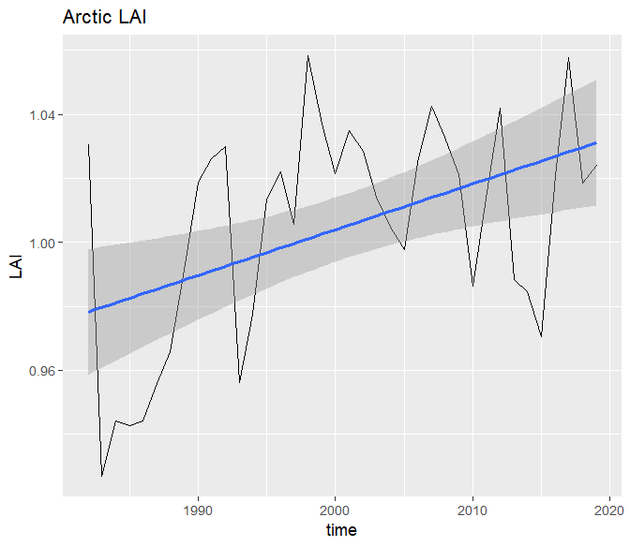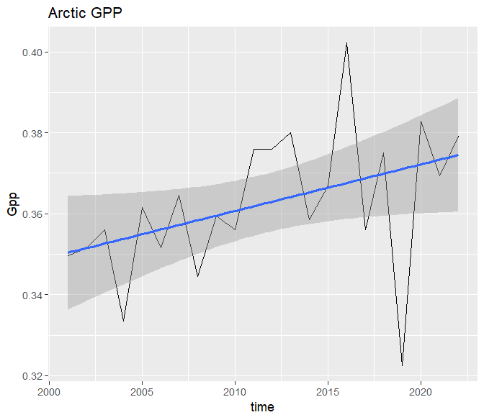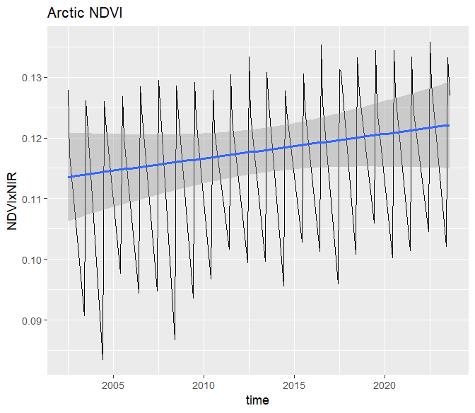
I will then write a script that performs the same task for the model data and automatically extracts and compares the trends in model data to trends in observations. I will examine if some models perform better in certain spatial regions by comparing the model performances for different biomes. As an observational benchmark, I will use the summer mean LAI from the AHVRR product, because LAI observations date back the furthest. For the models I will use LAI model output of 17 models downloaded from the Trendyv11 ( https://globalcarbonbudgetdata.org/). The ouput will be processed to the same time variable as the observations.
I will also perform a spatial performance analysis of the models. For each spatial cell, I will have a trendline for LAI observations and 17 model trendlines, one for each of the different DGVMs.
It will then be possible to compare the different models in their performance. I will calculate the R-squared values to find out how well the model data matches observation data.
Do the models that include soil nutrient cycling show more accuracy? This question will be answered by comparing the performance of nutrient-cycle-including models to the more basic DGVMs, using the (10?) models with enabled nitrogen cycle similar to Stocker et al. (2024) but only for the Arctic.

Timeline
07.04. | Proposal
21. 04. | Wrangle and process Observation data (LAI/GPP/NDVI mean, spatial analysis). Get familiar with R Terra and DGVMs.
26.05. | Do the programming. Process model data.
30. 06. | Draft Thesis
14.07. | Submission

Risks and contingency
I am not familiar with the analysis of DGVMs and will certainly encounter problems in automatizing my scripts, stemming from a lack of experience. Technical issues will cost me more time, making the submission in early July an ambitious deadline.
Currently, I have not yet decided which/how many DGVMs, this impedes a more concrete planning of the implementation part.
I will have to apply statistical methods on a large scale, which again is something new to me. Currently, the implementation part is too vague, this leads to uncertainties (what exact metrics will I be looking at? How do I automatize calculations?). These uncertainties have to be cleared, so that an efficient work becomes possible.

References
Frost, G. V., Bhatt, U. S., Macander, M. J., Berner, L. T., Walker, D. A., Raynolds, M. K., Magnússon, R. Í., Bartsch, A., Bjerke, J. W., Epstein, H. E., Forbes, B. C., Goetz, S. J., Hoy, E. E., Karlsen, S. R., Kumpula, T., Lantz, T. C., Lara, M. J., López-Blanco, E., Montesano, P. M., … Waigl, C. F. (2025). The changing face of the Arctic: Four decades of greening and implications for tundra ecosystems. Frontiers in Environmental Science, 13. https://doi.org/10.3389/fenvs.2025.1525574
Berner, L. T., Massey, R., Jantz, P., Forbes, B. C., Macias-Fauria, M., Myers-Smith, I., Kumpula, T., Gauthier, G., Andreu-Hayles, L., Gaglioti, B. V., Burns, P., Zetterberg, P., D’Arrigo, R., & Goetz, S. J. (2020). Summer warming explains widespread but not uniform greening in the Arctic tundra biome. Nature Communications, 11(1), 4621. https://doi.org/10.1038/s41467-020-18479-5
Winkler, A. J., Myneni, R. B., Hannart, A., Sitch, S., Haverd, V., Lombardozzi, D., Arora, V. K., Pongratz, J., Nabel, J. E. M. S., Goll, D. S., Kato, E., Tian, H., Arneth, A., Friedlingstein, P., Jain, A. K., Zaehle, S., & Brovkin, V. (2021). Slowdown of the greening trend in natural vegetation with further rise in atmospheric CO₂. Biogeosciences, 18(17), 4985–5010. https://doi.org/10.5194/bg-18-4985-2021
Fang, H., Baret, F., Plummer, S., & Schaepman-Strub, G. (2019). An Overview of Global Leaf Area Index (LAI): Methods, Products, Validation, and Applications. Reviews of Geophysics, 57(3), 739–799. https://doi.org/10.1029/2018RG000608
Pettorelli, N., Vik, J. O., Mysterud, A., Gaillard, J.-M., Tucker, C. J., & Stenseth, N. Chr. (2005). Using the satellite-derived NDVI to assess ecological responses to environmental change. Trends in Ecology & Evolution, 20(9), 503–510. https://doi.org/10.1016/j.tree.2005.05.011
Schulze, E.-D., Beck, E., Buchmann, N., Clemens, S., Müller-Hohenstein, K., & Scherer-Lorenzen, M. (2019). Dynamic Global Vegetation Models. In E.-D. Schulze, E. Beck, N. Buchmann, S. Clemens, K. Müller-Hohenstein, & M. Scherer-Lorenzen (Hrsg.), Plant Ecology (S. 843–863). Springer. https://doi.org/10.1007/978-3-662-56233-8_22
Liao, Z., Zhou, B., Zhu, J., Jia, H., & Fei, X. (2023). A critical review of methods, principles and progress for estimating the gross primary productivity of terrestrial ecosystems. Frontiers in Environmental Science, 11. https://doi.org/10.3389/fenvs.2023.1093095
Friedlingstein, P., O’Sullivan, M., Jones, M. W., Andrew, R. M., Hauck, J., Landschützer, P., Le Quéré, C., Li, H., Luijkx, I. T., Olsen, A., Peters, G. P., Peters, W., Pongratz, J., Schwingshackl, C., Sitch, S., Canadell, J. G., Ciais, P., Jackson, R. B., Alin, S. R., … Zeng, J. (2025). Global Carbon Budget 2024. Earth System Science Data, 17(3), 965–1039. https://doi.org/10.5194/essd-17-965-2025
Claverie, M., Matthews, J. L., Vermote, E. F., & Justice, C. O. (2016). A 30+ Year AVHRR LAI and FAPAR Climate Data Record: Algorithm Description and Validation. Remote Sensing, 8(3), 263. https://doi.org/10.3390/rs8030263
Lacroix, F., Zaehle, S., Caldararu, S., Schaller, J., Stimmler, P., Holl, D., Kutzbach, L., & Göckede, M. (2022). Mismatch of N release from the permafrost and vegetative uptake opens pathways of increasing nitrous oxide emissions in the high Arctic. Global Change Biology, 28(20), 5973–5990. https://doi.org/10.1111/gcb.16345
Strauss, J., Marushchak, M. E., van Delden, L., Sanders, T., Biasi, C., Voigt, C., Jongejans, L. L., & Treat, C. (2024). Potential nitrogen mobilisation from the Yedoma permafrost domain. Environmental Research Letters, 19(4), 043002. https://doi.org/10.1088/1748-9326/ad3167
Stocker, B. D., Dong, N., Perkowski, E. A., Schneider, P. D., Xu, H., de Boer, H. J., Rebel, K. T., Smith, N. G., Van Sundert, K., Wang, H., Jones, S. E., Prentice, I. C., & Harrison, S. P. (2025). Empirical evidence and theoretical understanding of ecosystem carbon and nitrogen cycle interactions. New Phytologist, 245(1), 49–68. https://doi.org/10.1111/nph.20178
Sitch, S., O’Sullivan, M., Robertson, E., Friedlingstein, P., Albergel, C., Anthoni, P., Arneth, A., Arora, V. K., Bastos, A., Bastrikov, V., Bellouin, N., Canadell, J. G., Chini, L., Ciais, P., Falk, S., Harris, I., Hurtt, G., Ito, A., Jain, A. K., … Zaehle, S. (2024). Trends and Drivers of Terrestrial Sources and Sinks of Carbon Dioxide: An Overview of the TRENDY Project. Global Biogeochemical Cycles, 38(7), e2024GB008102. https://doi.org/10.1029/2024GB008102

