Warm-up exercise report (SQL)

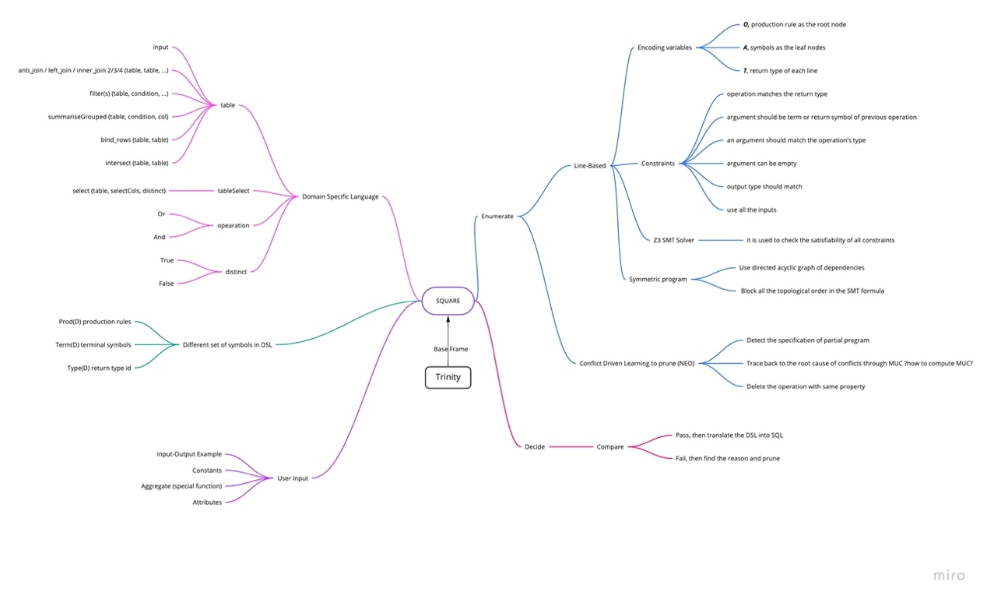

I read several papers about SQUARE and the tools it used and drew a mind map to clarify the concept and process of how it works.

For the domain specific language, in the SQUARE, there are four types of variables, table, tableSelect, operation and distinct. There are many functions, which are offered by R, such that they returns different types of variables. For example, *_join() function returns a table, bind_rows() function returns a table and select() returns a tableSelect.

The key idea of SQUARE is to enumerate all possible combination of different operations and then pick the one that outputs correctly given the input. To make it efficient, they change the frame into line base, add constraints of each operation, use SMT solver to detect the constraints, use NEO to detect the conflict of partial program and then give up the operation with same property.

The whole process of a single generation should be as followed, for example,

max_num_line = ?

max_arity = ?

for num_line in range(max_num_line):

enumerate num_line operations and max_arity arguments for each operation in the domain specific space:

if Z3 SMT solver checks constraints not pass:

continue

if the output is correct:

output the num_line operations

else:

use Neo to get the root cause of the conflict

block the operations with the same property from being placed at the same

postion in this loop

Try to play the SQUARE and evaluate the cost through PostgreSQL

After successfully installing SQUARE, I tried several test cases in the folder 55-tests/.

Then, I rewrite the generated SQL query into PostgreSQL format in order to use EXPLAIN query to calculate the cost of this SQL query.

Here are some examples.

Testcase 1,

The generated SQL:

SELECT DISTINCT `S_name`

FROM

(SELECT `F_key`,

`F_name`,

`C_name`,

`S_key`,

`S_name`,

`level`

FROM

(SELECT `F_key`,

`F_name`,

`C_name`,

`S_key`

FROM

(SELECT `F_key`,

`F_name`,

`C_name`

FROM `input2` AS `LHS`

INNER JOIN `input0` AS `RHS` ON (`LHS`.`F_key` = `RHS`.`F_key`)) AS `LHS`

INNER JOIN `input1` AS `RHS` ON (`LHS`.`C_name` = `RHS`.`C_name`)) AS `LHS`

INNER JOIN `input3` AS `RHS` ON (`LHS`.`S_key` = `RHS`.`S_key`))

WHERE (`level` = 'JR'

AND `F_name` = 'faculty1');

The manually transformed PostgreSQL:

SELECT DISTINCT S_name

FROM

(SELECT F_key, F_name, C_name, LHS.S_key, S_name, level

FROM

(SELECT F_key, F_name, RHS.C_name, S_key

FROM

(SELECT LHS.F_key, F_name, C_name

FROM input2 AS LHS

INNER JOIN input0 AS RHS ON (LHS.F_key = RHS.F_key)) AS LHS

INNER JOIN input1 AS RHS ON (LHS.C_name = RHS.C_name)) AS LHS

INNER JOIN input3 AS RHS ON (LHS.S_key = RHS.S_key)) AS FOO

WHERE (level = 'JR' AND F_name = 'faculty1’);

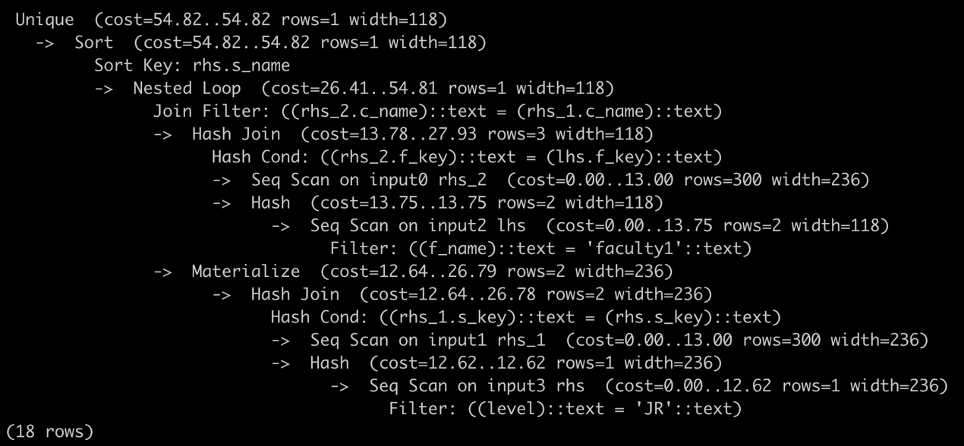

The optimal PostgreSQL:

SELECT DISTINCT S_name

FROM input0 i0

INNER JOIN input2 i2 ON i0.F_key = i2.F_key

INNER JOIN input1 i1 ON i0.C_name = i1.C_name

INNER JOIN input3 i3 ON i1.S_key = i3.S_key

WHERE (level = 'JR' AND F_name = 'faculty1');

Since the queries are generally the same, the resulting costs are the same.

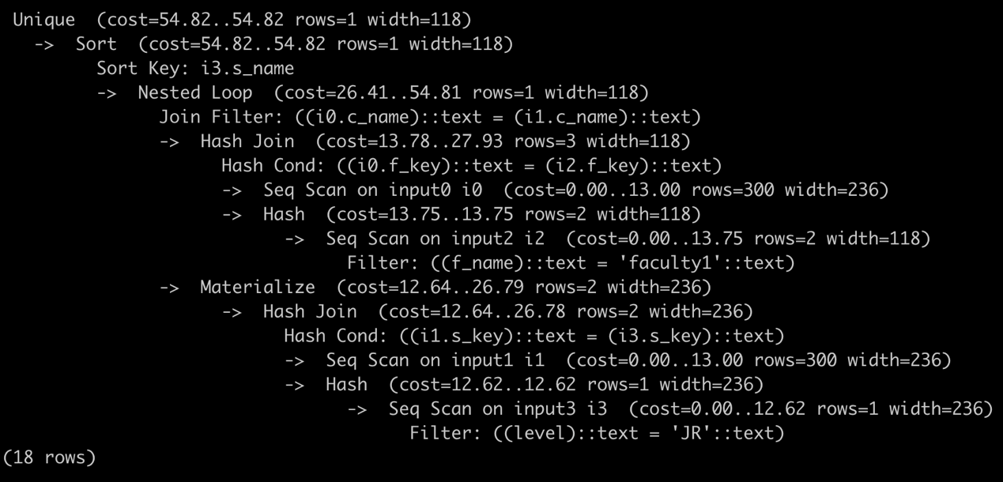

Testcase4:

Generated SQL:

SELECT `S_name`

FROM

(SELECT `S_name`,

`meets_at`,

COUNT() AS `n`

FROM

(SELECT `C_name`,

`meets_at`,

`S_key`,

`S_name`

FROM

(SELECT `C_name`,

`meets_at`,

`S_key`

FROM `input0` AS `LHS`

INNER JOIN `input1` AS `RHS` ON (`LHS`.`C_name` = `RHS`.`C_name`)) AS `LHS`

INNER JOIN `input2` AS `RHS` ON (`LHS`.`S_key` = `RHS`.`S_key`))

GROUP BY `S_name`,

`meets_at`)

WHERE (`n` > 2.0

OR `n` = 2.0)

Manually transformed PostgreSQL:

SELECT S_name

FROM

(SELECT S_name, meets_at, COUNT(*) AS n

FROM

(SELECT C_name, meets_at, LHS.S_key, S_name

FROM

(SELECT LHS.C_name, meets_at, S_key

FROM input0 AS LHS

INNER JOIN input1 AS RHS ON (LHS.C_name = RHS.C_name)) AS LHS

INNER JOIN input2 AS RHS ON (LHS.S_key = RHS.S_key)) AS FOO

GROUP BY S_name, meets_at) AS FOO

WHERE (n > 2.0 OR n = 2.0);

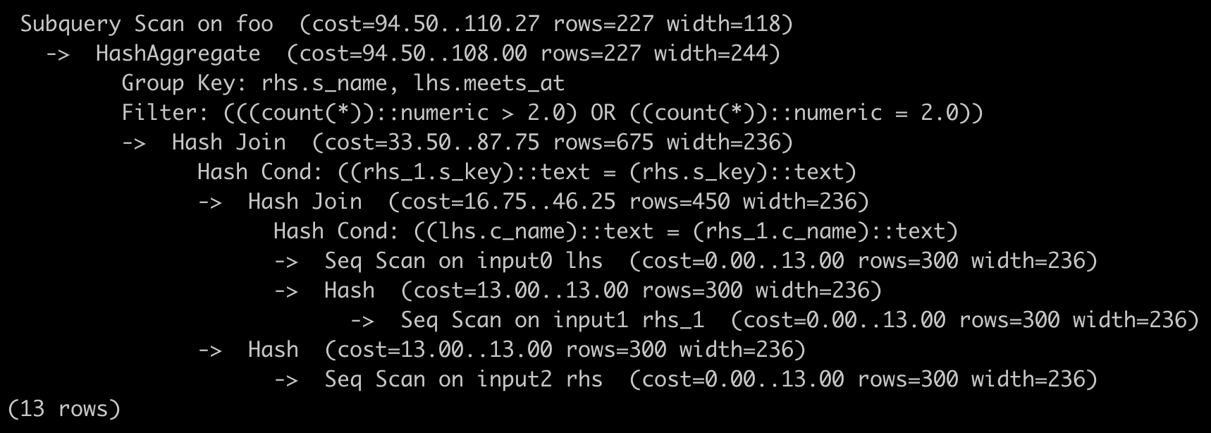

Optimal PostgreSQL:

SELECT S_name

FROM

(SELECT S_name, meets_at, COUNT(*) AS n

FROM (input0 i0

INNER JOIN input1 i1 on i0.C_name = i1.C_name

INNER JOIN input2 i2 on i1.S_key = i2.S_key) AS FOO

GROUP BY S_name, meets_at) AS FOO

WHERE (n = 2.0);

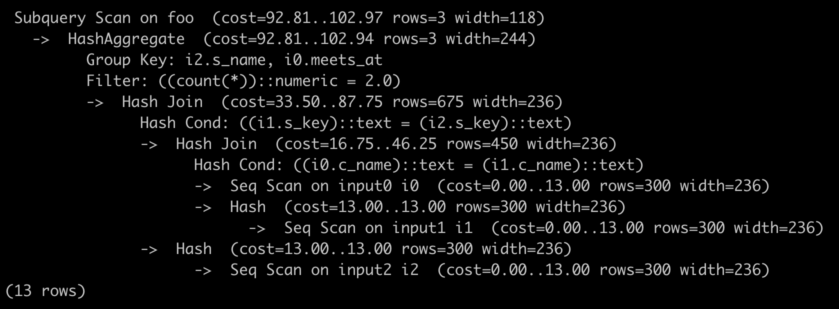

Although some testcases don’t give a SQL solution, I check their R query to see whether it is of huge cost.

For example, testcase4

Generated:

RET_DF4837 <- inner_join(inner_join(input0, input1), input2)

RET_DF4838 <- RET_DF4837 %>% group_by(S_name, meets_at) %>% summarise(n = n())

RET_DF4839 <- RET_DF4838 %>% ungroup() %>% filter(n > 2 | n == 2)

RET_DF4840 <- RET_DF4839 %>% ungroup() %>% select(S_name)

Optimal:

inner_join(class,enroll) %>% inner_join(student) %>%

group_by(S_name,meets_at) %>% summarize(n = n()) %>%

filter(n == 2) %>% select(S_name)

The cost is a little larger than the optimal. Mainly because of the filter having n > 2 besides n == 2. As a result, the returned data is more than necessary and the machine need more memory to store and more time to search.

Testcase11:

Generated:

RET_DF1618 <- left_join(input1, input0)

RET_DF1619 <- anti_join(select(input0,S_name), select(RET_DF1618, S_name))

RET_DF1620 <- RET_DF1619 %>% ungroup() %>% select(S_name) %>% distinct()

Optimal:

anti_join(student,enrolled) %>% select(S_name)

The larger cost is due to the extra left_join.

Testcase14:

Generated:

RET_DF193 <- input0 %>% group_by(S_key) %>% summarise(n = n())

RET_DF194 <- filter(RET_DF193, n == max(n))

RET_DF195 <- inner_join(inner_join(inner_join(input1, input0), input2), RET_DF194)

RET_DF196 <- RET_DF195 %>% ungroup() %>% select(S_name) %>% distinct()

Optimal:

inner_join(parts,catalog) %>% inner_join(suppliers) %>%

group_by(sname) %>% summarise(n=n()) %>%

filter(n == max(n)) %>% select(sname)

There is some information that relates with each other, such as S_name and S_key. The larger cost is due to the inner_join of an unnecessary table, which is produced by grouping by S_key.

From the examples above, I think the main reason for it should be that the machine tends to include more data than it needs. In this way, machine can compute the correct answer because all the data is selected but need more space and time to extract useful data.

My idea of generating low-cost query efficiently:

1. It is quite like doing a TSP problem. The idea is to brute-force enumerate all possible combination but with branch-and-bound method. For example, we can have a running cost when enumerating, when the running cost is greater than the current minimum cost, it can be ignored. But it should still consume much time. To make it more efficiently, we can have something similar to the TSP Heuristics. The heuristic is to calculate the lower bound of the cost of the unadded operations. With this lower-bound cost, the program should run faster.
2. The other idea is to rate each operation by their average cost and then greedily enumerate these operations in the increasing order of their cost.