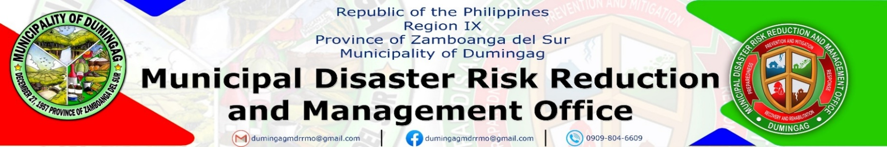

ACCOMPLISHMENT REPORT
APRIL 2026

Date |  | Activity | Status
April 1, 2026 | Monitored CCTV feeds; processed gas slip requests |  | Accomplished
April 2, 2026 |  | Regular Holiday (Holy Thursday) | Accomplished
April 3, 2026 |  | Regular Holiday (Good Friday) | Accomplished
April 6, 2026 |  | Released gas slip; CCTV monitoring and logbook update | Accomplished
April 7, 2026 |  | Processed fuel requests; reviewed CCTV footage | Accomplished
April 8, 2026 |  | Logged fuel usage; performed camera system check | Accomplished
April 9, 2026 |  | Regular Holiday (Araw ng Kagitingan) | Accomplished
April 10, 2026 |  | CWW pursuant to MC No. 114, s. 2026 | Accomplished
April 13, 2026 |  | Coordinated refueling schedule; monitored CCTV | Accomplished
April 14, 2026 |  | Processed gas slip requests; archived CCTV clips | Accomplished
April 15, 2026 |  | CCTV system maintenance; updated fuel records | Accomplished
April 16, 2026 |  | Released gas slip; monitored entry/exit cameras | Accomplished
April 17, 2026 |  | CWW pursuant to MC No. 114, s. 2026 | Accomplished
April 20, 2026 |  | Logged daily fuel usage; coordinated ambulance refueling | Accomplished
April 21, 2026 |  | Monitored CCTV; verified fuel receipts | Accomplished
April 22, 2026 |  | Processed gas slip requests; reviewed access logs | Accomplished
April 23, 2026 |  | CCTV recording review; performed system check | Accomplished
April 24, 2026 |  | CWW pursuant to MC No. 114, s. 2026 | Accomplished
April 27, 2026 |  | Released gas slips; monitored CCTV feeds | Accomplished
April 28, 2026 |  | Logged fuel usage; archived camera footage | Accomplished
April 29, 2026 |  | Issued fuel summary report; system inspection | Accomplished
April 30, 2026 |  | Wellness Leave | Accomplished

Prepared by: Approved by:
GERLAN B. DORONA JHUNAX L. CARDOZA
Clerk MDRRMO - OIC

