1. Tampilkan data Name, Region, Population pada tabel Country dan Language berdasarkan Country Population diatas rata-rata

select Name, Region, Population from country inner join countrylanguage on country.code = countrylanguage.CountryCode where Population > (select AVG(Population) from country) order by Population ASC

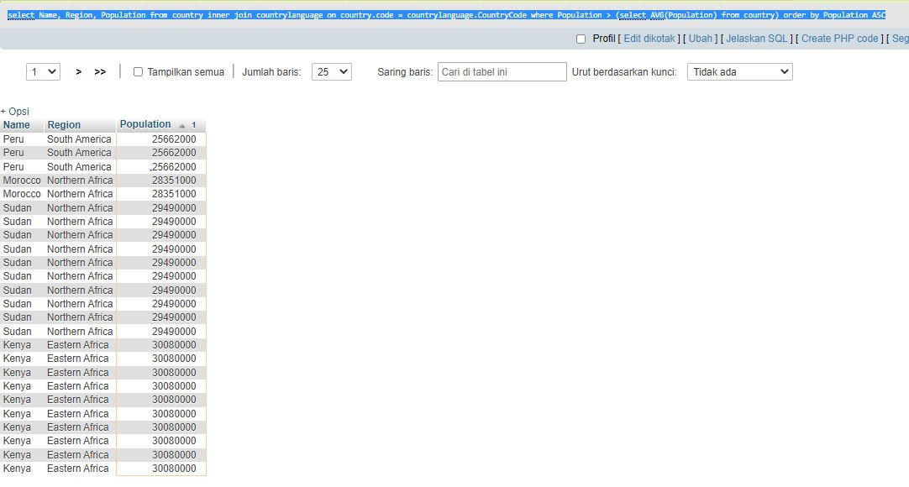

2. Tampilkan data Name, District, Population pada tabel City dan Name Country berdasarkan City Population diatas rata-rata

select city.Name, city.District, city.Population from city inner join country on city.CountryCode = country.Code where city.Population > (select AVG(city.Population) from city) order by city.Population ASC

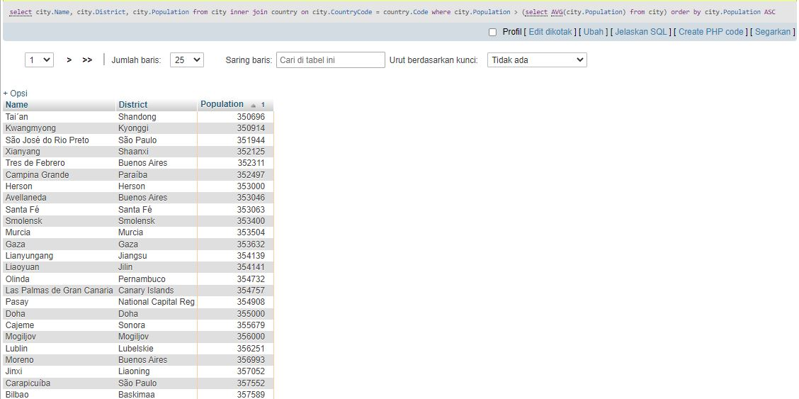

3. Tampilan data Name, Region, Population pada tabel Country berdasarkan IndepYear null

select Name, Region, Population from country where IndepYear is NULL

