Racial Prejudice in the Sharing Economy:

An Economic Analysis of Price Differentials in Airbnb Listings

Nicholas A. Ficeto

EC 127 – Urban Economics

Prof. Anna Hardman

December 12, 2016

**ABSTRACT**

Since the implementation of the Fair Housing Act of 1968, numerous urban economic studies have demonstrated that racial discrimination within housing buying and rental markets persists to this day. The rise of Airbnb as a major player in both the sharing economy and a modern short-term rental industry distinguishes itself from traditional housing industries, though several of its features that indicate a user’s race create the opportunity for racial discrimination between users. Traditionally, governmental studies determining racial bias in the housing industry have focused on differential treatment between White and African American house seekers – this paper seeks to highlight whether Asian American Airbnb hosts in the Oakland/Berkeley area of California price comparable units differently than do their White counterparts. Though several studies exist suggesting that both guests and hosts experience discriminatory treatment in Airbnb transactions, in this paper I will test specifically whether a statistically significant price differential exists in the rates charged by Asian and White Airbnb hosts, while also bringing attention to potential flaws in the data used in previous studies analyzing such a differential. Historic and modern examples of discrimination within both the broader rental industry and sharing economy are also discussed in order to situate the findings of this paper.

**INTRODUCTION**

In recent years, the rise of the “sharing economy”, in which consumers act as both buyers and sellers of some product they possess to other peers (hence the terms “peer-to-peer marketplace” or simply “p2p sharing”), has become a trending subject of economic, social, and political discourse nationwide (Kakar et al. 2016). While many companies have disrupted the fabric of numerous industries, such as Uber to the taxi industry, Airbnb, a peer-to-peer online marketplace that allows hosts to rent their residences to guests, has emerged as a particularly formidable force to the short-term housing rental market.

Central to the discipline of urban economics is the study of housing markets, and how factors such as race affect a number of phenomena such including neighborhood demographic trends or housing affordability. While economists have already performed decades of research in an effort to create models to examine racial discrimination within housing sales and rental markets, the rise and relative immaturity of the sharing economy, which involves a multitude of peer-to-peer transactions that have the potential to impact long-standing housing trends, make it a highly interesting and relevant topic to explore. Though the exact impact of Airbnb on US housing prices remains highly disputed, it is nevertheless clear that as a company with a $30 billion valuation, larger than that of hotel giant Marriott International, Inc., Airbnb is carving a financially significant niche within the short-term rental industry (Mo 2016).

Nevertheless, although some deem the sharing economy a means by which minority groups that are typically discriminated against may achieve equal economic opportunity, one aspect of the economy that has attracted sharp criticism is perceived weaknesses in transaction processes that allow certain users to discriminate against others (Edelmen et al. 2016). As a result of the weariness that users of services like Airbnb may feel about paying for a service provided by another peer (as opposed to an established company), companies like Airbnb often seek to facilitate trust and create personal connections between peers by necessitating biographical profiles filled with components such as a user’s age, reviews of their service, and even a picture (Edelmen et al. 2016). While this reduction in anonymity provides a number of benefits, in helping to prevent fraudulent transactions and facilitating trust amongst users, it also allows for users to discriminate against fellow peers on the basis of attributes such as race and gender (Kakar et al. 2016). For obvious reasons, this is concerning as it could give rise to disparities in economic opportunity amongst certain groups of people (e.g. White vs. non-White individuals).

Traditionally, literature in the field of housing discrimination in the rental industry focuses on prejudice against those *seeking* housing. However, since the sharing economy functions such that both ends of an exchange are operated by peers, there is increased potential for discrimination against both individuals on the “selling” end as well as the “purchasing” end. In this paper, I will be using a dataset created by a number of Harvard researches, Gilheany et al., to examine whether or not pricing differentials exist amongst Asian and White hosts in the Berkeley/Oakland area in California.

This is a particular interesting dataset for a couple of reasons: One is that the social and economic discourse surrounding housing discrimination tends focus around a White-Black racial binary, which while important oftentimes leaves out other minority groups such as Hispanics, and notably Asians (“CAPACD” n.d.). While the researchers that created this dataset note that Asian Americans are a group largely perceived to be defined by economic success and therefore lesser levels of adversity compared to other minority groups such as Blacks and Hispanics (Gilheany et al. 2015), it is interesting to see whether they quantitatively face similar levels of economic discrimination compared to these other groups.

Another reason is that the Berkeley/Oakland area is home to some of the most heated debate regarding the expansion of Airbnb; many residents complain that the service is responsible for limiting the already restricted supply of housing available, thus driving up rents in the area and giving way to a number of other negative externalities such as noise and a constant flow of tourists (Nichols 2015). Using the results of this dataset, I intend to situate my findings within broader economic theory regarding housing rental markets, in an effort to determine the extent to which my results suggest that discrimination within the short-term rental market is consistent with discrimination in general rental markets.

**BACKGROUND**

Before examining the role of racial discrimination within different types of housing markets, it is first important to describe the nature of the specific market that Airbnb occupies. The short-term rental market (STR market) has existed for some time, once operating as a largely informal temporary housing alternative until the post-war transformation of the hotel industry and construction of the interstate highway system (Rosen Consulting Group 2013). Historically, housing units in the STR market acted as a cheaper alternative to commercially zoned hotels, providing renters with the option to live in local, residentially zoned neighborhoods. “Operators” of the rental units, either owners or renters themselves, financially benefit from the ability to provide temporary housing to a “guest(s)” for short periods of time (generally less than 30 days) (Rosen Consulting Group 2013). While informal (and thus legally questionable) housing arrangements and vacation rentals advertised via bulletin boards or newspapers have traditionally comprised the bulk of the STR market, the recent rise of online services like Airbnb and Couchsurfing that facilitate host-guest transactions has led to a significant expansion of the modern STR market (Rosen Consulting Group 2013).

Due to the evolving landscape of this type of STR market, there is not an abundance of conclusive research examining the way racial discrimination impacts it. Nevertheless, extensive research exists examining the impact of racial discrimination in more general rental markets, especially since the implementation of the Fair Housing Act of 1968, which sought to protect buyers and renters of housing from landlord discrimination. Though the specific purpose of this paper is to examine potential pricing discrimination amongst Airbnb *hosts* based on race, discrimination in the general rental market is usually studied from the vantage point of real estate brokers discriminating against leasers. Furthermore, the bulk of existing research examines discrimination against potential leasers as a result of *indicators* of their race (i.e. their name and physical appearance); since my data will be examining whether Airbnb *hosts* face discrimination similarly as a result of their perceived physical appearance, this background information on discrimination faced by *leasers* in rental markets as a result of indicators of their race is still highly relevant.

**Racial Discrimination in Rental Markets**

Over the decades, one of the most prominent methods by which researchers have determined racial bias in the housing rental market is through the use of “paired tests”. Urban economist John Yinger notes that the implementation of the Fair Housing Act corresponded with a significant increase in the use of paired testing (i.e. “auditing”) in the 1960s and 1970s to determine whether equally qualified home seekers received different treatment based on race (generally one group of test subjects were White, while another were Black) (Oh & Yinger 2015).

The governmental agency responsible for conducting this research is the U.S. Department of Housing and Urban Development (HUD). One of their most recent studies, “Housing Discrimination Against Racial and Ethnic Minorities 2012”, has been frequently cited by urban economists as it reveals that racial bias continues to plague housing opportunities for racial minorities in subtle yet significant ways (HUD 2012). These researchers conducted more than 8,000 paired tests in 28 metropolitan areas, in which each test consisted of one White and one equally qualified Black, Asian or Hispanic subject that contacted a housing provider to inquire about details of a randomly selected housing unit.

The results were highly alarming; all non-White subjects were informed of up to ~17% fewer homes, as well as physically shown up to 18.8% fewer homes. More specifically, Asian Americans faced nearly equal or in some cases *more* discrimination in housing than did Blacks and Latinos with regards to buying. With regards to renting, Asian Americans were told about 9.8% fewer units, and shown 6.6% fewer units than their White counterparts (HUD 2012). Likewise, these researchers at HUD noted how subjects with easily identifiable markers of their ethnic identity (e.g. name, physical appearance, accent) were significantly more likely to be denied appointments than minorities that were perceived to be racially White (HUD 2012). This is an important finding to bear in mind when reviewing studies detailing how Airbnb users discriminate against other users based on identifiable markers of their race, e.g. distinctly African American names.

Historically, the tendency to keep racial minorities away from predominantly White neighborhoods, either as a result of a broker’s personal bias or their intention to “protect” their White clients from non-White individuals entering their neighborhoods (Ondrich et al. 1999), is known as “steering”. Based on these results, it seems highly plausible that this continues to be an issue for minorities seeking housing.

There are further reasons that the results of this study are significant when considering discrimination in the general rental and STR markets. One is that the only indicator of an Airbnb host’s race is their profile picture; with the incidence of discrimination Asian American subjects faced in the HUD study based on their non-White appearances, we may expect potential prejudice displayed against Airbnb hosts with non-White (i.e. in this case, Asian) features. Furthermore, this study rejects the popular notion explained by the researchers whose dataset I will be using for this paper in which Asian Americans are a “model minority”, and therefore subject to comparably lesser rates of discrimination in fields like housing (Gilheany et al. 2015).

With regards to trends in housing discrimination over time, Yinger notes that racial bias persists in less overt ways than it did decades ago. For example, though Black subjects were often blatantly denied appointments in a similar study conducted by the HUD in 1977, this rarely happens today (Oh & Yinger 2015). At the same time, there is no clear evidence that financing assistance for minorities has increased over time (Oh & Yinger 2015). This is reminiscent of the phenomenon of “redlining” that particularly characterized racial discrimination immediately following the Fair Housing Act, in which minorities in certain neighborhoods were consciously refused loans and other forms of financial assistance (Zhao et al. 2005). What is even more interesting is that data for 4 major HUD studies conducted in 1977, 1989, 2000, and 2012, data for Asian Americans only exists in the latter 2 instances, suggesting that governmental data on discrimination against Asian Americans in the 20th century is historically scarce compared to data on other minorities, namely African Americans. This evidence affirms the idea that studies specifically focusing on Asian American are lacking.

As a final note, it is important to highlight the fact that the position of an Airbnb host as the owner/renter of a short-term rental unit renders the role of a real estate agent unnecessary, meaning that trends that have historically characterized racial prejudice of real estate agents and landlords against home seekers cannot be studied in the STR market in the same way.

**Racial Discrimination in the Sharing Economy**

Since the modern sharing economy is a relatively new phenomenon, less research has been conducted on racial discrimination between users of p2p platforms, though some studies have been published suggesting the existence of such bias.

For example, researchers Jennifer Doleac and Luke C.D. Stein demonstrated that Black sellers in an online p2p marketplace are less likely to receive offers for their items when their physical appearance, a clear indicator of their race, is revealed. The duo posted advertisements for iPod Nanos on hundreds of local classified websites across the US. On select ads, the photos for the product showed the hand of a Black seller holding the iPod, while on others the hand was White. Interestingly, Doleac and Stein found that ads that featured a Black hand received 13% fewer responses as well as 18% fewer offers on average. Furthermore, the offers made on advertisements with Black hands were on average 11% lower (Doleac & Stein 2013). Consequently, visual indicators of a user’s race in the sharing economy may result in unintended price discrimination.

Another key example concerns two major transportation companies in the sharing economy, Uber and Lyft. In an article for the National Bureau of Economic Research, researchers conducted two-randomized control trials in Seattle and Boston, in which White and Black passengers were used as subjects to test driver discrimination in the Uber and Lyft apps (Ge et al. 2016). In Seattle specifically, African Americans saw as high as a 35% increased wait time when using Uber, but experienced approximately equal wait times as did their White counterparts when using Lyft. However, this implies discrimination due to the nature of how the ride request system for each of these apps works: UberX drivers see a passenger’s name only after accepting a trip request, whereas Lyft passengers see it beforehand. With this, these researchers theorize that prevalence of certain UberX drivers canceling trips after seeing an African American sounding name increases wait times for African Americans, whereas prejudiced Lyft drivers would simply opt to not accept the trip request from the start (Ge et al. 2016).

With this, we can clearly see evidence of certain users in the sharing economy discriminating against others based on a *perceived* factor that indicates race, in this particular case their name. Though the racial minority used as a subject in this study is African Americans as opposed to Asian Americans, the empirical evidence that White passengers benefit from preference over non-White passengers remains highly useful to contextualizing discrimination in peer-to-peer services.

**Racial Discrimination in Airbnb’s STR Market**

Though economic studies examining the role of racial discrimination strictly within Airbnb’s short-term rental industry are somewhat limited, a couple of very important ones do exist suggesting racial discrimination on the host as well as guest side of Airbnb users, and will be used to guide this paper. Since Airbnb does not explicitly request nor display a user’s race in their profile, *indicators* of a user’s race are used to discriminate against that user, namely their name and profile picture. This is consistent with the aforementioned studies testing discrimination in the sharing economy, in which users’ names were used as a basis by which to discriminate.

Examining the guest side of the Airbnb transaction, in an article for the American Economic Journal, researchers at Harvard collected data on all Airbnb listings in Baltimore, St. Louis, Dallas, Los Angeles, and Washington D.C. in July 2015. Their results showed that on average, hosts, both “big” (advertising several properties) and “small” (advertising one property) are 16% less likely to accept guests with distinctly African American names (Edelmen et. al 2015). These researchers importantly note that while discrimination within general rental markets has reduced over the decades, the nature of how Airbnb has designed its profiles allows for new potential forms of discrimination, thus underscoring past achievements in equalizing housing opportunity (Edelmen et. al 2015).

However, this paper will be examining a less often studied phenomenon – racial bias displayed against the host, or “seller” of the product. Perhaps the first major study to emerge observing this was conducted by researchers Benjamin Edelmen (whose studies have previously been cited in this paper) and Michael Luca in 2014, in which the duo examined all available Airbnb listings in NYC, and used the perceived race of a host to determine whether there was a price differential in rates charged by Black and non-Black hosts, which includes those who were deemed to be of Asian, Hispanic, multiple and unclear races (Edelmen & Luca 2014). Controlling for characteristics of the residence as well as factors like a host’s feedback rating, Edelmen and Luca were able to determine that Black hosts on average charge 12% less than non-Black hosts for identical rental units. In their view, such a discrepancy in pricing is a market design flaw, in that Airbnb allows for such discrimination by including these arguably unnecessary indicators of a user’s race.

The study that will be most influential in guiding the research of this paper is one completed in 2015 by Gilheany et al., in which these three researchers, inspired by the findings of Edelmen and Luca, performed a study to determine whether Airbnb rental prices of Asian Americans in the Berkeley/Oakland area in California differed from those of their White counterparts (Gilheany et al. 2015). The Berkeley/Oakland area was specifically chosen for its demographic diversity and relatively high population of Asian Americans (16.8% based on the 2010 Census vs. ~5% for the entire nation) (Gilheany et. al 2015; “2010 Census” 2011). I offer a racial breakdown of the area in Figure 1. By constructing a dataset for this area with 101 observations, in which randomly chosen White/Asian hosts were used as subjects, the researchers were able to determine that on average Asian hosts charge 20% less ($90) per week than their White counterparts for comparable rental units (Gilheany et al. 2015). Therefore, it can be said that Asian Americans do face discrimination in the sharing economy as do participants of other minority races. However, it is important to approach the results of this study with some degree of caution; the number of control variables used in their hedonic model (bedrooms, bathrooms, occupancy, race, price) are important, but they appear to omit other vitally important factors like a host’s rating (Gilheany et. al 2015).

**METHODOLOGY**

To test whether a price differential exists between Airbnb rental incomes for White and Asian hosts in the Oakland/Berkeley area, I will be using the dataset constructed by the researchers in the Gilheany et al. study. The values for this data set were originally obtained using a Mashape API to scrape information from Airbnb listings in the Oakland/Berkeley area; a more detailed description of these methods can be found in the original study (Gilheany et al. 2015). Data was originally obtained on April 23, 2015. Weekly prices were used as a variable instead of daily prices (as provided by Airbnb) in order to minimize price variability. A dummy variable is used to represent a host’s perceived race, either 0 = Caucasian (White) or 1 = Asian. Though the researchers did not specify, by checking the links provided in the dataset I was able to independently verify that by “Asian”, it seems the researchers refer to those exclusively of East Asian descent. All hosts that do not fit this description, or who had features too ambiguous to determine whether definitively Asian or Caucasian were omitted from the sample (Gilheany et al. 2015). However, because I believe that the rating of a host as well as their number of reviews can potentially influence its price, I intended to add both of these variables to all observations using links to the listings provided in the data set.

3 issues arose when I attempted to add this data: 1.) I could not determine the exact rating of a host since Airbnb does not provide an exact number (e.g. a unit may have an “actual” rating of 4.9 stars, but it visually looks like 5 stars). 2.) Some of the listings appear to no longer exist, meaning there are too many gaps in the data to make a reliable regression with these new regressors. 3.) A small portion of the listings appear to be from a similar short-term rental service called “HomeAway” – unless this was an error in the creation of the dataset, the inclusion of listings from this alternative website was not mentioned anywhere in their report, and so I approach the data collection methodology of these researchers with some degree of skepticism. For these reasons, I ended up using the identical dataset that the researchers provide to the public.

I downloaded this dataset on November 27, 2016 in the form of an excel file. The data from this file was imported into Stata 14 at Tufts University library facilities. I created a hedonic model in which variables include characteristics of the rental unit. I used OLS estimation to estimate a linear-log regression model, using robust standard errors. Diagnostic tests include a check for the fit of the model using the R-squared, determining the plausibility of omitted variable bias, checking for the statistical significance of the intercept and coefficients, and checking for multicollinearity between the coefficients.

**DATA**

The dataset I used has a total of 101 observations. The variables are:

* **Dependent Variable**: “costweek” (total cost of a unit per *week*)
* **Independent Variables (Regressors):**
  + 1.) “bathrooms” (number of bathrooms in a unit)
  + 2.) “bedrooms” (number of bedrooms in a unit)
  + 3.) “peopleoccupancy” (maximum number of people allowed in a unit)
  + 4.) “race0white1asian” (binary variable – a value of 0 indicates Caucasian race of host, a value of 1 indicates Asian race of host)

SUMMARY STATISTICS:

Figure 8 offers a breakdown of key summary statistics of the data. Airbnb units tend to be small, with the average number of bathrooms per unit being 1.32 and the average number of bedrooms per unit being 1.57. The average cost per week of a unit is $1,032.44. However, the cost of units per week can vary largely, as the cheapest is $315 and the most expensive is $4000. All variables have “101” observations, indicating there is no missing data. Figures 2 – 7 show frequency distributions of these regressors, most of which are largely skewed right. This suggests that most observations for most independent variables fall under a relatively small range of values, but a small number of exceptions consistently show up.

SUMMARY STATISTICS BY RACE:

Since this paper is examining differences in rental prices per week between Asian American and White hosts, I separated the cost per week variable into two different variables, one for White hosts and one for Asian hosts. Thus,

* asian_earnings = group of 26 observations in which all hosts are Asian American
* white_earnings = group of 75 observations in which all hosts are White

On average, White hosts charge a weekly rental rate of ~$1,134 (Figure 9). This is significantly higher than the average weekly rental rate that Asian hosts charge, which is ~738 (Figure 10). Considering this is a rather large difference in means, I ran a t-test to ensure that this difference in means is statistically significant. With a p-value of .0196, which is significantly significant at the 5% level, we can reject the null hypothesis that the difference in means is 0, meaning that this difference in means is significant (Figure 11). This may suggest the possibility of a price differential, but I have yet to control for characteristics of the units.

REGRESSION ANALYSIS:

In an attempt to find a regression model that best fits the data, I perform a number of transformations, including a linear, polynomial, and linear-log model. First, however, I reproduce the specific log-log model, which involves a number of transformations of the data (see Figure 12). Interestingly, however, my results differ from those of Gilheany et al. Like these researchers, my analysis gives an R-squared value of ~67%, meaning 67% of the total variance is explained by the included regressors, and the coefficient for “bathrooms” is statistically insignificant and therefore can be omitted. Notably different than Gilheany et al., however, I find that the key coefficient for the race binary variable turns out to *not* be statistically significant (Figure 12).

With this, I decided to approximate **3** other regression models to check whether the data could be better fitted, or the whether the significance of the coefficients would change. Based on their respective two-way scatter plots, there is a clear positive correlation between “costweek” and “bedrooms” as well as “costweek” and “peopleoccupancy” (see Figure 13). However, it is not completely clear which model best suits the data. Both the linear and polynomial models had shortcomings:

1. **Linear model** – Intercept is not statistically significant (see Figure 14).
2. **Polynomial model** - Almost all of the regressors are statistically insignificant (see Figure 15).

Finally, I successfully model a linear-log regression fitting the data as such (Figure 16):

**Costweek = 352.57 + 856.72 * ln(bedrooms) + 342.69 * ln(occupancy)**

**Significance:**

In all of the models, the coefficients for both “bathrooms” and “race” variables were not statistically significant. Thus, after dropping these from the regression, I finally settled on a linear-log model in which the log of bathrooms (“lbathrooms”) and log of peopleoccupancy (“loccupancy”) were statistically significant predictors of “costweek”.

**Fit of regression:**

With an adjusted R-squared of 0.65, the 2 regressors of this model (bedrooms and occupancy) explain approximately the same amount of the total variance in this model as the 3 regressors (bedrooms, occupancy, and race) did in the model of Gilheany et al. (adjusted R-squared of ~0.67), indicating a decent fit. The RMSE (459.4) is also less than the standard deviation of the dependent variable (750.33), which is good for the fit. The F-statistic is appropriate with a p-value of “0”, meaning we can reject the null hypothesis that the regressors jointly have no explanatory power.

With these concerns about fit, I also decided to check for potential heteroscedasticity in the error term. Using a Breusch-Pagan/Cook-Weisberg test for heteroscedasticity, I determine that we reject the null-hypothesis of homoscedasticity, indicating changing variance in the error term (Figure 17).

**Potential bias:**

However, with an adjusted R-squared of only 0.65, and only 2 regressors included in the model, I suspect there is some level of omitted variable bias. Therefore, I run a correlation matrix between the two independent variables (Figure 18). While there is no issue of perfect multicollinearity, a statistically significant value of “0.79” between “lbedrooms” and “loccupancy” indicates a high level of collinearity, suggesting there is a high probability of omitted variable bias in this model.

**RESULTS**

In assessing the fit of the regression, it was determined that there is a high potential for omitted variable bias. This should be unsurprising, as I mentioned earlier that key variables that may determine a unit’s price, such as the rating of a host, were not included in the data.

Interestingly, only bedrooms and the maximum occupancy of an apartment turn out to be important determinants of an Airbnb’s unit price. Thus, my initial hypothesis that race is an important indicator that will lead to a price differential between Whites and Asians turns out to be incorrect. My findings are consistent with Gilheany et al.’s finding that bathrooms are not a significant predictor, but inconsistent with their finding that race is an important predictor. Considering my exact replication of their regression model, I was surprised by this result. Nevertheless, I would undoubtedly advise that my results be viewed with a degree of skepticism. Apart from the issues of fit discussed earlier, I strongly suspect the possibility that the differences in our results may be the result of errors in constructing the data set they released to the public. I am skeptical of the dataset provided for a number of reasons:

1. In the dataset, Gilheany et al. provide links to the listings they used to gather their data, the majority of which are still active. However, a number of links come from a competitor of Airbnb called “HomeAway”, which provides very similar short-term rental services. However, nowhere in the published study of Gilheany et al. do the authors make any mention of some data being collected from the HomeAway website; until closer inspection, anyone who reads their original study is under the impression that all of the 101 observations used come from Airbnb’s website.
2. Though Gilheany et al. did include what one would expect to be four important regressors (“bathrooms”, “bedrooms”, “race0white1asian”, and “peopleoccupancy”), they also omitted some key factors that may affect the rental price of a unit, such as the number of reviews of a host as well as the overall rating they have received. I tried to add these to the dataset manually in order to test whether these factors are significant, but was unable to do for previously explained reasons, including the fact that a.) some listings are no longer available, and b.) small changes exist in the prices of some observations.
3. While the sample size of the dataset (n = 101 observations) may be large enough to provide reliable results (if on the smaller end), only 26 of these observations are actually Asian hosts, compared to a much larger 75 White hosts. I suspect that this is because it may be difficult to obtain equal numbers of Asian and White hosts while preserving the integrity of a random sample. Still, this small number of Asian hosts is enough to raise concern in the accuracy of regression calculations.
4. While Gilheany et al. make it clear in the description of the data that the variable used to determine the price of a rental unit on Airbnb is measured in cost per week, so as to reduce variability, in the dataset provided the column with this variable is labeled “Cost ($/month)”. Such a blatant error, especially in a dataset with as few variables as this one, is enough to raise reasonable suspicion about the accuracy of the rest of the dataset.

These 4 flaws considered, the veracity of the data provided is unfortunately questionable.

**DISCUSSION**

Considering the questionable veracity of the data used in this study as well as the results of previous research, it is imperative that better datasets be constructed to determine the potential for housing discrimination against Asian Americans, as well more specifically discrimination faced by Asian Airbnb users. Although this particular paper did not find race to be a key determinant of an Airbnb unit’s price, considerable discourse has been forming in the media and academic circles as to how to respond to the discovery of discriminatory treatment in the sharing economy. As Gilheany et al. noted that pinpointing reasons for their differential was beyond the scope of the behavior, there are few resources providing comprehensive explanations for the existence of such price differentials; there is an issue of causation vs. correlation that can be explored with well-constructed experiments. Therefore, as a final intent of this paper, I will use my findings to both a.) discuss how Airbnb is a different kind of housing good, and therefore needs to be studied using different approaches and b.) how past research on housing discrimination may nonetheless be useful in finding ways to minimize the incidence of discrimination amongst Airbnb users in the future.

As a side note, the reason for which Airbnb demands a profile picture is unclear. Though providing a visual field may facilitate trust between users, there is also the potential that it allows certain users to discriminate against others. As established earlier in this paper, the presence of indicators that a user of a peer-to-peer system is not White is correlated with undesirable outcomes, such as long waiting times in the case of Uber, or lower likelihood to be accepted by a host as a Black Airbnb guest. Pioneers of peer-to-peer marketplaces like eBay have never required users to upload pictures, so the assertion that a picture is necessary to create trust is debatable. However, unless Airbnb feels pressure as a result of factors like negative press, they otherwise have little incentive to change this feature. While some legal cases do exist like *Fair Housing Council of San Fernando Valley v. Roommates.com, LLC* which prohibit the probing of certain details from a user like sexual orientation and occupation in some peer-to-peer platforms (Edelman & Luca 2014), Airbnb’s requirement of a general-purpose photo does not meet these restrictions. Moreover, Airbnb claims no responsibility for potential incidents of economic racism in the service, as they view themselves merely as the third party that connects a host with a guest (Edelmen & Luca 2014). Nevertheless, I propose that in order to reduce this economic disadvantage faced by some users, Airbnb should find a way to fix this market design flaw, such as by making a photo optional.

As previously mentioned, the modern short-term rental is distinct from the standard rental market in that occupants are usually renting for periods shorter than 30 days (Somerville & Bellon 2016). In fact, many cities have laws against such short-term rentals; existing laws of New York state ban apartment-dwellers from renting out units for less than 30-days if not present at the time the STR occupant is living in the unit (Somerville & Bellon 2016). However, because Airbnb merely acts as a service to connect a host with a guest, and no “traditional” leasing contract is required, Airbnb occupies a gray area in which this type of STR industry is not subject to the same laws that most standard rental units are, or at the very least frequently chooses to ignore these laws (Nichols 2015). As a result of this, I argue that Airbnb units are not technically a “housing good” in the same way that housing units in the standard rental market are housing goods. Still, recent times have seen investors buying properties with the intent of profiting on them by using Airbnb as a platform, as the STR market can potentially be more lucrative than the standard rental market (Huston 2016).

Just to verify this, I have found data using 2015 American Community Survey estimates of the median monthly rental cost of a 1-bedroom unit in Berkeley and Oakland, and compare it to the estimated cost of renting via Airbnb based on my regression model:

* **Berkeley:**
  + 1-bedroom apartment, standard rental market: $1,340 (“Berkeley Median Gross Rent by Bedrooms” 2015)
  + Expected average cost of staying in an Airbnb unit: $2,530.96
* **Oakland:**
  + 1-bedroom apartment, standard rental market: $1,134 (“Oakland Median Gross Rent by Bedrooms” 2015)
  + Expected average cost of staying in an Airbnb unit: $2,530.96

Assuming a 2-person occupancy in a one-bedroom apartment, I multiplied the result of my regression model by 4.289, as there are ~4.289 weeks in a 30-day month. This regression model estimates Airbnb values in select unspecified zip codes of Oakland and Berkeley combined, and so the areas being examined are not identical. The values in the regression model also assume an Airbnb unit could be successfully rented for an entire month. Still, one can see that the cost of living in an Airbnb unit for a month is on average higher, in the case of Oakland over twice as high, than opting to rent a traditional apartment. The question remains as to the extent to which race impacts these profit margins, which can be determined should better data become available.

On a final note, the considerable amount of respectable work in the past measuring discrimination in housing markets can still broadly be applied to measuring discrimination in Airbnb. In a 1986 paper exploring whether realtors discriminate against housing seekers, Yinger provides a very useful formula to model this:

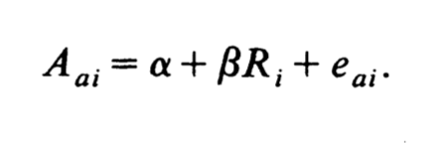

where “A” is a measure of the number of audits a house seeker is allowed by a broker, “e” is an error term, and “R” is a binary variable as to whether or not a house seeker is Black (0=White, 1=Black) (Yinger 1986). Though this model may initially seem to be unrelated to measuring discrimination in the STR market, especially since components in seeking housing in the traditional rental market like these audits are irrelevant in the STR market, one can see how the basic structure of this model could help to quantify such price discrimination. In fact, abstracting the purposes of these variables, this is very similar to what Gilheany et al. and I measured. “A” in this instance would be the weekly prices set for Airbnb units (dependent variable), and the beta would also be a binary variable corresponding to whether a host is White (=0) or not (=1). In either instance, should a negative beta be calculated, one can expect detrimental outcomes as a result of racial prejudice; in the case of Yinger, fewer audits for Black home seekers, in the case of Gilheany et al., lower weekly prices charged by Asian Airbnb hosts.

**CONCLUSION**

Racial discrimination in US housing markets has been consistently demonstrated to leave non-White participants economically disadvantaged. Since the implementation of the Fair Housing Act, urban economists have managed to measure the varied ways that real estate brokers give preferential treatment to Whites over non-Whites; in recent years, subtler forms of discrimination have taken precedent, such as informing non-Whites of fewer listings or less frequently offering assistance to them in exploring financing options, in contrast to behaviors like blatantly refusing to meet for an appointment that have characterized discrimination in previous decades.

Though Airbnb operates as part of a modern STR market, and thus distinguishes itself from “traditional” housing rental and buying markets, it is not exempt from the ways racial discrimination has been shown to plague transactions in the sharing economy. This can occur through indicators of race on both the host and guest end of the transaction, which include a user’s name or a profile picture indicating a non-White physical appearance.

Because literature on economic discrimination has historically centered around Black Americans, as well as the fact that popular perception often dictates Asian Americans do not face economic discrimination to the extent that other minorities do, I decided to test whether pricing differentials exist between Asian American and White Airbnb hosts in the Oakland/Berkeley area of CA. Using a linear-log regression, I found that my hypothesis that Asian American hosts charge lower prices on average turned out to be incorrect. Nevertheless, I question the accuracy of my model for reasons of omitted variable bias as well as a potentially flawed dataset. With this, it is very important in the future that better data be collected examining discrimination against Asian Americans in the Airbnb market, as recent HUD data demonstrates such discrimination in rental markets. For the future, it would be very beneficial if researchers could create a dataset relating White, Black, Latino, *and* Asian Airbnb users, as existing discourse and studies tend to revolve exclusively around a White-Black racial binary. Another step for the future would be to control for location, as none of the studies I have found thus far detailing discrimination faced by Airbnb users successfully control for varying neighborhood/locational attributes.

Ultimately, I believe that though Airbnb may occupy a grey area in its lawfulness of requesting features that indicate a user’s race, such as a profile picture and name, should it wish to maintain a progressive image as a company within a progressive type of economy, it should appropriately respond to these findings of discrimination. In fact, the company has already taken steps lately in an effort to reduce such discrimination, such as announcing that it would minimize the use of photos during the booking process as well as encourage hosts to use a feature that allows guests to instantly book rooms (Besinger 2016).

As it shows little sign of stopping, the sharing economy is likely to face increased forms of regulation in the near future as cities strive to define the legal gray areas it often inhabits. Out of such regulations should come formal legal efforts in order to curb discrimination, similar to the ways in which the Fair Housing Act at least sought to in traditional housing markets.

Bibliography

"Airbnb Tackles Racial Discrimination." The Economist. September 09, 2016. Accessed November 04, 2016. [http://www.economist.com/blogs/gulliver/2016/09/room- inn](http://www.economist.com/blogs/gulliver/2016/09/room-inn).

“CAPACD: Need for Data to Support AAPI Community & Economic Development”. National CAPACD. Washington D.C.: CAPACD. Accessed November 27, 2016.

Bensinger, Greg. "Airbnb Promotes Diversity to Prevent Booking Discrimination by Hosts." Wsj.com. September 08, 2016. Accessed November 27, 2016.

Doleac, Jennifer L., and Luke C.d. Stein. "The Visible Hand: Race and Online Market Outcomes." The Economic Journal 123, no. 572 (November 21, 2013). doi:10.1111/ecoj.12082.

Edelman, Benjamin, and Michael Luca. ["Digital Discrimination: The Case of Airbnb.com."](http://www.hbs.edu/faculty/Pages/download.aspx?name=Airbnb.pdf) Harvard Business School Working Paper, No. 14-054, January 2014.

Edelman, Benjamin, Michael Luca, and Dan Svirsky. "Racial Discrimination in the Sharing Economy: Evidence from a Field Experiment." American Economic Journal: Applied Economics. Accessed November 4, 2016.

Ge, Yanbo, Christopher R. Knittel, Don MacKenzie, and Stephen Zoepf. "Racial and Gender Discrimination in Transportation Network Companies." National Bureau of Economic Research, October 2016. Accessed November 27, 2016.

Gilheany, John, David Wang, and Stephen Xi. "The Model Minority? Not on Airbnb.com: A Hedonic Pricing Model to Quantify Racial Bias against Asian Americans - Technology Science." Technology Science. September 1, 2015. Accessed November 04, 2016.

Huston, Caitlin. "Buying a House as an Airbnb Investment Strategy Is a Risky Move." MarketWatch. September 03, 2016. Accessed November 27, 2016.

Kakar, Venoo, Julisa Franco, Joel Volez, and Julia Wu. "Effects of Host Race Information on Airbnb Listing Prices in San Francisco." Munich Personal RePEc Archive. March 10, 2016. Accessed November 04, 2016.

Mo, Hanying. "Racial Discrimination in the Online Consumer Marketplace.” UC Berkeley Department of Statistics. May 6, 2016. Accessed November 04, 2016.

Nichols, Barbara. "Airbnb Is Crashing the Neighborhood." Realtor Magazine. December 2015. Accessed November 27, 2016.

Oh, Sun Jung, and John Yinger. "What Have We Learned From Paired Testing in Housing Markets?" Syracuse University Working Paper. May 2015. Accessed November 27, 2016.

Ondrich, Jan, Alex Stricker, and John Yinger. "Do Landlords Discriminate? The Incidence and Causes of Racial Discrimination in Rental Housing Markets." Journal of Housing Economics 8, no. 3 (May 14, 1999): 185-204. Accessed November 27, 2016. doi:10.1006/jhec.1999.0249.

Rosen, Kenneth T., Sakamato, Randall, and David Bank. *Short-Term Rentals and Impact on the Apartment Market*. Berkeley: Rosen Consulting Group, October 2013. Accessed November 27, 2016.

Somerville, Heather, and Tina Bellon. "Will Airbnb’s Impact on the Short-term Rental Market Be Its Downfall?" Global News. October 21, 2016. Accessed November 27, 2016.

United States Census Bureau / American FactFinder. “B25031: Berkeley Median Gross Rent by Bedrooms” *2015 American Community Survey*. U.S. Census Bureau’s American Community Survey Office, 2015. Web. Accessed November 27, 2016.

United States Census Bureau / American FactFinder. “B25031: Oakland Median Gross Rent by Bedrooms” *2015 American Community Survey*. U.S. Census Bureau’s American Community Survey Office, 2015. Web. Accessed November 27, 2016.

US Census Bureau Public Information Office. "2010 Census Shows America's Diversity - 2010 Census - Newsroom - U.S. Census Bureau." Census.gov. 2010. Accessed November 27, 2016.

Yinger, John. "Measuring Racial Discrimination with Fair Housing Audits." The American Economic Review 76, no. 5 (December 1986): 881-93. Accessed November 27, 2016. JSTOR.

APPENDIX: TABLES AND FIGURES

Figure 1: Racial Breakdown of Alameda County (“race alone or in combination with one or more other races”).

Source: U.S. Census Bureau. (2007, January 12). *ACS Demographic and Housing Estimates 2014: Alameda County, CA.* Retrieved November 27, 2016, from http://factfinder.census.gov/bkmk/table/1.0/en/ACS/14_5YR/DP05/0500000US06001.

Note: Gilheany et al. did not provide information on the exact zip codes they used to obtain their data. Therefore, the demographic data of their zip codes is not identical to the data below, but likely very similar as both Berkeley and Oakland are located within Alameda County.

Figure 2: Distribution of number of bathrooms. Distribution skewed very right, “1” is by far the most frequently occurring value.

Figure 3: Distribution of maximum occupancy allowed. Skewed right.



Figure 4: Distribution of the cost per week of a unit. Skewed right.



Figure 5: Distribution of binary variable indicating 0 = White host, 1 = Asian host. Only 2 values, many more White hosts than Asian hosts in sample.



Figure 6: Distribution of prices per week for White hosts. Skewed right.

Figure 7: Distribution of prices per week for Asian hosts. Bimodal distribution.



Figure 8: Summary statistics of data.

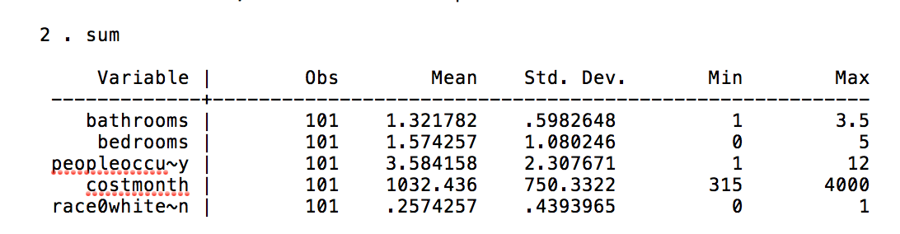

Figure 9: Weekly rental prices for White hosts.

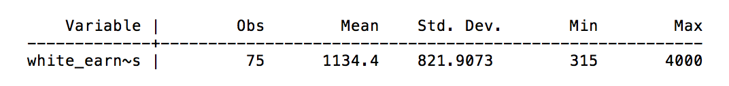

Figure 10: Weekly rental prices for Asian hosts.

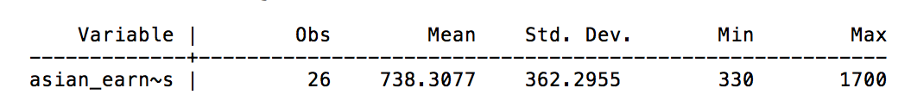

Figure 11: Difference of means test between weekly rental costs for Asian and White hosts.

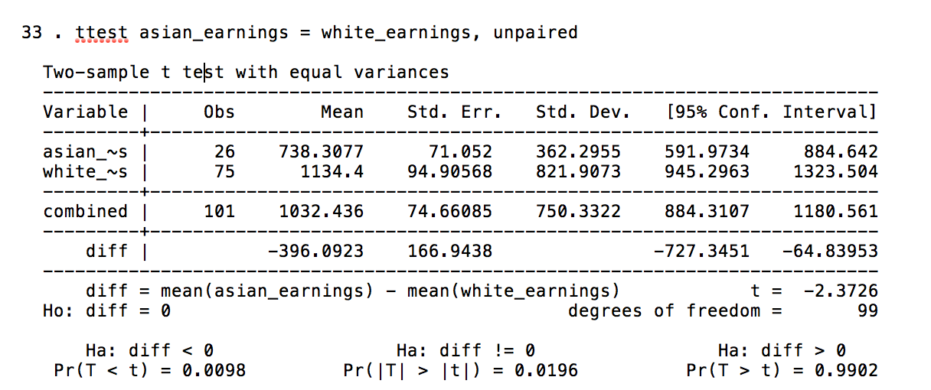

Figure 12: Original output Gilheany (top) et al. vs. replicated output (bottom).

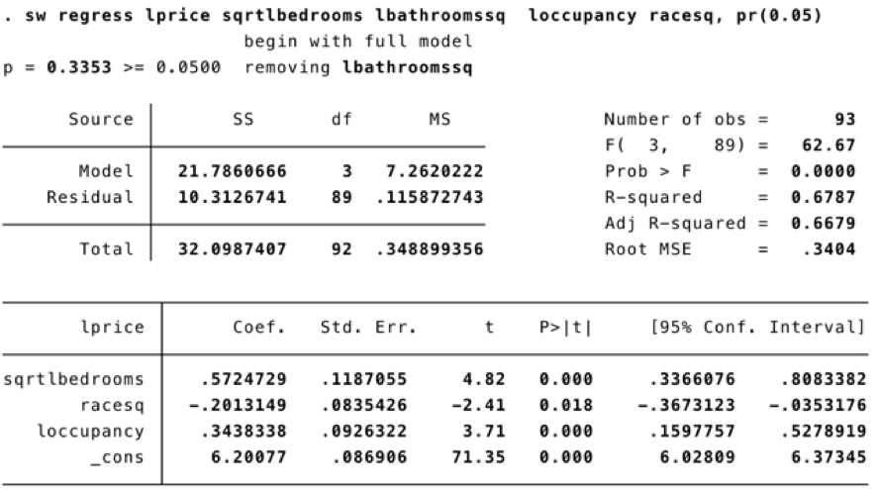

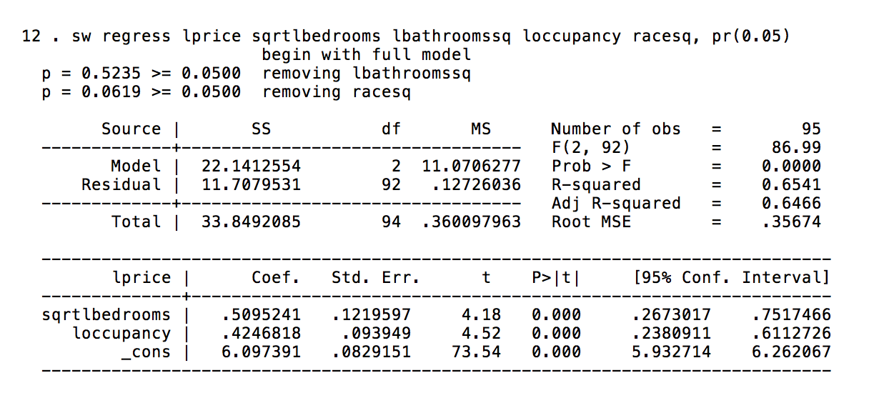

Figure 13: Two-way scatterplots using values of dependent variable and regressors of occupancy and bedrooms.





Figure 14: Linear model estimated using OLS and robust standard errors.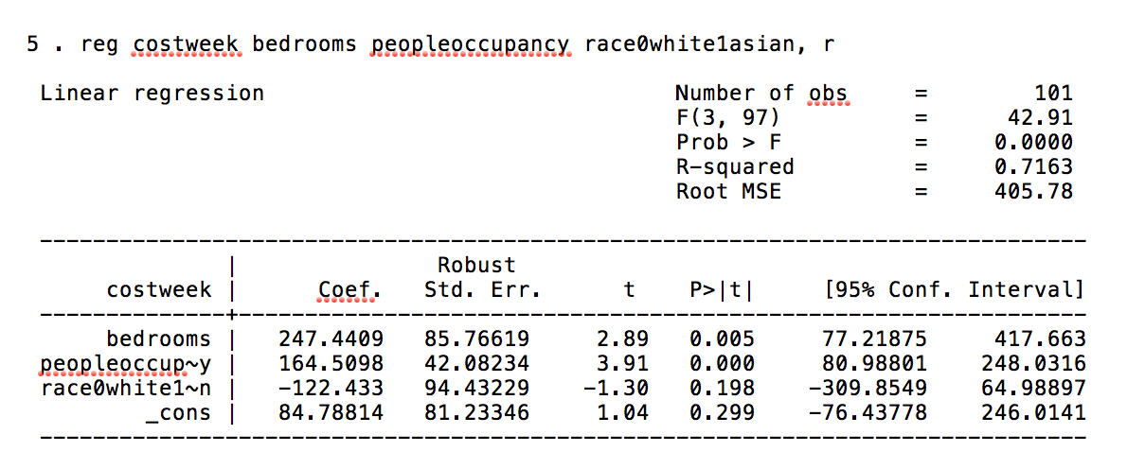

Figure 15: Polynomial model using robust standard errors. Interaction term included.

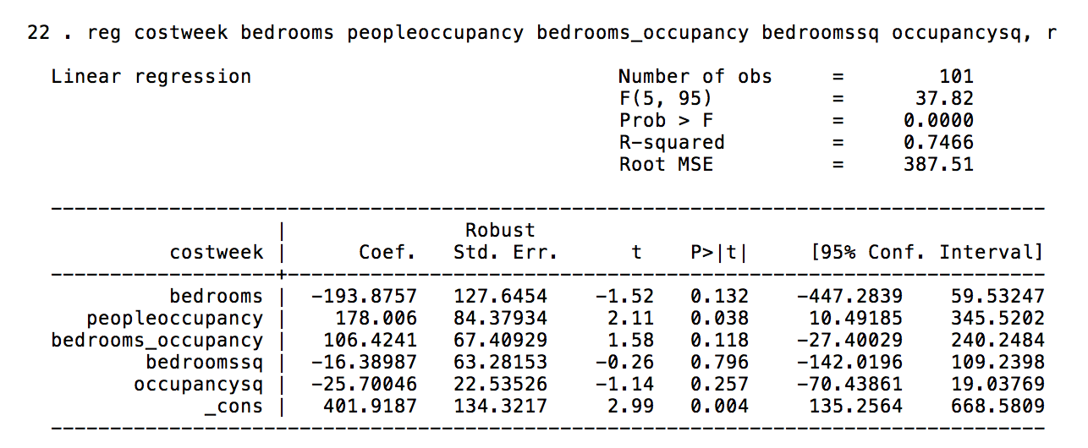

Figure 16: Linear-log model, robust standard errors.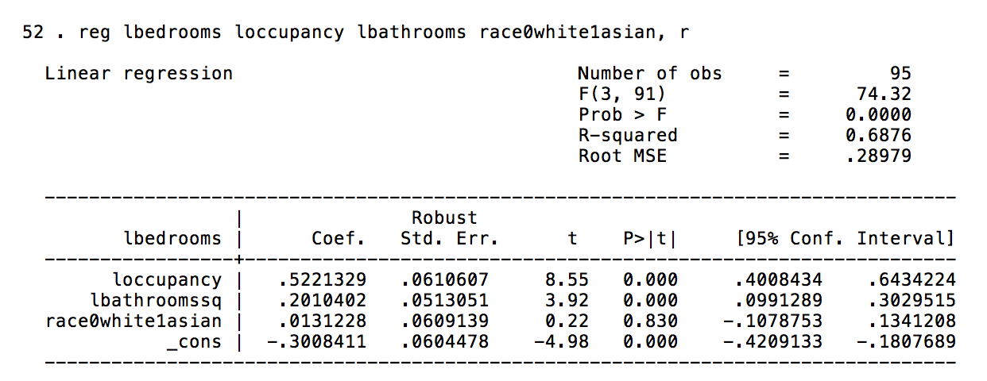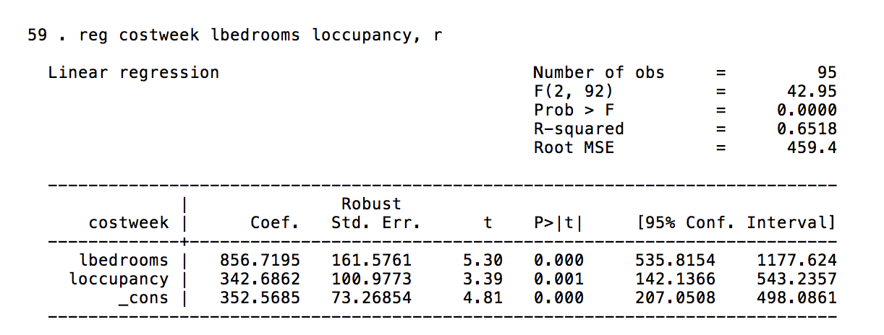

Figure 17: Breusch-Pagan / Cook-Weisberg test for heteroscedasticity.

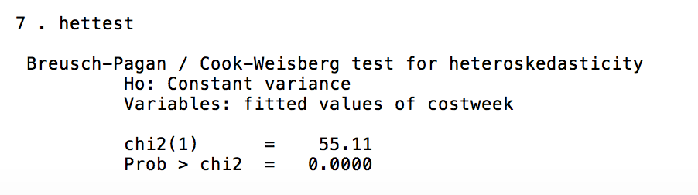

Figure 18: Correlation matrix between ln(bedrooms) and ln(occupancy).