Lab 8 –Java GUI Development
Answer the following questions.

Instructor-led Demo:

- Write a program that creates a JFrame for system login. The form/UI has username and password textfields, and a login button. Display a message box when the button is clicked. Note that the login authentication or authorisation can be hardcoded in this demo.

Exercise:

- Write a program that adds a group of radio buttons to select background colours. The available colours are red, yellow, white, gray, and green.

- Write a program that creates a simple calculator performs add, subtract, multiply and divide operations.

- Write a program that converts miles and kilometres. If you enter a value in the Mile text field and press that Enter key, the corresponding kilometre is displayed in the Kilometer text field.

- Write a program that calculates the future value of an investment at a given interest rate for a specified number of years. The formula for the calculation is as follows:

futureValue = investmentAmount * (1 + montlyInterestRate)^{years*12}
Use text fields for interest rate, investment amount, and years. Display the future amount in a text field when the user clicks the Calculator button.
- Create a JFrame form that display the following JComponent objects (JLabel, JTextField, JButton, and JTable).
Handle the events for Add, Edit and Delete buttons.
- The Add button inserting each JTextField's value to a row of JTable.
- The Edit button modifying the record in the JTable.
- The Delete button removing the record of JTable.

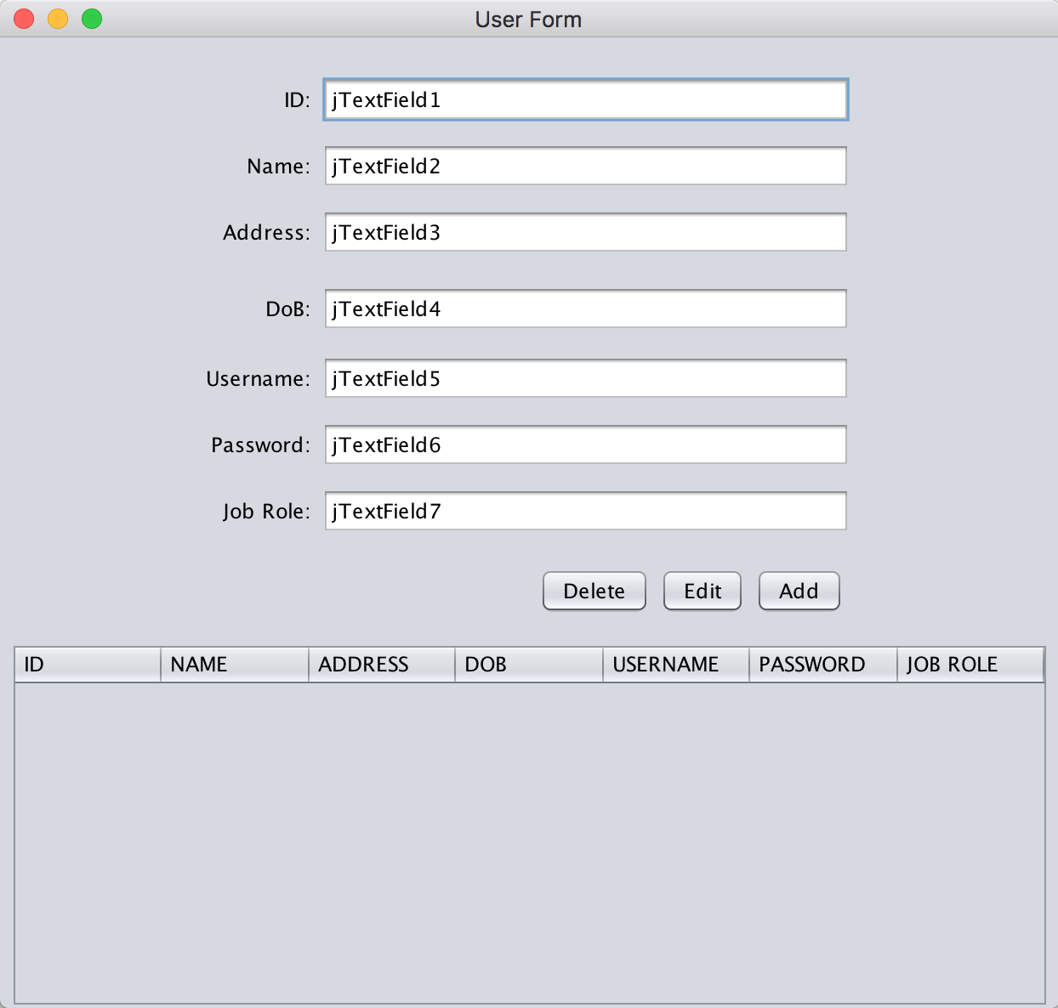
Figure 1: User Form
Reference:

JTable class
https://docs.oracle.com/javase/7/docs/api/javax/swing/JTable.html

DefaultTableModel class
https://docs.oracle.com/javase/7/docs/api/javax/swing/table/DefaultTableModel.html

