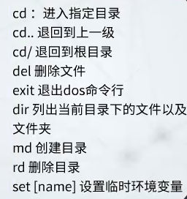

Window上没有telnet

https://jingyan.baidu.com/article/ed15cb1b76b6021be2698110.html