# Ip

## Ping连接

查看与某台机器的连接情况：ping

## ifconfig网络通信命令

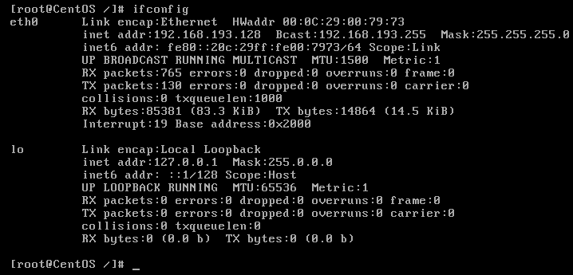查看当前系统的网卡信息：ifconfig

## Ip addr

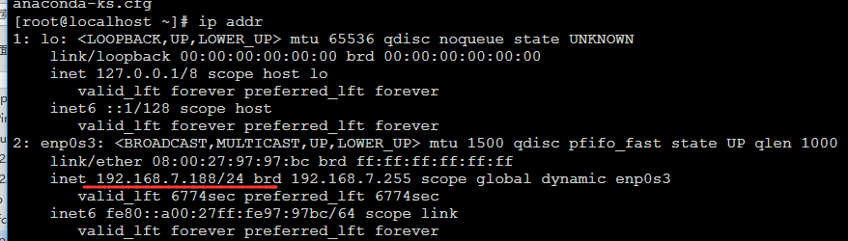

## 问题

### 没有ifconfig命令

https://blog.csdn.net/ryu2003/article/details/78492127

# http

## curl

### 作用

测试协议

### 测试es

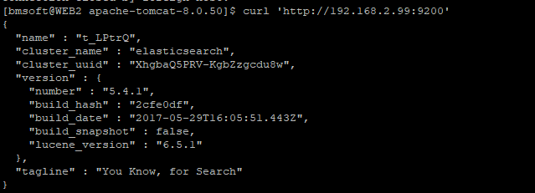

### 测试项目启动没有

### 应用

https://www.cnblogs.com/guixiaoming/p/8507268.html

#### Post 指定类型

curl -H "Content-Type:application/json" -X POST "http://pom.beijingcloud.com.cn:8080/TrinityAres-POM/jcjg/api/cm/getBaseAccountList"

#### Post 带参数指定类型

curl -H "Content-Type:application/json" -X POST --data '{"accountCode":"22_RMTWZ_BJDCOMCN_00_110000","startTime":"2018-11-10 20:00:10","endTime":"2019-11-10 20:00:10","pageSize":12,"pageIndex":1}' "http://pom.beijingcloud.com.cn:8080/TrinityAres-POM/jcjg/api/cm/getSpiderResultList"