# Cenos7绿色安装

## 安装

<https://www.cnblogs.com/daemon-/p/9009360.html>

# 问题

## Mmp 一定先关闭防火墙

## Mysql5.7 修改密码

update user set authentication_string=password('root') where user='root' and host='localhost';

https://my.oschina.net/u/3292411/blog/903942

## Warning: admin-server.service changed on disk. Run 'systemctl daemon-reload' to reload units.

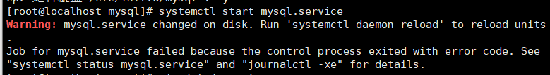

https://blog.csdn.net/shimengran107/article/details/81094419

## 问题

### 问题：The server quit without updating PID file错

https://blog.csdn.net/aa464971/article/details/52976230

### 问题/var/run/mysqld/mysqld.pid)

https://blog.csdn.net/purplegalaxy/article/details/48292083

### 问题'/var/lib/mysql/mysql.sock' (2)

mysql服务启动却连接不上的解决方法

https://www.jb51.net/article/109944.htm

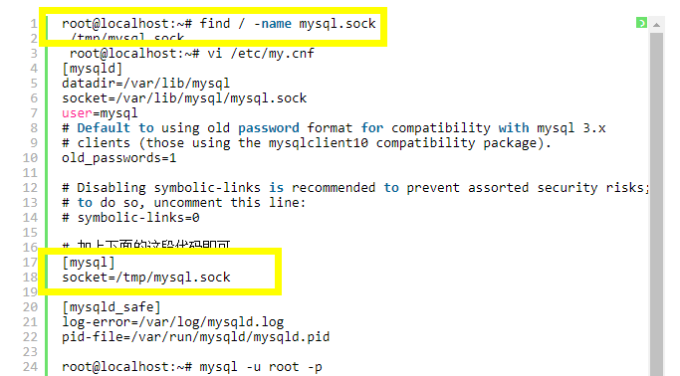

https://blog.csdn.net/a1173537204/article/details/88069724

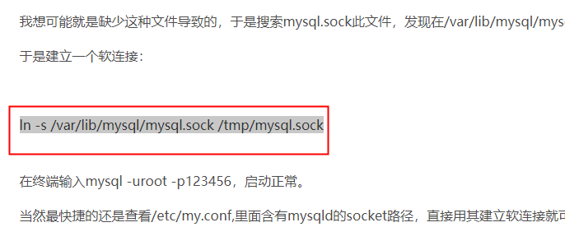

### ERROR! MySQL server PID file could not be found!



解决：在mysql目录下，chmod +x *

