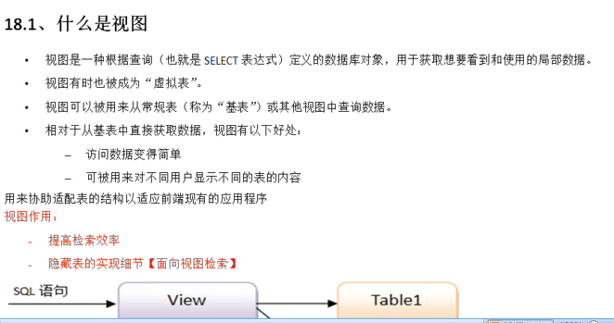

# 一个测试demo

## 表

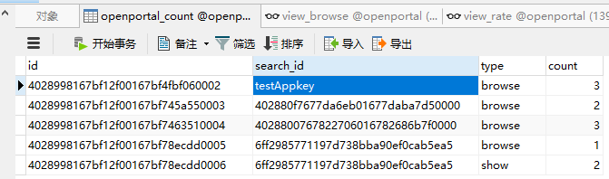

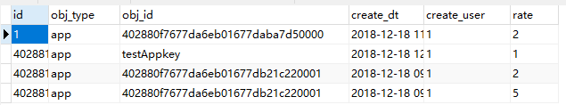

## 结果

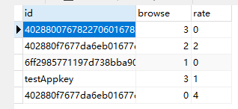

## 视图

### view_rate

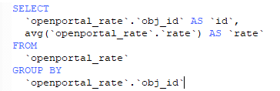

### view_browse

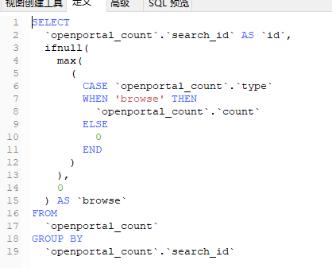

### view_browse_rate

左联接加右链接 union

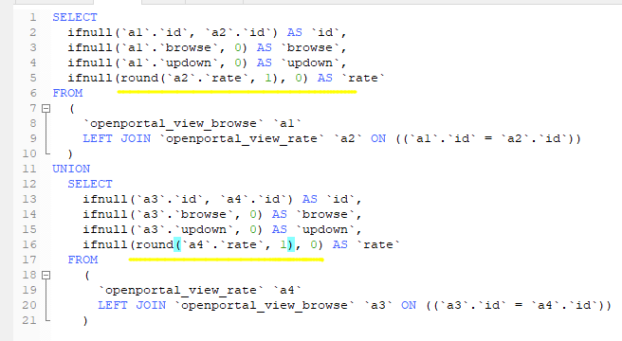

# 问题

## View's SELECT contains a subquery in the FROM clause

<https://blog.csdn.net/simplecnpay/article/details/39251667>