参考文档https://blog.csdn.net/sinat_27406925/article/details/77507478

## Demo

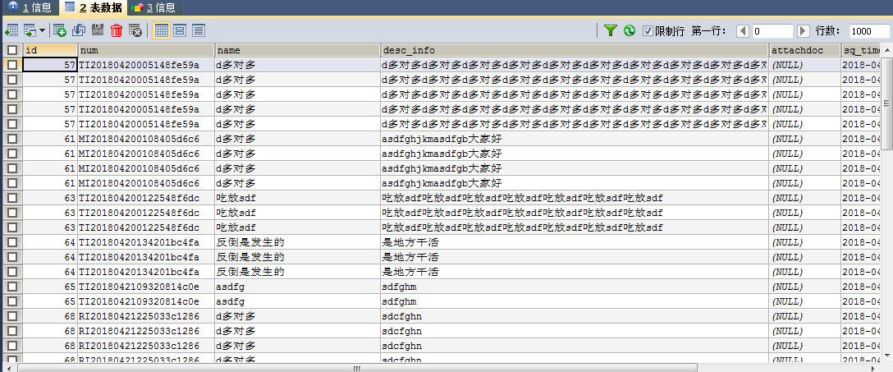

CREATE VIEW `view_project_info` AS

SELECT p.id AS id,p.num AS num,p.name AS NAME,p.desc_info AS descInfo,p.attachdoc AS attachdoc,p.sq_time AS sqTime,

p.progress_status AS progressStatus,p.apply_status AS applyStatus,

MAX((CASE p.user_level WHEN 1 THEN p.user_num END)) AS compareNum,

MAX((CASE p.user_level WHEN 1 THEN p.real_name END)) AS compareRealName,

MAX((CASE p.user_level WHEN 2 THEN p.user_num END)) AS memberOneNum,

MAX((CASE p.user_level WHEN 2 THEN p.real_name END)) AS memberOneRealName,

MAX((CASE p.user_level WHEN 3 THEN p.user_num END)) AS memberTwoNum,

MAX((CASE p.user_level WHEN 3 THEN p.real_name END)) AS memberTwoRealName,

MAX((CASE p.user_level WHEN 4 THEN p.user_num END)) AS teacherNum,

MAX((CASE p.user_level WHEN 4 THEN p.real_name END)) AS teacherRealName,

MAX((CASE p.user_level WHEN 4 THEN p.xg_time END)) AS teacherXgTime,

MAX((CASE p.user_level WHEN 4 THEN p.finalre_jection END)) AS teacherFinalreJection,

MAX((CASE p.user_level WHEN 5 THEN p.user_num END)) AS examineNum,

MAX((CASE p.user_level WHEN 5 THEN p.real_name END)) AS examineRealName,

MAX((CASE p.user_level WHEN 5 THEN p.xg_time END)) AS examineXgTime,

MAX((CASE p.user_level WHEN 5 THEN p.finalre_jection END)) AS examineFinalreJection

FROM view_pro_info AS p

GROUP BY p.num

ORDER BY p.sq_time

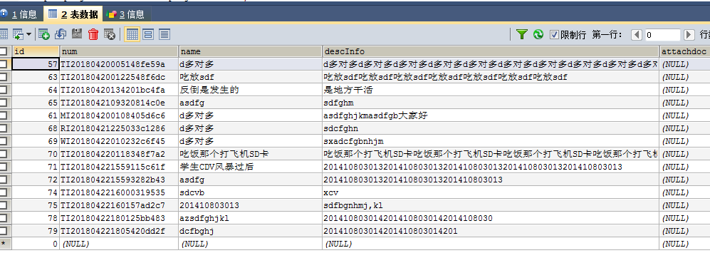

CREATE VIEW v_project_invest AS

SELECT fill_date,xzqy_dm,team_code,

case project_nature when 'QY_10' then SUM(investment_total) else 0 end as gykg,

case project_nature when 'QY_11' then SUM(investment_total) else 0 end as gydz,

case project_nature when 'QY_12' then SUM(investment_total) else 0 end as zwhz,

case project_nature when 'QY_13' then SUM(investment_total) else 0 end as zrrtzhkg,

case project_nature when 'QY_14' then SUM(investment_total) else 0 end as jtsyz,

case project_nature when 'QY_15' then SUM(investment_total) else 0 end as wsdz,

SUM(IFNULL(abroad_capital, 0)/100*investment_total) as wz,

SUM(IFNULL(home_capital, 0)/100*investment_total) as nz

FROM v_pp_pi_month vppm

WHERE 1=1 -- fill_date = date_format(DATE_SUB(STR_TO_DATE(now(), '%Y-%m-%d'),INTERVAL 1 MONTH),'%Y-%m')

AND project_nature IS NOT NULL

AND xzqy_dm IS NOT NULL

AND team_code IS NOT NULL

AND fill_date IS NOT NULL

GROUP BY fill_date,xzqy_dm,team_code,project_nature

