# Spring boot打包

## 无引导类打包- spring-boot-maven-plugin

https://blog.csdn.net/sinat_38570489/article/details/89504048

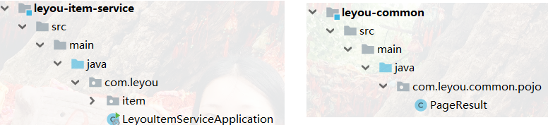

Springboot 打包有引导类

<**plugin**>  
 <**groupId**>org.springframework.boot</**groupId**>  
 <**artifactId**>spring-boot-maven-plugin</**artifactId**>  
</**plugin**>

没有引导类

<**plugin**>  
 <**groupId**>org.springframework.boot</**groupId**>  
 <**artifactId**>spring-boot-maven-plugin</**artifactId**>  
 <**executions**>  
 <**execution**>  
 <**phase**>none</**phase**>  
 </**execution**>  
 </**executions**>  
 <**configuration**>  
 <**classifier**>execute</**classifier**>  
 </**configuration**>  
</**plugin**>

## 建立 Spring Boot 项目时，当父依赖不再是 spring-boot-starter-parent 怎么办

https://blog.csdn.net/panchang199266/article/details/84026199