原理图
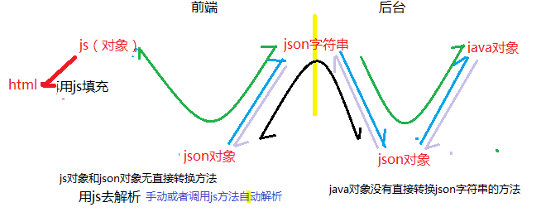

Jackson

springmvc
SpringMVC传回来的是字符,但是在success回调函数被调用前将其转换成json对象然后传给了data,所以data就是封装后的json对象,可以直接通过对象的方式获取值

demo

Jar包
<dependency>
<groupId>com.fasterxml.jackson.core</groupId>
<artifactId>jackson-databind</artifactId>
</dependency>
<dependency>
<groupId>com.alibaba</groupId>
<artifactId>fastjson</artifactId>
</dependency>

转换器
ObjectMapper mapper = new ObjectMapper(); //转换器

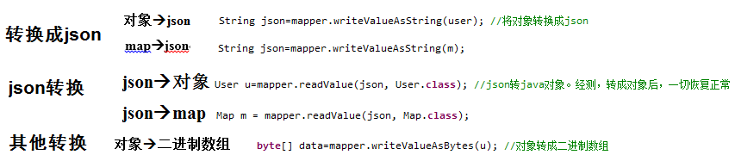

注意
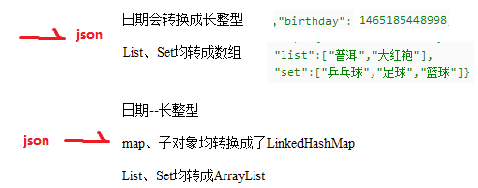

Json 改变值

https://www.iteye.com/blog/wangxinchun-2310812

ObjectMapper mapper = new ObjectMapper();
mapper.configure(JsonParser.Feature.ALLOW_UNQUOTED_FIELD_NAMES, true);
mapper.configure(JsonParser.Feature.ALLOW_SINGLE_QUOTES, true);
mapper.configure(JsonParser.Feature.ALLOW_COMMENTS, true);
mapper.configure(JsonParser.Feature.ALLOW_UNQUOTED_CONTROL_CHARS, true);
mapper.setVisibility(PropertyAccessor.FIELD, Visibility.ANY);
mapper.addMixIn(Object.class, PropertyFilterMixIn.class);

FilterProvider filters = new SimpleFilterProvider().addFilter(
"propertyFilterMixIn", new SimpleBeanPropertyFilter() {
@Override
public void serializeAsField(Object pojo,JsonGenerator jgen,SerializerProvider provider,PropertyWriter writer) throws Exception {
String fieldName = writer.getName();
if (finalApiBodyPermits.containsKey(fieldName)) {
writer.serializeAsField(desens(pojo, fieldName),jgen, provider);
} else {
writer.serializeAsField(pojo, jgen,provider);
}
}
});
mapper.setFilterProvider(filters);

result = mapper.writeValueAsString(returenObj);

工具类
参看：

