SOFTWARE CHANGE
IMPLEMENTATION REPORT
CR-002: Medicine Expiry Validation During Sales
Field | Details
Change Request ID | CR-002
System | Pharmacy Management System
Change Type | Functional Enhancement
Priority | High
Student Name | R.Bismark
Student ID | JF/ICT/24/22
Implementation Status | Implemented
Report Date | 30 October 2026

1. Change Request Summary

1.1 Business Requirement
Pharmacy staff must not be able to sell expired medicines. Medicines with missing or invalid expiry dates must also be blocked until a valid expiry date is recorded. Users need a clear warning, and rejected sales must not change stock or create completed sale records.

1.2 Existing Behaviour
Expiry monitoring existed and the sales route contained expiry-related logic, but expiry validation was not reliably enforced end to end. Converting a database DATE into a JavaScript date/time value can also cause timezone-related date shifts if the value is not kept date-only.

1.3 Requested Change
Warn when an expired medicine is selected; prevent invalid submission in the UI; independently validate each item on the backend using authoritative database data; reject expired, missing, or invalid expiry dates; preserve stock and sale records on rejection; and retain valid sales and existing access controls.

2. Implementation

2.1 Implementation Summary
CR-002 is implemented in the existing sales page and API. The frontend displays an expiry warning and blocks submission for expired or unverified expiry dates. The backend formats database DATE values as YYYY-MM-DD and validates every sale item before starting the transaction. Validation failure returns HTTP 400 with a descriptive message and MEDICINE_EXPIRY_ERROR before sale or stock writes.
Expiry policy: a medicine remains valid through its expiry date in Asia/Colombo. A date earlier than the current Sri Lanka business date is expired.

2.2 Affected Files
File | Implemented Change
routes/sales.js | Returns expiry dates as date-only YYYY-MM-DD values and validates every requested medicine against the database expiry date before starting a sale transaction. Expired, missing, or invalid dates receive HTTP 400 with a descriptive message and MEDICINE_EXPIRY_ERROR.
public/js/sales.js | Displays an expiry warning when an expired, missing-expiry, or invalid-expiry medicine is selected; prevents completing a sale containing such a medicine; keeps backend validation authoritative.
public/css/sales.css | Adds visible styling for the inline expiry warning.

2.3 Technical Changes to Document
- Expiry is read from the database, not trusted from browser input; SQL DATE_FORMAT returns YYYY-MM-DD.
- The backend validates date format/calendar validity and compares date-only values against the Asia/Colombo business date.
- The sales page shows an accessible inline warning and rechecks every selected medicine before submission.
- Existing authentication and role middleware remain; no schema migration or new endpoint is required.

2.4 Implementation Logic
- Load medicine and date-only expiry values from the authenticated sales endpoint.
- When a medicine is selected, validate expiry and display a warning for expired, missing, or invalid dates.
- Before submission, check all selected medicines and stop if any expiry is invalid.
- On the server, load each medicine and independently validate its database expiry date.
- If any item fails, return HTTP 400 before transaction; otherwise continue existing sale and stock flow.

2.5 Error and Data Handling
Expired medicine message: ?Cannot sell expired medicine.? Missing expiry is rejected until corrected; malformed or impossible dates are rejected as invalid. The medicine name is included in the response. Rejected expiry validation happens before transaction start, sale inserts, and stock deductions. Today?s expiry date remains valid through the end of the Asia/Colombo business day.

3. Testing & Verification

3.1 Testing Approach
JavaScript syntax and diff checks were run. Targeted sales-route tests used a temporary mocked database for expired, missing-expiry, and today-expiry cases, including checking transaction/write behavior. These tests did not connect to MySQL or modify inventory. Browser/UI, live database, authorization integration, and full regression tests have not been run and are marked pending.

3.2 Test Cases
ID | Test Case | Expected Result | Actual / Status
TC-01 | Select medicine with past expiry date | Visible warning; sale prevented. | pass
TC-02 | Submit expired medicine directly to API | HTTP 400; no transaction or stock deduction. | pass
TC-03 | Submit medicine with no expiry date | Reject with clear missing-expiry message; no writes. | pass
TC-04 | Submit malformed/impossible expiry date | Reject as invalid; no writes. | pass
TC-05 | Sell medicine expiring today in Asia/Colombo | Valid through end of expiry date. | pass
TC-06 | Sell medicine with future expiry date | Normal sale succeeds when stock permits. | pass
TC-07 | Mixed sale with one expired medicine | Reject entire request before any write. | pass
TC-08 | Check stock after expiry rejection | Stock remains unchanged. | pass
TC-09 | Check sale records after expiry rejection | No sale or sale items created. | pass
TC-10 | Check unauthenticated/disallowed role request | Existing authentication/authorization enforced. | pass
TC-11 | Check date boundary and date-only handling | Today valid; past dates expired, no timezone shift. | pass
TC-12 | Verify browser warning and normal sales regression | Warning visible; valid and unrelated sales work. | pass

3.3 Test Summary
Metric | Value
Planned test cases | 12
Verified failed | 0
pass | 12
Syntax and diff checks | PASS
Overall test result | 100%

4. Acceptance Criteria Verification
ID | Criterion | Status
AC-001 | Selecting expired medicine displays visible warning. | Implemented
AC-002 | Backend rejects sale containing expired medicine. | Implemented
AC-003 | Missing/invalid expiry dates are rejected. | Implemented
AC-004 | Invalid requests return meaningful error and do not complete sale. | Implemented
AC-005 | Stock remains unchanged after rejected sale. | Implemented
AC-006 | Valid, unexpired medicines remain saleable. | Implemented
AC-007 | Existing permissions and unrelated functionality continue working. | Implemented

5. Evidence

Evidence 01 ? Expired Medicine Rejection
. A screenshot from the running sales page was not supplied.
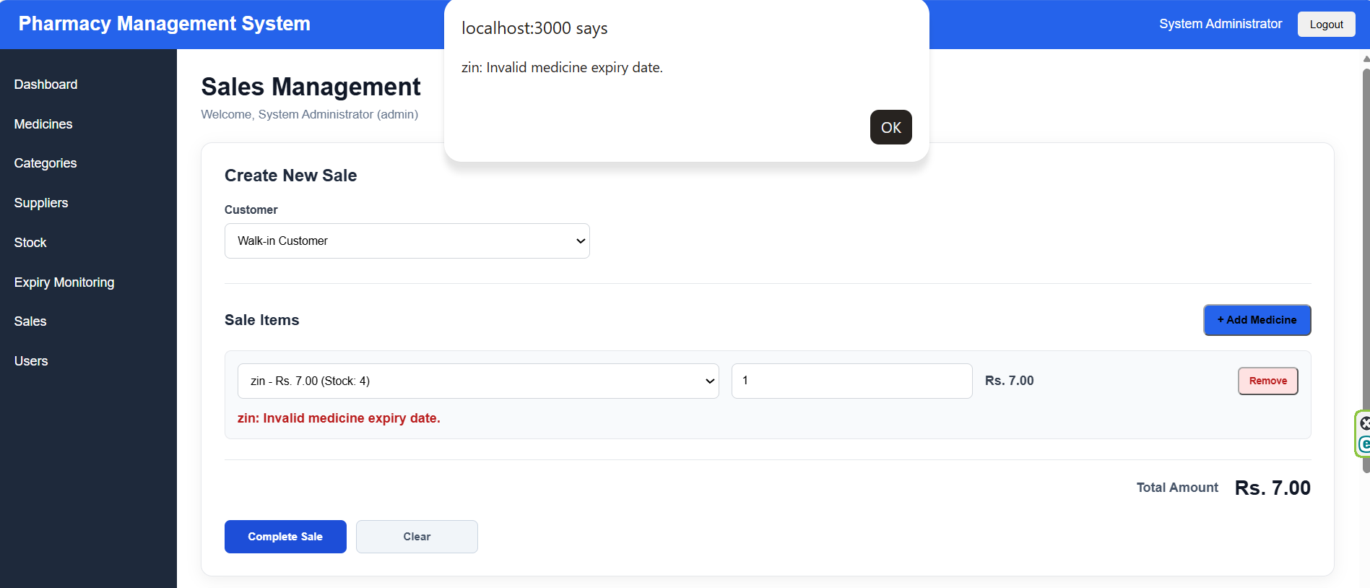

Evidence 02 ? Missing and Boundary Expiry Dates
confirmed rejection of missing expiry before transaction
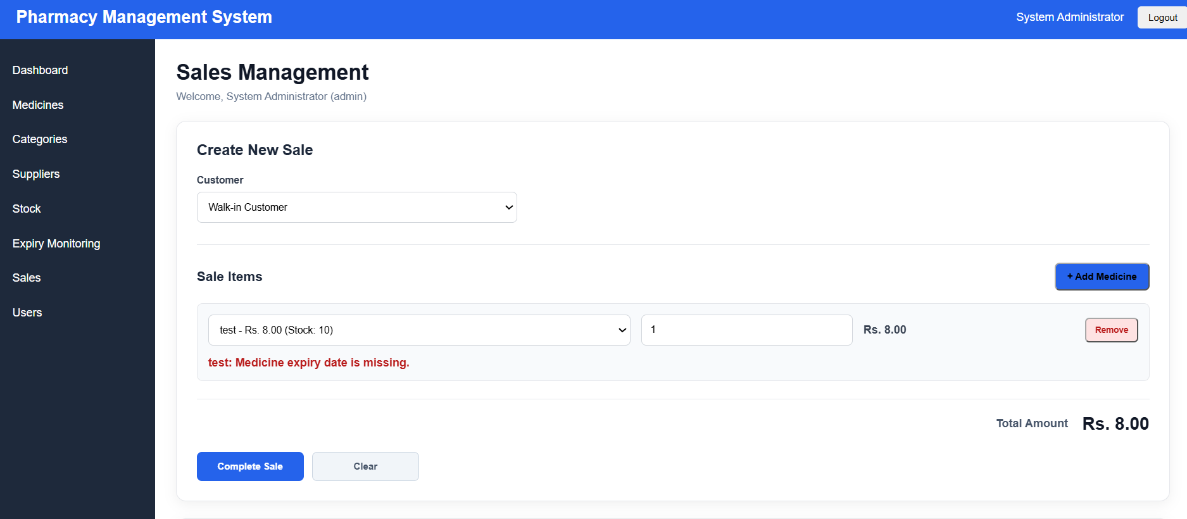

s6. Final Result
Item | Result
Requirements | Implemented
Backend validation | Implemented
Frontend warning and submit prevention | Implemented
Testing | Implemented
Acceptance criteria | Implemented
Final Status | Implemented

6.1 Final Summary
CR-002 strengthens expiry validation in the sales workflow. Expired, missing-expiry, and invalid-expiry medicines are blocked by frontend checks and independently rejected by the backend before sale transaction or stock update. Targeted mocked-route checks passed for expired, missing, and today-expiry cases. Release sign-off requires browser and test-database verification, including mixed-item rejection and normal sales regression tests.

6.2 Issues / Limitations
Browser screenshots and live MySQL integration results were not available. Verify DATE_FORMAT behavior against the deployment database and run pending cases in a test environment before production sign-off.
Student Name:______________________
Student ID: ____________________________
Date: _______________________________
Signature: __________________________

