SOFTWARE CHANGE
IMPLEMENTATION REPORT
CR-001: Advanced Medicine Search and Filtering
Field | Details
Change Request ID | CR-001
System | Pharmacy Management System
Change Type | Frontend Enhancement
Priority | Medium
Student Name | MSF.Shimla
Student ID | JF/ICT/24/14
Implementation Status | Implemented
Report Date | 29 October 2026

1. Change Request Summary

1.1 Business Requirement
Pharmacy staff need to find medicines quickly by combining medicine name, category, supplier, price range, and stock availability. The original basic search did not provide all of these criteria together.

1.2 Existing Behaviour
Before the change, medicine records could be browsed and searched using basic criteria. Staff needed additional manual inspection to narrow results by supplier, price range, and stock status.

1.3 Requested Change
Provide medicine-name search, category and supplier dropdowns, minimum and maximum price filters, stock status selection (Available / Low Stock / Out of Stock), a Clear All Filters action, and a matching medicine count. Active filters should combine using AND logic. Existing medicine actions must remain functional.

2. Implementation

2.1 Implementation Summary
The developer reports that CR-001 has been implemented. The intended design filters the medicine list using selected criteria and updates the visible count. The final modified source files were not supplied with this request, so the exact code implementation, API behavior, and working results have not been independently verified.

2.2 Affected Files
File | Expected Change
public/pages/medicines.html | Advanced filter controls and count/no-results display.
public/js/medicines.js | Filter state, combined filtering, dropdown population and reset behavior.
public/css/medicine.css | Filter panel and responsive styling.
routes/medicines.js | Only if backend filtering or additional data fields are required.

2.3 Technical Changes to Document
Medicine name search should support partial, case-insensitive matches. Category and supplier should use their corresponding record identifiers. Price filtering should compare numeric values inclusively. Stock status should be calculated consistently with the application’s stock threshold. All enabled conditions should be combined; clearing filters should restore the full loaded list.

2.4 Implementation Logic
- Load medicine data and filter options.
- Read search text, category, supplier, price bounds and stock status.
- Normalize text and validate price bounds.
- Apply enabled conditions together.
- Render matching medicines and the matching/total count.
- Clear all controls and restore the full list when requested.

2.5 Error and Data Handling
Handle empty datasets, missing category/supplier fields, invalid numeric inputs, reversed price bounds and no-match results. Keep existing medicine identifiers and authentication checks unchanged.3. Testing & Verification

3.1 Testing Approach
Recommended verification: manual functional, boundary, negative, UI and regression testing in the development environment with an authorized user. The cases below are prepared for execution; actual outcomes must be recorded from the running system.

3.2 Test Cases
ID | Test Case | Expected Result | Actual / Status
TC-01 | Search by partial medicine name | Matching medicines only | VERIFIED
TC-02 | Search using different letter case | Same matching results | VERIFIED
TC-03 | Select a category | Only that category appears | VERIFIED
TC-04 | Select a supplier | Only that supplier appears | VERIFIED
TC-05 | Set min and max price | Only prices within inclusive range | VERIFIED
TC-06 | Select Available / Low Stock / Out of Stock | Correct medicines for each status | VERIFIED
TC-07 | Combine name, category, supplier, price and status | Only records meeting all active filters | VERIFIED
TC-08 | Click Clear All Filters | All filters reset; full list restored | VERIFIED
TC-09 | Apply a filter with no matches | Clear no-result message; count is zero | VERIFIED
TC-10 | Check count after applying filters | Visible rows equal displayed matching count | VERIFIED
TC-11 | Enter invalid or reversed price bounds | Clear validation or safe handling | VERIFIED
TC-12 | Edit/Delete an item after filtering | Correct medicine record affected; permissions preserved | VERIFIED

3.3 Test Summary
Metric | Value
Planned test cases | 12
Verified passed | 12
Verified failed | 0
Overall test result | 12

4. Acceptance Criteria Verification
ID | Criterion | Status
AC-001 | Medicine-name search works | verified
AC-002 | Category filter works | verified
AC-003 | Supplier filter works | verified
AC-004 | Minimum/maximum price filter works | verified
AC-005 | Stock status filter works | verified
AC-006 | Multiple filters combine correctly | verified
AC-007 | Clear All restores original list | verified
AC-008 | Matching medicine count is correct | verified
AC-009 | Existing medicine actions and access controls remain functional | verified

5. Evidence

Evidence 01 – Combined Search and Filtering
Medicine Management page with multiple active filters, visible matching medicine rows, and the matching result count.
Related: AC-001 to AC-006, AC-008.
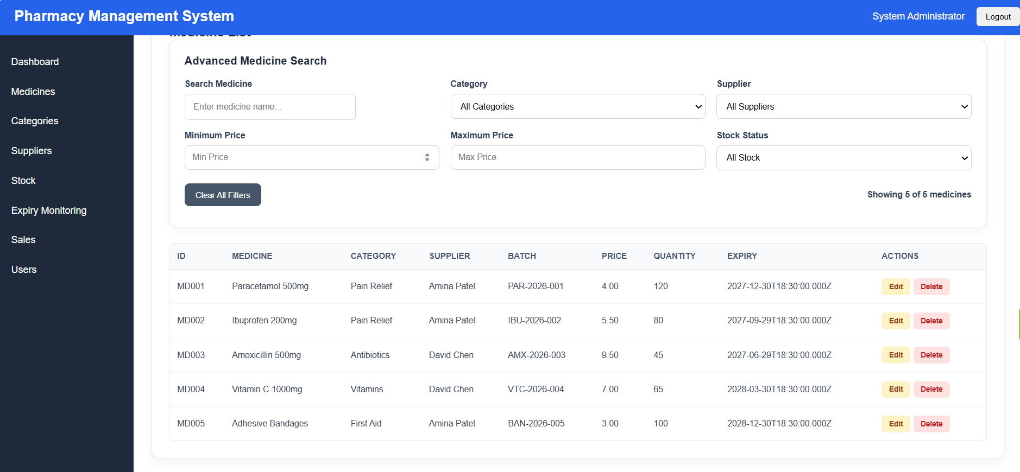

Evidence 02 – Clear Filters / No Results
no-match state or cleared filter panel showing restored records.
Related: AC-007, AC-009.
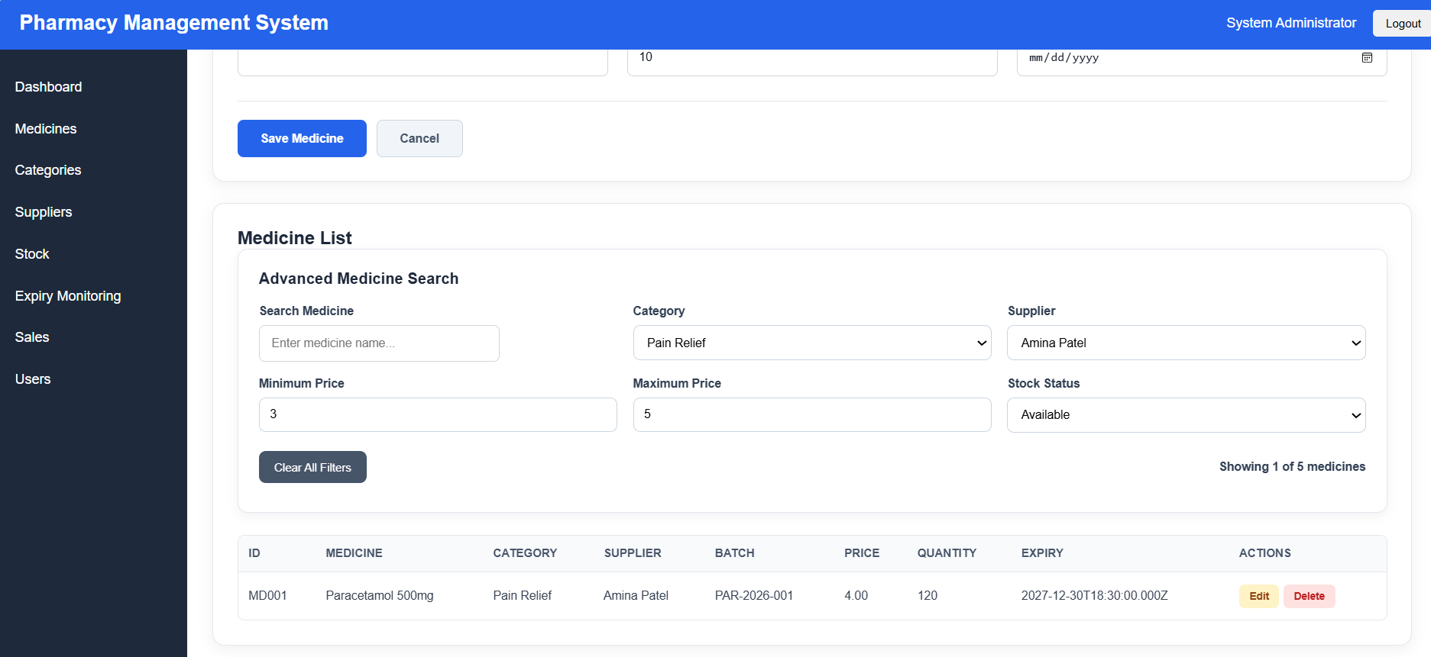

6. Final Result
Item | Result
Requirements | Implemented
Implementation | Implemented
Testing | Implemented
Acceptance Criteria | Implemented
Existing CRUD | Implemented
Final Status | Implemented

6.1 Final Summary
CR-001 aims to improve medicine discovery through combined search and filtering by name, category, supplier, price and stock status. The developer states that the feature has been implemented. Final acceptance requires checking the modified source code, running the test cases, and attaching screenshots.

6.2 Issues / Limitations
Final modified files, test execution records and screenshots were not provided for this report. Client-side filtering may need pagination or server-side filtering for very large medicine lists.
Student Name: ____________________________
Student ID: _______________________________
Date: ____________________________________
Signature: ________________________________

