Package with plastic box
No instruction supply

Package includes:

1 x Project Box (22.5*15.5*6cm)
1 x UNO R3 Compatible Board
1 x USB Cable
1 x 1 digit 7-segment Display
1 x 4 digit 7-segment Display
1 x Dot Matrix Display 8x8
1 x Shift Resister 74HC595N
1 x Foam Pad
1 x Stepper Motor
1 x DC Motor
1 x Servo Motor (SG90)
1 x Remote
1 x LCD1602 Character Display
1 x Stepper Motor Driver Board
1 x Arduino Extended Board
1 x 830 Holes Breadboard
10 x Resistor (220Ω)
10 x Resistor (330Ω)
10 x Resistor (1k)
10 x Resistor (4.7k)
10 x Resistor (10k)
1 x 9V Battery Connection for Ardunio
1 x Ultrasonic Sensor
1 x Active buzzer
1 x Passive buzzer
1 x Potentiometer
2 x Infrared emitter
1 x Infrared receiver
2 x Photosensitive resistor
1 x Arduino IR receiver
1 x Temperature sensor LM35
2 x Vibration switch SW-520D
1 x Electronic component box
4 x NPN Transistor (S8050)
4 x PNP Transistor (S8550)
4 x Big Key
4 x Key Cap
1 x 40Pin Header
10 x Red LED
10 x Green LED
10 x Blue LED
49 x 12cm Jumper Wire (Male to Male)
20 x Dupont wire (Female to Male)
1 x Breadboard Power Supply
1 x Fan
1 x RC522 RFID
1 x Color Ring Card
1 x Joystick
1 x Time Module DS3231
1 x Keyboard
1 x DHT11 Temperature and humidity module
1 x Water-level Sensor
1 x Rain Sensor
1 x Siol Humidity
1 x Battery Pack
1 x RGB LED Module
8 x 4148 Diodes

LCD1602 Module
• 1 Introduction
• 2 Pins Functions
• 3 The Experiment for Arduino
• 4 The Experiment for Raspberry Pi
• 5 Resource

Introduction
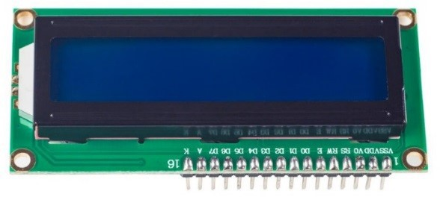
LCD1602, or 1602 character-type liquid crystal display, is a kind of dot matrix module to show letters, numbers, and characters and so on. It's composed of 5x7 or 5x11 dot matrix positions; each position can display one character. There's a dot pitch between two characters and a space between lines, thus separating characters and lines. The model 1602 means it displays 2 lines of 16 characters.
Generally, LCD1602 has parallel ports, that is, it would control several pins at the same time. LCD1602 can be categorized into eight-port and four-port connections. If the eight-port connection is used, then all the digital ports of the SunFounder Uno board are almost completely occupied. If you want to connect more sensors, there will be no ports available. Therefore, the four-port connection is used here for better application.

Pins Functions
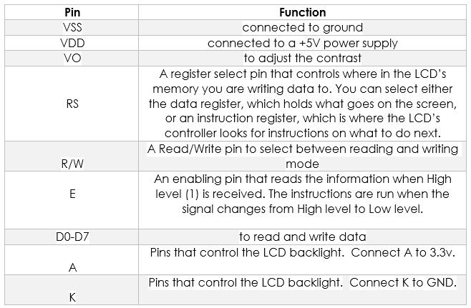

The Experiment for Arduino
Components
- 1 * SunFounder Uno Board
- 1 * Breadboard
- 1 * LCD1602
- 1 * Potentiometer (50kΩ)
- 1 * USB Cable
- Several Jumper Wires
Experimental Procedures
Note: Before connecting circuit, need to plug the pin headers onto a breadboard, and then put the LCD1602 on to it for easy soldering.
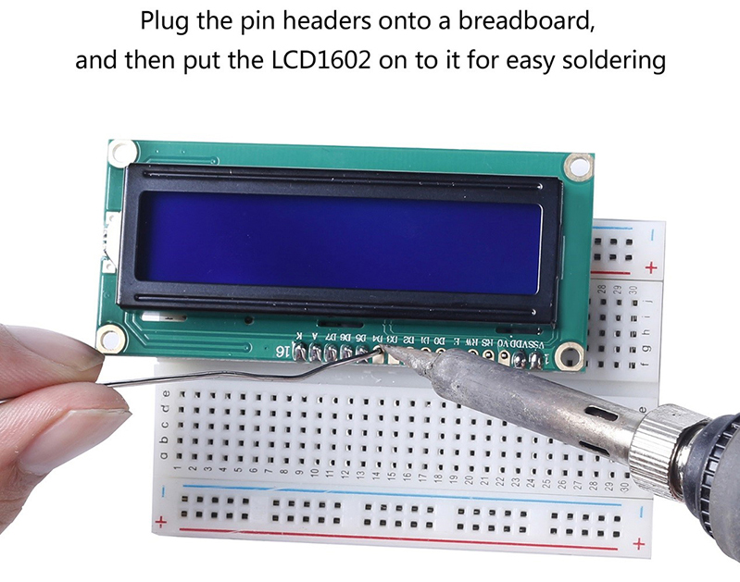
Step 1: Build the circuit (make sure the pins are connected correctly. Otherwise, characters will not be displayed properly):
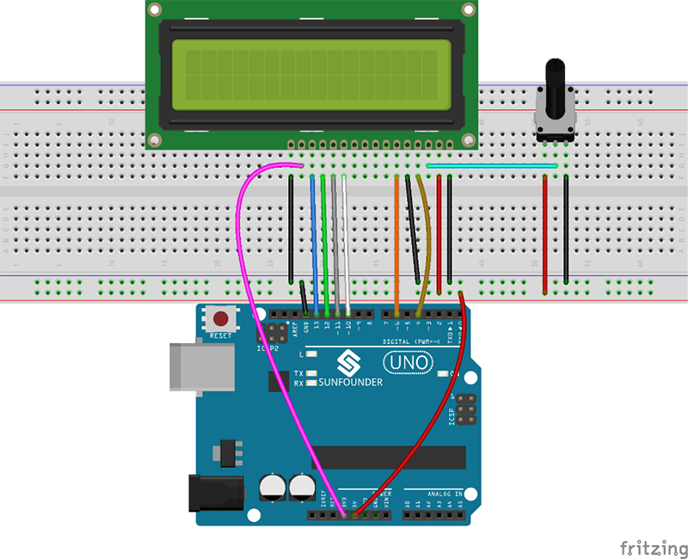
Step 2: Download the package LCD1602_for_Arduino, then unzip it and open the LCD1602.ino file
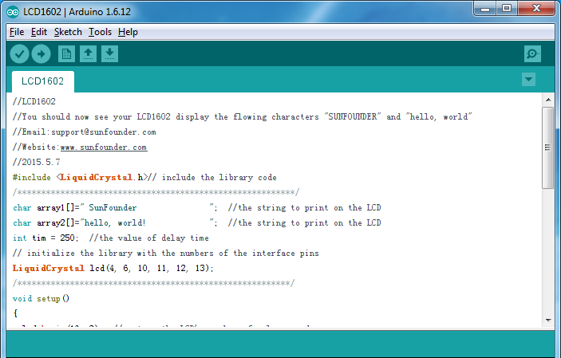
Step 3: Select correct Board and Port
Step 4: Upload the sketch to the SunFounder Uno board
Experimental Phenomenon
Note: You may need to adjust the potentiometer on the LCD1602 until it can display clearly.
You should now see the characters "SunFounder" and "hello, world! " rolling on the LCD.
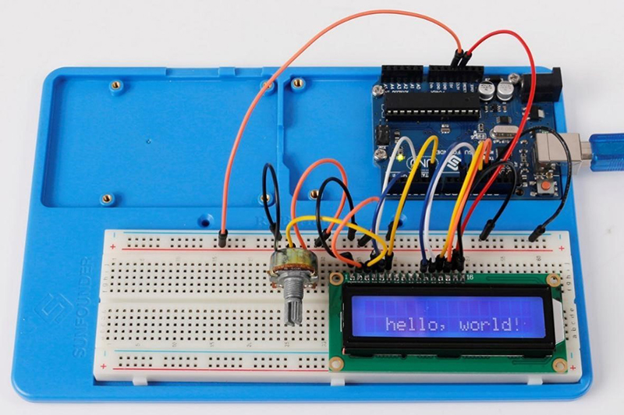

The Experiment for Raspberry Pi
Components
- 1 * Raspberry Pi
- 1 * Breadboard
- 1 * LCD1602
- 1 * Potentiometer
- Several Jumper Wires
Experimental Procedures
Step 1: Build the circuit (please be sure the pins are connected correctly. Otherwise, characters will not be displayed properly):
LCD1602/2004 | SunFounder Uno board
K | GND
A | 3.3V
D7 | GPIO18
D6 | GPIO23
D5 | GPIO24
D4 | GPIO25
D0-D3 | No Connected
E | GPIO22
R/W | GND
RS | GPIO27
OV | Connect to the middle pin of potentiometer
VDD | 5V
VSS | GND
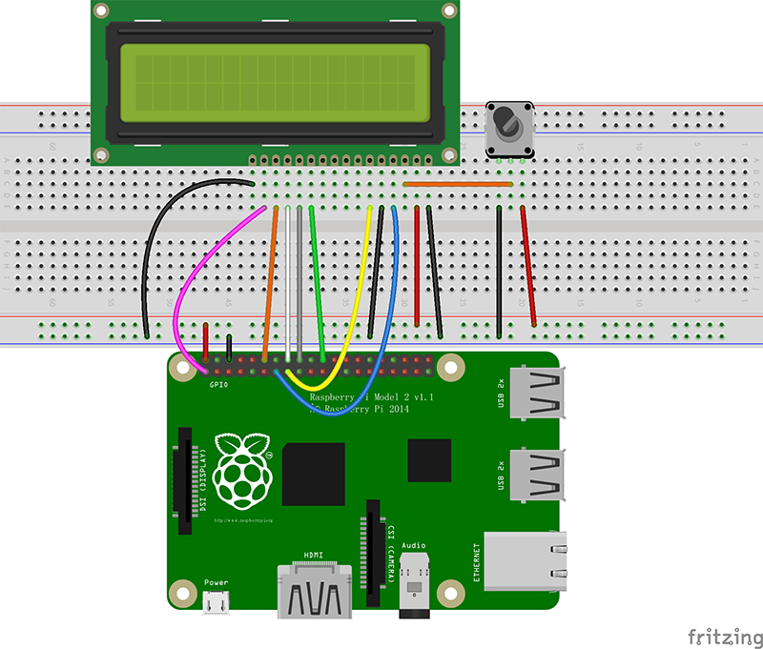
Note: After you run the code, characters may not appear on the LCD1602. You need to adjust the contrast of the screen (the gradual change from black to white) by spinning the potentiometer clockwise or anticlockwise, until the screen displays characters clearly.
Step 2: Transfer the package LCD1602_for_Raspberry_Pi to the Raspberry Pi
wget http://wiki.sunfounder.cc/images/8/87/LCD1602_for_Raspberry_Pi.zip
Step 3: Extract the package
unzip LCD1602_for_Raspberry_Pi.zip
(For C Language Users)
Step 4: Get into the folder of code
cd LCD1602_for_Raspberry_Pi/C
Step 5: Compile
gcc lcd1602.c –o lcd1602 –lwiringPiDev –lwiringPi
Step 6: Run
sudo ./lcd1602
(For Python Users)
Step 4: Get into the folder of code
cd LCD1602_for_Raspberry_Pi/Python
Step 5: Run
sudo python lcd1602.py

