**The Backtesting System Structure of vn.py**

（1）**engine = BacktestingEngine()**

（2）**engine.set_parameters**(vt_symbol="IF88.CFFEX",interval="1m",start=datetime(2018, 4, 30),end=datetime(2018, 5, 30),rate=0.3/10000,slippage=0.2,

size=300,pricetick=0.2,capital=1_000_000)

设置参数主要是把交易的相关基本信息输入计算机，如交易的级别1分钟，滑点，费率，本金等等。

（3）**engine.add_strategy(AtrRsiStrategy, {})**

把我们使用的策略加载进去，这个是我们交易思想的核心，相关参数在策略里面设定，setting里面拥有的参数有些事从set_parameters里面进行进行选取的，但是就是不知道哪些参数是必须传的，哪些是不需要传的。

（4）**engine.load_data()**

把我的回测数据加载进入内存当中，输出的是engine.history_data,



（5）**engine.run_backtesting():**

1.self.strategy.on_init():it’s to make preparations for running backtesting

self.load_bar(10): self.cta_engine.load_bar, the self.cta_engine is backtestingengine and the callback function is default on on_bar;It prepares the essential data for calculating the Finacial indicator

2. self.strategy.on_start():It’s in atr_rsi_strategy.py

3. self.strategy.trading = True：It‘s preparing for trading

4. new_bar(data):It’ in backtestingengine.py

self.cross_limit_order()：



self.cross_stop_order()：



self.strategy.on_bar(bar)：it returns vt_orderid

self.buy(bar.close_price + 5, self.fixed_size)：It is in template.py

self.send_order(Direction.LONG, Offset.OPEN, price, volume, stop, lock)：It is in template.py

self.cta_engine.send_order(self, direction, offset, price, volume, stop, lock): It is in template.py,it returns vt_orderids

self.update_daily_close(bar.close_price):It is in backtesting.py

self.daily_results[d] = DailyResult(d, price):the DailyResult is a class



（6）**engine.calculate_result()**

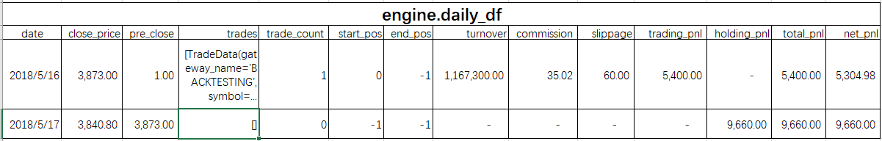

（7）**engine.calculate_statistics()**

（8）**engine.show_chart()**

**D:\The Road For Finacial Statics\GitHub\learning_for_stock_testing_and_trading_system\vnpy-2.0.9;C:\Users\Administrator\AppData\Local\Programs\Microsoft VS Code\bin;C:\Program Files\Bandizip\**