1. I will assume that you have successfully built the 2 apps required in HW 4. If not

please reach out to me or the TAs for code on which to build.

1. You should add a Cloud SQL database to your project and create a schema that

obeys 2nd normal form and can hold the following information about the requests that your web server is receiving: country, client ip, gender, age, income, is_banned, time of day, and requested file.

1. You should modify your web server to extract the information from the incoming requests, process it appropriately to convert it to 2nd normal and insert it into the database. You will need to make the appropriate changes to your VM so that it has the right permissions and installed libraries to be able to talk to your database. Requests that fail (return codes other than 200) should be logged into a separate table that also obeys 2nd normal form but only contains the time of request, the requested file, and the error code.

Build Data base

Upload countries

And test request table

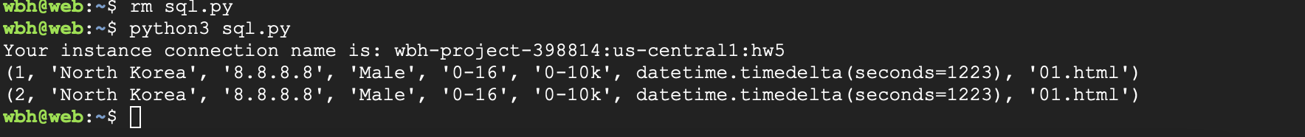

Create function

Use function in my app

1. Demonstrate the functionality of your app by using curl to issue one successful and 2 erroneous requests and show the contents of your tables before and after each request.

Successful

Fail

1. Provision a VM that can handle the request load from 2 concurrent clients (use the client that has been provided to you) and run each client to issue 50,000 requests against your VM. Make sure to start the 2 clients with the same random seed so the clients are consistent about their request generation. This may take a little while to finish (multiple minutes)
2. Once the clients have completed, compute the following statistics on your requests:
   * ○  How many requests were you able to process successfully vs unsuccessfully?
   * ○  How many requests came from banned countries?
   * ○  How many requests were made by Male vs Female users?
   * ○  What were the top 5 countries sending requests to your server?
   * ○  What age group issued the most requests to your server?
   * ○  What income group issued the most requests to your server?