巨噬细胞清除操作及文献实例分析
1.巨噬细胞清除简介
巨噬细胞是体内每个器官中唯一都存在的细胞，存在于表皮、角膜和没有血管的关节内部，其体内生物学研究的重要方法之一是巨噬细胞耗竭。清除巨噬细胞，可以全面了解巨噬细胞在病理条件下的功能。目前，巨噬细胞清除的主要方法包括构建巨噬细胞缺失动物模型和使用药物（氯膦酸盐脂质体）去除法，但是，构建巨噬细胞缺失动物模型价格昂贵，周期长，因此，氯膦酸盐脂质体（Clodronate Liposomes）是目前最为成熟，方便，经济的一种巨噬细胞清除工具，可以有效的清除动物体内包括肝脏，脾脏，肺部，血液等多个不同组织和部位中的巨噬细胞，也是目前使用最广泛的一种巨噬细胞清除的方法。
2.巨噬细胞清除剂的原理
将氯膦酸盐包裹进磷脂体的水相中形成氯膦酸盐脂质体，氯膦酸盐不能自由的通过脂质体磷脂体双分子层。注射到生物体内后，氯膦酸盐脂质体会被巨噬细胞吞噬，在巨噬细胞内的溶酶体磷酸酶的作用下，溶解在脂质体内的氯膦酸盐会被逐步释放出来并在细胞内积累，当达到一定浓度时，巨噬细胞将会受到不可逆损伤，诱发细胞凋亡。死亡细胞内的氯膦酸盐会被释放到细胞外，随尿液排出体外。
3.巨噬细胞清除剂给药方法参考：
不同种类的小鼠给药剂量略有差异，可根据以下表格中的给药剂量摸索。
表1 C57小鼠巨噬细胞清除给药方法
给药 | 内容
给药方法 | 腹腔注射、静脉注射、鼻内吸入等
给药剂量（C57小鼠） | 单次给药：150-200μL/小鼠(20-25g)；  多次给药，间隔3-7天，每次给药150-200μL/小鼠(20-25g)（注：不同小鼠和不同部位间隔给药时间和给药剂量不同，非固定值，可根据预实验结果或者参考相关文献调整）
4.巨噬细胞标志物
巨噬细胞有很多种亚型，不同的亚型部分标志物不同（见表2），另外，不同组织和器官的巨噬细胞的标志物也会有差异（见表3）。一般在做巨噬细胞清除实验前，应先查找相关文献，找出具体清除部位的巨噬细胞的表面标志物，选择最佳标志物进行流式实验。
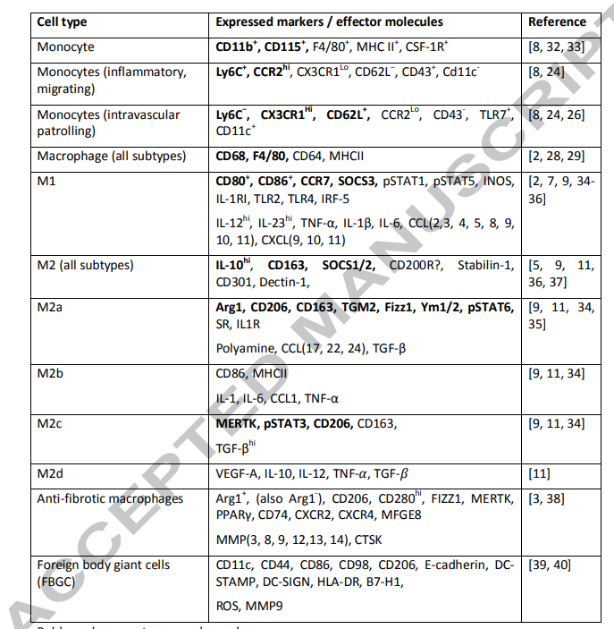
表2 不同亚型的巨噬细胞标志物
参考文献：Klopfleisch R. Macrophage reaction against biomaterials in the mouse model - Phenotypes, functions and markers. Acta Biomater. 2016 Oct 1;43:3-13. doi: 10.1016/j.actbio.2016.07.003. Epub 2016 Jul 6. PMID: 27395828.
表3 不同组织中巨噬细胞的标志物
巨噬细胞 | 组织 | 标志物
脂肪组织巨噬细胞 | 脂肪 | CD45⁺、F4/80⁺、PPARg⁺
Kupffer细胞 | 肝脏 | B7-1/CD80^{low/-}、CD11b/Integrin aM^{low} 、CD68/SR-D1⁺、F4/80^{high}、Galectin3/Mac-2⁺、 PPARd⁺、Siglec-1/CD169⁺
肺泡巨噬细胞 | 肺泡 | CD11b/Integrin aM^{low/-}、CD11c^{high}、CD68/SRD1⁺,、CD200 R1⁺、DEC205/CD205^{int}、Dectin1⁺、F4/80^{low}、Galectin3/Mac-2⁺、MARCO⁺、MHC class II ^{low} 、MMR/CD206^{high}、PPARg⁺ 、Siglec-F^{high}
肺胞肺间质巨噬细胞 | 肺 | CD11b/Integrin aM^{int}、CD11c⁻、CD68/SR-D1⁺、CD200 R1^{+/-}、F4/80⁺、 MHC class II^{+/-}、SiglecF⁻
骨髓巨噬细胞 | 骨髓 | CD169⁺、ER-HR3⁺、F4/80⁺、 TRAP-、 VCAM1/CD106⁺
肠道巨噬细胞 | 胃肠道 | CD11b/Integrin aM⁺、 CD11c^{low/int} 、CX3CR1^{high} 、F4/80⁺、Fcg RI/CD64MHC Class II ^{high}

5.巨噬细胞清除文献实例
文献一
小鼠品系：C57BL/6J小鼠
注射方式：腹腔注射
取样部位：外周血
注射剂量：200 μl /只
抗体选择：F4/80
检测方法：巨噬细胞耗竭模型采用氯膦酸脂质体，腹腔注射200μL每只小鼠，在注射氯钠脂质体后24小时，通过流式细胞术检测外周血巨噬细胞数量。
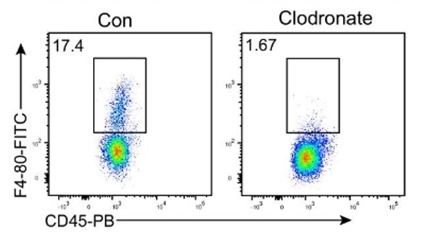
清除结果：
图1. 腹腔注射给药后巨噬细胞减少
参考文献：Xiong X, Chen S, Shen J, et al. Cannabis suppresses antitumor immunity by inhibiting JAK/STAT signaling in T cells through CNR2. Signal Transduct Target Ther. 2022;7(1):99. Published 2022 Apr 6. doi:10.1038/s41392-022-00918-y(IF:18.187)
文献二
小鼠品系：雌性C57BL/6J小鼠
注射方式：腹腔注射
取样部位：腹腔灌洗液
注射剂量：第0、3、6天分别给与15 mg/kg巨噬细胞清除剂
抗体选择：CD11b，F4/80双阳性
检测方法：在第0、3、6天将氯膦酸脂质体 (15 mg/kg)或悬浮在200 ml PBS中的空脂质体腹腔注射到6周龄雌性C57BL/6J小鼠体内，以消耗巨噬细胞，并在最后一次脂质体注射后的第3、6天将100万BMDMs悬浮在100 ml PBS中静脉注射重建巨噬细胞，然后通过流式细胞术分析小鼠腹腔灌洗液巨噬细胞的损耗和重构。
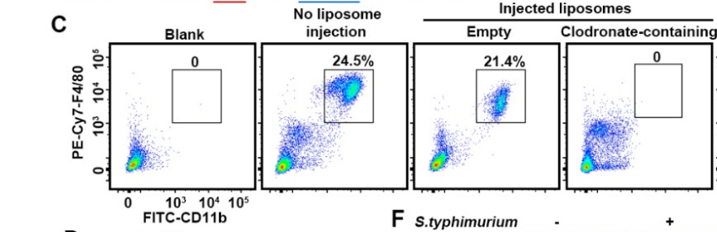
清除结果：
图2.注射脂质体后鼠腹腔灌洗液及巨噬细胞重建的流式分析
参考文献：Zhang Z, Chen C, Yang F, et al. Itaconate is a lysosomal inducer that promotes antibacterial innate immunity [published online ahead of print, 2022 May 25. Mol Cell. 2022;S1097-2765(22)00443-9. doi:10.1016/j.molcel.2022.05.009 (IF:17.970)
文献三
小鼠品系：C57BL/6J
注射方式：静脉注射
取样部位：血液、乳腺
注射剂量：200 μl /只
抗体选择：F4/80
清除方法：巨噬细胞耗竭模型采用氯膦酸脂质体(0.15-0.2 mL/25 g)，给与200μL每只小鼠，静脉注射于哺乳期小鼠体内，消耗血液和乳腺内巨噬细胞，在注射氯钠脂质体后24、48和72小时，通过流式细胞术检测乳腺巨噬细胞数量。
图3 a血液学自动分析仪检测血液中单核细胞(血液中巨噬细胞的一种形式)比例的变化。b流式细胞术检测乳腺巨噬细胞比例变化。
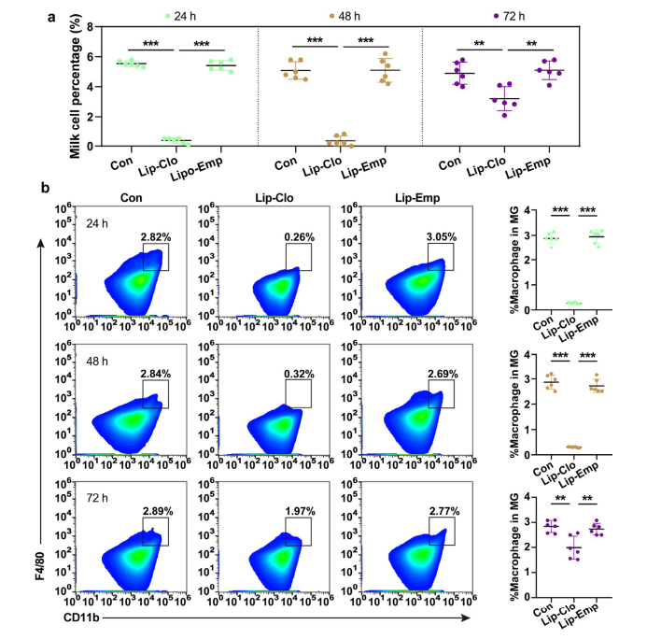
清除结果：
参考文献：Cai J, Peng J, Zang X, Feng J, Li R, Ren P, Zheng B, Wang J, Wang J, Yan M, Liu J, Deng R, Wang D. Mammary Leukocyte-Assisted Nanoparticle Transport Enhances Targeted Milk Trace Mineral Delivery. Adv Sci (Weinh). 2022 Sep;9(26):e2200841. doi: 10.1002/advs.202200841. Epub 2022 Jun 30. PMID: 35773238; PMCID: PMC9475556. (IF:17.521)
文献四
小鼠品系：C57BL/6
注射方式：腹腔注射
取样部位：外周血
注射剂量：200 μl /只
抗体选择：F4/80
检测方法： 第3天腹腔注射氯磷酸脂质体200 μL，去除巨噬细胞。用流式细胞术检测巨噬细胞缺失效应。
清除结果：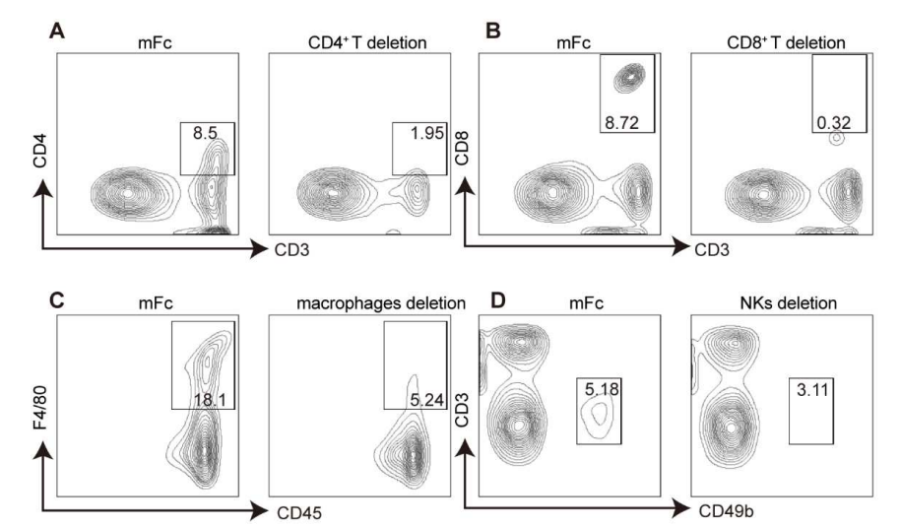
图4.免疫细胞缺失流式分析
参考文献：Yu X, Long Y, Chen B, et al. PD-L1/TLR7 dual-targeting nanobody-drug conjugate mediates potent tumor regression via elevating tumor immunogenicity in a host-expressed PD-L1 bias-dependent way. J Immunother Cancer. 2022;10(10):e004590. doi:10.1136/jitc-2022-004590(IF:12.469)
6.产品简介
产品组成：1 mL脂质体体悬液（1.5-2μm）中所含的氯膦酸大约为5 mg，所用的磷酸盐缓冲液为10 mM Na₂HPO₄，10 mM NaH₂PO₄，140 mM NaCl。
产品列表
产品名称 | 货号 | 规格
Clodronate Liposomes（From Vrije Universiteit Amsterdam）体内巨噬细胞清除剂 | 40337ES08 | 5 mL
 | 40337ES10 | 10 mL
Control Liposomes（PBS）体内巨噬细胞清除剂空白脂质体对照 | 40338ES08 | 5 mL
 | 40338ES10 | 10 mL

部分参考文献列表（滚动形成呈现）
[1] Liu Z, Gu Y, Chakarov S, et al. Fate Mapping via Ms4a3-Expression History Traces Monocyte-Derived Cells. Cell. 2019;178(6):1509-1525.e19. doi:10.1016/j.cell.2019.08.009(IF:36.216)
[2] Xiong X, Chen S, Shen J, et al. Cannabis suppresses antitumor immunity by inhibiting JAK/STAT signaling in T cells through CNR2. Signal Transduct Target Ther. 2022;7(1):99. Published 2022 Apr 6. doi:10.1038/s41392-022-00918-y(IF:18.187)
[3] Zhang Z, Chen C, Yang F, et al. Itaconate is a lysosomal inducer that promotes antibacterial innate immunity [published online ahead of print, 2022 May 25]. Mol Cell. 2022;S1097-2765(22)00443-9. doi:10.1016/j.molcel.2022.05.009(IF:17.970)
[4] Cai J, Peng J, Zang X, et al. Mammary Leukocyte-Assisted Nanoparticle Transport Enhances Targeted Milk Trace Mineral Delivery [published online ahead of print, 2022 Jun 30]. Adv Sci (Weinh). 2022;e2200841. doi:10.1002/advs.202200841(IF:17.521)
[5] Jin H, Liu K, Tang J, et al. Genetic fate-mapping reveals surface accumulation but not deep organ invasion of pleural and peritoneal cavity macrophages following injury. Nat Commun. 2021;12(1):2863. Published 2021 May 17. doi:10.1038/s41467-021-23197-7(IF:14.919)
[6] Sheng D, Ma W, Zhang R, et al. Ccl3 enhances docetaxel chemosensitivity in breast cancer by triggering proinflammatory macrophage polarization [published correction appears in J Immunother Cancer. 2022 Jun;10(6):]. J Immunother Cancer. 2022;10(5):e003793. doi:10.1136/jitc-2021-003793(IF:13.751)
[7] Yu X, Long Y, Chen B, et al. PD-L1/TLR7 dual-targeting nanobody-drug conjugate mediates potent tumor regression via elevating tumor immunogenicity in a host-expressed PD-L1 bias-dependent way. J Immunother Cancer. 2022;10(10):e004590. doi:10.1136/jitc-2022-004590(IF:12.469)
[8] Zhao L, Zhang H, Liu X, et al. TGR5 deficiency activates antitumor immunity in non-small cell lung cancer via restraining M2 macrophage polarization. Acta Pharm Sin B. 2022;12(2):787-800. doi:10.1016/j.apsb.2021.07.011(IF:11.614)
[9] Xia L, Zhang C, Lv N, et al. AdMSC-derived exosomes alleviate acute lung injury via transferring mitochondrial component to improve homeostasis of alveolar macrophages. Theranostics. 2022;12(6):2928-2947. Published 2022 Mar 21. doi:10.7150/thno.69533(IF:11.556)
[10] Zhang X, Hou L, Li F, et al. Piezo1-mediated mechanosensation in bone marrow macrophages promotes vascular niche regeneration after irradiation injury. Theranostics. 2022;12(4):1621-1638. Published 2022 Jan 16. doi:10.7150/thno.64963(IF:11.556)
[11] Xun J, Du L, Gao R, et al. Cancer-derived exosomal miR-138-5p modulates polarization of tumor-associated macrophages through inhibition of KDM6B. Theranostics. 2021;11(14):6847-6859. Published 2021 May 3. doi:10.7150/thno.51864(IF:11.556)
[12] Wang H, Li L, Li Y, et al. Intravital imaging of interactions between iNKT and kupffer cells to clear free lipids during steatohepatitis. Theranostics. 2021;11(5):2149-2169. Published 2021 Jan 1. doi:10.7150/thno.51369(IF:11.556)
[13] Wu H, Yin X, Zhao X, et al. HDAC11 negatively regulates antifungal immunity by inhibiting Nos2 expression via binding with transcriptional repressor STAT3. Redox Biol. 2022;56:102461. doi:10.1016/j.redox.2022.102461(IF:10.787)
[14] Liu X, Fei H, Yang C, et al. Trophoblast-Derived Extracellular Vesicles Promote Preeclampsia by Regulating Macrophage Polarization. Hypertension. 2022;79(10):2274-2287. doi:10.1161/HYPERTENSIONAHA.122.19244(IF:9.897)
[15] Zuo L, Li J, Zhang X, et al. Aberrant mesenteric adipose extracellular matrix remodeling is involved in adipocyte dysfunction in Crohn's disease: The role of TLR-4-mediated macrophages [published online ahead of print, 2022 Jun 16]. J Crohns Colitis. 2022;jjac087. doi:10.1093/ecco-jcc/jjac087(IF:9.071)
[16] Huang C, Wang J, Liu H, et al. Ketone body β-hydroxybutyrate ameliorates colitis by promoting M2 macrophage polarization through the STAT6-dependent signaling pathway. BMC Med. 2022;20(1):148. Published 2022 Apr 15. doi:10.1186/s12916-022-02352-x(IF:8.775)
[17] Wang Y, Sun Q, Ye Y, et al. FGF-2 signaling in nasopharyngeal carcinoma modulates pericyte-macrophage crosstalk and metastasis. JCI Insight. 2022;7(10):e157874. Published 2022 May 23. doi:10.1172/jci.insight.157874(IF:8.315)
[18] Jiang P, Gao W, Ma T, et al. CD137 promotes bone metastasis of breast cancer by enhancing the migration and osteoclast differentiation of monocytes/macrophages. Theranostics. 2019;9(10):2950-2966. Published 2019 May 9. doi:10.7150/thno.29617(IF:8.063)
[19] Yang XL, Wang G, Xie JY, et al. The Intestinal Microbiome Primes Host Innate Immunity against Enteric Virus Systemic Infection through Type I Interferon. mBio. 2021;12(3):e00366-21. Published 2021 May 11. doi:10.1128/mBio.00366-21(IF:7.867)
[20] Li C, Song J, Guo Z, et al. EZH2 Inhibitors Suppress Colorectal Cancer by Regulating Macrophage Polarization in the Tumor Microenvironment. Front Immunol. 2022;13:857808. Published 2022 Apr 1. doi:10.3389/fimmu.2022.857808(IF:7.561)
[21] Sun Z, Huang W, Zheng Y, et al. Fpr2/CXCL1/2 Controls Rapid Neutrophil Infiltration to Inhibit Streptococcus agalactiae Infection. Front Immunol. 2021;12:786602. Published 2021 Nov 24. doi:10.3389/fimmu.2021.786602(IF:7.561)
[22] Cai J, Cui X, Wang X, You L, Ji C, Cao Y. A Novel Anti-Infective Peptide BCCY-1 With Immunomodulatory Activities. Front Immunol. 2021;12:713960. Published 2021 Jul 22. doi:10.3389/fimmu.2021.713960(IF:7.561)
[23] Chen X, Zheng Y, Liu S, Yu W, Liu Z. CD169<sup>+</sup> subcapsular sinus macrophage-derived microvesicles are associated with light zone follicular dendritic cells. Eur J Immunol. 2022;52(10):1581-1594. doi:10.1002/eji.202249879(IF:6.688)
[24] Tian L, Li W, Yang L, et al. Cannabinoid Receptor 1 Participates in Liver Inflammation by Promoting M1 Macrophage Polarization via RhoA/NF-κB p65 and ERK1/2 Pathways, Respectively, in Mouse Liver Fibrogenesis. Front Immunol. 2017;8:1214. Published 2017 Sep 28. doi:10.3389/fimmu.2017.01214(IF:6.429)
[25] Zou D, Qin J, Hu W, et al. Macrophages Rapidly Seal off the Punctured Zebrafish Larval Brain through a Vital Honeycomb Network Structure. Int J Mol Sci. 2022;23(18):10551. Published 2022 Sep 11. doi:10.3390/ijms231810551(IF:6.208)
[26] Wang X, Li W, Jiang H, et al. Zebrafish Xenograft Model for Studying Pancreatic Cancer-Instructed Innate Immune Microenvironment. Int J Mol Sci. 2022;23(12):6442. Published 2022 Jun 9. doi:10.3390/ijms23126442(IF:5.924)
[27] Xiong C, Zhu Y, Xue M, et al. Tumor-associated macrophages promote pancreatic ductal adenocarcinoma progression by inducing epithelial-to-mesenchymal transition. Aging (Albany NY). 2021;13(3):3386-3404. doi:10.18632/aging.202264(IF:5.682)
[28] Pu S, Wu Y, Tong F, et al. Mechanosensitive Ion Channel TMEM63A Gangs Up with Local Macrophages to Modulate Chronic Post-amputation Pain [published online ahead of print, 2022 Jul 12]. Neurosci Bull. 2022;10.1007/s12264-022-00910-0. doi:10.1007/s12264-022-00910-0(IF:5.271)
[29] Wang J, Li X, Wang Y, Li Y, Shi F, Diao H. Osteopontin aggravates acute lung injury in influenza virus infection by promoting macrophages necroptosis. Cell Death Discov. 2022;8(1):97. Published 2022 Mar 4. doi:10.1038/s41420-022-00904-x(IF:5.241)
[30] Ma Y, Liang Y, Wang N, et al. Avian Flavivirus Infection of Monocytes/Macrophages by Extensive Subversion of Host Antiviral Innate Immune Responses. J Virol. 2019;93(22):e00978-19. Published 2019 Oct 29. doi:10.1128/JVI.00978-19(IF:5.103)
[31] Jiang Q, Li W, Zhu X, et al. Estrogen receptor β alleviates inflammatory lesions in a rat model of inflammatory bowel disease via down-regulating P2X7R expression in macrophages. Int J Biochem Cell Biol. 2021;139:106068. doi:10.1016/j.biocel.2021.106068(IF:5.085)
[32] Tang Y, Wang C, Chen S, et al. Dimethyl fumarate attenuates LPS induced septic acute kidney injury by suppression of NFκB p65 phosphorylation and macrophage activation. Int Immunopharmacol. 2022;102:108395. doi:10.1016/j.intimp.2021.108395(IF:4.932)
[33] Lu Y, Lu G, Gao L, et al. The Proresolving Lipid Mediator Maresin1 Alleviates Experimental Pancreatitis via Switching Macrophage Polarization. Mediators Inflamm. 2021;2021:6680456. Published 2021 Mar 9. doi:10.1155/2021/6680456(IF:4.711)
[34] Li W, Chang N, Tian L, et al. miR-27b-3p, miR-181a-1-3p, and miR-326-5p are involved in the inhibition of macrophage activation in chronic liver injury. J Mol Med (Berl). 2017;95(10):1091-1105. doi:10.1007/s00109-017-1570-0(IF:4.686)
[35] Ji L, Chen Y, Xie L, Liu Z. The role of Dock2 on macrophage migration and functions during Citrobacter rodentium infection. Clin Exp Immunol. 2021;204(3):361-372. doi:10.1111/cei.13590(IF:4.330)
[36] Yang L, Dong C, Tian L, Ji X, Yang L, Li L. Gadolinium Chloride Restores the Function of the Gap Junctional Intercellular Communication between Hepatocytes in a Liver Injury. Int J Mol Sci. 2019;20(15):3748. Published 2019 Jul 31. doi:10.3390/ijms20153748(IF:4.183)
[37] Wu H, Xu X, Li J, Gong J, Li M. TIM‑4 blockade of KCs combined with exogenous TGF‑β injection helps to reverse acute rejection and prolong the survival rate of mice receiving liver allografts. Int J Mol Med. 2018;42(1):346-358. doi:10.3892/ijmm.2018.3606(IF:4.101)
[38] Zhao J, Chen XD, Yan ZZ, Huang WF, Liu KX, Li C. Gut-Derived Exosomes Induce Liver Injury After Intestinal Ischemia/Reperfusion by Promoting Hepatic Macrophage Polarization [published online ahead of print, 2022 Jun 14]. Inflammation. 2022;10.1007/s10753-022-01695-0. doi:10.1007/s10753-022-01695-0(IF:4.092)
[39] Guan Z, Ding Y, Liu Y, et al. Extracellular gp96 is a crucial mediator for driving immune hyperactivation and liver damage. Sci Rep. 2020;10(1):12596. Published 2020 Jul 28. doi:10.1038/s41598-020-69517-7(IF:3.998)
[40] Song C, Li H, Li Y, et al. NETs promote ALI/ARDS inflammation by regulating alveolar macrophage polarization. Exp Cell Res. 2019;382(2):111486. doi:10.1016/j.yexcr.2019.06.031(IF:3.329)
[41] Li R, Yang L, Jiang N, et al. Activated macrophages are crucial during acute PM2.5 exposure-induced angiogenesis in lung cancer. Oncol Lett. 2020;19(1):725-734. doi:10.3892/ol.2019.11133(IF:1.871)

