1. 接口地址：

通用接口，需要使用wsdl文件，在后面增加(?WSDL)：

<http://10.62.170.2:9091/CommonService.svc>

扩展业务接口，需要使用wsdl文件，在后面增加(?WSDL)：

<http://10.62.170.2:9091/ExpandingBusinessService.svc>

1. 使用CommonService.xml （wsdl）文件，调用登录接口：

public string Login(string UserName, string Password, string DataSetID, string DataSetDBName);

用户名：testeq

密码：testeq1

DataSetID与DataSetDBName暂时不需要给具体数据，给空值就可以；以备后续登录指定数据库用的；现在为空，默认使用后台配置的数据库；

返回xml：

<s:Envelope xmlns:s="http://www.w3.org/2003/05/soap-envelope" xmlns:r="http://schemas.xmlsoap.org/ws/2005/02/rm" xmlns:a="http://www.w3.org/2005/08/addressing">

<s:Header>

<r:Sequence s:mustUnderstand="1">

<r:Identifier>urn:uuid:e9f4dad7-6bbb-46eb-b214-8aae19e88498</r:Identifier>

<r:MessageNumber>4</r:MessageNumber>

</r:Sequence>

<r:SequenceAcknowledgement>

<r:Identifier>urn:uuid:2cfc61b5-d462-4f6f-9902-2bb672c9bfa7</r:Identifier>

<r:AcknowledgementRange Lower="1" Upper="4" />

<netrm:BufferRemaining xmlns:netrm="http://schemas.microsoft.com/ws/2006/05/rm">8</netrm:BufferRemaining>

</r:SequenceAcknowledgement>

<a:Action s:mustUnderstand="1">http://tempuri.org/ICommonService/LoginResponse</a:Action>

<a:RelatesTo>urn:uuid:a52654bd-0edf-4f80-8156-48ac6fa9f512</a:RelatesTo>

</s:Header>

<s:Body>

<LoginResponse xmlns="http://tempuri.org/">

<LoginResult>{"Success":true,"ReturnMsg":"登录成功","Data":"testeq"}</LoginResult>

</LoginResponse>

</s:Body>

</s:Envelope>

异常：

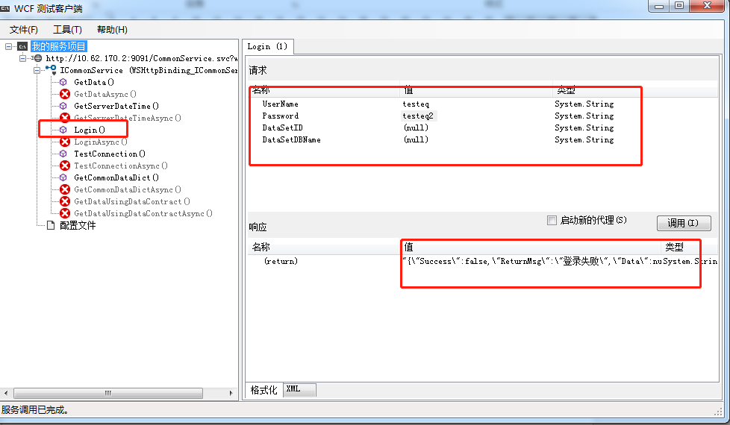

正常：

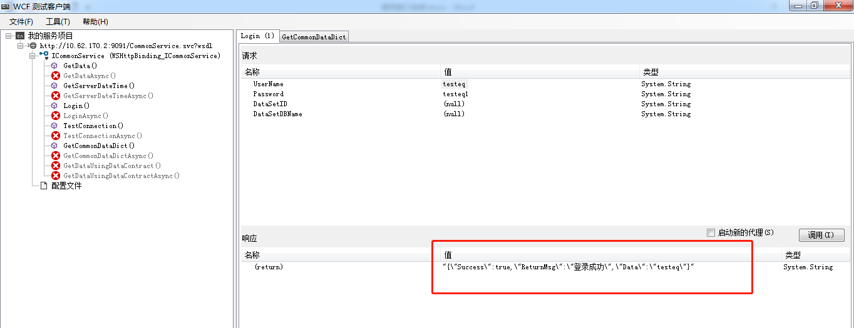

1. 使用CommonService.xml （wsdl）文件，调用获取数字字典接口：

public string GetCommonDataDict(string Account, string strDataTypes);

Account:登录时使用的账号

strDataTypes：需要获取的数据类型，一次取多组数据字典时，类型值使用“，”隔开，如：3,4

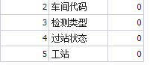

返回xml：

<s:Envelope xmlns:s="http://www.w3.org/2003/05/soap-envelope" xmlns:r="http://schemas.xmlsoap.org/ws/2005/02/rm" xmlns:a="http://www.w3.org/2005/08/addressing">

<s:Header>

<r:Sequence s:mustUnderstand="1">

<r:Identifier>urn:uuid:e9f4dad7-6bbb-46eb-b214-8aae19e88498</r:Identifier>

<r:MessageNumber>5</r:MessageNumber>

</r:Sequence>

<r:SequenceAcknowledgement>

<r:Identifier>urn:uuid:2cfc61b5-d462-4f6f-9902-2bb672c9bfa7</r:Identifier>

<r:AcknowledgementRange Lower="1" Upper="5" />

<netrm:BufferRemaining xmlns:netrm="http://schemas.microsoft.com/ws/2006/05/rm">8</netrm:BufferRemaining>

</r:SequenceAcknowledgement>

<a:Action s:mustUnderstand="1">http://tempuri.org/ICommonService/GetCommonDataDictResponse</a:Action>

<a:RelatesTo>urn:uuid:75f6b570-ad21-4a2d-8d81-30345597360c</a:RelatesTo>

</s:Header>

<s:Body>

<GetCommonDataDictResponse xmlns="http://tempuri.org/">

<GetCommonDataDictResult>{"Success":true,"ReturnMsg":"OK","Data":[{"ISID":2,"DataType":2,"DataCode":"20001","NativeName":"A车间","EnglishName":"A","CreationDate":null,"CreatedBy":null,"LastUpdateDate":null,"LastUpdatedBy":null,"status":0},{"ISID":3,"DataType":3,"DataCode":"30001","NativeName":"检测类型1","EnglishName":"CheckType1","CreationDate":null,"CreatedBy":null,"LastUpdateDate":null,"LastUpdatedBy":null,"status":0},{"ISID":4,"DataType":3,"DataCode":"30002","NativeName":"检测类型2","EnglishName":"CheckType2","CreationDate":null,"CreatedBy":null,"LastUpdateDate":null,"LastUpdatedBy":null,"status":0}]}</GetCommonDataDictResult>

</GetCommonDataDictResponse>

</s:Body>

</s:Envelope>

异常：提示需要先登录，再调用接口；

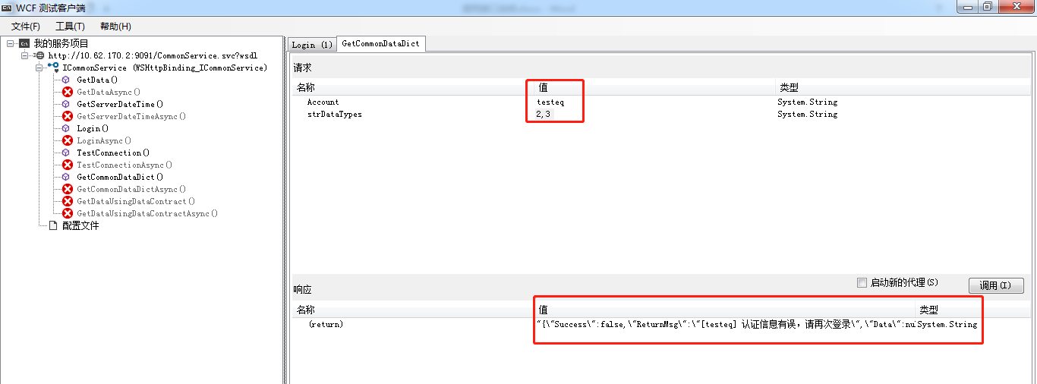

正常：

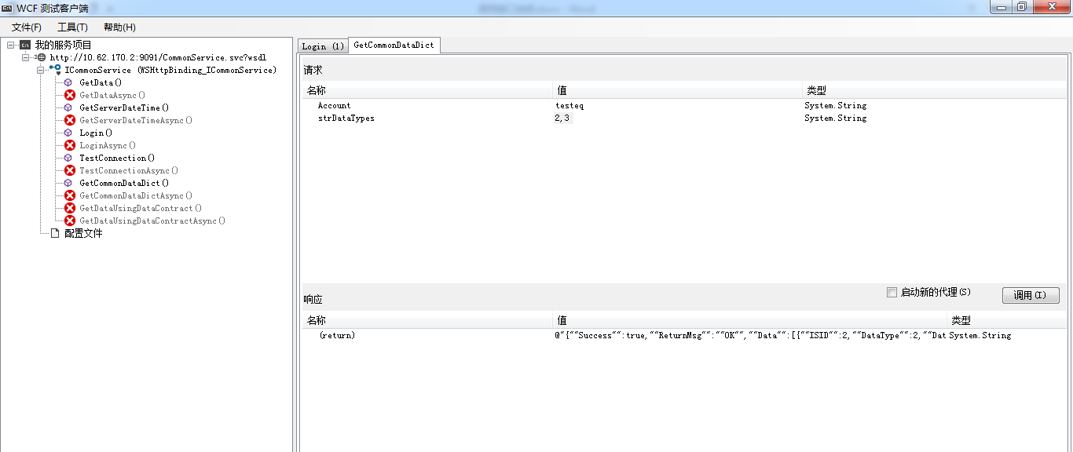

1. 使用ExpandingBusinessService.xml （wsdl）文件，调用过站接口：

public string PassStationCheck(string Account,

string BarCode, string ActionID, string CheckType,string TerminalID, string EquipmentID);

Account:登录账号

BarCode：条码

ActionID：状态id，使用数据字典，类型值=4

CheckType：检查类型，使用数据字典，类型值=3

TerminalID：工站id，使用数据字典，类型值=5

EquipmentID：设备id，后续使用设备台账信息，暂时可以任意给值，但不可以为空；

返回xml：

<s:Envelope xmlns:s="http://www.w3.org/2003/05/soap-envelope" xmlns:r="http://schemas.xmlsoap.org/ws/2005/02/rm" xmlns:a="http://www.w3.org/2005/08/addressing">

<s:Header>

<r:Sequence s:mustUnderstand="1">

<r:Identifier>urn:uuid:d93f8a80-c005-4f16-a104-0aa6d8da788a</r:Identifier>

<r:MessageNumber>3</r:MessageNumber>

</r:Sequence>

<r:SequenceAcknowledgement>

<r:Identifier>urn:uuid:84514e08-1855-4b01-987b-9aa066f67c8e</r:Identifier>

<r:AcknowledgementRange Lower="1" Upper="3" />

<netrm:BufferRemaining xmlns:netrm="http://schemas.microsoft.com/ws/2006/05/rm">8</netrm:BufferRemaining>

</r:SequenceAcknowledgement>

<a:Action s:mustUnderstand="1">http://tempuri.org/IExpandingBusinessService/PassStationCheckResponse</a:Action>

<a:RelatesTo>urn:uuid:50292844-6d0f-44fc-8eed-60d4c25032cc</a:RelatesTo>

</s:Header>

<s:Body>

<PassStationCheckResponse xmlns="http://tempuri.org/">

<PassStationCheckResult>{"Success":true,"ReturnMsg":"[A1-1_AF23-B01-36P] 过站成功","Data":[{"BarCode":"A1-1_AF23-B01-36P","CheckResult":"OK","CheckResultDesc":"OK TEST"}]}</PassStationCheckResult>

</PassStationCheckResponse>

</s:Body>

</s:Envelope>

异常：

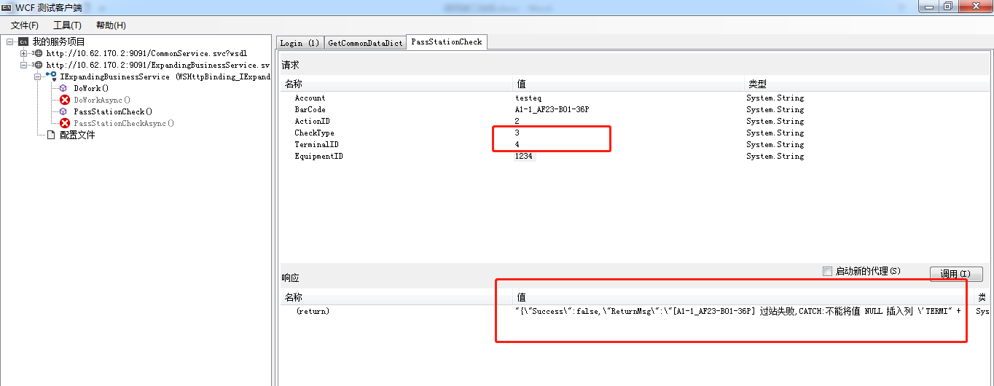

正常：

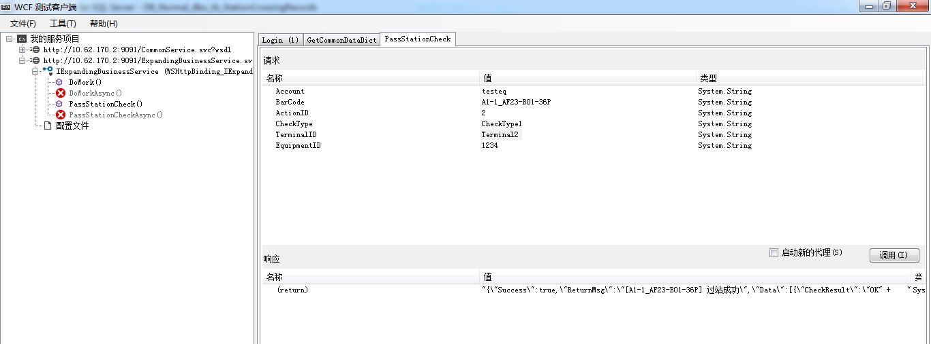

1. 注意：

* 调用接口时，都需要先登录，再使用；
* 登录后，如果一个小时内没有任何操作，后续再使用需要重新登录；

1. 返回数据类型：

public class ReturnValue

{

private bool _Success = false;

private string _ReturnMsg = "NG";

private object _Data = null;

[DataMember]

public bool Success

{

get { return _Success; }

set { _Success = value; }

}

[DataMember]

public string ReturnMsg

{

get { return _ReturnMsg; }

set { _ReturnMsg = value; }

}

[DataMember]

public object Data

{

get { return _Data; }

set { _Data = value; }

}

}

1. 其他：