|  |
| --- |
| **SOUTHERN CROSS UNIVERSITY** |

**ASSIGNMENT COVER SHEET**

For use with online submission of assignments

Please complete all of the following details and then make this sheet the **first page of each file of your assignment – do not send it as a separate document.**

Your assignments MUST be submitted as either **Word documents, text documents with .rtf extension or as .pdf documents**.

|  |  |
| --- | --- |
| Student Name: | **YongYe Wu** |
| Student ID No.: | **23347780** |
| Unit Name: | **Managing Software Development** |
| Unit Code: | **CMP73010** |
| Tutor’s name: | **Viettrung Luong** |
| Assignment No.: | **Ass1** |
| Assignment Title: | **Ass1** |
| Due date: | **2020/10/30** |
| Date submitted: | **2020/10/30** |

Declaration:

*I have read and understand the [Rules Relating to Awards s18](http://policies.scu.edu.au/view.current.php?id=00140) as contained in the SCU Policy Library. I understand the penalties that apply for plagiarism and agree to be bound by these rules. The work I am submitting electronically is entirely my own work.*

|  |  |
| --- | --- |
| Signed:  (please type your name) | YongYe Wu |
| Date: | 2020/10/30 |

**Executive Summary**

The report consists of three parts, first is the Acceptance test of an app and the detailed black-box test plan for the PowerPoint, second is the using of GitHub to take part in a project and the build management for the Mozilla Firefox, third is the RFP for the Spearhead Technology Services.

Contents

Introduction 3

**Part 1 – Testing** 3

**The Acceptance tests** 3

**Black-box test plan** 5

**Part 2 – Configuration management** 6

**Part 3 – Request for Proposal** 7

**Background information** 7

**Existing technical environment** 8

**Contact information.** 8

**Project overview** 8

**Main requirement of the project** 8

**Budget** 8

**Timeline and important deadlines** 10

**Criteria for selection** 10

**Team roles and collaboration for the new system** 10

**Conclusion** 11

# Introduction

The report consists of three parts, first is the Acceptance test of an app and the detailed black-box test plan for the PowerPoint, second is the using of GitHub to take part in a project and the build management for the Mozilla Firefox, third is the RFP for the Spearhead Technology Services.

**Part 1 – Testing**

**The Acceptance tests**

|  |  |
| --- | --- |
| **Scenario** | **Expected outcome** |
| **S1.0: Scenario 1** |  |
| S1.1: When the user wants to create a new account for the 'rideshare' app | After the new user fills in the basic information (such as setting password, the password should contain capital letters, lowercase letters and Arabic numerals), the user will be required to bind a mobile phone to ensure the security of the account and deal with unexpected situations such as account retrieval. After filling in the mobile phone number, the system will send SMS for the mobile phone number filled in the registration information, for example: "Dear user, the security verification code you applied for in 'rideshare' app is 682024, please use it within 10 minutes. If not my own operation, please delete the SMS or call customer service 027-34144657 ". After filling in the correct security verification code, the user can successfully register the new account. |
| S1.2: When the user logs in to the device used to register the 'rideshare' app or other authorized device | After entering the correct account name and password, the user can log in to 'rideshare' app on the device. Compared with the unauthorized device, when logging on the authorized device, the page will display some prompt information, such as: do you want to log in automatically? Do you want to save the account password? Users can operate according to their own needs. |
| S1.3: When a user logs in to the 'rideshare' app on an unauthorized device | When a user logs in to 'rideshare' app for the first time on an unauthorized device, the system will send the verification code to the authorized device or e-mail; after the verification code is filled in correctly, the user can log in by entering the correct account name and account password, and the system will ask whether the device is authorized. Fingerprint verification or face recognition can be performed in case of unexpected situations (such as device loss or power failure). |
| **S2.0 Scenario 2** |  |
| S2.1: When the user is ready to make a payment activity | When the user carries out payment activities, the system will pop up the order information to let the user confirm whether the information is wrong again. After completing this step, the system will carry out security detection on the current payment environment (such as whether the network status is a private link, etc.) |
| S2.2: When the user chooses the payment method | ‘rideshare' app supports 2 payment modes: the payment of wallet balance in app, and the payment of third party software (such as Alipay, WeChat, palpay). |
| S2.3: When the user chooses to pay with the balance of the wallet in the app | When making payment, the 'rideshare' app will provide a secure keyboard for users to enter the payment password. Users can also choose to use fingerprint payment |
| S2.4When users choose to pay with third-party software | The payment interface will jump to the third-party payment software for payment |
| **S3.0 Scenario 3** |  |
| S3.1: When the user clicks the "confirm boarding detection" button. | ‘Rideshare' app will display the license plate number and owner information on the page for the user to confirm again; it will require access to the location information of the device to check whether the location information is consistent; if the location information is inconsistent, the system will warn the user, and there is the alarm function. |
| **S4.0 Scenario 4** |  |
| S4.1: Before the user uses the app | The user must choose one of the two options, first option is location information is not allowed outside of use procedures, second option is allowing app to automatically retrieve user location information to improve user experience. If the user chooses the first option, then every time the app wants to get the location information, it must get the user's consent. |
| **S5.0 Scenario 5** |  |
| S5.1: Before the user uses the app | The user must choose one of the two options, the option is whether to authorize third-party services, if the user chooses no, then the third-party services can’t automatically obtain user information, if the user chooses yes, then he can then choose which third-party services to authorize. |

**Black-box test plan**

|  |  |  |
| --- | --- | --- |
| ***Screen: PowerPoint 2016 Print dialog*** | | |
| **Widget** | **Tests** | **Expected result** |
| button | 1. Move mouse cursor over the button. | 1. button colour should change. |
| 2. Click on the button. | 2. Function should process. |
| Input box | 1. Move mouse cursor over the input box. | 1. The mouse cursor should change to text input. |
| 2. Click on the input box. | 2. Everything in the text box is automatically selected and can be entered. |
| setting | 1. Move mouse cursor over the setting. | 1. The mouse cursor should change to “hand” shape |
| 2. Click on the setting. | 2. The preview is set to what you want it to look like. |
| Interference between  different button functions | 1. Choose to print 6 slides per page and select the “high quality” option too. | 1. The slides should be still high quality even the six slides on a page. |
| 2. Select print note page and select the slide box option at the same time. | 2. The slides should still be bordered around. |
| 3.Select both the print outline and the option to resize according to mental retardation. | 3.Slides are still automatically resized according to the paper. |

**Part 2 – Configuration management**

My user name is laige201x

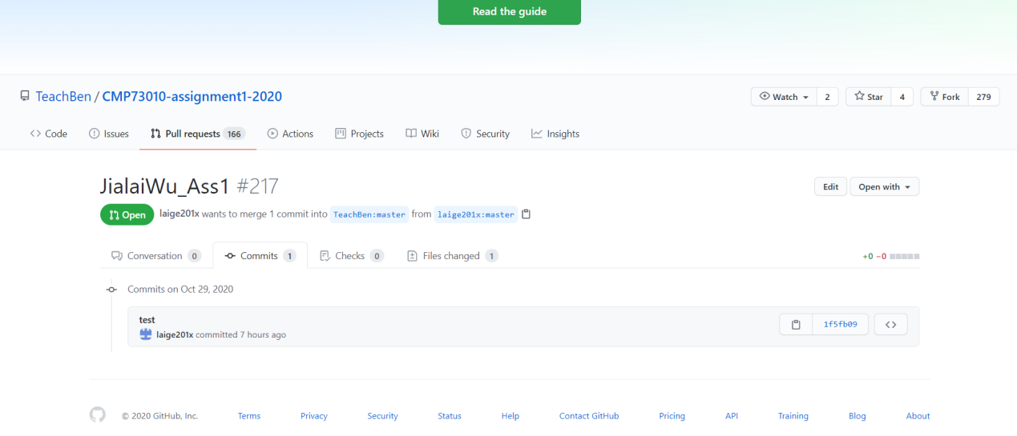

**Build Management**

The nightly build system of Mozilla Firefox is a platform for the testing and development, the nightly build system will send data to the Mozilla or the partners of Mozilla, so the others can help them to solve some problems and make the browser better. To be more specific, the developers will merge their codes to the Mozilla-central and compile these codes every day, and these codes will form a pre-release version of Firefox so we can test it and this is called the nightly build, after the codes have no problems, then they will publish a new version of Firefox based on this.

**How the company arrives at a release of the software**

When every part of the software were summary to the overall development code, test and appropriate modifications, will be the most important thing is to distinguish different blocks of code so as not to cause any other code errors affect the judgment and evaluation of the current code in front of a small part of the code is tentatively as no problem, you can to release the beta version of a small version of the browser to download and use, at this stage will receive a lot of different operating systems and different types of computers to provide feedback, if there is a problem, depending on the type of problem specific modified, if no problem according to the steps to modify the same part of the code. There is also an Unaltered Software Distribution Policy while publishing. *It includes that, you may not charge for the software, you may not collect personal information in the context of your distribution of the software, you may not add to, remove, or change any part of the software, including the Mozilla trademarks themselves, you may not modify the installation process of the software or use it to install any other themes, plugins, extensions, or software, we suggest that if you want to distribute Mozilla software, you do so by linking to official downloads at Mozilla.org to help ensure safe, reliable downloads, when distributing you must distribute the most recent version of Firefox and other Mozilla software.[1,Mozilla Firefox]*

**Advantages and Disadvantages of this system for the client**

Advantages: Nightly builds are builds from scratch. The build server checks out the code and builds it. This ensures that we can build from scratch and aren't relying on build artifacts from previous builds laying around in the build directory or whatever. We give these builds to QA every morning and they run tests on them.

Disadvantages: The periodic builds are just a compromise if you don't have enough such resources: you give up the ability to immediately identify a faulty commit as, if such build fails after picking up multiple new commits since the previous successful build, you need to perform additional work to exactly identify the faulty one(s) and fix the problem(s). And that may not always be simple, there is room for all kinds of potential complications

**Part 3 – Request for Proposal**

**Background information**

Spearhead Technology Services is a business which sells products about IoT (Internet of Things), we also provide repair of IoT device and so on, we want an integrated system for our six branch shops.

**Existing technical environment**

We have enough computers for work, the operating system is Windows, the web server we use is Apache, our software development tool is Eclipse, we also use GitHub as our software development platform, the cloud platform we use is the Ali Cloud.

**Contact information.**

Email: [STSIoT@conc.com](mailto:STSIoT@conc.com)

Address: #86, Cicero, Chicago, USA

Fax: 037-67981

Phone-Number: 64-178296-357

**Project overview**

We want an integrated system for our six branch shops and the system and the system will evolve over time because of the increase in the number of stores.

**Main requirement of the project**

1. Provide a customer relations database with information about products and services

purchased, devices left with them for repair (customer details, customer purchase history,

problem report, work details, etc.)

2. A marketing system that allows for digital marketing using e-mail, social media, and any other modern marketing techniques. This will use details in the customer relations database but allow other prospective customers details to be entered in an existing Spearhead Technology Services website (not part of this RFP).

3. A stock management system that includes products for sale, parts for use in repairs, automatic ordering from wholesalers. The system must be able to be used for individual locations to find products and parts at other Spearhead Technology Services locations when necessary. As the company specialises in IoT products the SMS will need to be able to have real-time monitoring and diagnostics of some IoT products (e.g. smart cities products).

4. Provide reports for management, who may be at any location, of the status of all the above so they can order stock, recruit staff and make other management decisions.

**Budget**

Income/ Revenue

Total

Special Events 276,000

Corporations/Foundation Grants 428,000

Contributions 110,000

Bequests/Legacies 8,000

Program fees 550,000

Government Contracts 950,100

Rental income 68,000

Investment Income 3,116

Total Revenue 2,393,216

Expenses

Program Services Program Administration Fundraising Total

Field

Centers

Summer

Programs

Special

Programs

Total Total Total Expenses

Salaries 95,000 92,100 99,000 286,100 210,000 62,000 558,100

Payroll taxes 1,592 1,336 1,641 4,569 985 750 6,304

Fringe benefits 15,968 23,900 24,050 63,918 7,000 2,000 72,918

Professional fees / contracted services 35,000 6,800 41,800

Supplies 14,200 3,800 7,000 25,000 2,000 1,500 28,500

Accounting fees 5,000 5,000

Legal fees 4,800 4,800

Telephone 400 400 400 1,200 3,400 1,000 5,600

Special events 97,000 97,000

Postage 700 700 700 2,100 2,000 1,115 5,215

Printing and publications 77,500 91,500 36,000 205,000 4,000 26,000 235,000

Insurance 14,500 12,000 8,500 35,000 1,300 1,000 37,300

Interest 5,789 5,789

Depreciation 3,930 8,520 5,950 18,400 7,890 1,200 27,490

Miscellaneous 104 68 104 276 100 376

Total Expenses 223,894 234,324 183,345 641,563 289,264 200,365 1,131,192

Net Income / (Deficit) 1,262,024 [ <https://www.template.net/business/budget-templates/sample-company-budget/>]

**Timeline and important deadlines**

1. Initial RFP Send: October 30

2. Deadline for vendors response: November 18

3. Deadline for first vendors selection: November 23rd

4. Confirm the final vendor: November 25

5. Targeted project start date: December 1st

6. Targeted project end date: January 1st

**Criteria for selection**

1, With a clean UI interface, even the non-expert will not find it particularly difficult to learn

2, The internal structure of the system is efficient and will not waste too much computer resources

3, Information security, high confidentiality

4, High cost performance

**Team roles and collaboration for the new system**

System analyst: Lucy, Rebeca

Customer service: Nancy, Jack

Maintenance technician: Kingsley, Ale

Data manager: Jeff, Lucas

Total management: Mike

**Conclusion**

This report concludes the Acceptance test of an app, the detailed black-box test plan for the PowerPoint, it also uses the GitHub to modify a document and request a pull of the project, there is also a build management for the Mozilla Firefox, finally is the RFP for the Spearhead Technology Services.

**References**

[1] <https://www.mozilla.org/en-US/foundation/trademarks/distribution-policy/>

[2] https://www.template.net/business/budget-templates/sample-company-budget/