Team Bravo: Milestone #3

Andrew Bach, Torren Davis, John Garcia III, Taylor Mommer & Ian Spresney

Bellevue University

CSD 310: Database and Development Use, Assignment #: 11.1

Professor Sue Sampson

December 10th, 2023

**Team Bravo: Milestone #3**

Report 1 Description:

Question: Is there any location that has a downward trend in bookings?

Solution: The solution that we, group Bravo, produced was a report that would query the database and display trip information such as the trip's name, its location, the country, the number of registrations the trip has had, and the year of the trip. With this information, Outland Adventures could see the booking trends for each location and be more informed about whether a specific location has had a downtrend in bookings or not.

Report 1 Screenshot:

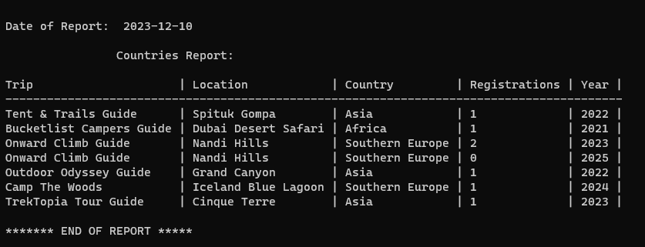

Report 2 Description:

Question: Do enough customers buy equipment to keep equipment sales?

Solution: The solution that we produced was a report that would query the database and display sales information such as the product (we substituted the name equipment for the product so that we can have a table filled with items that are for sale called products, and items that are not for sale called equipment) that is for sale, the price of that product, and the revenue the company has made from the sales of that product. With this information, Outland Adventures would be able to see how much money they make in revenue from selling products to customers and make an informed decision on whether to keep the product sales aspect of their business.

Report 2 Screenshot:

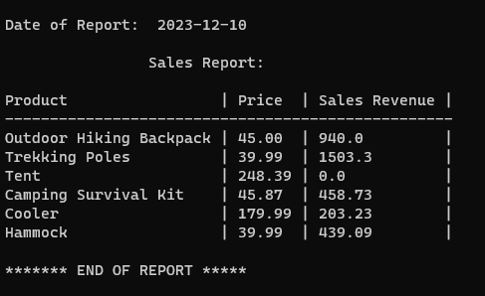

Report 3 Description:

Question: Are there inventory items that are over five years old?

Solution: The solution we produced was a report that would query the database and display information on equipment that is relevant to its age, such as the equipment name, the day it was ordered, the day it was received, the age (in days), and if the equipment was over 5 years old. The report will be from oldest to newest, so all older equipment will be shown first. With this information, Outland Adventures could identify any equipment they have that is over 5 years old. They would also be able to identify any equipment that is inching closer to 5 years of age since the report will show all older equipment first.

Report 3 Screenshot:

